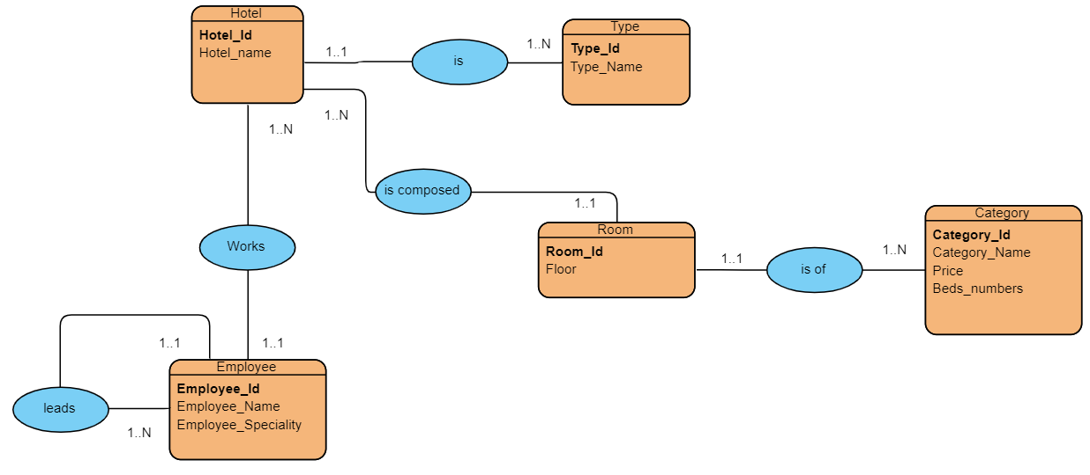

Hotel (Hotel_Id, Hotel_name, #Category_id, #type_id)

Type (type_id, type_name)

Employee (Employee_Id, Employee_Name, Employee_Speciality, #Hotel_Id, #Director_id)

Room (Room_id, Floor,#Hotel_Id)

Category (Category_Id, Category_Name, Price, Beds_numbers)