**Checkpoint : GitHub**

1. Creating a folder called ‘learn_git’ :

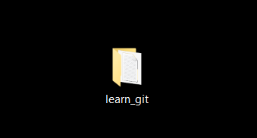

1. Changing the repository into the learn_git folder:

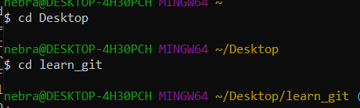

1. Creating a file called “third.txt”:

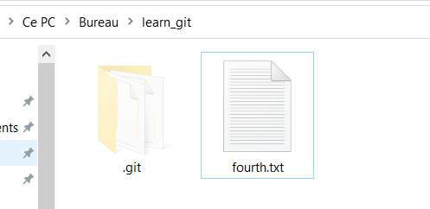

1. Initializing an empty git repository: command “git init”



1. Adding “third.txt” to the staging area: command “git add third.txt”

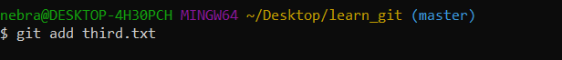

1. Commit with the message "adding third.txt" : command “git commit -m "adding third.txt" “

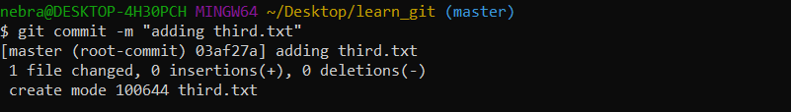

1. Checking the commit: command “git log”

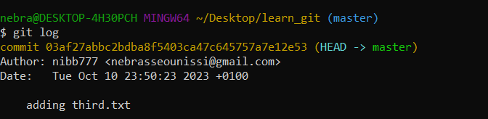

1. Creating a file called “fourth.txt”: command “touch fourth.txt”



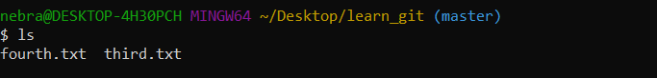

1. Adding fourth.txt to the staging area: command “ git add fourth.txt”

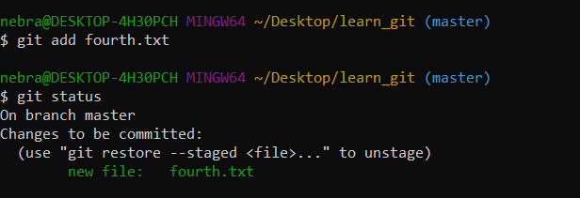

1. Commit with the message "adding fourth.txt": command “ git add fourth.txt”

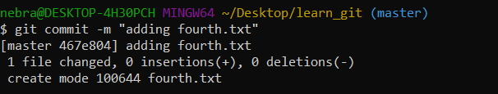

1. Removing the third.txt file: command “git rm third.txt”

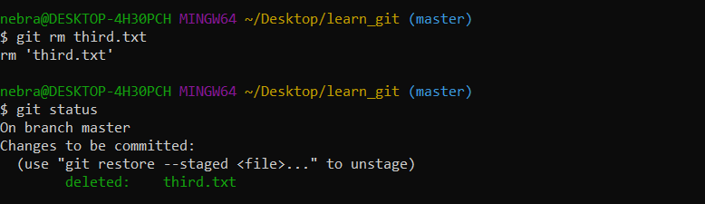

1. Adding this change to the staging area:

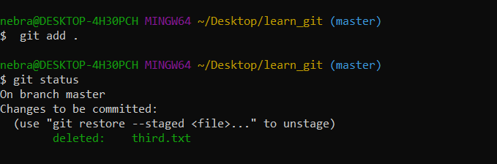

1. Commit with the message "removing third.txt": command “ git commit -m "removing third.txt" “

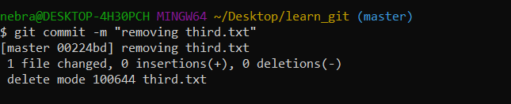

1. Checking the commits: command “git log”

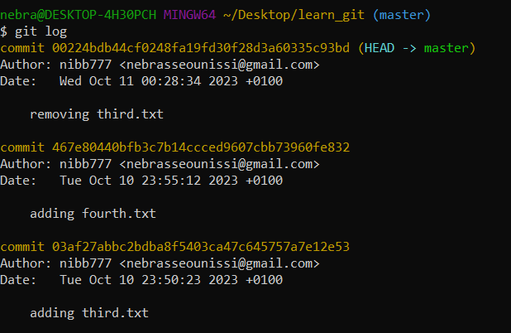

1. Changing the global settings to core.pager=cat: command “git config --global core.pager cat ”



1. Listing all the global configurations for git on my machine: command “git config --list”

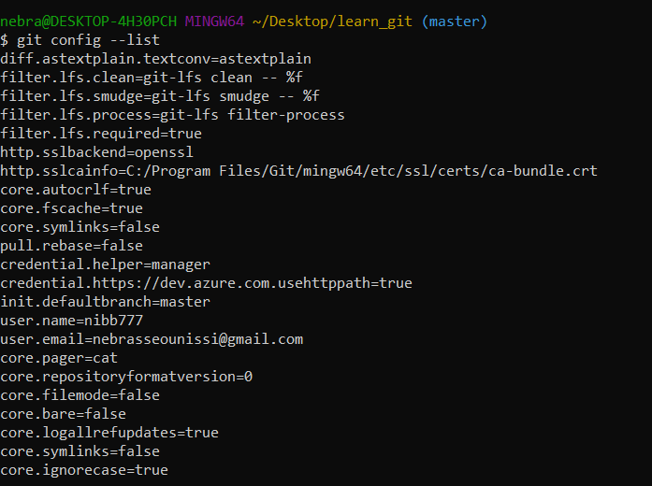

# Github:

1. Creating a new repository in Github “learn_git”

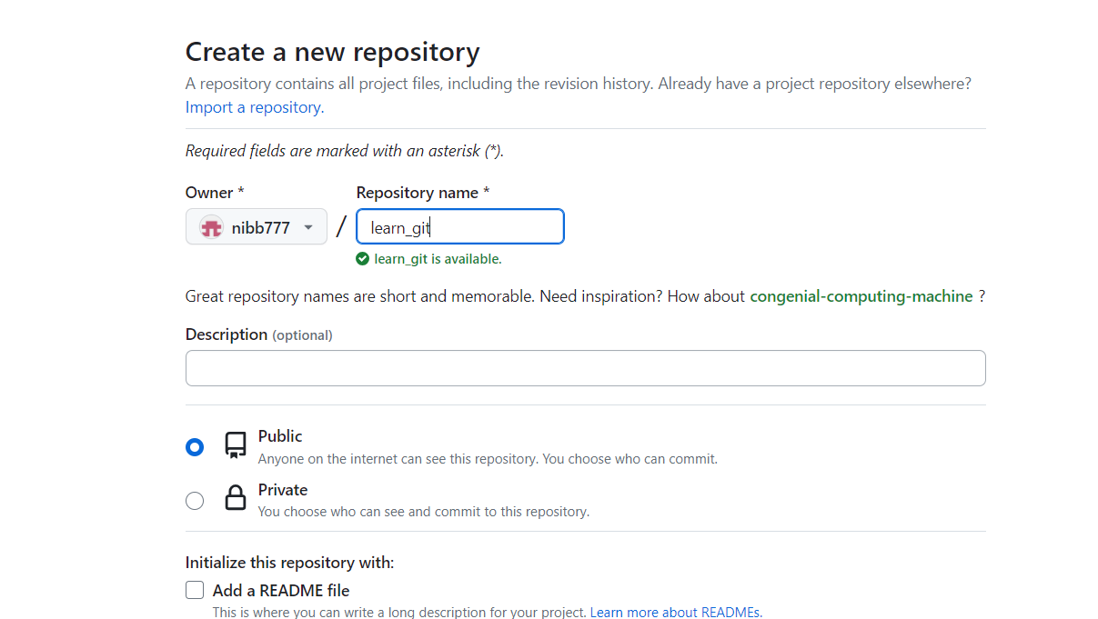

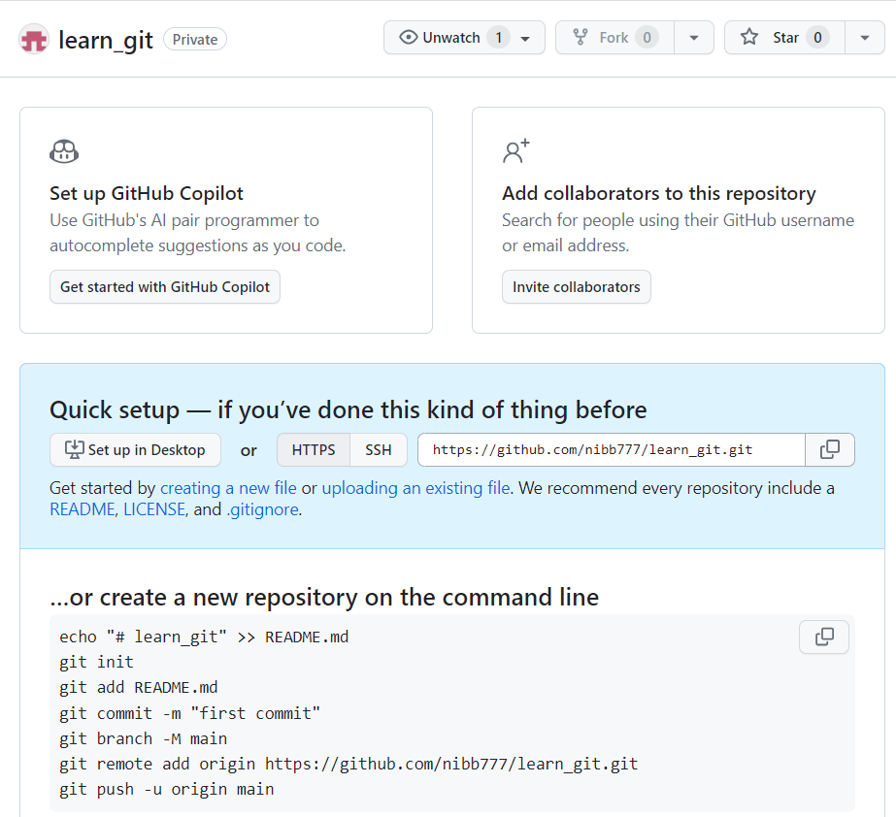

1. Adding repository origin in git:

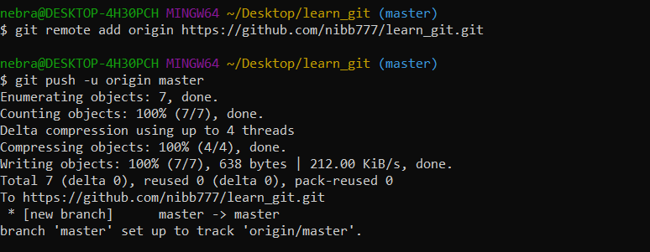

1. Adding the checkpoint file to Github repository “learn_git”:

