This is final Project of AI Driven Cyber Physical Systems: Summer 26.
Prepared by: Mohamed Abouhashem Salama (PhD Student in University of south Alabama)
Instructions and supervision: Dr. Kolitha Warnakulasooriya

GRU sensor Fustion and Velocity Prediction
Raspberry Pi Pico + MPU6050 in the Wokwi MicroPython Simulator

Project Mission:
Receive three-axis acceleration data (X, Y, Z) from the MPU6050, use 30 historical samples in a compact GRU model, and print both the next fused acceleration values (ax, ay, az) and the predicted velocity values (vx, vy, vz).
Project Overview:
The project demonstrates embedded machine-learning inference on a simulated Raspberry Pi Pico. The Pico reads acceleration through I2C, normalizes the measurements, maintains a rolling input window, and runs a manually implemented GRU forward pass in MicroPython.
MPU6050 Acceleration → 30-Sample Window → Compact GRU → Fused Acceleration + Predicted Velocity
Hardware and Software:
Hardware | Software
• Raspberry Pi Pico (RP2040), simulated in Wokwi  • MPU6050 IMU accelerometer  • I2C wiring: GP0 = SDA, GP1 = SCL  • Pico SRAM: 264 KB | • VS Code and Wokwi extension  • MicroPython v1.27.0 firmware  • Python, PyTorch, and Jupyter Notebook  • mpremote for file transfer

Main Project files:
train_gru_model.ipynb | Dataset preparation, training, testing, and checkpoint creation.
export_to_micropython.py | Exports PyTorch weights and model metadata.
main.py | Reads the IMU, manages the input window, runs inference, and prints outputs.
model.py | MicroPython-compatible manual GRU forward pass.
imu.py / vector3d.py | MPU6050 communication and three-axis sensor handling.
weights.bin | Compact float32 model weights.
weights_meta.py | Input, hidden, output, layer, and window configuration.
diagram.json / wokwi.toml | Wokwi circuit and simulator configuration.

Procedures:
- Developing ML model (Training and testing)
Note: all these parts inside (train_gru_model.ipynb.ipynb file)
- Loading dataset and perform EDA work on the data to figure the pattern inside the data.
- Preparing the dataset for the pytorch mode for training and testing stages.
- Building the Model
Memory calculations: GRU memory usage
Note that: The original Raspberry Pi Pico has only 264 KB of total SRAM, which must also hold the MicroPython runtime, Python objects, input window, hidden states, temporary GRU arrays, and program data
Compact GRU Model:
Input: 30 historical samples of normalized acceleration: [ax, ay, az].
Output order: [fused ax, fused ay, fused az, predicted vx, predicted vy, predicted vz].
Component | Configuration
GRU input size | 3
Hidden size | 32
GRU layers | 1
Activation | ReLU
Output layer | Linear 32 → 6
Window size | 30
Total parameters | 3,750
Float32 weight file | Approximately 15,000 bytes

So, This preserves the same general modeling approach while greatly reducing memory and computation.
Then train the model, test the model on the test dataset.
Save the checkpoint correctly for future usage in the deployment phase.
- Export the compact model
python export_to_micropython.py
In this script: the exporter loops over the number of GRU layers dynamically.
Expected output should be close to:
Wrote weights.bin (14604 bytes, 3651 floats)
Wrote weights_meta.py

input_size=3
hidden_size=32
num_layers=1
output_size=3
window_size=30
and also generated weights_meta.py with the same configuration of the GRU architecture.
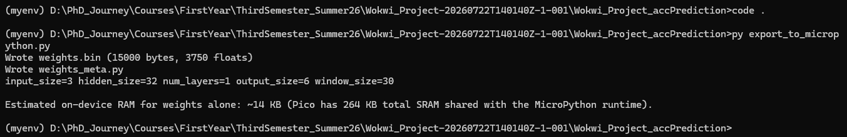
- Working with Wokwi Environment:
- In the wokwi.toml file
[wokwi]
version = 1
firmware = "RPI_PICO-20251209-v1.27.0.uf2"
rfc2217ServerPort = 4000
- Install mpremote on your computer
pip install mpremote
- Start the Wokwi simulator (after the installation it from the extension part inside VScode)
In VS Code:
- Open diagram.json.
- Start the Wokwi simulation.
- Keep the simulator running.
- Wait until the Wokwi terminal displays the MicroPython REPL:
>>>
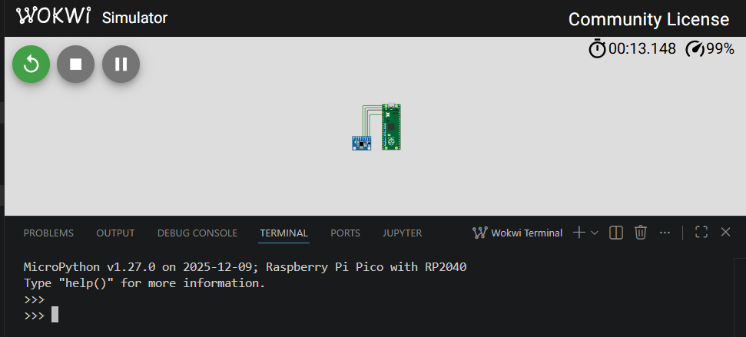

- Upload the deployment files
Run these commands from the project directory while the simulator is running:
mpremote connect port:rfc2217://localhost:4000 fs cp main.py :main.py
mpremote connect port:rfc2217://localhost:4000 fs cp imu.py :imu.py
mpremote connect port:rfc2217://localhost:4000 fs cp vector3d.py :vector3d.py
mpremote connect port:rfc2217://localhost:4000 fs cp model.py :model.py
mpremote connect port:rfc2217://localhost:4000 fs cp weights_meta.py :weights_meta.py
mpremote connect port:rfc2217://localhost:4000 fs cp weights.bin :weights.bin
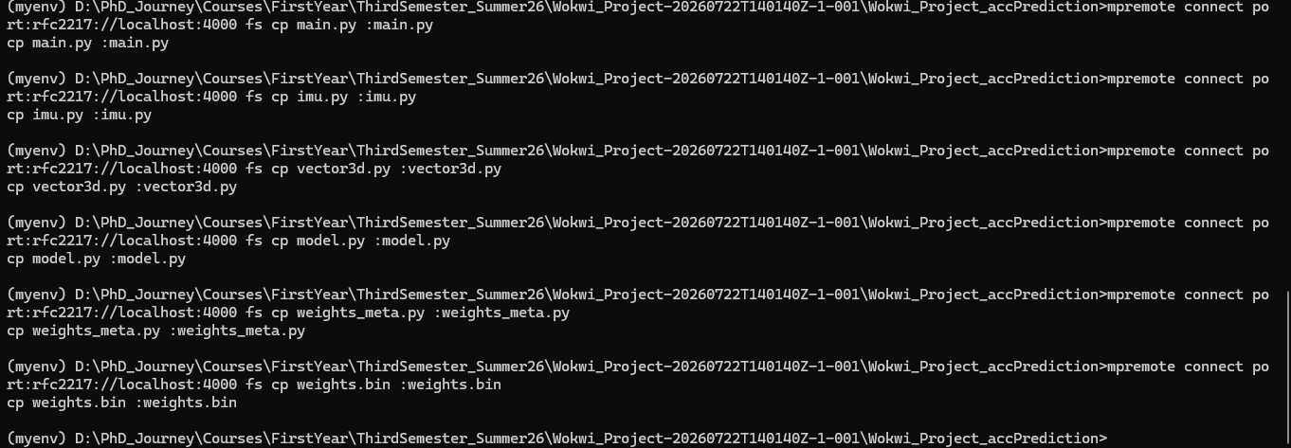

- Confirm the files were uploaded
Run inside the outside terminal:
mpremote connect port:rfc2217://localhost:4000 ls
the output should be:
main.py
imu.py
vector3d.py
model.py
weights_meta.py
weights.bin
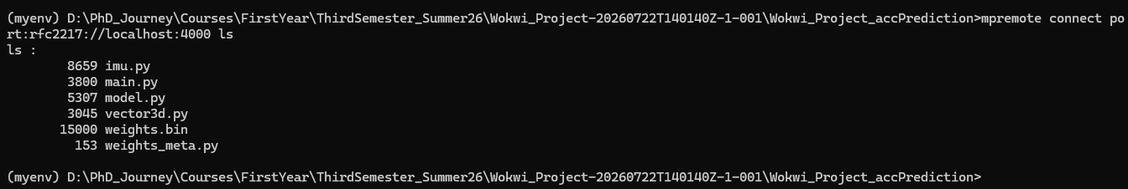

5.A or from the Wokwi MicroPython REPL:
import os
print(os.listdir("/"))

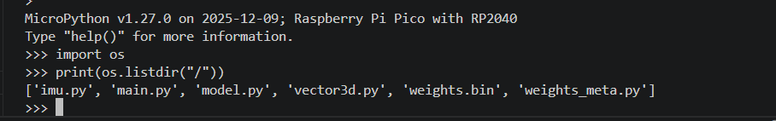

- Reset the simulated Pico
press Ctrl+D inside the Wokwi REPL for a soft reset.
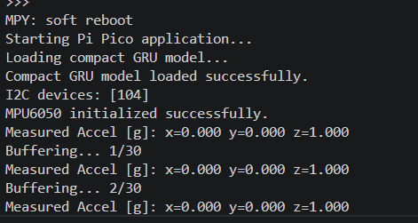
- After a normal reset, MicroPython automatically finds and executes main.py; you do not normally type python main.py

Hello, Pi Pico! Accel [g]: x=... Buffering... 1/30
After 30 accelerometer readings:
Fused Velocity [norm 0-1]: x=... y=... z=...
Inference Time: ... ms
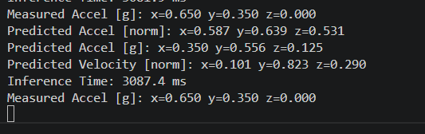
Final image after we interrupt the simulator:
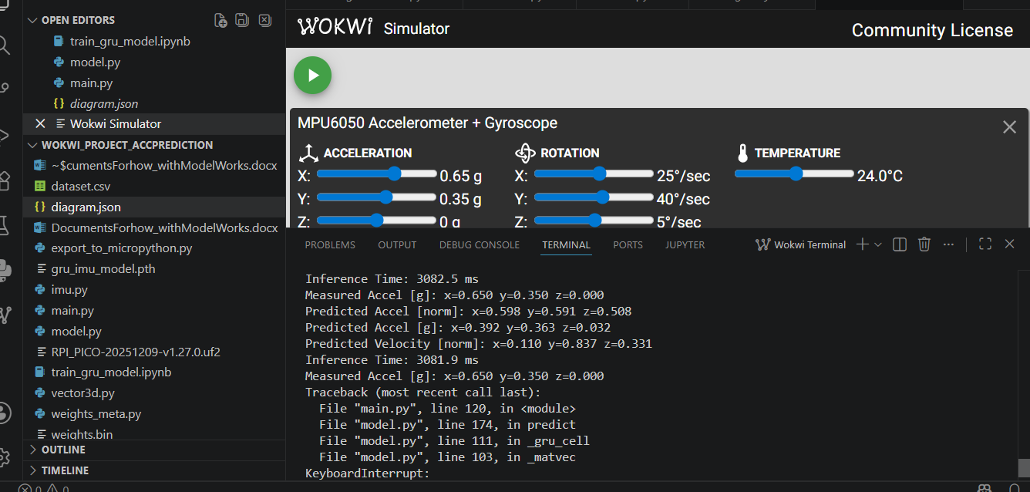

Thanks for reading!!

