

ASSIGNMENT REPORT
Digital Design
Asynchronous FIFO Depth Calculation

Course | Digital Design
Assignment | FIFO Depth Calculation – Examples 1, 2 & 3
Student Name | Mohamed Hossam El-Sawy
Instructor / TA | Eng. Ali Eltemsah
Submission Date | August 30, 2026

01 OBJECTIVE
This assignment determines the minimum required depth of an asynchronous FIFO that transfers a fixed-size burst of data between two modules running on independent clock domains, for three scenarios that differ in the idle (wait) cycles present on the write and read sides.

02 PROBLEM STATEMENT / REQUIREMENTS
Three worked examples are analyzed for an asynchronous FIFO transferring data from a faster writing module (A) to a slower reading module (B). In each case the FIFO must be sized so that it never overflows during the burst. The common and per-example parameters are:
- Writing clock f_A = 100 MHz (T_A = 10 ns); Reading clock f_B = 40 MHz (T_B = 25 ns); Burst Length (BL) = 100 data items — common to all three examples.
- Example 1: no idle cycles on either the write side or the read side (back-to-back writes and reads).
- Example 2: 2 idle cycles between successive writes and 2 idle cycles between successive reads.
- Example 3: 2 idle cycles between successive writes and 1 idle cycle between successive reads.

03 DESIGN & ANALYSIS

3.1 Design Approach
Because f_A > f_B in every example, module A always writes faster than module B can read, so FIFO occupancy grows throughout the burst and peaks when the last item is written. The minimum depth is found in three steps: (1) find the effective write period T_A' and read period T_B' by adding any idle cycles to the base period; (2) find the total time needed to write the whole burst, T_W = BL × T_A'; (3) find how many items B has managed to read during that same time, N_read = T_W / T_B'. The minimum required FIFO depth is then Depth = BL − N_read.

3.2 Given Data & Calculation
The table below lists the parameters and intermediate results for each example, derived using the method described in 3.1.
Parameter | Example 1 | Example 2 | Example 3
Write clock, f_A | 100 MHz | 100 MHz | 100 MHz
Read clock, f_B | 40 MHz | 40 MHz | 40 MHz
Write period, T_A | 10 ns | 10 ns | 10 ns
Read period, T_B | 25 ns | 25 ns | 25 ns
Idle cycles / write | 0 | 2 | 2
Idle cycles / read | 0 | 2 | 1
Effective write period, T_A' | 10 ns | 30 ns | 30 ns
Effective read period, T_B' | 25 ns | 75 ns | 50 ns
Burst Length, BL | 100 | 100 | 100
Total write time, T_W = BL × T_A' | 1000 ns | 3000 ns | 3000 ns
Items read, N_read = T_W / T_B' | 40 | 40 | 60
Minimum FIFO depth = BL − N_read | 60 | 60 | 40
Table 1: Calculation parameters and results for Examples 1, 2 and 3.

3.3 Async FIFO Architecture
All three examples share the same generic architecture: module A writes into the FIFO on its own clock domain, and module B reads from the FIFO on an independent, slower clock domain, as shown below.
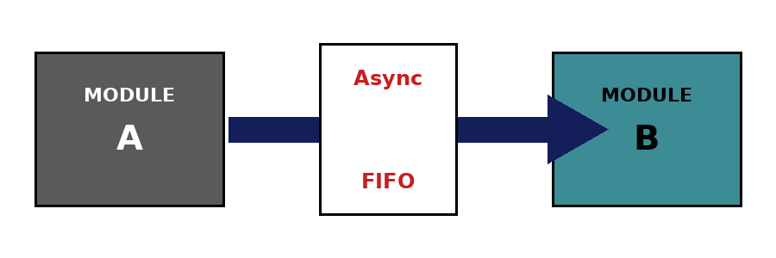
Figure 1: Generic asynchronous FIFO connecting Module A (write clock domain) and Module B (read clock domain).

3.4 Step-by-Step Calculation
The arithmetic performed for each example, following the method in 3.1, is shown below.
Example 1 (0 idle cycles write, 0 idle cycles read):
T_W = BL x T_A = 100 x 10 ns = 1000 ns
N_read = T_W / T_B = 1000 / 25 = 40 items
Depth = BL - N_read = 100 - 40 = 60 items

Example 2 (2 idle cycles write, 2 idle cycles read):
T_A' = 3 x T_A = 30 ns T_B' = 3 x T_B = 75 ns
T_W = BL x T_A' = 100 x 30 ns = 3000 ns
N_read = T_W / T_B' = 3000 / 75 = 40 items
Depth = BL - N_read = 100 - 40 = 60 items

Example 3 (2 idle cycles write, 1 idle cycle read):
T_A' = 3 x T_A = 30 ns T_B' = 2 x T_B = 50 ns
T_W = BL x T_A' = 100 x 30 ns = 3000 ns
N_read = T_W / T_B' = 3000 / 50 = 60 items
Depth = BL - N_read = 100 - 60 = 40 items

04 RESULTS SUMMARY
The table below summarizes the minimum FIFO depth obtained for each example.
Example | Idle Cycles (Write / Read) | Items Read During Burst | Minimum FIFO Depth
1 | 0 / 0 | 40 | 60
2 | 2 / 2 | 40 | 60
3 | 2 / 1 | 60 | 40

05 DISCUSSION
Examples 1 and 2 give the same minimum depth (60 items) even though idle cycles are introduced in Example 2, because the ratio between the effective read and write periods is unchanged (T_B'/T_A' = 2.5 in both cases) — adding equal proportional idle time on both sides does not change the relative speed difference between A and B. Example 3 requires a smaller depth (40 items) because the read side has fewer idle cycles than the write side, so B reads relatively faster compared to A than in Examples 1 and 2, and fewer items accumulate in the FIFO before B catches up. In a real design, these minimum depths would typically be rounded up to the next convenient binary size (e.g. 64) since FIFO read/write pointers are usually implemented with binary or Gray-code counters.

06 CONCLUSION
Using a burst-time / read-time analysis, the minimum FIFO depth needed to avoid overflow was found to be 60 items for Examples 1 and 2, and 40 items for Example 3. The key takeaway is that the required FIFO depth depends on the relative effective throughput of the write and read clock domains — including any idle cycles on either side — rather than on the raw clock frequencies alone.

A APPENDIX – HANDWRITTEN CALCULATIONS
Scanned original hand-written calculations for Examples 1, 2 and 3, corresponding to the results presented in Sections 3.2–3.4 above.
