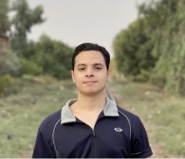Work Experience

Back End / Web Developer



Iam a web developer Framework laravel B Django Data Structure / mysql, MariDb , sqll1te , PostgreSgL Tools | pgAdm1n a phpMyAdmin 8 SQLite2udio

Front End Developer /



h1g h level / HTM L6 CSS3 B

Full Stack Web Devel oper



MohaMedNabiLpro2024@gma1l.¢om





Pghon



Fram ework D]ai gc



Fram ework Le re\'el











Skills and Tools , Docker Com aine r 8 n amps erver 8 XAMPP

Graphic Designer / Previously

Jun 2017 Mar 20J 9

Sen1o r t G ra phic Des1gn



Education

Self-Study Of Coding



i am a selfia ughi web developer

Russian Cultural Center July 2022 November 2022

4. Freelancing 8 HTML 8 OSS

2. OavaSoript 8 0Query

3. Bootstrap 8 Vue.js

5. Laravel Framework 8 Wordpress

decoration and advertisement 20J 9 2022



