1. download app “ip webcam” on google play

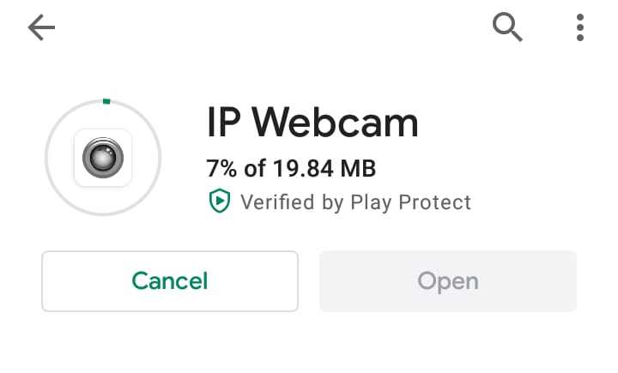
2.Open it then select “start server”

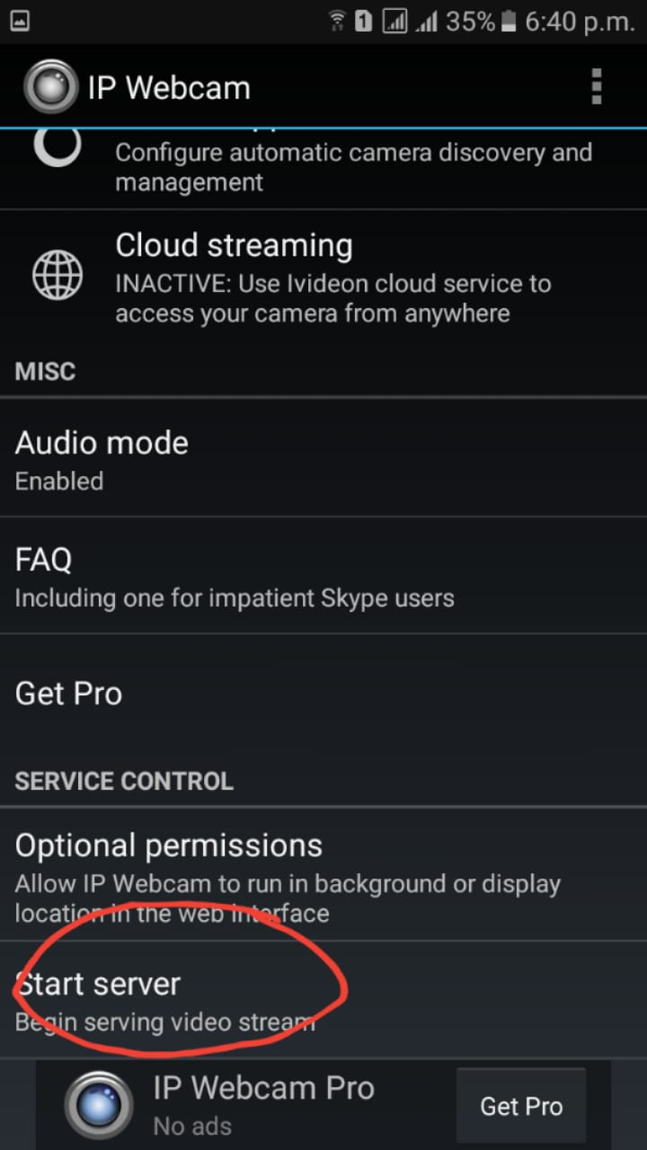

3.Then you should find this
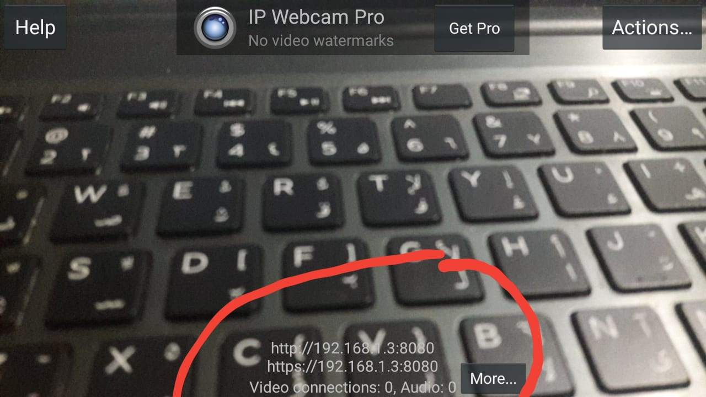
3.

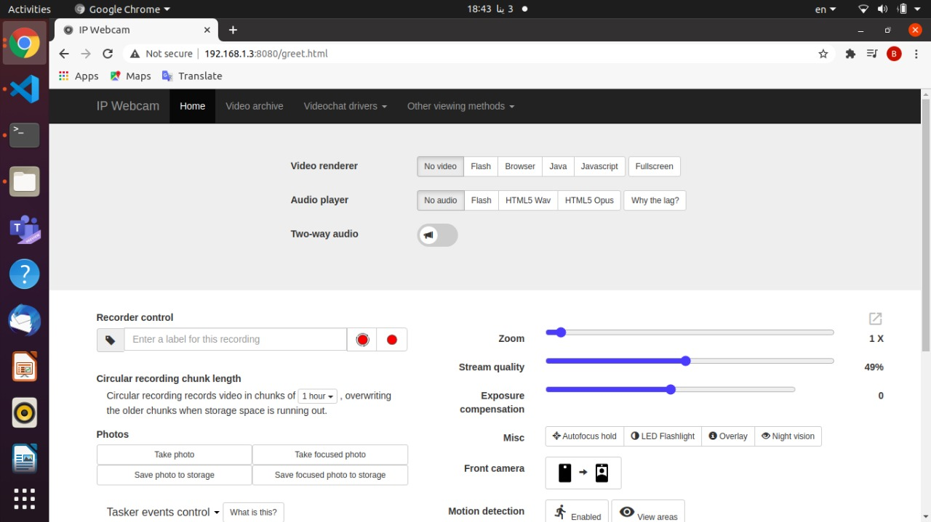
3. Write this http address in your browser, This page should appear

4.cllick on Javascript, “l mfrod l stream ykon zhar”

5.video = cv2.VideoCapture("http://192.168.1.3:8080/video") l http address mkan l zero
“3shan ta5od l frames mn camera l mobile”

6.3shan tgib l http address right click 3la l video f lap "copy image address"

