­

Database project

book store

Mohamed Mohamed Abdelhakem (45)

Mohamed Salah Osman (42)

Database systems | CSED 2021 | Alexandria University | 17 May 2020

# Database ERD

The triggers and DDL scripts is included within the source code.

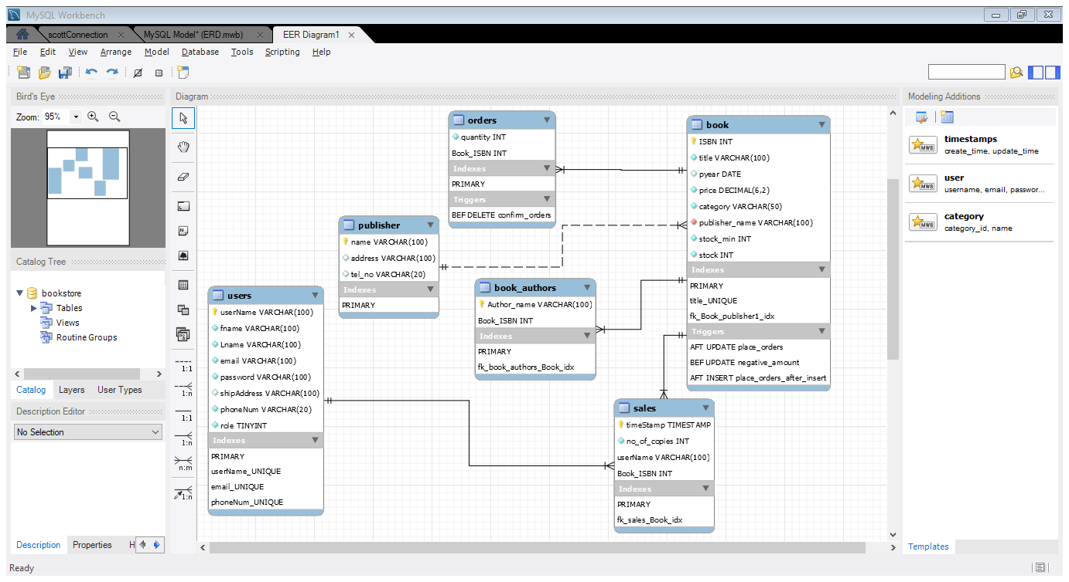

**Place orders trigger:** it inserts an order in orders table for every book that its stock quantity becomes below the threshold after either insert or update.

**Negative amount trigger:** it reject any update on the book table if the value of the stock quantity becomes a negative value (not enough quantity).

**Confirm orders:** it updates the stock quantity of the books whose orders have been confirmed and add the order quantity to the stock size.

# Code description

The project design mainly is divided according to the MVC pattern with the models define the database entities and controllers defining the routes to update and retrieve database records, views for user-friendly UI.

Relations:

1. User
2. Book
3. Publisher
4. Shopping cart
5. Order

Controllers:

1. **User Route:**  provide the functionality done on the user entity which are authentication (log in), sign up (create new user), make Manager (promote the user to be manager and update its database record), update user information.
2. **Book Route:** the functionalities are
   1. Insert new book in the database.
   2. Search for a book by the values set in the object Book.
   3. Get orders for the list of ISBNs of some books.
   4. Add new order to the database.
   5. Update book info.
   6. Delete order from the orders table of a specific book (confirm orders).
3. **Sales Route:**  checkout and add all the sales into the sales table, get the total sales of books last month, get the top 5 customers with the most purchase amount, get the top 10 books sold in the last 3 months.
4. **Data Manager:**  a singleton class provides a single connection to the database and authentication criteria, also it updates the database to hold only the data last 3 months
5. **Bookstore:** the main engine provide the way to call all the functionalities provided by the three routes, it also holds the current user of the system instance and it’s used by the front end views.

# Screenshots

