**Circus of Plates – Game**

Team members:

* Mohamed Mohamed AbdElHakem Mohamed.
* Karim Atef Ahmed.
* Abdallah Mohamed Fawzy ElSaman.
* Yousef Mohamed Fathy.

**Description**

It is single player-game in which each clown carries two stacks of plates, and there are a set of colored plates queues that fall and he tries to catch them, if he manages to collect three consecutive plates of the same color, then they are vanished and his score increases.

**Class Diagram:**

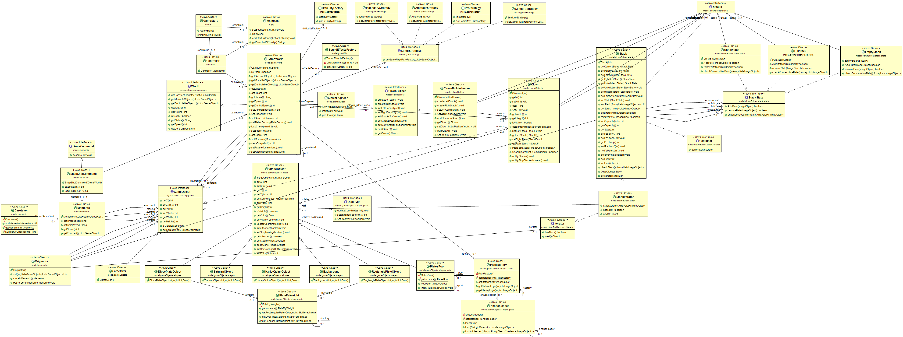

**Sequence Diagram:**

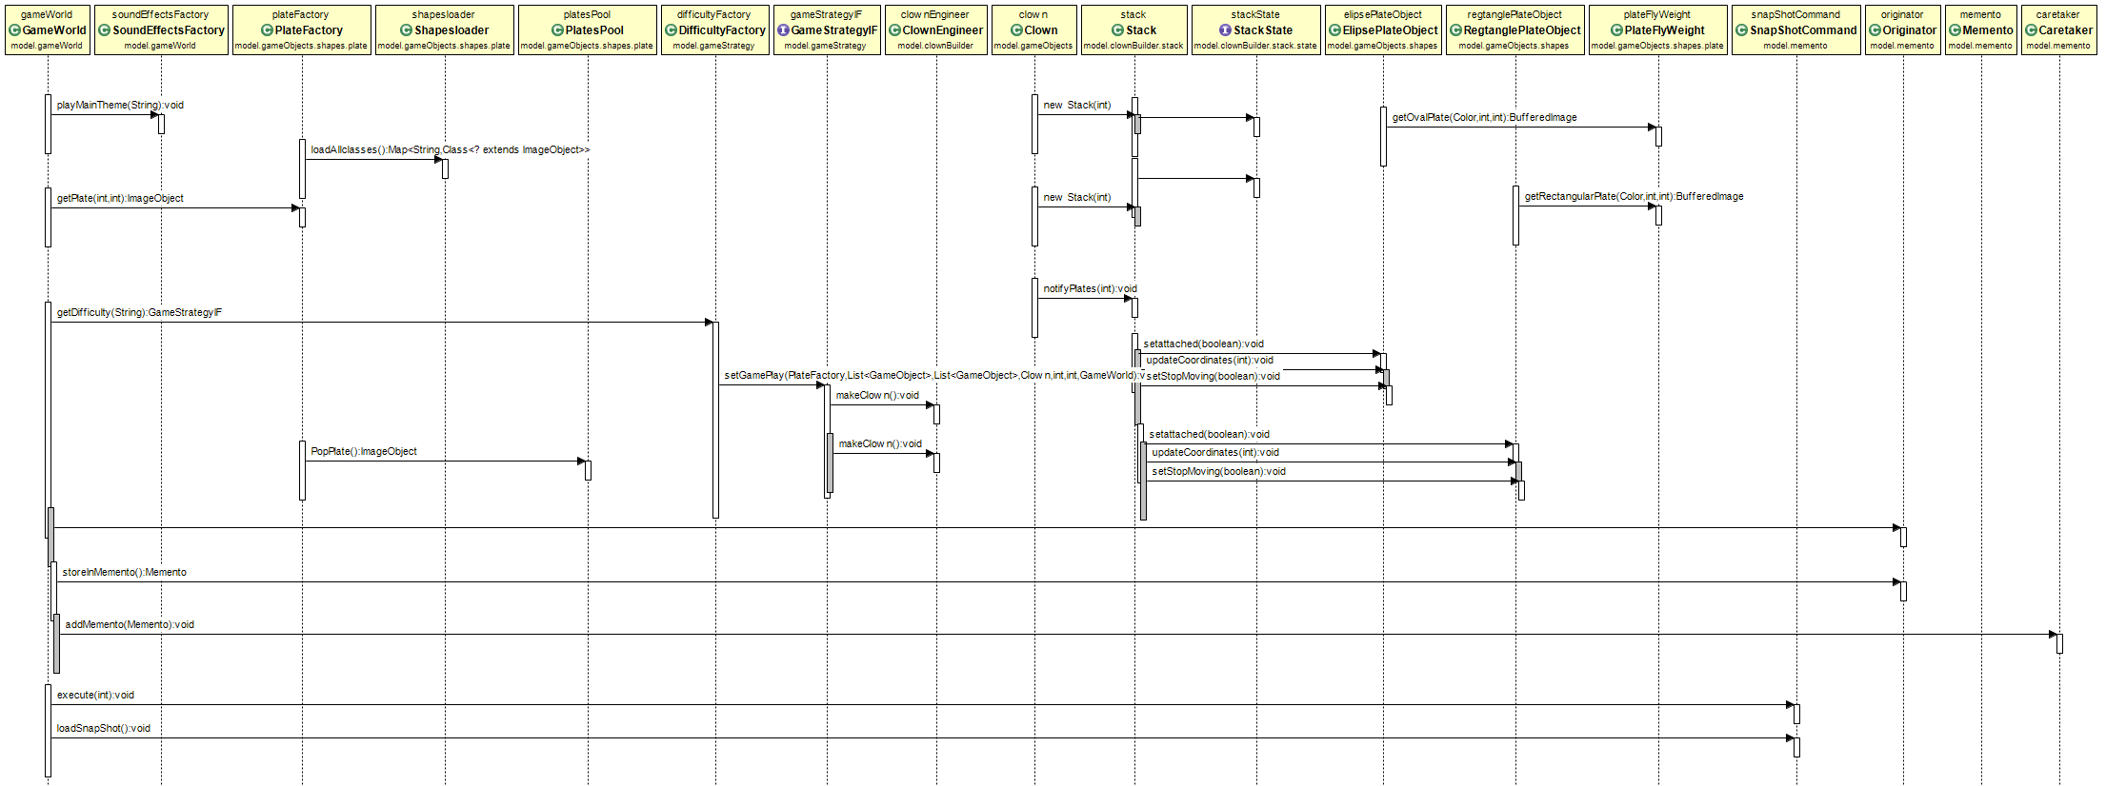

**Design Patterns**

* **Strategy**: the strategy design pattern is used in handling the difficulty of the game that the user chooses at the start of the game. The difficulty factory return the corresponding difficulty class as the user choose in the start menu of the game. The game strategy varies in lots of criteria like the game speed, the number of plates color falling and the stack capacity of the clown. All of them contributes together to make the gameplay unbeatable.

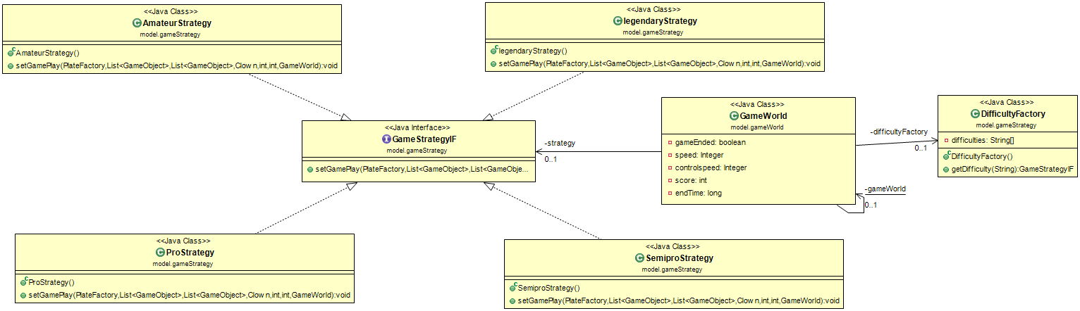

* **Factory:** the factory handles most of objects’ creation operations in the game as:

1. The plate factory class which creates the movable objects in the game like the oval plate, the rectangle, batman logo and Harley queen logo.
2. Difficulty factory as mentioned in the strategy pattern.

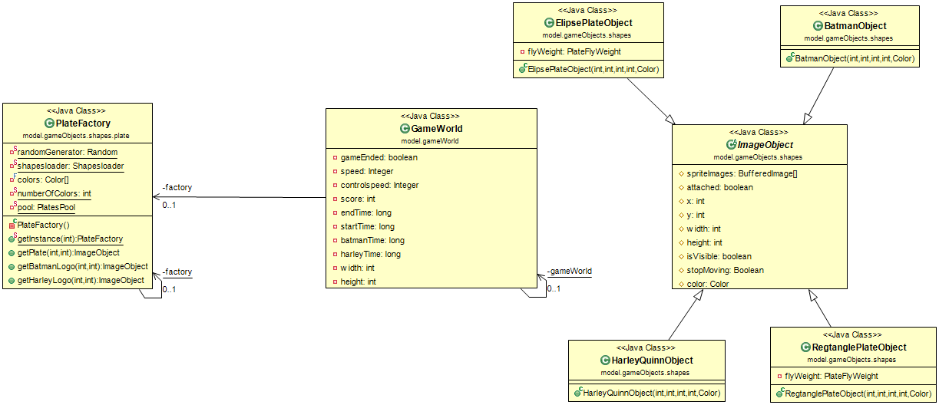

* **Dynamic Linkage:** the class shapes loader loads the shapes jar file at the start of the program for use of these 4 classes that extends image object images.