JDBC

Team members:

* Mohamed mohamed abdelhakem mohamed.
* Karim atef Ahmed.
* Abdallah mohamed fawzy elsman.
* Yousef mohamed fathy.

Description:

Java Database Connectivity (JDBC) provides Java developers with a standard API

That is used to access databases, regardless of the driver and database product.

JDBC presents a uniform interface to databases, change vendors and your applications only need to change their driver.

User guide:

* You should choose the path of the folder contains the database.
* Write the command in the text field in the GUI and press enter if the command syntax is right, it is not applied in case of wrong syntax.
* In case of selection the requested columns is passed to the Table.
* In case of update the number of updated columns is passed to the text area.
* In case of creating if the command succeeded, you are informed in the text area.
* In case of batch u should write the command in the text field and fire add batch when you finish batching click execute batch to get the results in the text area below

UML design: 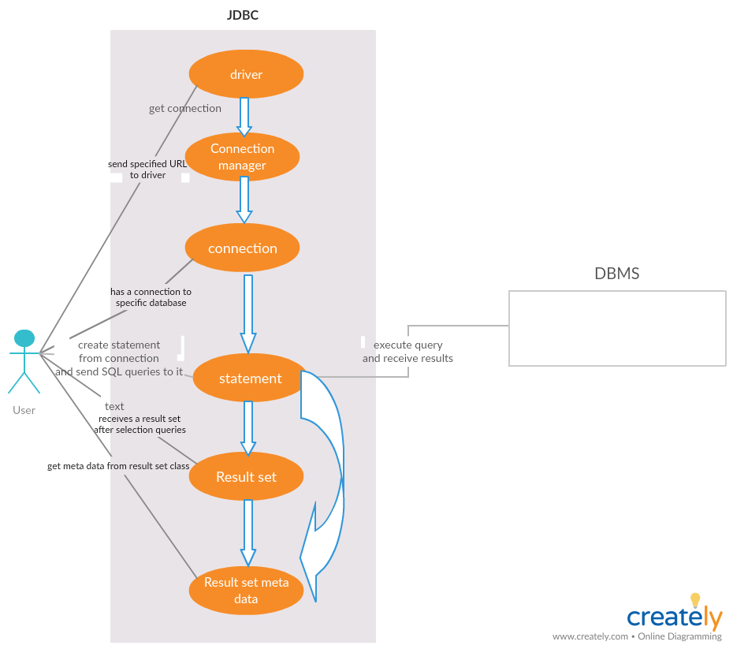

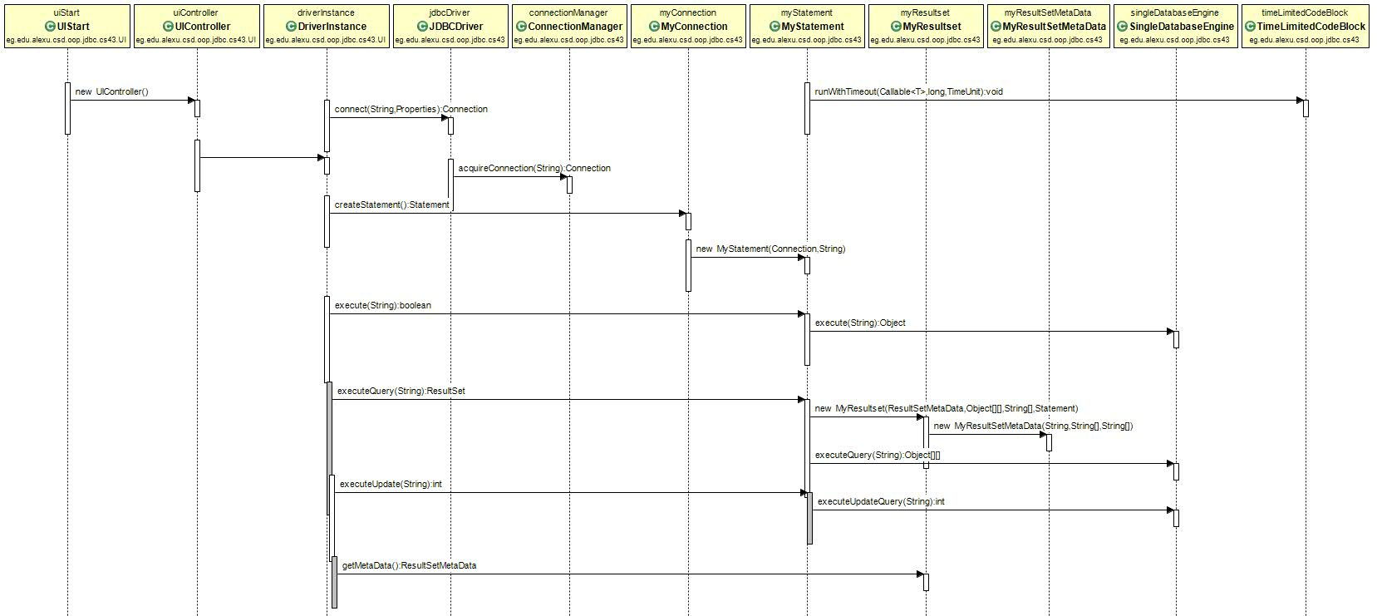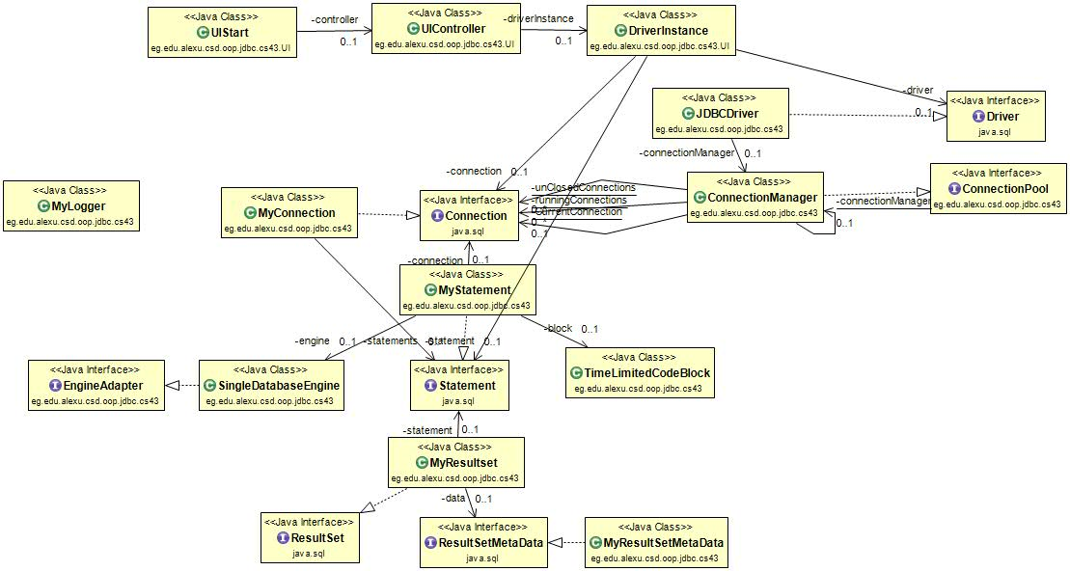

Scenario 1:

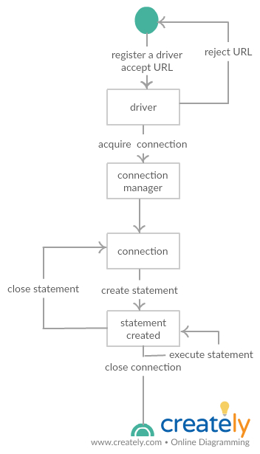

Scenario 2:

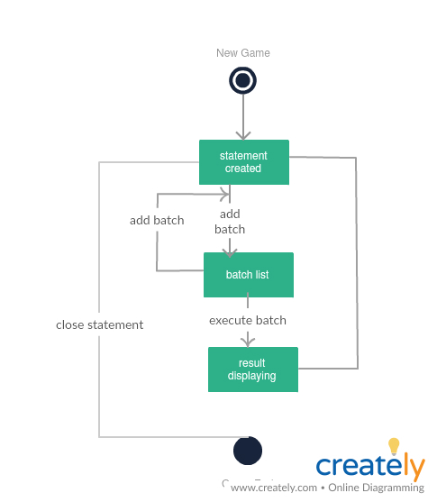

Scenario 3:

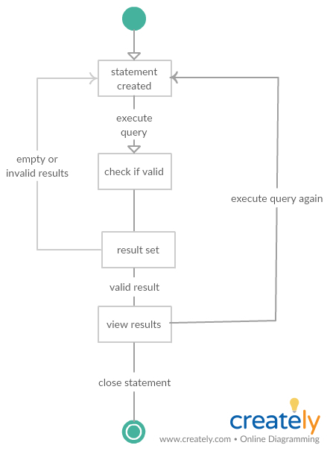

Design decisions:

* UIStart class is the GUI starter and calls the UI Controller and when stopped it saves the data in the cache.
* UIController initializes DriverInstance class to start a connection with the database the user chose and handle the user request queries and passes them to the statement class to execute them.
* Connection manager class handle driver several connections to several databases with different paths this class implements object pool , once you acquire a connection it is passed to a list of running connections ,once you close the connection , this connection instance is passed to the unused connections and remains there for its lifetime , if the driver acquires the same connection before its life time it’s okay , if not the manager creates a new connection instead of the expired one that passed its lifetime period
* Engine adapter interface makes the database interface reusable for the statement class to pass its queries to the specific functions in the DBMS.
* Time limit code block class handle the query timeout for statement class.

Sample runs:

