***Lung Tumor Detection and Segmentation - Project Documentation***

**🌐 Overview**

This project aims to detect and segment lung tumors in medical CT images. It consists of two primary tasks:

1. **Tumor Detection**: Using object detection models to localize tumor regions.
2. **Tumor Segmentation**: Using semantic segmentation models to extract precise tumor boundaries.

A Dash web interface allows clinicians and researchers to upload images, visualize results, and download PDF reports.

**📅 Project Workflow**

**1. Data Preparation**

All input CT images were preprocessed using the following steps:

* **Normalization**: Pixel values normalized to [0, 1].
* **Resizing**: Images resized to standard dimensions for model training.
* **Annotation Parsing**: Extracted bounding boxes and masks from provided annotation files.

**📊 Detection Models & Results**

**1. Faster R-CNN**

* **Description**: Two-stage detector using region proposal and classification.
* **Performance**: IOU = **0.68**
* **Conclusion**: Best performer among all detection models used.

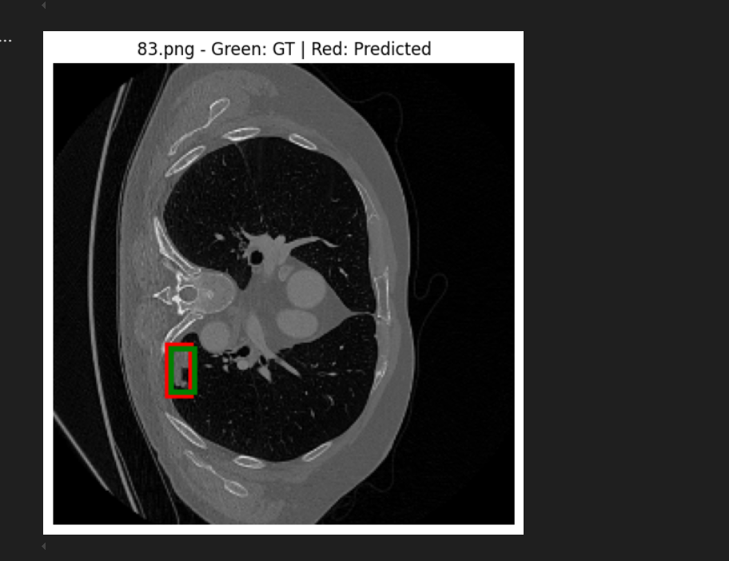

**2. RCNN**

* **Description**: Region-based CNN, older and slower.
* **Performance**: **Very poor** detection and localization.
* **Conclusion**: Not suitable for medical image applications with small targets.

**3. Fast R-CNN**

* **Description**: Improved version of RCNN using shared convolutions.
* **Performance**: **Overfitted** quickly on training data.
* **Conclusion**: Requires better regularization or more data.

**4. YOLO (You Only Look Once)**

* **Description**: One-stage real-time detector.
* **Performance**: **Very poor**, missed small tumors.
* **Conclusion**: Not effective for this fine-grained detection task.

**5. RetinaNet**

* **Description**: One-stage detector with Focal Loss.
* **Performance**: Intermediate, better than YOLO but worse than Faster R-CNN.
* **Conclusion**: A reasonable choice if Faster R-CNN is too slow.

**🎨 Segmentation Models & Results**

**1. U-Net on Full Dataset**

* **Description**: Standard U-Net architecture on entire CT scans.
* **Performance**: Dice Coefficient = **0.99**
* **Conclusion**: Highly accurate and generalizable.

**2. U-Net on Cropped Dataset**

* **Description**: Applied U-Net only on detected tumor regions.
* **Performance**: Dice Coefficient = **0.82**
* **Conclusion**: Decreased performance due to smaller context, but more efficient.

