SkyLearn LMS - Graduation Book Content
Requirements, System Architecture, and DFD Description

Part 1: Hardware and Software Requirements
This section is intentionally condensed to fit one to two pages while still covering all major technical requirements for the project: Flutter Web frontend, ASP.NET Core backend, SQL Server, and the Python Data Science layer.

Main Tools and Platforms
[Flutter] [.NET] [SQL Server] [Python] [Figma] [scikit-learn]
Software Area | Requirements
Frontend | Flutter SDK 3.9.x, Dart 3.9+, flutter_bloc, dio, flutter_svg, secure storage support
UI/UX Design | Figma used for wireframes, user flows, design system, spacing, and component consistency
Backend | ASP.NET Core Web API (.NET 9), EF Core 9, JWT auth, ASP.NET Identity, SignalR, Hangfire, Serilog
Database | SQL Server 2019+ with migration-based schema updates and transactional consistency
Data Science | Python 3.10+, pandas, numpy, scikit-learn, joblib, optional shap, openpyxl/xlsxwriter
DevOps / Tools | Git, Swagger/OpenAPI, Postman or API testing tool, CI-friendly build pipeline

Hardware Area | Minimum | Recommended
Development Machines | 4 cores CPU, 8 GB RAM, 256 GB SSD | 8 cores CPU, 16-32 GB RAM, 512 GB NVMe
Backend Hosting | 4 vCPU, 8 GB RAM | 8 vCPU, 16 GB RAM + autoscaling ready
Database Hosting | 4 vCPU, 16 GB RAM | 8 vCPU, 32 GB RAM + high-IO SSD + backup strategy
Data Science Worker | 4 vCPU, 8 GB RAM | 8 vCPU, 16-32 GB RAM, optional GPU for heavier experiments

Note on Figma: Although Figma is not part of the source code repository, it is a core project dependency for UI/UX planning, design handoff, and consistency between screens implemented in Flutter Web.

Part 2: System Architecture (Backend-Focused)
This architecture section is written to fit two to three pages. The backend is the central integration point between Flutter Web clients, the SQL Server database, real-time messaging through SignalR, and analytics generated by the Data Science pipeline.

2.1 Architecture Narrative
- Client Layer: Flutter Web sends authenticated HTTPS requests (JSON payloads) and receives structured API responses.
- API Layer: ASP.NET Core controllers validate incoming requests, enforce authorization policies, and route actions to services.
- Service Layer: business logic handles courses, users, quizzes, submissions, notifications, and analytics-trigger points.
- Data Layer: Entity Framework Core persists and reads normalized data from SQL Server using repositories and migration control.
- Realtime Layer: SignalR hub pushes live updates such as notifications and activity events to connected web clients.
- Async Layer: Hangfire handles scheduled and delayed tasks like digest notifications and deferred processing jobs.
- Data Science Integration: Python pipeline consumes exported/curated data, runs ML models, then publishes risk and insight outputs.

2.2 Request/Response Path
A typical flow starts when the Flutter Web client sends an HTTPS request with a JWT token. The backend authenticates the request, executes service-layer rules, reads/writes SQL Server through EF Core, and returns a JSON response. If the action requires live updates, the backend also emits a SignalR event. For predictive features, selected operational data is processed by the Python analytics pipeline, then summarized outputs are returned to dashboards.

2.3 Architecture Diagram
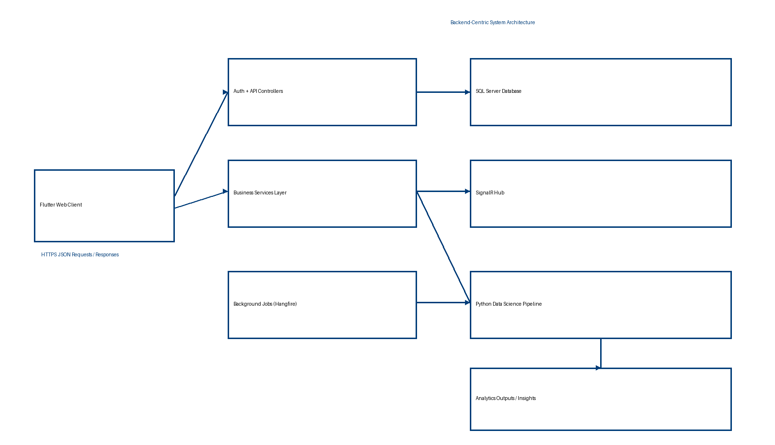
Figure: Backend-centric architecture and request/response flow.

Part 3: Data Flow Diagram (Text Description)
This page describes the DFD in text only, as requested. It is split into approximately half a page for Level 0 and half a page for Level 1.

3.1 DFD Level 0 (Context Level)
At Level 0, SkyLearn LMS is represented as one central process that interacts with four external entities: Students, Instructors, Administrators, and the Data Science/Reporting consumer. Students submit login requests, course interactions, assignments, and quiz responses to the system. Instructors send course management data, grading actions, and content updates. Administrators provide user governance, permissions, and configuration commands. The system responds to all entities with dashboards, status updates, notifications, and academic performance results. The same central process also exchanges curated datasets and generated insights with the analytics side, enabling early-warning and performance intelligence.

3.2 DFD Level 1 (Decomposition Level)
At Level 1, the system is decomposed into major subprocesses: (1) Authentication and Access Control, (2) Learning Content and Activities Management, (3) Assessment and Evaluation, (4) Notification and Realtime Communication, and (5) Analytics and Prediction. Process (1) validates identity and role permissions before passing authorized requests forward. Process (2) handles courses, lectures, files, and participation records. Process (3) manages quizzes, assignment submissions, grading, and feedback loops. Process (4) creates and delivers notifications through API and SignalR channels. Process (5) transforms operational data into indicators such as at-risk probability, engagement segments, and performance forecasts. Data stores at this level include the primary SQL Server operational database and exported analytical datasets used by the Python ML pipeline.

