SOC Detection Engineering, Alert Triage & SOC Operations
Week 1: SIEM Architecture & Log Onboarding
Lab report | Elastic Stack (Fleet + Kibana) | October 2026

1. Summary
This week I built the SIEM foundation for the lab on the Elastic Stack. A single Ubuntu server (ubuntu-siem) runs Fleet Server, Elasticsearch and Kibana. Three endpoints (Windows 10, Windows Server 2019 and Kali Linux) are enrolled as Fleet-managed Elastic Agents, and a FortiGate VM sends its logs to a file on the Ubuntu server that Filebeat reads.
All four agents show Healthy in Fleet (version 8.19.23) and Kibana Discover returns documents for each source. The report covers the five Week 1 deliverables: the architecture diagram, the data source inventory, the log onboarding evidence, the normalized field mapping and the retention plan.
What is verified. Windows Security logons (event.code 4624, dataset system.security) on the Windows Server, Sysmon process creation (event.code 1, dataset windows.sysmon_operational) on the Windows 10 machine, agent logs from Kali, and the FortiGate log file. Still to verify: Kali auditd events and the parsed FortiGate fields (section 9).
Changes during the week. The Windows 10 machine was renamed from DESKTOP-DDM5DBD to IT-machine (same agent ID). The Windows Server address moved from 192.168.1.91 to 192.168.1.116 (DHCP). The retention plan is based on measured disk growth: about 4.2 MB per minute, which is about 5.9 GB per day.

2. Week 1 Requirements and Where to Find Them
Required deliverable | What I produced | Section
SIEM architecture diagram | Architecture diagram of the lab with a medium-organization design | Section 4 (Figure 1)
Data source inventory | Inventory of endpoint, network, identity, cloud and application sources | Section 5
Log onboarding evidence | Fleet, agent enrollment and Discover screenshots for each source | Section 6
Normalized field mapping | Raw field to ECS field tables for Windows, Linux and FortiGate | Section 7
Retention plan | Measured disk growth, capacity table, lab ILM policy, target design | Section 8

3. Lab Environment
Everything runs as virtual machines in VMware Workstation on one host, on the 192.168.1.0/24 network. The values below were read from the screenshots in this report.
Machine | Hostname | IP address | Fleet policy | Role
Ubuntu server | ubuntu-siem | 192.168.1.84 | Fleet Server Policy | Fleet Server (8220), Elasticsearch, Kibana (5601), Filebeat for the FortiGate file
Windows 10 | IT-machine (was DESKTOP-DDM5DBD) | not captured | Windows10_VM | Endpoint, workstation telemetry, Sysmon
Windows Server 2019 | WIN-MKSP5LUC3TN | 192.168.1.116 (was .91 on 22 Oct) | WindowsServer_VM | Endpoint, server telemetry
Kali Linux | kali | 192.168.1.96 | KaliLinux_VM | Endpoint, Linux telemetry, attacker box for later weeks
FortiGate VM | FGT-VM64 | 192.168.1.167 | not an agent | Network firewall, source of network logs
The Windows Server changed address between 22 and 30 October (192.168.1.91 to 192.168.1.116), so the lab is on DHCP. Static addresses are needed so the agents do not lose the Fleet Server.

4. SIEM Architecture
The design target is a medium organization (a few hundred endpoints, a handful of servers, one perimeter firewall). The lab is a small copy of that design with every layer present once.
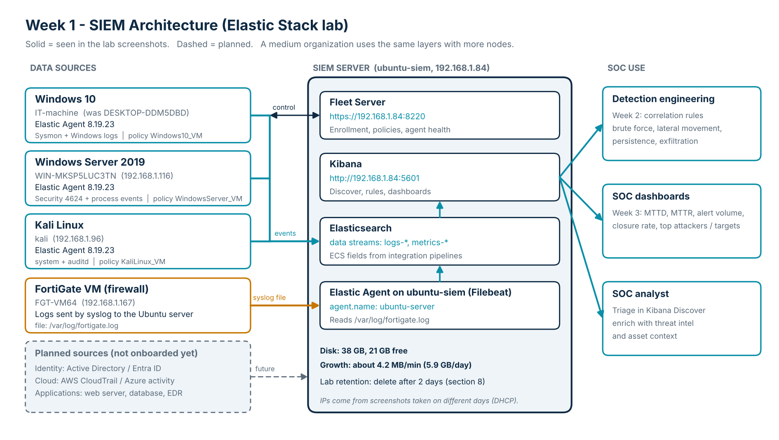
Figure 1. SIEM architecture for the lab. Solid arrows are paths seen in the screenshots; the dashed box shows sources planned for the full design.

4.1 How the data flows
- Enrollment and policy. Each agent enrolls to Fleet Server at https://192.168.1.84:8220. The Windows Server screenshot shows Test-NetConnection to port 8220 succeeding before enrollment.
- Endpoint events. The agent ships logs from the policy's integrations to Elasticsearch, where they land in data streams (for example logs-system.security-default and logs-windows.sysmon_operational-default) with ECS fields.
- Network events. FortiGate writes its logs to /var/log/fortigate.log on the Ubuntu server. The agent on that server reads the file with a Filebeat input (log.file.path and agent.type: filebeat are visible in Discover).
- Analysis. Analysts work in Kibana: Discover for hunting and triage, then rules and dashboards.

4.2 Design choices for a medium organization
Layer | Lab | Production design
Management | Fleet Server on the Ubuntu VM | 2 Fleet Servers behind a load balancer, separate from Elasticsearch
Storage / search | Single Elasticsearch node, 38 GB disk | 3 nodes minimum: hot/warm tiers, 1 replica, snapshots to object storage
Collection | Elastic Agent managed by Fleet; Filebeat input for the FortiGate file | Agents everywhere, syslog collector for network devices, policy per OS role
Security | Enrollment with --insecure (self-signed certificate) | Certificates from an internal CA, API keys per policy, role-based access in Kibana
Addressing | DHCP (addresses changed) | Static or reserved addresses for the SIEM and all agents

5. Data Source Inventory
The assignment asks for endpoints, network, identity, cloud and applications. Status shows what is onboarded in the lab and what is only part of the design.
Category | Source | Key log types | Collection method | Status
Endpoint | Windows 10 (IT-machine) | Sysmon operational (process creation), Windows event logs | Elastic Agent: system-2, windows-10 | Onboarded, Sysmon verified
Endpoint | Windows Server 2019 (WIN-MKSP5LUC3TN) | Windows Security (logons 4624), process creation, host metrics | Elastic Agent: system-3, WindowsServer-19 | Onboarded, Security verified
Endpoint | Kali Linux (kali) | auth and system logs, Linux audit records, host metrics | Elastic Agent: system-4, auditd-1 | Onboarded; auditd to verify
Endpoint | Ubuntu server (ubuntu-siem) | Agent and stack logs, host metrics | Elastic Agent (Fleet Server Policy) | Onboarded
Network | FortiGate VM | Traffic, UTM, event and VPN logs | Syslog to file, read by Filebeat | Onboarded; parsing to verify
Identity | Active Directory / Entra ID | Logons, group changes, Kerberos, directory changes | Domain controller agent / Entra connector | Planned
Cloud | AWS CloudTrail, Azure activity logs | API calls, console logins, config changes | Elastic cloud integrations | Planned
Application | Web server, database, EDR | Access and error logs, query audit, endpoint alerts | Agent integrations or log files | Planned

6. Log Onboarding Evidence

6.1 Fleet agents overview
Fleet lists four agents, all Healthy, all on version 8.19.23, each with a policy and a recent check-in (19 to 38 seconds ago when the screenshot was taken). The left side of the screenshot shows the VMware library with the same VMs.
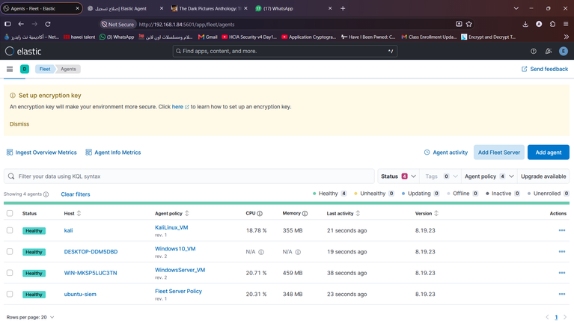
Figure 2. Fleet > Agents: kali, DESKTOP-DDM5DBD (now IT-machine), WIN-MKSP5LUC3TN and ubuntu-siem, all Healthy.

6.2 Kali Linux
The agent was installed from the elastic-agent-8.19.23-linux-x86_64 folder and enrolled with the enroll command against 192.168.1.84:8220. The terminal ends with "Successfully enrolled the Elastic Agent" and ifconfig shows eth0 at 192.168.1.96.
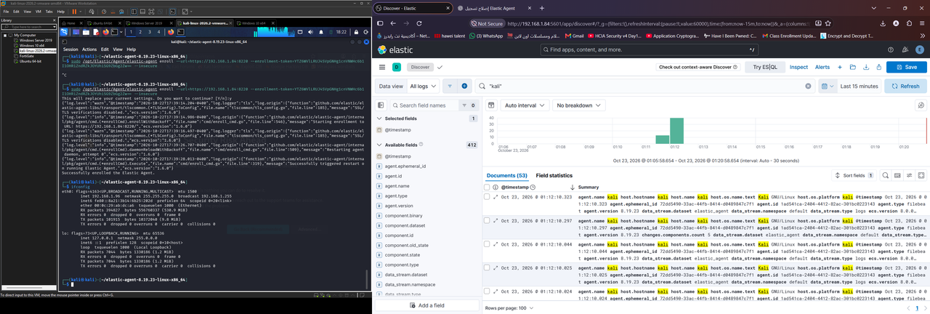
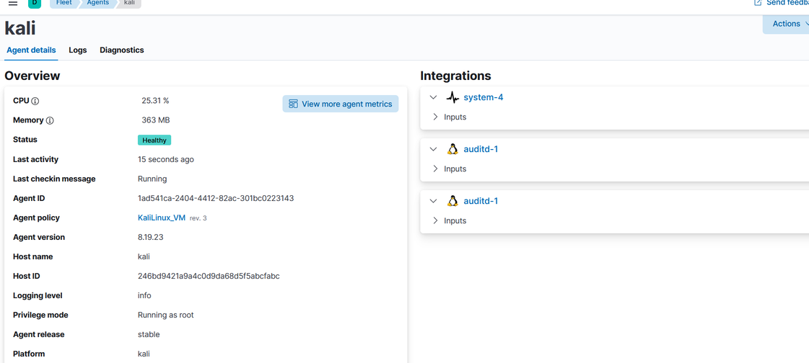
Figure 3. Top: enrollment on Kali (left) and Discover, query "kali", 53 documents (right). Bottom: Kali agent details, Healthy, policy KaliLinux_VM (rev. 3), integrations system-4 and auditd-1.
The documents carry agent.name, host.hostname, host.os.platform, agent.type (filebeat), agent.version 8.19.23, data_stream.dataset elastic_agent and ecs.version 8.0.0. These are the agent's own logs, so the agent ships data; auditd collection is still to verify. The auditd-1 integration is listed twice on the agent page, which looks like a duplicate to clean up.

6.3 Windows 10 (IT-machine)
Enrollment was done from an elevated PowerShell with elastic-agent.exe install against https://192.168.1.84:8220 and finished with "Elastic Agent has been successfully installed". The first Discover query returned 2 process documents.
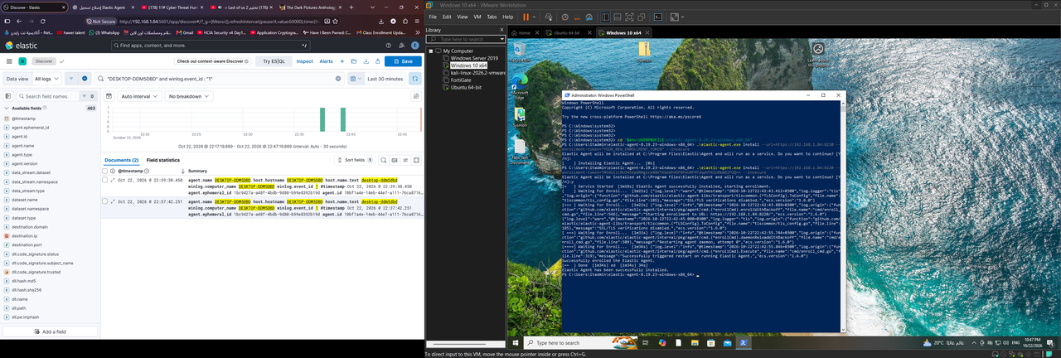
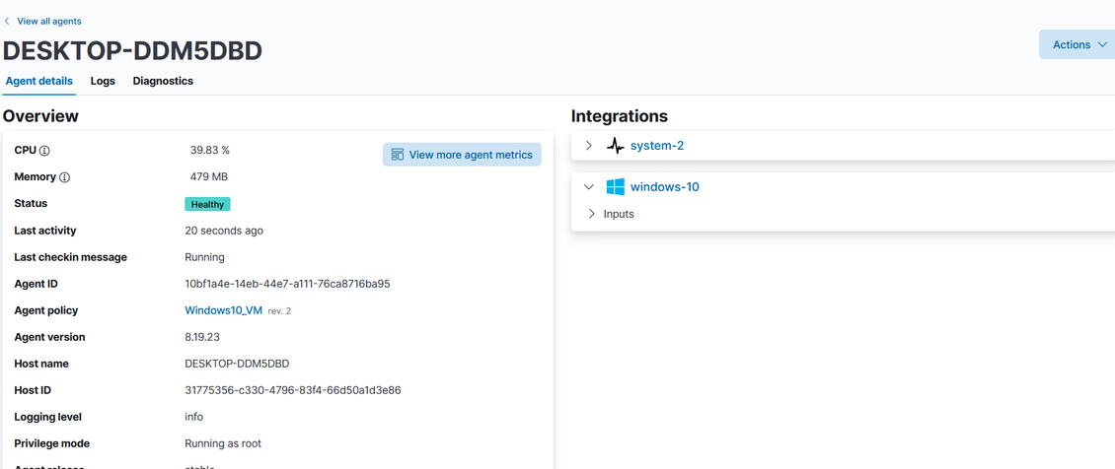
Figure 4. Top: Discover (left) and install output (right) for DESKTOP-DDM5DBD. Bottom: agent details, Healthy, policy Windows10_VM (rev. 2), integrations system-2 and windows-10.
The machine was later renamed to IT-machine. The agent ID is the same (10bf1a4e-14eb-44e7-a111-76ca8716ba95) in the Fleet detail page and in the new Discover documents, so it is the same agent under a new hostname.
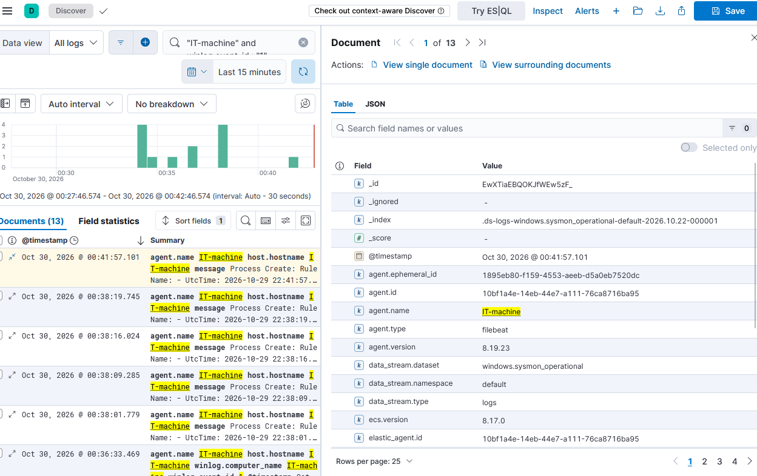
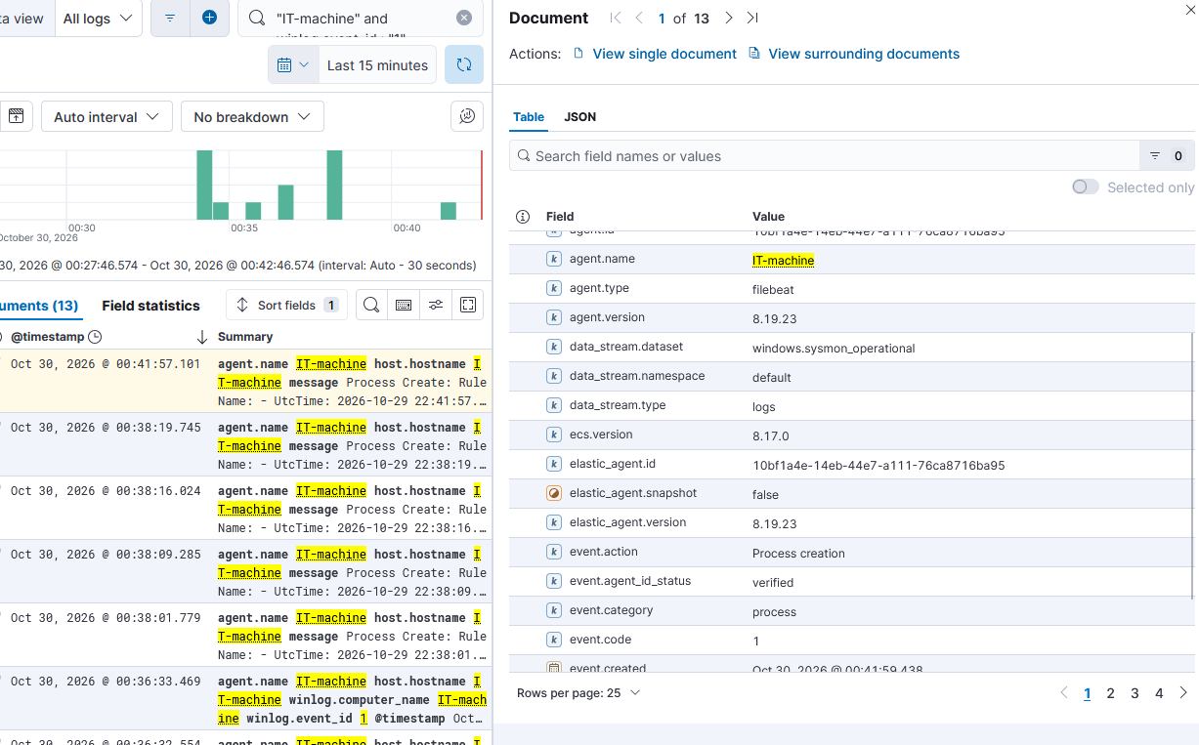
Figure 5. Sysmon process creation on IT-machine. Query "IT-machine" and winlog.event_id: "1", last 15 minutes, 13 documents. Top: index and data stream fields. Bottom: the same document scrolled down to the event fields.
Fields seen: data_stream.dataset windows.sysmon_operational, event.code 1, event.action "Process creation", event.category process, agent.type filebeat, ecs.version 8.17.0, in the index .ds-logs-windows.sysmon_operational-default-2026.10.22-000001.

6.4 Windows Server 2019
Before enrolling, Test-NetConnection 192.168.1.84 -Port 8220 returned TcpTestSucceeded: True. After enrollment, Restart-Service and the status command report both fleet and elastic-agent as HEALTHY.
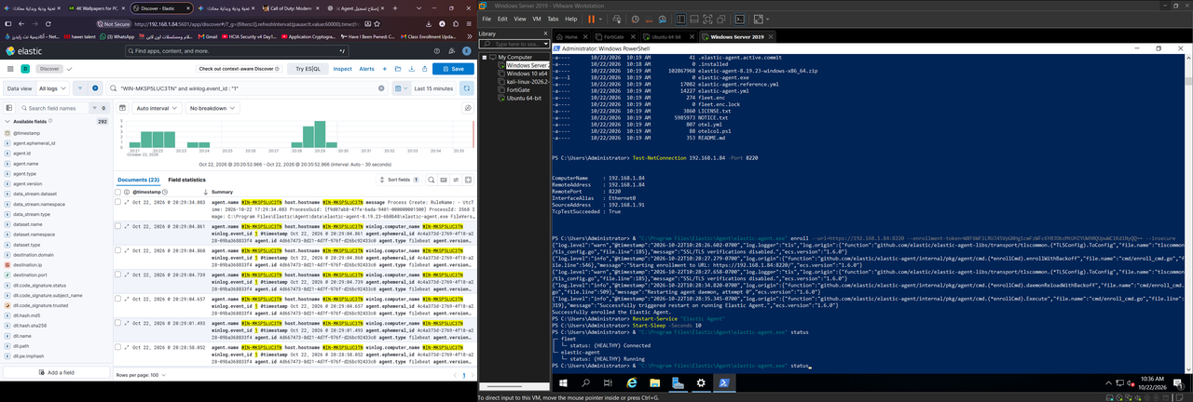
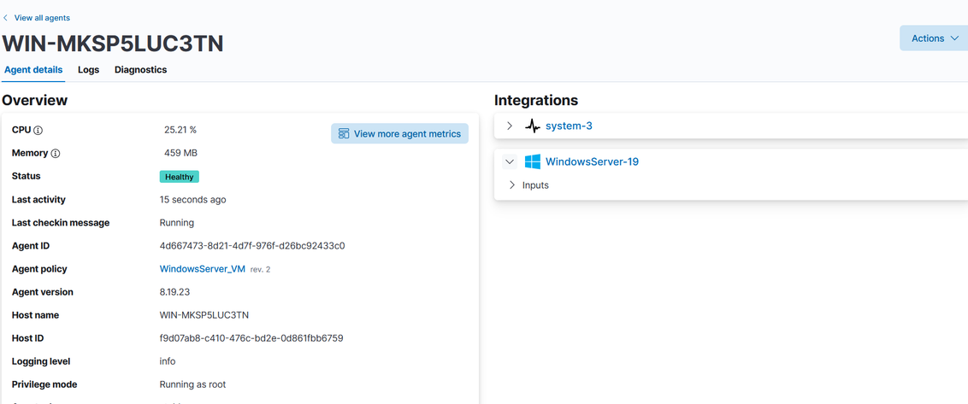
Figure 6. Top: Discover with 23 documents (left) and connectivity test, enrollment and status (right). Bottom: agent details, Healthy, policy WindowsServer_VM (rev. 2), integrations system-3 and WindowsServer-19.
Security logs are collected as well. The query on the machine name returns 70 documents in 15 minutes from the data stream logs-system.security-default.
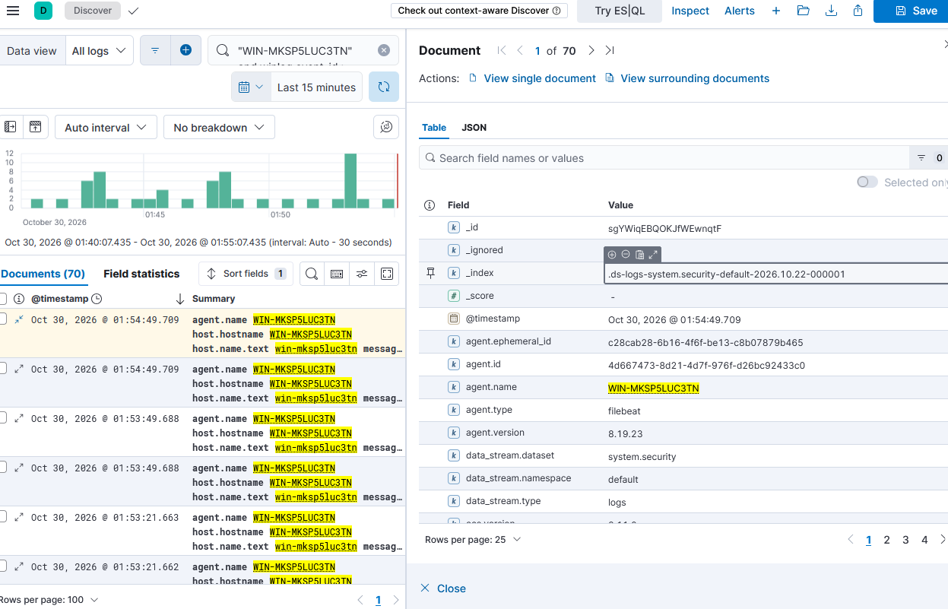
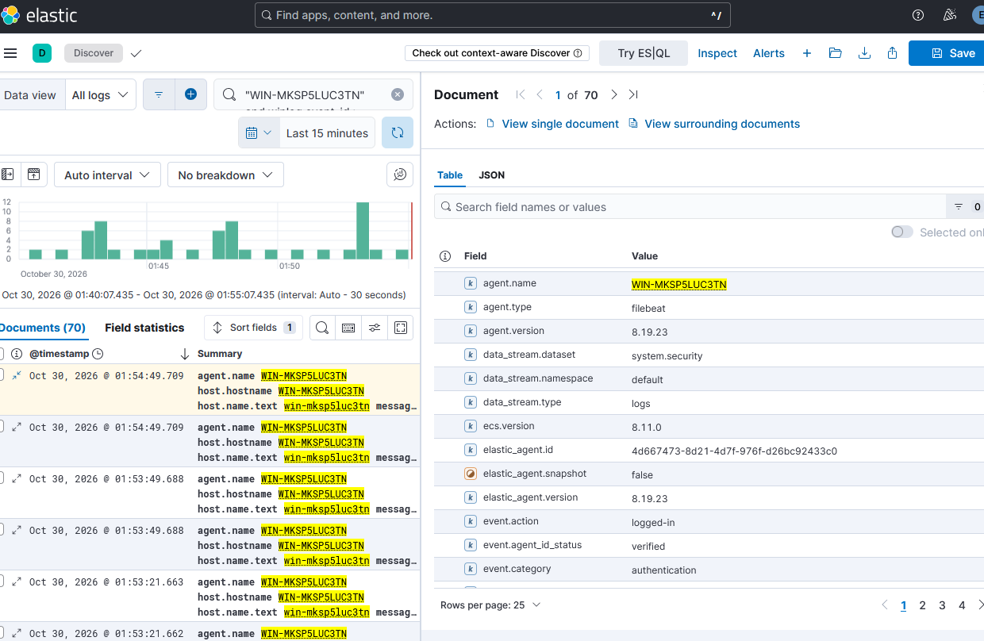
Figure 7. Windows Security events on WIN-MKSP5LUC3TN, 30 October. Top: index and data stream fields. Bottom: the same document scrolled down to the event fields.
Fields seen: data_stream.dataset system.security, event.action logged-in, event.category authentication, agent.type filebeat, ecs.version 8.11.0, in the index .ds-logs-system.security-default-2026.10.22-000001. So logon events are verified for this server.
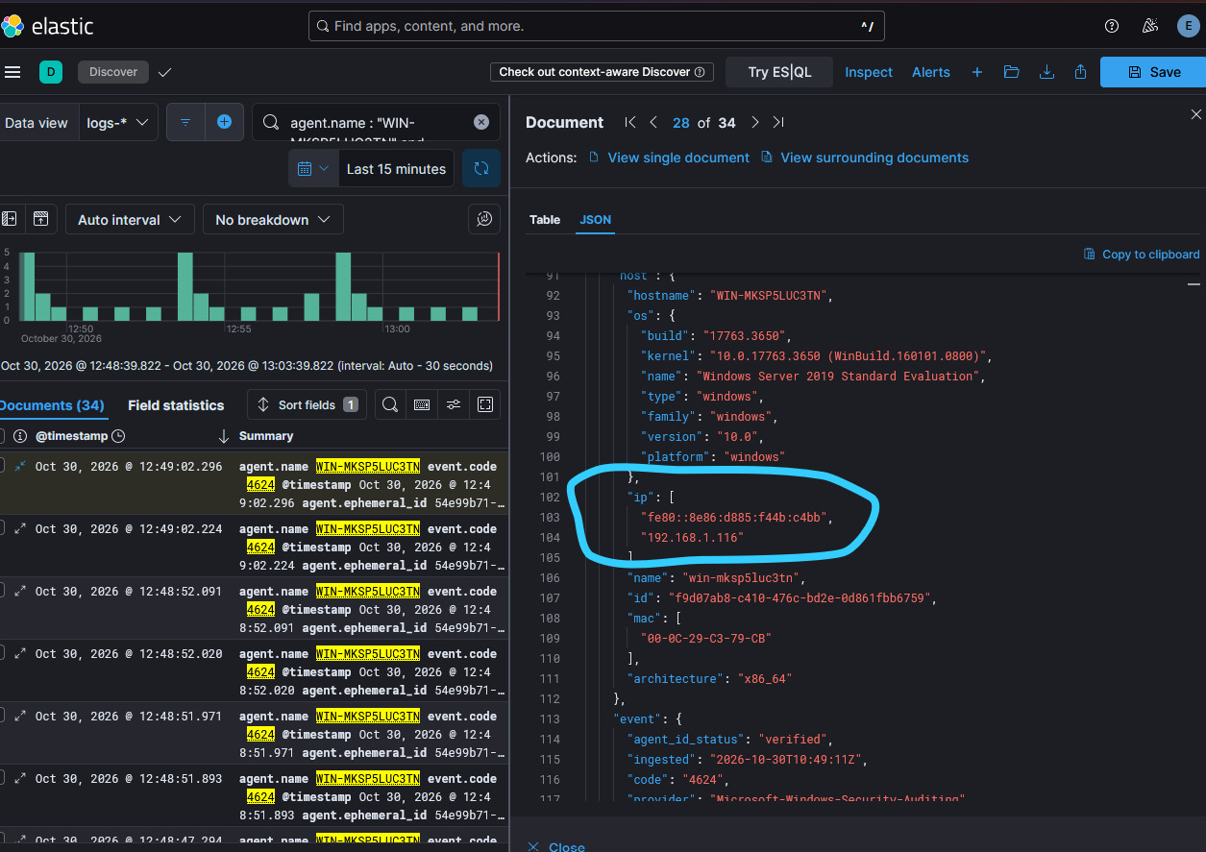
Figure 8. JSON view of a logon document (event.code 4624). The circled host.ip shows the current address 192.168.1.116. 34 documents, 12:48 to 13:03.
The same document shows host.mac 00-0C-29-C3-79-CB and host.os.name Windows Server 2019 Standard Evaluation (build 17763.3650). On 22 October this machine was at 192.168.1.91, so its address changed. The agent ID (4d667473-8d21-4d7f-976f-d26bc92433c0) and host ID are the same as before.

6.5 FortiGate
The FortiGate dashboard (FGT-VM64, 192.168.1.167) is on the right. On the left, Discover with the query "fortigate.log" returns 26 documents with log.file.path /var/log/fortigate.log, agent.name ubuntu-server and agent.type filebeat, so the logs reach Elasticsearch through the file input on the Ubuntu server.
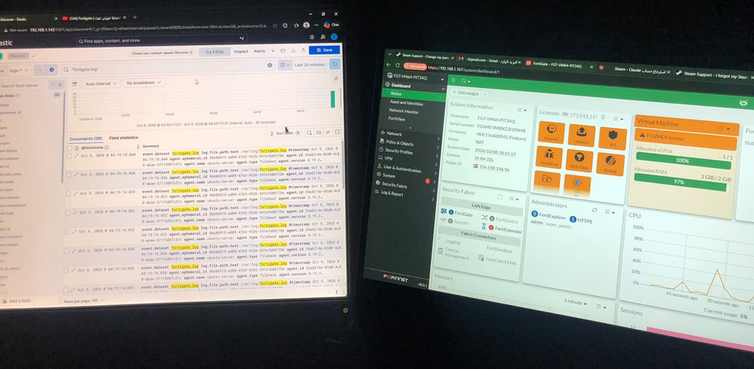
Figure 9. FortiGate dashboard (right) and Discover on fortigate.log (left, 8 October capture).
This capture is from 8 October and the summary shows file and agent fields but not the parsed firewall fields (source.ip, destination.ip, action). I need a fresh capture with those fields expanded (section 9).

6.6 Issue found and fixed: stopped agent service on Windows 10
While enrolling Windows 10 the Elastic Agent service was Stopped and Start-Service failed. The fix, visible in the screenshot, was to set the startup type to Automatic, start the service again and confirm with elastic-agent.exe status that the agent reports HEALTHY.
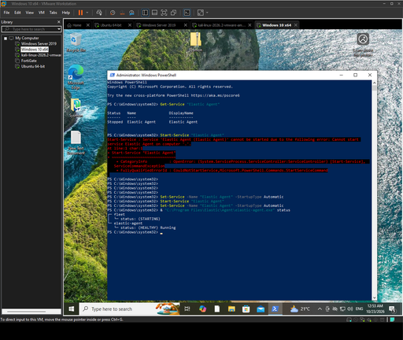
Figure 10. PowerShell on Windows 10: service Stopped, Start-Service error, Set-Service to Automatic, then status shows (HEALTHY).

7. Normalized Field Mapping
Elastic normalizes events to the Elastic Common Schema (ECS) so one query or rule works across sources. The integrations do most of this in their ingest pipelines. The tables list the mapping I will rely on for the detection rules. The Observed column says whether I saw the target field in a Discover screenshot.

7.1 Common fields (all sources)
Raw / source field | ECS field | Observed | Used for
event time | @timestamp | Yes | Timeline, ordering, rule windows
agent hostname | host.name, host.hostname | Yes | Asset identification
agent name / type / version | agent.name, agent.type, agent.version | Yes | Collector health
integration dataset | data_stream.dataset / .namespace / .type | Yes | Routing, retention, filters
event identity | event.code, event.action, event.category | Yes | Rule selection
host address / MAC | host.ip, host.mac | Yes | Asset context
OS name / platform | host.os.name.text, host.os.platform | Yes | OS-specific rules
file path read by Filebeat | log.file.path | Yes | FortiGate file source
schema version | ecs.version | Yes | Field compatibility
ecs.version is not the same everywhere, so fields must be checked per dataset:
Dataset | Data stream (index seen) | ecs.version | Source
elastic_agent | logs-elastic_agent-default | 8.0.0 | Kali, agent's own logs
system.security | logs-system.security-default (2026.10.22-000001) | 8.11.0 | Windows Server, logons
windows.sysmon_operational | logs-windows.sysmon_operational-default (2026.10.22-000001) | 8.17.0 | Windows 10, Sysmon

7.2 Windows event logs
Raw Windows field | ECS / normalized field | Observed | Used for
Computer / winlog.computer_name | host.name | Yes | Asset context
EventID | event.code, winlog.event_id | Yes (4624, 1) | Rule selection
logon success | event.action: logged-in, event.category: authentication | Yes | Logon rules
process creation (Sysmon 1) | event.action: Process creation, event.category: process | Yes | Process rules
TargetUserName / SubjectUserName | user.name, user.target.name | Yes | Brute force, suspicious login
IpAddress / WorkstationName | source.ip, source.domain | Yes | Logon source
LogonType | winlog.logon.type | Yes | Remote vs local logon
Image (Sysmon) | process.executable | Yes | Process rules
CommandLine | process.command_line | Yes | Suspicious command detection
ParentImage / ParentCommandLine | process.parent.executable, process.parent.command_line | Yes | Parent-child chains
Hashes | process.hash.*, file.hash.* | Yes | Threat intel match

7.3 Linux (system and auditd)
Raw Linux field | ECS / normalized field | Observed | Used for
syslog host | host.name, host.hostname | Yes | Asset context
auth log user | user.name | Yes | SSH and sudo activity
auth log source address | source.ip | Yes | Brute force on SSH
auditd syscall / key | auditd.data.syscall, event.action | Yes | Persistence and privilege changes
auditd exe / comm | process.executable, process.name | Yes | Process context
auditd file path | file.path | Yes | Sensitive file access

7.4 FortiGate
The current input reads the file as a log file. For parsed firewall fields the data needs the Fortinet FortiGate integration (or an ingest pipeline), which maps the raw key=value fields below.
Raw FortiGate field | ECS / normalized field | Observed | Used for
srcip / srcport | source.ip, source.port | Yes | Attacker and scanner view
dstip / dstport | destination.ip, destination.port | Yes | Targeted hosts and services
proto | network.transport / network.iana_number | Yes | Protocol filter
action | event.action, event.outcome | Yes | Allowed vs blocked

8. Retention Plan
Retention depends on how fast data arrives and how much disk there is, so I measured both on ubuntu-siem instead of guessing.

8.1 Measured disk growth
I ran du -sh on /var/lib/elasticsearch twice, about 43 seconds apart, and df -h for the disk.
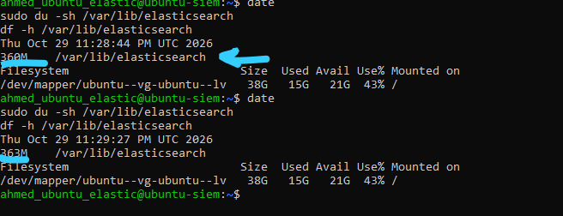
Figure 11. du -sh /var/lib/elasticsearch: 360M at 23:28:44 UTC and 363M at 23:29:27 UTC on 29 October. df -h: 38G disk, 15G used, 21G available (43%).
Item | Value
Folder measured | /var/lib/elasticsearch (Elasticsearch data)
Sample 1 / sample 2 | 360 MB at 23:28:44 UTC / 363 MB at 23:29:27 UTC
Interval | 43 seconds
Growth | 3 MB in 43 s
Per minute | 3 / 43 x 60 = 4.19 MB per minute
Per hour | 4.19 x 60 = 251 MB per hour
Per day | 251 x 24 = 6,028 MB = 5.9 GB per day
Per source | about 1.5 GB per day each (4 sources: 3 agent hosts and the Ubuntu server with FortiGate)
Rounding range | du rounds to whole MB, so the real growth is 2 to 4 MB: 3.9 to 7.8 GB per day
Sanity check: the whole folder held only 360 MB on 29 October although the indices were created on 22 October. At 5.9 GB per day it would be about 41.2 GB after a week. So the 43-second sample was taken during a busy period and is a worst case, not the average. I plan with the worst case and will re-measure every hour for 24 hours to get the real average.

8.2 What fits on this disk
Disk needed = daily ingest x days x (1 + replicas) x 1.15 overhead. There is one node and no replicas. Elasticsearch stops allocating at 85 to 95 percent disk use (default watermarks), so usage must stay below 85 percent.
Retention | Data | With 15% overhead | Disk used after (of 38 GB) | Fits?
1 day | 5.9 GB | 6.8 GB | 57% | Yes
2 days | 11.8 GB | 13.5 GB | 75% | Yes
3 days | 17.7 GB | 20.3 GB | 93% | No
7 days | 41.2 GB | 47.4 GB | 164% | No
30 days | 176.6 GB | 203.1 GB | 574% | No
90 days | 529.8 GB | 609.3 GB | 1643% | No
At the worst-case rate this disk holds 2 days safely. Three days already pass the high watermark and 7, 30 or 90 days need a much bigger disk (about 47 GB for 7 days, 203 GB for 30 days, 609 GB for 90 days).

8.3 Lab retention policy
For the lab I will use one ILM policy on all logs-* data streams: roll over every day and delete after 2 days. That uses about 13.5 GB at the worst case and keeps the disk near 75 percent. If the 24-hour measurement shows a lower average, I will raise the delete age.
PUT _ilm/policy/soc-lab-2d
{ "policy": { "phases": {
"hot": { "actions": { "rollover": { "max_age": "1d" } } },
"delete": { "min_age": "2d", "actions": { "delete": {} } }
} } }
To reduce volume I can also drop the elastic_agent logs, filter noisy Sysmon events and raise the metrics collection interval.

8.4 Target design for a medium organization
With enough disk the same plan becomes tiered: hot 0 to 7 days, warm 8 to 30 days, cold 31 to 90 days (searchable snapshot), delete after 90 days. Per source:
Source | Lab setting | Target for a medium organization
Windows Security / Sysmon | 2 days | 90 days searchable, 1 year archive
Linux auth / auditd | 2 days | 90 days searchable, 1 year archive
FortiGate traffic logs | 2 days | 30 days searchable, 180 days archive (high volume)
FortiGate security / UTM events | 2 days | 90 days searchable, 1 year archive
Agent / stack logs | 2 days | 14 days, no archive

9. Validation Status and Open Items
Check | Status | Evidence / note
All four agents enrolled and Healthy | Done | Fleet Agents overview, agent detail pages
Fleet Server reachable on 8220 | Done | Test-NetConnection on Windows Server, enrollment output
Events from Kali in Elasticsearch | Done | Discover, 53 docs (agent logs)
auditd and system events from Kali | To verify | Need a query on the auditd and system datasets
Windows process events (Sysmon) | Done | IT-machine, event.code 1, 13 docs
Windows Security logons | Done | WIN-MKSP5LUC3TN, system.security, event.code 4624, 70 docs
FortiGate file reaches Elasticsearch | Done | Discover, 26 docs, log.file.path /var/log/fortigate.log
FortiGate fields parsed to ECS | To verify | Need fresh capture, or switch to the Fortinet integration
Disk growth measured | Done | 3 MB in 43 s, about 5.9 GB per day (worst case)
Static IPs for server and agents | To do | Windows Server moved from .91 to .116
ILM policy applied | To do | soc-lab-2d, before detection rules go live
TLS with a trusted certificate | To do | Enrollment currently uses --insecure

10. Action Plan
This section records who did what in Week 1. The team is split by responsibility: documentation, Elastic Stack setup and lab infrastructure.

10.1 Team and responsibilities
Team member | Team | Week 1 responsibility
Mahmoud Ahmed Fathy Qamrahom Shalaby | Documentation | Wrote this report: architecture, data source inventory, log onboarding evidence, field mapping, retention plan and validation status.
Ahmed Mohamed Ahmed Mohamed Abdo | Elastic team | Set up Elastic (Fleet Server, Elasticsearch, Kibana), connected the agents to Elastic and set up the integrations.
Mohamed Emad Fathy Shabl | Elastic team | Set up Elastic (Fleet Server, Elasticsearch, Kibana), connected the agents to Elastic and set up the integrations.
Omnia Ali Mohamed Khallaf | Elastic team | Set up Elastic (Fleet Server, Elasticsearch, Kibana), connected the agents to Elastic and set up the integrations.
Mohamed Abdelhamid Abdelgalil Nagm | Infrastructure team | Set up the four lab VMs: FortiGate, Windows Server 2019, Windows 10 and Kali Linux.
Ahmed Ashraf Abdelhamid Mostafa Kandil | Infrastructure team | Set up the four lab VMs: FortiGate, Windows Server 2019, Windows 10 and Kali Linux.

10.2 Week 1 actions completed
Action | Owner | Result | Section
Set up the four VMs (FortiGate, Windows Server 2019, Windows 10, Kali) | Infrastructure team | Four VMs running on 192.168.1.0/24 and reachable from the SIEM server | 3
Install and configure Fleet Server, Elasticsearch and Kibana on ubuntu-siem | Elastic team | Fleet Server on port 8220, Kibana on port 5601 | 3, 4
Enroll Elastic Agents on Windows 10, Windows Server and Kali | Elastic team | All four agents Healthy on version 8.19.23 | 6.1 to 6.4
Set up integrations and policies (system, Windows, Sysmon, auditd) | Elastic team | Sysmon, Windows Security and agent logs visible in Discover | 5, 6
Send FortiGate logs to a file read by Filebeat | Elastic team and infrastructure team | 26 documents from /var/log/fortigate.log in Discover | 6.5
Write the Week 1 report and collect the evidence | Documentation | Report covering the five Week 1 deliverables | All

