

Database

Final project

khaled rabah elshorafa id:120190878

hosam hasan abohelal id:120190970

yousef abdellatef khalaf id:120190876

abdalnaser jehad abozbeda id:120192288

mohamed samer aboamsha id:120192262

Ghada khamis banat id:120192233

supervisor: shimaa jarou

ERD:

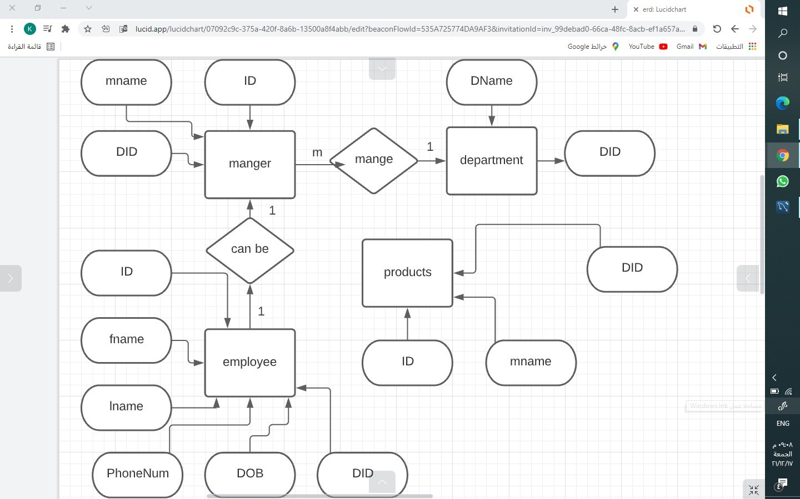

Description:

We are making a database for a company, which require 4 tables department, employee, manger and products we use DDL to define them

Department with attributes:

have 2 attributes DID (int) department id which is a primary key, and DName (nvarchar) department name.

Employee with attributes:

have 6 attributes ID (int) primary key, fname (nvarchar) first name, lname (nvarchar) last name, PhoneNum (nvarchar), dob (date) date of birth, DID (int) foreign key from department.

Manger with attributes:

Have 3 attributes ID (int) foreign key from employee, mname (nvarchar) manger name, DID (int) foreign key from department.

Products with attributes:

Have 3 attributes PID (int) product id, pname (nvarchar) product name, timesofPurchasing (nvarchar) times the product was sold.

Then use DML to manipulate the data and display it