

**Faculty of engineering - Shoubra**

**Benha University**

**Research Article / Research Project / Literature Review**

in fulfillment of the requirements of

|  |  |
| --- | --- |
| **Department** | **Engineering Mathematics and Physics** |
| **Division** | **-----------------** |
| **Academic Year** | **2019-2020 Preparatory** |
| **Course name** | **computer** |
| **Course code** | **ECE006** |

**Title: -**

**Programming languages**

By:

|  |  |  |  |
| --- | --- | --- | --- |
|  | Name | Edu mail | B.N |
| 1 | Mohamed Ahmed afifiy | Muhammed195726@feng.bu.edu.eg | 651 |

**Approved by:**

**What is a Programming Language? What is Code?**

The code is pretty much like writing a paragraph of instruction or creating a to-do list to computers. Unlike us humans, the to-do list and instructions you write for the computer has to be extremely detailed and written in some logic.

With code and programming, you can get the computer to draw complex shapes and create rich computer graphics, and then create programs that understand game mechanics and help you build games that feel real with gravity and particle collision, with these programs you can create the most intense and immersive games of all sorts.

With code and programming, you can create and send content all over the world with your blog and personal website and style your blog to meet your style. You can build tech-driven business solutions and reach a wider range of customer and cater to a wider range of needs.

Furthermore, with code and programming, you can create smart home applications, like an automated pet feeder, a smart mirror or even create a robot that can help around with household tasks and be your virtual assistant to talk to and understand you. Unlike what many people think, there’s a lot of art involved in computer engineering and computer science.

Screenshots:

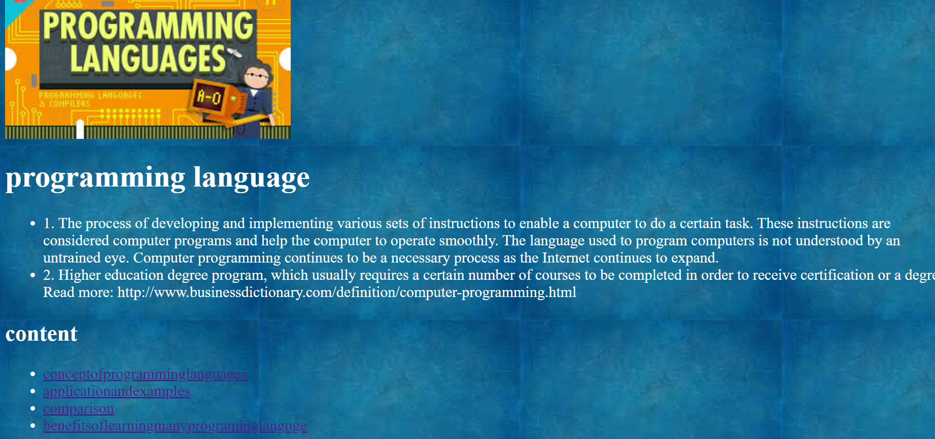

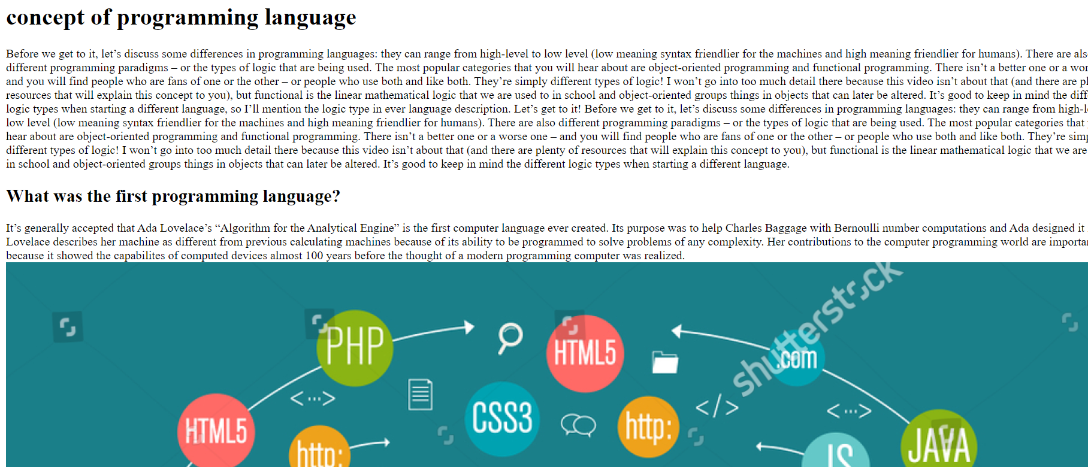

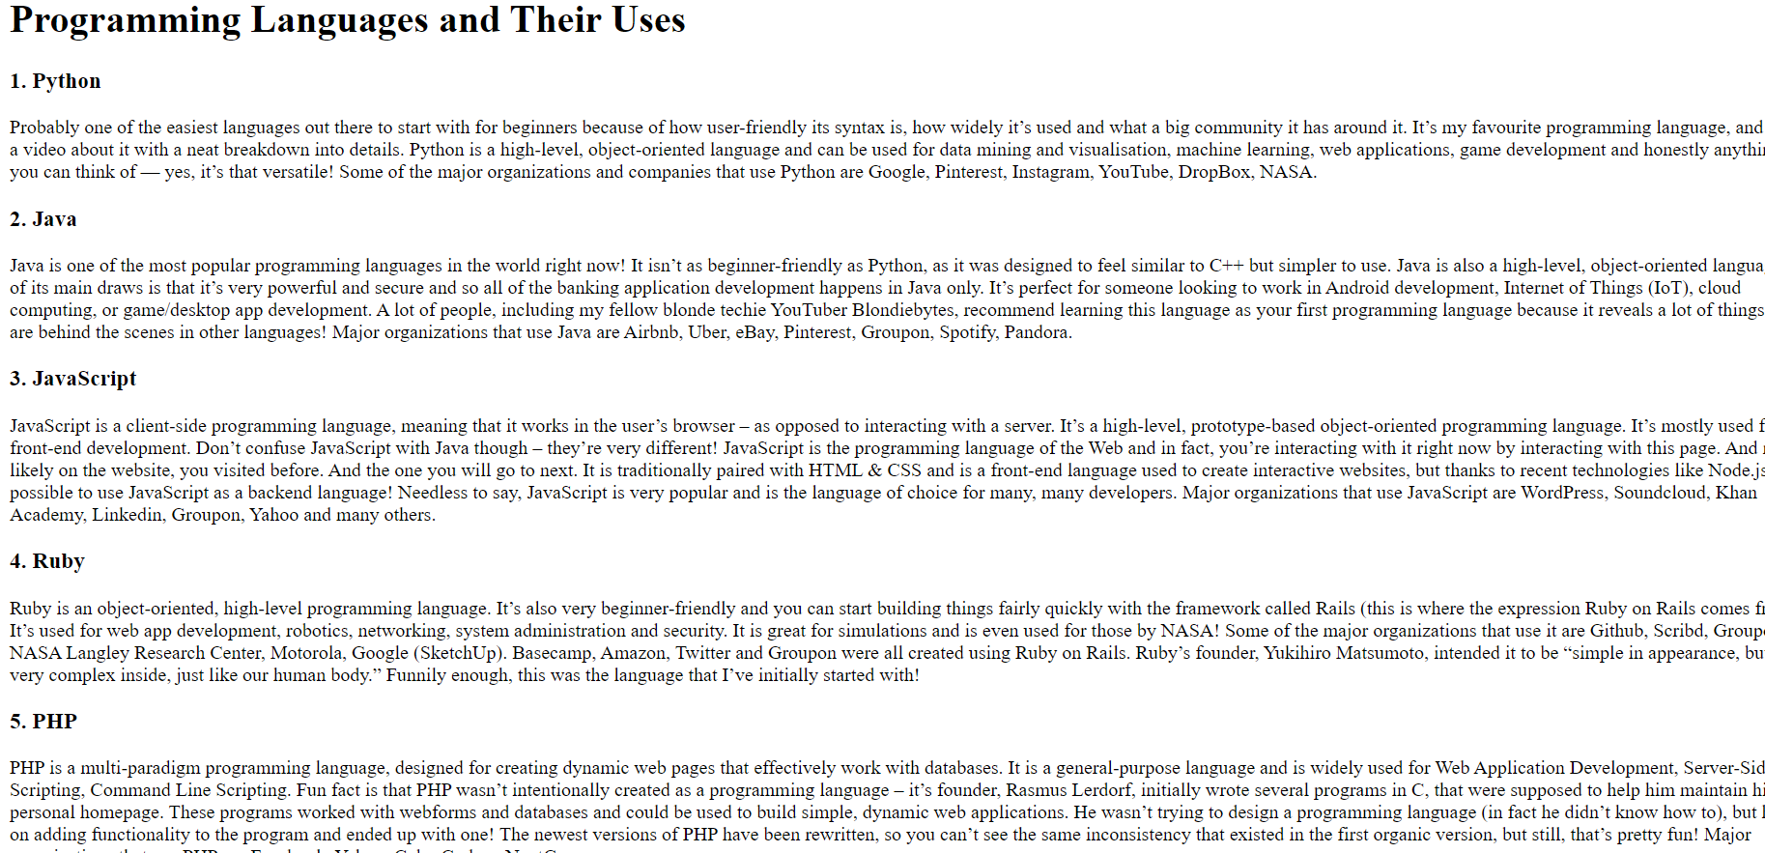

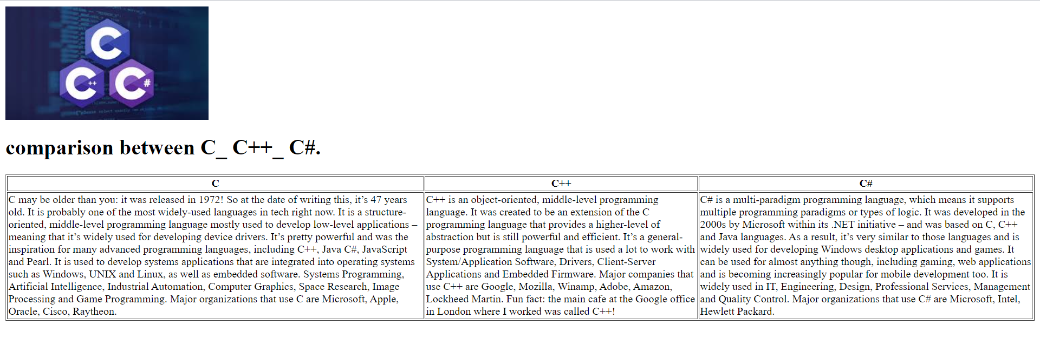

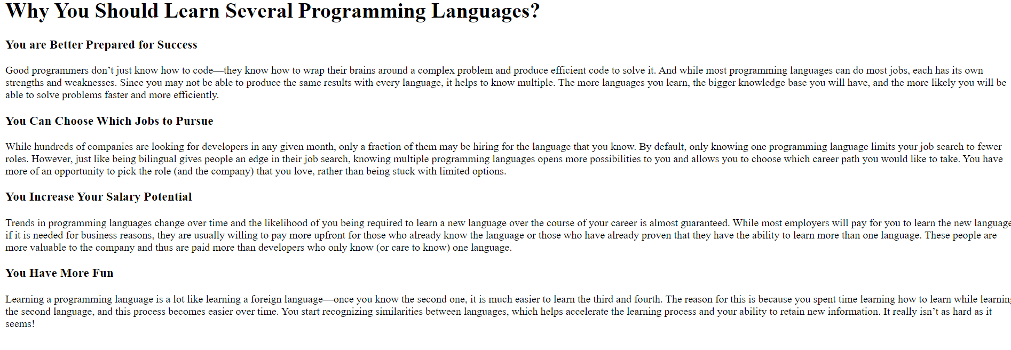

Source code:

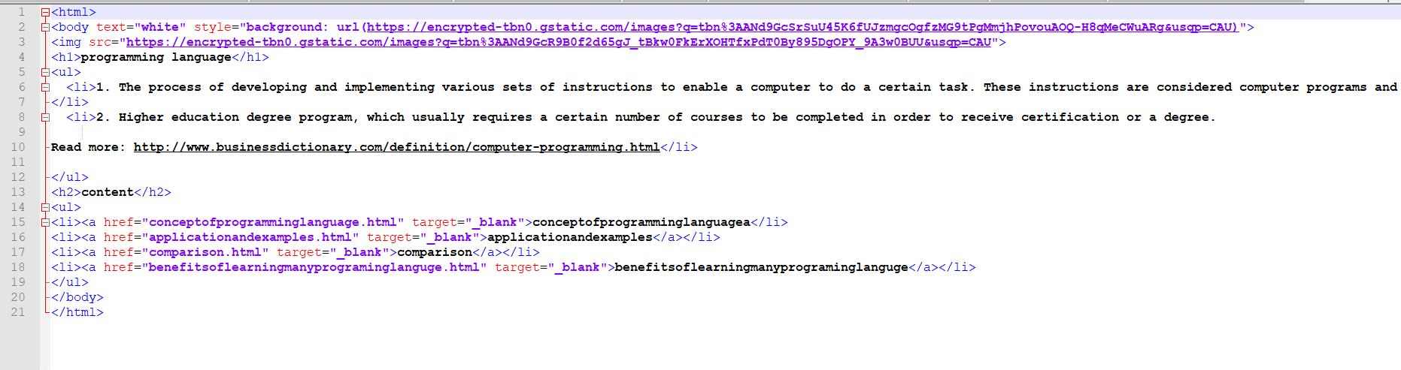

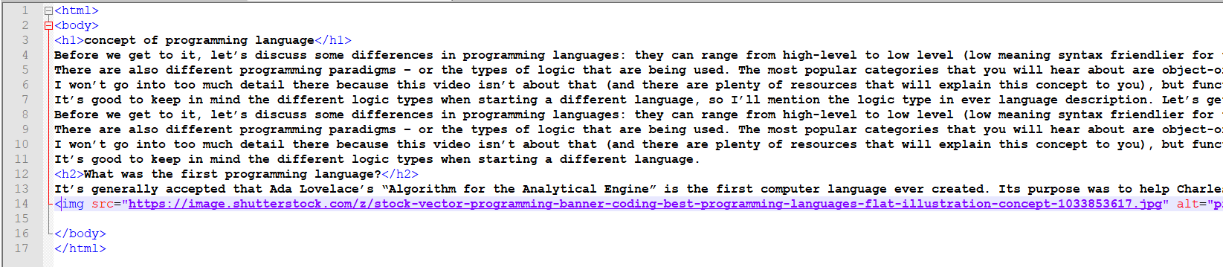

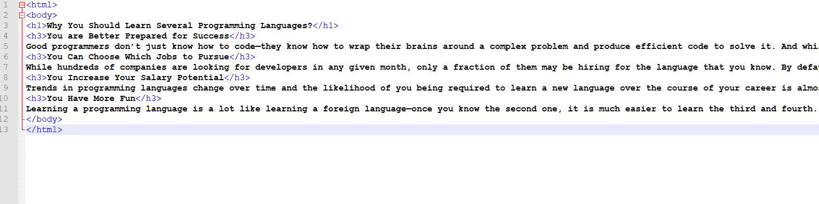

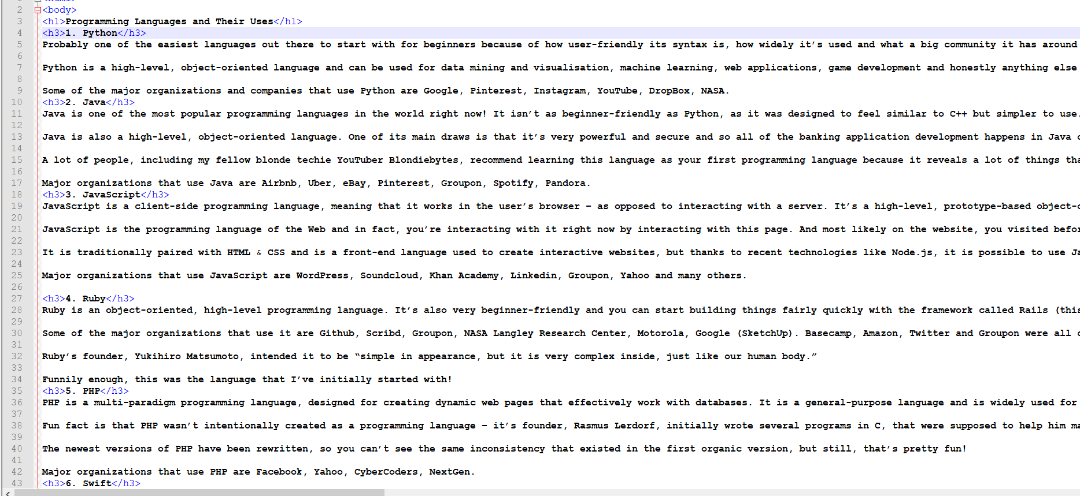

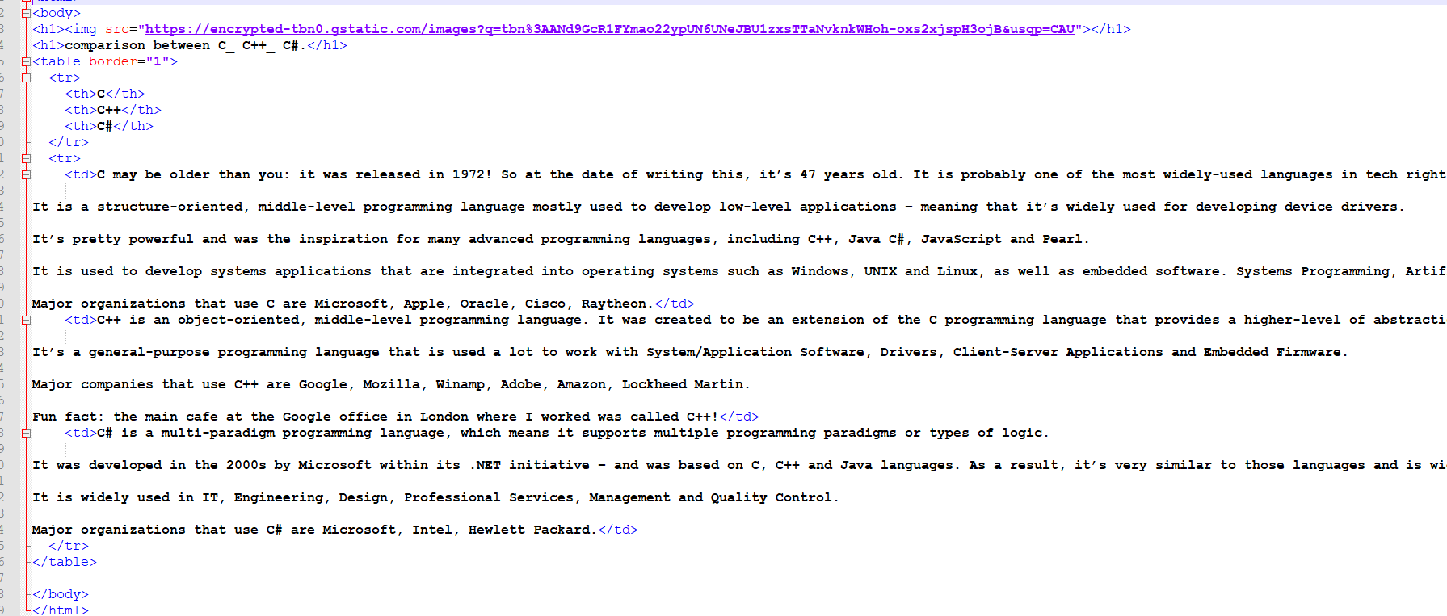

**Reference:**

<https://www.collinsdictionary.com/dictionary/english/programming>

<https://byte-notes.com/a-complete-list-of-all-types-of-programming-languages/>