### Regular Expression for symbols : ( + | - | * | / | && | || | ~ | == | < | > | != | <= | >= | = | -> | { | } | [ | ]| ( | ) | " | ' | /@ | @/ | /^ | $ | . )

### NFA:

### DFA:

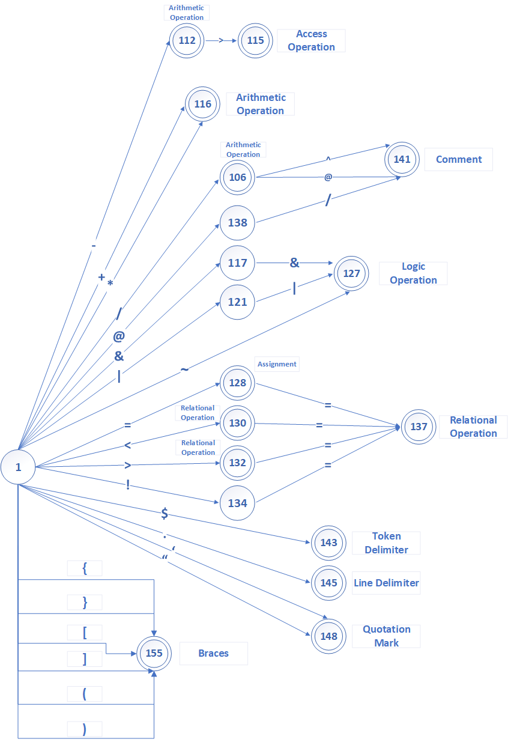

### Regular Expression : (Yesif | Otherwise | Omw| SIMww| Chji | Seriestl | IMwf | IMwf | NOReturn | RepeatWhen | Reiterate | GetBack | OutLoop | Loli | Include | Start | Last | [0-9] | ( ([a-z] | _ | [A-Z]) ([a-z] | _ | [A-Z] | [0-9])* )

DFA:

### Identifier DFA:

### 

