PROJECT TITLE : SMART WATER MANAGEMENT SYSTEM USING IOT

PHASE 2: INNOVATION

SENSORS:

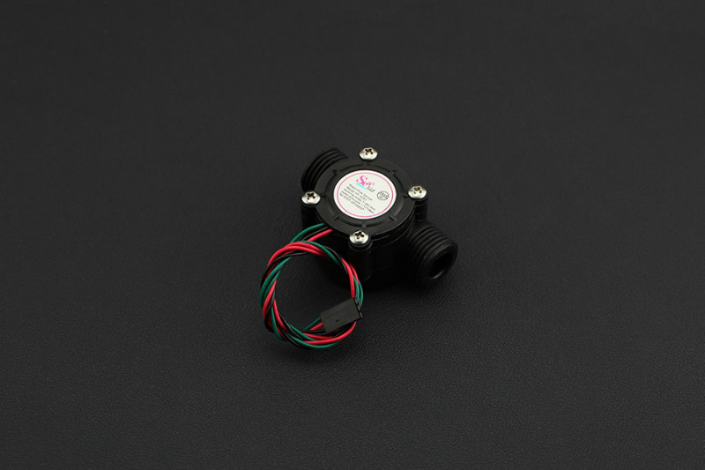

WATER FLOW SENSOR

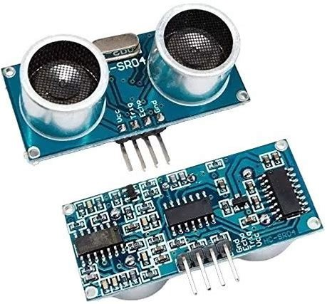

ULTRASONIC SENSOR

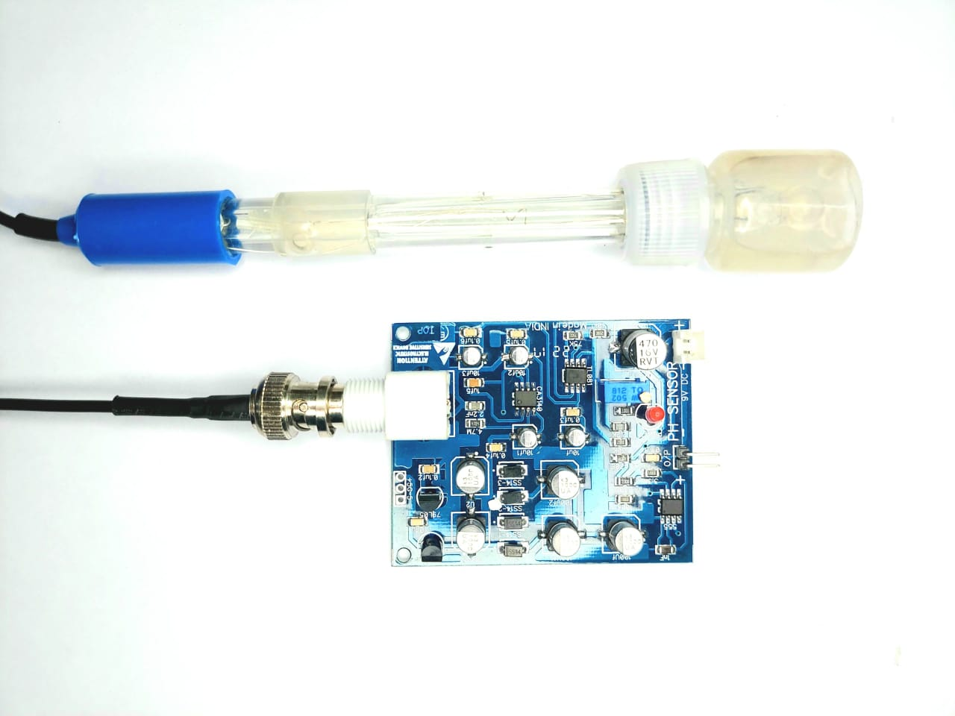

PH TESTING SENSOR

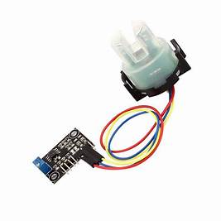

TURBIDITY SENSOR

DEFINITION FOR SENSORS:

ULTRASONIC SENSOR:

An ultrasonic sensor is a device that measures the distance to an object or surface by emitting high-frequency sound waves and measuring the time it takes for the sound waves to bounce back after hitting the object. It's commonly used for non-contact distance measurement, such as water level monitoring in tanks.

FLOW SENSOR:

A flow sensor, or flow meter, is a device that measures the rate of flow (velocity) of a fluid, typically a gas or liquid, passing through a pipe or conduit. It provides data on the volume or mass of fluid passing through per unit of time

TURBIDITY VALVE:

A turbidity sensor is a device used to measure the cloudiness or haziness of a fluid (typically water) caused by the presence of suspended particles or impurities. It quantifies the degree of light scattering in the fluid to determine its turbidity.

PH SENSOR:

A pH sensor is designed to measure the acidity or alkalinity of a liquid, typically water, by detecting the concentration of hydrogen ions (H+). It provides a pH value, which is a measure of the solution's hydrogen ion activity.

SOLENOID VALVE:

A solenoid valve is an electromechanical device that controls the flow of a fluid (e.g., water) by opening and closing a valve when an electrical current is applied to a coil (solenoid). It's commonly used to start or stop the flow of liquids or gases in automated systems.

STEPS FOR FLOWCHART:

Step 1: Initialization

Initialize sensors, actuators, and system parameters.

Set control thresholds and calibration.

Step 2: Data Acquisition

Continuously collect sensor data:

Water level (Ultrasonic sensor)

Flow rate (Flow sensor)

Turbidity (Turbidity sensor)

pH level (pH sensor)

Step 3: Control Logic

Check and react to sensor data:

If water level is too high, close the solenoid valve.

If turbidity is high, initiate filtration.

If pH is out of range, adjust it.

If flow rate is excessive, stop water distribution.

Step 4: User Interface and Alerts

Provide a user interface for monitoring.

Generate alerts for abnormal conditions.

Allow user control and adjustments.

Step 5: Loop

Repeat steps 2 to 4 in a continuous loop.

Step 6: End

Implement a system shutdown or exit condition.

FLOWCHART:

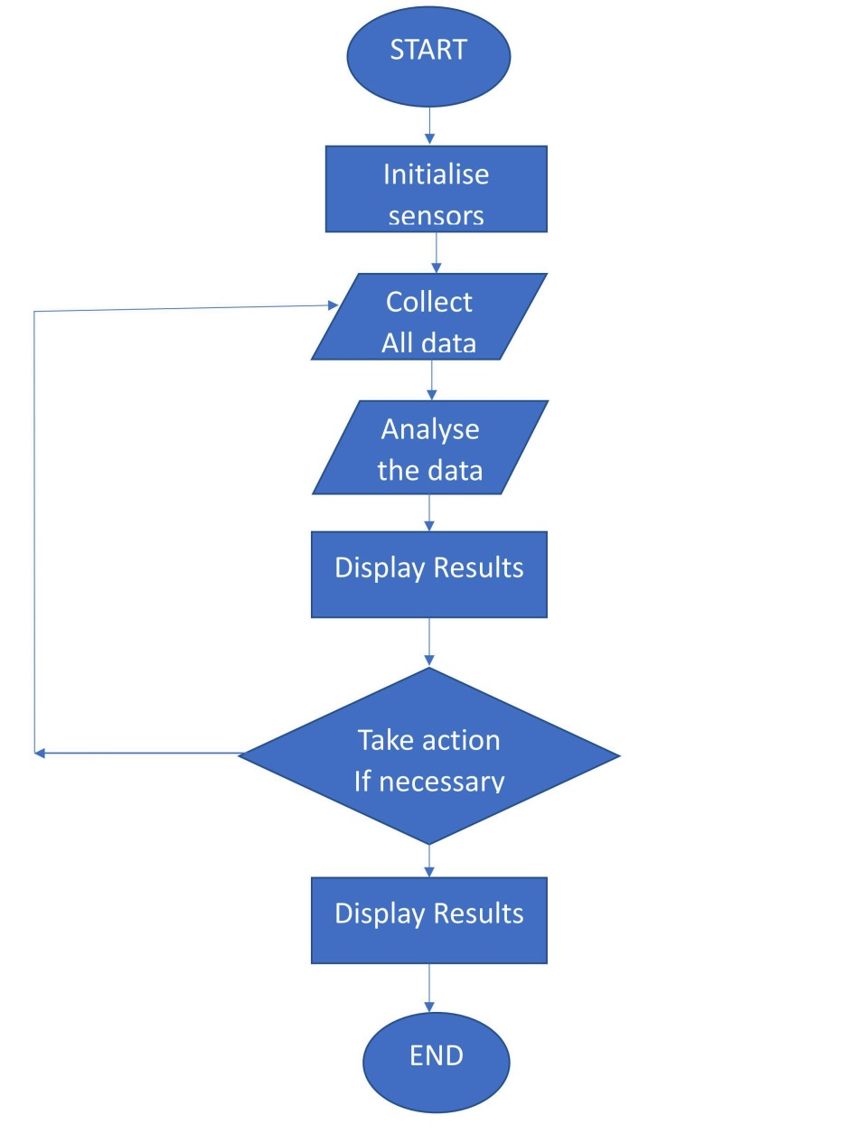

BLOCK DIAGRAM:

USER INTERFACE

USER CONTROL

MICRO CONTROLLER

ALERTS

SENSORS

SOLE

WATER TANK

SOLENOID VALVE

CONTROL LOGIC

BLOCK DIAGRAM DESCRIPTION:

USER CONTROL:

This component represents the user's interface for controlling and monitoring the smart water management system. Users can interact with the system, set preferences, and view data.

USER INTERFACE:

The User Interface component provides a visual interface for users to interact with the system. It displays system status, sensor data, and allows users to control various parameters.

MICROCONTROLLER:

The Microcontroller, such as an Arduino, serves as the central processing unit of the system. It processes data from sensors, implements control logic, and communicates with the User Control and Alerts components.

ALERTS:

Alerts are used to inform users of the system's status. This can include visual or audible alerts to indicate events like water level, system malfunctions, or any other critical information.

SENSORS:

Sensors include various types, such as Ultrasonic, Flow, Turbidity, and pH sensors. They collect essential data about water levels, flow rates, water clarity (turbidity), and pH levels in the system.

CONTROL LOGIC:

The Control Logic component processes the data from the sensors and makes decisions based on predefined rules and thresholds. It determines when to activate the Solenoid Valve to control water flow and may make adjustments based on the sensor data.

SOLENOID VALVE:

The Solenoid Valve is responsible for controlling the flow of water. It can open or close to regulate the flow of water in response to control signals from the Control Logic.

WATER TANK:

The Water Tank serves as a reservoir for storing and distributing water. It receives and stores rainwater or filtered water, and the Solenoid Valve controls the flow into and out of the tank.

CIRCUIT DIAGRAM:

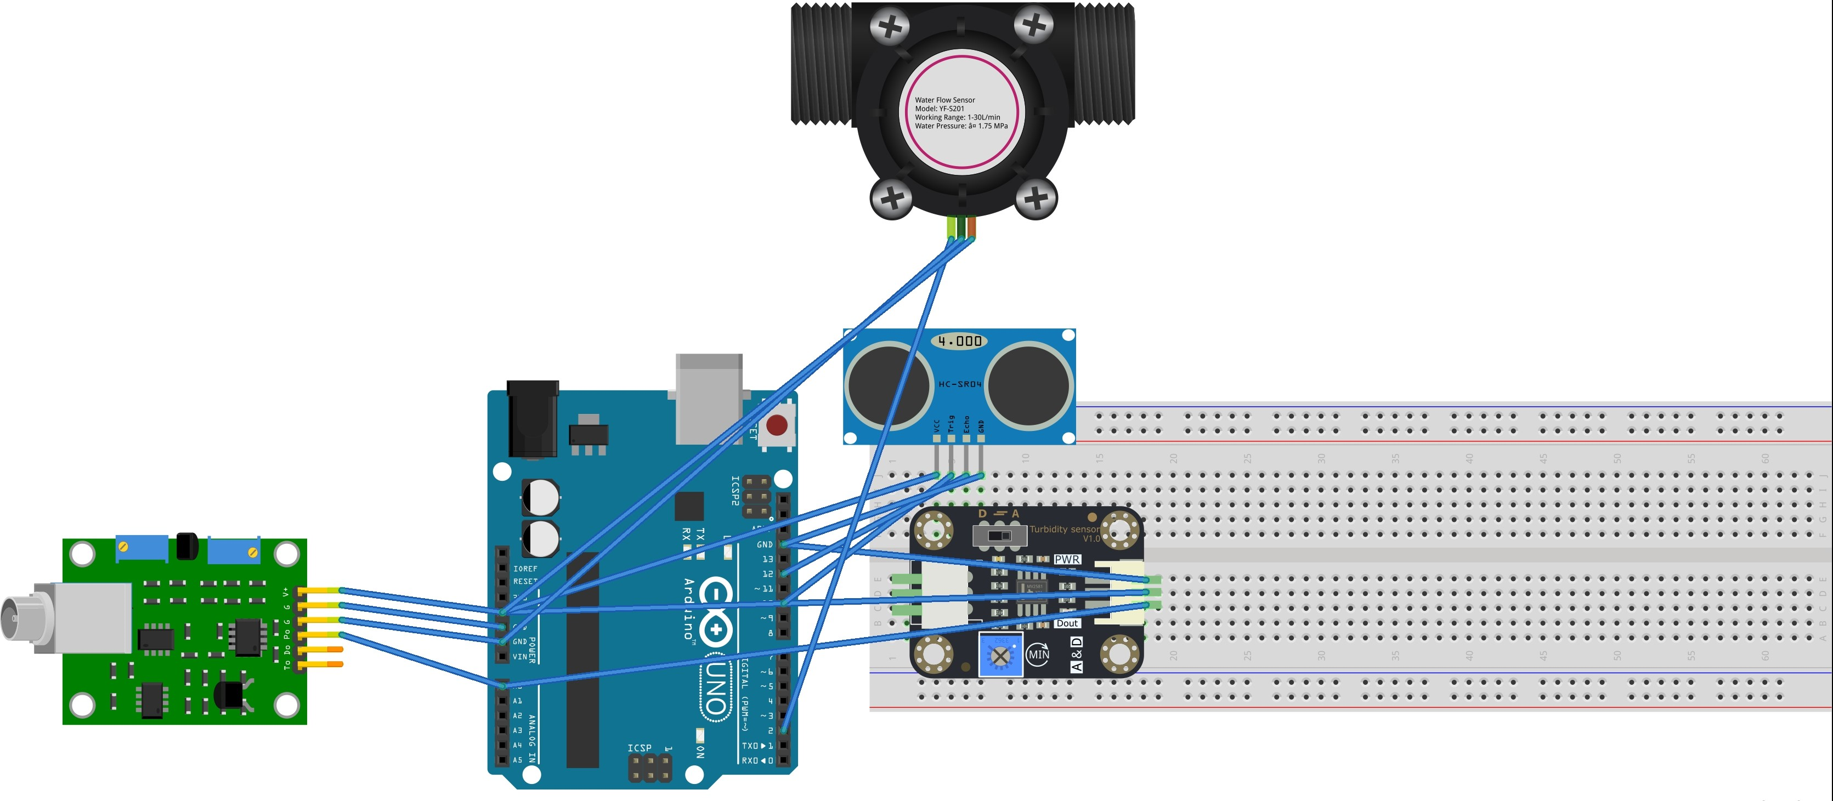

APPLICATIONS:

1)Residential water savings through rainwater reuse.

2)Agricultural irrigation efficiency.

3)Industrial water resource sustainability.

4)Environmental conservation and research.

5)Smart city water infrastructure.