Design patterns

Design patterns are the best solutions to the common problems encountered in software design.

Creational Patterns:
These patterns focus on object creation mechanisms

Structural Patterns:
Structural patterns deal with object composition and class relationships, helping to define how objects are connected to one another.

Behavioral Patterns:
Behavioral patterns focus on how objects interact and communicate with each other

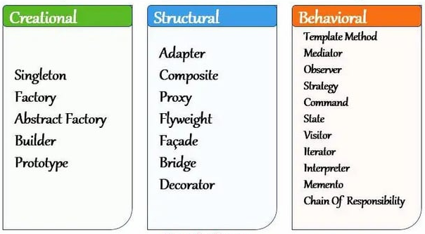

Creational

Singleton

The singleton pattern ensures that only one instance of a class is ever created.

1 – Using “object” keyword

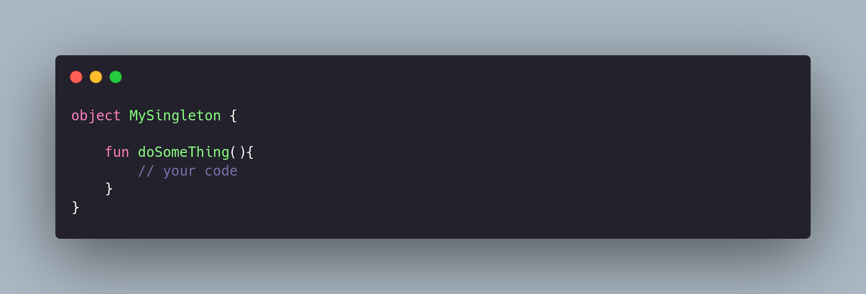

2 – With “ parameters”

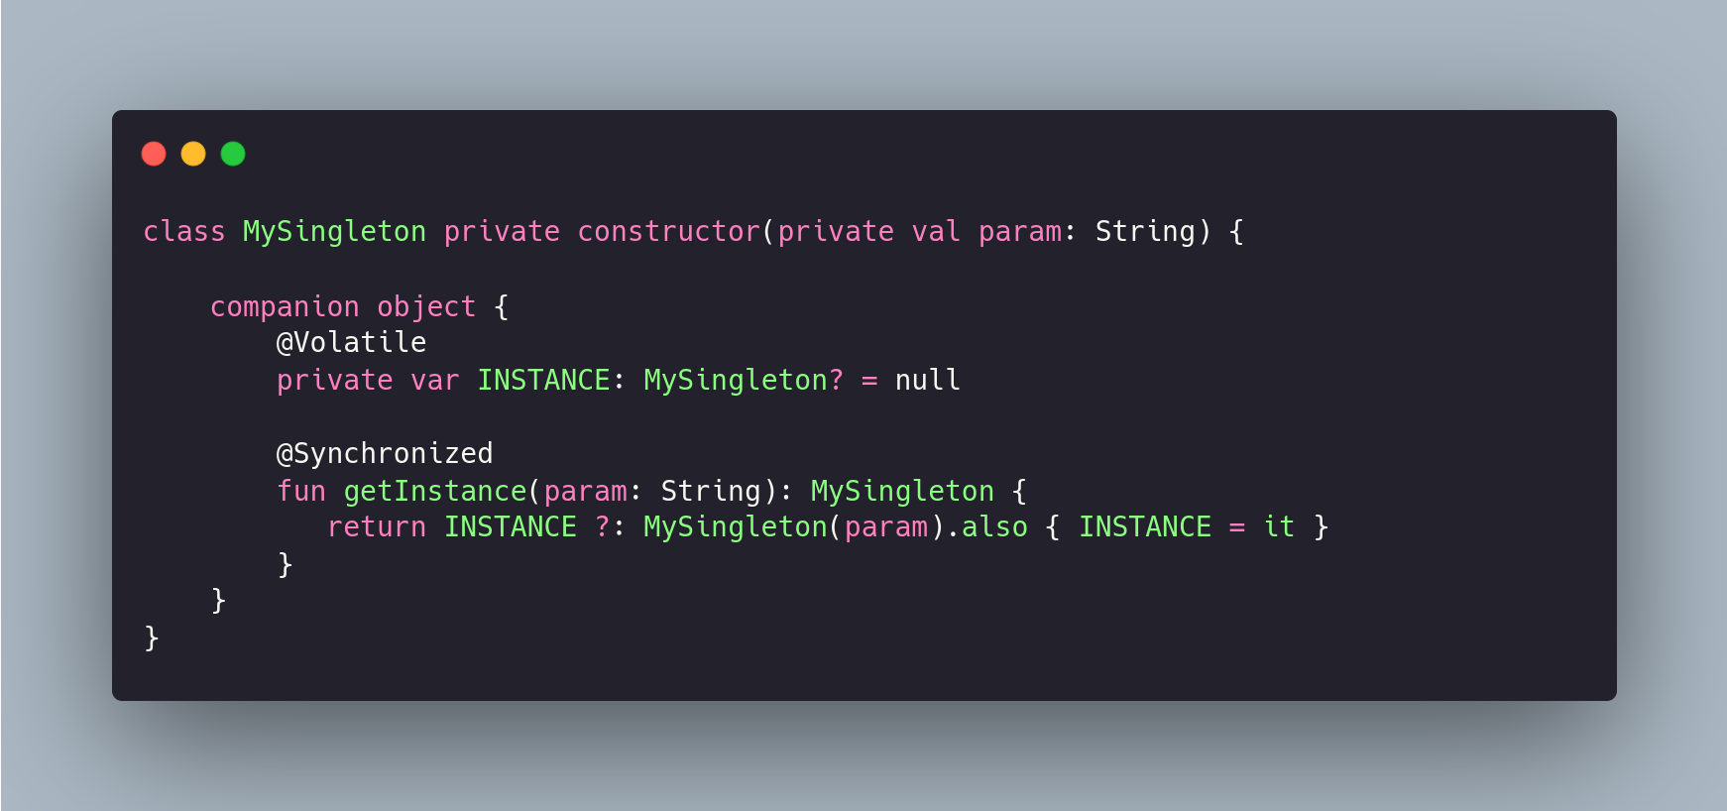

3 – Using “ Application Class “ & “ lazy initializer “
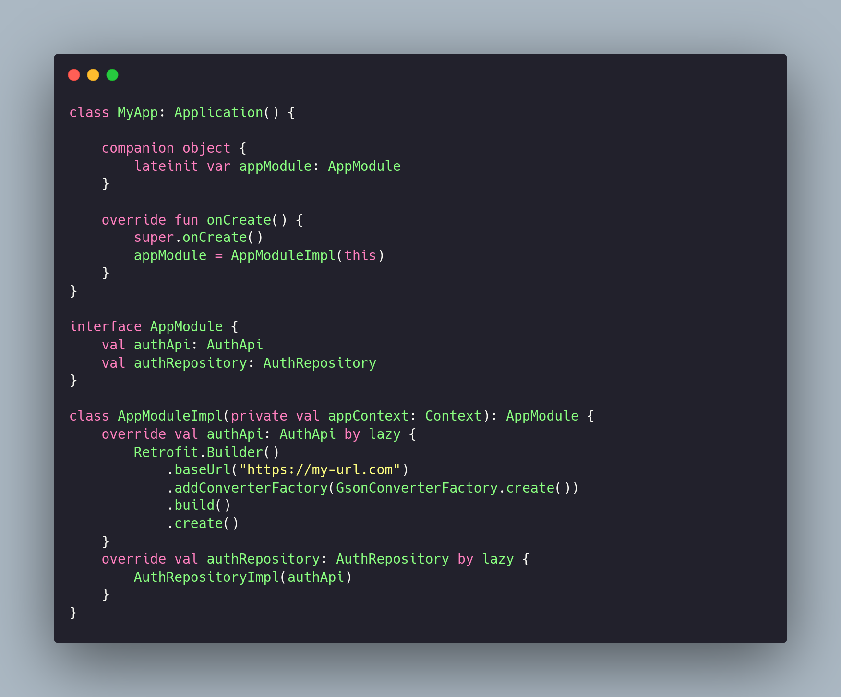

Creational

Builder

The Builder pattern allows you to create complex objects step-by-step using methds instead of the constructor overloading

