

CIS 3403 – Final Project

2018-05-07

Authors:

Mohamed Ebrahim Al-Ali (H00328791)

Abduljalil Mohammed Alolama (H00293814)

Saeed Ahmed Kalban (H00)

Abdullah Obaid (H0029)

Instructor: Tauseef Kamal

# Description

Our project provides all information about the most famous spots in all cities depending on what the database provides, it saves longitude and latitude. We created the database using mLab, six routes, a website, and a mobile app containing a WebView.

To view the project, [click here.](http://spotsonclick.eu-4.evennode.com/index.html)

# Cloud Database Design

* The **database** name is: spotsonclick
* The **collection** names are: spots, users
  + The documents inside spots contain keys including:
    - name
    - description
    - image_url
    - city
    - location
  + The documents inside users contain keys including:
    - username
    - display_name
    - email
* The database is hosted on **mLab.**
* The full project is hosted on **EvenNode.**

# Routes

## Users Resource

|  |  |  |
| --- | --- | --- |
| Route | Method | Description |
| /users | POST | Adds data to the ‘users’ collection in the database. |
| /users | GET | Gets all the users from the ‘users’ collection. |
| /users/:id | GET | Gets the user matching the parameter :id from the ‘users’ collection. |
| /users/:id | PATCH | Modifies the changed data for the user matching the parameter :id. |
| /users/:id | DELETE | Removes the user matching the parameter :id from ‘users’ collection. |
| /search/users/?key=x&value=y | GET | Search for users where key is (x) and value is (y) in the ‘users’ collection. |

## Spots Resource

|  |  |  |
| --- | --- | --- |
| Route | Method | Description |
| /spots | POST | Adds data to the ‘spots’ collection in the database. |
| /spots | GET | Gets all the spots from the ‘spots’ collection. |
| /spots/:id | GET | Gets the spot matching the parameter :id from the ‘spots’ collection. |
| /spots/:id | PATCH | Modifies the changed data for the spot matching the parameter :id. |
| /spots/:id | DELETE | Removes the spot matching the parameter :id from ‘spots’ collection. |
| /search/spots/?key=x&value=y | GET | Search for spots where key is (x) and value is (y) in the ‘spots’ collection. |

# Architecture Diagram

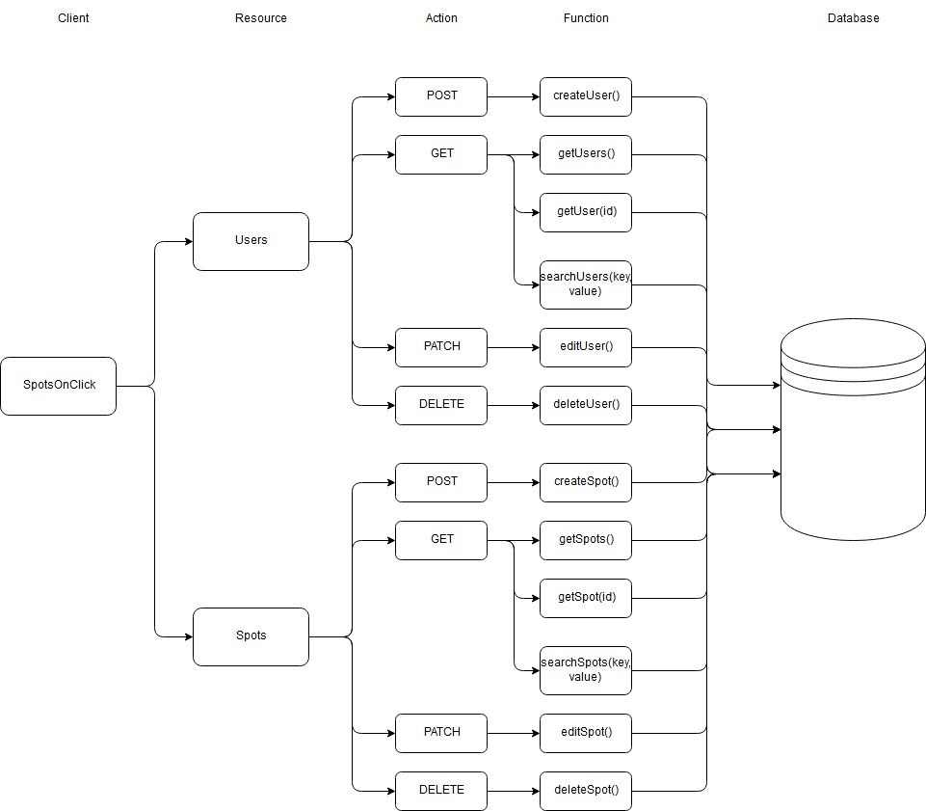

The SpotsOnClick application will have CRUD (Create, Read, Update, Delete) operations. POST is create, GET is read. PATCH is update and DELETE is delete.