

**Task 2**

**Reconstruction of Cardiac Ultrasound Images Using Phased Array Transducer Techniques**

**Under**

**Supervision:**

Dr.

Ahmed

Ehab

Eng.

Ola

Sarhan

Team

13

**Team**

**Members:**

1-

Mohammed

El

Naggar

2-

Omar

Atef

3-

Abdullah

Mohammed

4-

Mohand

Emad

5-

Carole

Emad



1. **Introduction:**

Ultrasound imaging is a cornerstone of non-invasive diagnostics, providing detailed views of internal organs. Specifically, diverging-wave echocardiography is a method to obtain high-quality images of the heart, critical for diagnosing cardiac conditions. This report focuses on simulating a five-chamber view of the heart using diverging waves, exploring the complete image reconstruction pipeline. Using seven diverging waves with a 60-degree aperture, we simulate, process, and beamform ultrasound signals to generate a compound echocardiographic image of the heart.

1. **Theory and Methodology**
2. **Transducer Configuration:** The P4-2v transducer, a 64-element phased array with a 2.7 MHz center frequency.
3. **Transmit apodization:** is applied using a cosine function to smooth the beam profile.
4. **Transmit Delays:** Seven diverging waves are transmitted at tilt angles ranging from -20° to +20°.

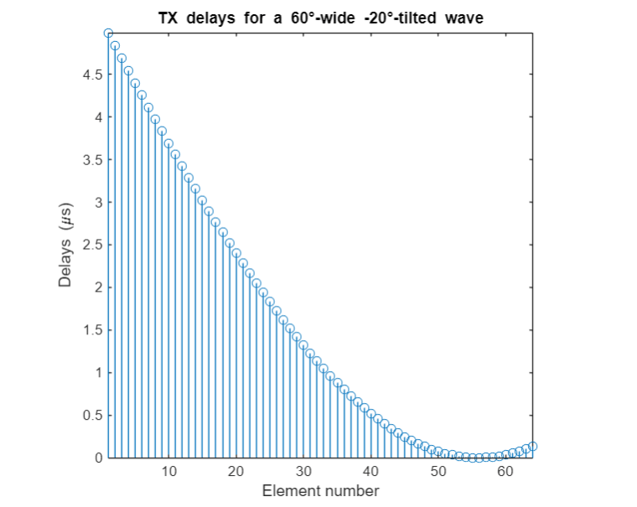

1. **Pressure Field Simulation:** The acoustic field is simulated on a 100 × 100 polar grid. The root-mean-square (RMS) pressure field is visualized to validate the 60-degree diverging wave steered at -20°.

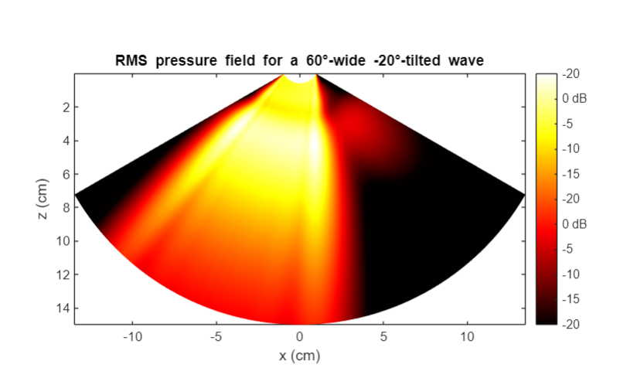

1. **RF Signal Simulation:** Scatterers representing heart structures are generated. Using the simus function, seven series of RF signals (each with 64 elements) were simulated, sampled at four times the center frequency.

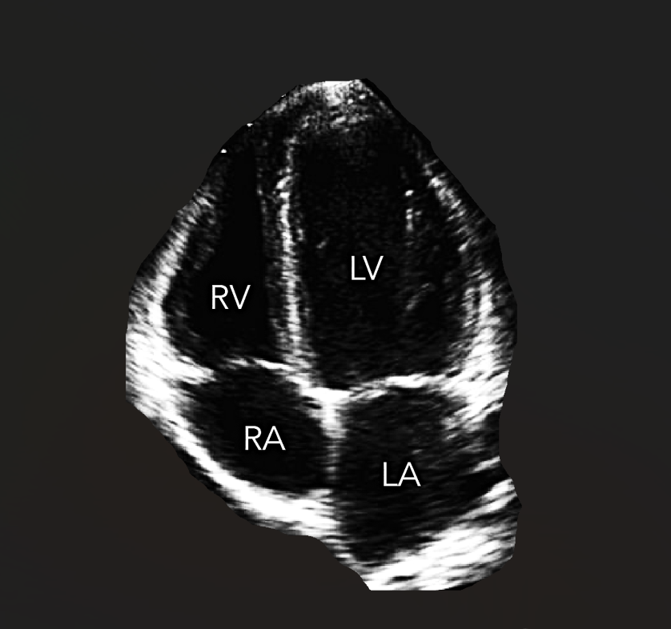 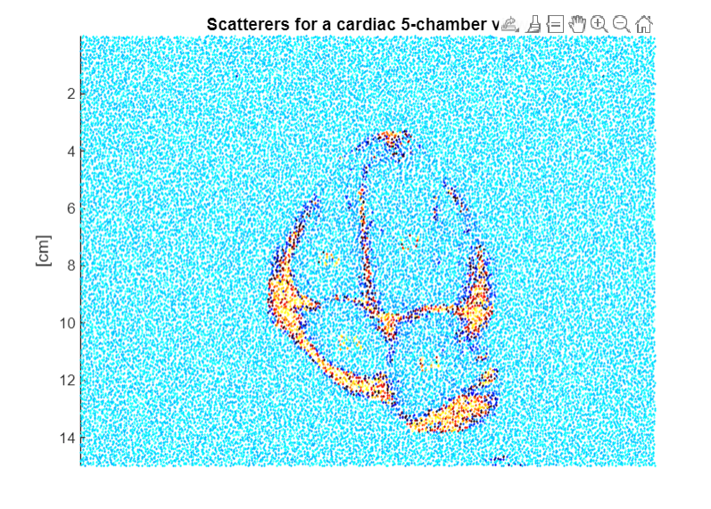

1. **I/Q Demodulation:** The RF signals are converted into in-phase (I) and quadrature (Q) components. This step prepared the data for beamforming by simplifying the signals into their analytic forms.

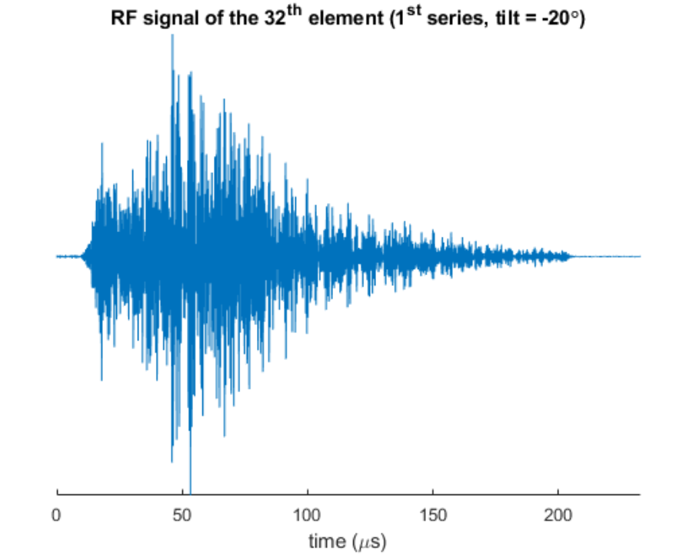 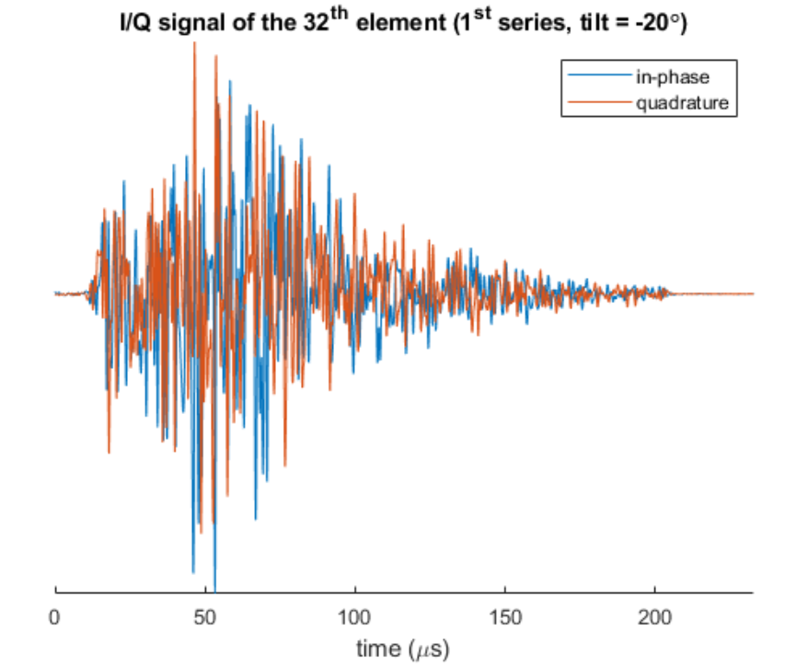

1. **Beamforming:** Delay-and-sum (DAS) beamforming is applied to focus the received signals onto a 256 × 128 polar grid. This step was repeated for all seven diverging wave series to produce I/Q beamformed images.
2. **Time-Gain Compensation (TGC):** The beamformed I/Q signals were time-gain compensated to equalize amplitudes across depths. This ensured a consistent dynamic range throughout the image.
3. **Image Compounding:** Individual images from all seven tilts were compounded by summing their beamformed signals. This enhanced image quality by reducing artifacts and improving resolution.

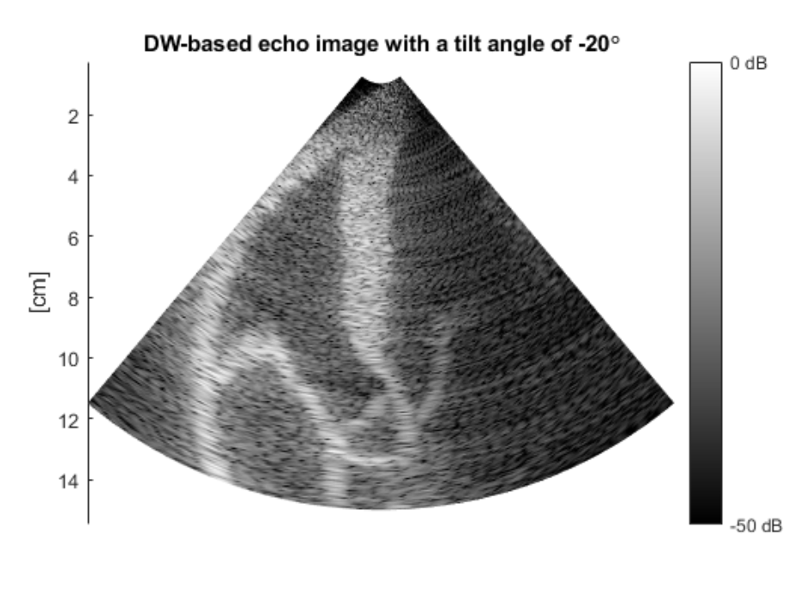 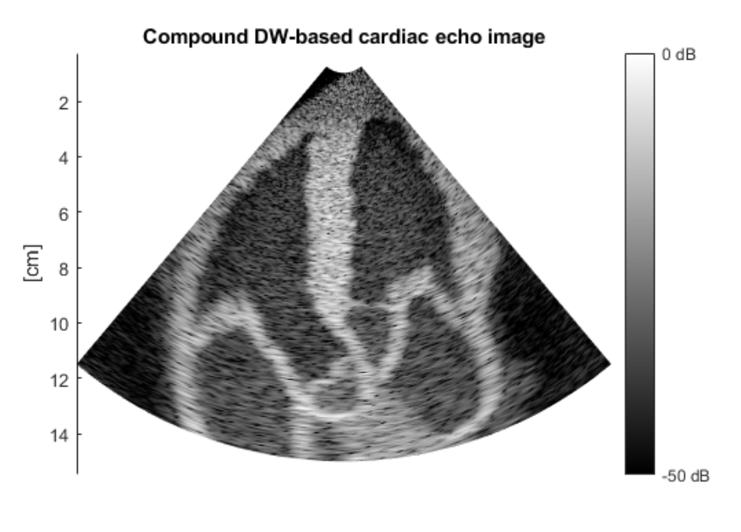

**Conclusions:**

This study successfully demonstrated the simulation and reconstruction of a five-chamber view of the heart using diverging-wave echocardiography. Key findings include:

* Diverging waves provide extensive insonification, enabling high-temporal-resolution imaging.
* Compounding multiple tilted acquisitions enhances image quality.
* Advanced processing steps like I/Q demodulation, DAS beamforming, and TGC contribute significantly to image clarity.

**References**

1. Garcia, D. (n.d.). BioméCardio: MUST Toolbox. Retrieved from [website URL].
2. Ultrasound Simulation Functions: getparam, txdelay, simus, rf2iq, das, and pfield documentation.
3. Biomedical Imaging Techniques: INSERM Research Publications.