**Gym Store Project**

**Gym Store – Project Proposal**

**Overview**

Gym Store is an online platform for selling fitness equipment, supplements, apparel, and accessories. The goal is to provide a smooth, secure, and efficient shopping experience for fitness enthusiasts.

**Objectives**

* Build a responsive and user-friendly e-commerce site.
* Enable product browsing, cart, and secure checkout.
* Improve customer satisfaction with reviews and promotions.

**Scope**

Develop a website with an easy-to-use interface, product management system.

**Project Plan**

* Timeline: period from March 9 to May 9.

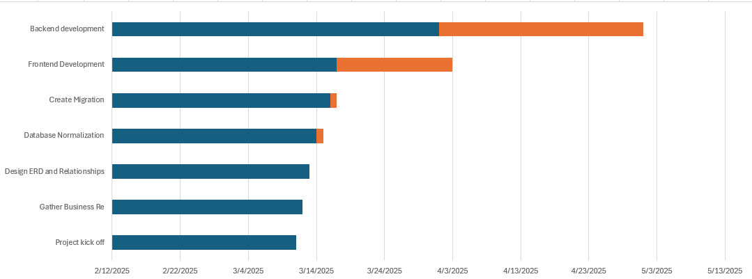

**Task Assignment & Roles**

* Backend Developer and Frontend Developer: Mohamed Ali
* Backend Developer and Frontend Developer: Mohamed Talal
* Tester and Backend Developer: Ahmed Mohamed
* Database Designer and Frontend Developer: Belal Mohamed

**Risk Assessment & Mitigation Plan**

**Potential Risks:**

**Data breaches or cyberattacks**  
Encrypt sensitive data using SSL and perform regular security audits to prevent unauthorized access.

**Payment gateway failures**  
Support multiple payment methods and provide fallback options like cash on delivery.

**Server downtime**  
Use reliable cloud hosting with auto-restart features and ensure 99.9% uptime through monitoring.

**Inaccurate inventory levels**  
Link inventory updates to purchases and set alerts for low-stock items.

**Poor user experience (UX)**  
Design a clean, intuitive UI and gather user feedback to continuously improve usability.

**Scalability issues during high traffic**  
Use scalable cloud infrastructure and run stress tests to ensure system stability under load.

**Shipping and delivery delays**  
Partner with reliable couriers and provide users with real-time tracking and estimated delivery dates.

**Negative product reviews**  
Monitor and respond to reviews professionally; encourage satisfied customers to leave positive feedback.

**Lack of regular backups**  
Enable daily automated backups and store them securely for quick recovery if needed.

**Mitigation Plan:**

**1. Data breaches or cyberattacks**  
Use SSL encryption, validate user input, and conduct regular security audits.

**2. Payment gateway failures**  
Support multiple payment methods and offer backup options like cash on delivery.

**3. Server downtime**  
Use reliable cloud hosting with auto-scaling and uptime monitoring.

**4. Inaccurate inventory levels**  
Automatically update stock after each purchase and set low-stock alerts.

**5. Poor user experience (UX)**  
Design a simple, mobile-friendly UI and improve based on user feedback.

**6. Scalability issues during high traffic**  
Use scalable cloud infrastructure and perform stress testing.

**7. Shipping and delivery delays**  
Work with trusted courier services and offer real-time tracking.

**8. Negative product reviews**  
Monitor reviews, respond professionally, and encourage happy users to rate products.

**9. Lack of regular backups**  
Schedule daily automatic backups and store them securely.

**Key Performance Indicators (KPIs)**

Website Load Time: less than 4 seconds

Customer Satisfaction Score (CSAT): 95% or higher

**Literature Review**

Research best practices in e-commerce design

**Use Cases & user experience**

* As a customer I want to search for gym equipment.
* As a customer I want to add products to the shopping cart.
* As a customer I want user friendly interface.

**Functional Requirements**

User Management

Customers should be able to register, log in, and manage their profiles.

Admins should be able to manage users (add, update, delete).

Product Management

Admins should be able to add, update, and delete products (gym equipment, supplements, and activewear).

Products should have details like name, description, price, stock availability, and images.

Product Search & Filtering

Users should be able to search for products using keywords.

Users should be able to filter products by category, price, brand, and rating.

Shopping Cart & Checkout

Users should be able to add/remove products to/from the shopping cart.

The system should calculate the total cost, including discounts and shipping fees.

Users should be able to proceed to check out and select a payment method.

Payment Processing

The system should support multiple payment options (credit/debit cards, PayPal, cash on delivery, etc.).

The system should generate invoices for completed orders.

Order Management

Users should be able to view their order history and track order status.

Admins should be able to manage orders (approve, ship, cancel, refund).

Reviews & Ratings

Users should be able to leave reviews and rate products after purchase.

Admins should have the ability to moderate reviews.

Wishlist Feature

Users should be able to add products to their wishlist for future purchases.

Inventory Management

The system should update stock levels automatically after each purchase.

Admins should receive alerts when stock is low.

Shipping & Delivery Tracking

Users should be able to select a shipping method at checkout.

The system should provide estimated delivery times and tracking information.

**Non-Functional Requirements**

Performance

The website should load within 3 seconds for an optimal user experience.

The system should handle at least 500 concurrent users.

Security

All user data and transactions should be encrypted using SSL.

The system should comply with PCI DSS standards for secure payments.

Scalability

The system should support future expansion (more products, categories, and users).

Cloud hosting should be considered for scaling.

Usability

The interface should be simple, intuitive, and mobile-friendly.

Users should be able to complete a purchase within 3-5 clicks.

Availability & Reliability

The website should have 99.9% uptime.

The system should provide automated backups to prevent data loss.

Maintainability

The system should have a modular code structure for easy updates and bug fixes.

**Problem Statement & Objectives**

Problem: users want reliable platform.

Objective: Provide Seamless user experience and customer support.

**Use Case Diagrams**

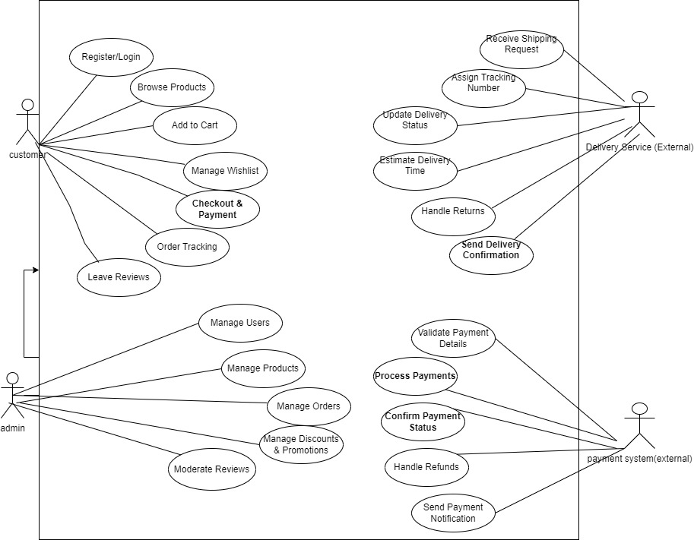

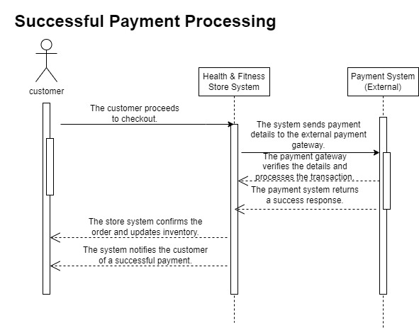

**Software Architecture**

* Design system based on MVC architecture within an n-tier structure.

**Database design**

ERD and Logical Shema

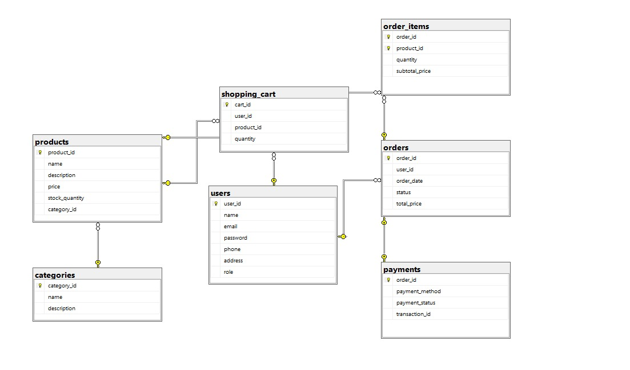

**Wireframes & Mockups**

Design search interface, product page.

**Source code**

You can access the project repository on github via this link:

**Security Measures**encrypt payment data.

**Unit Testing**

Each component (like user login, product add/edit, or cart logic) is tested in isolation to ensure it works correctly. For example, testing the AddToCart() method to confirm it adds items properly without relying on other parts of the system.

**Integration Testing**

Verifies that different module (e.g., frontend, backend, and database) work together seamlessly. For example, testing the full purchase flow from adding a product to the cart, checking out, and recording the order in the database.