**TECHNOLOGY NAME:** Data Analysis with COGNOS

**PROJECT:**Covid 19 cases analysis

**PHASE NO:** 04

**INTRODUCTION**:

In this phase, the data can be visualized using IBM Cognos.The graphs and charts can be created to visualize and compare the mean values and standard deviations of COVID-19 cases and associated deaths.

**CODE FOR VISUALIZATIONS:**

import pandas as pd

import numpy as np

import matplotlib.pyplot as plt

#extracting data from a given dataset

df=pd.read_csv("Covid_19_cases4.csv")

#extracting an associated columns "cases" and "deaths"

x=df['cases']

y=df['deaths']

z=df['day']

#Creating visualizations using bar graph between cases and day

plt.bar(z,x)

plt.xlabel("DAY")

plt.ylabel("CASES")

plt.title("DAY AND CASES")

#Creating visualizations using bar graph between deaths and day

plt.bar(z,y)

plt.xlabel("DAY")

plt.ylabel("DEATHS")

plt.title("DAYS AND DEATHS")

#Printing the values of x and y

print("Cases:",x)

print("Deaths:",y)

#Finding the mean value for cases

x_mean=np.mean(x)

print("Mean value for cases:",x_mean)

#Finding the mean value for deaths

y_mean=np.mean(y)

print("Mean value for deaths:",y_mean)

#Finding the Variance for CASES

for i in range(0,2730):

variance_x=((x[i]-x_mean)**2)/2730

print("Variance for CASES:",variance_x)

#Finding SD for CASES

sd_x=np.sqrt(variance_x)

print("Standard deviation for CASES:",sd_x)

#Finding the Variance for DEATHS

for i in range(0,2730):

variance_y=((y[i]-y_mean)**2)/2730

print("Variance for DEATHS:",variance_y)

#Finding SD for DEATHS

sd_y=np.sqrt(variance_y)

print("Standard deviation for DEATHS:",sd_y)

#Creating a visualizations between mean values and associated deaths

a=[x_mean,y_mean]

b=[sd_x,sd_y]

#Visualize a scatter plot

plt.scatter(a,b)

plt.xlabel("Mean of deaths and cases")

plt.ylabel("Standard deviation of deaths and cases")

plt.title("Scatter")

#visualize a simple graph plot

plt.plot(a,b)

plt.xlabel("Mean of deaths and cases")

plt.ylabel("Standard deviation of deaths and cases")

plt.title("Simple Graph")

**OUTPUT:**

Cases: 0 366

1 570

2 538

3 639

4 405

...

2725 3455

2726 4069

2727 4884

2728 4876

2729 6191

Name: cases, Length: 2730, dtype: int64

Deaths: 0 5

1 6

2 11

3 4

4 19

..

2725 17

2726 12

2727 14

2728 19

2729 19

Name: deaths, Length: 2730, dtype: int64

Mean value for cases: 3661.010989010989

Mean value for deaths: 65.29194139194139

Variance for CASES: 2344.631646785771

Standard deviation for CASES: 48.421396580290526

Variance for DEATHS: 0.7849611127600501

Standard deviation for DEATHS: 0.8859803117225857

**VISUALIZATIONS BETWEEN DAY AND CASES:**

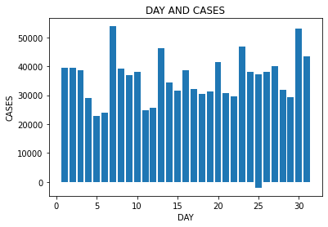

**VISUALIZATIONS BETWEEN DAY AND DEATHS:**

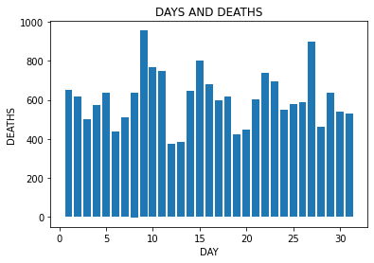

**VISUALIZATION BETWEEN THE MEAN VALUES AND STANDARD DEVIATION OF CASES AND**

**ASSOCIATED DEATHS:**

**SCATTER PLOT:**

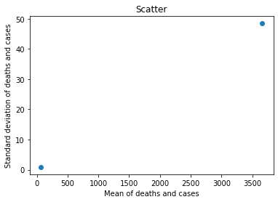

**SIMPLE GRAPH:**

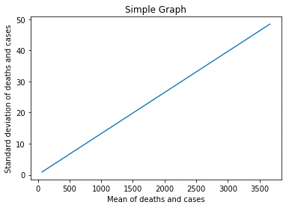

**SIMPLE GRAPH AND SCATTER PLOT:**

