Prepared by Mohamed Amine Jemni
The folder link :
ML Pipeline Updates

Jun 1, 2026
ML Pipeline Understanding :Autism 2024 and Young vs Older 2024

1. Purpose
This document summarizes my understanding of the ML pipeline steps and the results produced so far for the Autism 2024 and Young vs Older 2024 datasets. The goal is to explain what each phase does, what files/results were produced, and what still needs confirmation before final interpretation.
I worked through the pipeline up to Phase 4.4. Phase 4.4 was started, but SHAP attempted to run on thousands of models, so I asked the team whether SHAP should be limited to the top selected models only.

2. Datasets Used
Study | File used | Note
Autism 2024 | 2024 FINAL - Autism Study MAR2024 ALL (AM+NM) Features.xlsx  2024 FINAL - Autism Study MAR2024 ALL (AM+NM) Features.xlsx | This is the assigned Autism dataset.
Young vs Older 2024 | 2024 ALL Post-Processing Speeds Young and Older Adults ALL Features - FINAL AUGUST 20.xlsx  2024 ALL Post-Processing Speeds Young and Older Adults ALL Features - FINAL AUGUST 20.xlsx | Brett confirmed to use only this Post-Processing file and not the Collected Speeds file.

3. Pipeline Order
- Phase 1: Review features / JA and TS feature filtering
- Phase 2: Remove highly correlated features
- Phase 3: Split into train and test datasets
- Phase 4.1: SFS feature selection
- Phase 4.2: Model combinations
- Phase 4.3: RBF scores
- Phase 4.4: SHAP interpretability analysis

Configuration Setup

- Before running the pipeline, I reviewed the config.yaml file because the pipeline depends on this file to know which input files to use, where to save the outputs, and which group labels/classes belong to each dataset.
The original config.yaml config.yaml
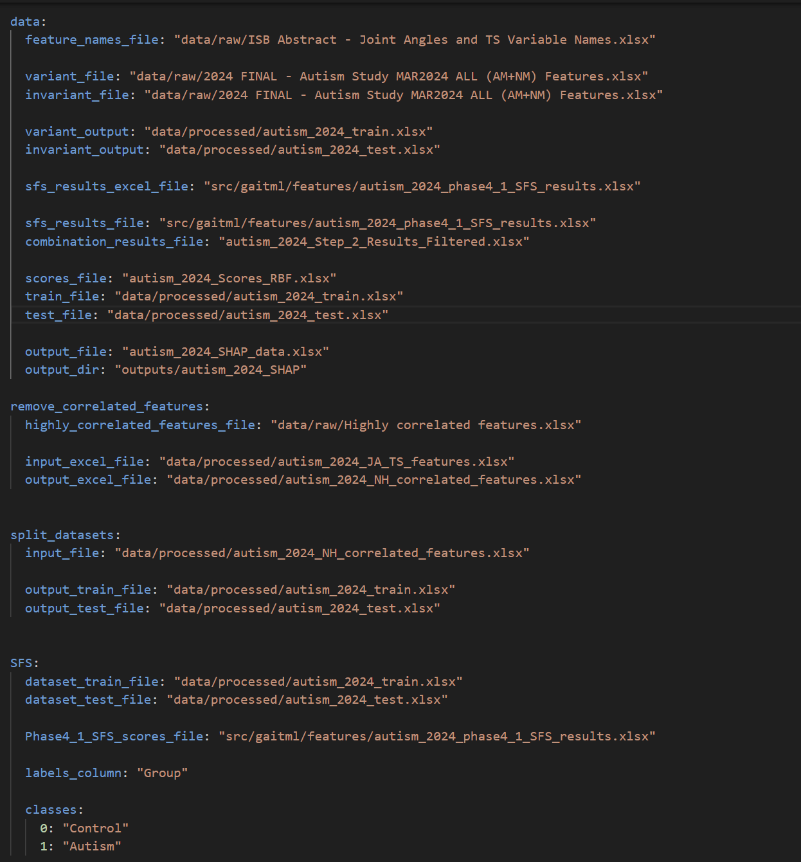

It was mainly prepared for a previous dataset, so I created separate configuration files to avoid mixing paths between studies and to keep the original setup safer.
I created two dataset-specific config files:
- config_autism_2024.yaml
- config_young_old_2024.yaml

The reason for separating them is that Autism 2024 and Young vs Older 2024 use different input files, output file names, and group labels.
For Autism 2024:
- Input file: 2024 FINAL - Autism Study MAR2024 ALL (AM+NM) Features.xlsx
- Group labels: Control and Autism
- Encoding used later in the ML steps: Control = 0, Autism = 1
For Young vs Older 2024:
- Input file: 2024 ALL Post-Processing Speeds Young and Older Adults ALL Features - FINAL AUGUST 20.xlsx
- Group labels: Young and Older
- Encoding used later in the ML steps: Young = 0, Older = 1
During the workflow, I updated config.yaml depending on which dataset and which phase I was running. This was important because some later phases use different fields from the config file. For example, Phase 1 uses the raw input and JA/TS output paths, while Phase 4.2 and Phase 4.3 use the train/test files, SFS results, filtered model combinations, and RBF score files.

Configuration note

I updated config.yaml depending on the dataset and phase being run. Phase 1 uses the raw input and JA/TS paths, while later phases use train/test files, SFS results, filtered model combinations, and RBF score files.

4. Understanding of Each Step and Result

Phase 1 - Feature Review / JA and TS Filtering
Item | Summary
Purpose | Keep the selected Joint Angle and Temporal-Spatial features from the original dataset.
Autism 2024 | The raw Autism file was filtered and produced an Autism JA/TS feature file. The output had fewer columns than the raw file, which means the filtering step worked.  At the first we have 260 columns and after phase 1 we have 118 columns
Young vs Older 2024 | Only the Young vs Older Post-Processing file was used. The processed JA/TS feature file was created from that file.  At the first we have 260 columns and after phase 1 we have 118 columns
Output / result | Autism: autism_2024_JA_TS_features.xlsx.  Young vs Older: young_old_2024_JA_TS_features.xlsx.
My understanding | This phase prepares the dataset before ML. It does not train a model; it only keeps the features that should enter the next cleaning step.
Step-wise Results / Notes

Autism 2024:
- Input file: 2024 FINAL - Autism Study MAR2024 ALL (AM+NM) Features.xlsx
- Initial number of columns: 260
- Output file: autism_2024_JA_TS_features.xlsx
autism_2024_JA_TS_features.xlsx

- Number of columns after Phase 1: 118
- Features kept: Joint Angle and Temporal-Spatial features
- Features removed: Features outside the selected JA/TS feature list
- My note: This step reduced the dataset to the main biomechanical features needed for the ML pipeline.

Young vs Older 2024:
- Input file: 2024 ALL Post-Processing Speeds Young and Older Adults ALL Features - FINAL AUGUST 20.xlsx
- Initial number of columns: 260
- Output file: young_old_2024_JA_TS_features.xlsx
young_old_2024_JA_TS_features.xlsx
- Number of columns after Phase 1: 118
- Features kept: Joint Angle and Temporal-Spatial features
- Features removed: Features outside the selected JA/TS feature list
So the features dropped are: 142
Phase 1 Dropped Features
Phase 1 reduced the dataset from 260 columns to 118 columns. Total features dropped: 142.
Feature list 1 | Feature list 2 | Feature list 3 | Feature list 4
1. Moment_A1S | 2. Moment_A1S_time | 3. Power_A2S | 4. Power_A2S_time
5. Moment_H1S | 6. Moment_H1S_time | 7. Power_H1S | 8. Power_H1S_time
9. Moment_H2S | 10. Moment_H2S_time | 11. Power_H2S | 12. Power_H2S_time
13. Moment_H3S | 14. Moment_H3S_time | 15. Power_H3S | 16. Power_H3S_time
17. Moment_H1F | 18. Moment_H1F_time | 19. Moment_H2F | 20. Moment_H2F_time
21. Power_K0S | 22. Power_K0S_time | 23. Moment_K1S | 24. Moment_K1S_time
25. Power_K1S | 26. Power_K1S_time | 27. Moment_K2S | 28. Moment_K2S_time
29. Power_K2S | 30. Power_K2S_time | 31. Moment_K3S | 32. Moment_K3S_time
33. Power_K3S | 34. Power_K3S_time | 35. Power_K4S | 36. Power_K4S_time
37. Planar_Time_to_OTO | 38. Planar_Time_to_OHS | 39. Planar_Time_to_TO | 40. Time_to_OTO
41. Time_to_OHS | 42. Time_to_TO | 43. F2G_ROM | 44. F2Ps_ROM
45. S2F_ROM | 46. S2G_ROM | 47. S2V_ROM | 48. V2G_ROM
49. F2Pt_ROM | 50. MLA_ROM | 51. Cal_Met_Angle_X_ROM | 52. Cal_Met_Angle_Y_ROM
53. Cal_Met_Angle_Z_ROM | 54. Cal_Mid_Angle_X_ROM | 55. Cal_Mid_Angle_Y_ROM | 56. Cal_Mid_Angle_Z_ROM
57. Mid_Met_Angle_X_ROM | 58. Mid_Met_Angle_Y_ROM | 59. Mid_Met_Angle_Z_ROM | 60. Sha_Cal_Angle_X_ROM
61. Sha_Cal_Angle_Y_ROM | 62. Sha_Cal_Angle_Z_ROM | 63. Sha_Cal_Angle_X_HS | 64. Sha_Cal_Angle_Y_HS
65. Sha_Cal_Angle_Z_HS | 66. Sha_Cal_Angle_X_OTO | 67. Sha_Cal_Angle_Y_OTO | 68. Sha_Cal_Angle_Z_OTO
69. Sha_Cal_Angle_X_OHS | 70. Sha_Cal_Angle_Y_OHS | 71. Sha_Cal_Angle_Z_OHS | 72. Sha_Cal_Angle_X_TO
73. Sha_Cal_Angle_Y_TO | 74. Sha_Cal_Angle_Z_TO | 75. Mid_Met_Angle_X_HS | 76. Mid_Met_Angle_Y_HS
77. Mid_Met_Angle_Z_HS | 78. Mid_Met_Angle_X_OTO | 79. Mid_Met_Angle_Y_OTO | 80. Mid_Met_Angle_Z_OTO
81. Mid_Met_Angle_X_OHS | 82. Mid_Met_Angle_Y_OHS | 83. Mid_Met_Angle_Z_OHS | 84. Mid_Met_Angle_X_TO
85. Mid_Met_Angle_Y_TO | 86. Mid_Met_Angle_Z_TO | 87. Cal_Met_Angle_X_HS | 88. Cal_Met_Angle_Y_HS
89. Cal_Met_Angle_Z_HS | 90. Cal_Met_Angle_X_OTO | 91. Cal_Met_Angle_Y_OTO | 92. Cal_Met_Angle_Z_OTO
93. Cal_Met_Angle_X_OHS | 94. Cal_Met_Angle_Y_OHS | 95. Cal_Met_Angle_Z_OHS | 96. Cal_Met_Angle_X_TO
97. Cal_Met_Angle_Y_TO | 98. Cal_Met_Angle_Z_TO | 99. Cal_Mid_Angle_X_HS | 100. Cal_Mid_Angle_Y_HS
101. Cal_Mid_Angle_Z_HS | 102. Cal_Mid_Angle_X_OTO | 103. Cal_Mid_Angle_Y_OTO | 104. Cal_Mid_Angle_Z_OTO
105. Cal_Mid_Angle_X_OHS | 106. Cal_Mid_Angle_Y_OHS | 107. Cal_Mid_Angle_Z_OHS | 108. Cal_Mid_Angle_X_TO
109. Cal_Mid_Angle_Y_TO | 110. Cal_Mid_Angle_Z_TO | 111. F2G_HS | 112. F2G_OTO
113. F2G_OHS | 114. F2G_TO | 115. F2Ps_HS | 116. F2Ps_OTO
117. F2Ps_OHS | 118. F2Ps_TO | 119. F2Pt_HS | 120. F2Pt_OTO
121. F2Pt_OHS | 122. F2Pt_TO | 123. MLA_HS | 124. MLA_OTO
125. MLA_OHS | 126. MLA_TO | 127. S2F_HS | 128. S2F_OTO
129. S2F_OHS | 130. S2F_TO | 131. S2G_HS | 132. S2G_OTO
133. S2G_OHS | 134. S2G_TO | 135. S2V_HS | 136. S2V_OTO
137. S2V_OHS | 138. S2V_TO | 139. V2G_HS | 140. V2G_OTO
141. V2G_OHS | 142. V2G_TO

Phase 2 - Remove Highly Correlated Features

Item | Summary
Purpose | Remove redundant features based on the highly correlated feature list.
Autism 2024 | The important point for Autism was to make sure Phase 2 uses the Phase 1 JA/TS file, not the raw Autism file. When the raw file was used by mistake, the output had more columns than expected. After correcting the config, the phase continued from the JA/TS output.  At the first we have 118 columns and after phase 2 we have 86 columns
Young vs Older 2024 | The Young vs Older JA/TS file was used as input, and the non-highly-correlated output file was generated.  At the first we have 118 columns and after phase 2 we have 86 columns
Output / result | Autism: autism_2024_NH_correlated_features.xlsx.  Young vs Older: young_old_2024_NH_correlated_features.xlsx.
My understanding | This phase reduces redundancy. Features removed here should still be confirmed with the team before they are treated as permanently dropped.
Step-wise Results / Notes

Autism 2024:
- Input file: autism_2024_JA_TS_features.xlsx
- Initial number of columns: 118
- Output file: autism_2024_NH_correlated_features.xlsx

autism_2024_NH_correlated_features.xlsx
- Number of columns after Phase 2: 86
Young vs Older 2024:
- Input file: young_old_2024_JA_TS_features.xlsx
- Initial number of columns: 118
- Output file: young_old_2024_NH_correlated_features.xlsx
young_old_2024_NH_correlated_features.xlsx
- Number of columns after Phase 2: 86

Dropped features: 32
Feature list 1 | Feature list 2 | Feature list 3 | Feature list 4
1. Hip_Angle_X_MIN_SW_time | 2. Stride_Length | 3. Speed | 4. Stance_Time
5. ND_DOUBLE_LIMB_SUPPORT_TIME | 6. ND_SPEED | 7. ND_STEP_LENGTH | 8. ND_STANCE_TIME
9. ND_STEPS_PER_MINUTE | 10. ND_STRIDE_LENGTH | 11. ND_SWING_TIME | 12. Trunk_Angle_Y_ROM
13. Hip_Angle_X_ROM | 14. Pelv_Angle_Y_HS | 15. Pelv_Angle_Z_HS | 16. Pelv_Angle_X_OTO
17. Pelv_Angle_X_OHS | 18. Pelv_Angle_X_TO | 19. Pelv_Angle_Y_TO | 20. Trunk_Angle_Z_HS
21. Trunk_Angle_X_OTO | 22. Trunk_Angle_X_OHS | 23. Trunk_Angle_Z_OHS | 24. Trunk_Angle_X_TO
25. Trunk_Angle_Y_TO | 26. Trunk_Angle_Z_TO | 27. Hip_Angle_X_HS | 28. Hip_Angle_X_OTO
29. Hip_Angle_X_OHS | 30. Hip_Angle_X_TO | 31. Hip_Angle_Y_TO | 32. Hip_Angle_Z_TO

Phase 3 - Train/Test Split
Item | Summary
Purpose | Split the cleaned dataset into train and test files. 80% train and 20%test
Autism 2024 | The Autism non-highly-correlated file was split into training and testing files.
Young vs Older 2024 | The Young vs Older non-highly-correlated file was split into training and testing files.
Output / result | Autism: autism_2024_train.xlsx and autism_2024_test.xlsx.  Young vs Older: young_old_2024_train.xlsx and young_old_2024_test.xlsx.
My understanding | The train set is used for feature/model selection. The test set is kept for evaluating model performance.

Step-wise Results / Notes
Autism 2024:
- Input file: autism_2024_NH_correlated_features.xlsx
- Output train file: autism_2024_train.xlsx
autism_2024_train.xlsx

- Output test file: autism_2024_test.xlsx
autism_2024_test.xlsx
- Split used: 80% train and 20% test
- My note: This step prepared the cleaned Autism dataset for model training and evaluation. The train file is used for feature/model selection, while the test file is used to check model performance on unseen data.

Young vs Older 2024:
- Input file: young_old_2024_NH_correlated_features.xlsx
- Output train file: young_old_2024_train.xlsx
young_old_2024_train.xlsx

- Output test file: young_old_2024_test.xlsx
young_old_2024_test.xlsx
- Split used: 80% train and 20% test
- My note: This step prepared the cleaned Young vs Older dataset for the ML phases. The split keeps the evaluation separate from the training process.

Phase 4.1 - SFS Feature Selection
Item | Summary
Purpose | Use Sequential Feature Selection to identify useful feature subsets for the model.
Autism 2024 | SFS ran for Autism and produced the Autism SFS results file.
Young vs Older 2024 | SFS ran for Young vs Older and produced the Young vs Older SFS results file.
Output / result | Autism: autism_2024_phase4_1_SFS_results.xlsx.  Young vs Older: young_old_2024_phase4_1_SFS_results.xlsx.
My understanding | This step gives candidate feature orders/subsets that are then used to build model combinations.

Step-wise Results / Notes

Autism 2024:
- Input files:
- autism_2024_train.xlsx
- autism_2024_test.xlsx
- Output file: autism_2024_phase4_1_SFS_results.xlsx

autism_2024_phase4_1_SFS_results.xlsx

- Purpose: identify ordered candidate feature subsets using Sequential Feature Selection.
- My note: This step does not choose the final model yet. It prepares ranked feature combinations that will be tested in Phase 4.2.

Young vs Older 2024:
- Input files:
- young_old_2024_train.xlsx
- young_old_2024_test.xlsx
- Output file: young_old_2024_phase4_1_SFS_results.xlsx
young_old_2024_phase4_1_SFS_results.xlsx
- Purpose: identify ordered candidate feature subsets using Sequential Feature Selection.
- My note: The SFS output is used as the base for generating model combinations in the next step.

Phase 4.2 - Model Combinations
Item | Summary
Purpose | Generate and evaluate many SVM/RBF model combinations using the SFS feature subsets.
Autism 2024 | The Autism Step 2 result file was generated and filtered. The best CV accuracy I observed was around 0.83, so the 0.90 threshold was too strict for this dataset. I used a lower threshold and filtered by number of features, test accuracy, and sensitivity.
Young vs Older 2024 | The Young vs Older Step 2 result file was also generated and filtered using the same logic.
Output / result | Autism: autism_2024_Step_2_Results_Filtered.xlsx.  Young vs Older: young_old_2024_Step_2_Results_Filtered.xlsx.
My understanding | This phase creates many candidate models. Filtering is needed before moving forward so that weak or irrelevant models do not dominate later interpretation.

Step-wise Results / Notes
Autism 2024:
- Input files:
- autism_2024_train.xlsx
- autism_2024_test.xlsx
- autism_2024_phase4_1_SFS_results.xlsx
- Output file: autism_2024_Step_2_Results_Filtered.xlsx
autism_2024_Step_2_Results_Filtered.xlsx

- Purpose: test many SVM/RBF model combinations using the feature subsets from SFS.
- Filtering decision: The original threshold CV_Accuracy >= 0.90 was too high for Autism because the best CV_Accuracy was around 0.83. I lowered the threshold to keep meaningful candidate models.
- Model selection criteria used:
- CV_Accuracy
- Test_Accuracy
- Sensitivity
- #Features
- My note: This step helps shortlist candidate models before final scoring. For Autism, I had to adjust the filtering threshold based on the actual results instead of forcing 0.90.

Young vs Older 2024:
- Input files:
- young_old_2024_train.xlsx
- young_old_2024_test.xlsx
- young_old_2024_phase4_1_SFS_results.xlsx
- Output file: young_old_2024_Step_2_Results_Filtered.xlsx

young_old_2024_Step_2_Results_Filtered.xlsx
- Purpose: generate and evaluate SVM/RBF model combinations using the SFS feature subsets.
- Model selection criteria used:
- CV_Accuracy
- Test_Accuracy
- Sensitivity
- #Features
- My note: I applied the same filtering logic to keep the strongest candidate models for the next scoring step.

Code adjustment note:
- In get_model_combinations_with_accuracy.py, I updated the Group label encoding so the model could work with both datasets.
- For Autism, the labels were mapped as Control = 0 and Autism = 1.
- For Young vs Older, the labels were mapped as Young = 0 and Older = 1.
- I also cleaned label text using .str.strip() and added a check for unmapped labels.
RESULTS:
results/_Step_2_Results_Filtered.xlsx.xlsx

FOR AUTISM :
-5 best model for autism
-best model for 5 features:
-best model for 6 features:
-best model for 10 features:
-best model for 15 features:

FOR YOUNG /OLD :
-5 best model
-best model for 5 features:
-best model for 6 features:
-best model for 10 features:
-best model for 15 features:

Phase 4.3 - RBF Scores
Item | Summary
Purpose | Use the filtered Step 2 results to calculate the final RBF score table.
Autism 2024 | The Autism Scores RBF file was generated successfully.
Young vs Older 2024 | The Young vs Older Scores RBF file was generated successfully.
Output / result | Autism: autism_2024_Scores_RBF.xlsx.  Young vs Older: young_old_2024_Scores_RBF.xlsx.
My understanding | This file helps shortlist the strongest models using performance scores such as CV accuracy, test accuracy, and sensitivity.

Output : autism_2024_Scores_RBF.xlsx. Young vs Older:
autism_2024_Scores_RBF.xlsx

output: young_old_2024_Scores_RBF.xlsx.
young_old_2024_Scores_RBF.xlsx

FOR AUTISM :
-5 best model for autism
-best model for 5 features:
num features
;28,4,36,21,30
-best model for 6 features:
-best model for 10 features:
-best model for 15 features:

Phase 4.4 - SHAP Interpretability
Item | Summary
Purpose | Explain the selected models and identify which features contribute most to model decisions.
Autism 2024 | SHAP was started for Autism. I fixed/handled setup issues such as installing SHAP, sheet naming expected by the code, and numeric group encoding. The run then started, but it attempted to process 4,191 models, which would take a very long time.
Young vs Older 2024 | Young vs Older SHAP has not been finalized yet. It should be run after the team confirms how many top models should be selected.
Output / result | Expected outputs: SHAP Excel data and SHAP plots for selected models.
My understanding | SHAP should probably be run only on the top selected models, such as top 3 or top 5, instead of all models. I asked Karansinh and Ashirbad to confirm this.

5. Main Files Generated So Far
Dataset | Generated files
Autism 2024 | autism_2024_JA_TS_features.xlsx  autism_2024_NH_correlated_features.xlsx  autism_2024_train.xlsx  autism_2024_test.xlsx  autism_2024_phase4_1_SFS_results.xlsx  autism_2024_Step_2_Results_Filtered.xlsx  autism_2024_Scores_RBF.xlsx
Young vs Older 2024 | young_old_2024_JA_TS_features.xlsx  young_old_2024_NH_correlated_features.xlsx  young_old_2024_train.xlsx  young_old_2024_test.xlsx  young_old_2024_phase4_1_SFS_results.xlsx  young_old_2024_Step_2_Results_Filtered.xlsx  young_old_2024_Scores_RBF.xlsx

6. Current Notes and Issues
- The original config file was not fully prepared for the two current datasets, so I had to update paths carefully depending on the phase and dataset.
- For Autism, the Phase 4.2 filtering showed that 0.90 was too strict because the best CV accuracy was around 0.83. I adjusted the filtering threshold to keep meaningful candidate models.

7. Current Interpretation
Both datasets successfully reached Phase 4.3. This means the pipeline can process the raw datasets, filter features, remove redundant features, split data, run SFS, generate model combinations, and calculate RBF scores.

8. Next Steps
- Run Phase 4.4 SHAP for Autism and Young vs Older using only the approved selected models.
- Prepare SHAP feature ranking tables and plots.
- Summarize which features are important, which features look redundant, and which decisions need team confirmation before dropping features.

Jun 2, 2026

XGBoost Pipeline Update

Dataset: Young vs Older 2024 Dataset

Today, I started working on an experimental version of the ML pipeline using XGBoost instead of the original SVM RBF model. The goal was to compare the performance of XGBoost with the existing SVM pipeline, while keeping the original SVM files unchanged.
First, I created a separate copy of the project folder named Gait-ML-Shap-main_y_Mohamed. This allowed me to safely modify and test the XGBoost version without affecting the original SVM pipeline.
Then, I created a new pipeline folder for XGBoost and started preparing separate files for the new model. I also added new output paths in the config.yaml file config.yaml

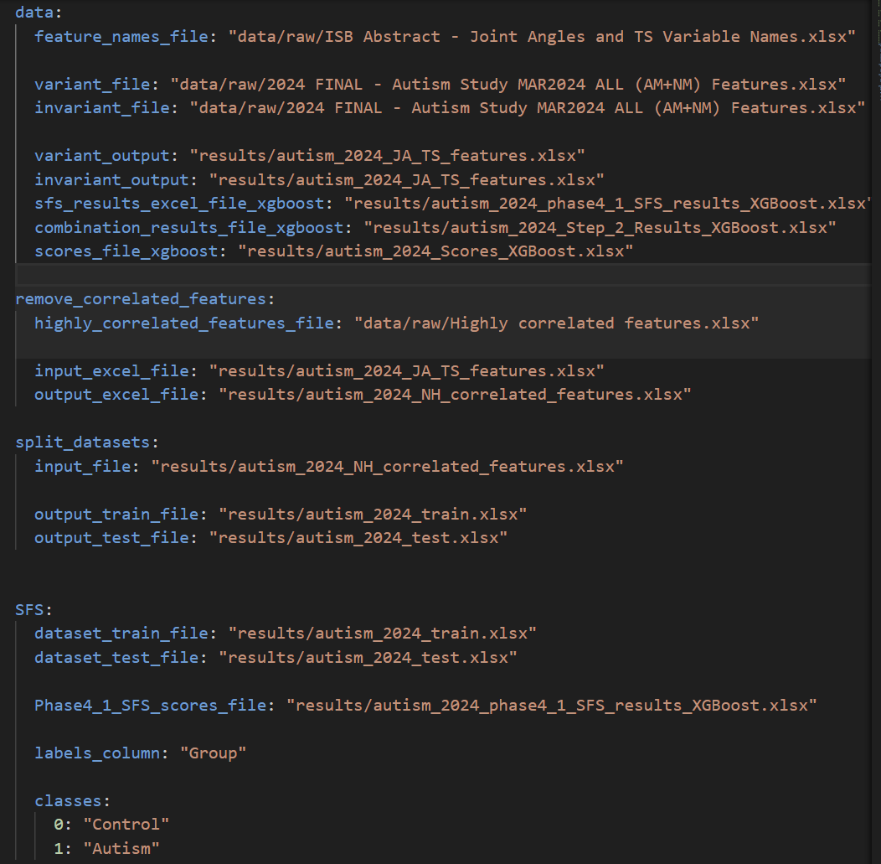

- To avoid changing the original configuration directly, I organized the configuration into separate files. I kept the original `config.yaml` as the general/default config, then created two additional config files: one for Autism 2024 and one for Young vs Older 2024.

The reason for doing this is that each dataset has different input files, output names, class labels, and generated results. For example, Autism uses `Control` and `Autism` as groups, while Young vs Older uses `Young` and `Older`. So having separate config files makes the workflow cleaner and reduces the risk of mixing paths between datasets.

The two new config files are:
- config_autism_2024.yaml
- config_young_old_2024.yaml

When I want to run the pipeline for a specific dataset, I use the corresponding config values for that dataset. This helped me run the same pipeline structure for both datasets while keeping the original setup safe and easier to track.

XGBoost Model-Combination Search Space
Parameter | Values tested
Number of selected features | 5 to 19
n_estimators | 50, 100, 150
max_depth | 2, 3, 4
learning_rate | 0.01, 0.05, 0.1
subsample | 0.8, 1.0
colsample_bytree | 0.8, 1.0
Cross-validation | 10-fold cross-validation

Early comparison
Early results showed XGBoost reaching around 0.95 CV accuracy, while the best SVM RBF CV accuracy was around 0.93. This suggests that XGBoost may be promising, but the final decision should use complete metrics: test accuracy, sensitivity, specificity, F1 score, and MCC.

This creates many model combinations, so Phase 4.2 takes a long time to run. While it was running, I observed that the process was progressing through different Feature_idx values and different numbers of selected features.
I also compared the early results with the original SVM RBF model. The best CV accuracy observed with XGBoost reached around 0.95, while the best CV accuracy from the SVM RBF model was around 0.93. This suggests that XGBoost may be promising, but the final decision should depend on the complete results, including test accuracy, sensitivity, specificity, F1 score, and MCC.
At the end of the day, I stopped while Phase 4.2 was still running/completing the XGBoost model combinations.
Output files created/planned:
1- results/young_old_2024_JA_TS_features.xlsx young_old_2024_JA_TS_features.xlsx
2- results/young_old_2024_NH_correlated_features.xlsx
young_old_2024_NH_correlated_features.xlsx
3- results/young_old_2024_train.xlsx young_old_2024_train.xlsx
4- results/young_old_2024_test.xlsx young_old_2024_test.xlsx
5- results/young_old_2024_phase4_1_SFS_results_XGBoost.xlsx
young_old_2024_phase4_1_SFS_results_XGBoost.xlsx
6- results/young_old_2024_Step_2_Results_XGBoost.xlsx young_old_2024_Step_2_Results_XGBoost.xlsx
7- results/young_old_2024_Scores_XGBoost.xlsx young_old_2024_Scores_XGBoost.xlsx
RESULTS:
results/2024_Step_2_Results_XGBoost.xlsx
FOR AUTISM :
-5 best model for autism
-best model for 5 features:
-best model for 6 features:
-best model for 10 features:
-best model for 15 features:
FOR YOUNG /OLD :
-5 best model
-best model for 5 features:
-best model for 6 features:
-best model for 10 features:
-best model for 15 features:

Jun 5, 2026

Today, I helped Ben with the V3D work. Most of the day was focused on verifying the diabetics dataset and checking that the data was correct before continuing with the analysis.

The main task was to review the V3D-exported data carefully and make sure the dataset structure, feature values, and organization were consistent. This step is important because any issue in the raw or exported data can affect the later ML pipeline results.
The priority was to support Ben and make sure the diabetics data was ready and reliable for the next steps.

Jun 8, 2026

SHAP Analysis, XGBoost Comparison, MLflow Tracking, and Time-Variable Raw Data Check

starting from the SVM SHAP review, continuing with the XGBoost SHAP implementation and MLflow logging, and ending with the raw-data/statistics/scatter-plot validation for time-related top features.

Main area | What was done | Main outputs
SVM Top 3 / SHAP | Reviewed the existing Top 3 SVM/RBF models and their SHAP results. | SVM top features and SHAP plots for Young/Old and Autism.
XGBoost Top 3 | Created/used Top 3 XGBoost model files after sorting by CV_accuracy, Test_Accuracy, and Sensitivity. | young_old_2024_Scores_XGBoost_Top3.xlsx and autism_2024_Scores_XGBoost_Top3.xlsx.
XGBoost SHAP | Implemented a modular XGBoost SHAP workflow and generated SHAP outputs. | XGBoost SHAP Excel files and summary plot PNGs.
MLflow | Logged XGBoost artifacts, metrics, and SHAP plots. | Autism and Young/Old MLflow runs.
Raw-data check | Checked top time-related features using descriptive statistics and scatter plots. | SVM and XGBoost time-variable stats files and scatter plots.
Discussion with Dr. Vicky | Prepared a short explanation for why XGBoost features differ from SVM. | Short summary message for Slack/discussion.

1. Starting Point and Objective
The work started from the need to analyze the best models and top features for both datasets. The goal was not only to identify high-performing models, but also to understand whether the features selected by the models are meaningful in the raw biomechanical data.
· Dataset 1: Young vs Older 2024.
· Dataset 2: Autism 2024.
· Models compared: SVM/RBF and XGBoost.
· Main validation focus requested by Dr. Vicky: raw data and statistics for the time-related variables among the top features.

2. Top 3 Model / Top Feature File Preparation
Before running SHAP or raw-data checks, the best models had to be identified. The Top 3 files were created by sorting the score files using the following priority:
1. CV_accuracy
2. Test_Accuracy
3. Sensitivity
This sorting strategy was used to keep the strongest models first, while also considering both cross-validation performance and test-set behavior.
1-
autism_2024_Scores_RBF_Top3.xlsx
young_old_2024_Scores_RBF_Top3.xlsx
2-
autism_2024_Scores_XGBoost_Top3.xlsx

young_old_2024_Scores_XGBoost_Top3.xlsx

Model type | Dataset | Top 3 input score file | Top 3 output file
SVM/RBF | Young vs Older | young_old_2024_Scores_RBF.xlsx | young_old_2024_Scores_RBF_Top3.xlsx
SVM/RBF | Autism | autism_2024_Scores_RBF.xlsx | autism_2024_Scores_RBF_Top3.xlsx
XGBoost | Young vs Older | results/young_old_2024_Scores_XGBoost.xlsx | results/young_old_2024_Scores_XGBoost_Top3.xlsx
XGBoost | Autism | results/autism_2024_Scores_XGBoost.xlsx | results/autism_2024_Scores_XGBoost_Top3.xlsx

Important implementation detail
For XGBoost, the selected features were stored as feature indices in the Features column. These indices were converted back into feature names using the feature columns from the train/test files.

3. SVM/RBF SHAP Analysis
The SVM/RBF SHAP analysis was reviewed first because it was the existing reference pipeline. The Top 3 SVM models were used to identify the most important features in the best SVM/RBF models.
· For Young vs Older, the label mapping is Young = 0 and Older = 1.
· For Autism, the label mapping is Control = 0 and Autism = 1.
· The SHAP bar plots show mean absolute SHAP values, so they represent feature importance magnitude rather than direction.
· The top SVM features were then used to identify features containing _time.
The purpose of this step was to know which time variables should be checked in the raw data and in scatter plots.

4. XGBoost SHAP Implementation
After the SVM SHAP review, the same type of SHAP analysis was implemented for XGBoost. The initial code was large, so it was separated into a clean pipeline file and a reusable model utility file.
File | Role
pipelines_xgboost/phase4_4_SHAP_XGBoost.py | Small runner file. It reads config.yaml and calls the XGBoost SHAP function.
src/gaitml/models/get_SHAP_data_XGBoost.py | Main SHAP logic. It reads the Top 3 file, trains XGBoost models, calculates SHAP values, creates Excel outputs, and saves SHAP summary plots.

This structure made the pipeline easier to maintain and closer to the style of the existing SVM pipeline.

Model type | Dataset | Top 3 input score file | Top 3 output file
SVM/RBF | Young vs Older | young_old_2024_Scores_RBF.xlsx | young_old_2024_Scores_RBF_Top3.xlsx
SVM/RBF | Autism | autism_2024_Scores_RBF.xlsx | autism_2024_Scores_RBF_Top3.xlsx
XGBoost | Young vs Older | results/young_old_2024_Scores_XGBoost.xlsx | results/young_old_2024_Scores_XGBoost_Top3.xlsx
XGBoost | Autism | results/autism_2024_Scores_XGBoost.xlsx | results/autism_2024_Scores_XGBoost_Top3.xlsx

Important implementation detail
For XGBoost, the selected features were stored as feature indices in the Features column. These indices were converted back into feature names using the feature columns from the train/test files.

3. SVM/RBF SHAP Analysis
The SVM/RBF SHAP analysis was reviewed first because it was the existing reference pipeline. The Top 3 SVM models were used to identify the most important features in the best SVM/RBF models.
· For Young vs Older, the label mapping is Young = 0 and Older = 1.
· For Autism, the label mapping is Control = 0 and Autism = 1.
· The SHAP bar plots show mean absolute SHAP values, so they represent feature importance magnitude rather than direction.
· The top SVM features were then used to identify features containing _time.
The purpose of this step was to know which time variables should be checked in the raw data and in scatter plots.

4. XGBoost SHAP Implementation
After the SVM SHAP review, the same type of SHAP analysis was implemented for XGBoost. The initial code was large, so it was separated into a clean pipeline file and a reusable model utility file.
File | Role
pipelines_xgboost/phase4_4_SHAP_XGBoost.py | Small runner file. It reads config.yaml and calls the XGBoost SHAP function.
src/gaitml/models/get_SHAP_data_XGBoost.py | Main SHAP logic. It reads the Top 3 file, trains XGBoost models, calculates SHAP values, creates Excel outputs, and saves SHAP summary plots.
This structure made the pipeline easier to maintain and closer to the style of the existing SVM pipeline.

4.2 XGBoost SHAP Outputs
XGBoost
Dataset | Top 3 XGBoost models | SHAP Excel output | SHAP plot examples
Young vs Older | 10833, 10844, 10823 | output-young_old/young_old_2024_SHAP_data_XGBoost.xlsx | SHAP_XGBoost_10823_summary.png, SHAP_XGBoost_10833_summary.png, SHAP_XGBoost_10844_summary.png
Autism | 4021, 3985, 8542 | output-autism/autism_2024_SHAP_data_XGBoost.xlsx | SHAP_XGBoost_3985_summary.png, SHAP_XGBoost_4021_summary.png, SHAP_XGBoost_8542_summary.png

output-young_old
RESULTS: SVM
FOR YOUNG /OLD :
Name_Model:7603
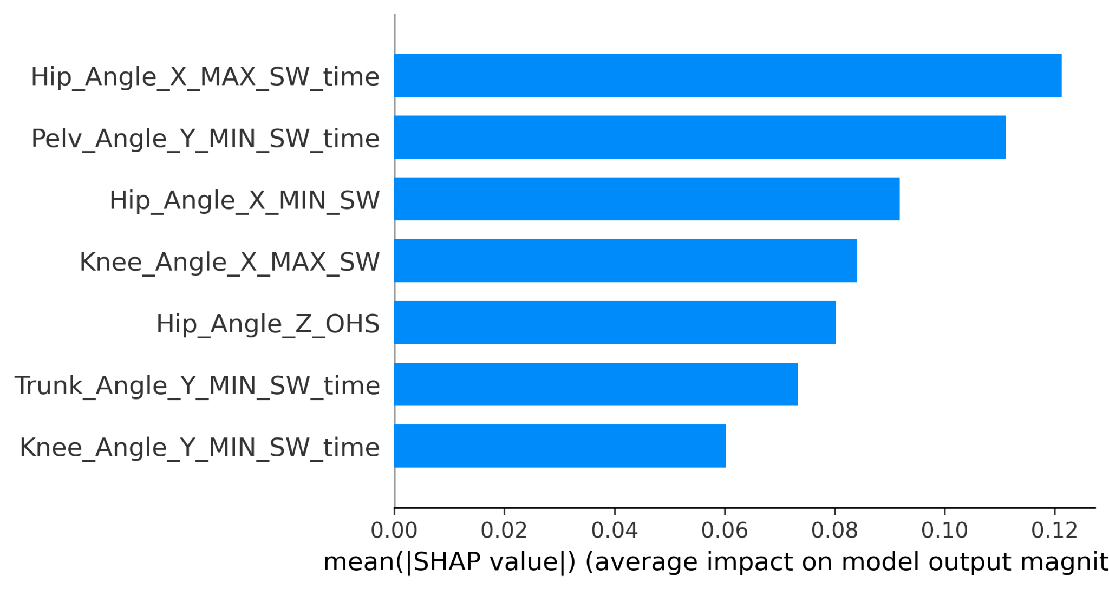
Name_Model:7610


Name_Model:7617


output-young_old
RESULTS: XGboost
FOR YOUNG /OLD :
Name_Model:823
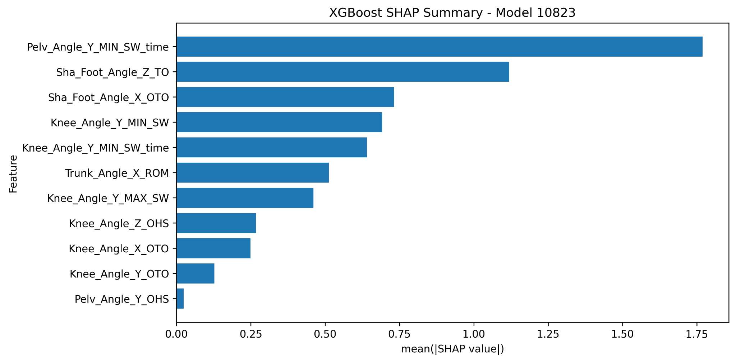

Name_Model:833
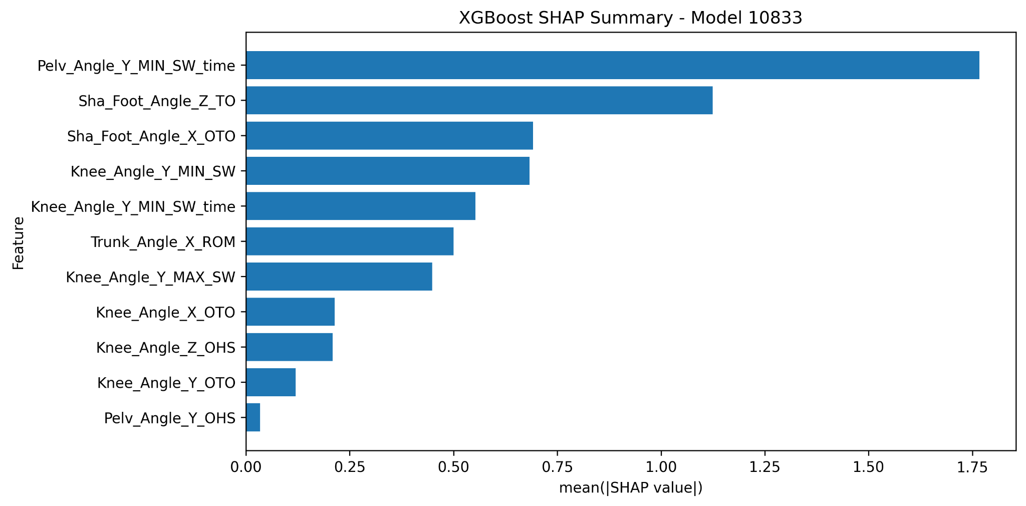

Name_Model:844
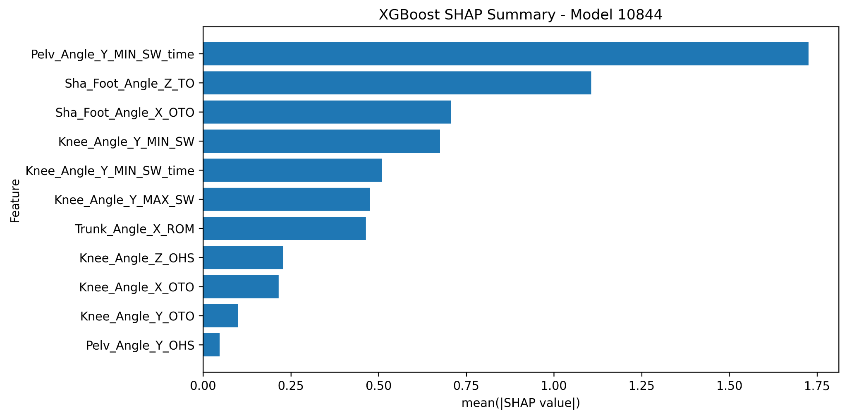

5. MLflow Logging
I also added MLflow tracking for the SVM and XGBoost results.
For Autism, the following files were logged successfully:
- configs/config.yaml
- results/autism_2024_JA_TS_features.xlsx
- results/autism_2024_NH_correlated_features.xlsx
- results/autism_2024_train.xlsx
- results/autism_2024_test.xlsx
- results/autism_2024_phase4_1_SFS_results_XGBoost.xlsx
- results/autism_2024_Step_2_Results_XGBoost.xlsx
- results/autism_2024_Scores_XGBoost.xlsx
- results/autism_2024_Scores_XGBoost_Top3.xlsx
- output-autism/autism_2024_SHAP_data_XGBoost.xlsx

6. SVM Time-Variable Raw Data and Statistics Check
Dr. Vicky asked to check the raw data and statistics on the time variables for the top features. To do this, the time-related features were extracted from the SVM Top 3 model files, and the raw processed train/test data was used to calculate descriptive statistics and create scatter plots.
Dataset | SVM time-related top features
Young vs Older | Hip_Angle_X_MAX_SW_time; Knee_Angle_Y_MIN_SW_time; Pelv_Angle_Y_MIN_SW_time; Trunk_Angle_Y_MIN_SW_time
Autism | Double_Limb_Support_Time; Knee_Angle_X_MAX_SW_time; Knee_Angle_Y_MAX_SW_time; Pelv_Angle_Y_MAX_SW_time; Trunk_Angle_Y_MAX_SW_time; Trunk_Angle_Z_MIN_SW_time

For each feature, the following statistics were calculated by group:
· Count
· Mean
· Standard deviation
· Median
· Minimum
· Maximum
· Q1
· Q3
· IQR
Output file | Content
young_old_2024_SVM_time_variable_stats.xlsx | Raw values, descriptive statistics, top time features, model-feature mapping, and potential outliers.
autism_2024_SVM_time_variable_stats.xlsx | Raw values, descriptive statistics, top time features, model-feature mapping, and potential outliers.

7. SVM Scatter Plots and Interpretation
Scatter plots were created because statistics alone give numbers, but scatter plots visually show whether the raw values look reasonable. In each scatter plot:
· X-axis = group
· Y-axis = raw value for the time feature
· Each dot = one sample
· Horizontal line = group mean
The scatter plots helped check whether the groups show visible differences, whether they overlap, and whether a few extreme values might be influencing the model. They are saved in these folders:
I created them to validate the raw values behind the top time-related features. The scatter plots help show whether the feature values look reasonable, whether the groups overlap, and whether outliers or missing values may affect the model.

young_old_2024_SVM_time_variable_plots
autism_2024_SVM_time_variable_plots
SVM Young/Old scatter plots: young_old_2024_SVM_time_variable_plots/
SVM Autism scatter plots: autism_2024_SVM_time_variable_plots/
Stats files: young_old_2024_SVM_time_variable_stats.xlsx andautism_2024_SVM_time_variable_stats.xlsx

8. XGBoost Time-Variable Raw Data and Statistics Check
The same raw-data validation was then performed for XGBoost. This was important because Dr. Vicky asked why the XGBoost model had different features compared to SVM.
The XGBoost Top 3 files were used to extract time-related features. Compared to SVM, XGBoost selected fewer time-related features. In the Young vs Older XGBoost results, only a small number of time features were found, such as Pelv_Angle_Y_MIN_SW_time and Knee_Angle_Y_MIN_SW_time. This suggests that XGBoost may rely more on other biomechanical variables and less on time variables overall.
Output file | Purpose
young_old_2024_XGBoost_time_variable_stats.xlsx | Statistics and raw-data check for XGBoost time-related features in Young vs Older.
autism_2024_XGBoost_time_variable_stats.xlsx | Statistics and raw-data check for XGBoost time-related features in Autism.

The XGBoost scatter plots were created using the same approach as SVM, so the results could be compared visually between both model types.

9. Why XGBoost and SVM Selected Different Features
Dr. Vicky asked for a short summary explaining why the XGBoost model selected different features compared to SVM. The main interpretation is that the two algorithms learn from the data in different ways.
Model | How it learns | Why selected features can differ
SVM/RBF | Tries to find one smooth nonlinear boundary between the groups. | It selects features that help create the overall smooth separation.
XGBoost | Uses many decision trees and cutoff points. | It can select features that create useful thresholds or local split patterns.

Therefore, even if SVM and XGBoost use the same dataset, they do not necessarily select the same features. XGBoost can focus on features that create strong decision splits, while SVM can focus on features that support the global boundary. Also, feature selection was run separately for each model type, so each model selected the best subset for its own learning method.
From the scatter plots, some XGBoost time features showed visible group-level differences, especially in the Older group. However, the groups still overlap, so these features should be interpreted as contributing features rather than features that separate the groups by themselves.

Jun 9, 2026

Today, I continued the MLflow documentation and experiment tracking work by improving the structure of the MLflow logging scripts for both datasets. The main objective was to organize the SVM and XGBoost results inside the same MLflow experiment while keeping them separated as different runs. This makes it easier to compare the two model types without mixing their artifacts, parameters, and metrics.

In addition to the MLflow integration work, I also reviewed all the comments and feedback provided by the AI team in this shared documentation. The goal was to make the documentation clearer, more complete, and easier to follow. Based on their comments, I clarified several parts of the workflow, especially the difference between Phase 1 feature filtering and Phase 2 correlation-based feature removal, the location of the generated files, the Top 3 model results, and the links or screenshots related to the outputs. This helped improve the documentation so that the reasoning, steps, results, and artifacts are easier for the team to review.

MLflow Organization:

The MLflow structure was organized by dataset. Each dataset has its own MLflow experiment, and inside each experiment, SVM and XGBoost are logged as two separate runs. This allows both models to be compared within the same dataset while keeping their files, metrics, parameters, and artifacts clearly separated.
For the Autism dataset, the MLflow experiment is named Autism. The corresponding logging script is mlflow_autism.py. This script creates two separate runs: one for the SVM RBF model and one for the XGBoost model.
For the Young vs Older dataset, the MLflow experiment is named Young_and_Old. The corresponding logging script is mlflow_log_young_old.py. This script also creates two separate runs: one for the SVM RBF model and one for the XGBoost model.
This structure makes the comparison clearer because the SVM and XGBoost results are stored under the same dataset experiment but separated by model type.

. Path Management
One important point was that the SVM and XGBoost files were not stored in the same project folder. The SVM files were located in the original project folder, while the XGBoost files were located in a separate modified project folder.

To solve this, two root paths were used in the MLflow scripts:
SVM_ROOT = Path(".")
and:
XGB_ROOT = Path(
r"C:\Users\k6qqj\Desktop\Gait-ML-Shap-main_y_Mohamed\Gait-ML-Shap-main"
)
This allowed the script to collect SVM files from the current project folder and XGBoost files from the separate XGBoost project folder. This was necessary because using only relative paths caused some XGBoost files to be skipped or not found.

. Logged Information
For each MLflow run, the script logs the main files and outputs related to the corresponding model. The goal was to make sure that all important results can be accessed directly from MLflow.
The logged information includes:
- Top 3 model results
- CV accuracy
- Test accuracy
- Sensitivity
- Specificity
- Selected features
- Model hyperparameters
- Train and test files
- SHAP Excel files
- SHAP summary plots
- Time-variable statistics files
- Time-variable scatter plots
For SVM, the logged artifacts include the official SVM RBF outputs, such as the Top 3 SVM results, SHAP files, and time-variable validation outputs.
For XGBoost, the logged artifacts include the experimental XGBoost outputs, such as the Top 3 XGBoost results, SHAP files, and XGBoost time-variable validation outputs.

I also started setting up a tunnel server to share the MLflow dashboard with the team in real time. The goal is to allow other team members to access the MLflow interface from their own computers instead of only viewing it locally on my laptop. However, this part is still not fully completed yet because the public link depends on the local MLflow server, the tunnel session, and the laptop remaining active.

Jun 10, 2026– Jun 12, 2026

I helped Ben with the V3D work. Most of the day was focused on verifying the diabetics dataset and checking that the data was correct before continuing with the analysis.

Jun 15, 2026

Objective
Today, the main objective was to continue the machine learning model comparison work by adding a Random Forest-based pipeline and integrating the results into MLflow. The goal was to compare SVM RBF, XGBoost, and Random Forest on the Autism dataset using the same general workflow, including feature selection, model evaluation, SHAP interpretation, and experiment tracking.

1. Random Forest Pipeline Work
Today, I worked on adapting the existing machine learning pipeline to support Random Forest as an additional classification model. The goal was to follow the same structure already used for SVM and XGBoost so that the results can be compared fairly.
The Random Forest pipeline was organized under:
pipelines_Random_forest
The Random Forest workflow follows the same phases as the other models:
Phase 4.1: Sequential Feature Selection
Phase 4.2: Model combinations and hyperparameter testing
Phase 4.3: Model scoring and ranking
Phase 4.4: SHAP analysis
This allows Random Forest to be evaluated using the same Autism dataset, the same train/test split, and similar evaluation metrics.

2. Random Forest Configuration
I prepared the configuration for Random Forest in the config.yaml file. The configuration defines the input and output files used by the Random Forest pipeline.
The main Random Forest output files are:
results/autism_2024_phase4_1_SFS_results_RandomForest.xlsx
results/autism_2024_Step_2_Results_RandomForest.xlsx
results/autism_2024_Scores_RandomForest.xlsx
results/autism_2024_Scores_RandomForest_Top3.xlsx
output-autism/autism_2024_SHAP_data_RandomForest.xlsx
output-autism/autism_2024_SHAP_RandomForest

These files store the SFS results, model combination results, final scores, top 3 selected models, SHAP Excel output, and SHAP plots.

3. Random Forest Model Combination and Scoring
I worked on the Random Forest model combination phase to test different Random Forest hyperparameters. The goal was to evaluate multiple configurations and identify the best-performing models.
The tested Random Forest parameters included:
n_estimators,max_depth,min_samples_split,min_samples_leaf,max_features
The results were ranked using model performance metrics such as:
CV accuracy,Test accuracy,Sensitivity,Specificity,F1 score,MCC
A Top 3 Random Forest results file was then used for tracking and comparison.

4. Random Forest SHAP Analysis
I also worked on the Random Forest SHAP part. The objective was to generate SHAP explanations for the selected top Random Forest models.
The SHAP output includes:
SHAP Excel file
SHAP summary plots
Feature importance values
Selected feature indices
Selected feature names
This helps explain which biomechanical features contributed the most to the Random Forest model predictions.

5. MLflow Integration
After preparing the Random Forest outputs, I worked on integrating all model results into MLflow.
The goal was to track the Autism model comparison between:
SVM RBF
XGBoost
Random Forest
The MLflow script logs:

Top 3 model metrics
CV accuracy
Test accuracy
Sensitivity
Specificity
F1 score
MCC
Test class counts
Excel output files
SHAP plots
Related artifacts
The final MLflow script was added as:
pipelines/mlflow_log_autism.py
This script allows the Autism model comparison results to be reviewed in one MLflow experiment.

6. MLflow Local and Shared Server Discussion
MLflow was working locally on my machine. I asked Ashirbad and Karansinh how we could make MLflow accessible to everyone instead of only running it locally.
Ashirbad suggested checking DagsHub as a possible option, but he also mentioned that one issue is that it may be an open/public server. This means we need to be careful about privacy and data sharing before using it.

7. GitHub PR Preparation
Ashirbad asked me to create a Pull Request for the MLflow integration and to keep the PR small with small commits.
At first, the PR contained too many changes, including several unrelated modified files. To fix this, I cleaned the Git branch and kept only the MLflow integration file.
The cleanup process included:
Saving unrelated local changes using git stash
Resetting the branch to main
Cherry-picking only the MLflow commit
Force-pushing the cleaned branch
Creating a new clean Pull Request

8. Final Pull Request Status
A new clean Pull Request was created for the MLflow integration.
The PR title is:
Add MLflow logging for Autism model comparison
The final PR contains:
1 commit
1 file changed
The changed file is:
pipelines/mlflow_log_autism.py
The PR has no conflicts with the main branch and is ready for review. I did not merge it myself because it should first be reviewed by Ashirbad and Karansinh.

9. Summary
Today, I completed important work on the Random Forest pipeline, including configuration, model evaluation, Top 3 results, and SHAP analysis. I also integrated SVM RBF, XGBoost, and Random Forest results into MLflow for the Autism dataset. Finally, I created a clean and focused GitHub Pull Request containing only the MLflow integration file, as requested by Ashirbad.

Jun 16, 2026

-MLflow/DagsHub Integration

-Flatfoot Pipeline Setup

Today, I continued the MLflow integration work and moved from local-only experiment tracking to a remote tracking setup using DagsHub. First, I tested the MLflow connection with DagsHub using a temporary repository under my account. After solving authentication and repository URL issues, the remote MLflow tracking started working correctly. I confirmed that experiment runs can be created and viewed from DagsHub, which means the setup can be accessed from other machines as long as users have the correct repository access and their own DagsHub token.
I updated both mlflow_log_autism.py and mlflow_log_young_old.py so they now support two modes: local MLflow tracking using SQLite and remote MLflow tracking using DagsHub. The scripts now read the tracking URI, experiment name, and credentials from environment variables instead of hardcoding them. I also added safer artifact controls. By default, raw datasets and train/test files are not uploaded to DagsHub for privacy reasons. When needed, result artifacts such as output files and SHAP plots can be enabled while still keeping raw data disabled.
Here is the link : https://dagshub.com/aminejemni181/Gait-ML-Shap-Test.mlflow
After that, Istarted preparing the new Control vs Flatfoot dataset, using the file ALL FEATURES OLDER - Pes Planus and Control JUNE 25.xlsx. The pipeline configuration was adapted for this dataset with the correct paths, output names, and label mapping: Control = 0 and Flatfoot/Pes Planus = 1.
The Flatfoot pipeline was prepared and tested for both SVM and XGBoost. For each pipeline, we followed the same full workflow: Phase 1 feature extraction, Phase 2 correlated-feature removal, Phase 3 train/test split, Phase 4.1 SFS, Phase 4.2 model combinations, score generation, Top 3 model selection, and SHAP output preparation.
Random Forest is still the remaining part to complete for the Flatfoot dataset. Once it is added, we will have the same complete comparison structure as the previous datasets: SVM, XGBoost, and Random Forest.

Jun 17, 2026

Objective
Today, I worked on improving the experiment tracking setup for the Flatfoot dataset using MLflow and DagsHub. The main goal was to make the MLflow results accessible outside my local machine, so the team can later review the experiments more easily.

Work Completed
I started by working on the MLflow integration for the Flatfoot dataset. The objective was to track the machine learning results in a structured way, similar to what was done for the Autism and Young/Old datasets.
The MLflow tracking includes model parameters, evaluation metrics, output files, and artifacts generated by the pipeline. This helps organize the results and makes it easier to compare different runs.
Since the local MLflow setup works only on my machine, I also explored using DagsHub as a remote MLflow tracking platform. The purpose of DagsHub is to allow MLflow experiments to be stored and viewed through an online interface instead of being limited to a local MLflow UI.

DagsHub Setup
I configured MLflow to connect with DagsHub as a remote tracking server. This allows experiment runs to be logged directly to DagsHub instead of only being saved in a local mlflow.db file.
The goal of this setup is to make the Flatfoot experiment results accessible from a shared platform, where supervisors and team members can view the logged runs, metrics, parameters, and artifacts.
This is important because local MLflow is useful for testing, but it is not practical for team collaboration. DagsHub provides a possible solution for sharing the MLflow dashboard.

Discussion with the Team
I asked Ashirbad and Karansinh how to make MLflow work beyond my local machine. Ashirbad suggested checking DagsHub as a possible solution, but he also mentioned that one issue is that DagsHub may be an open/public server.
Because of this, we need to be careful about privacy and data sharing before using DagsHub for sensitive data. The next step is to confirm whether DagsHub is acceptable for this project or whether another shared server setup should be used.

Summary
Today, I worked on connecting the Flatfoot MLflow tracking workflow with DagsHub. This is a first step toward making the experiment results accessible to the team instead of keeping them only on my local machine. The setup still needs to be reviewed, especially regarding privacy and whether DagsHub is the best option for shared MLflow tracking.

Daily ML Pipeline Updates: Jun 18, 2026 - Jun 30, 2026
This section replaces the short global summary with a daily work log. Each day is written across two pages so the work from ALL_MODELS is easier to review day by day.

Jun 18, 2026

Flatfoot and SVM Reference Consolidation - Page 1 of 2
I started this period by continuing the Flatfoot work from the previous days and using the SVM pipeline as the reference baseline. The first objective was to make sure the Flatfoot Control vs Pes Planus dataset followed the same logic already used for Autism and Young vs Older.
I reviewed the dataset naming and kept the label mapping clear: Control = 0 and Flatfoot / Pes Planus = 1. This was important because every later model comparison depends on using the same class definitions and the same train/test split logic.
I also checked that the SVM outputs could be used as the reference results when comparing additional model families. The SVM folder became the baseline area for reviewing outputs, Top 3 files, MLflow logs, and time-variable statistics.

Work Completed
Checked the Flatfoot dataset setup and naming convention.
- Checked the Flatfoot dataset setup and naming convention.
Kept SVM/RBF as the reference baseline for later comparisons.
- Kept SVM/RBF as the reference baseline for later comparisons.
Reviewed train/test, score, Top 3, and SHAP output naming patterns.
- Reviewed train/test, score, Top 3, and SHAP output naming patterns.
Prepared the work so the same dataset structure could be reused by other models.
- Prepared the work so the same dataset structure could be reused by other models.

Files / Areas Reviewed
Item | Details
Dataset | Flatfoot Control vs Pes Planus
Reference model | SVM/RBF
Main focus | Prepare consistent baseline outputs and naming
Next step | Start expanding the same workflow to additional models

Jun 18, 2026

Flatfoot and SVM Reference Consolidation - Page 2 of 2
The main result of this day was not only one new file, but a cleaner understanding of how the remaining model work should be organized. I confirmed that the project needed a consistent ALL_MODELS structure instead of mixing all experiments inside one folder.
This helped avoid overwriting outputs between SVM, XGBoost, Random Forest, and the new models. It also made it easier to explain the project in the documentation, because each model family could have its own folder and its own phase files.

My Understanding
My understanding is that this work is part of the transition from a single-pipeline report into a complete model-comparison workspace. The important point is to keep the same datasets, preprocessing logic, and output naming structure, so the final interpretation can focus on how the models behave differently.

Result / Next Step
Keep the model-specific folder structure clear and avoid mixing outputs between models.
- Keep the model-specific folder structure clear and avoid mixing outputs between models.
Use the same dataset names and model suffixes in result files.
- Use the same dataset names and model suffixes in result files.
Continue comparing models using metrics, Top 3 files, SHAP outputs, and MLflow/dashboard views.
- Continue comparing models using metrics, Top 3 files, SHAP outputs, and MLflow/dashboard views.
Respect the existing documentation already stored inside the project folders.
- Respect the existing documentation already stored inside the project folders.

Jun 19, 2026

XGBoost Review and Cross-Model Naming - Page 1 of 2
I continued by reviewing the existing XGBoost work and checking how its files were named compared with the SVM files. The goal was to make sure XGBoost could stay as a separate comparison model without damaging the original SVM pipeline.
I checked the XGBoost outputs such as Step 2 result files, score files, Top 3 files, and SHAP data files. I also kept the same dataset naming pattern: autism_2024, young_old_2024, and flatfoot_control_older_2024.
This day was important because XGBoost already had a different model logic from SVM, so it gave a good template for how to add more non-SVM models later.

Work Completed
Reviewed the existing XGBoost project folder.
- Reviewed the existing XGBoost project folder.
Confirmed that XGBoost should stay separate from the SVM reference folder.
- Confirmed that XGBoost should stay separate from the SVM reference folder.
Kept output names consistent across Autism, Young vs Older, and Flatfoot.
- Kept output names consistent across Autism, Young vs Older, and Flatfoot.
Used XGBoost as the first example for multi-model comparison organization.
- Used XGBoost as the first example for multi-model comparison organization.

Files / Areas Reviewed
Item | Details
Model | XGBoost
Folder | Gait-ML-Shap-main_y_Mohamed_XGboost
Main work | Review outputs and naming
Documentation point | Use model suffixes in result filenames

Jun 19, 2026

XGBoost Review and Cross-Model Naming - Page 2 of 2
I also considered how the score and SHAP outputs should be logged later in MLflow. Since each model has its own selected features and its own interpretation files, the model name must be present in the output filename.
This reduces confusion when the team reviews files such as Scores_XGBoost, Scores_RBF, or SHAP_data_XGBoost. The same rule was then reused for MLP, LightGBM, CatBoost, FT-Transformer, and Autoencoder Classifier.

My Understanding
My understanding is that this work is part of the transition from a single-pipeline report into a complete model-comparison workspace. The important point is to keep the same datasets, preprocessing logic, and output naming structure, so the final interpretation can focus on how the models behave differently.

Result / Next Step
Keep the model-specific folder structure clear and avoid mixing outputs between models.
- Keep the model-specific folder structure clear and avoid mixing outputs between models.
Use the same dataset names and model suffixes in result files.
- Use the same dataset names and model suffixes in result files.
Continue comparing models using metrics, Top 3 files, SHAP outputs, and MLflow/dashboard views.
- Continue comparing models using metrics, Top 3 files, SHAP outputs, and MLflow/dashboard views.
Respect the existing documentation already stored inside the project folders.
- Respect the existing documentation already stored inside the project folders.

Jun 20, 2026

Planning the ALL_MODELS Expansion - Page 1 of 2
I planned the larger ALL_MODELS structure so that every model could be handled in a separate workspace. The goal was to avoid mixing code and results between models while still keeping the same ML pipeline phases.
The model families selected for the expansion were MLP, LightGBM, CatBoost, FT-Transformer, and Autoencoder Classifier. These models were added because they provide different learning approaches and can be compared with SVM, XGBoost, and Random Forest.
I decided to keep one folder per model family. This makes the work safer because a change in one model pipeline does not directly overwrite another model pipeline.

Work Completed
Prepared the ALL_MODELS folder strategy.
- Prepared the ALL_MODELS folder strategy.
Planned one separate folder per model family.
- Planned one separate folder per model family.
Kept the same pipeline phase order for all models.
- Kept the same pipeline phase order for all models.
Prepared the naming convention for model-specific outputs.
- Prepared the naming convention for model-specific outputs.

Files / Areas Reviewed
Item | Details
Folder strategy | One folder per model
Models added | MLP, LightGBM, CatBoost, FT-Transformer, Autoencoder Classifier
Main reason | Avoid mixing outputs and code
Comparison goal | Keep preprocessing consistent across models

Jun 20, 2026

Planning the ALL_MODELS Expansion - Page 2 of 2
The main pipeline phases stayed the same: Phase 1 feature review, Phase 2 correlated-feature removal, Phase 3 train/test split, Phase 4.1 feature selection or feature preparation, Phase 4.2 model training or combinations, Phase 4.3 scoring, Top 3 selection, and Phase 4.4 SHAP analysis.
By keeping this same structure, the final comparison can focus on model behavior and performance instead of being confused by different preprocessing steps.

My Understanding
My understanding is that this work is part of the transition from a single-pipeline report into a complete model-comparison workspace. The important point is to keep the same datasets, preprocessing logic, and output naming structure, so the final interpretation can focus on how the models behave differently.

Result / Next Step
Keep the model-specific folder structure clear and avoid mixing outputs between models.
- Keep the model-specific folder structure clear and avoid mixing outputs between models.
Use the same dataset names and model suffixes in result files.
- Use the same dataset names and model suffixes in result files.
Continue comparing models using metrics, Top 3 files, SHAP outputs, and MLflow/dashboard views.
- Continue comparing models using metrics, Top 3 files, SHAP outputs, and MLflow/dashboard views.
Respect the existing documentation already stored inside the project folders.
- Respect the existing documentation already stored inside the project folders.

Jun 21, 2026

MLP Pipeline Preparation - Page 1 of 2
I worked on preparing the MLP pipeline as one of the additional model families. The MLP folder follows the same general pipeline structure as the earlier models, but the model training and scoring logic is adapted for a neural-network classifier.
The MLP outputs were organized for Autism, Young vs Older, and Flatfoot. This included JA/TS feature files, non-highly-correlated feature files, train/test files, SFS results, Step 2 model results, score files, Top 3 score files, and SHAP data files.
The goal was to make MLP comparable with the existing SVM, XGBoost, and Random Forest work.

Work Completed
Created or organized the pipelines_MLP folder.
- Created or organized the pipelines_MLP folder.
Prepared Phase 4.1, Phase 4.2, Phase 4.3, and Phase 4.4 MLP scripts.
- Prepared Phase 4.1, Phase 4.2, Phase 4.3, and Phase 4.4 MLP scripts.
Generated or organized MLP result files for the three datasets.
- Generated or organized MLP result files for the three datasets.
Kept MLP output names consistent with the rest of the project.
- Kept MLP output names consistent with the rest of the project.

Files / Areas Reviewed
Item | Details
Model | MLP
Pipeline folder | pipelines_MLP
Datasets | Autism, Young vs Older, Flatfoot
Key outputs | SFS, Step 2, Scores, Top3, SHAP data

Jun 21, 2026

MLP Pipeline Preparation - Page 2 of 2
The MLP work is important because it tests whether a neural-network model can learn useful patterns from the gait features. Since MLP can model nonlinear relationships, it gives another comparison point against SVM/RBF and tree-based models.
I also kept the result files readable by adding the MLP suffix in the filenames, such as Scores_MLP, Scores_MLP_Top3, Step_2_Results_MLP, and SHAP_data_MLP.

My Understanding
My understanding is that this work is part of the transition from a single-pipeline report into a complete model-comparison workspace. The important point is to keep the same datasets, preprocessing logic, and output naming structure, so the final interpretation can focus on how the models behave differently.

Result / Next Step
Keep the model-specific folder structure clear and avoid mixing outputs between models.
- Keep the model-specific folder structure clear and avoid mixing outputs between models.
Use the same dataset names and model suffixes in result files.
- Use the same dataset names and model suffixes in result files.
Continue comparing models using metrics, Top 3 files, SHAP outputs, and MLflow/dashboard views.
- Continue comparing models using metrics, Top 3 files, SHAP outputs, and MLflow/dashboard views.
Respect the existing documentation already stored inside the project folders.
- Respect the existing documentation already stored inside the project folders.

Jun 22, 2026

LightGBM Pipeline Preparation - Page 1 of 2
I continued the all-model expansion by preparing the LightGBM pipeline. LightGBM is a gradient boosting model and gives another tree-based comparison model beside XGBoost and CatBoost.
I organized LightGBM phase files for feature preparation, model combinations, scoring, and SHAP analysis. The output files were prepared using the same dataset prefixes so the results stay comparable with the other model folders.
The LightGBM work included result files for Autism, Young vs Older, and Flatfoot, with score and Top 3 outputs saved using the LightGBM suffix.

Work Completed
Prepared pipelines_LightGBM.
- Prepared pipelines_LightGBM.
Added LightGBM-specific model-combination and scoring scripts.
- Added LightGBM-specific model-combination and scoring scripts.
Organized Scores_LightGBM and Scores_LightGBM_Top3 files.
- Organized Scores_LightGBM and Scores_LightGBM_Top3 files.
Prepared SHAP data outputs for LightGBM.
- Prepared SHAP data outputs for LightGBM.

Files / Areas Reviewed
Item | Details
Model | LightGBM
Pipeline folder | pipelines_LightGBM
Main comparison | Tree boosting model compared with XGBoost and CatBoost
Key outputs | Scores_LightGBM, Top3, SHAP data

Jun 22, 2026

LightGBM Pipeline Preparation - Page 2 of 2
The reason for adding LightGBM is that it can handle tabular features efficiently and may perform differently from XGBoost, even though both are boosting methods. This gives the project a stronger model comparison instead of relying on one tree-based algorithm only.
I also kept the folder documentation and project docs untouched. The existing extras/docs files stayed in place because they are part of the project structure and should not be overwritten by the progress report.

My Understanding
My understanding is that this work is part of the transition from a single-pipeline report into a complete model-comparison workspace. The important point is to keep the same datasets, preprocessing logic, and output naming structure, so the final interpretation can focus on how the models behave differently.

Result / Next Step
Keep the model-specific folder structure clear and avoid mixing outputs between models.
- Keep the model-specific folder structure clear and avoid mixing outputs between models.
Use the same dataset names and model suffixes in result files.
- Use the same dataset names and model suffixes in result files.
Continue comparing models using metrics, Top 3 files, SHAP outputs, and MLflow/dashboard views.
- Continue comparing models using metrics, Top 3 files, SHAP outputs, and MLflow/dashboard views.
Respect the existing documentation already stored inside the project folders.
- Respect the existing documentation already stored inside the project folders.

Jun 23, 2026

CatBoost Pipeline Preparation - Page 1 of 2
I prepared the CatBoost pipeline as another boosting-based model. The CatBoost folder includes phase scripts, runner files, shared pipeline logic, top-feature scripts, score generation, and SHAP output preparation.
The main objective was to keep CatBoost organized in the same way as the other model folders while allowing CatBoost-specific training and evaluation logic. This makes it possible to compare CatBoost with XGBoost, LightGBM, Random Forest, SVM, and MLP.
The output files were prepared for Autism, Young vs Older, and Flatfoot using consistent names such as Scores_CatBoost, Scores_CatBoost_Top3, Step_2_Results_CatBoost, and SHAP_data_CatBoost.

Work Completed
Prepared pipelines_CATBOOST.
- Prepared pipelines_CATBOOST.
Added CatBoost runner and common pipeline files.
- Added CatBoost runner and common pipeline files.
Prepared CatBoost result files for the three datasets.
- Prepared CatBoost result files for the three datasets.
Kept Top 3 and SHAP outputs model-specific.
- Kept Top 3 and SHAP outputs model-specific.

Files / Areas Reviewed
Item | Details
Model | CatBoost
Pipeline folder | pipelines_CATBOOST
Additional scripts | run_catboost_pipeline.py, pipeline_common.py, top-feature scripts
Key outputs | Step 2, Scores, Top3, SHAP data

Jun 23, 2026

CatBoost Pipeline Preparation - Page 2 of 2
CatBoost is useful because it is another strong model for tabular data. Even if the dataset does not contain many categorical variables, CatBoost can still provide a robust boosting comparison.
I also kept top-feature scripts for Autism and Young vs Older so the selected features can be reviewed after model scoring. This is important because the final interpretation should include both performance metrics and the features selected by each model.

My Understanding
My understanding is that this work is part of the transition from a single-pipeline report into a complete model-comparison workspace. The important point is to keep the same datasets, preprocessing logic, and output naming structure, so the final interpretation can focus on how the models behave differently.

Result / Next Step
Keep the model-specific folder structure clear and avoid mixing outputs between models.
- Keep the model-specific folder structure clear and avoid mixing outputs between models.
Use the same dataset names and model suffixes in result files.
- Use the same dataset names and model suffixes in result files.
Continue comparing models using metrics, Top 3 files, SHAP outputs, and MLflow/dashboard views.
- Continue comparing models using metrics, Top 3 files, SHAP outputs, and MLflow/dashboard views.
Respect the existing documentation already stored inside the project folders.
- Respect the existing documentation already stored inside the project folders.

Jun 24, 2026

FT-Transformer Pipeline Preparation - Page 1 of 2
I worked on the FT-Transformer pipeline to add a transformer-based tabular model to the comparison. This model is different from SVM, tree-based models, and MLP because it uses a transformer-style architecture for tabular features.
The FT-Transformer folder includes phase scripts for feature preparation, model training, score generation, and SHAP output preparation. I kept the same dataset structure and output naming convention used by the rest of ALL_MODELS.
The purpose was to test whether a deeper tabular model could provide useful performance or feature behavior compared with the traditional ML models.

Work Completed
Prepared pipelines_FTTransformer.
- Prepared pipelines_FTTransformer.
Organized FT-Transformer result files for Autism, Young vs Older, and Flatfoot.
- Organized FT-Transformer result files for Autism, Young vs Older, and Flatfoot.
Prepared Scores_FTTransformer and Top3 outputs.
- Prepared Scores_FTTransformer and Top3 outputs.
Prepared SHAP data outputs for FT-Transformer.
- Prepared SHAP data outputs for FT-Transformer.

Files / Areas Reviewed
Item | Details
Model | FT-Transformer
Pipeline folder | pipelines_FTTransformer
Model type | Transformer-style tabular model
Key outputs | SFS, Step 2, Scores, Top3, SHAP data

Jun 24, 2026

FT-Transformer Pipeline Preparation - Page 2 of 2
This day also required checking that the folder structure did not conflict with the Autoencoder Classifier work, because both are deep-learning-style experiments. I kept FT-Transformer as its own folder so it can be reviewed independently.
The FT-Transformer outputs follow the same naming pattern: phase4_1_SFS_results_FTTransformer, Step_2_Results_FTTransformer, Scores_FTTransformer, Scores_FTTransformer_Top3, and SHAP_data_FTTransformer.

My Understanding
My understanding is that this work is part of the transition from a single-pipeline report into a complete model-comparison workspace. The important point is to keep the same datasets, preprocessing logic, and output naming structure, so the final interpretation can focus on how the models behave differently.

Result / Next Step
Keep the model-specific folder structure clear and avoid mixing outputs between models.
- Keep the model-specific folder structure clear and avoid mixing outputs between models.
Use the same dataset names and model suffixes in result files.
- Use the same dataset names and model suffixes in result files.
Continue comparing models using metrics, Top 3 files, SHAP outputs, and MLflow/dashboard views.
- Continue comparing models using metrics, Top 3 files, SHAP outputs, and MLflow/dashboard views.
Respect the existing documentation already stored inside the project folders.
- Respect the existing documentation already stored inside the project folders.

Jun 25, 2026

Autoencoder Classifier Structure - Page 1 of 2
I prepared the Autoencoder Classifier structure as another experimental model family. This model is different because it can learn a compressed representation of the gait features before classification.
The autoencoder_classifier folder was organized with its own configs, data folders, source files, and pipelines_AutoencoderClassifier phase scripts. This keeps it separate from the FT-Transformer and MLP folders.
The goal was to prepare the project so an autoencoder-based classifier can later be tested using the same Autism, Young vs Older, and Flatfoot dataset structure.

Work Completed
Created or organized autoencoder_classifier.
- Created or organized autoencoder_classifier.
Prepared pipelines_AutoencoderClassifier phase files.
- Prepared pipelines_AutoencoderClassifier phase files.
Kept configs and data folders separate inside the autoencoder project.
- Kept configs and data folders separate inside the autoencoder project.
Prepared the folder for later representation-learning experiments.
- Prepared the folder for later representation-learning experiments.

Files / Areas Reviewed
Item | Details
Model | Autoencoder Classifier
Folder | autoencoder_classifier/pipelines_AutoencoderClassifier
Main purpose | Representation-learning classifier experiment
Status | Pipeline structure prepared

Jun 25, 2026

Autoencoder Classifier Structure - Page 2 of 2
This work helps expand the project beyond standard classifiers. If the autoencoder can learn useful low-dimensional gait representations, it may support a different interpretation of the data.
At this stage, the most important task was organization and preparation: making sure the folder has the expected pipeline scripts and follows the same workflow style as the rest of ALL_MODELS.

My Understanding
My understanding is that this work is part of the transition from a single-pipeline report into a complete model-comparison workspace. The important point is to keep the same datasets, preprocessing logic, and output naming structure, so the final interpretation can focus on how the models behave differently.

Result / Next Step
Keep the model-specific folder structure clear and avoid mixing outputs between models.
- Keep the model-specific folder structure clear and avoid mixing outputs between models.
Use the same dataset names and model suffixes in result files.
- Use the same dataset names and model suffixes in result files.
Continue comparing models using metrics, Top 3 files, SHAP outputs, and MLflow/dashboard views.
- Continue comparing models using metrics, Top 3 files, SHAP outputs, and MLflow/dashboard views.
Respect the existing documentation already stored inside the project folders.
- Respect the existing documentation already stored inside the project folders.

Jun 26, 2026

All-Model MLflow Logging - Page 1 of 2
I continued the MLflow organization work by preparing all-model logging scripts. The objective was to move from logging only one or two model types toward logging all model families under the correct dataset experiment.
In the SVM/reference area, I prepared all-model MLflow files for Autism, Young vs Older, and Flatfoot. These scripts are intended to collect results from multiple model folders and make them easier to compare in MLflow.
This step is important because the project now contains many model families, so the results need a tracking structure that is clearer than manually opening many Excel files.

Work Completed
Prepared mlflow_log_autism_all_models.py.
- Prepared mlflow_log_autism_all_models.py.
Prepared mlflow_log_young_old_all_models.py.
- Prepared mlflow_log_young_old_all_models.py.
Prepared mlflow_log_flatfoot_all_models.py.
- Prepared mlflow_log_flatfoot_all_models.py.
Organized model outputs for comparison by dataset.
- Organized model outputs for comparison by dataset.

Files / Areas Reviewed
Item | Details
Tracking tool | MLflow
Main scripts | mlflow_log_autism_all_models.py; mlflow_log_young_old_all_models.py; mlflow_log_flatfoot_all_models.py
Comparison level | Dataset first, then model type
Privacy note | Avoid uploading raw datasets unless approved

Jun 26, 2026

All-Model MLflow Logging - Page 2 of 2
The MLflow structure should separate runs by model type while keeping the dataset as the main comparison group. For example, Autism can include SVM, XGBoost, Random Forest, MLP, LightGBM, CatBoost, FT-Transformer, and Autoencoder runs.
The important point is that raw data privacy must still be respected. Result artifacts and summary outputs can be useful for review, but raw datasets should not be uploaded unless the team confirms it is allowed.

My Understanding
My understanding is that this work is part of the transition from a single-pipeline report into a complete model-comparison workspace. The important point is to keep the same datasets, preprocessing logic, and output naming structure, so the final interpretation can focus on how the models behave differently.

Result / Next Step
Keep the model-specific folder structure clear and avoid mixing outputs between models.
- Keep the model-specific folder structure clear and avoid mixing outputs between models.
Use the same dataset names and model suffixes in result files.
- Use the same dataset names and model suffixes in result files.
Continue comparing models using metrics, Top 3 files, SHAP outputs, and MLflow/dashboard views.
- Continue comparing models using metrics, Top 3 files, SHAP outputs, and MLflow/dashboard views.
Respect the existing documentation already stored inside the project folders.
- Respect the existing documentation already stored inside the project folders.

Jun 27, 2026

Backend API and Research Assistant Preparation - Page 1 of 2
I started preparing the backend service so model results can be accessed through an interface instead of only through folders and Excel files. The backend includes routes for models, datasets, comparison, and the research assistant.
The backend work includes main.py, routers, schemas, services, and an Agents folder. The services are responsible for loading data and figures, while the routers expose the information through API endpoints.
This is useful because the project is becoming too large to review manually from folders only. A backend layer makes it possible to connect the results to a dashboard.

Work Completed
Created backend API structure.
- Created backend API structure.
Added routers for models, datasets, comparison, and agent endpoints.
- Added routers for models, datasets, comparison, and agent endpoints.
Prepared services for data loading and figure handling.
- Prepared services for data loading and figure handling.
Added agent knowledge files about metrics, models, overview, and pipelines.
- Added agent knowledge files about metrics, models, overview, and pipelines.

Files / Areas Reviewed
Item | Details
Backend file area | Purpose
routers/models.py | Model endpoints
routers/datasets.py | Dataset endpoints
routers/comparison.py | Comparison endpoints
Agents/knowledge | Project explanation for assistant

Jun 27, 2026

Backend API and Research Assistant Preparation - Page 2 of 2
I also prepared the agent knowledge folder so the assistant can answer questions about the project using local documentation. The knowledge files include metrics, model descriptions, pipeline overview, and project context.
The goal is not only to show metrics, but also to help explain what the metrics mean and where the results come from. This can make the dashboard more useful for review meetings and documentation.

My Understanding
My understanding is that this work is part of the transition from a single-pipeline report into a complete model-comparison workspace. The important point is to keep the same datasets, preprocessing logic, and output naming structure, so the final interpretation can focus on how the models behave differently.

Result / Next Step
Keep the model-specific folder structure clear and avoid mixing outputs between models.
- Keep the model-specific folder structure clear and avoid mixing outputs between models.
Use the same dataset names and model suffixes in result files.
- Use the same dataset names and model suffixes in result files.
Continue comparing models using metrics, Top 3 files, SHAP outputs, and MLflow/dashboard views.
- Continue comparing models using metrics, Top 3 files, SHAP outputs, and MLflow/dashboard views.
Respect the existing documentation already stored inside the project folders.
- Respect the existing documentation already stored inside the project folders.

Jun 28, 2026

Frontend Dashboard and Model Review Interface - Page 1 of 2
I worked on the frontend dashboard using React and Vite. The goal was to create a visual interface where the model results can be reviewed more easily than opening many Excel files manually.
The frontend includes pages for Home, Datasets, Models Overview, Model Detail, Comparison, and Biomechanics. It also includes reusable components for metric cards, tables, charts, confusion matrices, feature lists, figure galleries, dataset selection, and the gait research assistant.
This makes the project easier to present because the results can be organized into views instead of only being stored as files.

Work Completed
Prepared React/Vite frontend structure.
- Prepared React/Vite frontend structure.
Added pages for datasets, models, details, comparison, and biomechanics.
- Added pages for datasets, models, details, comparison, and biomechanics.
Added reusable components for metrics, charts, features, figures, and assistant UI.
- Added reusable components for metrics, charts, features, figures, and assistant UI.
Connected frontend logic to backend API service structure.
- Connected frontend logic to backend API service structure.

Files / Areas Reviewed
Item | Details
Frontend area | Files / examples
Pages | Home, Datasets, ModelsOverview, ModelDetail, Comparison, Biomechanics
Components | MetricsTable, MetricCard, ComparisonChart, ConfusionMatrix, FeatureList, FigureGallery
Assets | Biomechanics screenshots, images, and media

Jun 28, 2026

Frontend Dashboard and Model Review Interface - Page 2 of 2
I also added biomechanics media assets such as screenshots, images, and video files. These assets support the Biomechanics page and help explain the gait-analysis context behind the machine learning work.
The frontend is an important step because it turns the project from only a pipeline/results folder into a review tool. It can help the team compare models, inspect datasets, and understand the meaning of the outputs.

My Understanding
My understanding is that this work is part of the transition from a single-pipeline report into a complete model-comparison workspace. The important point is to keep the same datasets, preprocessing logic, and output naming structure, so the final interpretation can focus on how the models behave differently.

Result / Next Step
Keep the model-specific folder structure clear and avoid mixing outputs between models.
- Keep the model-specific folder structure clear and avoid mixing outputs between models.
Use the same dataset names and model suffixes in result files.
- Use the same dataset names and model suffixes in result files.
Continue comparing models using metrics, Top 3 files, SHAP outputs, and MLflow/dashboard views.
- Continue comparing models using metrics, Top 3 files, SHAP outputs, and MLflow/dashboard views.
Respect the existing documentation already stored inside the project folders.
- Respect the existing documentation already stored inside the project folders.

Jun 29, 2026

Backend/Frontend Integration and Final ALL_MODELS Review - Page 1 of 2
I continued working on the backend and frontend integration. The goal was to make sure the dashboard structure can connect to the backend API and display useful model information.
I reviewed the ALL_MODELS folders again to make sure the important model families are present: SVM, XGBoost, Random Forest, MLP, LightGBM, CatBoost, FT-Transformer, Autoencoder Classifier, backend, and frontend.
This day focused on connecting the technical pipeline work with the interface work, so the project can be reviewed in a more organized way.

Work Completed
Reviewed backend routes and frontend pages.
- Reviewed backend routes and frontend pages.
Checked that model folders and result patterns were consistent.
- Checked that model folders and result patterns were consistent.
Connected the dashboard idea with the ALL_MODELS output organization.
- Connected the dashboard idea with the ALL_MODELS output organization.
Prepared the project for easier review by the team.
- Prepared the project for easier review by the team.

Files / Areas Reviewed
Item | Details
Main focus | Backend/frontend integration and ALL_MODELS review
Folders checked | backend, frontend, MLP, LightGBM, CatBoost, FT-Transformer, Autoencoder, TASK_SVM
Documentation note | Keep extras/docs and Agents/knowledge files
Result | Project organized for model comparison and review

Jun 29, 2026

Backend/Frontend Integration and Final ALL_MODELS Review - Page 2 of 2
I also checked the documentation-related folders inside the project. Some documentation already exists under extras/docs and backend agent knowledge files, so I kept those files in place and treated them as part of the project structure.
The final point for this day was that the report should respect the existing documentation and only summarize the work in the main ML_Pipeline document. This avoids deleting or overwriting useful project notes.

My Understanding
My understanding is that this work is part of the transition from a single-pipeline report into a complete model-comparison workspace. The important point is to keep the same datasets, preprocessing logic, and output naming structure, so the final interpretation can focus on how the models behave differently.

Result / Next Step
Keep the model-specific folder structure clear and avoid mixing outputs between models.
- Keep the model-specific folder structure clear and avoid mixing outputs between models.
Use the same dataset names and model suffixes in result files.
- Use the same dataset names and model suffixes in result files.
Continue comparing models using metrics, Top 3 files, SHAP outputs, and MLflow/dashboard views.
- Continue comparing models using metrics, Top 3 files, SHAP outputs, and MLflow/dashboard views.
Respect the existing documentation already stored inside the project folders.
- Respect the existing documentation already stored inside the project folders.

Jun 30, 2026

Documentation Update and Final Report Organization - Page 1 of 2
I updated the main ML_Pipeline documentation so the work from June 18 to June 30 is written clearly day by day. The previous update was too compact, so I reorganized it into two pages per day as requested.
The purpose of this documentation update is to make the progress easier to follow. Instead of putting all the ALL_MODELS work into one summary, each day now has its own objective, completed work, outputs, and notes.
I also made sure to include the backend and frontend work because these parts are important for presenting and reviewing the model results.

Work Completed
Created a daily update from Jun 18 to Jun 30.
- Created a daily update from Jun 18 to Jun 30.
Used two pages for each day.
- Used two pages for each day.
Included model pipelines, MLflow, backend, frontend, and documentation notes.
- Included model pipelines, MLflow, backend, frontend, and documentation notes.
Kept the original report content before Jun 18 unchanged.
- Kept the original report content before Jun 18 unchanged.

Files / Areas Reviewed
Item | Details
Document update | Daily two-page section
Date range | Jun 18, 2026 to Jun 30, 2026
Main content | ALL_MODELS pipelines, MLflow, backend, frontend, documentation
Final status | Ready for review

Jun 30, 2026

Documentation Update and Final Report Organization - Page 2 of 2
The final document now gives a clearer timeline: first the baseline and XGBoost review, then the ALL_MODELS planning, then the new model pipelines, then all-model MLflow tracking, then backend/frontend dashboard work, and finally the documentation cleanup.
This version should be easier for Ashirbad, Karansinh, Dr. Vicky, or another reviewer to understand because the work is separated by date and each day has enough detail to explain what was done.

My Understanding
My understanding is that this work is part of the transition from a single-pipeline report into a complete model-comparison workspace. The important point is to keep the same datasets, preprocessing logic, and output naming structure, so the final interpretation can focus on how the models behave differently.

Result / Next Step
Keep the model-specific folder structure clear and avoid mixing outputs between models.
- Keep the model-specific folder structure clear and avoid mixing outputs between models.
Use the same dataset names and model suffixes in result files.
- Use the same dataset names and model suffixes in result files.
Continue comparing models using metrics, Top 3 files, SHAP outputs, and MLflow/dashboard views.
- Continue comparing models using metrics, Top 3 files, SHAP outputs, and MLflow/dashboard views.
Respect the existing documentation already stored inside the project folders.
- Respect the existing documentation already stored inside the project folders.

