Cairo University Faculty of Computers and Artificial Intelligence



**Software design specification document**

**2022**

Contents

Instructions[To be removed] 2

Class diagram design 2

Class diagram Explanation 3

Sequence diagram design 3

Github repository link 4

# Class diagram design

# 

# Class diagram Explanation

**1)Abstract Factory Method Design Pattern:**

**Justification**: we used this pattern while designing the part of service and service providers where we create a form and create handler for each service our factories are(service providers)and the products are the form and handler for each service provider ,we used this pattern in order to:

1. avoid tight coupling between concrete products and client code.
2. Achieve Single Responsibility Principle
3. Achieve  Open/Closed Principle.

**Participating classes:**

**- class** CancerHospitals

- **class** CancerHospitalDonationForm

- **class** CancerHospitalDonationHandler

- **class** Etislat

- **class** EtislatInternetForm

- **class** EtislatInternetHandler

- **class** EtislatMobileForm

- **class** EtislatMobileHandler

- **class** Vodafone

- **class** VodafoneInternetForm

- **class** VodafoneInternetHandler

- **class** VodafoneMobileForm

- **class** VodafoneMobileHandler

- **class** Orange

- **class** OrangeMobileForm

- **class** OrangeMobileHandler

- **class** OrangeInternetForm

- **class** OrangeInternetHandler

- **class** We

- **class** WeMobileForm

- **class** WeMobileHandler

- **class** WeInternetForm

- **class** WeInternetHandler

- **class** School

- **class** SchoolDonationForm

- **class** SchoolDonationHandler

- **class** NGOs

- **class** NGOsDonationForm

- **class** NGOsDonationHandler

- **class** MonthlyRecipt

- **class** MonthlyLandlineForm

- **class** MonthlyLandlineHandler

- **class** QuarterRecipt

- **class** QuarterLandlineForm

- **class** QuarterLandlineHandler

- **class** Iform

- **class** Ihandler

**-interface** IservicesProvider

**2)Decorator Design Pattern**

**Justification:** we used this pattern while designing the part of adding discounts via the admin as the admin should add two types of discounts which are(overall discount and special discount)with the capability of adding more types of discounts so that’s why we choose the decorator pattern as we wanted to decorate the payment that is done by the user by adding discounts (that is how we place the object which was the payment inside a special wrapper objects that contain the behaviour,this pattern also helped us in the point of adding new decorators(new types of discounts)without violating any solid principle and it helped us in

1. add or remove responsibilities from an object at runtime.
2. can combine several behaviors by wrapping an object into multiple decorators.
3. Achieve the Single Responsibility Principle

**Participating class:**

-class Decorator

-class OverallDiscounts

-class SpecificDiscounts

-class CashPayment

-class creditCard

-class WalletPayment

**3)Strategy Design Pattern:**

**Justification:** we used this design pattern in creating the three different ways of payment which are (pay by credit card, pay by wallet, pay via cash)

We used this pattern in order to define a family of algorithms by putting them into a separate class and make their objects interchangeable

We choose this pattern specifically in this functionality as we were just having a diff types of payments but at last they are all payments

This design pattern helped us in :

**1) swapping algorithms used inside an object at runtime.**

**2)  isolate the implementation details of an algorithm from the code that uses it.**

**3)  replace inheritance with composition.**

**4)achieve the Open/Closed Principle**

**Participating classes:**

-Interface(iPayment)

-class CashPayment

-class creditCard

-class WalletPayment

**5)Singleton Design Pattern:**

Justification: we used this pattern in our database where it helps us in ensuring that a class only have one instance while providing a global access point to this instance

**Participating Classes:**

-class DatabaseEntity

# Sequence diagram design

Sign in sequence

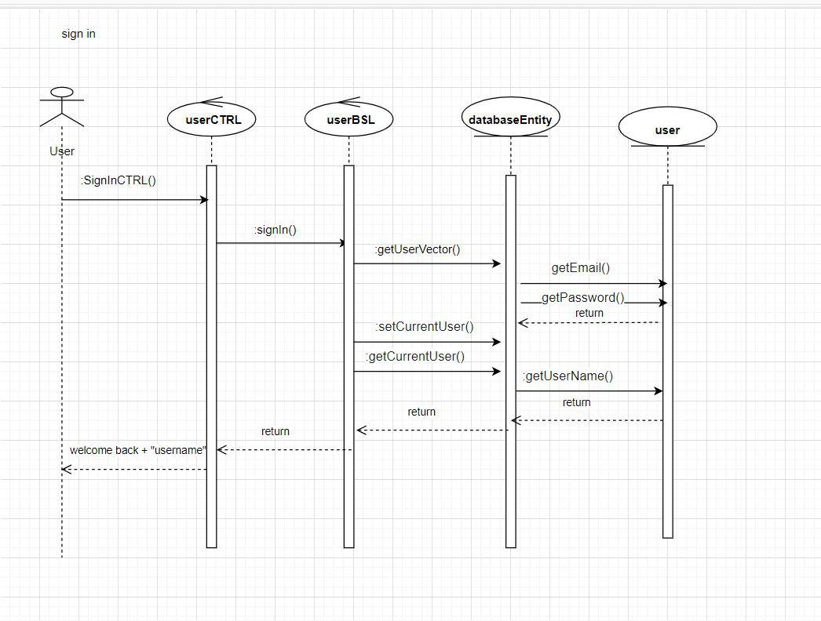

Sign up

REFUND

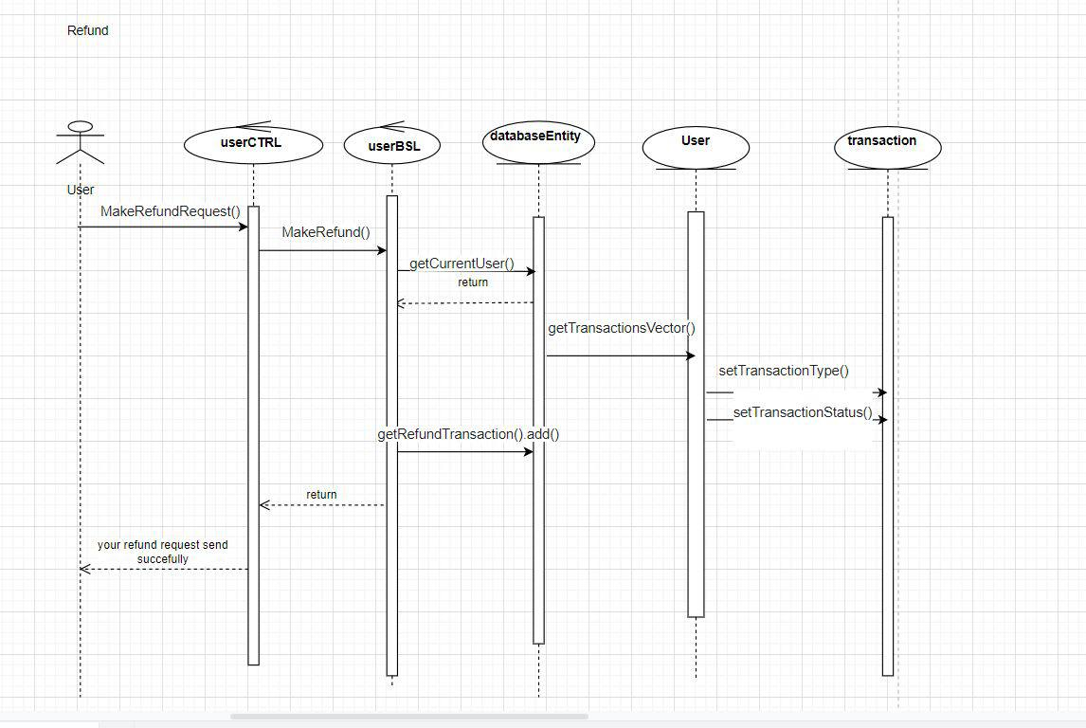

TRANSACTION

ADD OVERALL DISCOUNT

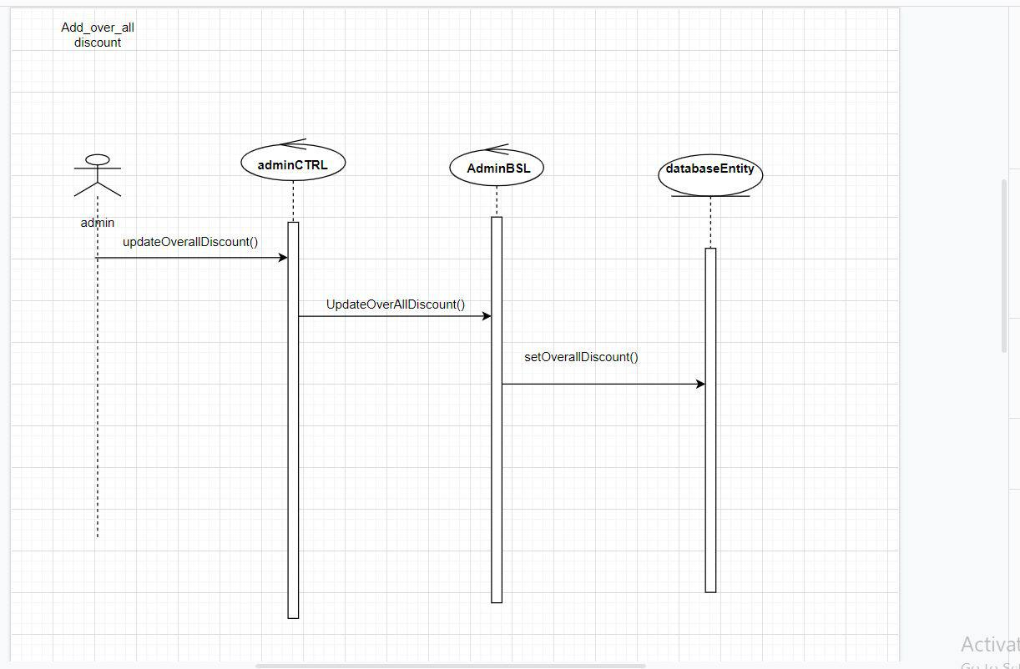

PAYMENT

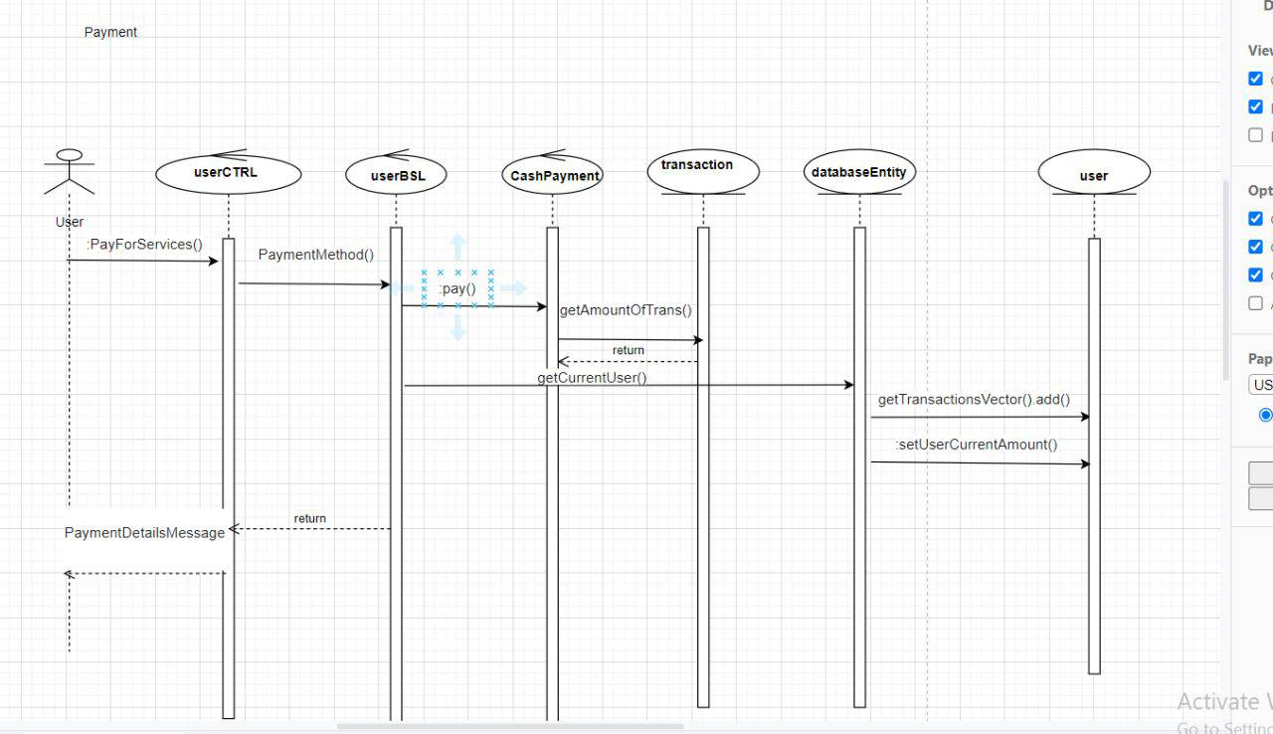

ADD TO WALLET

RESPONSE REFUNFD

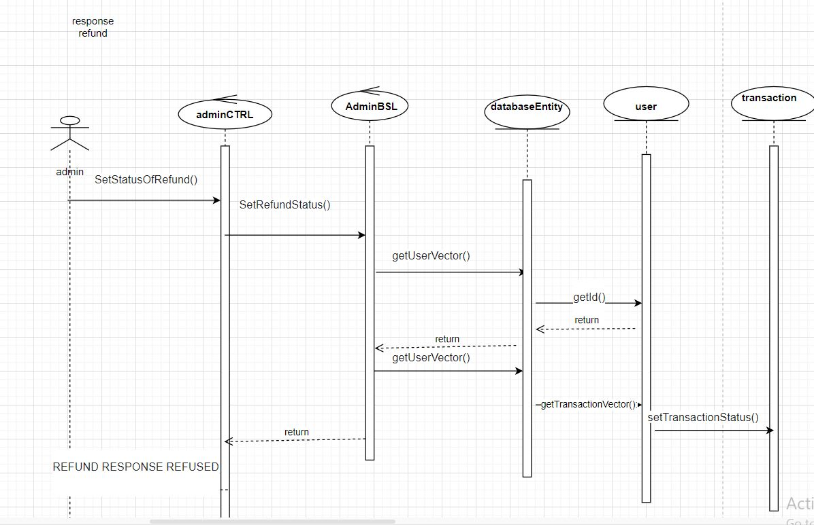

# Requirements Exposure as Web Service API

**Part 1: Exposed Postman Collection**



**Part 2:**

|  |  |  |  |
| --- | --- | --- | --- |
| Requirement |  | Exposed API | Input shape |
| The user should be able to sign-in to the system. Given the user’s email and a password, the user can login to the system and use any of the system functionalities |  | this functionality was handling by this URL  (http://localhost:8080/signinuser  its post so you should choose (body) then (raw) then (jason) | {  "email":"nada",  "password":"123"  } |
| The user should be able to sign up to the system. The user should provide his username, email and password. The system should check if the username or the email is registered before, if they are not registered before then the signup process should complete successfully, if not, the system will show an error to the use |  | this functionality was handling by this URL (http://localhost:8080/signupuser)  its post so you should choose( body) then (raw) then (Jason) | {"userName":"nada","email":"nada","password":"123" } |
| The user should be able to search for any service in the system. The user can type theservice name and the system will return all services that match the user query |  | this functionality was handling by this URL (http://localhost:8080/searchForServices/we)  2)the user can choose the service he want throught this url  (http://localhost:8080/choiceForm/13)  3)the user input his data that was required after choosing the service throught this url  (http://localhost:8080/formInput) | its Get so you should write after /searchForServices/(service you search for) 2) its Get so you should write after /choiceForm/ (the id of your choosen service which appear in the search list)  Ex:13  3) its post so you should choose body then raw you dont have to choose jason input should look like that  ["13","01123456789","BAHYA","11234","2"](where the first index is for the service id (which is constant at any form))(the other inputs changes according to the requirments of each service form) |
| The user can pay for any service in the system. The system should prompt the user tothe payment form when the user asks to pay for any service |  | this functionality was handling by two parts part 1)show the user a list of payment methods by this URL (http://localhost:8080/WayOfPaymentMethod)  its Get method  part2)enter the way he want to pay by and this by choosing one of the choices in the past form throught the id  by this URL  (http://localhost:8080/PaymentMethod) | Part2 is post so you should choose body then raw you dont have to choose jason input should look like that(3) which is the id of the payment method in the previous form (if the user choose any other number it will pay by credit card by default) |
| The user can ask for a refund for any complete transaction to any given service |  | this functionality was handling by this URL (http://localhost:8080/MakeRefundRequest)  **he can know the transaction id throught this url**  (http://localhost:8080/ ViewCurrentUserPaymentTransactions  )  its Get method | its post so you should choose body then raw you dont have to choose jason input should look like that 3 (which is the id of transaction which the user want to make refund for )he can know the transaction id throught this url |
| The system maintain a wallet balance for each user. The user should be able to add any funds to the wallet |  | functionality was handling by this URL (http://localhost:8080/AddToWallet) | its post so you should choose body then raw you dont have to choose jason input should look like that400 (which is the amount you want to add to wallet) |
| The user should be able to check any discount for any service in the system |  | functionality was handling by this URL http://localhost:8080/DiscountWithID | its Get method which show the available discount in the system |
| the user can show all his information |  | throught this url (http://localhost:8080/showYourData) | its Get method |
| The admin should be able to add discounts to the system |  | this functionality was handling by this URL (http://localhost:8080/AddOverallDiscount) | its post so you should choose body then raw you dont have to choose jason the input should look like that10 (which is the amount of overall discount) |
| To add spacific discount by admin this functionality |  | this functionality was handling by this URL (http://localhost:8080/ AddingSpecificDiscount  )  **in order to know the id of service this functionality was handling by this URL(get method)**  (http://localhost:8080/ listOfSpecificDiscountWithID  ) | its post so you should choose body then raw you dont have to choose jason input should look like that[1,10] (the first number is the id of the service you want to add spacific discount on it ,the secound is the amount of this discount) |
| The admin should be able to list all user transactions |  | this functionality was handling by this URL (http://localhost:8080/ listAllUserTransactions  /1/1) | its Get so you should write after/listAllUserTransactions/ (user id)/(type of transaction id) |
|  |  | the admin could list the types of transactions and know the id by this URL **http://localhost:8080/**TransactionsTypes | is Get method |
|  |  | the admin could list all the users info and know there id throught this URL **http://localhost:8080/**UsersData | is Get method |
| The admin should be able to list all refund requests Each refund request should containthe related service and the amount to be refunded. The admin should be able to accept |  | this functionality was handling by this URL (http://localhost:8080/ listOfRequestTransactions  ) throught this it he know the users request **to accept or reject**  **this was handle throught this URL**  **(http://localhost:8080/**SetStatusOfRefund**)** | is Get method **its post so you should choose body then raw you dont have to choose jason input should look like that**  **[3,1] (where the first number is the refund request id)(the secound number (1) for reject,(2) for accept)** |

# Github repository link

https://github.com/mohamedanas00/Software_Architecture_PhaseOne

SOME INSTRUCTIONS TO OPEN THE CODE :

TO OPEN THE CODE ON ECLIPSE

1)CHOOSE FROM FILE IMPORT

2)CHOSSE EXISTING MAVEN PROJECT

3)THEN PUT THE PATH OF THE FILE WHERE YOU DOWNLOAD IT

4)YOU SHOULD HAVE JAVA 17 TO COULD RUN THE CODE

5)PLEASE CHECK POSTMAN ZIP IN THE FOLDER TO SHOW COLLECTION