STOCK ANALYSIS

ITI Graduation Project

Team 1:

Ahmed Mohamed Elkholy Hossam Mohamed

Mohammed Adel Eltohamy Mohammed Arafa

Mohamed Abdel Karim Mohammed

[© TemplateLab.com](https://templatelab.com/)

Contents

Summary 2

Business requirements | KPIs 4

1- Price to earnings 4

2- Volume 5

3-Earning per share 5

4- Dividend Yield 6

5-Price to Sales 6

Data Sources 7

1-S&P 500 Stocks 7

2-Uber Technologies, Inc. (UBER) 8

3- S&P 500® 9

Data Warehouse Data Model 10

Logical Data Mapping 12

Queries 15

1- Creation Queries: 15

2-Query 1 17

3-Query 2 18

4-Query 3 18

5-Query 4 19

6- Query 5 19

6- Query 6 20

Dashboards 21

1- Page 1 21

2- Page 2 22

3-Page 3 23

Conclusion 24

# Summary

Owning stocks in different companies can help you build your savings, protect your money from inflation and taxes, and maximize income from your investments. It's important to know that there are risks when investing in the stock market. That's the part where our project comes in handy. We will take you on a mini-tour in the stock market. We expect you to have a clear understanding of the stock market and be aware of the right time and make use of the right opportunity to invest your money in, when the time is risky to invest, and when it's not even worth it.

Our focus will be on the 500 S&P Index.

The S&P 500 Index, or Standard & Poor's 500 Index, is a market-capitalization-weighted index of 500 leading publicly traded companies in the U.S. It is not a list of the top 500 U.S. companies by market cap because there are other criteria that the index includes. Still, the S&P 500 index is regarded as one of the best gauges of prominent American equities' performance, and by extension, that of the stock market overall.

After you gain enough knowledge about the 500 S&P Index, we will talk about the hero of our story, Uber.

Uber Technologies, Inc. (Uber) is an American mobility service provider based in San Francisco with operations in approximately 72 countries and 10,500 cities. Its services include:

•Ride-hailing

•Food delivery (Uber Eats and Postmates)

•Package delivery

•Couriers

•Freight transportation

•Electric bicycle

•Motorized scooter rental via a partnership with Lime

•Ferry transport (partnership with local operators).

Uber does not own any vehicles; instead, it receives a commission from each booking. Fares are quoted to the customer in advance but vary using a dynamic pricing model based on the local supply and demand at the time of the booking.

Our team chose Uber as our story's main focus because not only does the company have its ups and downs, but it also got an exciting story to tell.

# Business requirements | KPIs

## 1- Price to earnings

The price-to-earnings ratio (P/E) is one of the most widely used metrics for investors and analysts to determine stock valuation. In addition to showing whether a company's stock price is overvalued or undervalued, the P/E can reveal how a stock's valuation compares to its industry group or a benchmark like the S&P 500 index.

The P/E ratio helps investors determine the market value of a stock as compared to the company's earnings. In short, the P/E shows what the market is willing to pay today for a stock based on its past or future earnings. A high P/E could mean that a stock's price is high relative to earnings and possibly overvalued. Conversely, a low P/E might indicate that the current stock price is low relative to earnings.

A higher P/E ratio shows that investors are willing to pay a higher share price today because of growth expectations in the future. The average P/E for the S&P 500 has historically ranged from 13 to 15. For example, a company with a current P/E of 25, above the S&P average, trades at 25 times earnings. The high multiple indicates that investors expect higher growth from the company compared to the overall market.

**KPI-1: Consider if the values of stocks in each sector & know which sector have over or under values (Average) (Count).**

## 2- Volume

* Volume measures the number of shares traded in a stock or contracts traded in futures or options.
* Volume can indicate market strength, as rising markets on increasing volume are typically viewed as strong and healthy.
* When prices fall on increasing volume, the trend is gathering strength to the downside.

**KPI-2: The percentage of each country trading stocks per each day (To know which companies have the highest trading stocks in a certain year, to understand how investors think about companies).**

## 3-Earning per share

* Earnings per share (EPS) is the monetary value of earnings per outstanding share of common stock for a company.
* Earnings per share (EPS) is calculated as a company's profit divided by the outstanding shares of its common stock. The resulting number serves as an indicator of a company's profitability

**KPI-3: Which Sector (Average profit per stock) and company have the highest profit per stock.**

## 4- Dividend Yield

The dividend yield or dividend–price ratio of a share is the dividend per share, divided by the price per share. It is also a company's total annual dividend payments divided by its market capitalization, assuming the number of shares is constant. It is often expressed as a percentage.

Dividend yield is used to calculate the earnings on investment (shares) considering only the returns in the form of total dividends declared by the company during the year.

**KPI-4: Any dividend yields higher than current yield will be considered as startup and vice versa.**

## 5-Price to Sales

The price-to-sales (P/S) ratio is a valuation ratio that compares a company’s stock price to its revenues. It is an indicator of the value that financial markets have placed on each dollar of a company’s sales or revenues.

A low ratio may indicate the stock is undervalued, while a ratio that is significantly above the average may suggest overvaluation.

**KPI-5: Know companies that have overvalues and undervalues for each sector.**

# Data Sources

## 1-S&P 500 Stocks

The Standard and Poor's 500 or S&P 500 is the most famous financial benchmark in the world.

This stock market index tracks the performance of 500 large companies listed on stock exchanges in the United States. As of December 31, 2020, more than $5.4 trillion was invested in assets tied to the performance of this index.

Because the index includes multiple classes of stock of some constituent companies—for example, Alphabet's Class A (GOOGL) and Class C (GOOG)—there are 505 stocks in the gauge.

ETL: Our team downloaded the csv data from Kaggle

[S&P 500 Stocks (daily updated) | Kaggle](https://www.kaggle.com/andrewmvd/sp-500-stocks?select=sp500_companies.csv)

## 2-Uber Technologies, Inc. (UBER)

ETL: Our team downloaded the csv data in addition to the xlsx from the website

[Uber Technologies, Inc. (UBER)](https://finance.yahoo.com/quote/UBER/history?p=UBER)

## 3- S&P 500®

The S&P 500® is widely regarded as the best single gauge of large-cap U.S. equities. According to our Annual Survey of Assets, an estimated USD 13.5 trillion is indexed or benchmarked to the index, with indexed assets comprising approximately USD 5.4 trillion of this total (as of Dec. 31, 2020). The index includes 500 leading companies and covers approximately 80% of available market capitalization.

ETL: Our team downloaded the excel data from the website

[S&P 500®](https://www.spglobal.com/spdji/en/indices/equity/sp-500/#data)

# Data Warehouse Data Model

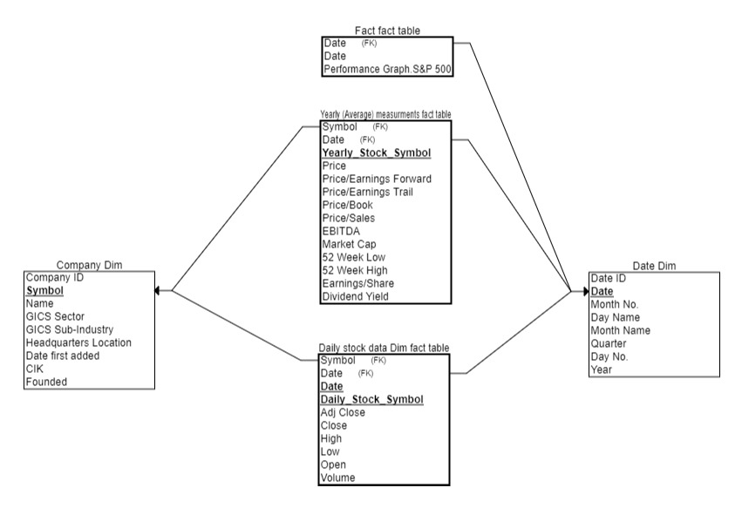

Our team designed the data warehouse model in the shape of Galaxy Schema.

We believe that galaxy schema is the best model for our case because we want to analyze numerical entities, but we have two levels of granularities which forces us to use two fact tables, so galaxy schema is the approach for our method.

Fact tables:

1. Daily stock data
2. Yearly (average) data
3. Fact table

Dimensions:

1. Company Dim
2. Date Dim

**Pros of the used schema:**

* Its multidimensional nature helps in structuring complex Database systems efficiently.
* Minimum or no redundancy, as a result of Normalization.
* This is a flexible Schema, considering the complexity of the system.
* Data Quality will be fine, as Normalization provides the advantage for well-defined tables/ data formats.
* When queried with Joins, clear & accurate data can be extracted.
* High Data quality & accuracy helps in creating exceptional Reporting & Analytical results.

**Cons of the used schema:**

* Galaxy schema can be Complex in structure.
* Working on this schema is tedious, as the complexity in both Schema and database systems makes it more intricate altogether.
* Data retrieval is done with multi-level joins combined with conditional expressions.
* The number of levels of normalization is expected, depending on the depth of the given database.
* Maintenance and support tasks get difficult as Galaxy schema is applied for larger database systems with complex structures.
* Large storage space is required for its larger design arrangement and detailed querying process.
* The analysis gets difficult, as it has no limitation on how many fact and dimension tables it can have.

# Logical Data Mapping

|  |  |  |  |  |  |
| --- | --- | --- | --- | --- | --- |
| **Source Table Name** | **Column** | **Data Type** | **PK** | **Table Type** | **Data Source** |
| COMPANY_DIM | Symbol | VARCHAR2(25) | Y | Dimension | Dim Company |
| COMPANY_DIM | Company_Name | VARCHAR2(50) |  | Dimension | Dim Company |
| COMPANY_DIM | GICS_Sector | VARCHAR2(50) |  | Dimension | Dim Company |
| COMPANY_DIM | GICS_Sub_Industry | VARCHAR2(100) |  | Dimension | Dim Company |
| COMPANY_DIM | Headquarters_Location | VARCHAR2(100) |  | Dimension | Dim Company |
| COMPANY_DIM | Date_First_Added | Date |  | Dimension | Dim Company |
| COMPANY_DIM | CIK | NUMBER (12,2) |  | Dimension | Dim Company |
| COMPANY_DIM | Founded | NUMBER (5) |  | Dimension | Dim Company |

|  |  |  |  |  |  |
| --- | --- | --- | --- | --- | --- |
| **Source Table Name** | **Column** | **Data Type** | **PK** | **Table Type** | **Data Source** |
| DAILY_STOCKS_DATA_FACT | Day_Date | DATE | Y | Fact | Dim Daily stocks data |
| DAILY_STOCKS_DATA_FACT | Symbol | VARCHAR2(50) | Y | Fact | Dim Daily stocks data |
| DAILY_STOCKS_DATA_FACT | Adj_Close | NUMBER(12,6) |  | Fact | Dim Daily stocks data |
| DAILY_STOCKS_DATA_FACT | Close_Price | NUMBER(12,6) |  | Fact | Dim Daily stocks data |
| DAILY_STOCKS_DATA_FACT | Open_Price | NUMBER(12,6) |  | Fact | Dim Daily stocks data |
| DAILY_STOCKS_DATA_FACT | High_Price | NUMBER(12,6) |  | Fact | Dim Daily stocks data |
| DAILY_STOCKS_DATA_FACT | Low_Price | NUMBER(12,6) |  | Fact | Dim Daily stocks data |
| DAILY_STOCKS_DATA_FACT | Volume | NUMBER(15) |  | Fact | Dim Daily stocks data |
| DAILY_STOCKS_DATA_FACT | Performance_General_Stock | NUMBER(12,6) |  | Fact | Dim Daily stocks data |

|  |  |  |  |  |  |
| --- | --- | --- | --- | --- | --- |
| **Source Table Name** | **Column** | **Data Type** | **PK** | **Table Type** | **Data Source** |
| DATE_DIM | Day_Date | DATE | Y | Dimension | Dim Date |
| DATE_DIM | Month_Number | NUMBER(6) |  | Dimension | Dim Date |
| DATE_DIM | Day_Name | VARCHAR2(25) |  | Dimension | Dim Date |
| DATE_DIM | Month_Name | VARCHAR2(25) |  | Dimension | Dim Date |
| DATE_DIM | Quarter | VARCHAR2(5) |  | Dimension | Dim Date |
| DATE_DIM | Year_No | NUMBER(5) |  | Dimension | Dim Date |
| DATE_DIM | Day_Number | NUMBER(3) |  | Dimension | Dim Date |

|  |  |  |  |  |  |
| --- | --- | --- | --- | --- | --- |
| **Source Table Name** | **Column** | **Data Type** | **PK** | **Table Type** | **Data Source** |
| YEARLY_AVERAGE_MEASURMENT_FACT | Symbol | VARCHAR2(25) | Y | Fact | Dim yearly (average) measurments |
| YEARLY_AVERAGE_MEASURMENT_FACT | Price | NUMBER(8,2) |  | Fact | Dim yearly (average) measurments |
| YEARLY_AVERAGE_MEASURMENT_FACT | Price_Per_Earnings_Forward | NUMBER(8,2) |  | Fact | Dim yearly (average) measurments |
| YEARLY_AVERAGE_MEASURMENT_FACT | Dividend_Yield | NUMBER(10,6) |  | Fact | Dim yearly (average) measurments |
| YEARLY_AVERAGE_MEASURMENT_FACT | Earnings_Per_Share | NUMBER(6,2) |  | Fact | Dim yearly (average) measurments |
| YEARLY_AVERAGE_MEASURMENT_FACT | fiftytwo_Week_High | NUMBER(7,2) |  | Fact | Dim yearly (average) measurments |
| YEARLY_AVERAGE_MEASURMENT_FACT | fiftytwo_Week_Low | NUMBER(10,4) |  | Fact | Dim yearly (average) measurments |
| YEARLY_AVERAGE_MEASURMENT_FACT | Market_Cap | NUMBER(14) |  | Fact | Dim yearly (average) measurments |
| YEARLY_AVERAGE_MEASURMENT_FACT | EBITDA | NUMBER(14) |  | Fact | Dim yearly (average) measurments |
| YEARLY_AVERAGE_MEASURMENT_FACT | Price_Per_Sales | NUMBER(10,6) |  | Fact | Dim yearly (average) measurments |
| YEARLY_AVERAGE_MEASURMENT_FACT | Price_Per_Book | NUMBER(6,2) |  | Fact | Dim yearly (average) measurments |
| YEARLY_AVERAGE_MEASURMENT_FACT | Price_Per_Earnings_Trail | NUMBER(12,6) |  | Fact | Dim yearly (average) measurments |

|  |  |  |  |  |  |
| --- | --- | --- | --- | --- | --- |
| **Source Table Name** | **Column** | **Data Type** | **PK** | **Table Type** | **Data Source** |
| Performance_General_Stock_Fact | Daily_Date | DATE | Y | Fact | Copy of PerformanceGraphExport (1) |
| Performance_General_Stock_Fact | General_Stock_Value | NUMBER(12,6) |  | Fact | Copy of PerformanceGraphExport (1) |

# Queries

## 1- Creation Queries:

CREATE TABLE **COMPANY_DIM**

(

Symbol VARCHAR2(25) CONSTRAINT Symbol_PK PRIMARY KEY,

Company_Name VARCHAR2(50),

GICS_Sector VARCHAR2(50),

GICS_Sub_Industry VARCHAR2(100),

Headquarters_Location VARCHAR2(100),

Date_First_Added Date,

CIK NUMBER(12,2),

Founded NUMBER(5)

);

CREATE TABLE **DAILY_STOCKS_DATA_FACT**

(

Day_Date DATE ,

Symbol VARCHAR2(50),

Adj_Close NUMBER(12,6),

Close_Price NUMBER(12,6),

Open_Price NUMBER(12,6),

High_Price NUMBER(12,6),

Low_Price NUMBER(12,6),

Volume NUMBER(15),

Performance_General_Stock NUMBER(12,6),

CONSTRAINT Comp_PK PRIMARY KEY (Day_Date,Symbol)

);

CREATE TABLE **DATE_DIM**

(

Date_Day DATE CONSTRAINT Date_PK PRIMARY KEY,

Month_Number NUMBER(6),

Day_Name VARCHAR2(25),

Month_Name VARCHAR2(25),

Quarter VARCHAR2(5),

Year_No NUMBER(5),

Day_Number NUMBER(3)

);

CREATE TABLE **YEARLY_AVERAGE_MEASURMENT_FACT**

(

Symbol VARCHAR2(25) CONSTRAINT Symbol_Yearly_PK PRIMARY KEY,

Price NUMBER(8,2),

Price_Per_Earnings_Forward NUMBER(8,2),

Dividend_Yield NUMBER(10,6),

Earnings_Per_Share NUMBER(6,2),

fiftytwo_Week_High NUMBER(7,2),

fiftytwo_Week_Low NUMBER(10,4),

Market_Cap NUMBER(14),

EBITDA NUMBER(14),

Price_Per_Sales NUMBER(10,6),

Price_Per_Book NUMBER(6,2),

Price_Per_Earnings_Trail NUMBER(12,6)

);

CREATE TABLE **Performance_General_Stock_Fact**

(

Daily_Date DATE CONSTRAINT Daily_Date_PK PRIMARY KEY,

General_Stock_Value NUMBER(12,6)

);

## 2-Query 1

SELECT GICS_Sub_Industry, SUM (Market_Cap) / AVG (Price) AS TOTAL_NO_OF_STOCKS

FROM COMPANY_DIM COM, YEARLY_AVERAGE_MEASURMENT_FACT YEARLY

WHERE COM.SYMBOL = YEARLY.SYMBOL

GROUP BY GICS_Sub_Industry

ORDER BY TOTAL_NO_OF_STOCKS DESC;

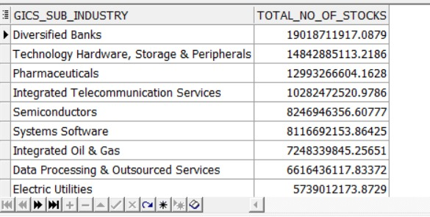

## Query 23-Query 2

SELECT DAY_DATE, AVG(CLOSE_PRICE)

FROM DAILY_STOCKS_DATA_FACT

GROUP BY DAY_DATE;

Query 3


## 4-Query 3

SELECT SYMBOL, AVG(VOLUME), SUM(VOLUME)

FROM DAILY_STOCKS_DATA_FACT

GROUP BY SYMBOL

ORDER BY AVG(VOLUME) ;

## 5-Query 4

SELECT GICS_Sector, AVG (OPEN_PRICE) ,AVG(CLOSE_PRICE), AVG (HIGH_PRICE), AVG (LOW_PRICE), AVG (VOLUME)

FROM COMPANY_DIM COM, DAILY_STOCKS_DATA_FACT DAILY

WHERE COM.SYMBOL = DAILY.SYMBOL

GROUP BY GICS_Sector

ORDER BY AVG(CLOSE_PRICE) DESC;

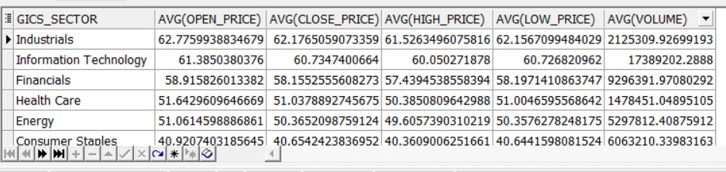

## 6- Query 5

SELECT GICS_Sub_Industry, SUM (EBITDA) ,SUM (Dividend_Yield),AVG(Earnings_Per_Share) ,AVG (Price_Per_Book)

FROM COMPANY_DIM COM, YEARLY_AVERAGE_MEASURMENT_FACT YEARLY

WHERE COM.SYMBOL = YEARLY.SYMBOL

GROUP BY GICS_Sub_Industry

ORDER BY SUM (Dividend_Yield) DESC;

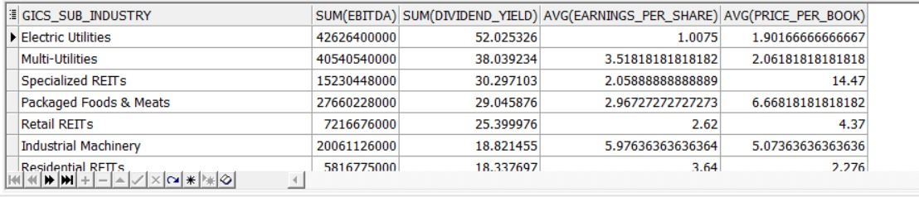

## 6- Query 6

SELECT AVG(General_Stock_Value)

FROM Performance_General_Stock_Fact

GROUP BY DAILY_DATE

ORDER BY AVG(General_Stock_Value) DESC ;

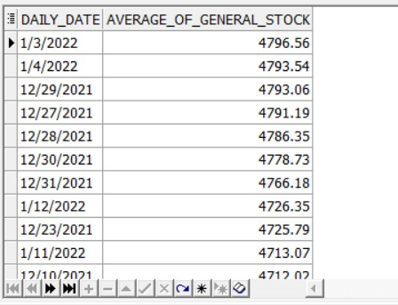

# Dashboards

## 1- Page 1

This is an analysis of Uber stocks during the last 4 years.

This dashboard can tell the story of what Uber went through in the last couple of years specially COVID-19 days because that was a critical hit to its business.

## 2- Page 2

This page represents daily statistics of the S&P 500

You can also see Sector/Sub sector stats, or even company stats

## 3-Page 3

This page indicates the KPI which our team demonstrated in the KPIs section, and it’s very important as it’s the major business metric

## 4-Page 4

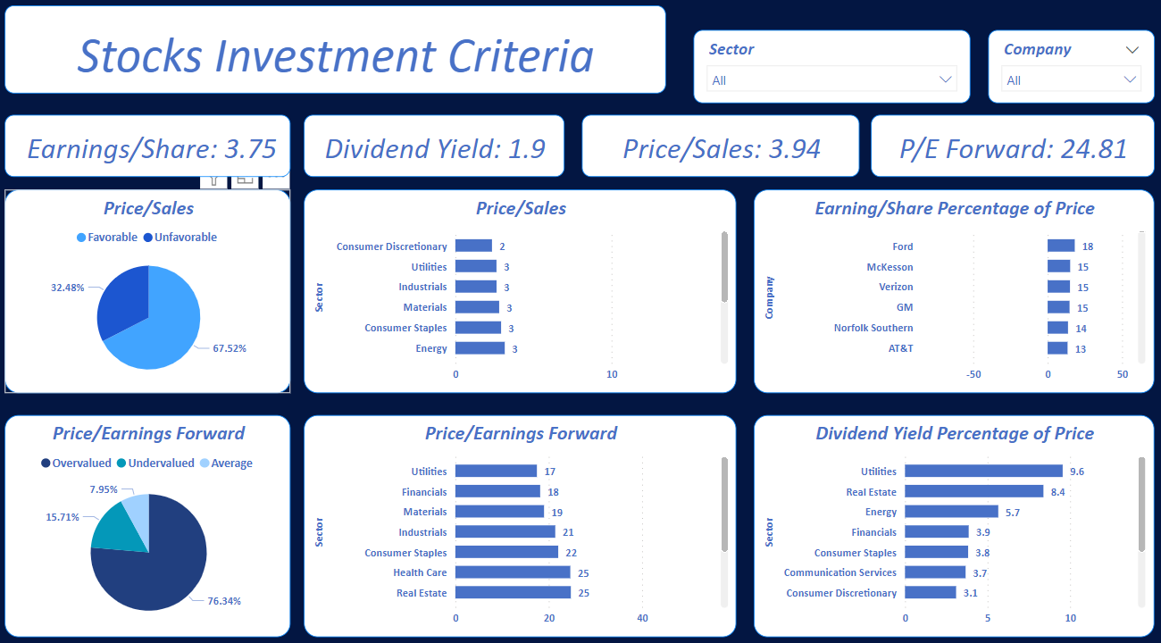

# Conclusion

In the beginning, Every one of our team checked the data and studied it carefully. We brainstormed together to be on the same land.

• We gathered outsource data

• Extracted and loading the data

• Explored the data

• Defining our Data Model

• Creating queries

• Extracting useful information from the queries

• Loading the data into Power BI

• Creating dashboards

In the end, we believe that our project delivered its purpose and it gave you a strong idea about the stocks market, maybe you can invest into it in the future someday with the help of this project.

As a future work, we're studying on implementing an AI script that keeps tracking of the current 500 S&P stocks and helps you in deciding which shares to buy and when to sell them to gain maximum profit.

We hope this project helped you.