**CONTROLLER**

**Introduction**

Wait for true 1 and true 2 flag to ensure that check 1 and check 2 is correct and the channel is secure

**Design and Implementation**:

Block Diagram

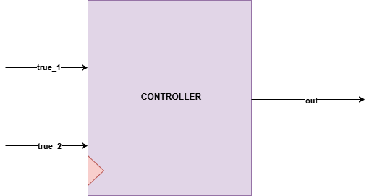z

**Interfaces**

|  |  |  |
| --- | --- | --- |
| **Signals** | **Width** | **Description** |
| True_1 | INPUT | check flag 1 |
| True_2 | INPUT | check flag 1 |
| out | OUTPUT | Represent accept in ascii code |