**Exponentiation**

**Introduction**

Exponentiation is a mathematical operation involving two numbers, the base ( b ) and the exponent ( n ), and is written as ( b^n ).

**Problem Statement**

Exponentiation is only supported if the base is a power of 2 or the exponent is 2.

**Design and Implementation**:

Block Diagram

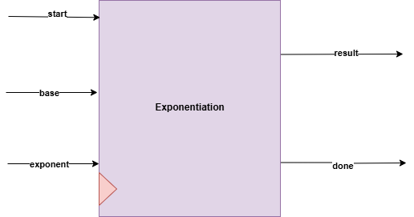

**Interfaces**

|  |  |  |
| --- | --- | --- |
| **Signals** | **Width** | **Description** |
| start | INPUT | Start flag |
| base | INPUT | The base is the number that is being multiplied. |
| exponent | INPUT | The **exponent** (or power) indicates how many times the base is multiplied by itself. |
| result | OUTPUT | Base ^ exponent |
| done | OUTPUT | Done flag |

* Note that this block is instantiated twice in top module to U0_exponentiation and U1_exponentiation
* Exponentiation_For_R block does the same operation but for (R1 ^X) and (R2^Y) instated