CHECK_2
Introduction
verify (R1 = R1') by decrypt D(K , C2 ) if they are equal then is verified (Accepted), otherwise it is a
dishonest prover (rejected).
Design and Implementation:
Block Diagram
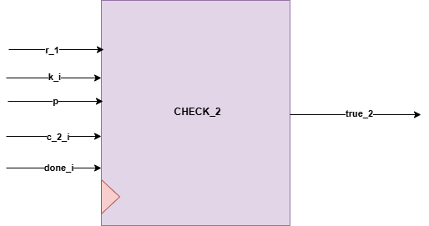
Interfaces
Signals | Width | Interface
R1 | INPUT | U0_CLC_R1
K_i | INPUT | U0_ENCRYPTION_R2
p | INPUT | TOP MODULE INPUT
C_2_i | INPUT | U0_ENCRYPTION_R1
Done_i | INPUT | U3_exponentiation_r
True_2 | OUTPUT | U0_CONTROLKER

