ENCRYPTION_2
Introduction
This block contain 2 blocks ( CLC_K , CLC_C1 ), which calculate the required key then encrypt by this key c1 input
Design and Implementation:
Block Diagram
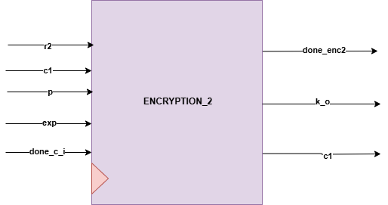
Interfaces
Signals | Width | Interface | Description
R2 | INPUT | U0_CLC_R2 | R2 = (g^y) mod p
C1 | INPUT | U0_ENCRYPTION_R1 | C1 = K, ExOR R2
exp | INPUT | U2_exponentiation_r | (g^x)
P | INPUT | TOP MODULE INPUT | The prime number p must be very large
Done_i_enc2 | INPUT | U1_exponentiation | Start flag
Done_enc2 | OUTPUT | U2_exponentiation_r | Start flag to U2_exponentiation_r
C1 | OUTPUT | U0_CHECK_2 | C1=E (K , R2)
K_o | OUTPUT | U0_CHECK_2 | Input to U0_CHECK_2 to decrypt c2 and check if R1 = R1`

