

Safety Plan Lane Assistance

**Document Version: V 1.0**



# 

# Document history

|  |  |  |  |
| --- | --- | --- | --- |
| Date | Version | Editor | Description |
| 2020/09/12 | 1.0 | Mohamed Ayman | First submission |
|  |  |  |  |
|  |  |  |  |
|  |  |  |  |
|  |  |  |  |

# Table of Contents

Document history

Table of Contents

Introduction

Purpose of the Safety Plan

Scope of the Project

Deliverables of the Project

Item Definition

Goals and Measures

Goals

Measures

Safety Culture

Safety Lifecycle Tailoring

Roles

Development Interface Agreement

Confirmation Measures

# Introduction

## Purpose of the Safety Plan

This document defines an overall framework for lane assistance system. It includes the assignment of responsibilities and the roles for functional safety.

## Scope of the Project

For the lane assistance project, the following safety lifecycle phases are in scope:

Concept phase

Product Development at the System Level

Product Development at the Software Level

The following phases are out of scope:

Product Development at the Hardware Level

Production and Operation

## Deliverables of the Project

The deliverables of the project are:

Safety Plan

Hazard Analysis and Risk Assessment

Functional Safety Concept

Technical Safety Concept

Software Safety Requirements and Architecture

# Item Definition

The item is Lane Assistance System, and it will do two functions:

1. Lane departure warning
2. Lane keeping assistance

When the driver drifts towards the edge of the lane, two things will happen:

* the **lane departure warning function** will vibrate the steering wheel
* the **lane keeping assistance function** will move the steering wheel so that the wheels turn towards the center of the lane

The lane departure warning function shall apply an oscillating steering torque to provide the driver a haptic feedback.

The lane keeping assistance function shall apply the steering torque when active in order to stay in ego lane

When the camera senses that the vehicle is leaving the lane, the camera sends a signal to the electronic power steering system asking to turn and vibrate the steering wheel.

The camera sensor will also request that a warning light turn on in the car display dashboard. That way the driver knows that the lane assistance system is active.

What if the driver wants to leave the lane? If the driver uses a turn signal, then the lane assistance system deactivates so that the vehicle can leave the lane. The driver can also turn off the system completely with a button on the dashboard.

The sub systems are:

* Camera subsystem which contains: Camera sensor and camera sensor ECU
* Electronic power subsystem which contains: Driving steering torque sensor, electronic power steering ECU and motor provide torque.
* Car Display subsystem which contains : Car display ECU and Car display

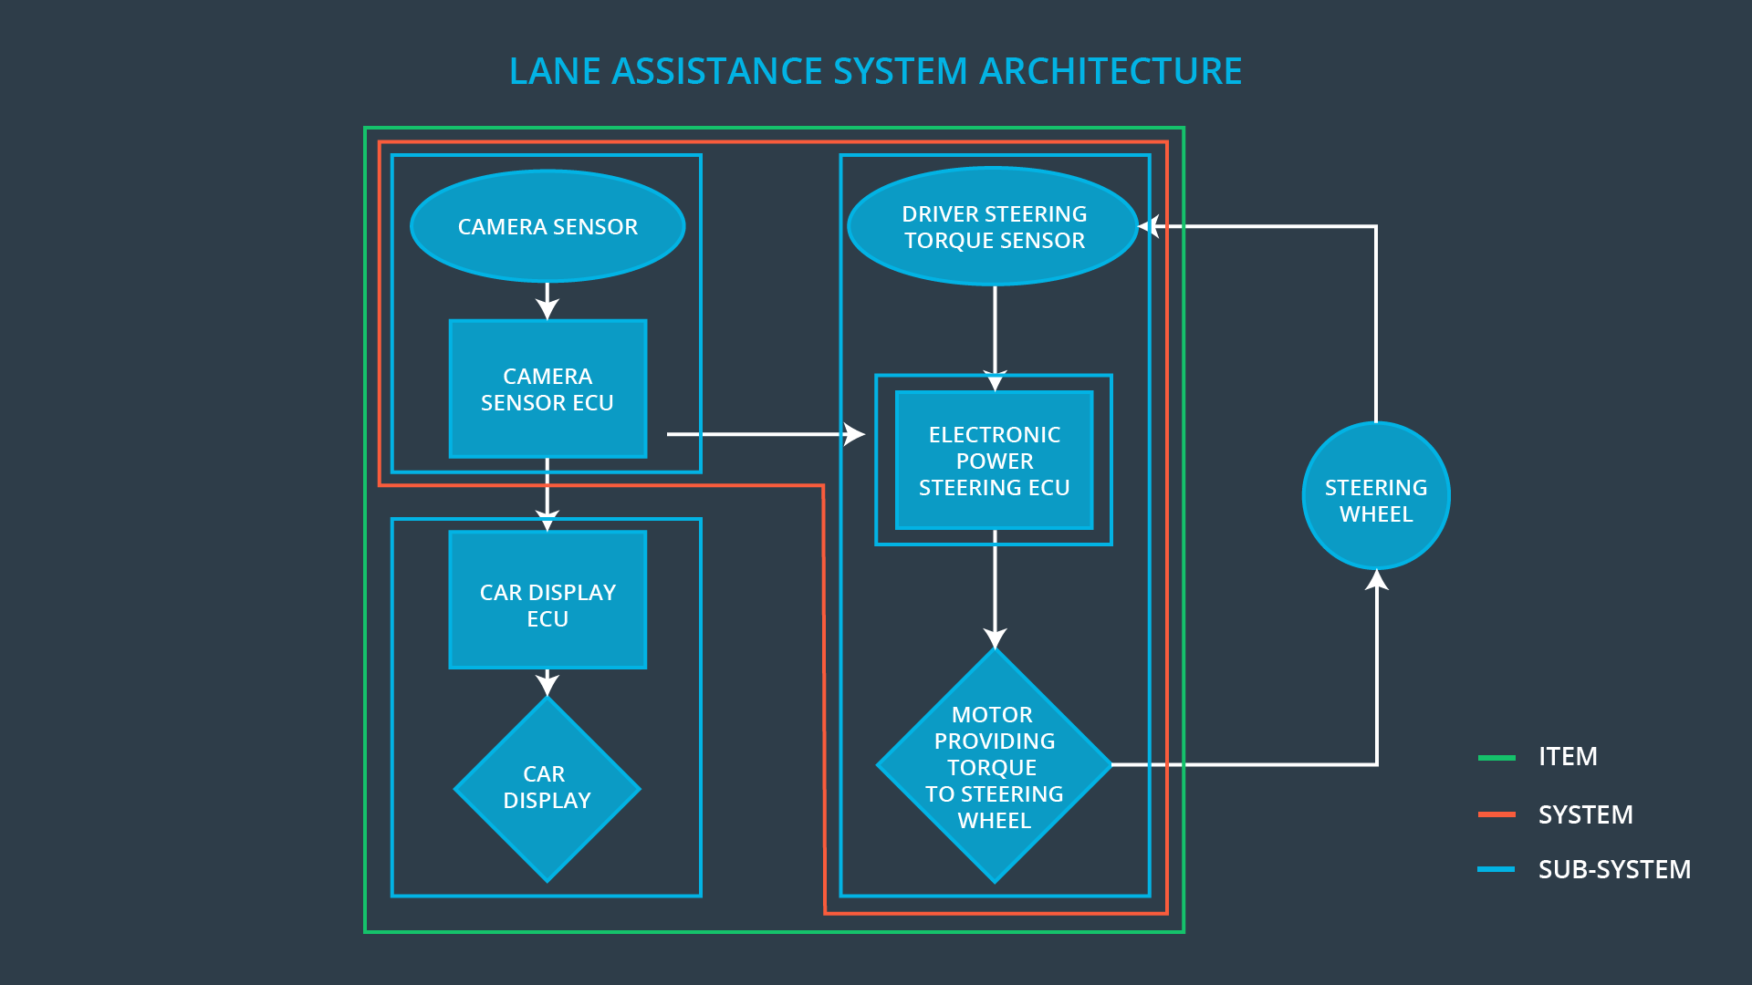

# Goals and Measures

## Goals

1. Identify risk and hazardous situations in the Line Assistance system components malfunction causing injuries to a person.
2. Evaluate the risks of the hazardous situations.
3. Low to risk of the malfunctions to a reasonable acceptable levels.

## Measures

|  |  |  |
| --- | --- | --- |
| Measures and Activities | Responsibility | Timeline |
| Follow safety processes | All team members | Constantly |
| Create and sustain a safety culture | All team members | Constantly |
| Coordinate and document the planned safety activities | All team members | Constantly |
| Allocate resources with adequate functional safety competency | Project manager | Within 2 weeks of start of project |
| Tailor the safety lifecycle | Safety manager | Within 4 weeks of start of project |
| Plan the safety activities of the safety lifecycle | Safety manager | Within 4 weeks of start of project |
| Perform regular functional safety audits | Safety auditor | Once every 2 months |
| Perform functional safety pre-assessment prior to audit by external functional safety assessor | Safety manager | 3 months prior to main assessment |
| Perform functional safety assessment | Safety assessor | Conclusion of functional safety activities |

# Safety Culture

**High priority:** safety has the highest priority among competing constraints like cost and productivity.

**Accountability:** processes ensure accountability such that design decisions are traceable back to people and teams who made the decisions.

**Rewards:** the organization motivates and supports the achievements of functional safety.

**Penalties:** the organization penalizes shortcuts that jeopardize safety or quality**.**

**Independent:** teams who develop and design the system should be independent from the teams who audit the work.

**Well defined process:** company design & management processes should be clear.

**Resources:** projects should have necessary resources like people and skills.

**Diversity:** intellectual diversity is sought after, valued and integrated into processes**.**

**Communication:** communication channels encourage disclosure of problems.

# Safety Lifecycle Tailoring

For the lane assistance project, the following safety lifecycle phases are in scope:

Concept phase

Product Development at the System Level

Product Development at the Software Level

The following phases are out of scope:

Product Development at the Hardware Level

Production and Operation

# Roles

|  |  |
| --- | --- |
| Role | Org |
| Functional Safety Manager- Item Level | OEM |
| Functional Safety Engineer- Item Level | OEM |
| Project Manager - Item Level | OEM |
| Functional Safety Manager- Component Level | Tier-1 |
| Functional Safety Engineer- Component Level | Tier-1 |
| Functional Safety Auditor | OEM or external |
| Functional Safety Assessor | OEM or external |

# Development Interface Agreement

**The purposes of a development interface agreement are to define the roles and the responsibilities between the companies that involved in the project, and to specify what evidence and work products each party will provide to prove that work was done according to the agreement.**

**OEM role:** supplying a functioning lane assistance system**.**

**Our company role:** analyze and modify the various sub-systems from a functional safety viewpoint.

# Confirmation Measures

**Confirmation measures purposes are:**

1. that a functional safety project conforms to ISO 26262
2. the project really does make the vehicle safer

**Confirmation review is** to ensure that the project complies with ISO 26262.

**Functional safety audit is** checking to make sure that the actual implementation of the project conforms to safety plan.

**Safety assessment is** confirming that plans, designs and developed products actually achieve functional safety.