

Functional Safety Concept Lane Assistance

**Document Version: V1.0**



# 

# Document history

|  |  |  |  |
| --- | --- | --- | --- |
| Date | Version | Editor | Description |
| 2020/09/15 | V1.0 | Mohamed Ayman | First submission |
|  |  |  |  |
|  |  |  |  |
|  |  |  |  |
|  |  |  |  |

# Table of Contents

Document history

Table of Contents

Purpose of the Functional Safety Concept

Inputs to the Functional Safety Analysis

Safety goals from the Hazard Analysis and Risk Assessment

Preliminary Architecture

Description of architecture elements

Functional Safety Concept

Functional Safety Analysis

Functional Safety Requirements

Refinement of the System Architecture

Allocation of Functional Safety Requirements to Architecture Elements

Warning and Degradation Concept

# 

# Purpose of the Functional Safety Concept

The functional safety concept is looking at the item from a higher level; also it looks for the general functionality of the item. By identifying the higher level requirements and allocating them to the different parts of the architecture.

# Inputs to the Functional Safety Concept

## Safety goals from the Hazard Analysis and Risk Assessment

|  |  |
| --- | --- |
| **ID** | **Safety Goal** |
| Safety_Goal_01 | lane keeping assistance function shall be time limited |
| Safety_Goal_02 | Lane Departure warning function shall be less |
| Safety_Goal_03 | Lane keeping assistance shall be deactivated under some environmental conditions |
| Safety_Goal_04 | Lane Departure warning function shall be more |

## 

## Preliminary Architecture

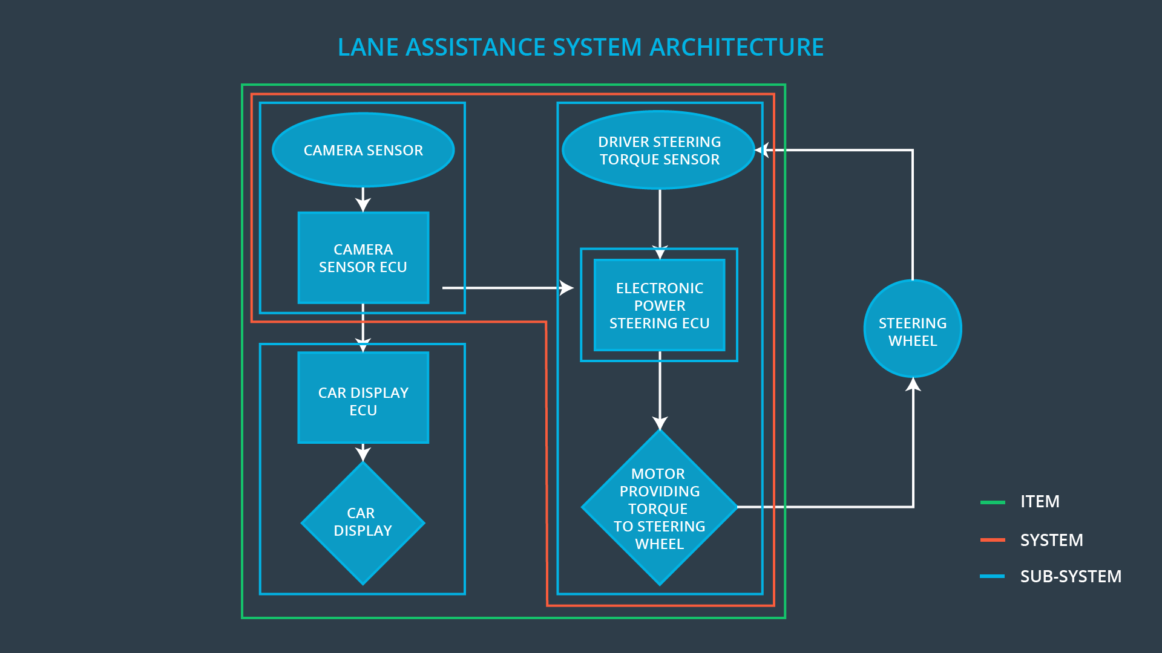

### Description of architecture elements

|  |  |
| --- | --- |
| **Element** | **Description** |
| Camera Sensor | Take images for the road and provide it to the Camera ECU |
| Camera Sensor ECU | Determine the position of the car according to the center of the ego lane line |
| Car Display | Display information to the driver about the item and the status of the item |
| Car Display ECU | Turn on/off warning light based on the instructions from camera ECU |
| Driver Steering Torque Sensor | Measure the torque applied to steering wheel |
| Electronic Power Steering ECU | Receive the information from the camera and give the orders to motor and receive the measurements from the torque sensor |
| Motor | Apply the torque to the steering wheel |

# Functional Safety Concept

The functional safety concept consists of:

* Functional safety analysis
* Functional safety requirements
* Functional safety architecture
* Warning and degradation concept

## Functional Safety Analysis

|  |  |  |  |
| --- | --- | --- | --- |
| **Malfunction ID** | **Main Function of the Item Related to Safety Goal Violations** | **Guidewords (NO, WRONG, EARLY, LATE, MORE, LESS)** | **Resulting Malfunction** |
| Malfunction_01 | Lane Departure Warning (LDW) function shall apply an oscillating steering torque to provide the driver a haptic feedback | More | The lane departure warning function applies an oscillating torque with very high torque amplitude (above limit) |
| Malfunction_02 | Lane Departure Warning (LDW) function shall apply an oscillating steering torque to provide the driver a haptic feedback | More | The lane departure warning function applies an oscillating torque with very high torque frequency (above limit) |
| Malfunction_03 | Lane Keeping Assistance (LKA) function shall apply the steering torque when active in order to stay in ego lane | No | The lane keeping assistance function is not limited in time duration which leads to misuse as an autonomous driving function |
| Malfunction_04 | Lane Keeping Assistance (LKA) function shall be deactivated under some environmental conditions | Wrong | The camera sensor is not working under some environmental conditions |
| Malfunction_05 | Lane Departure Warning (LDW) function shall apply an oscillating steering torque to provide the driver a haptic feedback | Less | The lane departure warning function applies an oscillating torque with very low torque frequency (under limit) |

## Functional Safety Requirements

Lane Departure Warning (LDW) Requirements:

|  |  |  |  |  |
| --- | --- | --- | --- | --- |
| **ID** | **Functional Safety Requirement** | **ASIL** | **Fault Tolerant Time Interval** | **Safe State** |
| Functional  Safety  Requirement  01-01 | The Electronic power steering ECU shall ensure that the lane departure oscillating torque amplitude is below Max_toruque_amplitude | C | 50ms | the lane departure oscillating torque amplitude is below Max_toruque_amplitude |
| Functional  Safety  Requirement  01-02 | The Electronic power steering ECU shall ensure that the lane departure oscillating torque frequency is below Max_toruque_frequency | C | 50ms | the lane departure oscillating torque frequency is below Max_toruque_frequency |
| Functional  Safety  Requirement  01-03 | The Electronic power steering ECU shall ensure that the lane departure oscillating torque amplitude is upper Min_toruque_amplitude | A | 500ms | the lane departure oscillating torque amplitude is upper Min_toruque_amplitude |
| Functional  Safety  Requirement  01-04 | The Electronic power steering ECU shall ensure that the lane departure oscillating torque frequency is upper Min_toruque_frequency | A | 500ms | the lane departure oscillating torque frequency is upper Min_toruque_frequency |

Lane Departure Warning (LDW) Verification and Validation Acceptance Criteria:

|  |  |  |
| --- | --- | --- |
| **ID** | **Validation Acceptance**  **Criteria and Method** | **Verification Acceptance**  **Criteria and Method** |
| Functional  Safety  Requirement  01-01 | ensure that the lane departure oscillating torque amplitude is at a level could be detected by a driver | Verify that the system don't turn off when exceeded the detected amplitude |
| Functional  Safety  Requirement  01-02 | ensure that the lane departure oscillating torque frequency is at a level could be detected by a driver | Verify that the system don't turn off when exceeded the detected frequency |
| Functional  Safety  Requirement  01-03 | ensure that the lane departure oscillating torque amplitude is not very low so the driver can't detect it | Verify that the system work at acceptable level of amplitude |
| Functional  Safety  Requirement  01-04 | ensure that the lane departure oscillating torque frequency is not very low so the driver can't detect it | Verify that the system work at acceptable level of frequency |

Lane Keeping Assistance (LKA) Requirements:

|  |  |  |  |  |
| --- | --- | --- | --- | --- |
| **ID** | **Functional Safety Requirement** | **ASIL** | **Fault Tolerant Time Interval** | **Safe State** |
| Functional  Safety  Requirement  02-01 | Electronic power steering ECU shall be time limited and the additional steering torque shall end after a given timer interval so that the driver cannot misuse the system for autonomous driving | C | 50ms | lane keeping assistance function shall be time limited |
| Functional  Safety  Requirement  02-02 | Lane keeping assistance function shall be deactivated in case of the camera can't work under some environmental condition | C | 50ms | Lane keeping assistance function shall be deactivated in some environmental conditions |

Lane Keeping Assistance (LKA) Verification and Validation Acceptance Criteria:

|  |  |  |
| --- | --- | --- |
| **ID** | **Validation Acceptance**  **Criteria and Method** | **Verification Acceptance**  **Criteria and Method** |
| Functional  Safety  Requirement  02-01 | Validate the duration chosen not allow the driver to use the car at autonomous mode | Verify the system stop if it exceeded the duration |
| Functional  Safety  Requirement  02-01 | Validate the system is stopping under some environmental conditions | Verify that the system stop under some environmental conditions |

## Refinement of the System Architecture

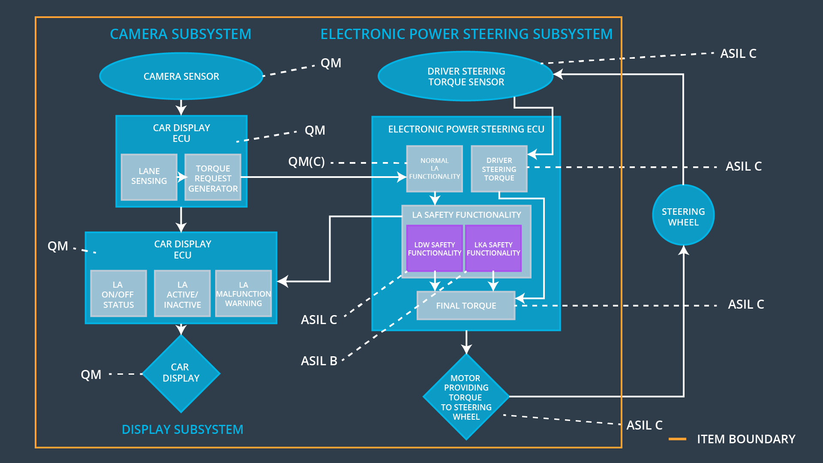

## Allocation of Functional Safety Requirements to Architecture Elements

|  |  |  |  |  |
| --- | --- | --- | --- | --- |
| **ID** | **Functional Safety Requirement** | **Electronic Power Steering ECU** | **Camera ECU** | **Car Display ECU** |
| Functional  Safety  Requirement  01-01 | The Lane departure item shall ensure that the oscillating torque amplitude is below Max_toruque_amplitude | **T** |  |  |
| Functional  Safety  Requirement  01-02 | The Lane departure item shall ensure that the oscillating torque frequency is below Max_toruque_frequency | **T** |  |  |
| Functional  Safety  Requirement  01-03 | The Lane departure item shall ensure that the oscillating torque amplitude is upper Min_toruque_amplitude | **T** |  |  |
| Functional  Safety  Requirement  01-04 | The Lane departure item shall ensure that the oscillating torque frequency is upper Min_toruque_frequency | **T** |  |  |
| Functional  Safety  Requirement  02-01 | lane keeping assistance function shall be time limited and the additional steering torque shall end after a given timer interval so that the driver cannot misuse the system for autonomous driving | **T** |  |  |
| Functional  Safety  Requirement  02-02 | Lane keeping assistance function shall be deactivated under some environmental condition |  | **T** |  |

## Warning and Degradation Concept

|  |  |  |  |  |
| --- | --- | --- | --- | --- |
| **ID** | **Degradation Mode** | **Trigger for Degradation Mode** | **Safe State invoked?** | **Driver Warning** |
| WDC-01 | turn off the lane departure functionality | Malfunction_1  Malfunction_2  Malfunction_5 | Yes | Lane departure warning work on car display |
| WDC-02 | turn off the lane keeping assistance functionality | Malfunction_3  Malfunction_4 | Yes | Lane keeping assistance warning work on car display |