

Technical Safety Concept Lane Assistance

**Document Version: V1.0**



# Document history

|  |  |  |  |
| --- | --- | --- | --- |
| Date | Version | Editor | Description |
| 2020/09/15 | V1.0 | Mohamed Ayman | First submission |
|  |  |  |  |
|  |  |  |  |
|  |  |  |  |
|  |  |  |  |

# Table of Contents

Document history

Table of Contents

Purpose of the Technical Safety Concept

Inputs to the Technical Safety Concept

Functional Safety Requirements

Refined System Architecture from Functional Safety Concept

Functional overview of architecture elements

Technical Safety Concept

Technical Safety Requirements

Refinement of the System Architecture

Warning and Degradation Concept

# Purpose of the Technical Safety Concept

Technical Safety Concept gets into details of the item Technology and build more concrete requirements.

# Inputs to the Technical Safety Concept

## Functional Safety Requirements

|  |  |  |  |  |
| --- | --- | --- | --- | --- |
| **ID** | **Functional Safety Requirement** | **ASIL** | **Fault Tolerant Time Interval** | **Safe State** |
| Functional  Safety  Requirement  01-01 | The Electronic power steering ECU shall ensure that the lane departure oscillating torque amplitude is below Max_toruque_amplitude. | C | 50ms | the lane departure oscillating torque amplitude is below Max_toruque_amplitude |
| Functional  Safety  Requirement  01-02 | The Electronic power steering ECU shall ensure that the lane departure oscillating torque frequency is below Max_toruque_frequency | C | 50ms | the lane departure oscillating torque frequency is below Max_toruque_frequency |
| Functional  Safety  Requirement  01-03 | The Electronic power steering ECU shall ensure that the lane departure oscillating torque amplitude is upper Min_toruque_amplitude | A | 500ms | the lane departure oscillating torque amplitude is upper Min_toruque_amplitude |
| Functional  Safety  Requirement  01-04 | The Electronic power steering ECU shall ensure that the lane departure oscillating torque frequency is upper Min_toruque_frequency | A | 500ms | the lane departure oscillating torque frequency is upper |
| Functional  Safety  Requirement  02-01 | Electronic power steering ECU shall be time limited and the additional steering torque shall end after a given timer interval so that the driver cannot misuse the system for autonomous driving | C | 50ms | lane keeping assistance function shall be time limited |
| Functional  Safety  Requirement  02-02 | Lane keeping assistance function shall be deactivated in case of the camera can't work under some environmental condition | C | 50ms | Lane keeping assistance function shall be deactivated in some environmental conditions |

## Refined System Architecture from Functional Safety Concept

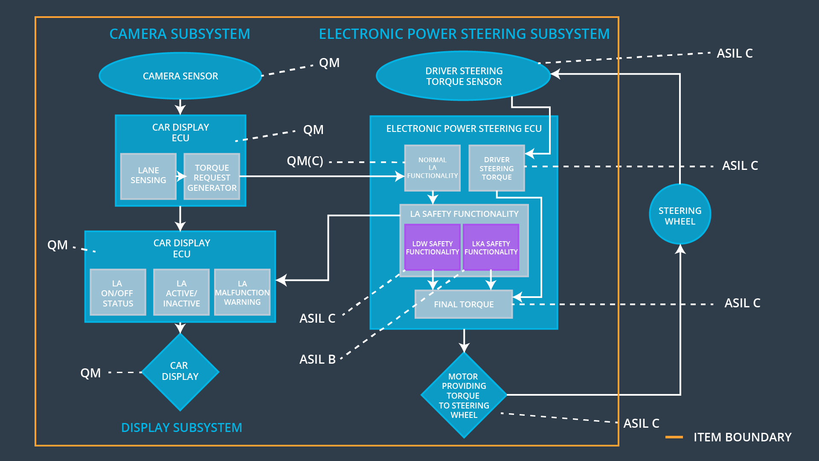

### 

### Functional overview of architecture elements

|  |  |
| --- | --- |
| **Element** | **Description** |
| Camera Sensor | Take images for the road and provide it to the Camera ECU |
| Camera Sensor ECU - Lane Sensing | Detect the lane lines and the position of the car according to Lane line. |
| Camera Sensor ECU - Torque request generator | Calculate the torque and send it to the electronic power steering ECU |
| Car Display | Display warnings and the status of the system |
| Car Display ECU - Lane Assistance On/Off Status | Display the status of the Lane assistance if it is on or off |
| Car Display ECU - Lane Assistant Active/Inactive | Display the status of the Lane assistance if it is active and inactive |
| Car Display ECU - Lane Assistance malfunction warning | Display warnings of malfunctions |
| Driver Steering Torque Sensor | Measure the torque that applied to the steering wheel |
| Electronic Power Steering (EPS) ECU - Driver Steering Torque | Receive the driver steering torque from camera sensor ECU |
| EPS ECU - Normal Lane Assistance Functionality | Receive the torque amplitude and frequency from the Camera sensor ECU |
| EPS ECU - Lane Departure Warning Safety Functionality | Receive the torque amplitude and frequency from the Camera sensor ECU |
| EPS ECU - Lane Keeping Assistant Safety Functionality | Ensure that the torque is limited and doesn't exceed the maximum limit |
| EPS ECU - Final Torque | Receive the torque and send it to the motor |
| Motor | Apply the torque to the steering wheel |

# 

# Technical Safety Concept

## Technical Safety Requirements

**Lane Departure Warning (LDW) Requirements:**

Functional Safety Requirement 01-01 with its associated system elements

(derived in the functional safety concept)

|  |  |  |  |  |
| --- | --- | --- | --- | --- |
| **ID** | **Functional Safety Requirement** | **Electronic Power Steering ECU** | **Camera ECU** | **Car Display ECU** |
| Functional  Safety  Requirement  01-01 | The lane keeping item shall ensure that the lane departure oscillating torque amplitude is below Max_Torque_Amplitude | X |  |  |

Technical Safety Requirements related to Functional Safety Requirement 01-01 are:

|  |  |  |  |  |  |
| --- | --- | --- | --- | --- | --- |
| **ID** | **Technical Safety Requirement** | **ASIL** | **Fault Tolerant Time Interval** | **Architecture Allocation** | **Safe State** |
| Technical  Safety  Requirement  01 | The Lane Departure Warning safety component shall ensure that the amplitude of the ‘LDW_Torque_Request’ sent to the ‘Final electronic power steering Torque’ component is below ‘Max_Torque_Amplitude. | C | 50ms | LDW Safety | Lane Departure Warning torque to zero. |
| Technical  Safety  Requirement  02 | The validity and integrity of the data transmission for LDW_Torque_Request signal shall be ensured. | C | 50ms | LDW Safety | Lane Departure Warning torque to zero. |
| Technical  Safety  Requirement  03 | The Lane Departure Warning safety component shall ensure that if there is any fault , the amplitude of the ‘LDW_Torque_Request’ sent to the ‘Final electronic power steering Torque’ component should return back to the safe state | C | 50ms | LDW Safety | Lane Departure Warning torque to zero. |

Functional Safety Requirement 01-2 with its associated system elements

(derived in the functional safety concept)

|  |  |  |  |  |
| --- | --- | --- | --- | --- |
| **ID** | **Functional Safety Requirement** | **Electronic Power Steering ECU** | **Camera ECU** | **Car Display ECU** |
| Functional  Safety  Requirement  01-02 | The lane keeping item shall ensure that the lane departure oscillating torque frequency is below Max_Torque_Frequency | X |  |  |

Technical Safety Requirements related to Functional Safety Requirement 01-02 are:

|  |  |  |  |  |  |
| --- | --- | --- | --- | --- | --- |
| **ID** | **Technical Safety Requirement** | **ASIL** | **Fault Tolerant Time Interval** | **Architecture Allocation** | **Safe State** |
| Technical  Safety  Requirement  01 | The Lane Departure Warning safety component shall ensure that the frequency of the ‘LDW_Torque_Request’ sent to the ‘Final electronic power steering Torque’ component is below ‘Max_Torque_frequency. | C | 50ms | LDW Safety | Lane Departure Warning torque to zero. |
| Technical  Safety  Requirement  02 | The validity and integrity of the data transmission for LDW_Torque_Request signal shall be ensured. | C | 50ms | LDW Safety | Lane Departure Warning torque to zero. |
| Technical  Safety  Requirement  03 | The Lane Departure Warning safety component shall ensure that if there is any fault , the amplitude of the ‘LDW_Torque_Request’ sent to the ‘Final electronic power steering Torque’ component should return back to the safe state | C | 50ms | LDW Safety | Lane Departure Warning torque to zero. |

**Lane Keeping Assistance (LKA) Requirements:**

Functional Safety Requirement 02-1 with its associated system elements

(derived in the functional safety concept)

|  |  |  |  |  |
| --- | --- | --- | --- | --- |
| **ID** | **Functional Safety Requirement** | **Electronic Power Steering ECU** | **Camera ECU** | **Car Display ECU** |
| Functional  Safety  Requirement  02-01 | The lane keeping item shall ensure that the lane keeping assistance torque is applied for only Max_Duration | X |  |  |

Technical Safety Requirements related to Functional Safety Requirement 02-01 are:

|  |  |  |  |  |  |
| --- | --- | --- | --- | --- | --- |
| **ID** | **Technical Safety Requirement** | **ASIL** | **Fault Tolerant Time Interval** | **Allocation to Architecture** | **Safe State** |
| Technical  Safety  Requirement  01 | The Lane Keeping Assistance shall ensure that the duration of applying the torque is less than the Max_Duration | C | 50ms | LKA Safety | Lane keeping assistance torque to zero |
| Technical  Safety  Requirement  02 | The Lane Keeping Assistance shall set the torque to zero if there is a fault | C | 50ms | LKA Safety | Lane keeping assistance torque to zero |
| Technical  Safety  Requirement  03 | The Lane Keeping Assistance shall warn the car display and turn on the warning light if there is a malfunction | C | 500ms | LKA Safety | Lane keeping assistance torque to zero |

## Refinement of the System Architecture

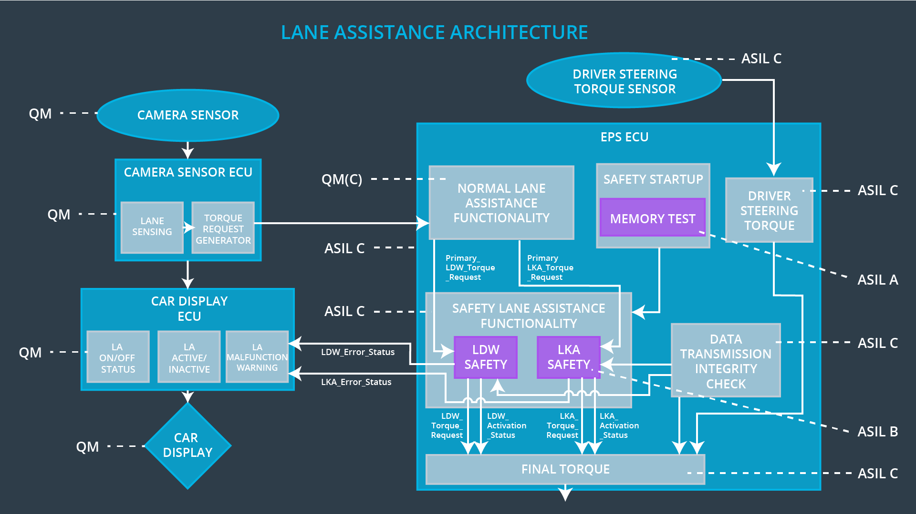

## Warning and Degradation Concept

|  |  |  |  |  |
| --- | --- | --- | --- | --- |
| **ID** | **Degradation Mode** | **Trigger for Degradation Mode** | **Safe State invoked?** | **Driver Warning** |
| WDC-01 | turn off the lane departure functionality | Malfunction_1  Malfunction_2  Malfunction_5 | Yes | Lane departure warning work on car display |
| WDC-02 | turn off the lane keeping assistance functionality | Malfunction_3  Malfunction_4 | Yes | Lane keeping assistance warning work on car display |