|  |  |
| --- | --- |
| **Name** | **Mohamed ayman salah Abd-elaziz** |
| **B.N** | **676** |
| **Edu-email** | **Muhammed195754@feng.bu.edu.eg** |
| **topic** | **Artificial intelligence** |
| **Code** | **ECE001** |
| **Gethub link** |  |

### **About artificial intelligence.**

In computer science, artificial intelligence (AI), some of the time called machine insights, is insights illustrated by machines, in differentiate to the common insights shown by people and creatures. Driving AI course readings characterize the field as the think about of "brilliantly operators": any gadget that sees its environment and takes activities that maximize its chance of effectively accomplishing its goals. Colloquially, the term "artificial intelligence" is frequently utilized to depict machines that imitate "cognitive" capacities that people relate with the human intellect, such as "learning" and "issue solving. As machines ended up progressively competent, assignments considered to require "insights" are frequently expelled from the definition of AI, a wonder known as the AI impact. A jest in Tesler's Hypothesis says "AI is anything hasn't been done however." For occurrence, optical character acknowledgment is habitually prohibited from things considered to be AI, having ended up a schedule innovation. Advanced machine capabilities for the most part classified as AI incorporate effectively understanding human discourse, competing at the most noteworthy level in vital amusement frameworks (such as chess and Go), independently working cars, brilliantly steering in substance conveyance systems, and military simulations. The conventional issues (or objectives) of AI investigate incorporate thinking, information representation, arranging, learning, normal dialect preparing, recognition and the capacity to move and control objects. Common intelligence is among the field's long-term objectives. Approaches incorporate factual strategies, computational insights, and conventional typical AI. Numerous devices are utilized in AI, counting adaptations of look and numerical optimization, counterfeit neural systems, and strategies based on insights, likelihood and financial matters. The AI field draws upon computer science, data designing, arithmetic, brain research, phonetics, reasoning, and numerous other fields. Numerous AI calculations are competent of learning from information; they can upgrade themselves by learning modern heuristics (procedures, or "rules of thumb", that have worked well within the past), or can themselves compose other calculations. A few of the "learners" depicted underneath, counting Bayesian systems, choice trees, and nearest-neighbor, may hypothetically, (given unbounded information, time, and memory) learn to inexact any work, counting which combination of numerical capacities would best depict the world[citation required]. These learners might hence, infer all conceivable information, by considering each conceivable theory and coordinating them against the information. In hone, it is nearly never conceivable to consider each plausibility, since of the marvel of "combinatorial blast. where the sum of time required to unravel a issue develops exponentially. Much of AI investigate includes figuring out how to distinguish and maintain a strategic distance from considering wide extend of conceivable outcomes that are impossible to be beneficial.For illustration, when seeing a outline and searching for the shortest driving course from Denver to Modern York within the East, one can in most cases skip looking at any way through San Francisco or other zones distant to the West; in this way, an AI using a pathfinding calculation like A* can maintain a strategic distance from the combinatorial blast that would result in the event that each conceivable course had to be awkwardly."

صورة تحتوي على لقطة شاشة

تم إنشاء الوصف تلقائياً**Screen shots**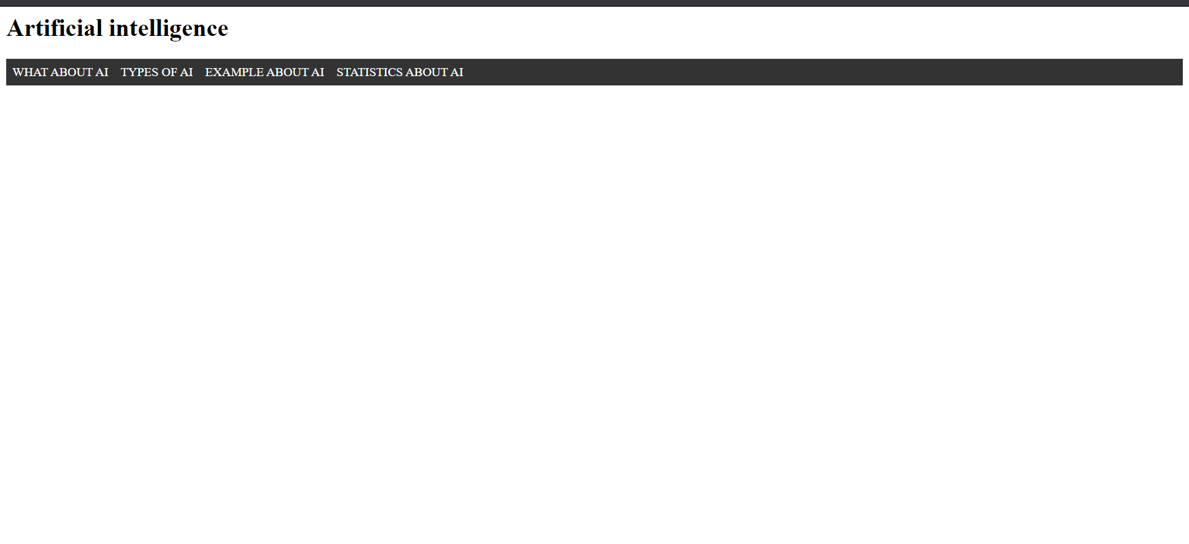

صورة تحتوي على لقطة شاشة

تم إنشاء الوصف تلقائياًصورة تحتوي على لقطة شاشة, كمبيوتر

تم إنشاء الوصف تلقائياًصورة تحتوي على لقطة شاشة

تم إنشاء الوصف تلقائياً

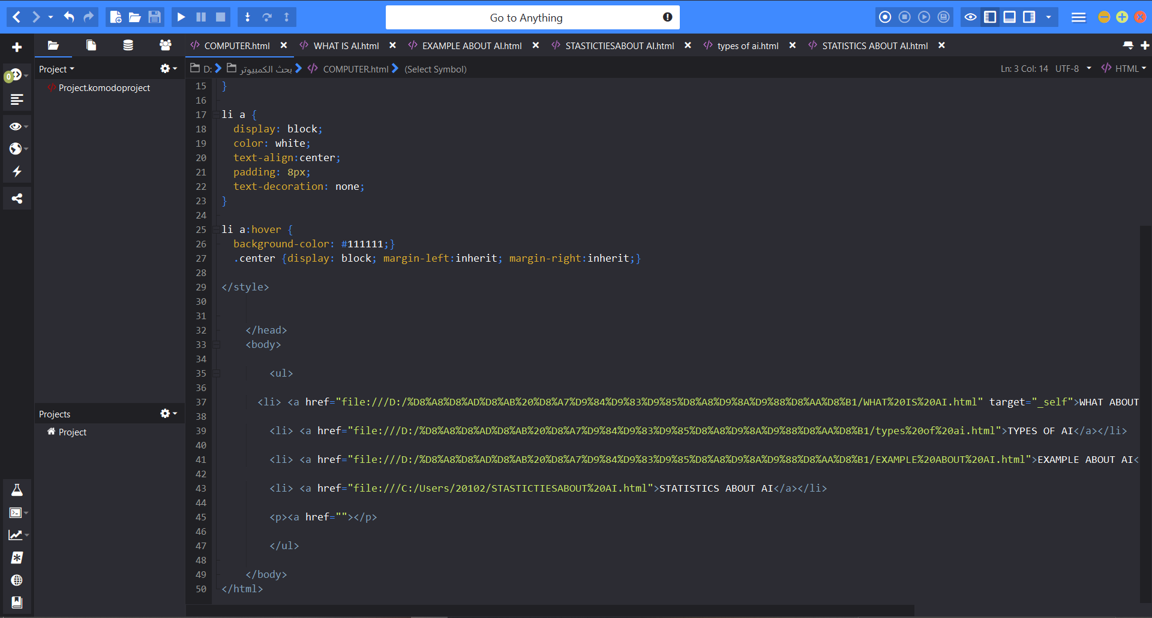

صورة تحتوي على لقطة شاشة, داخلي, كمبيوتر, كمبيوتر محمول

تم إنشاء الوصف تلقائياً

صورة تحتوي على لقطة شاشة, شاشة عرض, كمبيوتر محمول, كمبيوتر

تم إنشاء الوصف تلقائياًصورة تحتوي على شاشة عرض, لقطة شاشة, كمبيوتر, كمبيوتر محمول

تم إنشاء الوصف تلقائياً صورة تحتوي على لقطة شاشة, شاشة عرض, كمبيوتر, كمبيوتر محمول

تم إنشاء الوصف تلقائياً

**References**

Engdahl, S. (2008). Artificial intelligence. Farmington Hills, MI: Greenhaven Press

Perry, R. (2000). Artificial intelligence. New York: Franklin Watts

Brazdil, P., & Jorge, A. (2001). Progress in artificial intelligence. Berlin: Springer.