

Technical Safety Concept Lane Assistance

**Document Version: 1.0**



# Document history

|  |  |  |  |
| --- | --- | --- | --- |
| Date | Version | Editor | Description |
| 06/06/2019 | 1.0 | M. Elbanhawi | First submissio |
|  |  |  |  |
|  |  |  |  |
|  |  |  |  |
|  |  |  |  |

# 

# Table of Contents

Document history

Table of Contents

Purpose of the Technical Safety Concept

Inputs to the Technical Safety Concept

Functional Safety Requirements

Refined System Architecture from Functional Safety Concept

Functional overview of architecture elements

Technical Safety Concept

Technical Safety Requirements

Refinement of the System Architecture

Allocation of Technical Safety Requirements to Architecture Elements

Warning and Degradation Concept

# Purpose of the Technical Safety Concept

**[Instructions: Answer what is the purpose of a technical safety concept?]**

# Inputs to the Technical Safety Concept

## Functional Safety Requirements

|  |  |  |  |  |
| --- | --- | --- | --- | --- |
| **ID** | **Functional Safety Requirement** | **ASIL** | **Fault Tolerant Time Interval** | **Safe State** |
| Functional  Safety  Requirement  01-01 | The lane keeping item shall ensure that the lane departure oscillating torque amplitude is below Max_Torque_Amplitude | C | 50 ms | Disable system |
| Functional  Safety  Requirement  01-02 | The lane keeping item shall ensure that the lane departure oscillating torque frequency is below Max_Torque_Frequency | C | 50 ms | Disable system |
| Functional  Safety  Requirement  02-01 | The electronic power steering ECU shall limit lane keeping assistance torque for only Max_Duration | B | 500 ms | Disable system. |

## Refined System Architecture from Functional Safety Concept

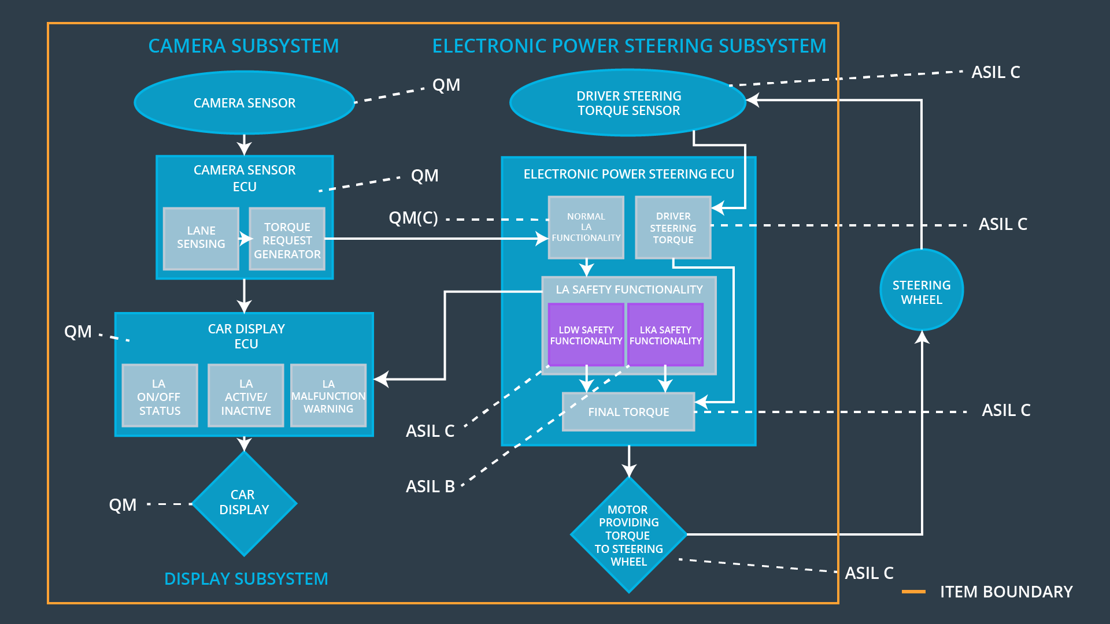

### 

### Functional overview of architecture elements

|  |  |
| --- | --- |
| **Element** | **Description** |
| Camera Sensor | Capture images of the road and send to the camera ECU |
| Camera Sensor ECU - Lane Sensing | Software module that processes images to determine lane and position of vehicle in lane |
| Camera Sensor ECU - Torque request generator | Software module the sends a torque request based on the lane sensing output to the power steering ECU |
| Car Display | HMI to the driver, displays light status for LKA and LDW |
| Car Display ECU - Lane Assistance On/Off Status | Indicates the status of Lane Assistance |
| Car Display ECU - Lane Assistant Active/Inactive | Indicates the activity of Lane Assistance |
| Car Display ECU - Lane Assistance malfunction warning | Indicates the functionality of Lane Assistance |
| Driver Steering Torque Sensor | Measures the steering input from the driver |
| Electronic Power Steering (EPS) ECU - Driver Steering Torque | Software block that receives torque input from the driver |
| EPS ECU - Normal Lane Assistance Functionality | Software block that receives torque request from Camera Sensor ECU – Torque request block |
| EPS ECU - Lane Departure Warning Safety Functionality | Software block that constrains the torque amplitude and frequency to Max_Torque_Amplitude and Max_Torque_Frequency respectively. |
| EPS ECU - Lane Keeping Assistant Safety Functionality | Software block that limits the LKA activity duration to Max_Duration |
| EPS ECU - Final Torque | Software block that combines torque request from LKA, LDW and send it to the motor |
| Motor | Applies torque request to the steering wheel |

# Technical Safety Concept

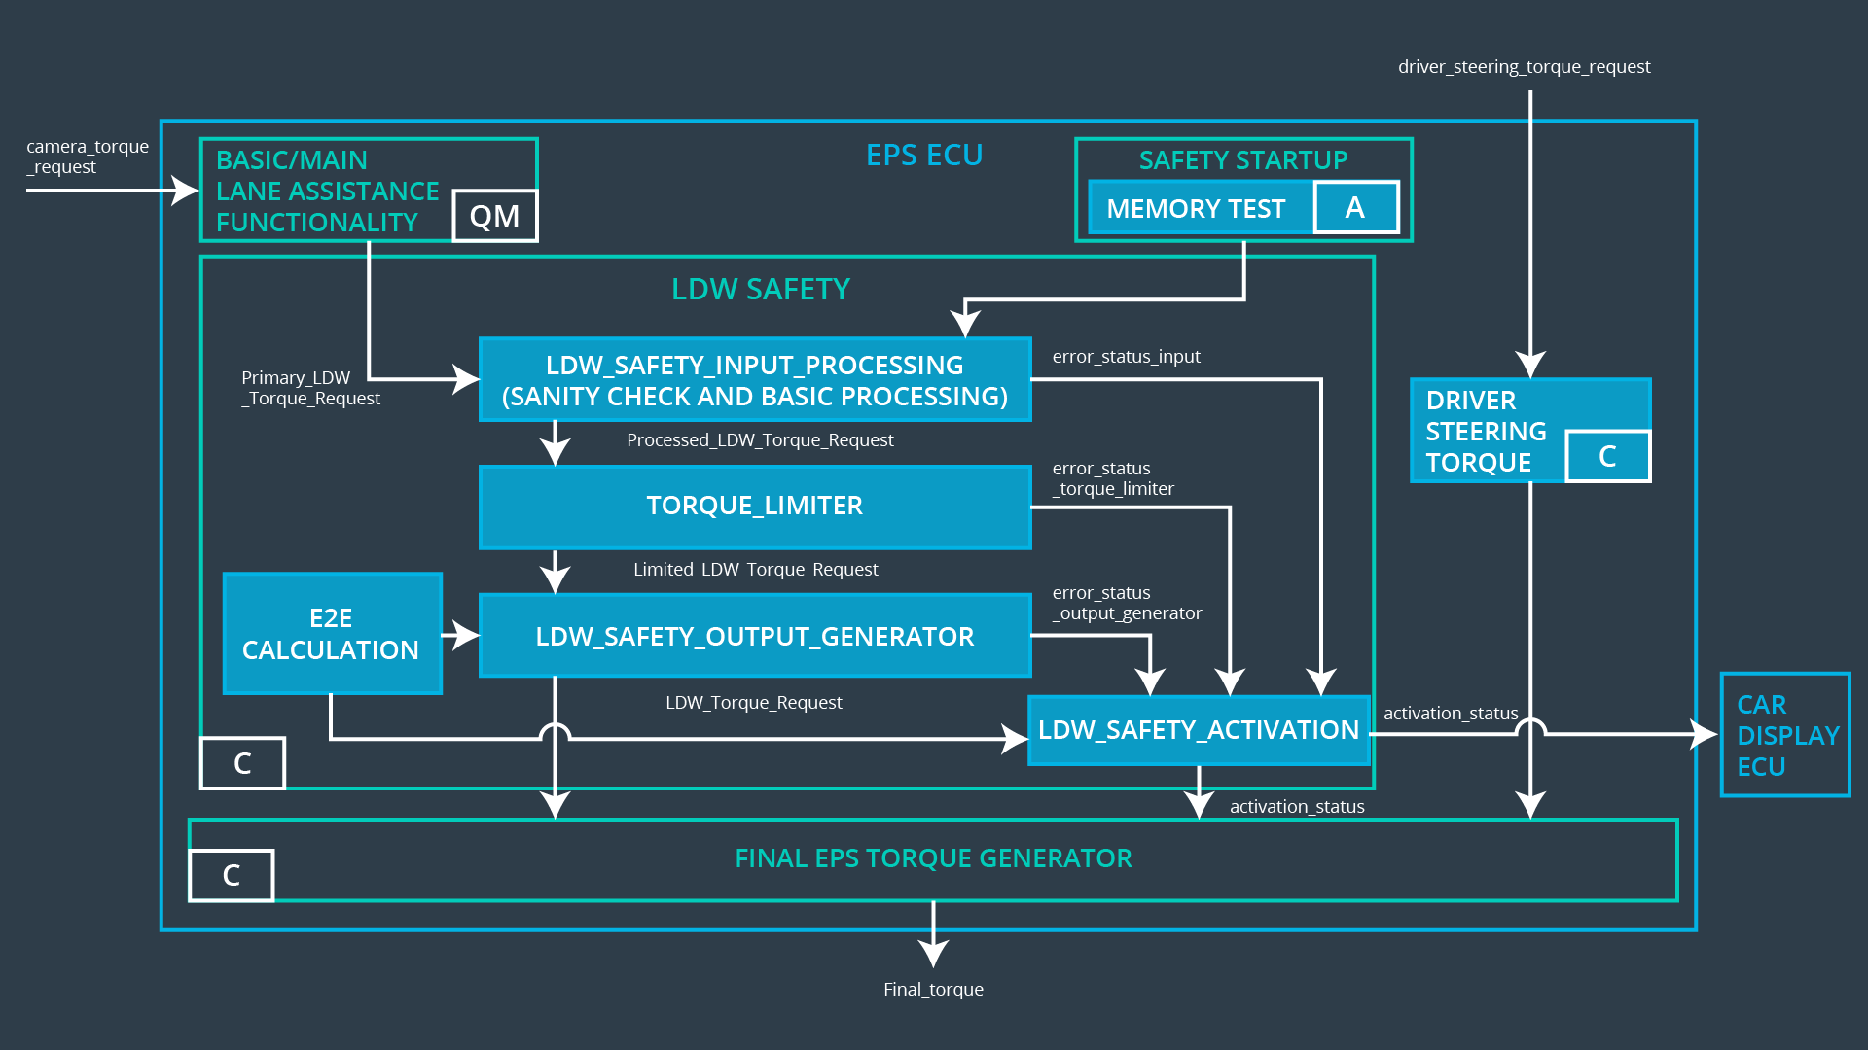

## Technical Safety Requirements

**Lane Departure Warning (LDW) Requirements:**

Functional Safety Requirement 01-01 with its associated system elements

(derived in the functional safety concept)

|  |  |  |  |  |
| --- | --- | --- | --- | --- |
| **ID** | **Functional Safety Requirement** | **Electronic Power Steering ECU** | **Camera ECU** | **Car Display ECU** |
| Functional  Safety  Requirement  01-01 | The lane keeping item shall ensure that the lane departure oscillating torque amplitude is below Max_Torque_Amplitude | X |  |  |

Technical Safety Requirements related to Functional Safety Requirement 01-01 are:

|  |  |  |  |  |  |
| --- | --- | --- | --- | --- | --- |
| **ID** | **Technical Safety Requirement** | **ASIL** | **Fault Tolerant Time Interval** | **Architecture Allocation** | **Safe State** |
| Technical  Safety  Requirement  01 | The LDW safety component shall ensure that the amplitude of the LDW_Torque_Request sent to the Final Electronic Power Steering Torque component is below Max_Torque_Amplitude | C | 50ms | LDW Safety | Disable LDW |
| Technical  Safety  Requirement  02 | The validity and integrity of the data transmission for LDW_Torque_Request signal shall be ensured | C | 50ms | LDW Safety | Disable LDW |
| Technical  Safety  Requirement  03 | As soon as a failure is detected by the LDW function, it shall deactivate the LDW feature and the LDW_Torque_Request shall be set to zero | C | 50ms | LDW Safety | Disable LDW |
| Technical  Safety  Requirement  04 | As soon as the LDW function deactivates the LDW feature, the LDW Safety software block shall send a signal to the car display ECU to turn on a warning light | C | 50ms | LDW Safety | Disable LDW |
| Technical  Safety  Requirement  05 | Memory test shall be conducted at start up of the EPS ECU to check for any faults in memory | A | Ignition Cycle | Data Transmission Integrity Check | Disable LDW |

Functional Safety Requirement 01-2 with its associated system elements

(derived in the functional safety concept)

|  |  |  |  |  |
| --- | --- | --- | --- | --- |
| **ID** | **Functional Safety Requirement** | **Electronic Power Steering ECU** | **Camera ECU** | **Car Display ECU** |
| Functional  Safety  Requirement  01-02 | The lane keeping item shall ensure that the lane departure oscillating torque frequency is below Max_Torque_Frequency | X |  |  |

Technical Safety Requirements related to Functional Safety Requirement 01-02 are:

|  |  |  |  |  |  |
| --- | --- | --- | --- | --- | --- |
| **ID** | **Technical Safety Requirement** | **ASIL** | **Fault Tolerant Time Interval** | **Architecture Allocation** | **Safe State** |
| Technical  Safety  Requirement  01 | The LDW safety component shall ensure that the amplitude of the LDW_Torque_Request sent to the Final Electronic Power Steering Torque component is below Max_Torque_Frequency | C | 50ms | LDW Safety | Disable LDW |
| Technical  Safety  Requirement  02 | The validity and integrity of the data transmission for LDW_Torque_Request signal shall be ensured | C | 50ms | LDW Safety | Disable LDW |
| Technical  Safety  Requirement  03 | As soon as a failure is detected by the LDW function, it shall deactivate the LDW feature and the LDW_Torque_Request shall be set to zero | C | 50ms | LDW Safety | Disable LDW |
| Technical  Safety  Requirement  04 | As soon as the LDW function deactivates the LDW feature, the LDW Safety software block shall send a signal to the car display ECU to turn on a warning light | C | 50ms | LDW Safety | Disable LDW |
| Technical  Safety  Requirement  05 | Memory test shall be conducted at start up of the EPS ECU to check for any faults in memory | A | Ignition Cycle | Data Transmission Integrity Check | Disable LDW |

**Lane Keeping Assistance (LKA) Requirements:**

Functional Safety Requirement 02-1 with its associated system elements

(derived in the functional safety concept)

|  |  |  |  |  |
| --- | --- | --- | --- | --- |
| **ID** | **Functional Safety Requirement** | **Electronic Power Steering ECU** | **Camera ECU** | **Car Display ECU** |
| Functional  Safety  Requirement  02-01 | The lane keeping item shall ensure that the lane keeping assistance torque is applied for only Max_Duration | X |  |  |

Technical Safety Requirements related to Functional Safety Requirement 02-01 are:

|  |  |  |  |  |  |
| --- | --- | --- | --- | --- | --- |
| **ID** | **Technical Safety Requirement** | **ASIL** | **Fault Tolerant Time Interval** | **Architecture Allocation** | **Safe State** |
| Technical  Safety  Requirement  01 | The LKA safety component shall ensure that the duration of the LKA_Torque_Request sent to the Final Electronic Power Steering Torque component is below Max_Duration | B | 50ms | LKA Safety | Disable LKA |
| Technical  Safety  Requirement  02 | The validity and integrity of the data transmission for LKA_Torque_Request Request signal shall be ensured | B | 50ms | LKA Safety | Disable LKA |
| Technical  Safety  Requirement  03 | As soon as a failure is detected by theLKA function, it shall deactivate the LKA feature and the LKA_Torque_Request shall be set to zero | B | 50ms | LKA Safety | Disable LKA |
| Technical  Safety  Requirement  04 | As soon as the LKA function deactivates the LKA feature, the LKA_Torque_Request block shall send a signal to the car display ECU to turn on a warning light | B | 50ms | LKA Safety | Disable LKA |
| Technical  Safety  Requirement  05 | Memory test shall be conducted at start up of the EPS ECU to check for any faults in memory | A | Ignition Cycle | Data Transmission Integrity Check | Disable LKA |

## Refinement of the System Architecture

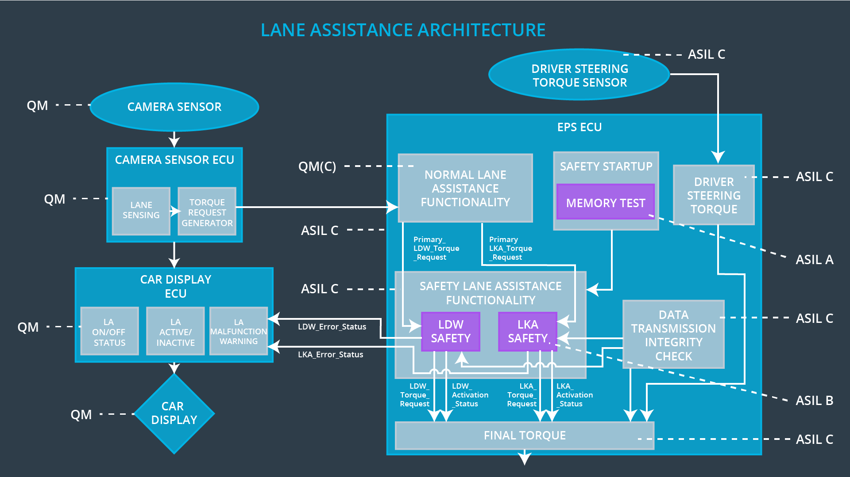

## Allocation of Technical Safety Requirements to Architecture Elements

|  |  |  |  |  |
| --- | --- | --- | --- | --- |
| **ID** | **Technical Safety Requirement** | **Electronic Power Steering ECU** | **Camera ECU** | **Car Display ECU** |
| Technical  Safety  Requirement  01-01-01 | The LDW safety component shall ensure that the amplitude of the LDW_Torque_Request sent to the Final Electronic Power Steering Torque component is below Max_Torque_Amplitude | **X** |  |  |
| Technical  Safety  Requirement  01-01-02 | The validity and integrity of the data transmission for LDW_Torque_Request signal shall be ensured | **X** |  |  |
| Technical  Safety  Requirement  01-01-03 | As soon as a failure is detected by the LDW function, it shall deactivate the LDW feature and the LDW_Torque_Request shall be set to zero | **X** |  |  |
| Technical  Safety  Requirement  01-01-04 | As soon as the LDW function deactivates the LDW feature, the LDW Safety software block shall send a signal to the car display ECU to turn on a warning light | **X** |  |  |
| Technical  Safety  Requirement  01-01-05 | Memory test shall be conducted at start up of the EPS ECU to check for any faults in memory | **X** |  |  |
| Technical  Safety  Requirement  01-02-01 | The LDW safety component shall ensure that the amplitude of the LDW_Torque_Request sent to the Final Electronic Power Steering Torque component is below Max_Torque_Frequency | **X** |  |  |
| Technical  Safety  Requirement  01-02-02 | The validity and integrity of the data transmission for LDW_Torque_Request signal shall be ensured | **X** |  |  |
| Technical  Safety  Requirement  01-02-03 | As soon as a failure is detected by the LDW function, it shall deactivate the LDW feature and the LDW_Torque_Request shall be set to zero | **X** |  |  |
| Technical  Safety  Requirement  01-02-04 | As soon as the LDW function deactivates the LDW feature, the LDW Safety software block shall send a signal to the car display ECU to turn on a warning light | **X** |  |  |
| Technical  Safety  Requirement  01-02-05 | Memory test shall be conducted at start up of the EPS ECU to check for any faults in memory | **X** |  |  |
| Technical  Safety  Requirement  02-01-01 | The LKA safety component shall ensure that the duration of the LKA_Torque_Request sent to the Final Electronic Power Steering Torque component is below Max_Duration | **X** |  |  |
| Technical  Safety  Requirement  02-01-02 | The validity and integrity of the data transmission for LKA_Torque_Request Request signal shall be ensured | **X** |  |  |
| Technical  Safety  Requirement  02-01-03 | As soon as a failure is detected by theLKA function, it shall deactivate the LKA feature and the LKA_Torque_Request shall be set to zero | **X** |  |  |
| Technical  Safety  Requirement  02-01-04 | As soon as the LKA function deactivates the LKA feature, the LKA_Torque_Request block shall send a signal to the car display ECU to turn on a warning light | **X** |  |  |
| Technical  Safety  Requirement  02-01-05 | Memory test shall be conducted at start up of the EPS ECU to check for any faults in memory | **X** |  |  |

## Warning and Degradation Concept

|  |  |  |  |  |
| --- | --- | --- | --- | --- |
| **ID** | **Degradation Mode** | **Trigger for Degradation Mode** | **Safe State invoked?** | **Driver Warning** |
| WDC-01 | Disable LDW | Malfunction_01,  Malfunction_02, | Yes | LDW Malfunction Warning on Car Display |
| WDC-02 | Disable LKW | Malfunction_03, | Yes | LKA Malfunction Warning on Car Display |