

Software Safety Requirements and Architecture

Lane Assistance

**Document Version: 1.0**



# Document history

|  |  |  |  |
| --- | --- | --- | --- |
| Date | Version | Editor | Description |
| 07/06/2019 | 1.0 | M. Elbanhawi | First submission |
|  |  |  |  |
|  |  |  |  |
|  |  |  |  |
|  |  |  |  |

# Table of Contents

Document history

Table of Contents

Purpose

Inputs to the Software Requirements and Architecture Document

Technical safety requirements

Refined Architecture Diagram from the Technical Safety Concept

Software Requirements

Refined Architecture Diagram

# Purpose

This document lists safety requirements for the software components at component level to identify potential failures on software design and architecture that could lead to a violation of safety goals. These Requirements are more detailed and fine grained than the technical safety concept requirements.

# Inputs to the Software Requirements and Architecture Document

## Technical safety requirements

Technical Safety Requirements related to Functional Safety Requirement 01-01 are:

|  |  |  |  |  |  |
| --- | --- | --- | --- | --- | --- |
| **ID** | **Technical Safety Requirement** | **ASIL** | **Fault Tolerant Time Interval** | **Architecture Allocation** | **Safe State** |
| Technical  Safety  Requirement  01 | The LDW safety component shall ensure that the amplitude of the LDW_Torque_Request sent to the Final Electronic Power Steering Torque component is below Max_Torque_Amplitude | C | 50ms | LDW Safety | Disable LDW |
| Technical  Safety  Requirement  02 | The validity and integrity of the data transmission for LDW_Torque_Request signal shall be ensured | C | 50ms | LDW Safety | Disable LDW |
| Technical  Safety  Requirement  03 | As soon as a failure is detected by the LDW function, it shall deactivate the LDW feature and the LDW_Torque_Request shall be set to zero | C | 50ms | LDW Safety | Disable LDW |
| Technical  Safety  Requirement  04 | As soon as the LDW function deactivates the LDW feature, the LDW Safety software block shall send a signal to the car display ECU to turn on a warning light | C | 50ms | LDW Safety | Disable LDW |
| Technical  Safety  Requirement  05 | Memory test shall be conducted at start up of the EPS ECU to check for any faults in memory | A | Ignition Cycle | Data Transmission Integrity Check | Disable LDW |

## Refined Architecture Diagram from the Technical Safety Concept

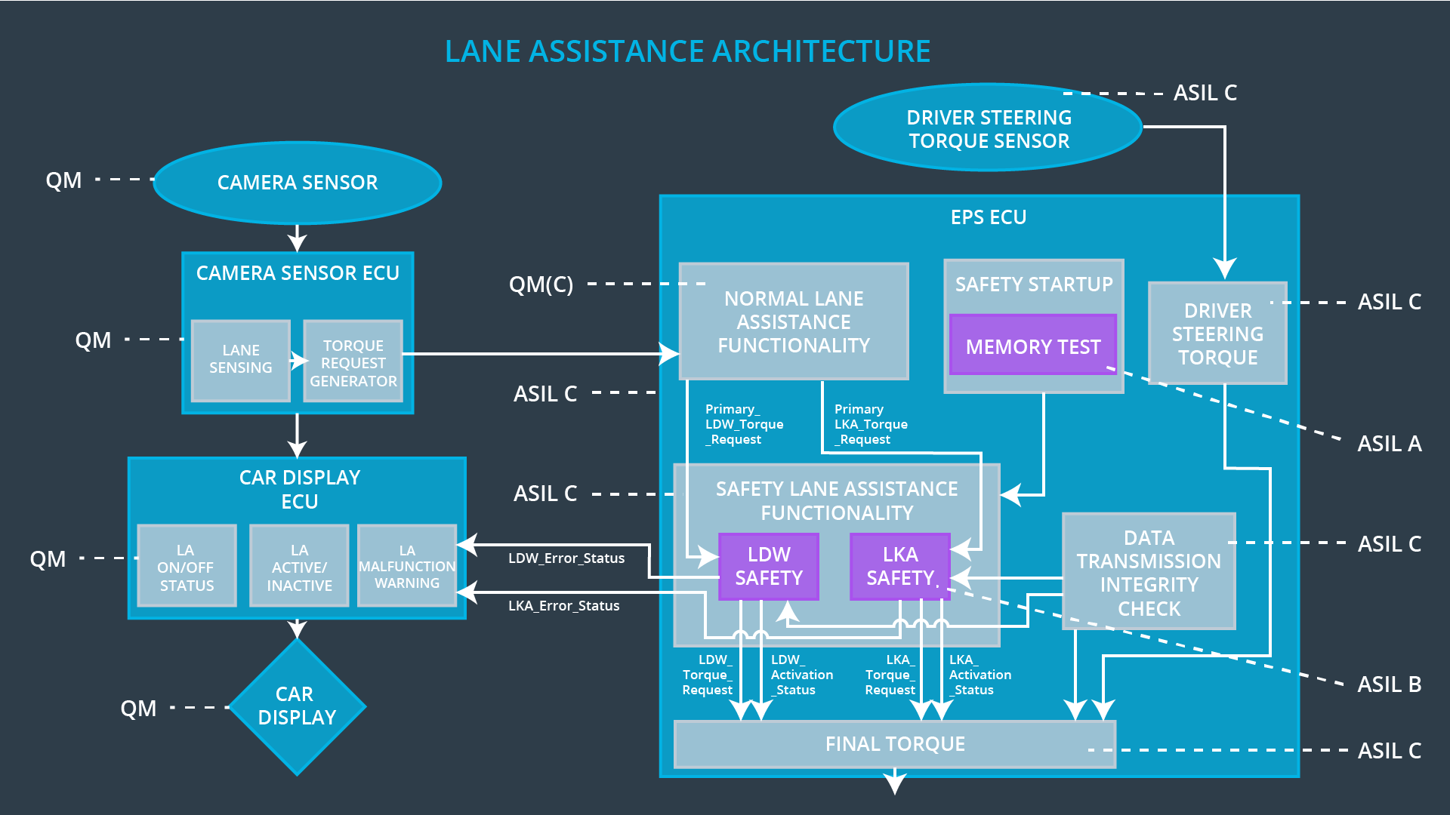

# Software Requirements

**Lane Departure Warning (LDW) Amplitude Malfunction Software Requirements:**

**]**

|  |  |  |  |  |  |
| --- | --- | --- | --- | --- | --- |
| **ID** | **Technical Safety Requirement** | **ASIL** | **Fault Tolerant Time Interval** | **Allocation to Architecture** | **Safe State** |
| Technical  Safety  Requirement  01 | The LDW safety component shall ensure that the amplitude of the LDW_Torque_Request sent to the Final Electronic Power Steering Torque component is below Max_Torque_Amplitude | C | 50ms | LDW Safety | Disable LDW |

|  |  |  |  |  |
| --- | --- | --- | --- | --- |
| ID | Software Safety Requirement | ASIL | Allocation Software Elements | Safe State |
| Software  Safety  Requirement  01-01 | The input signal “Primary_LDW_Torq_Req” shall be read and pre-processed to determine the torque request coming from the “Basic/Main LAFunctionality” SW Component. Signal “processed_LDW_Torq_Req” shall be generated at the end of the processing. | C | LDW_SAFETY_INPUT_PROCESSING | N/A |
| Software Safety Requirement 01-02 | In case the “processed_LDW_Torq_Req” signal has a value greater than “Max_Torque_Amplitude_LDW” (maximum allowed safe torque), the torque signal “limited_LDW_Torq_Req” shall be set to 0, else “limited_LDW_Torq_Req” shall take the value of “processed_LDW_Torq_Req”. | C | TORQUE_LIMITER | “limited_LDW_Torq_Req” = 0 (Nm=Newton-meter) |
| Software Safety Requirement 01-03 | The “limited_LDW_Torq_Req” shall be transformed into a signal “LDW_Torq_Req” which is suitable to be transmitted outside of the LDW Safety component (“LDW Safety”) to the “Final EPS Torque”component. Also see Software Safety Requirement 01-01 and Software Safety Requirement 02-02. | C | LDW_SAFETY_OUTPUT_GENERATOR | LDW_Torq_Req= 0 (Nm) |

|  |  |  |  |  |  |
| --- | --- | --- | --- | --- | --- |
| **ID** | **Technical Safety Requirement** | **ASIL** | **Fault Tolerant Time Interval** | **Allocation to Architecture** | **Safe State** |
| Technical  Safety  Requirement  02 | The validity and integrity of the data transmission for LDW_Torque_Request signal shall be ensured | C | 50ms | LDW Safety | Disable LDW by setting torque to zero |

|  |  |  |  |  |
| --- | --- | --- | --- | --- |
| **ID** | **Software Safety Requirement** | **ASIL** | **Allocation Software Elements** | **Safe State** |
| Software Safety Requirement 02-01 | Any data to be transmitted outside of the LDW Safety component (“LDW Safety”) including "LDW_Torque_Req" and “activation_status” (see Software Safety Requirement 01-01-03–02) shall be protected by an End2End(E2E) protection mechanism. | C | E2ECalc | LDW_Torq_Req= 0 (Nm) |
| Software Safety Requirement 02-02 | The E2E protection protocol shall contain and attach the control data: alive counter (SQC) and CRC to the data to be transmitted. | C | E2ECalc | LDW_Torq_Req= 0 (Nm) |

|  |  |  |  |  |  |
| --- | --- | --- | --- | --- | --- |
| **ID** | **Technical Safety Requirement** | **ASIL** | **Fault Tolerant Time Interval** | **Allocation to Architecture** | **Safe State** |
| Technical  Safety  Requirement  03 | As soon as a failure is detected by the LDW function, it shall deactivate the LDW feature and the LDW_Torque_Request shall be set to zero | C | 50ms | LDW Safety | Disable LDW by setting torque to zero |

|  |  |  |  |  |
| --- | --- | --- | --- | --- |
| **ID** | **Software Safety Requirement** | **ASIL** | **Allocation Software Elements** | **Safe State** |
| Software Safety Requirement03-01 | Each element shall output an error signal. Error signal = error_status_input(LDW_SAFETY_INPUT_PROCESSING), error_status_torque_limiter(TORQUE_LIMITER), error_status_output_gen(LDW_SAFETY_OUTPUT_GENERATOR) | C | All | N/A |
| Software Safety Requirement03-02 | A software element shall evaluate the error status of all the other software elements and in case any 1 of them indicates an error, it shall deactivate the LDW feature (“activation_status”=0) | C | LDW_SAFETY_ACTIVATION | Activation_status = 0 (LDW function deactivated) |
| Software Safety Requirement03-03 | In case of no errors from the software elements, the status of the LDW feature shall be set to activated (“activation_status”=1) | C | LDW_SAFETY_ACTIVATION | LDW_Torq_Req = 0 |
| Software Safety Requirement03-04 | In case an error is detected by any of the software elements, it shall set the value of its corresponding torque to 0 so that “LDW_Torq_Req” is set to 0 | C | All | N/A |
| Software Safety Requirement03-05 | Once the LDW functionality has been deactivated, it shall stay deactivated till the time the ignition is switched from off to on again. | C | LDW_SAFETY_ACTIVATION | Activation_status = 0 (LDW function deactivated) |

|  |  |  |  |  |  |
| --- | --- | --- | --- | --- | --- |
| **ID** | **Technical Safety Requirement** | **ASIL** | **Fault Tolerant Time Interval** | **Allocation to Architecture** | **Safe State** |
| Technical  Safety  Requirement  04 | As soon as the LDW function deactivates the LDW feature, the LDW Safety software block shall send a signal to the car display ECU to turn on a warning light | C | 50ms | LDW Safety | Disable LDW by setting torque to zero |

|  |  |  |  |  |
| --- | --- | --- | --- | --- |
| **ID** | **Software Safety Requirement** | **ASIL** | **Allocation Software Elements** | **Safe State** |
| Software Safety Requirement 04-01 | When the LDW function is deactivated the activation_status shall be relayed to the displayECU. | C | LDW_SAFETY_ACTIVATION, CarDisplay ECU | activation_status = 0 |

|  |  |  |  |  |  |
| --- | --- | --- | --- | --- | --- |
| **ID** | **Technical Safety Requirement** | **ASIL** | **Fault Tolerant Time Interval** | **Allocation to Architecture** | **Safe State** |
| Technical  Safety  Requirement  05 | Memory test shall be conducted at start up of the EPS ECU to check for any faults in memory | A | Ignition Cycle | Memory Test | LDW torque output set to zero |

|  |  |  |  |  |
| --- | --- | --- | --- | --- |
| **ID** | **Software Safety Requirement** | **ASIL** | **Allocation Software Elements** | **Safe State** |
| Software Safety Requirement 05-01 | A CRC verification check over the software code in the memory shall be on ignition | A | MEMORYTEST | Activation_status = 0 |
| Software Safety Requirement 05-02 | Standard RAM tests to check the data bus, address bus and device integrity shall be on ignition | A | MEMORYTEST | Activation_status = 0 |
| Software Safety Requirement 05-03 | The test result of the RAM or Flash memory shall be indicated to the LDW_Safety component via the “test_status” signal | A | MEMORYTEST | Activation_status = 0 |
| Software Safety Requirement 05-04 | In case any fault is indicated via the “test_status” signal the INPUT_LDW_PROCESSING shall set an error on error_status_input (=1) so that the LDW functionality is deactivated and the LDWTorque is set to 0 | A | LDW_SAFETY_INPUT_PROCESSING | Activation_status = 0 |

# 

# Refined Architecture Diagram

