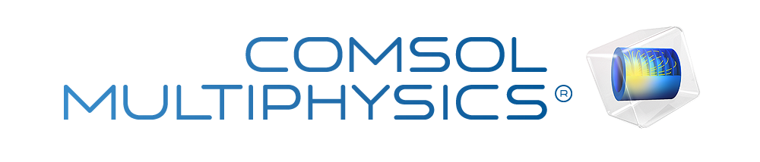

MEMS Pressure Sensor Phase5
Author | Belloula Mohamed Iyed
Report date | Sep 22, 2026, 9:07:06 AM
Company | National School of Nanoscience and Nanotechnology

Summary
Piezoresistive MEMS pressure sensor simulation under varying pressure and temperature conditions.
Contents
1. Global Definitions
1.1. Parameters
1.2. Shared Properties
2. Component 1
2.1. Definitions
2.2. Geometry 1
2.3. Materials
2.4. Solid Mechanics
2.5. Electric Currents
2.6. Electrical Circuit
2.7. Multiphysics
2.8. Mesh 1
3. Study 1
3.1. Parametric Sweep
3.2. Stationary
3.3. Solver Configurations
4. Results
4.1. Datasets
4.2. Derived Values
4.3. Tables
4.4. Plot Groups

- Global Definitions
Date | Sep 15, 2026, 3:42:25 PM

Global settings
Name | MEMS Pressure Sensor Phase5.mph
Path | D:\Nano_Sensors_2026\COMSOL\day 1\MEMS_Pressure_Sensor_Phase5.mph
Version | COMSOL Multiphysics 6.1 (Build: 282)
Unit system | SI

Used products
CAD Import Module
COMSOL Multiphysics
MEMS Module

Computer information
CPU | Intel64 Family 6 Model 154 Stepping 3, 16 cores, 15.69 GB RAM
Operating system | Windows 10

  - Parameters
Parameters 1
Name | Expression | Value | Description
L_sub | 2000[um] | 0.002 m | طول القاعدة
th_sub | 400[um] | 4E−4 m | سمك القاعدة الكلي
L_mem | 1000[um] | 0.001 m | طول الغشاء
th_mem | 20[um] | 2E−5 m | سمك الغشاء المرن
P_app | 100[kPa] | 1E5 Pa | الضغط التجريبي
T_ref | 293.15[K] | 293.15 K | Reference temperature (20 deg C)
T_amb | 293.15[K] | 293.15 K | Ambient operating temperature
alpha_TCR | 1.5e-3[1/K] | 0.0015 1/K | Temperature coefficient of resistance
alpha_TCS | -1.8e-3[1/K] | −0.0018 1/K | Temperature coefficient of sensitivity
A_v | 1475 | 1475 | Amplifier voltage gain

  - Shared Properties
    - Default Model Inputs
Tag | cminpt

- Component 1
Date | Sep 9, 2026, 3:56:44 PM

Settings
Description | Value
Unit system | Same as global system (SI)
Geometry shape function | Automatic

Spatial frame coordinates
First | Second | Third
x | y | z

Material frame coordinates
First | Second | Third
X | Y | Z

Geometry frame coordinates
First | Second | Third
Xg | Yg | Zg

Mesh frame coordinates
First | Second | Third
Xm | Ym | Zm

  - Definitions
    - Coordinate Systems

Boundary System 1
Coordinate system type | Boundary system
Tag | sys1

Coordinate names
First | Second | Third
t1 | t2 | n

  - Geometry 1
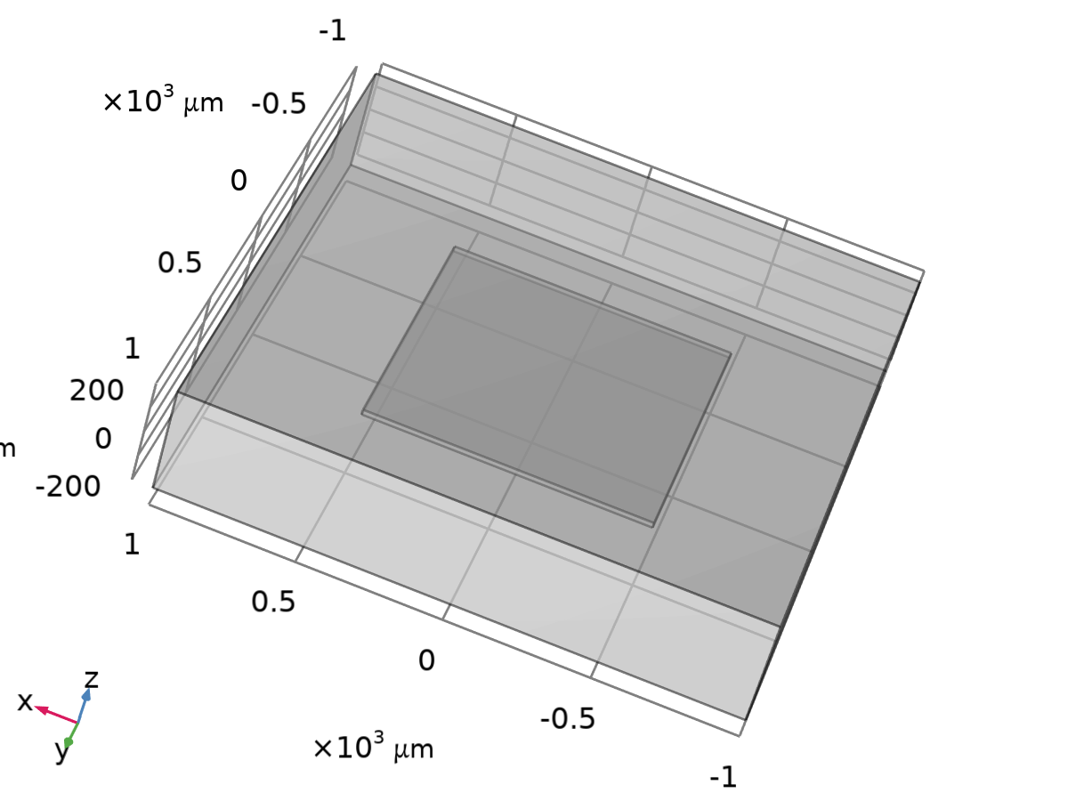
Geometry 1
Units
Length unit | µm
Angular unit | deg

Geometry statistics
Description | Value
Space dimension | 3
Number of domains | 1
Number of boundaries | 12
Number of edges | 24
Number of vertices | 16

    - Block 1 (blk1)
Position
Description | Value
Position | {0, 0, 0}
Base | Center

Axis
Description | Value
Axis type | z - axis

Size and shape
Description | Value
Width | L_sub
Depth | L_sub
Height | th_sub

    - Block 2 (blk2)
Position
Description | Value
Position | {0, 0, -th_mem / 2}
Base | Center

Axis
Description | Value
Axis type | z - axis

Size and shape
Description | Value
Width | L_mem
Depth | L_mem
Height | th_mem

  - Materials
    - p-Silicon (single-crystal, lightly doped)
C. S. Smith, “Piezoresistance Effect in Silicon and Germanium”, Physical Review, vol. 94, no. 1, pp. 42-49, 1957.
C. Jacoboni, C. Canali, G. Ottaviani and A. Alberigi Quaranta, “A Review of some Charge Transport Properties of Silicon”, Solid-State Electronics, vol. 20, pp. 77-89, 1977.
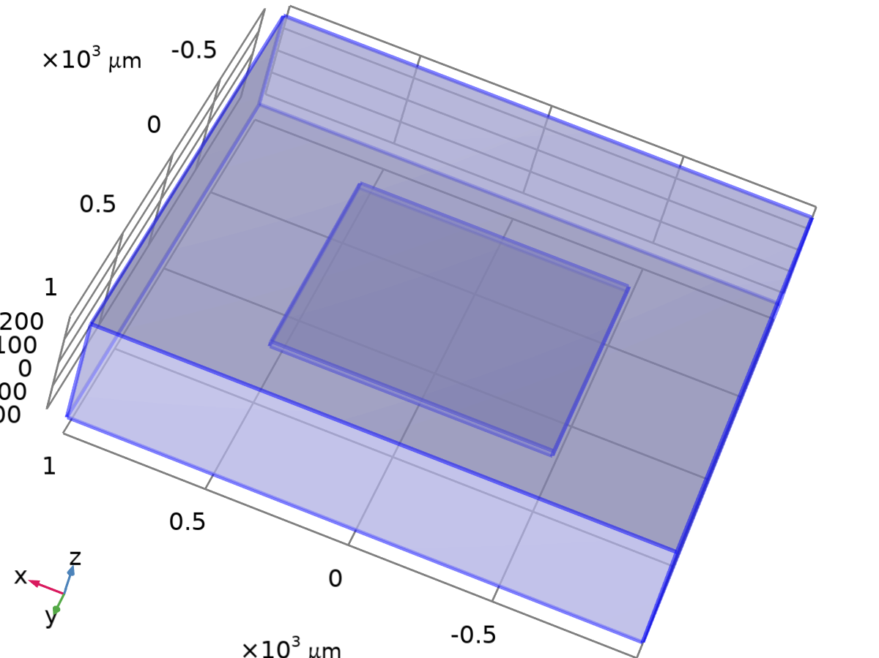
p-Silicon (single-crystal, lightly doped)
Selection
Geometric entity level | Domain
Selection | Geometry geom1: Dimension 3: Domain 1

Material parameters
Name | Value | Unit | Property group
Density | 2330 | kg/m³ | Basic
Relative permittivity | 4.5 | 1 | Basic
Electrical conductivity | sigma0(nd) | S/m | Basic
Elasticity matrix | {1.66E11, 6.4E10, 1.66E11, 6.4E10, 6.4E10, 1.66E11, 0, 0, 0, 8E10, 0, 0, 0, 0, 8E10, 0, 0, 0, 0, 0, 8E10} | Pa | Anisotropic
Piezoresistive coupling matrix, Voigt notation | {6.6E-11/sigma0(nd),-1.1E-11/sigma0(nd),6.6E-11/sigma0(nd),-1.1E-11/sigma0(nd),-1.1E-11/sigma0(nd),6.6E-11/sigma0(nd),0,0,0,1.381E-9/sigma0(nd),0,0,0,0,1.381E-9/sigma0(nd),0,0,0,0,0,1.381E-9/sigma0(nd)} | m⁴/(s·A²) | Piezoresistance form

Basic
Description | Value | Unit
Density | 2330 | kg/m³
Relative permittivity | 4.5 | 1
Electrical conductivity | sigma0(nd) | S/m

Functions
Function name | Type
sigma0 | Analytic

Anisotropic
Description | Value | Unit
Elasticity matrix | {1.66E11, 6.4E10, 6.4E10, 0, 0, 0, 6.4E10, 1.66E11, 6.4E10, 0, 0, 0, 6.4E10, 6.4E10, 1.66E11, 0, 0, 0, 0, 0, 0, 8E10, 0, 0, 0, 0, 0, 0, 8E10, 0, 0, 0, 0, 0, 0, 8E10} | Pa

Piezoresistance form
Description | Value | Unit
Piezoresistive coupling matrix, Voigt notation | {6.6E-11/sigma0(nd), -1.1E-11/sigma0(nd), -1.1E-11/sigma0(nd), 0, 0, 0, -1.1E-11/sigma0(nd), 6.6E-11/sigma0(nd), -1.1E-11/sigma0(nd), 0, 0, 0, -1.1E-11/sigma0(nd), -1.1E-11/sigma0(nd), 6.6E-11/sigma0(nd), 0, 0, 0, 0, 0, 0, 1.381E-9/sigma0(nd), 0, 0, 0, 0, 0, 0, 1.381E-9/sigma0(nd), 0, 0, 0, 0, 0, 0, 1.381E-9/sigma0(nd)} | m⁴/(s·A²)

Functions
Function name | Type
sigma0 | Analytic

Functions
Function name | Type
sigma0 | Analytic

  - Solid Mechanics
Used products
COMSOL Multiphysics
MEMS Module

Solid Mechanics
Selection
Geometric entity level | Domain
Selection | Geometry geom1: Dimension 3: All domains

Equations
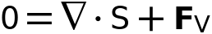
    - Interface Settings

Physics Symbols
Settings
Description | Value
Enable physics symbols | Off

Discretization
Settings
Description | Value
Displacement field | Quadratic serendipity

Settings
Description | Value
Structural transient behavior | Include inertial terms

Transient Solver Settings
Settings
Description | Value
Description | Changes made to these settings only take effect when the default solver is generated.
Maximum frequency to resolve | Off

Typical Wave Speed for Perfectly Matched Layers
Settings
Description | Value | Unit
Typical wave speed for perfectly matched layers | solid.cp | m/s

Port Sweep Settings
Settings
Description | Value
Activate port sweep | Off

    - Variables
Name | Expression | Unit | Description | Selection | Details
solid.X | X | m | Material coordinates, X-component | Domain 1
solid.Y | Y | m | Material coordinates, Y-component | Domain 1
solid.Z | Z | m | Material coordinates, Z-component | Domain 1
solid.X | X | m | Material coordinates, X-component | Boundaries 1–12
solid.Y | Y | m | Material coordinates, Y-component | Boundaries 1–12
solid.Z | Z | m | Material coordinates, Z-component | Boundaries 1–12
solid.x | x | m | Spatial coordinates, x-component | Domain 1
solid.y | y | m | Spatial coordinates, y-component | Domain 1
solid.z | z | m | Spatial coordinates, z-component | Domain 1
solid.x | x | m | Spatial coordinates, x-component | Boundaries 1–12
solid.y | y | m | Spatial coordinates, y-component | Boundaries 1–12
solid.z | z | m | Spatial coordinates, z-component | Boundaries 1–12
solid.uf | u | m | Displacement field, X-component | Domain 1
solid.vf | v | m | Displacement field, Y-component | Domain 1
solid.wf | w | m | Displacement field, Z-component | Domain 1
solid.uf | u | m | Displacement field, X-component | Boundaries 1–12
solid.vf | v | m | Displacement field, Y-component | Boundaries 1–12
solid.wf | w | m | Displacement field, Z-component | Boundaries 1–12
solid.nX | dnX | 1 | Normal vector, X-component | Boundaries 1–12
solid.nY | dnY | 1 | Normal vector, Y-component | Boundaries 1–12
solid.nZ | dnZ | 1 | Normal vector, Z-component | Boundaries 1–12
solid.nx | dnx | 1 | Normal vector, x-component | Boundaries 1–12
solid.ny | dny | 1 | Normal vector, y-component | Boundaries 1–12
solid.nz | dnz | 1 | Normal vector, z-component | Boundaries 1–12
solid.nXmesh | dnXmesh | 1 | Normal vector (mesh), X-component | Boundaries 1–12
solid.nYmesh | dnYmesh | 1 | Normal vector (mesh), Y-component | Boundaries 1–12
solid.nZmesh | dnZmesh | 1 | Normal vector (mesh), Z-component | Boundaries 1–12
solid.nxmesh | dnxmesh | 1 | Normal vector (mesh), x-component | Boundaries 1–12
solid.nymesh | dnymesh | 1 | Normal vector (mesh), y-component | Boundaries 1–12
solid.nzmesh | dnzmesh | 1 | Normal vector (mesh), z-component | Boundaries 1–12
solid.beta_dK | 0 | s | Stiffness damping parameter | Domain 1 | + operation
solid.cref | solid.cp | m/s | Typical wave speed for perfectly matched layers | Domain 1
solid.isGeomNon | 0 | 1 | Geometric nonlinearity variable | Global
solid.RFtotalx | solid.sumreaction(solid.RFx)+solid.RFfsx+solid.RFfdx | N | Total reaction force, x-component | Global | + operation
solid.RFtotaly | solid.sumreaction(solid.RFy)+solid.RFfsy+solid.RFfdy | N | Total reaction force, y-component | Global | + operation
solid.RFtotalz | solid.sumreaction(solid.RFz)+solid.RFfsz+solid.RFfdz | N | Total reaction force, z-component | Global | + operation
solid.RMtotalx | solid.sumreaction(solid.RMx)+solid.RMmsx+solid.RMmdx | N·m | Total reaction moment, x-component | Global | + operation
solid.RMtotaly | solid.sumreaction(solid.RMy)+solid.RMmsy+solid.RMmdy | N·m | Total reaction moment, y-component | Global | + operation
solid.RMtotalz | solid.sumreaction(solid.RMz)+solid.RMmsz+solid.RMmdz | N·m | Total reaction moment, z-component | Global | + operation
xt | d(x,TIME) | m/s | Mesh velocity, x-component | Global
yt | d(y,TIME) | m/s | Mesh velocity, y-component | Global
zt | d(z,TIME) | m/s | Mesh velocity, z-component | Global

    - Linear Elastic Material 1
Linear Elastic Material 1
Selection
Geometric entity level | Domain
Selection | Geometry geom1: Dimension 3: All domains

Equations
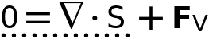
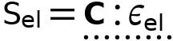
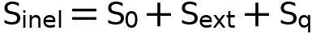
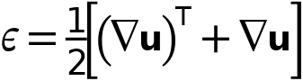
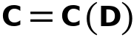

Linear Elastic Material
Settings
Description | Value
Material symmetry | Anisotropic
Specify | Elasticity matrix
Material data ordering | Standard (11, 22, 33, 12, 23, 13)
Elasticity matrix | From material
Density | From material
Use mixed formulation | None

Geometric Nonlinearity
Settings
Description | Value
Geometrically linear formulation | Off
Additive strain decomposition | Off

Quadrature Settings
Settings
Description | Value
Reduced integration | Off

Coordinate System Selection
Settings
Description | Value
Coordinate system | Global coordinate system

Model Input
Settings
Description | Value | Unit
Number density | User defined
Number density | 0 | 1/m³

Properties from material
Property | Material | Property group
Elasticity matrix | p-Silicon (single-crystal, lightly doped) | Anisotropic
Density | p-Silicon (single-crystal, lightly doped) | Basic

Variables
Name | Expression | Unit | Description | Selection | Details
solid.eXX | solid.gradUxX | 1 | Strain tensor, XX-component | Domain 1 | + operation
solid.eXY | 0.5*(solid.gradUxY+solid.gradUyX) | 1 | Strain tensor, XY-component | Domain 1 | + operation
solid.eXZ | 0.5*(solid.gradUxZ+solid.gradUzX) | 1 | Strain tensor, XZ-component | Domain 1 | + operation
solid.eYY | solid.gradUyY | 1 | Strain tensor, YY-component | Domain 1 | + operation
solid.eYZ | 0.5*(solid.gradUyZ+solid.gradUzY) | 1 | Strain tensor, YZ-component | Domain 1 | + operation
solid.eZZ | solid.gradUzZ | 1 | Strain tensor, ZZ-component | Domain 1 | + operation
solid.SXX | solid.Sl11 | N/m² | Second Piola-Kirchhoff stress, XX-component | Domain 1
solid.SXY | solid.Sl12 | N/m² | Second Piola-Kirchhoff stress, XY-component | Domain 1
solid.SXZ | solid.Sl13 | N/m² | Second Piola-Kirchhoff stress, XZ-component | Domain 1
solid.SYY | solid.Sl22 | N/m² | Second Piola-Kirchhoff stress, YY-component | Domain 1
solid.SYZ | solid.Sl23 | N/m² | Second Piola-Kirchhoff stress, YZ-component | Domain 1
solid.SZZ | solid.Sl33 | N/m² | Second Piola-Kirchhoff stress, ZZ-component | Domain 1
solid.disp | sqrteps(real(u)^2+real(v)^2+real(w)^2) | m | Displacement magnitude | Domain 1
solid.curlUX | solid.gradUzY-solid.gradUyZ | 1 | Curl of displacement, X-component | Domain 1
solid.curlUY | solid.gradUxZ-solid.gradUzX | 1 | Curl of displacement, Y-component | Domain 1
solid.curlUZ | solid.gradUyX-solid.gradUxY | 1 | Curl of displacement, Z-component | Domain 1
solid.gradUxX | uX | 1 | Displacement gradient, xX-component | Domain 1
solid.gradUyX | vX | 1 | Displacement gradient, yX-component | Domain 1
solid.gradUzX | wX | 1 | Displacement gradient, zX-component | Domain 1
solid.gradUxY | uY | 1 | Displacement gradient, xY-component | Domain 1
solid.gradUyY | vY | 1 | Displacement gradient, yY-component | Domain 1
solid.gradUzY | wY | 1 | Displacement gradient, zY-component | Domain 1
solid.gradUxZ | uZ | 1 | Displacement gradient, xZ-component | Domain 1
solid.gradUyZ | vZ | 1 | Displacement gradient, yZ-component | Domain 1
solid.gradUzZ | wZ | 1 | Displacement gradient, zZ-component | Domain 1
solid.FdxX | 1+solid.gradUxX | 1 | Deformation gradient, xX-component | Domain 1
solid.FdyX | solid.gradUyX | 1 | Deformation gradient, yX-component | Domain 1
solid.FdzX | solid.gradUzX | 1 | Deformation gradient, zX-component | Domain 1
solid.FdxY | solid.gradUxY | 1 | Deformation gradient, xY-component | Domain 1
solid.FdyY | 1+solid.gradUyY | 1 | Deformation gradient, yY-component | Domain 1
solid.FdzY | solid.gradUzY | 1 | Deformation gradient, zY-component | Domain 1
solid.FdxZ | solid.gradUxZ | 1 | Deformation gradient, xZ-component | Domain 1
solid.FdyZ | solid.gradUyZ | 1 | Deformation gradient, yZ-component | Domain 1
solid.FdzZ | 1+solid.gradUzZ | 1 | Deformation gradient, zZ-component | Domain 1
solid.FdiXx | (solid.FdyY*solid.FdzZ-solid.FdyZ*solid.FdzY)/(solid.FdxX*solid.FdyY*solid.FdzZ+solid.FdxY*solid.FdyZ*solid.FdzX+solid.FdxZ*solid.FdyX*solid.FdzY-solid.FdxX*solid.FdyZ*solid.FdzY-solid.FdxY*solid.FdyX*solid.FdzZ-solid.FdxZ*solid.FdyY*solid.FdzX) | 1 | Deformation gradient inverse, Xx-component | Domain 1
solid.FdiYx | (solid.FdyZ*solid.FdzX-solid.FdyX*solid.FdzZ)/(solid.FdxX*solid.FdyY*solid.FdzZ+solid.FdxY*solid.FdyZ*solid.FdzX+solid.FdxZ*solid.FdyX*solid.FdzY-solid.FdxX*solid.FdyZ*solid.FdzY-solid.FdxY*solid.FdyX*solid.FdzZ-solid.FdxZ*solid.FdyY*solid.FdzX) | 1 | Deformation gradient inverse, Yx-component | Domain 1
solid.FdiZx | (solid.FdyX*solid.FdzY-solid.FdyY*solid.FdzX)/(solid.FdxX*solid.FdyY*solid.FdzZ+solid.FdxY*solid.FdyZ*solid.FdzX+solid.FdxZ*solid.FdyX*solid.FdzY-solid.FdxX*solid.FdyZ*solid.FdzY-solid.FdxY*solid.FdyX*solid.FdzZ-solid.FdxZ*solid.FdyY*solid.FdzX) | 1 | Deformation gradient inverse, Zx-component | Domain 1
solid.FdiXy | (solid.FdxZ*solid.FdzY-solid.FdxY*solid.FdzZ)/(solid.FdxX*solid.FdyY*solid.FdzZ+solid.FdxY*solid.FdyZ*solid.FdzX+solid.FdxZ*solid.FdyX*solid.FdzY-solid.FdxX*solid.FdyZ*solid.FdzY-solid.FdxY*solid.FdyX*solid.FdzZ-solid.FdxZ*solid.FdyY*solid.FdzX) | 1 | Deformation gradient inverse, Xy-component | Domain 1
solid.FdiYy | (solid.FdxX*solid.FdzZ-solid.FdxZ*solid.FdzX)/(solid.FdxX*solid.FdyY*solid.FdzZ+solid.FdxY*solid.FdyZ*solid.FdzX+solid.FdxZ*solid.FdyX*solid.FdzY-solid.FdxX*solid.FdyZ*solid.FdzY-solid.FdxY*solid.FdyX*solid.FdzZ-solid.FdxZ*solid.FdyY*solid.FdzX) | 1 | Deformation gradient inverse, Yy-component | Domain 1
solid.FdiZy | (solid.FdxY*solid.FdzX-solid.FdxX*solid.FdzY)/(solid.FdxX*solid.FdyY*solid.FdzZ+solid.FdxY*solid.FdyZ*solid.FdzX+solid.FdxZ*solid.FdyX*solid.FdzY-solid.FdxX*solid.FdyZ*solid.FdzY-solid.FdxY*solid.FdyX*solid.FdzZ-solid.FdxZ*solid.FdyY*solid.FdzX) | 1 | Deformation gradient inverse, Zy-component | Domain 1
solid.FdiXz | (solid.FdxY*solid.FdyZ-solid.FdxZ*solid.FdyY)/(solid.FdxX*solid.FdyY*solid.FdzZ+solid.FdxY*solid.FdyZ*solid.FdzX+solid.FdxZ*solid.FdyX*solid.FdzY-solid.FdxX*solid.FdyZ*solid.FdzY-solid.FdxY*solid.FdyX*solid.FdzZ-solid.FdxZ*solid.FdyY*solid.FdzX) | 1 | Deformation gradient inverse, Xz-component | Domain 1
solid.FdiYz | (solid.FdxZ*solid.FdyX-solid.FdxX*solid.FdyZ)/(solid.FdxX*solid.FdyY*solid.FdzZ+solid.FdxY*solid.FdyZ*solid.FdzX+solid.FdxZ*solid.FdyX*solid.FdzY-solid.FdxX*solid.FdyZ*solid.FdzY-solid.FdxY*solid.FdyX*solid.FdzZ-solid.FdxZ*solid.FdyY*solid.FdzX) | 1 | Deformation gradient inverse, Yz-component | Domain 1
solid.FdiZz | (solid.FdxX*solid.FdyY-solid.FdxY*solid.FdyX)/(solid.FdxX*solid.FdyY*solid.FdzZ+solid.FdxY*solid.FdyZ*solid.FdzX+solid.FdxZ*solid.FdyX*solid.FdzY-solid.FdxX*solid.FdyZ*solid.FdzY-solid.FdxY*solid.FdyX*solid.FdzZ-solid.FdxZ*solid.FdyY*solid.FdzX) | 1 | Deformation gradient inverse, Zz-component | Domain 1
solid.J | solid.FdxX*solid.FdyY*solid.FdzZ+solid.FdxY*solid.FdyZ*solid.FdzX+solid.FdxZ*solid.FdyX*solid.FdzY-solid.FdxX*solid.FdyZ*solid.FdzY-solid.FdxY*solid.FdyX*solid.FdzZ-solid.FdxZ*solid.FdyY*solid.FdzX | 1 | Volume ratio | Domain 1
solid.Ji | 1/(solid.Fiil11*solid.Fiil22*solid.Fiil33+solid.Fiil12*solid.Fiil23*solid.Fiil31+solid.Fiil13*solid.Fiil21*solid.Fiil32-solid.Fiil11*solid.Fiil23*solid.Fiil32-solid.Fiil12*solid.Fiil21*solid.Fiil33-solid.Fiil13*solid.Fiil22*solid.Fiil31) | 1 | Inelastic volume ratio | Domain 1
solid.Fdlx1 | solid.FdxX | 1 | Deformation gradient, local, x1-component | Domain 1
solid.Fdly1 | solid.FdyX | 1 | Deformation gradient, local, y1-component | Domain 1
solid.Fdlz1 | solid.FdzX | 1 | Deformation gradient, local, z1-component | Domain 1
solid.Fdlx2 | solid.FdxY | 1 | Deformation gradient, local, x2-component | Domain 1
solid.Fdly2 | solid.FdyY | 1 | Deformation gradient, local, y2-component | Domain 1
solid.Fdlz2 | solid.FdzY | 1 | Deformation gradient, local, z2-component | Domain 1
solid.Fdlx3 | solid.FdxZ | 1 | Deformation gradient, local, x3-component | Domain 1
solid.Fdly3 | solid.FdyZ | 1 | Deformation gradient, local, y3-component | Domain 1
solid.Fdlz3 | solid.FdzZ | 1 | Deformation gradient, local, z3-component | Domain 1
solid.Fil11 | (solid.Fiil22*solid.Fiil33-solid.Fiil23*solid.Fiil32)/(solid.Fiil11*solid.Fiil22*solid.Fiil33+solid.Fiil12*solid.Fiil23*solid.Fiil31+solid.Fiil13*solid.Fiil21*solid.Fiil32-solid.Fiil11*solid.Fiil23*solid.Fiil32-solid.Fiil12*solid.Fiil21*solid.Fiil33-solid.Fiil13*solid.Fiil22*solid.Fiil31) | 1 | Inelastic deformation gradient, local coordinate system, 11-component | Domain 1 | Matrix multiplication
solid.Fil21 | (solid.Fiil23*solid.Fiil31-solid.Fiil21*solid.Fiil33)/(solid.Fiil11*solid.Fiil22*solid.Fiil33+solid.Fiil12*solid.Fiil23*solid.Fiil31+solid.Fiil13*solid.Fiil21*solid.Fiil32-solid.Fiil11*solid.Fiil23*solid.Fiil32-solid.Fiil12*solid.Fiil21*solid.Fiil33-solid.Fiil13*solid.Fiil22*solid.Fiil31) | 1 | Inelastic deformation gradient, local coordinate system, 21-component | Domain 1 | Matrix multiplication
solid.Fil31 | (solid.Fiil21*solid.Fiil32-solid.Fiil22*solid.Fiil31)/(solid.Fiil11*solid.Fiil22*solid.Fiil33+solid.Fiil12*solid.Fiil23*solid.Fiil31+solid.Fiil13*solid.Fiil21*solid.Fiil32-solid.Fiil11*solid.Fiil23*solid.Fiil32-solid.Fiil12*solid.Fiil21*solid.Fiil33-solid.Fiil13*solid.Fiil22*solid.Fiil31) | 1 | Inelastic deformation gradient, local coordinate system, 31-component | Domain 1 | Matrix multiplication
solid.Fil12 | (solid.Fiil13*solid.Fiil32-solid.Fiil12*solid.Fiil33)/(solid.Fiil11*solid.Fiil22*solid.Fiil33+solid.Fiil12*solid.Fiil23*solid.Fiil31+solid.Fiil13*solid.Fiil21*solid.Fiil32-solid.Fiil11*solid.Fiil23*solid.Fiil32-solid.Fiil12*solid.Fiil21*solid.Fiil33-solid.Fiil13*solid.Fiil22*solid.Fiil31) | 1 | Inelastic deformation gradient, local coordinate system, 12-component | Domain 1 | Matrix multiplication
solid.Fil22 | (solid.Fiil11*solid.Fiil33-solid.Fiil13*solid.Fiil31)/(solid.Fiil11*solid.Fiil22*solid.Fiil33+solid.Fiil12*solid.Fiil23*solid.Fiil31+solid.Fiil13*solid.Fiil21*solid.Fiil32-solid.Fiil11*solid.Fiil23*solid.Fiil32-solid.Fiil12*solid.Fiil21*solid.Fiil33-solid.Fiil13*solid.Fiil22*solid.Fiil31) | 1 | Inelastic deformation gradient, local coordinate system, 22-component | Domain 1 | Matrix multiplication
solid.Fil32 | (solid.Fiil12*solid.Fiil31-solid.Fiil11*solid.Fiil32)/(solid.Fiil11*solid.Fiil22*solid.Fiil33+solid.Fiil12*solid.Fiil23*solid.Fiil31+solid.Fiil13*solid.Fiil21*solid.Fiil32-solid.Fiil11*solid.Fiil23*solid.Fiil32-solid.Fiil12*solid.Fiil21*solid.Fiil33-solid.Fiil13*solid.Fiil22*solid.Fiil31) | 1 | Inelastic deformation gradient, local coordinate system, 32-component | Domain 1 | Matrix multiplication
solid.Fil13 | (solid.Fiil12*solid.Fiil23-solid.Fiil13*solid.Fiil22)/(solid.Fiil11*solid.Fiil22*solid.Fiil33+solid.Fiil12*solid.Fiil23*solid.Fiil31+solid.Fiil13*solid.Fiil21*solid.Fiil32-solid.Fiil11*solid.Fiil23*solid.Fiil32-solid.Fiil12*solid.Fiil21*solid.Fiil33-solid.Fiil13*solid.Fiil22*solid.Fiil31) | 1 | Inelastic deformation gradient, local coordinate system, 13-component | Domain 1 | Matrix multiplication
solid.Fil23 | (solid.Fiil13*solid.Fiil21-solid.Fiil11*solid.Fiil23)/(solid.Fiil11*solid.Fiil22*solid.Fiil33+solid.Fiil12*solid.Fiil23*solid.Fiil31+solid.Fiil13*solid.Fiil21*solid.Fiil32-solid.Fiil11*solid.Fiil23*solid.Fiil32-solid.Fiil12*solid.Fiil21*solid.Fiil33-solid.Fiil13*solid.Fiil22*solid.Fiil31) | 1 | Inelastic deformation gradient, local coordinate system, 23-component | Domain 1 | Matrix multiplication
solid.Fil33 | (solid.Fiil11*solid.Fiil22-solid.Fiil12*solid.Fiil21)/(solid.Fiil11*solid.Fiil22*solid.Fiil33+solid.Fiil12*solid.Fiil23*solid.Fiil31+solid.Fiil13*solid.Fiil21*solid.Fiil32-solid.Fiil11*solid.Fiil23*solid.Fiil32-solid.Fiil12*solid.Fiil21*solid.Fiil33-solid.Fiil13*solid.Fiil22*solid.Fiil31) | 1 | Inelastic deformation gradient, local coordinate system, 33-component | Domain 1 | Matrix multiplication
solid.Fiil11 | 1 | 1 | Inelastic deformation gradient inverse, local coordinate system, 11-component | Domain 1 | Matrix multiplication
solid.Fiil21 | 0 | 1 | Inelastic deformation gradient inverse, local coordinate system, 21-component | Domain 1 | Matrix multiplication
solid.Fiil31 | 0 | 1 | Inelastic deformation gradient inverse, local coordinate system, 31-component | Domain 1 | Matrix multiplication
solid.Fiil12 | 0 | 1 | Inelastic deformation gradient inverse, local coordinate system, 12-component | Domain 1 | Matrix multiplication
solid.Fiil22 | 1 | 1 | Inelastic deformation gradient inverse, local coordinate system, 22-component | Domain 1 | Matrix multiplication
solid.Fiil32 | 0 | 1 | Inelastic deformation gradient inverse, local coordinate system, 32-component | Domain 1 | Matrix multiplication
solid.Fiil13 | 0 | 1 | Inelastic deformation gradient inverse, local coordinate system, 13-component | Domain 1 | Matrix multiplication
solid.Fiil23 | 0 | 1 | Inelastic deformation gradient inverse, local coordinate system, 23-component | Domain 1 | Matrix multiplication
solid.Fiil33 | 1 | 1 | Inelastic deformation gradient inverse, local coordinate system, 33-component | Domain 1 | Matrix multiplication
solid.Jel | sqrt(solid.Cel11*solid.Cel22*solid.Cel33+2*solid.Cel12*solid.Cel23*solid.Cel13-solid.Cel11*solid.Cel23^2-solid.Cel12^2*solid.Cel33-solid.Cel22*solid.Cel13^2) | 1 | Elastic volume ratio | Domain 1
solid.CXX | solid.FdxX^2+solid.FdyX^2+solid.FdzX^2 | 1 | Cauchy-Green tensor, XX-component | Domain 1
solid.CXY | solid.FdxX*solid.FdxY+solid.FdyX*solid.FdyY+solid.FdzX*solid.FdzY | 1 | Cauchy-Green tensor, XY-component | Domain 1
solid.CXZ | solid.FdxX*solid.FdxZ+solid.FdyX*solid.FdyZ+solid.FdzX*solid.FdzZ | 1 | Cauchy-Green tensor, XZ-component | Domain 1
solid.CYY | solid.FdxY^2+solid.FdyY^2+solid.FdzY^2 | 1 | Cauchy-Green tensor, YY-component | Domain 1
solid.CYZ | solid.FdxY*solid.FdxZ+solid.FdyY*solid.FdyZ+solid.FdzY*solid.FdzZ | 1 | Cauchy-Green tensor, YZ-component | Domain 1
solid.CZZ | solid.FdxZ^2+solid.FdyZ^2+solid.FdzZ^2 | 1 | Cauchy-Green tensor, ZZ-component | Domain 1
solid.Cl11 | 1+2*solid.el11 | 1 | Cauchy-Green tensor, local coordinate system, 11-component | Domain 1
solid.Cl12 | 2*solid.el12 | 1 | Cauchy-Green tensor, local coordinate system, 12-component | Domain 1
solid.Cl13 | 2*solid.el13 | 1 | Cauchy-Green tensor, local coordinate system, 13-component | Domain 1
solid.Cl22 | 1+2*solid.el22 | 1 | Cauchy-Green tensor, local coordinate system, 22-component | Domain 1
solid.Cl23 | 2*solid.el23 | 1 | Cauchy-Green tensor, local coordinate system, 23-component | Domain 1
solid.Cl33 | 1+2*solid.el33 | 1 | Cauchy-Green tensor, local coordinate system, 33-component | Domain 1
solid.Cel11 | (solid.Fiil11*solid.Cl11+solid.Fiil21*solid.Cl12+solid.Fiil31*solid.Cl13)*solid.Fiil11+(solid.Fiil11*solid.Cl12+solid.Fiil21*solid.Cl22+solid.Fiil31*solid.Cl23)*solid.Fiil21+(solid.Fiil11*solid.Cl13+solid.Fiil21*solid.Cl23+solid.Fiil31*solid.Cl33)*solid.Fiil31 | 1 | Elastic Cauchy-Green tensor, local coordinate system, 11-component | Domain 1
solid.Cel12 | (solid.Fiil11*solid.Cl11+solid.Fiil21*solid.Cl12+solid.Fiil31*solid.Cl13)*solid.Fiil12+(solid.Fiil11*solid.Cl12+solid.Fiil21*solid.Cl22+solid.Fiil31*solid.Cl23)*solid.Fiil22+(solid.Fiil11*solid.Cl13+solid.Fiil21*solid.Cl23+solid.Fiil31*solid.Cl33)*solid.Fiil32 | 1 | Elastic Cauchy-Green tensor, local coordinate system, 12-component | Domain 1
solid.Cel13 | (solid.Fiil11*solid.Cl11+solid.Fiil21*solid.Cl12+solid.Fiil31*solid.Cl13)*solid.Fiil13+(solid.Fiil11*solid.Cl12+solid.Fiil21*solid.Cl22+solid.Fiil31*solid.Cl23)*solid.Fiil23+(solid.Fiil11*solid.Cl13+solid.Fiil21*solid.Cl23+solid.Fiil31*solid.Cl33)*solid.Fiil33 | 1 | Elastic Cauchy-Green tensor, local coordinate system, 13-component | Domain 1
solid.Cel22 | (solid.Fiil12*solid.Cl11+solid.Fiil22*solid.Cl12+solid.Fiil32*solid.Cl13)*solid.Fiil12+(solid.Fiil12*solid.Cl12+solid.Fiil22*solid.Cl22+solid.Fiil32*solid.Cl23)*solid.Fiil22+(solid.Fiil12*solid.Cl13+solid.Fiil22*solid.Cl23+solid.Fiil32*solid.Cl33)*solid.Fiil32 | 1 | Elastic Cauchy-Green tensor, local coordinate system, 22-component | Domain 1
solid.Cel23 | (solid.Fiil12*solid.Cl11+solid.Fiil22*solid.Cl12+solid.Fiil32*solid.Cl13)*solid.Fiil13+(solid.Fiil12*solid.Cl12+solid.Fiil22*solid.Cl22+solid.Fiil32*solid.Cl23)*solid.Fiil23+(solid.Fiil12*solid.Cl13+solid.Fiil22*solid.Cl23+solid.Fiil32*solid.Cl33)*solid.Fiil33 | 1 | Elastic Cauchy-Green tensor, local coordinate system, 23-component | Domain 1
solid.Cel33 | (solid.Fiil13*solid.Cl11+solid.Fiil23*solid.Cl12+solid.Fiil33*solid.Cl13)*solid.Fiil13+(solid.Fiil13*solid.Cl12+solid.Fiil23*solid.Cl22+solid.Fiil33*solid.Cl23)*solid.Fiil23+(solid.Fiil13*solid.Cl13+solid.Fiil23*solid.Cl23+solid.Fiil33*solid.Cl33)*solid.Fiil33 | 1 | Elastic Cauchy-Green tensor, local coordinate system, 33-component | Domain 1
solid.Ceil11 | (solid.Cel22*solid.Cel33-solid.Cel23^2)/(solid.Cel11*solid.Cel22*solid.Cel33+2*solid.Cel12*solid.Cel23*solid.Cel13-solid.Cel11*solid.Cel23^2-solid.Cel12^2*solid.Cel33-solid.Cel22*solid.Cel13^2) | 1 | Elastic Cauchy-Green tensor inverse, local coordinate system, 11-component | Domain 1
solid.Ceil12 | (solid.Cel23*solid.Cel13-solid.Cel12*solid.Cel33)/(solid.Cel11*solid.Cel22*solid.Cel33+2*solid.Cel12*solid.Cel23*solid.Cel13-solid.Cel11*solid.Cel23^2-solid.Cel12^2*solid.Cel33-solid.Cel22*solid.Cel13^2) | 1 | Elastic Cauchy-Green tensor inverse, local coordinate system, 12-component | Domain 1
solid.Ceil13 | (solid.Cel12*solid.Cel23-solid.Cel22*solid.Cel13)/(solid.Cel11*solid.Cel22*solid.Cel33+2*solid.Cel12*solid.Cel23*solid.Cel13-solid.Cel11*solid.Cel23^2-solid.Cel12^2*solid.Cel33-solid.Cel22*solid.Cel13^2) | 1 | Elastic Cauchy-Green tensor inverse, local coordinate system, 13-component | Domain 1
solid.Ceil22 | (solid.Cel11*solid.Cel33-solid.Cel13^2)/(solid.Cel11*solid.Cel22*solid.Cel33+2*solid.Cel12*solid.Cel23*solid.Cel13-solid.Cel11*solid.Cel23^2-solid.Cel12^2*solid.Cel33-solid.Cel22*solid.Cel13^2) | 1 | Elastic Cauchy-Green tensor inverse, local coordinate system, 22-component | Domain 1
solid.Ceil23 | (solid.Cel12*solid.Cel13-solid.Cel11*solid.Cel23)/(solid.Cel11*solid.Cel22*solid.Cel33+2*solid.Cel12*solid.Cel23*solid.Cel13-solid.Cel11*solid.Cel23^2-solid.Cel12^2*solid.Cel33-solid.Cel22*solid.Cel13^2) | 1 | Elastic Cauchy-Green tensor inverse, local coordinate system, 23-component | Domain 1
solid.Ceil33 | (solid.Cel11*solid.Cel22-solid.Cel12^2)/(solid.Cel11*solid.Cel22*solid.Cel33+2*solid.Cel12*solid.Cel23*solid.Cel13-solid.Cel11*solid.Cel23^2-solid.Cel12^2*solid.Cel33-solid.Cel22*solid.Cel13^2) | 1 | Elastic Cauchy-Green tensor inverse, local coordinate system, 33-component | Domain 1
solid.el11 | solid.eXX | 1 | Strain tensor, local coordinate system, 11-component | Domain 1 | + operation
solid.el12 | solid.eXY | 1 | Strain tensor, local coordinate system, 12-component | Domain 1 | + operation
solid.el13 | solid.eXZ | 1 | Strain tensor, local coordinate system, 13-component | Domain 1 | + operation
solid.el22 | solid.eYY | 1 | Strain tensor, local coordinate system, 22-component | Domain 1 | + operation
solid.el23 | solid.eYZ | 1 | Strain tensor, local coordinate system, 23-component | Domain 1 | + operation
solid.el33 | solid.eZZ | 1 | Strain tensor, local coordinate system, 33-component | Domain 1 | + operation
solid.evol | solid.eXX+solid.eYY+solid.eZZ | 1 | Volumetric strain | Domain 1
solid.eldev11 | solid.el11-solid.evol/3 | 1 | Deviatoric strain tensor, local coordinate system, 11-component | Domain 1
solid.eldev12 | solid.el12 | 1 | Deviatoric strain tensor, local coordinate system, 12-component | Domain 1
solid.eldev13 | solid.el13 | 1 | Deviatoric strain tensor, local coordinate system, 13-component | Domain 1
solid.eldev22 | solid.el22-solid.evol/3 | 1 | Deviatoric strain tensor, local coordinate system, 22-component | Domain 1
solid.eldev23 | solid.el23 | 1 | Deviatoric strain tensor, local coordinate system, 23-component | Domain 1
solid.eldev33 | solid.el33-solid.evol/3 | 1 | Deviatoric strain tensor, local coordinate system, 33-component | Domain 1
solid.edeve | sqrt(2*(solid.eldev11^2+2*solid.eldev12^2+2*solid.eldev13^2+solid.eldev22^2+2*solid.eldev23^2+solid.eldev33^2)/3+eps^2) | 1 | Equivalent deviatoric strain | Domain 1
solid.eel11 | solid.el11-solid.eiel11 | 1 | Elastic strain tensor, local coordinate system, 11-component | Domain 1
solid.eel12 | solid.el12-solid.eiel12 | 1 | Elastic strain tensor, local coordinate system, 12-component | Domain 1
solid.eel13 | solid.el13-solid.eiel13 | 1 | Elastic strain tensor, local coordinate system, 13-component | Domain 1
solid.eel22 | solid.el22-solid.eiel22 | 1 | Elastic strain tensor, local coordinate system, 22-component | Domain 1
solid.eel23 | solid.el23-solid.eiel23 | 1 | Elastic strain tensor, local coordinate system, 23-component | Domain 1
solid.eel33 | solid.el33-solid.eiel33 | 1 | Elastic strain tensor, local coordinate system, 33-component | Domain 1
solid.eil11 | 0 | 1 | Initial strain tensor, local coordinate system, 11-component | Domain 1 | + operation
solid.eil12 | 0 | 1 | Initial strain tensor, local coordinate system, 12-component | Domain 1 | + operation
solid.eil13 | 0 | 1 | Initial strain tensor, local coordinate system, 13-component | Domain 1 | + operation
solid.eil22 | 0 | 1 | Initial strain tensor, local coordinate system, 22-component | Domain 1 | + operation
solid.eil23 | 0 | 1 | Initial strain tensor, local coordinate system, 23-component | Domain 1 | + operation
solid.eil33 | 0 | 1 | Initial strain tensor, local coordinate system, 33-component | Domain 1 | + operation
solid.eiel11 | solid.eil11 | 1 | Inelastic strain tensor, local coordinate system, 11-component | Domain 1 | + operation
solid.eiel12 | solid.eil12 | 1 | Inelastic strain tensor, local coordinate system, 12-component | Domain 1 | + operation
solid.eiel13 | solid.eil13 | 1 | Inelastic strain tensor, local coordinate system, 13-component | Domain 1 | + operation
solid.eiel22 | solid.eil22 | 1 | Inelastic strain tensor, local coordinate system, 22-component | Domain 1 | + operation
solid.eiel23 | solid.eil23 | 1 | Inelastic strain tensor, local coordinate system, 23-component | Domain 1 | + operation
solid.eiel33 | solid.eil33 | 1 | Inelastic strain tensor, local coordinate system, 33-component | Domain 1 | + operation
solid.II2eel | 0.5*(solid.eeldev11^2+2*solid.eeldev12^2+2*solid.eeldev13^2+solid.eeldev22^2+2*solid.eeldev23^2+solid.eeldev33^2) | 1 | Second invariant of deviatoric elastic strain tensor | Domain 1
solid.eelvol | solid.eel11+solid.eel22+solid.eel33 | 1 | First invariant of elastic strain tensor | Domain 1
solid.eeldev11 | solid.eel11-(solid.eel11+solid.eel22+solid.eel33)/3 | 1 | Deviatoric elastic strain tensor, local coordinate system, 11-component | Domain 1
solid.eeldev12 | solid.eel12 | 1 | Deviatoric elastic strain tensor, local coordinate system, 12-component | Domain 1
solid.eeldev13 | solid.eel13 | 1 | Deviatoric elastic strain tensor, local coordinate system, 13-component | Domain 1
solid.eeldev22 | solid.eel22-(solid.eel11+solid.eel22+solid.eel33)/3 | 1 | Deviatoric elastic strain tensor, local coordinate system, 22-component | Domain 1
solid.eeldev23 | solid.eel23 | 1 | Deviatoric elastic strain tensor, local coordinate system, 23-component | Domain 1
solid.eeldev33 | solid.eel33-(solid.eel11+solid.eel22+solid.eel33)/3 | 1 | Deviatoric elastic strain tensor, local coordinate system, 33-component | Domain 1
solid.eeXX | solid.eel11 | 1 | Elastic strain tensor, local coordinate system, | Domain 1
solid.eeXY | solid.eel12 | 1 | Elastic strain tensor, local coordinate system, | Domain 1
solid.eeXZ | solid.eel13 | 1 | Elastic strain tensor, local coordinate system, | Domain 1
solid.eeYY | solid.eel22 | 1 | Elastic strain tensor, local coordinate system, | Domain 1
solid.eeYZ | solid.eel23 | 1 | Elastic strain tensor, local coordinate system, | Domain 1
solid.eeZZ | solid.eel33 | 1 | Elastic strain tensor, local coordinate system, | Domain 1
solid.sel11 | solid.D11*solid.eel11+solid.D12*solid.eel22+solid.D13*solid.eel33+2*solid.D14*solid.eel12+2*solid.D15*solid.eel23+2*solid.D16*solid.eel13 | N/m² | Elastic stress tensor, local coordinate system, 11-component | Domain 1
solid.sel12 | solid.D14*solid.eel11+solid.D24*solid.eel22+solid.D34*solid.eel33+2*solid.D44*solid.eel12+2*solid.D45*solid.eel23+2*solid.D46*solid.eel13 | N/m² | Elastic stress tensor, local coordinate system, 12-component | Domain 1
solid.sel13 | solid.D16*solid.eel11+solid.D26*solid.eel22+solid.D36*solid.eel33+2*solid.D46*solid.eel12+2*solid.D56*solid.eel23+2*solid.D66*solid.eel13 | N/m² | Elastic stress tensor, local coordinate system, 13-component | Domain 1
solid.sel22 | solid.D12*solid.eel11+solid.D22*solid.eel22+solid.D23*solid.eel33+2*solid.D24*solid.eel12+2*solid.D25*solid.eel23+2*solid.D26*solid.eel13 | N/m² | Elastic stress tensor, local coordinate system, 22-component | Domain 1
solid.sel23 | solid.D15*solid.eel11+solid.D25*solid.eel22+solid.D35*solid.eel33+2*solid.D45*solid.eel12+2*solid.D55*solid.eel23+2*solid.D56*solid.eel13 | N/m² | Elastic stress tensor, local coordinate system, 23-component | Domain 1
solid.sel33 | solid.D13*solid.eel11+solid.D23*solid.eel22+solid.D33*solid.eel33+2*solid.D34*solid.eel12+2*solid.D35*solid.eel23+2*solid.D36*solid.eel13 | N/m² | Elastic stress tensor, local coordinate system, 33-component | Domain 1
solid.siel11 | solid.Siel11 | N/m² | Inelastic stress tensor, local coordinate system, 11-component | Domain 1
solid.siel12 | solid.Siel12 | N/m² | Inelastic stress tensor, local coordinate system, 12-component | Domain 1
solid.siel13 | solid.Siel13 | N/m² | Inelastic stress tensor, local coordinate system, 13-component | Domain 1
solid.siel22 | solid.Siel22 | N/m² | Inelastic stress tensor, local coordinate system, 22-component | Domain 1
solid.siel23 | solid.Siel23 | N/m² | Inelastic stress tensor, local coordinate system, 23-component | Domain 1
solid.siel33 | solid.Siel33 | N/m² | Inelastic stress tensor, local coordinate system, 33-component | Domain 1
solid.sxx | solid.SXX | N/m² | Stress tensor, xx-component | Domain 1
solid.sxy | solid.SXY | N/m² | Stress tensor, xy-component | Domain 1
solid.sxz | solid.SXZ | N/m² | Stress tensor, xz-component | Domain 1
solid.syy | solid.SYY | N/m² | Stress tensor, yy-component | Domain 1
solid.syz | solid.SYZ | N/m² | Stress tensor, yz-component | Domain 1
solid.szz | solid.SZZ | N/m² | Stress tensor, zz-component | Domain 1
solid.sl11 | solid.Sl11 | N/m² | Stress tensor, local coordinate system, 11-component | Domain 1
solid.sl12 | solid.Sl12 | N/m² | Stress tensor, local coordinate system, 12-component | Domain 1
solid.sl13 | solid.Sl13 | N/m² | Stress tensor, local coordinate system, 13-component | Domain 1
solid.sl22 | solid.Sl22 | N/m² | Stress tensor, local coordinate system, 22-component | Domain 1
solid.sl23 | solid.Sl23 | N/m² | Stress tensor, local coordinate system, 23-component | Domain 1
solid.sl33 | solid.Sl33 | N/m² | Stress tensor, local coordinate system, 33-component | Domain 1
solid.sdevxx | solid.sxx-(solid.sxx+solid.syy+solid.szz)/3 | N/m² | Deviatoric stress tensor, xx-component | Domain 1
solid.sdevxy | solid.sxy | N/m² | Deviatoric stress tensor, xy-component | Domain 1
solid.sdevxz | solid.sxz | N/m² | Deviatoric stress tensor, xz-component | Domain 1
solid.sdevyy | solid.syy-(solid.sxx+solid.syy+solid.szz)/3 | N/m² | Deviatoric stress tensor, yy-component | Domain 1
solid.sdevyz | solid.syz | N/m² | Deviatoric stress tensor, yz-component | Domain 1
solid.sdevzz | solid.szz-(solid.sxx+solid.syy+solid.szz)/3 | N/m² | Deviatoric stress tensor, zz-component | Domain 1
solid.sldev11 | solid.sl11-(solid.sl11+solid.sl22+solid.sl33)/3 | N/m² | Deviatoric stress tensor, local coordinate system, 11-component | Domain 1
solid.sldev12 | solid.sl12 | N/m² | Deviatoric stress tensor, local coordinate system, 12-component | Domain 1
solid.sldev13 | solid.sl13 | N/m² | Deviatoric stress tensor, local coordinate system, 13-component | Domain 1
solid.sldev22 | solid.sl22-(solid.sl11+solid.sl22+solid.sl33)/3 | N/m² | Deviatoric stress tensor, local coordinate system, 22-component | Domain 1
solid.sldev23 | solid.sl23 | N/m² | Deviatoric stress tensor, local coordinate system, 23-component | Domain 1
solid.sldev33 | solid.sl33-(solid.sl11+solid.sl22+solid.sl33)/3 | N/m² | Deviatoric stress tensor, local coordinate system, 33-component | Domain 1
solid.I1s | solid.sl11+solid.sl22+solid.sl33 | N/m² | First principal invariant of stress | Domain 1
solid.I2s | 0.5*(solid.I1s^2-solid.sl11^2-2*solid.sl12^2-2*solid.sl13^2-solid.sl22^2-2*solid.sl23^2-solid.sl33^2) | kg²/(m²·s⁴) | Second principal invariant of stress | Domain 1
solid.I3s | solid.sl11*solid.sl22*solid.sl33+2*solid.sl12*solid.sl23*solid.sl13-solid.sl11*solid.sl23^2-solid.sl12^2*solid.sl33-solid.sl22*solid.sl13^2 | kg³/(m³·s⁶) | Third principal invariant of stress | Domain 1
solid.II2s | 0.5*(solid.sldev11^2+2*solid.sldev12^2+2*solid.sldev13^2+solid.sldev22^2+2*solid.sldev23^2+solid.sldev33^2) | kg²/(m²·s⁴) | Second invariant of stress deviator | Domain 1
solid.II3s | solid.sldev11*solid.sldev22*solid.sldev33+2*solid.sldev12*solid.sldev23*solid.sldev13-solid.sldev11*solid.sldev23^2-solid.sldev12^2*solid.sldev33-solid.sldev22*solid.sldev13^2 | kg³/(m³·s⁶) | Third invariant of stress deviator | Domain 1
solid.Sel11 | solid.sel11 | N/m² | Elastic second Piola-Kirchhoff stress, local coordinate system, 11-component | Domain 1
solid.Sel12 | solid.sel12 | N/m² | Elastic second Piola-Kirchhoff stress, local coordinate system, 12-component | Domain 1
solid.Sel13 | solid.sel13 | N/m² | Elastic second Piola-Kirchhoff stress, local coordinate system, 13-component | Domain 1
solid.Sel22 | solid.sel22 | N/m² | Elastic second Piola-Kirchhoff stress, local coordinate system, 22-component | Domain 1
solid.Sel23 | solid.sel23 | N/m² | Elastic second Piola-Kirchhoff stress, local coordinate system, 23-component | Domain 1
solid.Sel33 | solid.sel33 | N/m² | Elastic second Piola-Kirchhoff stress, local coordinate system, 33-component | Domain 1
solid.Siel11 | 0 | N/m² | Inelastic second Piola-Kirchhoff stress tensor, local coordinate system, 11-component | Domain 1 | + operation
solid.Siel12 | 0 | N/m² | Inelastic second Piola-Kirchhoff stress tensor, local coordinate system, 12-component | Domain 1 | + operation
solid.Siel13 | 0 | N/m² | Inelastic second Piola-Kirchhoff stress tensor, local coordinate system, 13-component | Domain 1 | + operation
solid.Siel22 | 0 | N/m² | Inelastic second Piola-Kirchhoff stress tensor, local coordinate system, 22-component | Domain 1 | + operation
solid.Siel23 | 0 | N/m² | Inelastic second Piola-Kirchhoff stress tensor, local coordinate system, 23-component | Domain 1 | + operation
solid.Siel33 | 0 | N/m² | Inelastic second Piola-Kirchhoff stress tensor, local coordinate system, 33-component | Domain 1 | + operation
solid.Sl11 | solid.Siel11+solid.Sel11 | N/m² | Second Piola-Kirchhoff stress, local coordinate system, 11-component | Domain 1 | + operation
solid.Sl12 | solid.Siel12+solid.Sel12 | N/m² | Second Piola-Kirchhoff stress, local coordinate system, 12-component | Domain 1 | + operation
solid.Sl13 | solid.Siel13+solid.Sel13 | N/m² | Second Piola-Kirchhoff stress, local coordinate system, 13-component | Domain 1 | + operation
solid.Sl22 | solid.Siel22+solid.Sel22 | N/m² | Second Piola-Kirchhoff stress, local coordinate system, 22-component | Domain 1 | + operation
solid.Sl23 | solid.Siel23+solid.Sel23 | N/m² | Second Piola-Kirchhoff stress, local coordinate system, 23-component | Domain 1 | + operation
solid.Sl33 | solid.Siel33+solid.Sel33 | N/m² | Second Piola-Kirchhoff stress, local coordinate system, 33-component | Domain 1 | + operation
solid.SdevXX | solid.SXX-(solid.SXX+solid.SYY+solid.SZZ)/3 | N/m² | Deviatoric second Piola-Kirchhoff stress, XX-component | Domain 1
solid.SdevXY | solid.SXY | N/m² | Deviatoric second Piola-Kirchhoff stress, XY-component | Domain 1
solid.SdevXZ | solid.SXZ | N/m² | Deviatoric second Piola-Kirchhoff stress, XZ-component | Domain 1
solid.SdevYY | solid.SYY-(solid.SXX+solid.SYY+solid.SZZ)/3 | N/m² | Deviatoric second Piola-Kirchhoff stress, YY-component | Domain 1
solid.SdevYZ | solid.SYZ | N/m² | Deviatoric second Piola-Kirchhoff stress, YZ-component | Domain 1
solid.SdevZZ | solid.SZZ-(solid.SXX+solid.SYY+solid.SZZ)/3 | N/m² | Deviatoric second Piola-Kirchhoff stress, ZZ-component | Domain 1
solid.PxX | solid.SXX | N/m² | First Piola-Kirchhoff stress, xX-component | Domain 1
solid.PyX | solid.SXY | N/m² | First Piola-Kirchhoff stress, yX-component | Domain 1
solid.PzX | solid.SXZ | N/m² | First Piola-Kirchhoff stress, zX-component | Domain 1
solid.PxY | solid.SXY | N/m² | First Piola-Kirchhoff stress, xY-component | Domain 1
solid.PyY | solid.SYY | N/m² | First Piola-Kirchhoff stress, yY-component | Domain 1
solid.PzY | solid.SYZ | N/m² | First Piola-Kirchhoff stress, zY-component | Domain 1
solid.PxZ | solid.SXZ | N/m² | First Piola-Kirchhoff stress, xZ-component | Domain 1
solid.PyZ | solid.SYZ | N/m² | First Piola-Kirchhoff stress, yZ-component | Domain 1
solid.PzZ | solid.SZZ | N/m² | First Piola-Kirchhoff stress, zZ-component | Domain 1
solid.Sil11 | 0 | N/m² | Initial stress tensor, local coordinate system, 11-component | Domain 1 | + operation
solid.Sil12 | 0 | N/m² | Initial stress tensor, local coordinate system, 12-component | Domain 1 | + operation
solid.Sil13 | 0 | N/m² | Initial stress tensor, local coordinate system, 13-component | Domain 1 | + operation
solid.Sil22 | 0 | N/m² | Initial stress tensor, local coordinate system, 22-component | Domain 1 | + operation
solid.Sil23 | 0 | N/m² | Initial stress tensor, local coordinate system, 23-component | Domain 1 | + operation
solid.Sil33 | 0 | N/m² | Initial stress tensor, local coordinate system, 33-component | Domain 1 | + operation
solid.mises | sqrteps(3*solid.II2s) | N/m² | von Mises stress | Domain 1
solid.pm | -(solid.sl11+solid.sl22+solid.sl33)/3 | N/m² | Pressure | Domain 1
solid.SlGp11 | solid.gpeval(solid.Sl11) | N/m² | Second Piola-Kirchhoff stress, local coordinate system, Gauss point evaluation, 11-component | Domain 1
solid.SlGp12 | solid.gpeval(solid.Sl12) | N/m² | Second Piola-Kirchhoff stress, local coordinate system, Gauss point evaluation, 12-component | Domain 1
solid.SlGp13 | solid.gpeval(solid.Sl13) | N/m² | Second Piola-Kirchhoff stress, local coordinate system, Gauss point evaluation, 13-component | Domain 1
solid.SlGp22 | solid.gpeval(solid.Sl22) | N/m² | Second Piola-Kirchhoff stress, local coordinate system, Gauss point evaluation, 22-component | Domain 1
solid.SlGp23 | solid.gpeval(solid.Sl23) | N/m² | Second Piola-Kirchhoff stress, local coordinate system, Gauss point evaluation, 23-component | Domain 1
solid.SlGp33 | solid.gpeval(solid.Sl33) | N/m² | Second Piola-Kirchhoff stress, local coordinate system, Gauss point evaluation, 33-component | Domain 1
solid.misesGp | max(0,solid.gpeval(solid.mises)) | N/m² | von Mises stress, Gauss point evaluation | Domain 1
solid.trescaGp | max(0,solid.gpeval(solid.tresca)) | N/m² | Tresca stress, Gauss point evaluation | Domain 1
solid.SGpXX | solid.gpeval(solid.SXX) | N/m² | Second Piola-Kirchhoff stress, Gauss point evaluation, XX-component | Domain 1
solid.SGpXY | solid.gpeval(solid.SXY) | N/m² | Second Piola-Kirchhoff stress, Gauss point evaluation, XY-component | Domain 1
solid.SGpXZ | solid.gpeval(solid.SXZ) | N/m² | Second Piola-Kirchhoff stress, Gauss point evaluation, XZ-component | Domain 1
solid.SGpYY | solid.gpeval(solid.SYY) | N/m² | Second Piola-Kirchhoff stress, Gauss point evaluation, YY-component | Domain 1
solid.SGpYZ | solid.gpeval(solid.SYZ) | N/m² | Second Piola-Kirchhoff stress, Gauss point evaluation, YZ-component | Domain 1
solid.SGpZZ | solid.gpeval(solid.SZZ) | N/m² | Second Piola-Kirchhoff stress, Gauss point evaluation, ZZ-component | Domain 1
solid.SdevGpXX | solid.gpeval(solid.SdevXX) | N/m² | Deviatoric second Piola-Kirchhoff stress, Gauss point evaluation, XX-component | Domain 1
solid.SdevGpXY | solid.gpeval(solid.SdevXY) | N/m² | Deviatoric second Piola-Kirchhoff stress, Gauss point evaluation, XY-component | Domain 1
solid.SdevGpXZ | solid.gpeval(solid.SdevXZ) | N/m² | Deviatoric second Piola-Kirchhoff stress, Gauss point evaluation, XZ-component | Domain 1
solid.SdevGpYY | solid.gpeval(solid.SdevYY) | N/m² | Deviatoric second Piola-Kirchhoff stress, Gauss point evaluation, YY-component | Domain 1
solid.SdevGpYZ | solid.gpeval(solid.SdevYZ) | N/m² | Deviatoric second Piola-Kirchhoff stress, Gauss point evaluation, YZ-component | Domain 1
solid.SdevGpZZ | solid.gpeval(solid.SdevZZ) | N/m² | Deviatoric second Piola-Kirchhoff stress, Gauss point evaluation, ZZ-component | Domain 1
solid.sGpxx | solid.gpeval(solid.sxx) | N/m² | Stress tensor, Gauss point evaluation, xx-component | Domain 1
solid.sGpxy | solid.gpeval(solid.sxy) | N/m² | Stress tensor, Gauss point evaluation, xy-component | Domain 1
solid.sGpxz | solid.gpeval(solid.sxz) | N/m² | Stress tensor, Gauss point evaluation, xz-component | Domain 1
solid.sGpyy | solid.gpeval(solid.syy) | N/m² | Stress tensor, Gauss point evaluation, yy-component | Domain 1
solid.sGpyz | solid.gpeval(solid.syz) | N/m² | Stress tensor, Gauss point evaluation, yz-component | Domain 1
solid.sGpzz | solid.gpeval(solid.szz) | N/m² | Stress tensor, Gauss point evaluation, zz-component | Domain 1
solid.slGp11 | solid.gpeval(solid.sl11) | N/m² | Stress tensor, local coordinate system, Gauss point evaluation, 11-component | Domain 1
solid.slGp12 | solid.gpeval(solid.sl12) | N/m² | Stress tensor, local coordinate system, Gauss point evaluation, 12-component | Domain 1
solid.slGp13 | solid.gpeval(solid.sl13) | N/m² | Stress tensor, local coordinate system, Gauss point evaluation, 13-component | Domain 1
solid.slGp22 | solid.gpeval(solid.sl22) | N/m² | Stress tensor, local coordinate system, Gauss point evaluation, 22-component | Domain 1
solid.slGp23 | solid.gpeval(solid.sl23) | N/m² | Stress tensor, local coordinate system, Gauss point evaluation, 23-component | Domain 1
solid.slGp33 | solid.gpeval(solid.sl33) | N/m² | Stress tensor, local coordinate system, Gauss point evaluation, 33-component | Domain 1
solid.sdevGpxx | solid.gpeval(solid.sdevxx) | N/m² | Deviatoric stress tensor, Gauss point evaluation, xx-component | Domain 1
solid.sdevGpxy | solid.gpeval(solid.sdevxy) | N/m² | Deviatoric stress tensor, Gauss point evaluation, xy-component | Domain 1
solid.sdevGpxz | solid.gpeval(solid.sdevxz) | N/m² | Deviatoric stress tensor, Gauss point evaluation, xz-component | Domain 1
solid.sdevGpyy | solid.gpeval(solid.sdevyy) | N/m² | Deviatoric stress tensor, Gauss point evaluation, yy-component | Domain 1
solid.sdevGpyz | solid.gpeval(solid.sdevyz) | N/m² | Deviatoric stress tensor, Gauss point evaluation, yz-component | Domain 1
solid.sdevGpzz | solid.gpeval(solid.sdevzz) | N/m² | Deviatoric stress tensor, Gauss point evaluation, zz-component | Domain 1
solid.PGpxX | solid.gpeval(solid.PxX) | N/m² | First Piola-Kirchhoff stress, Gauss point evaluation, xX-component | Domain 1
solid.PGpyX | solid.gpeval(solid.PyX) | N/m² | First Piola-Kirchhoff stress, Gauss point evaluation, yX-component | Domain 1
solid.PGpzX | solid.gpeval(solid.PzX) | N/m² | First Piola-Kirchhoff stress, Gauss point evaluation, zX-component | Domain 1
solid.PGpxY | solid.gpeval(solid.PxY) | N/m² | First Piola-Kirchhoff stress, Gauss point evaluation, xY-component | Domain 1
solid.PGpyY | solid.gpeval(solid.PyY) | N/m² | First Piola-Kirchhoff stress, Gauss point evaluation, yY-component | Domain 1
solid.PGpzY | solid.gpeval(solid.PzY) | N/m² | First Piola-Kirchhoff stress, Gauss point evaluation, zY-component | Domain 1
solid.PGpxZ | solid.gpeval(solid.PxZ) | N/m² | First Piola-Kirchhoff stress, Gauss point evaluation, xZ-component | Domain 1
solid.PGpyZ | solid.gpeval(solid.PyZ) | N/m² | First Piola-Kirchhoff stress, Gauss point evaluation, yZ-component | Domain 1
solid.PGpzZ | solid.gpeval(solid.PzZ) | N/m² | First Piola-Kirchhoff stress, Gauss point evaluation, zZ-component | Domain 1
solid.pGp | solid.gpeval(solid.p) | N/m² | Pressure, Gauss point evaluation | Domain 1
solid.pmGp | solid.gpeval(solid.pm) | N/m² | Pressure, Gauss point evaluation | Domain 1
solid.Ws | 0.5*(solid.Sel11*solid.eel11+2*solid.Sel12*solid.eel12+2*solid.Sel13*solid.eel13+solid.Sel22*solid.eel22+2*solid.Sel23*solid.eel23+solid.Sel33*solid.eel33) | J/m³ | Elastic strain energy density | Domain 1 | + operation
solid.Wh | solid.Ws | J/m³ | Stored energy density | Domain 1 | + operation
solid.Ws_tot | solid.lemm1.intDom(solid.Ws*solid.lemm1.integrand*solid.lemm1.gsv) | J | Total elastic strain energy | Global | + operation
solid.Wh_tot | solid.lemm1.intDom(solid.Wh*solid.lemm1.integrand*solid.lemm1.gsv) | J | Total stored energy | Global | + operation
solid.Eequ | 9*solid.K*solid.Gequ/(3*solid.K+solid.Gequ) | Pa | Equivalent Young's modulus | Domain 1
solid.nuequ | -1+0.5*solid.Eequ/solid.Gequ | 1 | Equivalent Poisson's ratio | Domain 1
solid.Gequ | (solid.D11+solid.D22+solid.D33-solid.D12-solid.D23-solid.D13)/15+0.2*(solid.D44+solid.D55+solid.D66) | N/m² | Equivalent shear modulus | Domain 1
solid.K | (solid.D11+solid.D22+solid.D33+2*(solid.D12+solid.D13+solid.D23))/9 | N/m² | Bulk modulus | Domain 1 | * operation
solid.D11 | material.D11 | Pa | Elasticity matrix, 11-component | Domain 1 | Meta, * operation
solid.D12 | material.D12 | Pa | Elasticity matrix, 12-component | Domain 1 | Meta, * operation
solid.D13 | material.D13 | Pa | Elasticity matrix, 13-component | Domain 1 | Meta, * operation
solid.D14 | material.D14 | Pa | Elasticity matrix, 14-component | Domain 1 | Meta, * operation
solid.D15 | material.D15 | Pa | Elasticity matrix, 15-component | Domain 1 | Meta, * operation
solid.D16 | material.D16 | Pa | Elasticity matrix, 16-component | Domain 1 | Meta, * operation
solid.D22 | material.D22 | Pa | Elasticity matrix, 22-component | Domain 1 | Meta, * operation
solid.D23 | material.D23 | Pa | Elasticity matrix, 23-component | Domain 1 | Meta, * operation
solid.D24 | material.D24 | Pa | Elasticity matrix, 24-component | Domain 1 | Meta, * operation
solid.D25 | material.D25 | Pa | Elasticity matrix, 25-component | Domain 1 | Meta, * operation
solid.D26 | material.D26 | Pa | Elasticity matrix, 26-component | Domain 1 | Meta, * operation
solid.D33 | material.D33 | Pa | Elasticity matrix, 33-component | Domain 1 | Meta, * operation
solid.D34 | material.D34 | Pa | Elasticity matrix, 34-component | Domain 1 | Meta, * operation
solid.D35 | material.D35 | Pa | Elasticity matrix, 35-component | Domain 1 | Meta, * operation
solid.D36 | material.D36 | Pa | Elasticity matrix, 36-component | Domain 1 | Meta, * operation
solid.D44 | material.D44 | Pa | Elasticity matrix, 44-component | Domain 1 | Meta, * operation
solid.D45 | material.D45 | Pa | Elasticity matrix, 45-component | Domain 1 | Meta, * operation
solid.D46 | material.D46 | Pa | Elasticity matrix, 46-component | Domain 1 | Meta, * operation
solid.D55 | material.D55 | Pa | Elasticity matrix, 55-component | Domain 1 | Meta, * operation
solid.D56 | material.D56 | Pa | Elasticity matrix, 56-component | Domain 1 | Meta, * operation
solid.D66 | material.D66 | Pa | Elasticity matrix, 66-component | Domain 1 | Meta, * operation
solid.DVo11 | solid.D11 | Pa | Elasticity matrix, Voigt notation, 11-component | Domain 1
solid.DVo12 | solid.D12 | Pa | Elasticity matrix, Voigt notation, 12-component | Domain 1
solid.DVo13 | solid.D13 | Pa | Elasticity matrix, Voigt notation, 13-component | Domain 1
solid.DVo14 | solid.D15 | Pa | Elasticity matrix, Voigt notation, 14-component | Domain 1
solid.DVo15 | solid.D16 | Pa | Elasticity matrix, Voigt notation, 15-component | Domain 1
solid.DVo16 | solid.D14 | Pa | Elasticity matrix, Voigt notation, 16-component | Domain 1
solid.DVo22 | solid.D22 | Pa | Elasticity matrix, Voigt notation, 22-component | Domain 1
solid.DVo23 | solid.D23 | Pa | Elasticity matrix, Voigt notation, 23-component | Domain 1
solid.DVo24 | solid.D25 | Pa | Elasticity matrix, Voigt notation, 24-component | Domain 1
solid.DVo25 | solid.D26 | Pa | Elasticity matrix, Voigt notation, 25-component | Domain 1
solid.DVo26 | solid.D24 | Pa | Elasticity matrix, Voigt notation, 26-component | Domain 1
solid.DVo33 | solid.D33 | Pa | Elasticity matrix, Voigt notation, 33-component | Domain 1
solid.DVo34 | solid.D35 | Pa | Elasticity matrix, Voigt notation, 34-component | Domain 1
solid.DVo35 | solid.D36 | Pa | Elasticity matrix, Voigt notation, 35-component | Domain 1
solid.DVo36 | solid.D34 | Pa | Elasticity matrix, Voigt notation, 36-component | Domain 1
solid.DVo44 | solid.D55 | Pa | Elasticity matrix, Voigt notation, 44-component | Domain 1
solid.DVo45 | solid.D56 | Pa | Elasticity matrix, Voigt notation, 45-component | Domain 1
solid.DVo46 | solid.D45 | Pa | Elasticity matrix, Voigt notation, 46-component | Domain 1
solid.DVo55 | solid.D66 | Pa | Elasticity matrix, Voigt notation, 55-component | Domain 1
solid.DVo56 | solid.D46 | Pa | Elasticity matrix, Voigt notation, 56-component | Domain 1
solid.DVo66 | solid.D44 | Pa | Elasticity matrix, Voigt notation, 66-component | Domain 1
solid.Dg11 | solid.D11 | Pa | Elasticity matrix (global), 11-component | Domain 1
solid.Dg12 | solid.D12 | Pa | Elasticity matrix (global), 12-component | Domain 1
solid.Dg13 | solid.D13 | Pa | Elasticity matrix (global), 13-component | Domain 1
solid.Dg14 | solid.D14 | Pa | Elasticity matrix (global), 14-component | Domain 1
solid.Dg15 | solid.D15 | Pa | Elasticity matrix (global), 15-component | Domain 1
solid.Dg16 | solid.D16 | Pa | Elasticity matrix (global), 16-component | Domain 1
solid.Dg22 | solid.D22 | Pa | Elasticity matrix (global), 22-component | Domain 1
solid.Dg23 | solid.D23 | Pa | Elasticity matrix (global), 23-component | Domain 1
solid.Dg24 | solid.D24 | Pa | Elasticity matrix (global), 24-component | Domain 1
solid.Dg25 | solid.D25 | Pa | Elasticity matrix (global), 25-component | Domain 1
solid.Dg26 | solid.D26 | Pa | Elasticity matrix (global), 26-component | Domain 1
solid.Dg33 | solid.D33 | Pa | Elasticity matrix (global), 33-component | Domain 1
solid.Dg34 | solid.D34 | Pa | Elasticity matrix (global), 34-component | Domain 1
solid.Dg35 | solid.D35 | Pa | Elasticity matrix (global), 35-component | Domain 1
solid.Dg36 | solid.D36 | Pa | Elasticity matrix (global), 36-component | Domain 1
solid.Dg44 | solid.D44 | Pa | Elasticity matrix (global), 44-component | Domain 1
solid.Dg45 | solid.D45 | Pa | Elasticity matrix (global), 45-component | Domain 1
solid.Dg46 | solid.D46 | Pa | Elasticity matrix (global), 46-component | Domain 1
solid.Dg55 | solid.D55 | Pa | Elasticity matrix (global), 55-component | Domain 1
solid.Dg56 | solid.D56 | Pa | Elasticity matrix (global), 56-component | Domain 1
solid.Dg66 | solid.D66 | Pa | Elasticity matrix (global), 66-component | Domain 1
solid.DVog11 | solid.DVo11 | Pa | Elasticity matrix, Voigt notation (global), 11-component | Domain 1
solid.DVog12 | solid.DVo12 | Pa | Elasticity matrix, Voigt notation (global), 12-component | Domain 1
solid.DVog13 | solid.DVo13 | Pa | Elasticity matrix, Voigt notation (global), 13-component | Domain 1
solid.DVog14 | solid.DVo14 | Pa | Elasticity matrix, Voigt notation (global), 14-component | Domain 1
solid.DVog15 | solid.DVo15 | Pa | Elasticity matrix, Voigt notation (global), 15-component | Domain 1
solid.DVog16 | solid.DVo16 | Pa | Elasticity matrix, Voigt notation (global), 16-component | Domain 1
solid.DVog22 | solid.DVo22 | Pa | Elasticity matrix, Voigt notation (global), 22-component | Domain 1
solid.DVog23 | solid.DVo23 | Pa | Elasticity matrix, Voigt notation (global), 23-component | Domain 1
solid.DVog24 | solid.DVo24 | Pa | Elasticity matrix, Voigt notation (global), 24-component | Domain 1
solid.DVog25 | solid.DVo25 | Pa | Elasticity matrix, Voigt notation (global), 25-component | Domain 1
solid.DVog26 | solid.DVo26 | Pa | Elasticity matrix, Voigt notation (global), 26-component | Domain 1
solid.DVog33 | solid.DVo33 | Pa | Elasticity matrix, Voigt notation (global), 33-component | Domain 1
solid.DVog34 | solid.DVo34 | Pa | Elasticity matrix, Voigt notation (global), 34-component | Domain 1
solid.DVog35 | solid.DVo35 | Pa | Elasticity matrix, Voigt notation (global), 35-component | Domain 1
solid.DVog36 | solid.DVo36 | Pa | Elasticity matrix, Voigt notation (global), 36-component | Domain 1
solid.DVog44 | solid.DVo44 | Pa | Elasticity matrix, Voigt notation (global), 44-component | Domain 1
solid.DVog45 | solid.DVo45 | Pa | Elasticity matrix, Voigt notation (global), 45-component | Domain 1
solid.DVog46 | solid.DVo46 | Pa | Elasticity matrix, Voigt notation (global), 46-component | Domain 1
solid.DVog55 | solid.DVo55 | Pa | Elasticity matrix, Voigt notation (global), 55-component | Domain 1
solid.DVog56 | solid.DVo56 | Pa | Elasticity matrix, Voigt notation (global), 56-component | Domain 1
solid.DVog66 | solid.DVo66 | Pa | Elasticity matrix, Voigt notation (global), 66-component | Domain 1
solid.Kpar0 | 0 |  | Instantaneous bulk modulus | Domain 1 | + operation
solid.Qser0 | 0 | 1/Pa | Instantaneous bulk compliance | Domain 1 | + operation
solid.Jser0 | 0 | 1/Pa | Instantaneous shear compliance | Domain 1 | + operation
solid.Gpar0 | 0 |  | Instantaneous shear modulus | Domain 1 | + operation
solid.K0 | 1/(1/(solid.Kequ+solid.Kpar0)+solid.Qser0) | N/m² | Instantaneous bulk modulus | Domain 1
solid.G0 | 1/(1/(solid.Gequ+solid.Gpar0)+solid.Jser0) | N/m² | Instantaneous shear modulus | Domain 1
solid.Qh | 0 | W/m³ | Total power dissipation density | Domain 1 | + operation
solid.rho | material.rho | kg/m³ | Density | Domain 1 | Meta, * operation
solid.lemm1.integrand | 1 |  | Intermediate variable | Domain 1 | Meta
solid.lemm1.gsv | 1 |  | Geometry scale factor (volume) | Domain 1
solid.Dinv11 | solid.lemm1.Dinv11 | 1/Pa | Compliance matrix, 11-component | Domain 1 | * operation
solid.Dinv12 | solid.lemm1.Dinv12 | 1/Pa | Compliance matrix, 12-component | Domain 1 | * operation
solid.Dinv13 | solid.lemm1.Dinv13 | 1/Pa | Compliance matrix, 13-component | Domain 1 | * operation
solid.Dinv14 | solid.lemm1.Dinv14 | 1/Pa | Compliance matrix, 14-component | Domain 1 | * operation
solid.Dinv15 | solid.lemm1.Dinv15 | 1/Pa | Compliance matrix, 15-component | Domain 1 | * operation
solid.Dinv16 | solid.lemm1.Dinv16 | 1/Pa | Compliance matrix, 16-component | Domain 1 | * operation
solid.Dinv22 | solid.lemm1.Dinv22 | 1/Pa | Compliance matrix, 22-component | Domain 1 | * operation
solid.Dinv23 | solid.lemm1.Dinv23 | 1/Pa | Compliance matrix, 23-component | Domain 1 | * operation
solid.Dinv24 | solid.lemm1.Dinv24 | 1/Pa | Compliance matrix, 24-component | Domain 1 | * operation
solid.Dinv25 | solid.lemm1.Dinv25 | 1/Pa | Compliance matrix, 25-component | Domain 1 | * operation
solid.Dinv26 | solid.lemm1.Dinv26 | 1/Pa | Compliance matrix, 26-component | Domain 1 | * operation
solid.Dinv33 | solid.lemm1.Dinv33 | 1/Pa | Compliance matrix, 33-component | Domain 1 | * operation
solid.Dinv34 | solid.lemm1.Dinv34 | 1/Pa | Compliance matrix, 34-component | Domain 1 | * operation
solid.Dinv35 | solid.lemm1.Dinv35 | 1/Pa | Compliance matrix, 35-component | Domain 1 | * operation
solid.Dinv36 | solid.lemm1.Dinv36 | 1/Pa | Compliance matrix, 36-component | Domain 1 | * operation
solid.Dinv44 | solid.lemm1.Dinv44 | 1/Pa | Compliance matrix, 44-component | Domain 1 | * operation
solid.Dinv45 | solid.lemm1.Dinv45 | 1/Pa | Compliance matrix, 45-component | Domain 1 | * operation
solid.Dinv46 | solid.lemm1.Dinv46 | 1/Pa | Compliance matrix, 46-component | Domain 1 | * operation
solid.Dinv55 | solid.lemm1.Dinv55 | 1/Pa | Compliance matrix, 55-component | Domain 1 | * operation
solid.Dinv56 | solid.lemm1.Dinv56 | 1/Pa | Compliance matrix, 56-component | Domain 1 | * operation
solid.Dinv66 | solid.lemm1.Dinv66 | 1/Pa | Compliance matrix, 66-component | Domain 1 | * operation
solid.DinvVo11 | solid.Dinv11 | 1/Pa | Compliance matrix, Voigt notation, 11-component | Domain 1 | * operation
solid.DinvVo12 | solid.Dinv12 | 1/Pa | Compliance matrix, Voigt notation, 12-component | Domain 1 | * operation
solid.DinvVo13 | solid.Dinv13 | 1/Pa | Compliance matrix, Voigt notation, 13-component | Domain 1 | * operation
solid.DinvVo14 | solid.Dinv15 | 1/Pa | Compliance matrix, Voigt notation, 14-component | Domain 1 | * operation
solid.DinvVo15 | solid.Dinv16 | 1/Pa | Compliance matrix, Voigt notation, 15-component | Domain 1 | * operation
solid.DinvVo16 | solid.Dinv14 | 1/Pa | Compliance matrix, Voigt notation, 16-component | Domain 1 | * operation
solid.DinvVo22 | solid.Dinv22 | 1/Pa | Compliance matrix, Voigt notation, 22-component | Domain 1 | * operation
solid.DinvVo23 | solid.Dinv23 | 1/Pa | Compliance matrix, Voigt notation, 23-component | Domain 1 | * operation
solid.DinvVo24 | solid.Dinv25 | 1/Pa | Compliance matrix, Voigt notation, 24-component | Domain 1 | * operation
solid.DinvVo25 | solid.Dinv26 | 1/Pa | Compliance matrix, Voigt notation, 25-component | Domain 1 | * operation
solid.DinvVo26 | solid.Dinv24 | 1/Pa | Compliance matrix, Voigt notation, 26-component | Domain 1 | * operation
solid.DinvVo33 | solid.Dinv33 | 1/Pa | Compliance matrix, Voigt notation, 33-component | Domain 1 | * operation
solid.DinvVo34 | solid.Dinv35 | 1/Pa | Compliance matrix, Voigt notation, 34-component | Domain 1 | * operation
solid.DinvVo35 | solid.Dinv36 | 1/Pa | Compliance matrix, Voigt notation, 35-component | Domain 1 | * operation
solid.DinvVo36 | solid.Dinv34 | 1/Pa | Compliance matrix, Voigt notation, 36-component | Domain 1 | * operation
solid.DinvVo44 | solid.Dinv55 | 1/Pa | Compliance matrix, Voigt notation, 44-component | Domain 1 | * operation
solid.DinvVo45 | solid.Dinv56 | 1/Pa | Compliance matrix, Voigt notation, 45-component | Domain 1 | * operation
solid.DinvVo46 | solid.Dinv45 | 1/Pa | Compliance matrix, Voigt notation, 46-component | Domain 1 | * operation
solid.DinvVo55 | solid.Dinv66 | 1/Pa | Compliance matrix, Voigt notation, 55-component | Domain 1 | * operation
solid.DinvVo56 | solid.Dinv46 | 1/Pa | Compliance matrix, Voigt notation, 56-component | Domain 1 | * operation
solid.DinvVo66 | solid.Dinv44 | 1/Pa | Compliance matrix, Voigt notation, 66-component | Domain 1 | * operation
solid.Dinvg11 | solid.Dinv11 | 1/Pa | Compliance matrix (global) , 11-component | Domain 1
solid.Dinvg12 | solid.Dinv12 | 1/Pa | Compliance matrix (global) , 12-component | Domain 1
solid.Dinvg13 | solid.Dinv13 | 1/Pa | Compliance matrix (global) , 13-component | Domain 1
solid.Dinvg14 | solid.Dinv14 | 1/Pa | Compliance matrix (global) , 14-component | Domain 1
solid.Dinvg15 | solid.Dinv15 | 1/Pa | Compliance matrix (global) , 15-component | Domain 1
solid.Dinvg16 | solid.Dinv16 | 1/Pa | Compliance matrix (global) , 16-component | Domain 1
solid.Dinvg22 | solid.Dinv22 | 1/Pa | Compliance matrix (global) , 22-component | Domain 1
solid.Dinvg23 | solid.Dinv23 | 1/Pa | Compliance matrix (global) , 23-component | Domain 1
solid.Dinvg24 | solid.Dinv24 | 1/Pa | Compliance matrix (global) , 24-component | Domain 1
solid.Dinvg25 | solid.Dinv25 | 1/Pa | Compliance matrix (global) , 25-component | Domain 1
solid.Dinvg26 | solid.Dinv26 | 1/Pa | Compliance matrix (global) , 26-component | Domain 1
solid.Dinvg33 | solid.Dinv33 | 1/Pa | Compliance matrix (global) , 33-component | Domain 1
solid.Dinvg34 | solid.Dinv34 | 1/Pa | Compliance matrix (global) , 34-component | Domain 1
solid.Dinvg35 | solid.Dinv35 | 1/Pa | Compliance matrix (global) , 35-component | Domain 1
solid.Dinvg36 | solid.Dinv36 | 1/Pa | Compliance matrix (global) , 36-component | Domain 1
solid.Dinvg44 | solid.Dinv44 | 1/Pa | Compliance matrix (global) , 44-component | Domain 1
solid.Dinvg45 | solid.Dinv45 | 1/Pa | Compliance matrix (global) , 45-component | Domain 1
solid.Dinvg46 | solid.Dinv46 | 1/Pa | Compliance matrix (global) , 46-component | Domain 1
solid.Dinvg55 | solid.Dinv55 | 1/Pa | Compliance matrix (global) , 55-component | Domain 1
solid.Dinvg56 | solid.Dinv56 | 1/Pa | Compliance matrix (global) , 56-component | Domain 1
solid.Dinvg66 | solid.Dinv66 | 1/Pa | Compliance matrix (global) , 66-component | Domain 1
solid.DinvVog11 | solid.DinvVo11 | 1/Pa | Compliance matrix, Voigt notation (global), 11-component | Domain 1
solid.DinvVog12 | solid.DinvVo12 | 1/Pa | Compliance matrix, Voigt notation (global), 12-component | Domain 1
solid.DinvVog13 | solid.DinvVo13 | 1/Pa | Compliance matrix, Voigt notation (global), 13-component | Domain 1
solid.DinvVog14 | solid.DinvVo14 | 1/Pa | Compliance matrix, Voigt notation (global), 14-component | Domain 1
solid.DinvVog15 | solid.DinvVo15 | 1/Pa | Compliance matrix, Voigt notation (global), 15-component | Domain 1
solid.DinvVog16 | solid.DinvVo16 | 1/Pa | Compliance matrix, Voigt notation (global), 16-component | Domain 1
solid.DinvVog22 | solid.DinvVo22 | 1/Pa | Compliance matrix, Voigt notation (global), 22-component | Domain 1
solid.DinvVog23 | solid.DinvVo23 | 1/Pa | Compliance matrix, Voigt notation (global), 23-component | Domain 1
solid.DinvVog24 | solid.DinvVo24 | 1/Pa | Compliance matrix, Voigt notation (global), 24-component | Domain 1
solid.DinvVog25 | solid.DinvVo25 | 1/Pa | Compliance matrix, Voigt notation (global), 25-component | Domain 1
solid.DinvVog26 | solid.DinvVo26 | 1/Pa | Compliance matrix, Voigt notation (global), 26-component | Domain 1
solid.DinvVog33 | solid.DinvVo33 | 1/Pa | Compliance matrix, Voigt notation (global), 33-component | Domain 1
solid.DinvVog34 | solid.DinvVo34 | 1/Pa | Compliance matrix, Voigt notation (global), 34-component | Domain 1
solid.DinvVog35 | solid.DinvVo35 | 1/Pa | Compliance matrix, Voigt notation (global), 35-component | Domain 1
solid.DinvVog36 | solid.DinvVo36 | 1/Pa | Compliance matrix, Voigt notation (global), 36-component | Domain 1
solid.DinvVog44 | solid.DinvVo44 | 1/Pa | Compliance matrix, Voigt notation (global), 44-component | Domain 1
solid.DinvVog45 | solid.DinvVo45 | 1/Pa | Compliance matrix, Voigt notation (global), 45-component | Domain 1
solid.DinvVog46 | solid.DinvVo46 | 1/Pa | Compliance matrix, Voigt notation (global), 46-component | Domain 1
solid.DinvVog55 | solid.DinvVo55 | 1/Pa | Compliance matrix, Voigt notation (global), 55-component | Domain 1
solid.DinvVog56 | solid.DinvVo56 | 1/Pa | Compliance matrix, Voigt notation (global), 56-component | Domain 1
solid.DinvVog66 | solid.DinvVo66 | 1/Pa | Compliance matrix, Voigt notation (global), 66-component | Domain 1
solid.cp | sqrt((solid.K+4*solid.Gequ/3)/solid.rho) | m/s | Equivalent speed of pressure wave | Domain 1
solid.cs | sqrt(solid.Gequ/solid.rho) | m/s | Equivalent speed of shear wave | Domain 1
solid.Cgl11 | solid.D11+solid.D12+solid.D13 | Pa | C:g tensor, local coordinate system, 11-component | Domain 1
solid.Cgl12 | solid.D14+solid.D24+solid.D34 | Pa | C:g tensor, local coordinate system, 12-component | Domain 1
solid.Cgl13 | solid.D16+solid.D26+solid.D36 | Pa | C:g tensor, local coordinate system, 13-component | Domain 1
solid.Cgl22 | solid.D12+solid.D22+solid.D23 | Pa | C:g tensor, local coordinate system, 22-component | Domain 1
solid.Cgl23 | solid.D15+solid.D25+solid.D35 | Pa | C:g tensor, local coordinate system, 23-component | Domain 1
solid.Cgl33 | solid.D13+solid.D23+solid.D33 | Pa | C:g tensor, local coordinate system, 33-component | Domain 1
solid.elogxx | log(solid.stchp1)*solid.LW11^2+log(solid.stchp2)*solid.LW12^2+log(solid.stchp3)*solid.LW13^2 | 1 | Logarithmic strain tensor, xx-component | Domain 1
solid.elogxy | log(solid.stchp1)*solid.LW11*solid.LW21+log(solid.stchp2)*solid.LW12*solid.LW22+log(solid.stchp3)*solid.LW13*solid.LW23 | 1 | Logarithmic strain tensor, xy-component | Domain 1
solid.elogxz | log(solid.stchp1)*solid.LW11*solid.LW31+log(solid.stchp2)*solid.LW12*solid.LW32+log(solid.stchp3)*solid.LW13*solid.LW33 | 1 | Logarithmic strain tensor, xz-component | Domain 1
solid.elogyy | log(solid.stchp1)*solid.LW21^2+log(solid.stchp2)*solid.LW22^2+log(solid.stchp3)*solid.LW23^2 | 1 | Logarithmic strain tensor, yy-component | Domain 1
solid.elogyz | log(solid.stchp1)*solid.LW21*solid.LW31+log(solid.stchp2)*solid.LW22*solid.LW32+log(solid.stchp3)*solid.LW23*solid.LW33 | 1 | Logarithmic strain tensor, yz-component | Domain 1
solid.elogzz | log(solid.stchp1)*solid.LW31^2+log(solid.stchp2)*solid.LW32^2+log(solid.stchp3)*solid.LW33^2 | 1 | Logarithmic strain tensor, zz-component | Domain 1
solid.ellog11 | (solid.sysT11*solid.elogxx+solid.sysT12*solid.elogxy+solid.sysT13*solid.elogxz)*solid.sysT11+(solid.sysT11*solid.elogxy+solid.sysT12*solid.elogyy+solid.sysT13*solid.elogyz)*solid.sysT12+(solid.sysT11*solid.elogxz+solid.sysT12*solid.elogyz+solid.sysT13*solid.elogzz)*solid.sysT13 | 1 | Logarithmic strain tensor, local coordinate system, 11-component | Domain 1
solid.ellog12 | (solid.sysT11*solid.elogxx+solid.sysT12*solid.elogxy+solid.sysT13*solid.elogxz)*solid.sysT21+(solid.sysT11*solid.elogxy+solid.sysT12*solid.elogyy+solid.sysT13*solid.elogyz)*solid.sysT22+(solid.sysT11*solid.elogxz+solid.sysT12*solid.elogyz+solid.sysT13*solid.elogzz)*solid.sysT23 | 1 | Logarithmic strain tensor, local coordinate system, 12-component | Domain 1
solid.ellog13 | (solid.sysT11*solid.elogxx+solid.sysT12*solid.elogxy+solid.sysT13*solid.elogxz)*solid.sysT31+(solid.sysT11*solid.elogxy+solid.sysT12*solid.elogyy+solid.sysT13*solid.elogyz)*solid.sysT32+(solid.sysT11*solid.elogxz+solid.sysT12*solid.elogyz+solid.sysT13*solid.elogzz)*solid.sysT33 | 1 | Logarithmic strain tensor, local coordinate system, 13-component | Domain 1
solid.ellog22 | (solid.sysT21*solid.elogxx+solid.sysT22*solid.elogxy+solid.sysT23*solid.elogxz)*solid.sysT21+(solid.sysT21*solid.elogxy+solid.sysT22*solid.elogyy+solid.sysT23*solid.elogyz)*solid.sysT22+(solid.sysT21*solid.elogxz+solid.sysT22*solid.elogyz+solid.sysT23*solid.elogzz)*solid.sysT23 | 1 | Logarithmic strain tensor, local coordinate system, 22-component | Domain 1
solid.ellog23 | (solid.sysT21*solid.elogxx+solid.sysT22*solid.elogxy+solid.sysT23*solid.elogxz)*solid.sysT31+(solid.sysT21*solid.elogxy+solid.sysT22*solid.elogyy+solid.sysT23*solid.elogyz)*solid.sysT32+(solid.sysT21*solid.elogxz+solid.sysT22*solid.elogyz+solid.sysT23*solid.elogzz)*solid.sysT33 | 1 | Logarithmic strain tensor, local coordinate system, 23-component | Domain 1
solid.ellog33 | (solid.sysT31*solid.elogxx+solid.sysT32*solid.elogxy+solid.sysT33*solid.elogxz)*solid.sysT31+(solid.sysT31*solid.elogxy+solid.sysT32*solid.elogyy+solid.sysT33*solid.elogyz)*solid.sysT32+(solid.sysT31*solid.elogxz+solid.sysT32*solid.elogyz+solid.sysT33*solid.elogzz)*solid.sysT33 | 1 | Logarithmic strain tensor, local coordinate system, 33-component | Domain 1
solid.u_ttX | d(uTIME,TIME) | m/s² | Acceleration, X-component | Domain 1
solid.u_ttY | d(vTIME,TIME) | m/s² | Acceleration, Y-component | Domain 1
solid.u_ttZ | d(wTIME,TIME) | m/s² | Acceleration, Z-component | Domain 1
solid.u_tX | uTIME | m/s | Velocity, X-component | Domain 1
solid.u_tY | vTIME | m/s | Velocity, Y-component | Domain 1
solid.u_tZ | wTIME | m/s | Velocity, Z-component | Domain 1
solid.afX | 0 | m/s² | Frame acceleration, X-component | Domain 1 | + operation
solid.afY | 0 | m/s² | Frame acceleration, Y-component | Domain 1 | + operation
solid.afZ | 0 | m/s² | Frame acceleration, Z-component | Domain 1 | + operation
solid.accX | solid.u_ttX | m/s² | Effective acceleration, X-component | Domain 1 | + operation
solid.accY | solid.u_ttY | m/s² | Effective acceleration, Y-component | Domain 1 | + operation
solid.accZ | solid.u_ttZ | m/s² | Effective acceleration, Z-component | Domain 1 | + operation
solid.vel | sqrteps(real(solid.u_tX)^2+real(solid.u_tY)^2+real(solid.u_tZ)^2) | m/s | Velocity magnitude | Domain 1
solid.acc | sqrteps(real(solid.accX)^2+real(solid.accY)^2+real(solid.accZ)^2) | m/s² | Effective acceleration magnitude | Domain 1
solid.u_tt | sqrteps(real(solid.u_ttX)^2+real(solid.u_ttY)^2+real(solid.u_ttZ)^2) | m/s² | Acceleration magnitude | Domain 1
solid.thetaL | atan2(sqrt(max(0.14814814814814814*solid.II2s^3-solid.II3s^2,eps)),solid.II3s)/3 | rad | Lode angle | Domain 1
solid.tresca | max(max(abs(solid.sp1-solid.sp2),abs(solid.sp1-solid.sp3)),abs(solid.sp2-solid.sp3)) | N/m² | Tresca stress | Domain 1
solid.Tax | mean(solid.sxx)*solid.nx+mean(solid.sxy)*solid.ny+mean(solid.sxz)*solid.nz | N/m² | Traction (force/area), x-component | Boundaries 1–12
solid.Tay | mean(solid.sxy)*solid.nx+mean(solid.syy)*solid.ny+mean(solid.syz)*solid.nz | N/m² | Traction (force/area), y-component | Boundaries 1–12
solid.Taz | mean(solid.sxz)*solid.nx+mean(solid.syz)*solid.ny+mean(solid.szz)*solid.nz | N/m² | Traction (force/area), z-component | Boundaries 1–12
solid.stn | solid.Tax*solid.nx+solid.Tay*solid.ny+solid.Taz*solid.nz | N/m² | Normal stress | Boundaries 1–12
solid.Tanx | solid.stn*solid.nx | N/m² | Normal component of traction, x-component | Boundaries 1–12
solid.Tany | solid.stn*solid.ny | N/m² | Normal component of traction, y-component | Boundaries 1–12
solid.Tanz | solid.stn*solid.nz | N/m² | Normal component of traction, z-component | Boundaries 1–12
solid.Tatx | solid.Tax-solid.Tanx | N/m² | Shear component of traction, x-component | Boundaries 1–12
solid.Taty | solid.Tay-solid.Tany | N/m² | Shear component of traction, y-component | Boundaries 1–12
solid.Tatz | solid.Taz-solid.Tanz | N/m² | Shear component of traction, z-component | Boundaries 1–12
solid.stt | sqrt(solid.Tatx^2+solid.Taty^2+solid.Tatz^2) | N/m² | Shear stress | Boundaries 1–12
solid.sysT11 | 1 | 1 | Transform to global system, 11-component | Domain 1
solid.sysT21 | 0 | 1 | Transform to global system, 21-component | Domain 1
solid.sysT31 | 0 | 1 | Transform to global system, 31-component | Domain 1
solid.sysT12 | 0 | 1 | Transform to global system, 12-component | Domain 1
solid.sysT22 | 1 | 1 | Transform to global system, 22-component | Domain 1
solid.sysT32 | 0 | 1 | Transform to global system, 32-component | Domain 1
solid.sysT13 | 0 | 1 | Transform to global system, 13-component | Domain 1
solid.sysT23 | 0 | 1 | Transform to global system, 23-component | Domain 1
solid.sysT33 | 1 | 1 | Transform to global system, 33-component | Domain 1
uTXt | uTXTIME | 1/s | Tangential gradient of u, X component, first time derivative | Boundaries 1–12
uTYt | uTYTIME | 1/s | Tangential gradient of u, Y component, first time derivative | Boundaries 1–12
uTZt | uTZTIME | 1/s | Tangential gradient of u, Z component, first time derivative | Boundaries 1–12
uTXtt | uTXTIMETIME | 1/s² | Tangential gradient of u, X component, second time derivative | Boundaries 1–12
uTYtt | uTYTIMETIME | 1/s² | Tangential gradient of u, Y component, second time derivative | Boundaries 1–12
uTZtt | uTZTIMETIME | 1/s² | Tangential gradient of u, Z component, second time derivative | Boundaries 1–12
uXt | uXTIME | 1/s | Gradient of u, X component, first time derivative | Domain 1
uYt | uYTIME | 1/s | Gradient of u, Y component, first time derivative | Domain 1
uZt | uZTIME | 1/s | Gradient of u, Z component, first time derivative | Domain 1
uXtt | uXTIMETIME | 1/s² | Gradient of u, X component, second time derivative | Domain 1
uYtt | uYTIMETIME | 1/s² | Gradient of u, Y component, second time derivative | Domain 1
uZtt | uZTIMETIME | 1/s² | Gradient of u, Z component, second time derivative | Domain 1
vTXt | vTXTIME | 1/s | Tangential gradient of v, X component, first time derivative | Boundaries 1–12
vTYt | vTYTIME | 1/s | Tangential gradient of v, Y component, first time derivative | Boundaries 1–12
vTZt | vTZTIME | 1/s | Tangential gradient of v, Z component, first time derivative | Boundaries 1–12
vTXtt | vTXTIMETIME | 1/s² | Tangential gradient of v, X component, second time derivative | Boundaries 1–12
vTYtt | vTYTIMETIME | 1/s² | Tangential gradient of v, Y component, second time derivative | Boundaries 1–12
vTZtt | vTZTIMETIME | 1/s² | Tangential gradient of v, Z component, second time derivative | Boundaries 1–12
vXt | vXTIME | 1/s | Gradient of v, X component, first time derivative | Domain 1
vYt | vYTIME | 1/s | Gradient of v, Y component, first time derivative | Domain 1
vZt | vZTIME | 1/s | Gradient of v, Z component, first time derivative | Domain 1
vXtt | vXTIMETIME | 1/s² | Gradient of v, X component, second time derivative | Domain 1
vYtt | vYTIMETIME | 1/s² | Gradient of v, Y component, second time derivative | Domain 1
vZtt | vZTIMETIME | 1/s² | Gradient of v, Z component, second time derivative | Domain 1
wTXt | wTXTIME | 1/s | Tangential gradient of w, X component, first time derivative | Boundaries 1–12
wTYt | wTYTIME | 1/s | Tangential gradient of w, Y component, first time derivative | Boundaries 1–12
wTZt | wTZTIME | 1/s | Tangential gradient of w, Z component, first time derivative | Boundaries 1–12
wTXtt | wTXTIMETIME | 1/s² | Tangential gradient of w, X component, second time derivative | Boundaries 1–12
wTYtt | wTYTIMETIME | 1/s² | Tangential gradient of w, Y component, second time derivative | Boundaries 1–12
wTZtt | wTZTIMETIME | 1/s² | Tangential gradient of w, Z component, second time derivative | Boundaries 1–12
wXt | wXTIME | 1/s | Gradient of w, X component, first time derivative | Domain 1
wYt | wYTIME | 1/s | Gradient of w, Y component, first time derivative | Domain 1
wZt | wZTIME | 1/s | Gradient of w, Z component, first time derivative | Domain 1
wXtt | wXTIMETIME | 1/s² | Gradient of w, X component, second time derivative | Domain 1
wYtt | wYTIMETIME | 1/s² | Gradient of w, Y component, second time derivative | Domain 1
wZtt | wZTIMETIME | 1/s² | Gradient of w, Z component, second time derivative | Domain 1
ut | uTIME | m/s | Structural velocity field, X-component | Domain 1
vt | vTIME | m/s | Structural velocity field, Y-component | Domain 1
wt | wTIME | m/s | Structural velocity field, Z-component | Domain 1
utt | uTIMETIME | m/s² | Acceleration field, X-component | Domain 1
vtt | vTIMETIME | m/s² | Acceleration field, Y-component | Domain 1
wtt | wTIMETIME | m/s² | Acceleration field, Z-component | Domain 1
solid.Ldx | d(solid.gradUxX,TIME) | 1/s | Rate of strain tensor, x-component | Domain 1
solid.Ldxy | 0.5*(d(solid.gradUxY,TIME)+d(solid.gradUyX,TIME)) | 1/s | Rate of strain tensor, xy-component | Domain 1
solid.Ldxz | 0.5*(d(solid.gradUxZ,TIME)+d(solid.gradUzX,TIME)) | 1/s | Rate of strain tensor, xz-component | Domain 1
solid.Ldy | d(solid.gradUyY,TIME) | 1/s | Rate of strain tensor, y-component | Domain 1
solid.Ldyz | 0.5*(d(solid.gradUyZ,TIME)+d(solid.gradUzY,TIME)) | 1/s | Rate of strain tensor, yz-component | Domain 1
solid.Ldz | d(solid.gradUzZ,TIME) | 1/s | Rate of strain tensor, z-component | Domain 1
solid.Lwx | 0 | 1/s | Spin tensor, x-component | Domain 1
solid.Lwxy | 0.5*(d(solid.gradUxY,TIME)-d(solid.gradUyX,TIME)) | 1/s | Spin tensor, xy-component | Domain 1
solid.Lwxz | 0.5*(d(solid.gradUxZ,TIME)-d(solid.gradUzX,TIME)) | 1/s | Spin tensor, xz-component | Domain 1
solid.Lwy | 0 | 1/s | Spin tensor, y-component | Domain 1
solid.Lwyz | 0.5*(d(solid.gradUyZ,TIME)-d(solid.gradUzY,TIME)) | 1/s | Spin tensor, yz-component | Domain 1
solid.Lwz | 0 | 1/s | Spin tensor, z-component | Domain 1
solid.sp1Gp | solid.gpeval(solid.sp1) | N/m² | First principal stress, Gauss point evaluation | Domain 1
solid.sp2Gp | solid.gpeval(solid.sp2) | N/m² | Second principal stress, Gauss point evaluation | Domain 1
solid.sp3Gp | solid.gpeval(solid.sp3) | N/m² | Third principal stress, Gauss point evaluation | Domain 1
solid.RFx | reacf(u) | N | Reaction force, x-component | Domain 1
solid.RFy | reacf(v) | N | Reaction force, y-component | Domain 1
solid.RFz | reacf(w) | N | Reaction force, z-component | Domain 1
solid.RMx | solid.RFz*(y-solid.refpnty)-solid.RFy*(z-solid.refpntz) | N·m | Reaction moment, x-component | Domain 1
solid.RMy | -solid.RFz*(x-solid.refpntx)+solid.RFx*(z-solid.refpntz) | N·m | Reaction moment, y-component | Domain 1
solid.RMz | solid.RFy*(x-solid.refpntx)-solid.RFx*(y-solid.refpnty) | N·m | Reaction moment, z-component | Domain 1

Shape functions
Name | Shape function | Unit | Description | Shape frame | Selection
u | Nodal serendipity (Quadratic) | m | Displacement field, X-component | Material | Domain 1
v | Nodal serendipity (Quadratic) | m | Displacement field, Y-component | Material | Domain 1
w | Nodal serendipity (Quadratic) | m | Displacement field, Z-component | Material | Domain 1

Weak Expressions
Weak expression | Integration order | Integration frame | Selection
-solid.Sl11*test(solid.el11)-2*solid.Sl12*test(solid.el12)-2*solid.Sl13*test(solid.el13)-solid.Sl22*test(solid.el22)-2*solid.Sl23*test(solid.el23)-solid.Sl33*test(solid.el33) | 4 | Material | Domain 1

    - Free 1
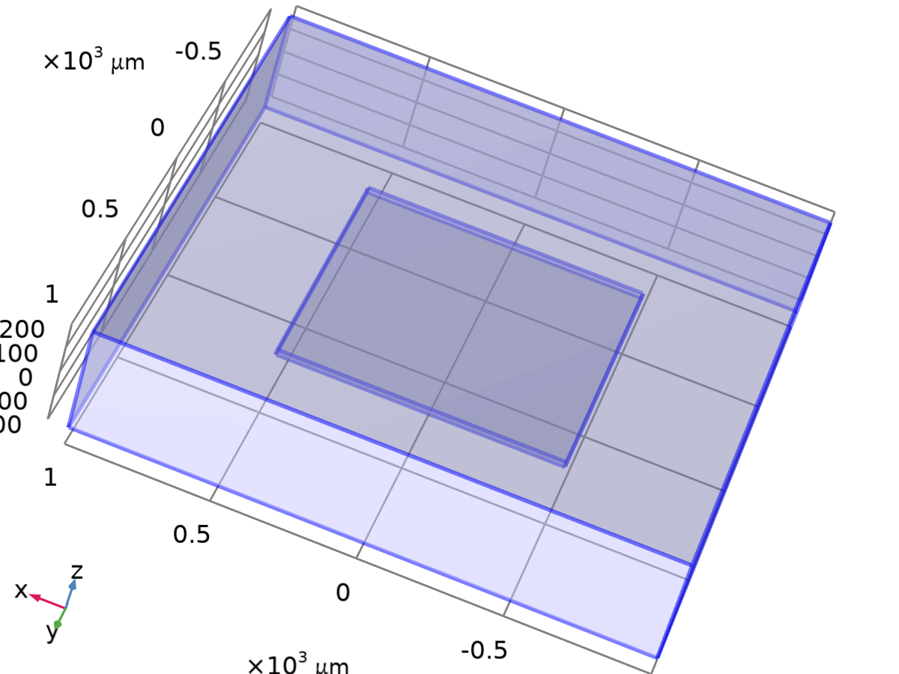
Free 1
Selection
Geometric entity level | Boundary
Selection | Geometry geom1: Dimension 2: All boundaries

Used products
COMSOL Multiphysics

    - Initial Values 1
Initial Values 1
Selection
Geometric entity level | Domain
Selection | Geometry geom1: Dimension 3: All domains

Initial Values
Settings
Description | Value | Unit
Displacement field, X-component | 0 | m
Displacement field, Y-component | 0 | m
Displacement field, Z-component | 0 | m
Structural velocity field, X-component | 0 | m/s
Structural velocity field, Y-component | 0 | m/s
Structural velocity field, Z-component | 0 | m/s

Coordinate System Selection
Settings
Description | Value
Coordinate system | Global coordinate system

Used products
COMSOL Multiphysics

Variables
Name | Expression | Unit | Description | Selection
solid.init1.u1 | 0 | m | Initial value of displacement, 1-component | Domain 1
solid.init1.u2 | 0 | m | Initial value of displacement, 2-component | Domain 1
solid.init1.u3 | 0 | m | Initial value of displacement, 3-component | Domain 1
solid.init1.ut1 | 0 | m/s | Initial value of structural velocity, 1-component | Domain 1
solid.init1.ut2 | 0 | m/s | Initial value of structural velocity, 2-component | Domain 1
solid.init1.ut3 | 0 | m/s | Initial value of structural velocity, 3-component | Domain 1
solid.uInitx | solid.init1.u1 | m | Initial value of displacement, x-component | Domain 1
solid.uInity | solid.init1.u2 | m | Initial value of displacement, y-component | Domain 1
solid.uInitz | solid.init1.u3 | m | Initial value of displacement, z-component | Domain 1
solid.utInitx | solid.init1.ut1 | m/s | Initial value of structural velocity, x-component | Domain 1
solid.utInity | solid.init1.ut2 | m/s | Initial value of structural velocity, y-component | Domain 1
solid.utInitz | solid.init1.ut3 | m/s | Initial value of structural velocity, z-component | Domain 1

    - Fixed Constraint 1
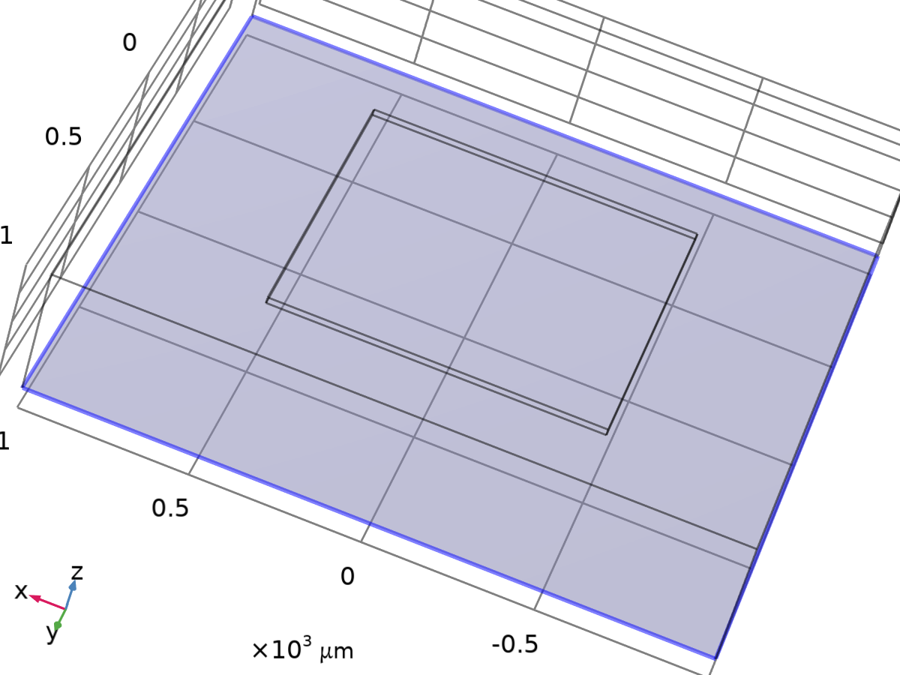
Fixed Constraint 1
Selection
Geometric entity level | Boundary
Selection | Geometry geom1: Dimension 2: Boundary 3

Equations
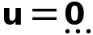
Used products
COMSOL Multiphysics

Variables
Name | Expression | Unit | Description | Selection | Details
solid.fix1.usx | u | m | Displacement, spatial coordinate system, x-component | Boundary 3 | + operation
solid.fix1.usy | v | m | Displacement, spatial coordinate system, y-component | Boundary 3 | + operation
solid.fix1.usz | w | m | Displacement, spatial coordinate system, z-component | Boundary 3 | + operation

Constraints
Constraint | Constraint force | Shape function | Selection | Details
-solid.fix1.usx | test(-solid.fix1.usx) | Nodal serendipity (Quadratic) | Boundary 3 | Nodal
-solid.fix1.usy | test(-solid.fix1.usy) | Nodal serendipity (Quadratic) | Boundary 3 | Nodal
-solid.fix1.usz | test(-solid.fix1.usz) | Nodal serendipity (Quadratic) | Boundary 3 | Nodal

    - Boundary Load 1
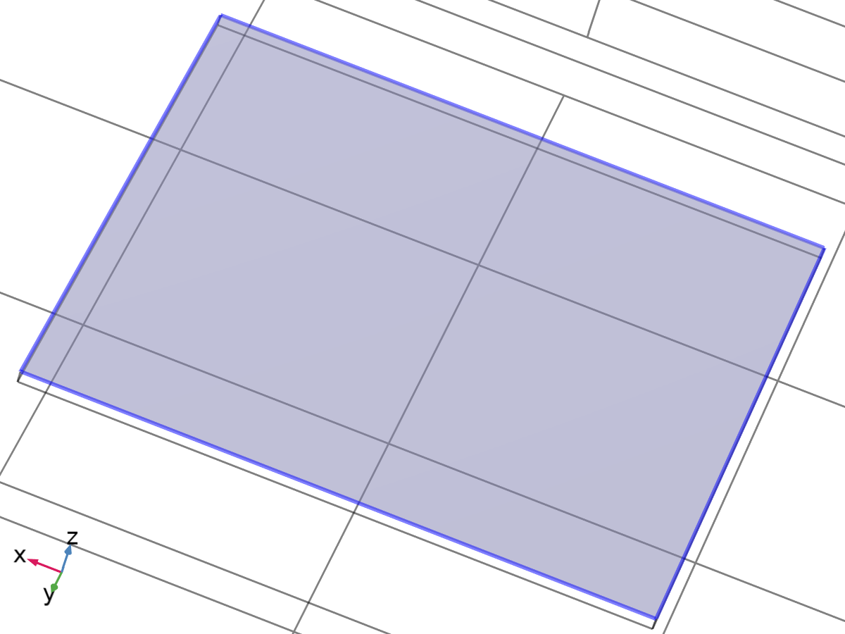
Boundary Load 1
Selection
Geometric entity level | Boundary
Selection | Geometry geom1: Dimension 2: Boundary 9

Equations
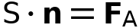
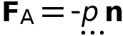

Force
Settings
Description | Value | Unit
Load type | Pressure
Pressure | P_app | Pa
Force, x-component | 0 | N
Force, y-component | 0 | N
Force, z-component | 0 | N
Moment, x-component | 0 | N·m
Moment, y-component | 0 | N·m
Moment, z-component | 0 | N·m
Application point defined using | Centroid

Coordinate System Selection
Settings
Description | Value
Coordinate system | Global coordinate system

Used products
COMSOL Multiphysics

Variables
Name | Expression | Unit | Description | Selection | Details
solid.bndl1.FollowerPressure | P_app | Pa | Pressure | Boundary 9 | * operation
solid.bndl1.ux | u | m | Displacement, x-component | Boundary 9
solid.bndl1.uy | v | m | Displacement, y-component | Boundary 9
solid.bndl1.uz | w | m | Displacement, z-component | Boundary 9
solid.bndl1.F_Ax | solid.bndl1.FperAreax | N/m² | Load, x-component | Boundary 9
solid.bndl1.F_Ay | solid.bndl1.FperAreay | N/m² | Load, y-component | Boundary 9
solid.bndl1.F_Az | solid.bndl1.FperAreaz | N/m² | Load, z-component | Boundary 9
solid.bndl1.F_A_Mag | sqrteps(real(solid.bndl1.F_Ax)^2+real(solid.bndl1.F_Ay)^2+real(solid.bndl1.F_Az)^2) | N/m² | Load magnitude | Boundary 9
solid.F_Ax | solid.bndl1.FperAreax | N/m² | Load, x-component | Boundary 9 | + operation
solid.F_Ay | solid.bndl1.FperAreay | N/m² | Load, y-component | Boundary 9 | + operation
solid.F_Az | solid.bndl1.FperAreaz | N/m² | Load, z-component | Boundary 9 | + operation
solid.F_A_Mag | sqrteps(real(solid.F_Ax)^2+real(solid.F_Ay)^2+real(solid.F_Az)^2) | N/m² | Load magnitude | Boundary 9
solid.bndl1.FperAreax | -solid.bndl1.FollowerPressure*solid.nX | N/m² | Load, x-component | Boundary 9
solid.bndl1.FperAreay | -solid.bndl1.FollowerPressure*solid.nY | N/m² | Load, y-component | Boundary 9
solid.bndl1.FperAreaz | -solid.bndl1.FollowerPressure*solid.nZ | N/m² | Load, z-component | Boundary 9

Weak Expressions
Weak expression | Integration order | Integration frame | Selection
solid.bndl1.F_Ax*test(solid.bndl1.ux)+solid.bndl1.F_Ay*test(solid.bndl1.uy)+solid.bndl1.F_Az*test(solid.bndl1.uz) | 4 | Material | Boundary 9

  - Electric Currents
Used products
COMSOL Multiphysics
MEMS Module

Electric Currents
Selection
Geometric entity level | Domain
Selection | Geometry geom1: Dimension 3: All domains

Equations
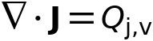
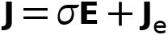
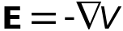
    - Interface Settings

Discretization
Settings
Description | Value
Electric potential | Quadratic

Settings
Description | Value
Equation form | Study controlled

Manual Terminal Sweep Settings
Settings
Description | Value | Unit
Use manual terminal sweep | Off
Reference impedance | 50 | Ω

    - Variables
Name | Expression | Unit | Description | Selection | Details
ec.d | 1 | 1 | Contribution | Domain 1
ec.I_sXX | (spatial.invF11*(spatial.invF11*ec.I_sxx+spatial.invF21*ec.I_syx+spatial.invF31*ec.I_szx)+spatial.invF21*(spatial.invF11*ec.I_sxy+spatial.invF21*ec.I_syy+spatial.invF31*ec.I_szy)+spatial.invF31*(spatial.invF11*ec.I_sxz+spatial.invF21*ec.I_syz+spatial.invF31*ec.I_szz))*spatial.detF | 1 | Spatial identity matrix, material frame, XX-component | Domain 1
ec.I_sYX | (spatial.invF11*(spatial.invF12*ec.I_sxx+spatial.invF22*ec.I_syx+spatial.invF32*ec.I_szx)+spatial.invF21*(spatial.invF12*ec.I_sxy+spatial.invF22*ec.I_syy+spatial.invF32*ec.I_szy)+spatial.invF31*(spatial.invF12*ec.I_sxz+spatial.invF22*ec.I_syz+spatial.invF32*ec.I_szz))*spatial.detF | 1 | Spatial identity matrix, material frame, YX-component | Domain 1
ec.I_sZX | (spatial.invF11*(spatial.invF13*ec.I_sxx+spatial.invF23*ec.I_syx+spatial.invF33*ec.I_szx)+spatial.invF21*(spatial.invF13*ec.I_sxy+spatial.invF23*ec.I_syy+spatial.invF33*ec.I_szy)+spatial.invF31*(spatial.invF13*ec.I_sxz+spatial.invF23*ec.I_syz+spatial.invF33*ec.I_szz))*spatial.detF | 1 | Spatial identity matrix, material frame, ZX-component | Domain 1
ec.I_sXY | (spatial.invF12*(spatial.invF11*ec.I_sxx+spatial.invF21*ec.I_syx+spatial.invF31*ec.I_szx)+spatial.invF22*(spatial.invF11*ec.I_sxy+spatial.invF21*ec.I_syy+spatial.invF31*ec.I_szy)+spatial.invF32*(spatial.invF11*ec.I_sxz+spatial.invF21*ec.I_syz+spatial.invF31*ec.I_szz))*spatial.detF | 1 | Spatial identity matrix, material frame, XY-component | Domain 1
ec.I_sYY | (spatial.invF12*(spatial.invF12*ec.I_sxx+spatial.invF22*ec.I_syx+spatial.invF32*ec.I_szx)+spatial.invF22*(spatial.invF12*ec.I_sxy+spatial.invF22*ec.I_syy+spatial.invF32*ec.I_szy)+spatial.invF32*(spatial.invF12*ec.I_sxz+spatial.invF22*ec.I_syz+spatial.invF32*ec.I_szz))*spatial.detF | 1 | Spatial identity matrix, material frame, YY-component | Domain 1
ec.I_sZY | (spatial.invF12*(spatial.invF13*ec.I_sxx+spatial.invF23*ec.I_syx+spatial.invF33*ec.I_szx)+spatial.invF22*(spatial.invF13*ec.I_sxy+spatial.invF23*ec.I_syy+spatial.invF33*ec.I_szy)+spatial.invF32*(spatial.invF13*ec.I_sxz+spatial.invF23*ec.I_syz+spatial.invF33*ec.I_szz))*spatial.detF | 1 | Spatial identity matrix, material frame, ZY-component | Domain 1
ec.I_sXZ | (spatial.invF13*(spatial.invF11*ec.I_sxx+spatial.invF21*ec.I_syx+spatial.invF31*ec.I_szx)+spatial.invF23*(spatial.invF11*ec.I_sxy+spatial.invF21*ec.I_syy+spatial.invF31*ec.I_szy)+spatial.invF33*(spatial.invF11*ec.I_sxz+spatial.invF21*ec.I_syz+spatial.invF31*ec.I_szz))*spatial.detF | 1 | Spatial identity matrix, material frame, XZ-component | Domain 1
ec.I_sYZ | (spatial.invF13*(spatial.invF12*ec.I_sxx+spatial.invF22*ec.I_syx+spatial.invF32*ec.I_szx)+spatial.invF23*(spatial.invF12*ec.I_sxy+spatial.invF22*ec.I_syy+spatial.invF32*ec.I_szy)+spatial.invF33*(spatial.invF12*ec.I_sxz+spatial.invF22*ec.I_syz+spatial.invF32*ec.I_szz))*spatial.detF | 1 | Spatial identity matrix, material frame, YZ-component | Domain 1
ec.I_sZZ | (spatial.invF13*(spatial.invF13*ec.I_sxx+spatial.invF23*ec.I_syx+spatial.invF33*ec.I_szx)+spatial.invF23*(spatial.invF13*ec.I_sxy+spatial.invF23*ec.I_syy+spatial.invF33*ec.I_szy)+spatial.invF33*(spatial.invF13*ec.I_sxz+spatial.invF23*ec.I_syz+spatial.invF33*ec.I_szz))*spatial.detF | 1 | Spatial identity matrix, material frame, ZZ-component | Domain 1
ec.I_sxx | 1 | 1 | Spatial identity matrix, xx-component | Domain 1
ec.I_syx | 0 | 1 | Spatial identity matrix, yx-component | Domain 1
ec.I_szx | 0 | 1 | Spatial identity matrix, zx-component | Domain 1
ec.I_sxy | 0 | 1 | Spatial identity matrix, xy-component | Domain 1
ec.I_syy | 1 | 1 | Spatial identity matrix, yy-component | Domain 1
ec.I_szy | 0 | 1 | Spatial identity matrix, zy-component | Domain 1
ec.I_sxz | 0 | 1 | Spatial identity matrix, xz-component | Domain 1
ec.I_syz | 0 | 1 | Spatial identity matrix, yz-component | Domain 1
ec.I_szz | 1 | 1 | Spatial identity matrix, zz-component | Domain 1
ec.nx | dnx |  | Normal vector, x-component | Boundaries 1–12
ec.ny | dny |  | Normal vector, y-component | Boundaries 1–12
ec.nz | dnz |  | Normal vector, z-component | Boundaries 1–12
ec.nmeshx | dnxmesh |  | Mesh normal vector, x-component | Boundaries 1–12
ec.nmeshy | dnymesh |  | Mesh normal vector, y-component | Boundaries 1–12
ec.nmeshz | dnzmesh |  | Mesh normal vector, z-component | Boundaries 1–12
ec.unmeshx | unxmesh |  | Mesh normal vector, upside, x-component | Boundaries 1–12
ec.unmeshy | unymesh |  | Mesh normal vector, upside, y-component | Boundaries 1–12
ec.unmeshz | unzmesh |  | Mesh normal vector, upside, z-component | Boundaries 1–12
ec.dnmeshx | dnxmesh |  | Mesh normal vector, downside, x-component | Boundaries 1–12
ec.dnmeshy | dnymesh |  | Mesh normal vector, downside, y-component | Boundaries 1–12
ec.dnmeshz | dnzmesh |  | Mesh normal vector, downside, z-component | Boundaries 1–12
ec.unTx | ec.unTex | Pa | Maxwell upward surface stress tensor, x-component | Boundaries 1–12
ec.unTy | ec.unTey | Pa | Maxwell upward surface stress tensor, y-component | Boundaries 1–12
ec.unTz | ec.unTez | Pa | Maxwell upward surface stress tensor, z-component | Boundaries 1–12
ec.dnTx | ec.dnTex | Pa | Maxwell downward surface stress tensor, x-component | Boundaries 1–12
ec.dnTy | ec.dnTey | Pa | Maxwell downward surface stress tensor, y-component | Boundaries 1–12
ec.dnTz | ec.dnTez | Pa | Maxwell downward surface stress tensor, z-component | Boundaries 1–12
ec.unx | unx |  | Normal vector up direction, x-component | Boundaries 1–12
ec.uny | uny |  | Normal vector up direction, y-component | Boundaries 1–12
ec.unz | unz |  | Normal vector up direction, z-component | Boundaries 1–12
ec.dnx | dnx |  | Normal vector down direction, x-component | Boundaries 1–12
ec.dny | dny |  | Normal vector down direction, y-component | Boundaries 1–12
ec.dnz | dnz |  | Normal vector down direction, z-component | Boundaries 1–12
ec.unTex | 0 | Pa | Maxwell upward electric surface stress tensor, x-component | Boundaries 1–12
ec.unTey | 0 | Pa | Maxwell upward electric surface stress tensor, y-component | Boundaries 1–12
ec.unTez | 0 | Pa | Maxwell upward electric surface stress tensor, z-component | Boundaries 1–12
ec.dnTex | -0.5*ec.unx*(real(down(ec.Dx))*real(down(ec.Ex))+real(down(ec.Dy))*real(down(ec.Ey))+real(down(ec.Dz))*real(down(ec.Ez)))+real(down(ec.Dx))*(real(down(ec.Ex))*ec.unx+real(down(ec.Ey))*ec.uny+real(down(ec.Ez))*ec.unz) | Pa | Maxwell downward electric surface stress tensor, x-component | Boundaries 1–12
ec.dnTey | -0.5*ec.uny*(real(down(ec.Dx))*real(down(ec.Ex))+real(down(ec.Dy))*real(down(ec.Ey))+real(down(ec.Dz))*real(down(ec.Ez)))+real(down(ec.Dy))*(real(down(ec.Ex))*ec.unx+real(down(ec.Ey))*ec.uny+real(down(ec.Ez))*ec.unz) | Pa | Maxwell downward electric surface stress tensor, y-component | Boundaries 1–12
ec.dnTez | -0.5*ec.unz*(real(down(ec.Dx))*real(down(ec.Ex))+real(down(ec.Dy))*real(down(ec.Ey))+real(down(ec.Dz))*real(down(ec.Ez)))+real(down(ec.Dz))*(real(down(ec.Ex))*ec.unx+real(down(ec.Ey))*ec.uny+real(down(ec.Ez))*ec.unz) | Pa | Maxwell downward electric surface stress tensor, z-component | Boundaries 1–12
ec.intWe | ec.int_We(ec.d*ec.dWe) | J | Total electric energy | Global | + operation
ec.Qh | 0 | W/m³ | Volumetric loss density, electromagnetic | Domain 1
ec.Qsh | 0 | W/m² | Surface loss density, electromagnetic | Boundaries 1–12
ec.Qlh | 0 | W/m | Line loss density, electromagnetic | Edges 1–24
ec.CPx | ec.int_CP(x)/ec.int_CP(1) | m | Physics selection center point, spatial frame, x-component | Global
ec.CPy | ec.int_CP(y)/ec.int_CP(1) | m | Physics selection center point, spatial frame, y-component | Global
ec.CPz | ec.int_CP(z)/ec.int_CP(1) | m | Physics selection center point, spatial frame, z-component | Global
ec.R11 | NaN+NaN*i |  | Resistance | Global
ec.G11 | ec.I0_1/ec.V0_1 | S | Conductance | Global
ec.S11 | NaN+NaN*i |  | S-parameter | Global
ec.S11dB | 10*log10(realdot(ec.S11,ec.S11)) | dB | S-parameter, dB | Global
ec.zref | 50[ohm] | Ω | Reference impedance | Global

    - Current Conservation 1
Current Conservation 1
Selection
Geometric entity level | Domain
Selection | Geometry geom1: Dimension 3: All domains

Equations
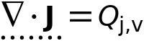

Constitutive Relation Jc-E
Settings
Description | Value
Conduction model | Electrical conductivity
Electrical conductivity | From material

Constitutive Relation D-E
Settings
Description | Value
Dielectric model | Relative permittivity
Relative permittivity | From material

Coordinate System Selection
Settings
Description | Value
Coordinate system | Global coordinate system

Used products
COMSOL Multiphysics

Properties from material
Property | Material | Property group
Electrical conductivity | p-Silicon (single-crystal, lightly doped) | Basic
Relative permittivity | p-Silicon (single-crystal, lightly doped) | Basic

Variables
Name | Expression | Unit | Description | Selection | Details
ec.sigmaxx | material.sigma11 | S/m | Electrical conductivity, xx-component | Domain 1 | Meta
ec.sigmayx | material.sigma21 | S/m | Electrical conductivity, yx-component | Domain 1 | Meta
ec.sigmazx | material.sigma31 | S/m | Electrical conductivity, zx-component | Domain 1 | Meta
ec.sigmaxy | material.sigma12 | S/m | Electrical conductivity, xy-component | Domain 1 | Meta
ec.sigmayy | material.sigma22 | S/m | Electrical conductivity, yy-component | Domain 1 | Meta
ec.sigmazy | material.sigma32 | S/m | Electrical conductivity, zy-component | Domain 1 | Meta
ec.sigmaxz | material.sigma13 | S/m | Electrical conductivity, xz-component | Domain 1 | Meta
ec.sigmayz | material.sigma23 | S/m | Electrical conductivity, yz-component | Domain 1 | Meta
ec.sigmazz | material.sigma33 | S/m | Electrical conductivity, zz-component | Domain 1 | Meta
ec.Qh | ec.Qrh | W/m³ | Volumetric loss density, electromagnetic | Domain 1
ec.Jix | ec.sigmaxx*ec.Ex+ec.sigmaxy*ec.Ey+ec.sigmaxz*ec.Ez | A/m² | Conduction current density, x-component | Domain 1
ec.Jiy | ec.sigmayx*ec.Ex+ec.sigmayy*ec.Ey+ec.sigmayz*ec.Ez | A/m² | Conduction current density, y-component | Domain 1
ec.Jiz | ec.sigmazx*ec.Ex+ec.sigmazy*ec.Ey+ec.sigmazz*ec.Ez | A/m² | Conduction current density, z-component | Domain 1
ec.Jdx | 0 | A/m² | Displacement current density, x-component | Domain 1
ec.Jdy | 0 | A/m² | Displacement current density, y-component | Domain 1
ec.Jdz | 0 | A/m² | Displacement current density, z-component | Domain 1
ec.Jex | 0 | A/m² | External current density, x-component | Domain 1 | + operation
ec.Jey | 0 | A/m² | External current density, y-component | Domain 1 | + operation
ec.Jez | 0 | A/m² | External current density, z-component | Domain 1 | + operation
ec.Jx | ec.Jix+ec.Jdx+ec.Jex | A/m² | Current density, x-component | Domain 1
ec.Jy | ec.Jiy+ec.Jdy+ec.Jey | A/m² | Current density, y-component | Domain 1
ec.Jz | ec.Jiz+ec.Jdz+ec.Jez | A/m² | Current density, z-component | Domain 1
ec.normJ | sqrt(realdot(ec.Jx,ec.Jx)+realdot(ec.Jy,ec.Jy)+realdot(ec.Jz,ec.Jz)) | A/m² | Current density norm | Domain 1
ec.rhoq | ppr(d(ec.Dx,x)+d(ec.Dy,y)+d(ec.Dz,z)) | C/m³ | Space charge density | Domain 1
ec.sigma_iso | material.sigma_iso | S/m | Electrical conductivity, isotropic value | Domain 1 | Meta
ec.epsilonrxx | material.epsilonr11 | 1 | Relative permittivity, xx-component | Domain 1 | Meta
ec.epsilonryx | material.epsilonr21 | 1 | Relative permittivity, yx-component | Domain 1 | Meta
ec.epsilonrzx | material.epsilonr31 | 1 | Relative permittivity, zx-component | Domain 1 | Meta
ec.epsilonrxy | material.epsilonr12 | 1 | Relative permittivity, xy-component | Domain 1 | Meta
ec.epsilonryy | material.epsilonr22 | 1 | Relative permittivity, yy-component | Domain 1 | Meta
ec.epsilonrzy | material.epsilonr32 | 1 | Relative permittivity, zy-component | Domain 1 | Meta
ec.epsilonrxz | material.epsilonr13 | 1 | Relative permittivity, xz-component | Domain 1 | Meta
ec.epsilonryz | material.epsilonr23 | 1 | Relative permittivity, yz-component | Domain 1 | Meta
ec.epsilonrzz | material.epsilonr33 | 1 | Relative permittivity, zz-component | Domain 1 | Meta
ec.epsilonr_iso | material.epsilonr_iso | 1 | Relative permittivity, isotropic value | Domain 1 | Meta
ec.Dx | epsilon0_const*ec.I_sxx*ec.Ex+epsilon0_const*ec.I_sxy*ec.Ey+epsilon0_const*ec.I_sxz*ec.Ez+ec.Px+ec.Pex+ec.Phx | C/m² | Electric displacement field, x-component | Domain 1
ec.Dy | epsilon0_const*ec.I_syx*ec.Ex+epsilon0_const*ec.I_syy*ec.Ey+epsilon0_const*ec.I_syz*ec.Ez+ec.Py+ec.Pey+ec.Phy | C/m² | Electric displacement field, y-component | Domain 1
ec.Dz | epsilon0_const*ec.I_szx*ec.Ex+epsilon0_const*ec.I_szy*ec.Ey+epsilon0_const*ec.I_szz*ec.Ez+ec.Pz+ec.Pez+ec.Phz | C/m² | Electric displacement field, z-component | Domain 1
ec.Px | epsilon0_const*(ec.chixx*ec.Ex+ec.chixy*ec.Ey+ec.chixz*ec.Ez) | C/m² | Polarization, x-component | Domain 1
ec.Py | epsilon0_const*(ec.chiyx*ec.Ex+ec.chiyy*ec.Ey+ec.chiyz*ec.Ez) | C/m² | Polarization, y-component | Domain 1
ec.Pz | epsilon0_const*(ec.chizx*ec.Ex+ec.chizy*ec.Ey+ec.chizz*ec.Ez) | C/m² | Polarization, z-component | Domain 1
ec.normD | sqrt(realdot(ec.Dx,ec.Dx)+realdot(ec.Dy,ec.Dy)+realdot(ec.Dz,ec.Dz)) | C/m² | Electric displacement field norm | Domain 1
ec.normP | sqrt(realdot(ec.Px,ec.Px)+realdot(ec.Py,ec.Py)+realdot(ec.Pz,ec.Pz)) | C/m² | Polarization norm | Domain 1
ec.Pex | 0 | C/m² | Polarization contribution, x-component | Domain 1 | + operation
ec.Pey | 0 | C/m² | Polarization contribution, y-component | Domain 1 | + operation
ec.Pez | 0 | C/m² | Polarization contribution, z-component | Domain 1 | + operation
ec.Phx | 0 | C/m² | Polarization contribution, x-component | Domain 1 | + operation
ec.Phy | 0 | C/m² | Polarization contribution, y-component | Domain 1 | + operation
ec.Phz | 0 | C/m² | Polarization contribution, z-component | Domain 1 | + operation
ec.chixx | -1+ec.epsilonrxx | 1 | Electric susceptibility, xx-component | Domain 1
ec.chiyx | ec.epsilonryx | 1 | Electric susceptibility, yx-component | Domain 1
ec.chizx | ec.epsilonrzx | 1 | Electric susceptibility, zx-component | Domain 1
ec.chixy | ec.epsilonrxy | 1 | Electric susceptibility, xy-component | Domain 1
ec.chiyy | -1+ec.epsilonryy | 1 | Electric susceptibility, yy-component | Domain 1
ec.chizy | ec.epsilonrzy | 1 | Electric susceptibility, zy-component | Domain 1
ec.chixz | ec.epsilonrxz | 1 | Electric susceptibility, xz-component | Domain 1
ec.chiyz | ec.epsilonryz | 1 | Electric susceptibility, yz-component | Domain 1
ec.chizz | -1+ec.epsilonrzz | 1 | Electric susceptibility, zz-component | Domain 1
ec.Ex | -Vx | V/m | Electric field, x-component | Domain 1
ec.Ey | -Vy | V/m | Electric field, y-component | Domain 1
ec.Ez | -Vz | V/m | Electric field, z-component | Domain 1
ec.tEx | -VTx | V/m | Tangential electric field, x-component | Boundaries 1–12
ec.tEy | -VTy | V/m | Tangential electric field, y-component | Boundaries 1–12
ec.tEz | -VTz | V/m | Tangential electric field, z-component | Boundaries 1–12
ec.normE | sqrt(realdot(ec.Ex,ec.Ex)+realdot(ec.Ey,ec.Ey)+realdot(ec.Ez,ec.Ez)) | V/m | Electric field norm | Domain 1
ec.Qrh | ec.Jx*ec.Ex+ec.Jy*ec.Ey+ec.Jz*ec.Ez | W/m³ | Volumetric loss density, electric | Domain 1 | + operation
ec.W | ec.We | J/m³ | Energy density | Domain 1 | + operation
ec.dWe | ec.We | J/m³ | Integrand for total electric energy | Domain 1 | Meta
ec.We | 0.5*epsilon0_const*(((ec.I_sxx+ec.chixx)*ec.Ex+(ec.I_sxy+ec.chixy)*ec.Ey+(ec.I_sxz+ec.chixz)*ec.Ez)*ec.Ex+((ec.I_syx+ec.chiyx)*ec.Ex+(ec.I_syy+ec.chiyy)*ec.Ey+(ec.I_syz+ec.chiyz)*ec.Ez)*ec.Ey+((ec.I_szx+ec.chizx)*ec.Ex+(ec.I_szy+ec.chizy)*ec.Ey+(ec.I_szz+ec.chizz)*ec.Ez)*ec.Ez) | J/m³ | Electric energy density | Domain 1
ec.rhoqs | -ec.dnx*down(ec.Dx)-ec.dny*down(ec.Dy)-ec.dnz*down(ec.Dz) | C/m² | Surface charge density | Boundaries 1–12

Shape functions
Name | Shape function | Unit | Description | Shape frame | Selection
V | Lagrange (Quadratic) | V | Electric potential | Spatial | Domain 1
V | Lagrange (Quadratic) | V | Electric potential | Material | Domain 1
V | Lagrange (Quadratic) | V | Electric potential | Geometry | Domain 1
V | Lagrange (Quadratic) | V | Electric potential | Mesh | Domain 1

Weak Expressions
Weak expression | Integration order | Integration frame | Selection
(ec.Jx*test(Vx)+ec.Jy*test(Vy)+ec.Jz*test(Vz))*ec.d | 4 | Spatial | Domain 1

    - Electric Insulation 1
Electric Insulation 1
Selection
Geometric entity level | Boundary
Selection | Geometry geom1: Dimension 2: All boundaries

Equations
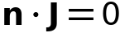
Used products
COMSOL Multiphysics

Variables
Name | Expression | Unit | Description | Selection | Details
ec.nJ | 0 | A/m² | Normal current density | Boundaries 1–2, 4–8, 10–12 | + operation

Shape functions
Name | Shape function | Unit | Description | Shape frame | Selection | Details
V | Lagrange (Quadratic) | V | Electric potential | Spatial | No boundaries | Slit
V | Lagrange (Quadratic) | V | Electric potential | Material | No boundaries | Slit
V | Lagrange (Quadratic) | V | Electric potential | Geometry | No boundaries | Slit
V | Lagrange (Quadratic) | V | Electric potential | Mesh | No boundaries | Slit

    - Initial Values 1
Initial Values 1
Selection
Geometric entity level | Domain
Selection | Geometry geom1: Dimension 3: All domains

Settings
Description | Value | Unit
Electric potential | 0 | V

Used products
COMSOL Multiphysics

    - Piezoresistive Material 1
Piezoresistive Material 1
Selection
Geometric entity level | Domain
Selection | Geometry geom1: Dimension 3: All domains

Equations
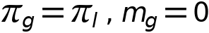

Piezoresistive Material Property
Settings
Description | Value | Unit
Constitutive model | Piezoresistance form
Electrical conductivity, zero stress | User defined
Electrical conductivity, zero stress | 1000 | S/m
Piezoresistive coupling matrix, Voigt notation | From material

Coordinate System Selection
Settings
Description | Value
Coordinate system | Global coordinate system

Model Input
Settings
Description | Value | Unit
Number density | User defined
Number density | 1E22 | 1/m³

Properties from material
Property | Material | Property group
Piezoresistive coupling matrix, Voigt notation | p-Silicon (single-crystal, lightly doped) | Piezoresistance form

Variables
Name | Expression | Unit | Description | Selection | Details
ec.sigma0XX | 1000 | S/m | Electrical conductivity, zero stress, XX-component | Domain 1
ec.sigma0YX | 0 | S/m | Electrical conductivity, zero stress, YX-component | Domain 1
ec.sigma0ZX | 0 | S/m | Electrical conductivity, zero stress, ZX-component | Domain 1
ec.sigma0XY | 0 | S/m | Electrical conductivity, zero stress, XY-component | Domain 1
ec.sigma0YY | 1000 | S/m | Electrical conductivity, zero stress, YY-component | Domain 1
ec.sigma0ZY | 0 | S/m | Electrical conductivity, zero stress, ZY-component | Domain 1
ec.sigma0XZ | 0 | S/m | Electrical conductivity, zero stress, XZ-component | Domain 1
ec.sigma0YZ | 0 | S/m | Electrical conductivity, zero stress, YZ-component | Domain 1
ec.sigma0ZZ | 1000 | S/m | Electrical conductivity, zero stress, ZZ-component | Domain 1
ec.Pig11 | ec.Pil11 | m⁴/(s·A²) | Piezoresistive coupling matrix, (global), Voigt notation, 11-component | Domain 1
ec.Pig21 | ec.Pil21 | m⁴/(s·A²) | Piezoresistive coupling matrix, (global), Voigt notation, 21-component | Domain 1
ec.Pig31 | ec.Pil31 | m⁴/(s·A²) | Piezoresistive coupling matrix, (global), Voigt notation, 31-component | Domain 1
ec.Pig41 | ec.Pil41 | m⁴/(s·A²) | Piezoresistive coupling matrix, (global), Voigt notation, 41-component | Domain 1
ec.Pig51 | ec.Pil51 | m⁴/(s·A²) | Piezoresistive coupling matrix, (global), Voigt notation, 51-component | Domain 1
ec.Pig61 | ec.Pil61 | m⁴/(s·A²) | Piezoresistive coupling matrix, (global), Voigt notation, 61-component | Domain 1
ec.Pig12 | ec.Pil12 | m⁴/(s·A²) | Piezoresistive coupling matrix, (global), Voigt notation, 12-component | Domain 1
ec.Pig22 | ec.Pil22 | m⁴/(s·A²) | Piezoresistive coupling matrix, (global), Voigt notation, 22-component | Domain 1
ec.Pig32 | ec.Pil32 | m⁴/(s·A²) | Piezoresistive coupling matrix, (global), Voigt notation, 32-component | Domain 1
ec.Pig42 | ec.Pil42 | m⁴/(s·A²) | Piezoresistive coupling matrix, (global), Voigt notation, 42-component | Domain 1
ec.Pig52 | ec.Pil52 | m⁴/(s·A²) | Piezoresistive coupling matrix, (global), Voigt notation, 52-component | Domain 1
ec.Pig62 | ec.Pil62 | m⁴/(s·A²) | Piezoresistive coupling matrix, (global), Voigt notation, 62-component | Domain 1
ec.Pig13 | ec.Pil13 | m⁴/(s·A²) | Piezoresistive coupling matrix, (global), Voigt notation, 13-component | Domain 1
ec.Pig23 | ec.Pil23 | m⁴/(s·A²) | Piezoresistive coupling matrix, (global), Voigt notation, 23-component | Domain 1
ec.Pig33 | ec.Pil33 | m⁴/(s·A²) | Piezoresistive coupling matrix, (global), Voigt notation, 33-component | Domain 1
ec.Pig43 | ec.Pil43 | m⁴/(s·A²) | Piezoresistive coupling matrix, (global), Voigt notation, 43-component | Domain 1
ec.Pig53 | ec.Pil53 | m⁴/(s·A²) | Piezoresistive coupling matrix, (global), Voigt notation, 53-component | Domain 1
ec.Pig63 | ec.Pil63 | m⁴/(s·A²) | Piezoresistive coupling matrix, (global), Voigt notation, 63-component | Domain 1
ec.Pig14 | ec.Pil14 | m⁴/(s·A²) | Piezoresistive coupling matrix, (global), Voigt notation, 14-component | Domain 1
ec.Pig24 | ec.Pil24 | m⁴/(s·A²) | Piezoresistive coupling matrix, (global), Voigt notation, 24-component | Domain 1
ec.Pig34 | ec.Pil34 | m⁴/(s·A²) | Piezoresistive coupling matrix, (global), Voigt notation, 34-component | Domain 1
ec.Pig44 | ec.Pil44 | m⁴/(s·A²) | Piezoresistive coupling matrix, (global), Voigt notation, 44-component | Domain 1
ec.Pig54 | ec.Pil54 | m⁴/(s·A²) | Piezoresistive coupling matrix, (global), Voigt notation, 54-component | Domain 1
ec.Pig64 | ec.Pil64 | m⁴/(s·A²) | Piezoresistive coupling matrix, (global), Voigt notation, 64-component | Domain 1
ec.Pig15 | ec.Pil15 | m⁴/(s·A²) | Piezoresistive coupling matrix, (global), Voigt notation, 15-component | Domain 1
ec.Pig25 | ec.Pil25 | m⁴/(s·A²) | Piezoresistive coupling matrix, (global), Voigt notation, 25-component | Domain 1
ec.Pig35 | ec.Pil35 | m⁴/(s·A²) | Piezoresistive coupling matrix, (global), Voigt notation, 35-component | Domain 1
ec.Pig45 | ec.Pil45 | m⁴/(s·A²) | Piezoresistive coupling matrix, (global), Voigt notation, 45-component | Domain 1
ec.Pig55 | ec.Pil55 | m⁴/(s·A²) | Piezoresistive coupling matrix, (global), Voigt notation, 55-component | Domain 1
ec.Pig65 | ec.Pil65 | m⁴/(s·A²) | Piezoresistive coupling matrix, (global), Voigt notation, 65-component | Domain 1
ec.Pig16 | ec.Pil16 | m⁴/(s·A²) | Piezoresistive coupling matrix, (global), Voigt notation, 16-component | Domain 1
ec.Pig26 | ec.Pil26 | m⁴/(s·A²) | Piezoresistive coupling matrix, (global), Voigt notation, 26-component | Domain 1
ec.Pig36 | ec.Pil36 | m⁴/(s·A²) | Piezoresistive coupling matrix, (global), Voigt notation, 36-component | Domain 1
ec.Pig46 | ec.Pil46 | m⁴/(s·A²) | Piezoresistive coupling matrix, (global), Voigt notation, 46-component | Domain 1
ec.Pig56 | ec.Pil56 | m⁴/(s·A²) | Piezoresistive coupling matrix, (global), Voigt notation, 56-component | Domain 1
ec.Pig66 | ec.Pil66 | m⁴/(s·A²) | Piezoresistive coupling matrix, (global), Voigt notation, 66-component | Domain 1
ec.mg11 | 0 | Ω·m | Elastoresistive coupling matrix (global), Voigt notation, 11-component | Domain 1
ec.mg21 | 0 | Ω·m | Elastoresistive coupling matrix (global), Voigt notation, 21-component | Domain 1
ec.mg31 | 0 | Ω·m | Elastoresistive coupling matrix (global), Voigt notation, 31-component | Domain 1
ec.mg41 | 0 | Ω·m | Elastoresistive coupling matrix (global), Voigt notation, 41-component | Domain 1
ec.mg51 | 0 | Ω·m | Elastoresistive coupling matrix (global), Voigt notation, 51-component | Domain 1
ec.mg61 | 0 | Ω·m | Elastoresistive coupling matrix (global), Voigt notation, 61-component | Domain 1
ec.mg12 | 0 | Ω·m | Elastoresistive coupling matrix (global), Voigt notation, 12-component | Domain 1
ec.mg22 | 0 | Ω·m | Elastoresistive coupling matrix (global), Voigt notation, 22-component | Domain 1
ec.mg32 | 0 | Ω·m | Elastoresistive coupling matrix (global), Voigt notation, 32-component | Domain 1
ec.mg42 | 0 | Ω·m | Elastoresistive coupling matrix (global), Voigt notation, 42-component | Domain 1
ec.mg52 | 0 | Ω·m | Elastoresistive coupling matrix (global), Voigt notation, 52-component | Domain 1
ec.mg62 | 0 | Ω·m | Elastoresistive coupling matrix (global), Voigt notation, 62-component | Domain 1
ec.mg13 | 0 | Ω·m | Elastoresistive coupling matrix (global), Voigt notation, 13-component | Domain 1
ec.mg23 | 0 | Ω·m | Elastoresistive coupling matrix (global), Voigt notation, 23-component | Domain 1
ec.mg33 | 0 | Ω·m | Elastoresistive coupling matrix (global), Voigt notation, 33-component | Domain 1
ec.mg43 | 0 | Ω·m | Elastoresistive coupling matrix (global), Voigt notation, 43-component | Domain 1
ec.mg53 | 0 | Ω·m | Elastoresistive coupling matrix (global), Voigt notation, 53-component | Domain 1
ec.mg63 | 0 | Ω·m | Elastoresistive coupling matrix (global), Voigt notation, 63-component | Domain 1
ec.mg14 | 0 | Ω·m | Elastoresistive coupling matrix (global), Voigt notation, 14-component | Domain 1
ec.mg24 | 0 | Ω·m | Elastoresistive coupling matrix (global), Voigt notation, 24-component | Domain 1
ec.mg34 | 0 | Ω·m | Elastoresistive coupling matrix (global), Voigt notation, 34-component | Domain 1
ec.mg44 | 0 | Ω·m | Elastoresistive coupling matrix (global), Voigt notation, 44-component | Domain 1
ec.mg54 | 0 | Ω·m | Elastoresistive coupling matrix (global), Voigt notation, 54-component | Domain 1
ec.mg64 | 0 | Ω·m | Elastoresistive coupling matrix (global), Voigt notation, 64-component | Domain 1
ec.mg15 | 0 | Ω·m | Elastoresistive coupling matrix (global), Voigt notation, 15-component | Domain 1
ec.mg25 | 0 | Ω·m | Elastoresistive coupling matrix (global), Voigt notation, 25-component | Domain 1
ec.mg35 | 0 | Ω·m | Elastoresistive coupling matrix (global), Voigt notation, 35-component | Domain 1
ec.mg45 | 0 | Ω·m | Elastoresistive coupling matrix (global), Voigt notation, 45-component | Domain 1
ec.mg55 | 0 | Ω·m | Elastoresistive coupling matrix (global), Voigt notation, 55-component | Domain 1
ec.mg65 | 0 | Ω·m | Elastoresistive coupling matrix (global), Voigt notation, 65-component | Domain 1
ec.mg16 | 0 | Ω·m | Elastoresistive coupling matrix (global), Voigt notation, 16-component | Domain 1
ec.mg26 | 0 | Ω·m | Elastoresistive coupling matrix (global), Voigt notation, 26-component | Domain 1
ec.mg36 | 0 | Ω·m | Elastoresistive coupling matrix (global), Voigt notation, 36-component | Domain 1
ec.mg46 | 0 | Ω·m | Elastoresistive coupling matrix (global), Voigt notation, 46-component | Domain 1
ec.mg56 | 0 | Ω·m | Elastoresistive coupling matrix (global), Voigt notation, 56-component | Domain 1
ec.mg66 | 0 | Ω·m | Elastoresistive coupling matrix (global), Voigt notation, 66-component | Domain 1
ec.sigma0_iso | 1000 | S/m | Electrical conductivity, zero stress, isotropic value | Domain 1
ec.Pil11 | material.Pil11 | m⁴/(s·A²) | Piezoresistive coupling matrix, Voigt notation, 11-component | Domain 1 | Meta
ec.Pil21 | material.Pil21 | m⁴/(s·A²) | Piezoresistive coupling matrix, Voigt notation, 21-component | Domain 1 | Meta
ec.Pil31 | material.Pil31 | m⁴/(s·A²) | Piezoresistive coupling matrix, Voigt notation, 31-component | Domain 1 | Meta
ec.Pil41 | material.Pil41 | m⁴/(s·A²) | Piezoresistive coupling matrix, Voigt notation, 41-component | Domain 1 | Meta
ec.Pil51 | material.Pil51 | m⁴/(s·A²) | Piezoresistive coupling matrix, Voigt notation, 51-component | Domain 1 | Meta
ec.Pil61 | material.Pil61 | m⁴/(s·A²) | Piezoresistive coupling matrix, Voigt notation, 61-component | Domain 1 | Meta
ec.Pil12 | material.Pil12 | m⁴/(s·A²) | Piezoresistive coupling matrix, Voigt notation, 12-component | Domain 1 | Meta
ec.Pil22 | material.Pil22 | m⁴/(s·A²) | Piezoresistive coupling matrix, Voigt notation, 22-component | Domain 1 | Meta
ec.Pil32 | material.Pil32 | m⁴/(s·A²) | Piezoresistive coupling matrix, Voigt notation, 32-component | Domain 1 | Meta
ec.Pil42 | material.Pil42 | m⁴/(s·A²) | Piezoresistive coupling matrix, Voigt notation, 42-component | Domain 1 | Meta
ec.Pil52 | material.Pil52 | m⁴/(s·A²) | Piezoresistive coupling matrix, Voigt notation, 52-component | Domain 1 | Meta
ec.Pil62 | material.Pil62 | m⁴/(s·A²) | Piezoresistive coupling matrix, Voigt notation, 62-component | Domain 1 | Meta
ec.Pil13 | material.Pil13 | m⁴/(s·A²) | Piezoresistive coupling matrix, Voigt notation, 13-component | Domain 1 | Meta
ec.Pil23 | material.Pil23 | m⁴/(s·A²) | Piezoresistive coupling matrix, Voigt notation, 23-component | Domain 1 | Meta
ec.Pil33 | material.Pil33 | m⁴/(s·A²) | Piezoresistive coupling matrix, Voigt notation, 33-component | Domain 1 | Meta
ec.Pil43 | material.Pil43 | m⁴/(s·A²) | Piezoresistive coupling matrix, Voigt notation, 43-component | Domain 1 | Meta
ec.Pil53 | material.Pil53 | m⁴/(s·A²) | Piezoresistive coupling matrix, Voigt notation, 53-component | Domain 1 | Meta
ec.Pil63 | material.Pil63 | m⁴/(s·A²) | Piezoresistive coupling matrix, Voigt notation, 63-component | Domain 1 | Meta
ec.Pil14 | material.Pil14 | m⁴/(s·A²) | Piezoresistive coupling matrix, Voigt notation, 14-component | Domain 1 | Meta
ec.Pil24 | material.Pil24 | m⁴/(s·A²) | Piezoresistive coupling matrix, Voigt notation, 24-component | Domain 1 | Meta
ec.Pil34 | material.Pil34 | m⁴/(s·A²) | Piezoresistive coupling matrix, Voigt notation, 34-component | Domain 1 | Meta
ec.Pil44 | material.Pil44 | m⁴/(s·A²) | Piezoresistive coupling matrix, Voigt notation, 44-component | Domain 1 | Meta
ec.Pil54 | material.Pil54 | m⁴/(s·A²) | Piezoresistive coupling matrix, Voigt notation, 54-component | Domain 1 | Meta
ec.Pil64 | material.Pil64 | m⁴/(s·A²) | Piezoresistive coupling matrix, Voigt notation, 64-component | Domain 1 | Meta
ec.Pil15 | material.Pil15 | m⁴/(s·A²) | Piezoresistive coupling matrix, Voigt notation, 15-component | Domain 1 | Meta
ec.Pil25 | material.Pil25 | m⁴/(s·A²) | Piezoresistive coupling matrix, Voigt notation, 25-component | Domain 1 | Meta
ec.Pil35 | material.Pil35 | m⁴/(s·A²) | Piezoresistive coupling matrix, Voigt notation, 35-component | Domain 1 | Meta
ec.Pil45 | material.Pil45 | m⁴/(s·A²) | Piezoresistive coupling matrix, Voigt notation, 45-component | Domain 1 | Meta
ec.Pil55 | material.Pil55 | m⁴/(s·A²) | Piezoresistive coupling matrix, Voigt notation, 55-component | Domain 1 | Meta
ec.Pil65 | material.Pil65 | m⁴/(s·A²) | Piezoresistive coupling matrix, Voigt notation, 65-component | Domain 1 | Meta
ec.Pil16 | material.Pil16 | m⁴/(s·A²) | Piezoresistive coupling matrix, Voigt notation, 16-component | Domain 1 | Meta
ec.Pil26 | material.Pil26 | m⁴/(s·A²) | Piezoresistive coupling matrix, Voigt notation, 26-component | Domain 1 | Meta
ec.Pil36 | material.Pil36 | m⁴/(s·A²) | Piezoresistive coupling matrix, Voigt notation, 36-component | Domain 1 | Meta
ec.Pil46 | material.Pil46 | m⁴/(s·A²) | Piezoresistive coupling matrix, Voigt notation, 46-component | Domain 1 | Meta
ec.Pil56 | material.Pil56 | m⁴/(s·A²) | Piezoresistive coupling matrix, Voigt notation, 56-component | Domain 1 | Meta
ec.Pil66 | material.Pil66 | m⁴/(s·A²) | Piezoresistive coupling matrix, Voigt notation, 66-component | Domain 1 | Meta
ec.Pil_iso | material.Pil_iso | m⁴/(s·A²) | Piezoresistive coupling matrix, Voigt notation, isotropic value | Domain 1 | Meta

    - Terminal 1
Terminal 1
Selection
Geometric entity level | Boundary
Selection | Geometry geom1: Dimension 2: Boundary 9

Equations
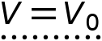

Terminal
Settings
Description | Value | Unit
Terminal name | 1
Terminal type | Voltage
Voltage | 1 | V

Variables
Name | Expression | Unit | Description | Selection | Details
ec.nJ | ec.unx*down(ec.Jx)+ec.uny*down(ec.Jy)+ec.unz*down(ec.Jz) | A/m² | Normal current density | Boundary 9 | + operation
ec.V0 | ec.term1.V0 | V | Voltage | Boundary 9
ec.term1.V0 | 1 | V | Voltage | Boundary 9
ec.term1.Vinit | 0 | V | Initial value for voltage | Global
ec.I0_1 | ec.term1.sum(reacf(V)) | A | Terminal current | Global
ec.Vterm | ec.V0 | V | Voltage | Boundary 9
ec.V0_1 | ec.term1.int(V)/ec.term1.int(1) | V | Terminal voltage | Global

Constraints
Constraint | Constraint force | Shape function | Selection | Details
ec.Vterm-V | test(ec.Vterm-V) | Lagrange (Quadratic) | Boundary 9 | Elemental

    - Ground 1
Ground 1
Selection
Geometric entity level | Boundary
Selection | Geometry geom1: Dimension 2: Boundary 3

Equations
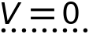
Used products
COMSOL Multiphysics

Variables
Name | Expression | Unit | Description | Selection | Details
ec.nJ | ec.unx*down(ec.Jx)+ec.uny*down(ec.Jy)+ec.unz*down(ec.Jz) | A/m² | Normal current density | Boundary 3 | + operation
ec.V0 | 0 | V | Voltage | Boundary 3

Constraints
Constraint | Constraint force | Shape function | Selection | Details
ec.V0-V | test(ec.V0-V) | Lagrange (Quadratic) | Boundary 3 | Elemental

  - Electrical Circuit
Used products
COMSOL Multiphysics
MEMS Module

Selection
Geometric entity level | Entire model

    - Interface Settings
Settings
Description | Value
Equation form | Study controlled

Circuit Settings
Settings
Description | Value | Unit
Resistance in parallel to pn junctions | 1E12 | Ω
Create unique nodes for new devices | On
Check for hanging nodes before solving | On
Use solver events for diodes | On
Use solver events for pulse sources | On

    - Variables
Name | Expression | Unit | Description | Selection
cir.Rj | 1.0E12[Ω] | Ω | Resistance in parallel to pn junctions | Global

    - Ground Node 1
Selection
Geometric entity level | Entire model

Node Connections
Label | Node name
p | 0

    - Voltage Source 1
Selection
Geometric entity level | Entire model

Node Connections
Label | Node names
p | 1
n | 0

Device Parameters
Settings
Description | Value | Unit
Source type | General source
Voltage | 5 | V

Variables
Name | Expression | Unit | Description | Selection
cir.V1.value | 5[V] | V | Voltage | Global

    - Resistor 1
Selection
Geometric entity level | Entire model

Node Connections
Label | Node names
p | 1
n | 2

Device Parameters
Settings
Description | Value | Unit
Resistance | 0.25066*(1 + 6.78E-9*(1 + alpha_TCS*(T_amb - T_ref))*P_app)*(1 + alpha_TCR*(T_amb - T_ref)) | Ω

Variables
Name | Expression | Unit | Description | Selection
cir.R1.Qh | cir.R1_q | W | Heat source | Global

    - Resistor 2
Selection
Geometric entity level | Entire model

Node Connections
Label | Node names
p | 2
n | 0

Device Parameters
Settings
Description | Value | Unit
Resistance | 0.25066*(1 - 6.78E-9*(1 + alpha_TCS*(T_amb - T_ref))*P_app)*(1 + alpha_TCR*(T_amb - T_ref)) | Ω

Variables
Name | Expression | Unit | Description | Selection
cir.R2.Qh | cir.R2_q | W | Heat source | Global

    - Resistor 3
Selection
Geometric entity level | Entire model

Node Connections
Label | Node names
p | 1
n | 3

Device Parameters
Settings
Description | Value | Unit
Resistance | 0.25066*(1 - 6.78E-9*(1 + alpha_TCS*(T_amb - T_ref))*P_app)*(1 + alpha_TCR*(T_amb - T_ref)) | Ω

Variables
Name | Expression | Unit | Description | Selection
cir.R3.Qh | cir.R3_q | W | Heat source | Global

    - Resistor 4
Selection
Geometric entity level | Entire model

Node Connections
Label | Node names
p | 3
n | 0

Device Parameters
Settings
Description | Value | Unit
Resistance | 0.25066*(1 + 6.78E-9*(1 + alpha_TCS*(T_amb - T_ref))*P_app)*(1 + alpha_TCR*(T_amb - T_ref)) | Ω

Variables
Name | Expression | Unit | Description | Selection
cir.R4.Qh | cir.R4_q | W | Heat source | Global

    - Voltage-Controlled Voltage Source 1
Selection
Geometric entity level | Entire model

Node Connections
Label | Node names
p | 4
n | 0
measure (+) | 3
measure (-) | 2

Device Parameters
Settings
Description | Value
Method | Use gain
Gain | A_v

    - Resistor 5
Selection
Geometric entity level | Entire model

Node Connections
Label | Node names
p | 4
n | 0

Device Parameters
Settings
Description | Value | Unit
Resistance | 1E6 | Ω

Variables
Name | Expression | Unit | Description | Selection
cir.R5.Qh | cir.R5_q | W | Heat source | Global

  - Multiphysics
    - Piezoresistive Effect, Domain Currents 1
Used products
COMSOL Multiphysics
MEMS Module

Piezoresistive Effect, Domain Currents 1
Selection
Geometric entity level | Domain
Selection | Geometry geom1: Dimension 3: All domains

Equations
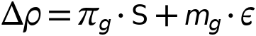
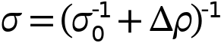

Coupled Interfaces
Settings
Description | Value
Solid mechanics | Solid Mechanics (solid)
Electric currents | Electric Currents (ec)

Variables
Name | Expression | Unit | Description | Selection
ec.sigmaxx | (spatial.F11*(spatial.F11*pzrd1.sigmaXX+spatial.F21*pzrd1.sigmaYX+spatial.F31*pzrd1.sigmaZX)+spatial.F21*(spatial.F11*pzrd1.sigmaXY+spatial.F21*pzrd1.sigmaYY+spatial.F31*pzrd1.sigmaZY)+spatial.F31*(spatial.F11*pzrd1.sigmaXZ+spatial.F21*pzrd1.sigmaYZ+spatial.F31*pzrd1.sigmaZZ))*spatial.detInvF | S/m | Electrical conductivity, xx-component | Domain 1
ec.sigmayx | (spatial.F11*(spatial.F12*pzrd1.sigmaXX+spatial.F22*pzrd1.sigmaYX+spatial.F32*pzrd1.sigmaZX)+spatial.F21*(spatial.F12*pzrd1.sigmaXY+spatial.F22*pzrd1.sigmaYY+spatial.F32*pzrd1.sigmaZY)+spatial.F31*(spatial.F12*pzrd1.sigmaXZ+spatial.F22*pzrd1.sigmaYZ+spatial.F32*pzrd1.sigmaZZ))*spatial.detInvF | S/m | Electrical conductivity, yx-component | Domain 1
ec.sigmazx | (spatial.F11*(spatial.F13*pzrd1.sigmaXX+spatial.F23*pzrd1.sigmaYX+spatial.F33*pzrd1.sigmaZX)+spatial.F21*(spatial.F13*pzrd1.sigmaXY+spatial.F23*pzrd1.sigmaYY+spatial.F33*pzrd1.sigmaZY)+spatial.F31*(spatial.F13*pzrd1.sigmaXZ+spatial.F23*pzrd1.sigmaYZ+spatial.F33*pzrd1.sigmaZZ))*spatial.detInvF | S/m | Electrical conductivity, zx-component | Domain 1
ec.sigmaxy | (spatial.F12*(spatial.F11*pzrd1.sigmaXX+spatial.F21*pzrd1.sigmaYX+spatial.F31*pzrd1.sigmaZX)+spatial.F22*(spatial.F11*pzrd1.sigmaXY+spatial.F21*pzrd1.sigmaYY+spatial.F31*pzrd1.sigmaZY)+spatial.F32*(spatial.F11*pzrd1.sigmaXZ+spatial.F21*pzrd1.sigmaYZ+spatial.F31*pzrd1.sigmaZZ))*spatial.detInvF | S/m | Electrical conductivity, xy-component | Domain 1
ec.sigmayy | (spatial.F12*(spatial.F12*pzrd1.sigmaXX+spatial.F22*pzrd1.sigmaYX+spatial.F32*pzrd1.sigmaZX)+spatial.F22*(spatial.F12*pzrd1.sigmaXY+spatial.F22*pzrd1.sigmaYY+spatial.F32*pzrd1.sigmaZY)+spatial.F32*(spatial.F12*pzrd1.sigmaXZ+spatial.F22*pzrd1.sigmaYZ+spatial.F32*pzrd1.sigmaZZ))*spatial.detInvF | S/m | Electrical conductivity, yy-component | Domain 1
ec.sigmazy | (spatial.F12*(spatial.F13*pzrd1.sigmaXX+spatial.F23*pzrd1.sigmaYX+spatial.F33*pzrd1.sigmaZX)+spatial.F22*(spatial.F13*pzrd1.sigmaXY+spatial.F23*pzrd1.sigmaYY+spatial.F33*pzrd1.sigmaZY)+spatial.F32*(spatial.F13*pzrd1.sigmaXZ+spatial.F23*pzrd1.sigmaYZ+spatial.F33*pzrd1.sigmaZZ))*spatial.detInvF | S/m | Electrical conductivity, zy-component | Domain 1
ec.sigmaxz | (spatial.F13*(spatial.F11*pzrd1.sigmaXX+spatial.F21*pzrd1.sigmaYX+spatial.F31*pzrd1.sigmaZX)+spatial.F23*(spatial.F11*pzrd1.sigmaXY+spatial.F21*pzrd1.sigmaYY+spatial.F31*pzrd1.sigmaZY)+spatial.F33*(spatial.F11*pzrd1.sigmaXZ+spatial.F21*pzrd1.sigmaYZ+spatial.F31*pzrd1.sigmaZZ))*spatial.detInvF | S/m | Electrical conductivity, xz-component | Domain 1
ec.sigmayz | (spatial.F13*(spatial.F12*pzrd1.sigmaXX+spatial.F22*pzrd1.sigmaYX+spatial.F32*pzrd1.sigmaZX)+spatial.F23*(spatial.F12*pzrd1.sigmaXY+spatial.F22*pzrd1.sigmaYY+spatial.F32*pzrd1.sigmaZY)+spatial.F33*(spatial.F12*pzrd1.sigmaXZ+spatial.F22*pzrd1.sigmaYZ+spatial.F32*pzrd1.sigmaZZ))*spatial.detInvF | S/m | Electrical conductivity, yz-component | Domain 1
ec.sigmazz | (spatial.F13*(spatial.F13*pzrd1.sigmaXX+spatial.F23*pzrd1.sigmaYX+spatial.F33*pzrd1.sigmaZX)+spatial.F23*(spatial.F13*pzrd1.sigmaXY+spatial.F23*pzrd1.sigmaYY+spatial.F33*pzrd1.sigmaZY)+spatial.F33*(spatial.F13*pzrd1.sigmaXZ+spatial.F23*pzrd1.sigmaYZ+spatial.F33*pzrd1.sigmaZZ))*spatial.detInvF | S/m | Electrical conductivity, zz-component | Domain 1
pzrd1.sigma0XX | ec.sigma0XX | S/m | Electrical conductivity, zero stress, XX-component | Domain 1
pzrd1.sigma0YX | ec.sigma0YX | S/m | Electrical conductivity, zero stress, YX-component | Domain 1
pzrd1.sigma0ZX | ec.sigma0ZX | S/m | Electrical conductivity, zero stress, ZX-component | Domain 1
pzrd1.sigma0XY | ec.sigma0XY | S/m | Electrical conductivity, zero stress, XY-component | Domain 1
pzrd1.sigma0YY | ec.sigma0YY | S/m | Electrical conductivity, zero stress, YY-component | Domain 1
pzrd1.sigma0ZY | ec.sigma0ZY | S/m | Electrical conductivity, zero stress, ZY-component | Domain 1
pzrd1.sigma0XZ | ec.sigma0XZ | S/m | Electrical conductivity, zero stress, XZ-component | Domain 1
pzrd1.sigma0YZ | ec.sigma0YZ | S/m | Electrical conductivity, zero stress, YZ-component | Domain 1
pzrd1.sigma0ZZ | ec.sigma0ZZ | S/m | Electrical conductivity, zero stress, ZZ-component | Domain 1
pzrd1.Pig11 | ec.Pig11 | m⁴/(s·A²) | Piezoresistive coupling matrix, (global), Voigt notation, 11-component | Domain 1
pzrd1.Pig21 | ec.Pig21 | m⁴/(s·A²) | Piezoresistive coupling matrix, (global), Voigt notation, 21-component | Domain 1
pzrd1.Pig31 | ec.Pig31 | m⁴/(s·A²) | Piezoresistive coupling matrix, (global), Voigt notation, 31-component | Domain 1
pzrd1.Pig41 | ec.Pig41 | m⁴/(s·A²) | Piezoresistive coupling matrix, (global), Voigt notation, 41-component | Domain 1
pzrd1.Pig51 | ec.Pig51 | m⁴/(s·A²) | Piezoresistive coupling matrix, (global), Voigt notation, 51-component | Domain 1
pzrd1.Pig61 | ec.Pig61 | m⁴/(s·A²) | Piezoresistive coupling matrix, (global), Voigt notation, 61-component | Domain 1
pzrd1.Pig12 | ec.Pig12 | m⁴/(s·A²) | Piezoresistive coupling matrix, (global), Voigt notation, 12-component | Domain 1
pzrd1.Pig22 | ec.Pig22 | m⁴/(s·A²) | Piezoresistive coupling matrix, (global), Voigt notation, 22-component | Domain 1
pzrd1.Pig32 | ec.Pig32 | m⁴/(s·A²) | Piezoresistive coupling matrix, (global), Voigt notation, 32-component | Domain 1
pzrd1.Pig42 | ec.Pig42 | m⁴/(s·A²) | Piezoresistive coupling matrix, (global), Voigt notation, 42-component | Domain 1
pzrd1.Pig52 | ec.Pig52 | m⁴/(s·A²) | Piezoresistive coupling matrix, (global), Voigt notation, 52-component | Domain 1
pzrd1.Pig62 | ec.Pig62 | m⁴/(s·A²) | Piezoresistive coupling matrix, (global), Voigt notation, 62-component | Domain 1
pzrd1.Pig13 | ec.Pig13 | m⁴/(s·A²) | Piezoresistive coupling matrix, (global), Voigt notation, 13-component | Domain 1
pzrd1.Pig23 | ec.Pig23 | m⁴/(s·A²) | Piezoresistive coupling matrix, (global), Voigt notation, 23-component | Domain 1
pzrd1.Pig33 | ec.Pig33 | m⁴/(s·A²) | Piezoresistive coupling matrix, (global), Voigt notation, 33-component | Domain 1
pzrd1.Pig43 | ec.Pig43 | m⁴/(s·A²) | Piezoresistive coupling matrix, (global), Voigt notation, 43-component | Domain 1
pzrd1.Pig53 | ec.Pig53 | m⁴/(s·A²) | Piezoresistive coupling matrix, (global), Voigt notation, 53-component | Domain 1
pzrd1.Pig63 | ec.Pig63 | m⁴/(s·A²) | Piezoresistive coupling matrix, (global), Voigt notation, 63-component | Domain 1
pzrd1.Pig14 | ec.Pig14 | m⁴/(s·A²) | Piezoresistive coupling matrix, (global), Voigt notation, 14-component | Domain 1
pzrd1.Pig24 | ec.Pig24 | m⁴/(s·A²) | Piezoresistive coupling matrix, (global), Voigt notation, 24-component | Domain 1
pzrd1.Pig34 | ec.Pig34 | m⁴/(s·A²) | Piezoresistive coupling matrix, (global), Voigt notation, 34-component | Domain 1
pzrd1.Pig44 | ec.Pig44 | m⁴/(s·A²) | Piezoresistive coupling matrix, (global), Voigt notation, 44-component | Domain 1
pzrd1.Pig54 | ec.Pig54 | m⁴/(s·A²) | Piezoresistive coupling matrix, (global), Voigt notation, 54-component | Domain 1
pzrd1.Pig64 | ec.Pig64 | m⁴/(s·A²) | Piezoresistive coupling matrix, (global), Voigt notation, 64-component | Domain 1
pzrd1.Pig15 | ec.Pig15 | m⁴/(s·A²) | Piezoresistive coupling matrix, (global), Voigt notation, 15-component | Domain 1
pzrd1.Pig25 | ec.Pig25 | m⁴/(s·A²) | Piezoresistive coupling matrix, (global), Voigt notation, 25-component | Domain 1
pzrd1.Pig35 | ec.Pig35 | m⁴/(s·A²) | Piezoresistive coupling matrix, (global), Voigt notation, 35-component | Domain 1
pzrd1.Pig45 | ec.Pig45 | m⁴/(s·A²) | Piezoresistive coupling matrix, (global), Voigt notation, 45-component | Domain 1
pzrd1.Pig55 | ec.Pig55 | m⁴/(s·A²) | Piezoresistive coupling matrix, (global), Voigt notation, 55-component | Domain 1
pzrd1.Pig65 | ec.Pig65 | m⁴/(s·A²) | Piezoresistive coupling matrix, (global), Voigt notation, 65-component | Domain 1
pzrd1.Pig16 | ec.Pig16 | m⁴/(s·A²) | Piezoresistive coupling matrix, (global), Voigt notation, 16-component | Domain 1
pzrd1.Pig26 | ec.Pig26 | m⁴/(s·A²) | Piezoresistive coupling matrix, (global), Voigt notation, 26-component | Domain 1
pzrd1.Pig36 | ec.Pig36 | m⁴/(s·A²) | Piezoresistive coupling matrix, (global), Voigt notation, 36-component | Domain 1
pzrd1.Pig46 | ec.Pig46 | m⁴/(s·A²) | Piezoresistive coupling matrix, (global), Voigt notation, 46-component | Domain 1
pzrd1.Pig56 | ec.Pig56 | m⁴/(s·A²) | Piezoresistive coupling matrix, (global), Voigt notation, 56-component | Domain 1
pzrd1.Pig66 | ec.Pig66 | m⁴/(s·A²) | Piezoresistive coupling matrix, (global), Voigt notation, 66-component | Domain 1
pzrd1.mg11 | ec.mg11 | Ω·m | Elastoresistive coupling matrix (global), Voigt notation, 11-component | Domain 1
pzrd1.mg21 | ec.mg21 | Ω·m | Elastoresistive coupling matrix (global), Voigt notation, 21-component | Domain 1
pzrd1.mg31 | ec.mg31 | Ω·m | Elastoresistive coupling matrix (global), Voigt notation, 31-component | Domain 1
pzrd1.mg41 | ec.mg41 | Ω·m | Elastoresistive coupling matrix (global), Voigt notation, 41-component | Domain 1
pzrd1.mg51 | ec.mg51 | Ω·m | Elastoresistive coupling matrix (global), Voigt notation, 51-component | Domain 1
pzrd1.mg61 | ec.mg61 | Ω·m | Elastoresistive coupling matrix (global), Voigt notation, 61-component | Domain 1
pzrd1.mg12 | ec.mg12 | Ω·m | Elastoresistive coupling matrix (global), Voigt notation, 12-component | Domain 1
pzrd1.mg22 | ec.mg22 | Ω·m | Elastoresistive coupling matrix (global), Voigt notation, 22-component | Domain 1
pzrd1.mg32 | ec.mg32 | Ω·m | Elastoresistive coupling matrix (global), Voigt notation, 32-component | Domain 1
pzrd1.mg42 | ec.mg42 | Ω·m | Elastoresistive coupling matrix (global), Voigt notation, 42-component | Domain 1
pzrd1.mg52 | ec.mg52 | Ω·m | Elastoresistive coupling matrix (global), Voigt notation, 52-component | Domain 1
pzrd1.mg62 | ec.mg62 | Ω·m | Elastoresistive coupling matrix (global), Voigt notation, 62-component | Domain 1
pzrd1.mg13 | ec.mg13 | Ω·m | Elastoresistive coupling matrix (global), Voigt notation, 13-component | Domain 1
pzrd1.mg23 | ec.mg23 | Ω·m | Elastoresistive coupling matrix (global), Voigt notation, 23-component | Domain 1
pzrd1.mg33 | ec.mg33 | Ω·m | Elastoresistive coupling matrix (global), Voigt notation, 33-component | Domain 1
pzrd1.mg43 | ec.mg43 | Ω·m | Elastoresistive coupling matrix (global), Voigt notation, 43-component | Domain 1
pzrd1.mg53 | ec.mg53 | Ω·m | Elastoresistive coupling matrix (global), Voigt notation, 53-component | Domain 1
pzrd1.mg63 | ec.mg63 | Ω·m | Elastoresistive coupling matrix (global), Voigt notation, 63-component | Domain 1
pzrd1.mg14 | ec.mg14 | Ω·m | Elastoresistive coupling matrix (global), Voigt notation, 14-component | Domain 1
pzrd1.mg24 | ec.mg24 | Ω·m | Elastoresistive coupling matrix (global), Voigt notation, 24-component | Domain 1
pzrd1.mg34 | ec.mg34 | Ω·m | Elastoresistive coupling matrix (global), Voigt notation, 34-component | Domain 1
pzrd1.mg44 | ec.mg44 | Ω·m | Elastoresistive coupling matrix (global), Voigt notation, 44-component | Domain 1
pzrd1.mg54 | ec.mg54 | Ω·m | Elastoresistive coupling matrix (global), Voigt notation, 54-component | Domain 1
pzrd1.mg64 | ec.mg64 | Ω·m | Elastoresistive coupling matrix (global), Voigt notation, 64-component | Domain 1
pzrd1.mg15 | ec.mg15 | Ω·m | Elastoresistive coupling matrix (global), Voigt notation, 15-component | Domain 1
pzrd1.mg25 | ec.mg25 | Ω·m | Elastoresistive coupling matrix (global), Voigt notation, 25-component | Domain 1
pzrd1.mg35 | ec.mg35 | Ω·m | Elastoresistive coupling matrix (global), Voigt notation, 35-component | Domain 1
pzrd1.mg45 | ec.mg45 | Ω·m | Elastoresistive coupling matrix (global), Voigt notation, 45-component | Domain 1
pzrd1.mg55 | ec.mg55 | Ω·m | Elastoresistive coupling matrix (global), Voigt notation, 55-component | Domain 1
pzrd1.mg65 | ec.mg65 | Ω·m | Elastoresistive coupling matrix (global), Voigt notation, 65-component | Domain 1
pzrd1.mg16 | ec.mg16 | Ω·m | Elastoresistive coupling matrix (global), Voigt notation, 16-component | Domain 1
pzrd1.mg26 | ec.mg26 | Ω·m | Elastoresistive coupling matrix (global), Voigt notation, 26-component | Domain 1
pzrd1.mg36 | ec.mg36 | Ω·m | Elastoresistive coupling matrix (global), Voigt notation, 36-component | Domain 1
pzrd1.mg46 | ec.mg46 | Ω·m | Elastoresistive coupling matrix (global), Voigt notation, 46-component | Domain 1
pzrd1.mg56 | ec.mg56 | Ω·m | Elastoresistive coupling matrix (global), Voigt notation, 56-component | Domain 1
pzrd1.mg66 | ec.mg66 | Ω·m | Elastoresistive coupling matrix (global), Voigt notation, 66-component | Domain 1
pzrd1.S1 | solid.SXX | N/m² | Second Piola-Kirchhoff stress, 1-component | Domain 1
pzrd1.S2 | solid.SYY | N/m² | Second Piola-Kirchhoff stress, 2-component | Domain 1
pzrd1.S3 | solid.SZZ | N/m² | Second Piola-Kirchhoff stress, 3-component | Domain 1
pzrd1.S4 | solid.SYZ | N/m² | Second Piola-Kirchhoff stress, 4-component | Domain 1
pzrd1.S5 | solid.SXZ | N/m² | Second Piola-Kirchhoff stress, 5-component | Domain 1
pzrd1.S6 | solid.SXY | N/m² | Second Piola-Kirchhoff stress, 6-component | Domain 1
pzrd1.e1 | solid.eXX | 1 | Strain tensor, 1-component | Domain 1
pzrd1.e2 | solid.eYY | 1 | Strain tensor, 2-component | Domain 1
pzrd1.e3 | solid.eZZ | 1 | Strain tensor, 3-component | Domain 1
pzrd1.e4 | 2*solid.eYZ | 1 | Strain tensor, 4-component | Domain 1
pzrd1.e5 | 2*solid.eXZ | 1 | Strain tensor, 5-component | Domain 1
pzrd1.e6 | 2*solid.eXY | 1 | Strain tensor, 6-component | Domain 1
pzrd1.deltar1 | pzrd1.Pig11*pzrd1.S1+pzrd1.Pig12*pzrd1.S2+pzrd1.Pig13*pzrd1.S3+pzrd1.Pig14*pzrd1.S4+pzrd1.Pig15*pzrd1.S5+pzrd1.Pig16*pzrd1.S6+pzrd1.mg11*pzrd1.e1+pzrd1.mg12*pzrd1.e2+pzrd1.mg13*pzrd1.e3+pzrd1.mg14*pzrd1.e4+pzrd1.mg15*pzrd1.e5+pzrd1.mg16*pzrd1.e6 | Ω·m | Change in resistivity, 1-component | Domain 1
pzrd1.deltar2 | pzrd1.Pig21*pzrd1.S1+pzrd1.Pig22*pzrd1.S2+pzrd1.Pig23*pzrd1.S3+pzrd1.Pig24*pzrd1.S4+pzrd1.Pig25*pzrd1.S5+pzrd1.Pig26*pzrd1.S6+pzrd1.mg21*pzrd1.e1+pzrd1.mg22*pzrd1.e2+pzrd1.mg23*pzrd1.e3+pzrd1.mg24*pzrd1.e4+pzrd1.mg25*pzrd1.e5+pzrd1.mg26*pzrd1.e6 | Ω·m | Change in resistivity, 2-component | Domain 1
pzrd1.deltar3 | pzrd1.Pig31*pzrd1.S1+pzrd1.Pig32*pzrd1.S2+pzrd1.Pig33*pzrd1.S3+pzrd1.Pig34*pzrd1.S4+pzrd1.Pig35*pzrd1.S5+pzrd1.Pig36*pzrd1.S6+pzrd1.mg31*pzrd1.e1+pzrd1.mg32*pzrd1.e2+pzrd1.mg33*pzrd1.e3+pzrd1.mg34*pzrd1.e4+pzrd1.mg35*pzrd1.e5+pzrd1.mg36*pzrd1.e6 | Ω·m | Change in resistivity, 3-component | Domain 1
pzrd1.deltar4 | pzrd1.Pig41*pzrd1.S1+pzrd1.Pig42*pzrd1.S2+pzrd1.Pig43*pzrd1.S3+pzrd1.Pig44*pzrd1.S4+pzrd1.Pig45*pzrd1.S5+pzrd1.Pig46*pzrd1.S6+pzrd1.mg41*pzrd1.e1+pzrd1.mg42*pzrd1.e2+pzrd1.mg43*pzrd1.e3+pzrd1.mg44*pzrd1.e4+pzrd1.mg45*pzrd1.e5+pzrd1.mg46*pzrd1.e6 | Ω·m | Change in resistivity, 4-component | Domain 1
pzrd1.deltar5 | pzrd1.Pig51*pzrd1.S1+pzrd1.Pig52*pzrd1.S2+pzrd1.Pig53*pzrd1.S3+pzrd1.Pig54*pzrd1.S4+pzrd1.Pig55*pzrd1.S5+pzrd1.Pig56*pzrd1.S6+pzrd1.mg51*pzrd1.e1+pzrd1.mg52*pzrd1.e2+pzrd1.mg53*pzrd1.e3+pzrd1.mg54*pzrd1.e4+pzrd1.mg55*pzrd1.e5+pzrd1.mg56*pzrd1.e6 | Ω·m | Change in resistivity, 5-component | Domain 1
pzrd1.deltar6 | pzrd1.Pig61*pzrd1.S1+pzrd1.Pig62*pzrd1.S2+pzrd1.Pig63*pzrd1.S3+pzrd1.Pig64*pzrd1.S4+pzrd1.Pig65*pzrd1.S5+pzrd1.Pig66*pzrd1.S6+pzrd1.mg61*pzrd1.e1+pzrd1.mg62*pzrd1.e2+pzrd1.mg63*pzrd1.e3+pzrd1.mg64*pzrd1.e4+pzrd1.mg65*pzrd1.e5+pzrd1.mg66*pzrd1.e6 | Ω·m | Change in resistivity, 6-component | Domain 1
pzrd1.deltarhoXX | pzrd1.deltar1 | Ω·m | Change in resistivity matrix, XX-component | Domain 1
pzrd1.deltarhoYX | pzrd1.deltar6 | Ω·m | Change in resistivity matrix, YX-component | Domain 1
pzrd1.deltarhoZX | pzrd1.deltar5 | Ω·m | Change in resistivity matrix, ZX-component | Domain 1
pzrd1.deltarhoXY | pzrd1.deltar6 | Ω·m | Change in resistivity matrix, XY-component | Domain 1
pzrd1.deltarhoYY | pzrd1.deltar2 | Ω·m | Change in resistivity matrix, YY-component | Domain 1
pzrd1.deltarhoZY | pzrd1.deltar4 | Ω·m | Change in resistivity matrix, ZY-component | Domain 1
pzrd1.deltarhoXZ | pzrd1.deltar5 | Ω·m | Change in resistivity matrix, XZ-component | Domain 1
pzrd1.deltarhoYZ | pzrd1.deltar4 | Ω·m | Change in resistivity matrix, YZ-component | Domain 1
pzrd1.deltarhoZZ | pzrd1.deltar3 | Ω·m | Change in resistivity matrix, ZZ-component | Domain 1
pzrd1.rho0XX | (pzrd1.sigma0YY*pzrd1.sigma0ZZ-pzrd1.sigma0YZ*pzrd1.sigma0ZY)/(pzrd1.sigma0XX*pzrd1.sigma0YY*pzrd1.sigma0ZZ+pzrd1.sigma0XY*pzrd1.sigma0YZ*pzrd1.sigma0ZX+pzrd1.sigma0XZ*pzrd1.sigma0YX*pzrd1.sigma0ZY-pzrd1.sigma0XX*pzrd1.sigma0YZ*pzrd1.sigma0ZY-pzrd1.sigma0XY*pzrd1.sigma0YX*pzrd1.sigma0ZZ-pzrd1.sigma0XZ*pzrd1.sigma0YY*pzrd1.sigma0ZX) | Ω·m | Resistivity, zero stress, XX-component | Domain 1
pzrd1.rho0YX | (pzrd1.sigma0YZ*pzrd1.sigma0ZX-pzrd1.sigma0YX*pzrd1.sigma0ZZ)/(pzrd1.sigma0XX*pzrd1.sigma0YY*pzrd1.sigma0ZZ+pzrd1.sigma0XY*pzrd1.sigma0YZ*pzrd1.sigma0ZX+pzrd1.sigma0XZ*pzrd1.sigma0YX*pzrd1.sigma0ZY-pzrd1.sigma0XX*pzrd1.sigma0YZ*pzrd1.sigma0ZY-pzrd1.sigma0XY*pzrd1.sigma0YX*pzrd1.sigma0ZZ-pzrd1.sigma0XZ*pzrd1.sigma0YY*pzrd1.sigma0ZX) | Ω·m | Resistivity, zero stress, YX-component | Domain 1
pzrd1.rho0ZX | (pzrd1.sigma0YX*pzrd1.sigma0ZY-pzrd1.sigma0YY*pzrd1.sigma0ZX)/(pzrd1.sigma0XX*pzrd1.sigma0YY*pzrd1.sigma0ZZ+pzrd1.sigma0XY*pzrd1.sigma0YZ*pzrd1.sigma0ZX+pzrd1.sigma0XZ*pzrd1.sigma0YX*pzrd1.sigma0ZY-pzrd1.sigma0XX*pzrd1.sigma0YZ*pzrd1.sigma0ZY-pzrd1.sigma0XY*pzrd1.sigma0YX*pzrd1.sigma0ZZ-pzrd1.sigma0XZ*pzrd1.sigma0YY*pzrd1.sigma0ZX) | Ω·m | Resistivity, zero stress, ZX-component | Domain 1
pzrd1.rho0XY | (pzrd1.sigma0XZ*pzrd1.sigma0ZY-pzrd1.sigma0XY*pzrd1.sigma0ZZ)/(pzrd1.sigma0XX*pzrd1.sigma0YY*pzrd1.sigma0ZZ+pzrd1.sigma0XY*pzrd1.sigma0YZ*pzrd1.sigma0ZX+pzrd1.sigma0XZ*pzrd1.sigma0YX*pzrd1.sigma0ZY-pzrd1.sigma0XX*pzrd1.sigma0YZ*pzrd1.sigma0ZY-pzrd1.sigma0XY*pzrd1.sigma0YX*pzrd1.sigma0ZZ-pzrd1.sigma0XZ*pzrd1.sigma0YY*pzrd1.sigma0ZX) | Ω·m | Resistivity, zero stress, XY-component | Domain 1
pzrd1.rho0YY | (pzrd1.sigma0XX*pzrd1.sigma0ZZ-pzrd1.sigma0XZ*pzrd1.sigma0ZX)/(pzrd1.sigma0XX*pzrd1.sigma0YY*pzrd1.sigma0ZZ+pzrd1.sigma0XY*pzrd1.sigma0YZ*pzrd1.sigma0ZX+pzrd1.sigma0XZ*pzrd1.sigma0YX*pzrd1.sigma0ZY-pzrd1.sigma0XX*pzrd1.sigma0YZ*pzrd1.sigma0ZY-pzrd1.sigma0XY*pzrd1.sigma0YX*pzrd1.sigma0ZZ-pzrd1.sigma0XZ*pzrd1.sigma0YY*pzrd1.sigma0ZX) | Ω·m | Resistivity, zero stress, YY-component | Domain 1
pzrd1.rho0ZY | (pzrd1.sigma0XY*pzrd1.sigma0ZX-pzrd1.sigma0XX*pzrd1.sigma0ZY)/(pzrd1.sigma0XX*pzrd1.sigma0YY*pzrd1.sigma0ZZ+pzrd1.sigma0XY*pzrd1.sigma0YZ*pzrd1.sigma0ZX+pzrd1.sigma0XZ*pzrd1.sigma0YX*pzrd1.sigma0ZY-pzrd1.sigma0XX*pzrd1.sigma0YZ*pzrd1.sigma0ZY-pzrd1.sigma0XY*pzrd1.sigma0YX*pzrd1.sigma0ZZ-pzrd1.sigma0XZ*pzrd1.sigma0YY*pzrd1.sigma0ZX) | Ω·m | Resistivity, zero stress, ZY-component | Domain 1
pzrd1.rho0XZ | (pzrd1.sigma0XY*pzrd1.sigma0YZ-pzrd1.sigma0XZ*pzrd1.sigma0YY)/(pzrd1.sigma0XX*pzrd1.sigma0YY*pzrd1.sigma0ZZ+pzrd1.sigma0XY*pzrd1.sigma0YZ*pzrd1.sigma0ZX+pzrd1.sigma0XZ*pzrd1.sigma0YX*pzrd1.sigma0ZY-pzrd1.sigma0XX*pzrd1.sigma0YZ*pzrd1.sigma0ZY-pzrd1.sigma0XY*pzrd1.sigma0YX*pzrd1.sigma0ZZ-pzrd1.sigma0XZ*pzrd1.sigma0YY*pzrd1.sigma0ZX) | Ω·m | Resistivity, zero stress, XZ-component | Domain 1
pzrd1.rho0YZ | (pzrd1.sigma0XZ*pzrd1.sigma0YX-pzrd1.sigma0XX*pzrd1.sigma0YZ)/(pzrd1.sigma0XX*pzrd1.sigma0YY*pzrd1.sigma0ZZ+pzrd1.sigma0XY*pzrd1.sigma0YZ*pzrd1.sigma0ZX+pzrd1.sigma0XZ*pzrd1.sigma0YX*pzrd1.sigma0ZY-pzrd1.sigma0XX*pzrd1.sigma0YZ*pzrd1.sigma0ZY-pzrd1.sigma0XY*pzrd1.sigma0YX*pzrd1.sigma0ZZ-pzrd1.sigma0XZ*pzrd1.sigma0YY*pzrd1.sigma0ZX) | Ω·m | Resistivity, zero stress, YZ-component | Domain 1
pzrd1.rho0ZZ | (pzrd1.sigma0XX*pzrd1.sigma0YY-pzrd1.sigma0XY*pzrd1.sigma0YX)/(pzrd1.sigma0XX*pzrd1.sigma0YY*pzrd1.sigma0ZZ+pzrd1.sigma0XY*pzrd1.sigma0YZ*pzrd1.sigma0ZX+pzrd1.sigma0XZ*pzrd1.sigma0YX*pzrd1.sigma0ZY-pzrd1.sigma0XX*pzrd1.sigma0YZ*pzrd1.sigma0ZY-pzrd1.sigma0XY*pzrd1.sigma0YX*pzrd1.sigma0ZZ-pzrd1.sigma0XZ*pzrd1.sigma0YY*pzrd1.sigma0ZX) | Ω·m | Resistivity, zero stress, ZZ-component | Domain 1
pzrd1.sigmaXX | ((pzrd1.rho0YY+pzrd1.deltarhoYY)*(pzrd1.rho0ZZ+pzrd1.deltarhoZZ)-(pzrd1.rho0YZ+pzrd1.deltarhoYZ)*(pzrd1.rho0ZY+pzrd1.deltarhoZY))/((pzrd1.rho0XX+pzrd1.deltarhoXX)*(pzrd1.rho0YY+pzrd1.deltarhoYY)*(pzrd1.rho0ZZ+pzrd1.deltarhoZZ)+(pzrd1.rho0XY+pzrd1.deltarhoXY)*(pzrd1.rho0YZ+pzrd1.deltarhoYZ)*(pzrd1.rho0ZX+pzrd1.deltarhoZX)+(pzrd1.rho0XZ+pzrd1.deltarhoXZ)*(pzrd1.rho0YX+pzrd1.deltarhoYX)*(pzrd1.rho0ZY+pzrd1.deltarhoZY)-(pzrd1.rho0XX+pzrd1.deltarhoXX)*(pzrd1.rho0YZ+pzrd1.deltarhoYZ)*(pzrd1.rho0ZY+pzrd1.deltarhoZY)-(pzrd1.rho0XY+pzrd1.deltarhoXY)*(pzrd1.rho0YX+pzrd1.deltarhoYX)*(pzrd1.rho0ZZ+pzrd1.deltarhoZZ)-(pzrd1.rho0XZ+pzrd1.deltarhoXZ)*(pzrd1.rho0YY+pzrd1.deltarhoYY)*(pzrd1.rho0ZX+pzrd1.deltarhoZX)) | S/m | Electrical conductivity, XX-component | Domain 1
pzrd1.sigmaYX | ((pzrd1.rho0YZ+pzrd1.deltarhoYZ)*(pzrd1.rho0ZX+pzrd1.deltarhoZX)-(pzrd1.rho0YX+pzrd1.deltarhoYX)*(pzrd1.rho0ZZ+pzrd1.deltarhoZZ))/((pzrd1.rho0XX+pzrd1.deltarhoXX)*(pzrd1.rho0YY+pzrd1.deltarhoYY)*(pzrd1.rho0ZZ+pzrd1.deltarhoZZ)+(pzrd1.rho0XY+pzrd1.deltarhoXY)*(pzrd1.rho0YZ+pzrd1.deltarhoYZ)*(pzrd1.rho0ZX+pzrd1.deltarhoZX)+(pzrd1.rho0XZ+pzrd1.deltarhoXZ)*(pzrd1.rho0YX+pzrd1.deltarhoYX)*(pzrd1.rho0ZY+pzrd1.deltarhoZY)-(pzrd1.rho0XX+pzrd1.deltarhoXX)*(pzrd1.rho0YZ+pzrd1.deltarhoYZ)*(pzrd1.rho0ZY+pzrd1.deltarhoZY)-(pzrd1.rho0XY+pzrd1.deltarhoXY)*(pzrd1.rho0YX+pzrd1.deltarhoYX)*(pzrd1.rho0ZZ+pzrd1.deltarhoZZ)-(pzrd1.rho0XZ+pzrd1.deltarhoXZ)*(pzrd1.rho0YY+pzrd1.deltarhoYY)*(pzrd1.rho0ZX+pzrd1.deltarhoZX)) | S/m | Electrical conductivity, YX-component | Domain 1
pzrd1.sigmaZX | ((pzrd1.rho0YX+pzrd1.deltarhoYX)*(pzrd1.rho0ZY+pzrd1.deltarhoZY)-(pzrd1.rho0YY+pzrd1.deltarhoYY)*(pzrd1.rho0ZX+pzrd1.deltarhoZX))/((pzrd1.rho0XX+pzrd1.deltarhoXX)*(pzrd1.rho0YY+pzrd1.deltarhoYY)*(pzrd1.rho0ZZ+pzrd1.deltarhoZZ)+(pzrd1.rho0XY+pzrd1.deltarhoXY)*(pzrd1.rho0YZ+pzrd1.deltarhoYZ)*(pzrd1.rho0ZX+pzrd1.deltarhoZX)+(pzrd1.rho0XZ+pzrd1.deltarhoXZ)*(pzrd1.rho0YX+pzrd1.deltarhoYX)*(pzrd1.rho0ZY+pzrd1.deltarhoZY)-(pzrd1.rho0XX+pzrd1.deltarhoXX)*(pzrd1.rho0YZ+pzrd1.deltarhoYZ)*(pzrd1.rho0ZY+pzrd1.deltarhoZY)-(pzrd1.rho0XY+pzrd1.deltarhoXY)*(pzrd1.rho0YX+pzrd1.deltarhoYX)*(pzrd1.rho0ZZ+pzrd1.deltarhoZZ)-(pzrd1.rho0XZ+pzrd1.deltarhoXZ)*(pzrd1.rho0YY+pzrd1.deltarhoYY)*(pzrd1.rho0ZX+pzrd1.deltarhoZX)) | S/m | Electrical conductivity, ZX-component | Domain 1
pzrd1.sigmaXY | ((pzrd1.rho0XZ+pzrd1.deltarhoXZ)*(pzrd1.rho0ZY+pzrd1.deltarhoZY)-(pzrd1.rho0XY+pzrd1.deltarhoXY)*(pzrd1.rho0ZZ+pzrd1.deltarhoZZ))/((pzrd1.rho0XX+pzrd1.deltarhoXX)*(pzrd1.rho0YY+pzrd1.deltarhoYY)*(pzrd1.rho0ZZ+pzrd1.deltarhoZZ)+(pzrd1.rho0XY+pzrd1.deltarhoXY)*(pzrd1.rho0YZ+pzrd1.deltarhoYZ)*(pzrd1.rho0ZX+pzrd1.deltarhoZX)+(pzrd1.rho0XZ+pzrd1.deltarhoXZ)*(pzrd1.rho0YX+pzrd1.deltarhoYX)*(pzrd1.rho0ZY+pzrd1.deltarhoZY)-(pzrd1.rho0XX+pzrd1.deltarhoXX)*(pzrd1.rho0YZ+pzrd1.deltarhoYZ)*(pzrd1.rho0ZY+pzrd1.deltarhoZY)-(pzrd1.rho0XY+pzrd1.deltarhoXY)*(pzrd1.rho0YX+pzrd1.deltarhoYX)*(pzrd1.rho0ZZ+pzrd1.deltarhoZZ)-(pzrd1.rho0XZ+pzrd1.deltarhoXZ)*(pzrd1.rho0YY+pzrd1.deltarhoYY)*(pzrd1.rho0ZX+pzrd1.deltarhoZX)) | S/m | Electrical conductivity, XY-component | Domain 1
pzrd1.sigmaYY | ((pzrd1.rho0XX+pzrd1.deltarhoXX)*(pzrd1.rho0ZZ+pzrd1.deltarhoZZ)-(pzrd1.rho0XZ+pzrd1.deltarhoXZ)*(pzrd1.rho0ZX+pzrd1.deltarhoZX))/((pzrd1.rho0XX+pzrd1.deltarhoXX)*(pzrd1.rho0YY+pzrd1.deltarhoYY)*(pzrd1.rho0ZZ+pzrd1.deltarhoZZ)+(pzrd1.rho0XY+pzrd1.deltarhoXY)*(pzrd1.rho0YZ+pzrd1.deltarhoYZ)*(pzrd1.rho0ZX+pzrd1.deltarhoZX)+(pzrd1.rho0XZ+pzrd1.deltarhoXZ)*(pzrd1.rho0YX+pzrd1.deltarhoYX)*(pzrd1.rho0ZY+pzrd1.deltarhoZY)-(pzrd1.rho0XX+pzrd1.deltarhoXX)*(pzrd1.rho0YZ+pzrd1.deltarhoYZ)*(pzrd1.rho0ZY+pzrd1.deltarhoZY)-(pzrd1.rho0XY+pzrd1.deltarhoXY)*(pzrd1.rho0YX+pzrd1.deltarhoYX)*(pzrd1.rho0ZZ+pzrd1.deltarhoZZ)-(pzrd1.rho0XZ+pzrd1.deltarhoXZ)*(pzrd1.rho0YY+pzrd1.deltarhoYY)*(pzrd1.rho0ZX+pzrd1.deltarhoZX)) | S/m | Electrical conductivity, YY-component | Domain 1
pzrd1.sigmaZY | ((pzrd1.rho0XY+pzrd1.deltarhoXY)*(pzrd1.rho0ZX+pzrd1.deltarhoZX)-(pzrd1.rho0XX+pzrd1.deltarhoXX)*(pzrd1.rho0ZY+pzrd1.deltarhoZY))/((pzrd1.rho0XX+pzrd1.deltarhoXX)*(pzrd1.rho0YY+pzrd1.deltarhoYY)*(pzrd1.rho0ZZ+pzrd1.deltarhoZZ)+(pzrd1.rho0XY+pzrd1.deltarhoXY)*(pzrd1.rho0YZ+pzrd1.deltarhoYZ)*(pzrd1.rho0ZX+pzrd1.deltarhoZX)+(pzrd1.rho0XZ+pzrd1.deltarhoXZ)*(pzrd1.rho0YX+pzrd1.deltarhoYX)*(pzrd1.rho0ZY+pzrd1.deltarhoZY)-(pzrd1.rho0XX+pzrd1.deltarhoXX)*(pzrd1.rho0YZ+pzrd1.deltarhoYZ)*(pzrd1.rho0ZY+pzrd1.deltarhoZY)-(pzrd1.rho0XY+pzrd1.deltarhoXY)*(pzrd1.rho0YX+pzrd1.deltarhoYX)*(pzrd1.rho0ZZ+pzrd1.deltarhoZZ)-(pzrd1.rho0XZ+pzrd1.deltarhoXZ)*(pzrd1.rho0YY+pzrd1.deltarhoYY)*(pzrd1.rho0ZX+pzrd1.deltarhoZX)) | S/m | Electrical conductivity, ZY-component | Domain 1
pzrd1.sigmaXZ | ((pzrd1.rho0XY+pzrd1.deltarhoXY)*(pzrd1.rho0YZ+pzrd1.deltarhoYZ)-(pzrd1.rho0XZ+pzrd1.deltarhoXZ)*(pzrd1.rho0YY+pzrd1.deltarhoYY))/((pzrd1.rho0XX+pzrd1.deltarhoXX)*(pzrd1.rho0YY+pzrd1.deltarhoYY)*(pzrd1.rho0ZZ+pzrd1.deltarhoZZ)+(pzrd1.rho0XY+pzrd1.deltarhoXY)*(pzrd1.rho0YZ+pzrd1.deltarhoYZ)*(pzrd1.rho0ZX+pzrd1.deltarhoZX)+(pzrd1.rho0XZ+pzrd1.deltarhoXZ)*(pzrd1.rho0YX+pzrd1.deltarhoYX)*(pzrd1.rho0ZY+pzrd1.deltarhoZY)-(pzrd1.rho0XX+pzrd1.deltarhoXX)*(pzrd1.rho0YZ+pzrd1.deltarhoYZ)*(pzrd1.rho0ZY+pzrd1.deltarhoZY)-(pzrd1.rho0XY+pzrd1.deltarhoXY)*(pzrd1.rho0YX+pzrd1.deltarhoYX)*(pzrd1.rho0ZZ+pzrd1.deltarhoZZ)-(pzrd1.rho0XZ+pzrd1.deltarhoXZ)*(pzrd1.rho0YY+pzrd1.deltarhoYY)*(pzrd1.rho0ZX+pzrd1.deltarhoZX)) | S/m | Electrical conductivity, XZ-component | Domain 1
pzrd1.sigmaYZ | ((pzrd1.rho0XZ+pzrd1.deltarhoXZ)*(pzrd1.rho0YX+pzrd1.deltarhoYX)-(pzrd1.rho0XX+pzrd1.deltarhoXX)*(pzrd1.rho0YZ+pzrd1.deltarhoYZ))/((pzrd1.rho0XX+pzrd1.deltarhoXX)*(pzrd1.rho0YY+pzrd1.deltarhoYY)*(pzrd1.rho0ZZ+pzrd1.deltarhoZZ)+(pzrd1.rho0XY+pzrd1.deltarhoXY)*(pzrd1.rho0YZ+pzrd1.deltarhoYZ)*(pzrd1.rho0ZX+pzrd1.deltarhoZX)+(pzrd1.rho0XZ+pzrd1.deltarhoXZ)*(pzrd1.rho0YX+pzrd1.deltarhoYX)*(pzrd1.rho0ZY+pzrd1.deltarhoZY)-(pzrd1.rho0XX+pzrd1.deltarhoXX)*(pzrd1.rho0YZ+pzrd1.deltarhoYZ)*(pzrd1.rho0ZY+pzrd1.deltarhoZY)-(pzrd1.rho0XY+pzrd1.deltarhoXY)*(pzrd1.rho0YX+pzrd1.deltarhoYX)*(pzrd1.rho0ZZ+pzrd1.deltarhoZZ)-(pzrd1.rho0XZ+pzrd1.deltarhoXZ)*(pzrd1.rho0YY+pzrd1.deltarhoYY)*(pzrd1.rho0ZX+pzrd1.deltarhoZX)) | S/m | Electrical conductivity, YZ-component | Domain 1
pzrd1.sigmaZZ | ((pzrd1.rho0XX+pzrd1.deltarhoXX)*(pzrd1.rho0YY+pzrd1.deltarhoYY)-(pzrd1.rho0XY+pzrd1.deltarhoXY)*(pzrd1.rho0YX+pzrd1.deltarhoYX))/((pzrd1.rho0XX+pzrd1.deltarhoXX)*(pzrd1.rho0YY+pzrd1.deltarhoYY)*(pzrd1.rho0ZZ+pzrd1.deltarhoZZ)+(pzrd1.rho0XY+pzrd1.deltarhoXY)*(pzrd1.rho0YZ+pzrd1.deltarhoYZ)*(pzrd1.rho0ZX+pzrd1.deltarhoZX)+(pzrd1.rho0XZ+pzrd1.deltarhoXZ)*(pzrd1.rho0YX+pzrd1.deltarhoYX)*(pzrd1.rho0ZY+pzrd1.deltarhoZY)-(pzrd1.rho0XX+pzrd1.deltarhoXX)*(pzrd1.rho0YZ+pzrd1.deltarhoYZ)*(pzrd1.rho0ZY+pzrd1.deltarhoZY)-(pzrd1.rho0XY+pzrd1.deltarhoXY)*(pzrd1.rho0YX+pzrd1.deltarhoYX)*(pzrd1.rho0ZZ+pzrd1.deltarhoZZ)-(pzrd1.rho0XZ+pzrd1.deltarhoXZ)*(pzrd1.rho0YY+pzrd1.deltarhoYY)*(pzrd1.rho0ZX+pzrd1.deltarhoZX)) | S/m | Electrical conductivity, ZZ-component | Domain 1

  - Mesh 1
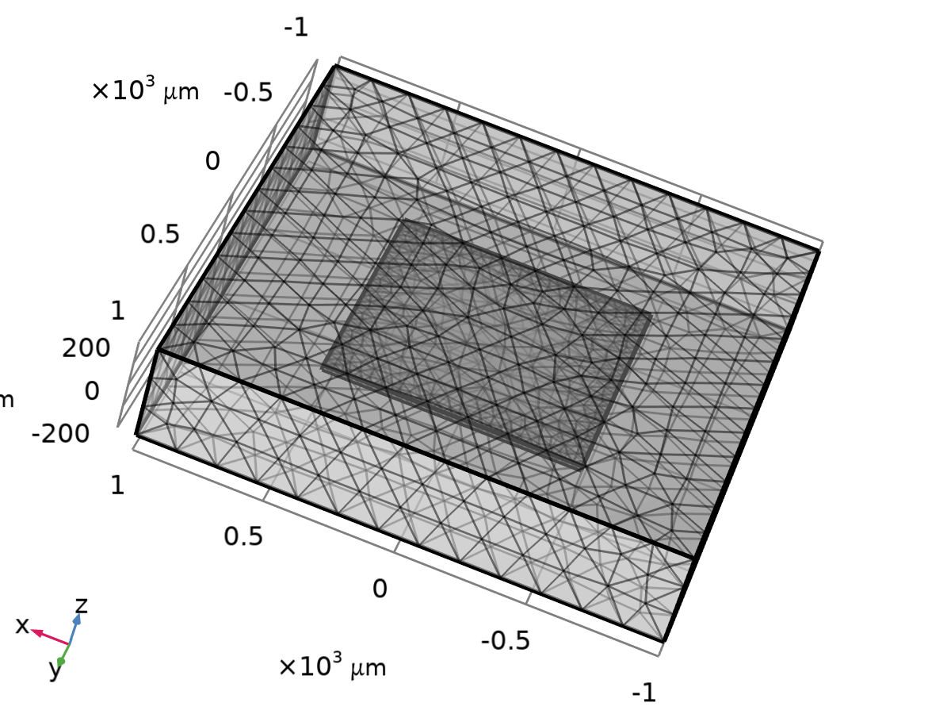
Mesh 1
Mesh statistics
Description | Value
Status | Complete mesh
Mesh vertices | 3027
Tetrahedra | 14360
Triangles | 2560
Edge elements | 328
Vertex elements | 16
Number of elements | 14360
Minimum element quality | 0.1877
Average element quality | 0.6463
Element volume ratio | 0.0022991
Mesh volume | 1.58E9 µm³

    - Size (size)
Settings
Description | Value
Maximum element size | 160
Minimum element size | 20
Curvature factor | 0.5
Resolution of narrow regions | 0.6
Maximum element growth rate | 1.45
Predefined size | Fine

    - Free Tetrahedral 1 (ftet1)
Selection
Geometric entity level | Domain
Selection | Remaining

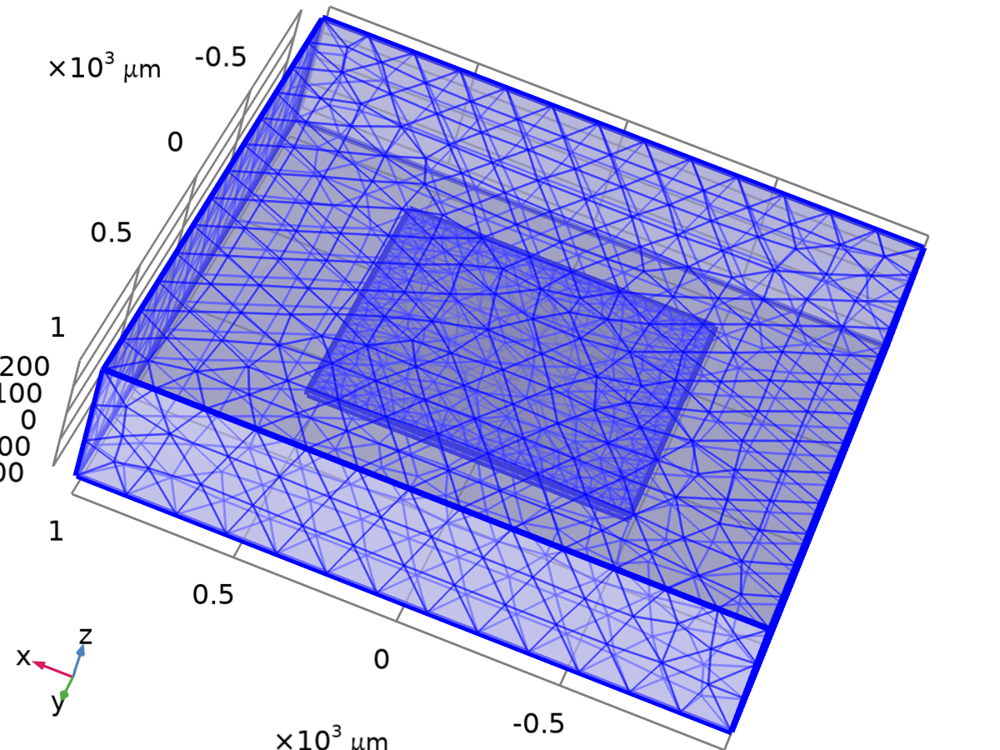
Free Tetrahedral 1
Settings
Description | Value
Avoid inverted curved elements | On
Last build time | 0
Built with | COMSOL 6.1.0.282 (win64)|2026 - 09 - 09T16:35:38.130474400

- Study 1
Computation information
Computation time | 25 s

  - Parametric Sweep
Parameter name | Parameter value list | Parameter unit
P_app | range(0, 20[kPa], 100[kPa]) | kPa
T_amb | range(293.15, 15, 358.15) | K

Study settings
Description | Value
Sweep type | All combinations
Parameter name | {P_app, T_amb}
Unit | {kPa, K}

Parameters
Parameter name | Parameter value list | Parameter unit
P_app (الضغط التجريبي) | range(0, 20[kPa], 100[kPa]) | kPa
T_amb (Ambient operating temperature) | range(293.15, 15, 358.15) | K

  - Stationary
Study settings
Description | Value
Include geometric nonlinearity | Off

Physics and variables selection
Physics interface | Solve for | Equation form
Solid Mechanics (solid) | On | Automatic (Stationary)
Electric Currents (ec) | On | Automatic (Stationary)
Electrical Circuit (cir) | On | Automatic (Stationary)

Physics and variables selection
Multiphysics couplings | Solve for | Equation form
Piezoresistive Effect, Domain Currents 1 (pzrd1) | On | Automatic (Stationary)

Mesh selection
Component | Mesh
Component 1 | Mesh 1

  - Solver Configurations
    - Solution 1

Compile Equations: Stationary (st1)
Study and step
Description | Value
Use study
Use study step | Stationary

Log
<---- Compile Equations: Stationary in Study 1/Solution 1 (sol1) ---------------
Started at Sep 15, 2026, 3:48:34 PM.
Geometry shape function: Quadratic serendipity
Running on Intel64 Family 6 Model 154 Stepping 3, GenuineIntel.
Using 1 socket with 16 cores in total on DESKTOP-QQN3U8M.
Available memory: 16.07 GB.
Time: 2 s.
Physical memory: 1.54 GB
Virtual memory: 1.72 GB
Ended at Sep 15, 2026, 3:48:35 PM.
----- Compile Equations: Stationary in Study 1/Solution 1 (sol1) -------------->

Dependent Variables 1 (v1)
General
Description | Value
Defined by study step

Initial value calculation constants
Constant name | Initial value source
P_app | range(0, 20[kPa], 100[kPa])
T_amb | range(293.15, 15, 358.15)[K]

Log
<---- Dependent Variables 1 in Study 1/Solution 1 (sol1) -----------------------
Started at Sep 15, 2026, 3:48:35 PM.
Solution time: 0 s.
Physical memory: 1.54 GB
Virtual memory: 1.72 GB
Ended at Sep 15, 2026, 3:48:36 PM.
----- Dependent Variables 1 in Study 1/Solution 1 (sol1) ---------------------->

Displacement field (comp1.u) (comp1_u)
General
Description | Value
Field components | {comp1.u, comp1.v, comp1.w}

Electric potential (comp1.V) (comp1_V)
General
Description | Value
Field components | comp1.V

comp1.currents (comp1_currents)
General
Description | Value
State components | {comp1.cir.R1_i, comp1.cir.R2_i, comp1.cir.R3_i, comp1.cir.R4_i, comp1.cir.R5_i}

comp1.voltages (comp1_voltages)
General
Description | Value
State components | {comp1.cir.R1_n_v, comp1.cir.R3_n_v, comp1.cir.E1_sens_v}

Stationary Solver 1 (s1)
General
Description | Value
Defined by study step

Results while solving
Description | Value
Probes | None

Log
2.7e-15, 9.1e-05, 3e-14
Residual error estimates for segregated groups
2.8e+03, 0.0025, 2.4e-10

Parameter P_app = 20000.
Parameter T_amb = 353.15.
Segregated solver iteration 1.
Electrical Circuit
Iter SolEst Damping Stepsize #Res #Jac #Sol LinErr LinRes
1 0.86 1.0000000 0.86 47 10 19 1.7e-16 6.4e-14
Electric Currents
Iter SolEst Damping Stepsize #Res #Jac #Sol LinIt LinErr LinRes
1 0.97 1.0000000 0.97 47 10 19 76 0.00018 3.6e-07
Solid Mechanics
Iter SolEst Damping Stepsize #Res #Jac #Sol LinErr LinRes
1 0.88 1.0000000 0.88 47 1 19 1.2e-14 1.4e-13
Solution error estimates for segregated groups
0.86, 0.97, 0.88
Residual error estimates for segregated groups
2.6e+03, 3.9e+02, 1.2e+04
Segregated solver iteration 2.
Electrical Circuit
Iter SolEst Damping Stepsize #Res #Jac #Sol LinErr LinRes
1 6.6e-16 1.0000000 6.6e-16 49 10 20 1.7e-16 2.4e-16
Electric Currents
Iter SolEst Damping Stepsize #Res #Jac #Sol LinIt LinErr LinRes
1 9.1e-05 1.0000000 9.1e-05 49 10 20 80 0.00017 2.7e-07
Solid Mechanics
Iter SolEst Damping Stepsize #Res #Jac #Sol LinErr LinRes
1 3e-14 1.0000000 3e-14 49 1 20 1.1e-14 3.2e-14
Solution error estimates for segregated groups
6.6e-16, 9.1e-05, 3e-14
Residual error estimates for segregated groups
3.2e+02, 0.0025, 2.4e-10

Parameter P_app = 40000.
Parameter T_amb = 293.15.
Segregated solver iteration 1.
Electrical Circuit
Iter SolEst Damping Stepsize #Res #Jac #Sol LinErr LinRes
1 0.86 1.0000000 0.86 52 11 21 2.9e-16 9.1e-14
Electric Currents
Iter SolEst Damping Stepsize #Res #Jac #Sol LinIt LinErr LinRes
1 0.97 1.0000000 0.97 52 11 21 84 0.00018 3.6e-07
Solid Mechanics
Iter SolEst Damping Stepsize #Res #Jac #Sol LinErr LinRes
1 0.88 1.0000000 0.88 52 1 21 1.2e-14 1.4e-13
Solution error estimates for segregated groups
0.86, 0.97, 0.88
Residual error estimates for segregated groups
1.9e+03, 3.9e+02, 1.2e+04
Segregated solver iteration 2.
Electrical Circuit
Iter SolEst Damping Stepsize #Res #Jac #Sol LinErr LinRes
1 1.1e-15 1.0000000 1.1e-15 54 11 22 9e-17 2.2e-16
Electric Currents
Iter SolEst Damping Stepsize #Res #Jac #Sol LinIt LinErr LinRes
1 0.00018 1.0000000 0.00018 54 11 22 88 0.00017 2.7e-07
Solid Mechanics
Iter SolEst Damping Stepsize #Res #Jac #Sol LinErr LinRes
1 3e-14 1.0000000 3e-14 54 1 22 8.1e-15 3.1e-14
Solution error estimates for segregated groups
1.1e-15, 0.00018, 3e-14
Residual error estimates for segregated groups
2.9e+02, 0.01, 2.4e-10

Parameter P_app = 40000.
Parameter T_amb = 308.15.
Segregated solver iteration 1.
Electrical Circuit
Iter SolEst Damping Stepsize #Res #Jac #Sol LinErr LinRes
1 0.86 1.0000000 0.86 57 12 23 8.9e-17 1.5e-16
Electric Currents
Iter SolEst Damping Stepsize #Res #Jac #Sol LinIt LinErr LinRes
1 0.97 1.0000000 0.97 57 12 23 92 0.00018 3.6e-07
Solid Mechanics
Iter SolEst Damping Stepsize #Res #Jac #Sol LinErr LinRes
1 0.88 1.0000000 0.88 57 1 23 1.2e-14 1.4e-13
Solution error estimates for segregated groups
0.86, 0.97, 0.88
Residual error estimates for segregated groups
2.6e+03, 3.9e+02, 1.2e+04
Segregated solver iteration 2.
Electrical Circuit
Iter SolEst Damping Stepsize #Res #Jac #Sol LinErr LinRes
1 2.7e-15 1.0000000 2.7e-15 59 12 24 4.5e-16 1.2e-15
Electric Currents
Iter SolEst Damping Stepsize #Res #Jac #Sol LinIt LinErr LinRes
1 0.00018 1.0000000 0.00018 59 12 24 96 0.00017 2.7e-07
Solid Mechanics
Iter SolEst Damping Stepsize #Res #Jac #Sol LinErr LinRes
1 3e-14 1.0000000 3e-14 59 1 24 6.5e-15 3.2e-14
Solution error estimates for segregated groups
2.7e-15, 0.00018, 3e-14
Residual error estimates for segregated groups
2.1e-13, 0.01, 2.4e-10

Parameter P_app = 40000.
Parameter T_amb = 323.15.
Segregated solver iteration 1.
Electrical Circuit
Iter SolEst Damping Stepsize #Res #Jac #Sol LinErr LinRes
1 0.86 1.0000000 0.86 62 13 25 1.9e-16 4.6e-14
Electric Currents
Iter SolEst Damping Stepsize #Res #Jac #Sol LinIt LinErr LinRes
1 0.97 1.0000000 0.97 62 13 25 100 0.00018 3.6e-07
Solid Mechanics
Iter SolEst Damping Stepsize #Res #Jac #Sol LinErr LinRes
1 0.88 1.0000000 0.88 62 1 25 1.3e-14 1.4e-13
Solution error estimates for segregated groups
0.86, 0.97, 0.88
Residual error estimates for segregated groups
2.3e+03, 3.9e+02, 1.2e+04
Segregated solver iteration 2.
Electrical Circuit
Iter SolEst Damping Stepsize #Res #Jac #Sol LinErr LinRes
1 5.6e-16 1.0000000 5.6e-16 64 13 26 1.8e-16 2.9e-16
Electric Currents
Iter SolEst Damping Stepsize #Res #Jac #Sol LinIt LinErr LinRes
1 0.00018 1.0000000 0.00018 64 13 26 104 0.00017 2.7e-07
Solid Mechanics
Iter SolEst Damping Stepsize #Res #Jac #Sol LinErr LinRes
1 3e-14 1.0000000 3e-14 64 1 26 5.6e-15 3.1e-14
Solution error estimates for segregated groups
5.5e-16, 0.00018, 3e-14
Residual error estimates for segregated groups
0, 0.01, 2.4e-10

Parameter P_app = 40000.
Parameter T_amb = 338.15.
Segregated solver iteration 1.
Electrical Circuit
Iter SolEst Damping Stepsize #Res #Jac #Sol LinErr LinRes
1 0.86 1.0000000 0.86 67 14 27 1.4e-16 7.2e-14
Electric Currents
Iter SolEst Damping Stepsize #Res #Jac #Sol LinIt LinErr LinRes
1 0.97 1.0000000 0.97 67 14 27 108 0.00018 3.6e-07
Solid Mechanics
Iter SolEst Damping Stepsize #Res #Jac #Sol LinErr LinRes
1 0.88 1.0000000 0.88 67 1 27 1.4e-14 1.4e-13
Solution error estimates for segregated groups
0.86, 0.97, 0.88
Residual error estimates for segregated groups
2.5e+03, 3.9e+02, 1.2e+04
Segregated solver iteration 2.
Electrical Circuit
Iter SolEst Damping Stepsize #Res #Jac #Sol LinErr LinRes
1 6.4e-16 1.0000000 6.4e-16 69 14 28 1.2e-16 1.5e-16
Electric Currents
Iter SolEst Damping Stepsize #Res #Jac #Sol LinIt LinErr LinRes
1 0.00018 1.0000000 0.00018 69 14 28 112 0.00017 2.7e-07
Solid Mechanics
Iter SolEst Damping Stepsize #Res #Jac #Sol LinErr LinRes
1 3e-14 1.0000000 3e-14 69 1 28 2e-14 3.3e-14
Solution error estimates for segregated groups
6.4e-16, 0.00018, 3e-14
Residual error estimates for segregated groups
3.3e+02, 0.01, 2.4e-10

Parameter P_app = 40000.
Parameter T_amb = 353.15.
Segregated solver iteration 1.
Electrical Circuit
Iter SolEst Damping Stepsize #Res #Jac #Sol LinErr LinRes
1 0.86 1.0000000 0.86 72 15 29 1.9e-16 9.1e-14
Electric Currents
Iter SolEst Damping Stepsize #Res #Jac #Sol LinIt LinErr LinRes
1 0.97 1.0000000 0.97 72 15 29 116 0.00018 3.6e-07
Solid Mechanics
Iter SolEst Damping Stepsize #Res #Jac #Sol LinErr LinRes
1 0.88 1.0000000 0.88 72 1 29 1.2e-14 1.4e-13
Solution error estimates for segregated groups
0.86, 0.97, 0.88
Residual error estimates for segregated groups
2.1e+03, 3.9e+02, 1.2e+04
Segregated solver iteration 2.
Electrical Circuit
Iter SolEst Damping Stepsize #Res #Jac #Sol LinErr LinRes
1 7.8e-16 1.0000000 7.8e-16 74 15 30 1.3e-16 1.1e-16
Electric Currents
Iter SolEst Damping Stepsize #Res #Jac #Sol LinIt LinErr LinRes
1 0.00018 1.0000000 0.00018 74 15 30 120 0.00017 2.7e-07
Solid Mechanics
Iter SolEst Damping Stepsize #Res #Jac #Sol LinErr LinRes
1 3e-14 1.0000000 3e-14 74 1 30 8.2e-15 3.1e-14
Solution error estimates for segregated groups
7.8e-16, 0.00018, 3e-14
Residual error estimates for segregated groups
1.8e+02, 0.01, 2.5e-10

Parameter P_app = 60000.
Parameter T_amb = 293.15.
Segregated solver iteration 1.
Electrical Circuit
Iter SolEst Damping Stepsize #Res #Jac #Sol LinErr LinRes
1 0.86 1.0000000 0.86 77 16 31 7.6e-17 3.2e-14
Electric Currents
Iter SolEst Damping Stepsize #Res #Jac #Sol LinIt LinErr LinRes
1 0.97 1.0000000 0.97 77 16 31 124 0.00018 3.6e-07
Solid Mechanics
Iter SolEst Damping Stepsize #Res #Jac #Sol LinErr LinRes
1 0.88 1.0000000 0.88 77 1 31 7.9e-15 1.4e-13
Solution error estimates for segregated groups
0.86, 0.97, 0.88
Residual error estimates for segregated groups
2.3e+03, 3.9e+02, 1.2e+04
Segregated solver iteration 2.
Electrical Circuit
Iter SolEst Damping Stepsize #Res #Jac #Sol LinErr LinRes
1 1.6e-15 1.0000000 1.6e-15 79 16 32 3.4e-17 7.5e-17
Electric Currents
Iter SolEst Damping Stepsize #Res #Jac #Sol LinIt LinErr LinRes
1 0.00027 1.0000000 0.00027 79 16 32 128 0.00017 2.7e-07
Solid Mechanics
Iter SolEst Damping Stepsize #Res #Jac #Sol LinErr LinRes
1 2.9e-14 1.0000000 2.9e-14 79 1 32 1.5e-14 3.1e-14
Solution error estimates for segregated groups
1.6e-15, 0.00027, 2.9e-14
Residual error estimates for segregated groups
0, 0.023, 2.3e-10

Parameter P_app = 60000.
Parameter T_amb = 308.15.
Segregated solver iteration 1.
Electrical Circuit
Iter SolEst Damping Stepsize #Res #Jac #Sol LinErr LinRes
1 0.86 1.0000000 0.86 82 17 33 9.9e-17 3.2e-14
Electric Currents
Iter SolEst Damping Stepsize #Res #Jac #Sol LinIt LinErr LinRes
1 0.97 1.0000000 0.97 82 17 33 132 0.00018 3.6e-07
Solid Mechanics
Iter SolEst Damping Stepsize #Res #Jac #Sol LinErr LinRes
1 0.88 1.0000000 0.88 82 1 33 5.8e-15 1.4e-13
Solution error estimates for segregated groups
0.86, 0.97, 0.88
Residual error estimates for segregated groups
2.5e+03, 3.9e+02, 1.2e+04
Segregated solver iteration 2.
Electrical Circuit
Iter SolEst Damping Stepsize #Res #Jac #Sol LinErr LinRes
1 7.8e-17 1.0000000 7.8e-17 84 17 34 3e-16 2.3e-16
Electric Currents
Iter SolEst Damping Stepsize #Res #Jac #Sol LinIt LinErr LinRes
1 0.00027 1.0000000 0.00027 84 17 34 136 0.00017 2.7e-07
Solid Mechanics
Iter SolEst Damping Stepsize #Res #Jac #Sol LinErr LinRes
1 3e-14 1.0000000 3e-14 84 1 34 1.7e-14 3.1e-14
Solution error estimates for segregated groups
9.4e-17, 0.00027, 3e-14
Residual error estimates for segregated groups
5.9e+02, 0.023, 2.3e-10

Parameter P_app = 60000.
Parameter T_amb = 323.15.
Segregated solver iteration 1.
Electrical Circuit
Iter SolEst Damping Stepsize #Res #Jac #Sol LinErr LinRes
1 0.86 1.0000000 0.86 87 18 35 2.1e-16 7.2e-14
Electric Currents
Iter SolEst Damping Stepsize #Res #Jac #Sol LinIt LinErr LinRes
1 0.97 1.0000000 0.97 87 18 35 140 0.00018 3.6e-07
Solid Mechanics
Iter SolEst Damping Stepsize #Res #Jac #Sol LinErr LinRes
1 0.88 1.0000000 0.88 87 1 35 9.1e-15 1.4e-13
Solution error estimates for segregated groups
0.86, 0.97, 0.88
Residual error estimates for segregated groups
1.8e+03, 3.9e+02, 1.2e+04
Segregated solver iteration 2.
Electrical Circuit
Iter SolEst Damping Stepsize #Res #Jac #Sol LinErr LinRes
1 5.7e-16 1.0000000 5.7e-16 89 18 36 1.2e-16 1.2e-16
Electric Currents
Iter SolEst Damping Stepsize #Res #Jac #Sol LinIt LinErr LinRes
1 0.00027 1.0000000 0.00027 89 18 36 144 0.00017 2.7e-07
Solid Mechanics
Iter SolEst Damping Stepsize #Res #Jac #Sol LinErr LinRes
1 2.9e-14 1.0000000 2.9e-14 89 1 36 9.4e-15 3e-14
Solution error estimates for segregated groups
5.7e-16, 0.00027, 2.9e-14
Residual error estimates for segregated groups
2.9e+02, 0.023, 2.3e-10

Parameter P_app = 60000.
Parameter T_amb = 338.15.
Segregated solver iteration 1.
Electrical Circuit
Iter SolEst Damping Stepsize #Res #Jac #Sol LinErr LinRes
1 0.86 1.0000000 0.86 92 19 37 1.6e-16 6.4e-14
Electric Currents
Iter SolEst Damping Stepsize #Res #Jac #Sol LinIt LinErr LinRes
1 0.97 1.0000000 0.97 92 19 37 148 0.00018 3.6e-07
Solid Mechanics
Iter SolEst Damping Stepsize #Res #Jac #Sol LinErr LinRes
1 0.88 1.0000000 0.88 92 1 37 9.1e-15 1.4e-13
Solution error estimates for segregated groups
0.86, 0.97, 0.88
Residual error estimates for segregated groups
2.7e+03, 3.9e+02, 1.2e+04
Segregated solver iteration 2.
Electrical Circuit
Iter SolEst Damping Stepsize #Res #Jac #Sol LinErr LinRes
1 4.8e-16 1.0000000 4.8e-16 94 19 38 1.7e-16 2.2e-16
Electric Currents
Iter SolEst Damping Stepsize #Res #Jac #Sol LinIt LinErr LinRes
1 0.00027 1.0000000 0.00027 94 19 38 152 0.00017 2.7e-07
Solid Mechanics
Iter SolEst Damping Stepsize #Res #Jac #Sol LinErr LinRes
1 3e-14 1.0000000 3e-14 94 1 38 9.3e-15 3e-14
Solution error estimates for segregated groups
4.9e-16, 0.00027, 3e-14
Residual error estimates for segregated groups
9.4e-14, 0.023, 2.3e-10

Parameter P_app = 60000.
Parameter T_amb = 353.15.
Segregated solver iteration 1.
Electrical Circuit
Iter SolEst Damping Stepsize #Res #Jac #Sol LinErr LinRes
1 0.86 1.0000000 0.86 97 20 39 2.6e-16 4.6e-14
Electric Currents
Iter SolEst Damping Stepsize #Res #Jac #Sol LinIt LinErr LinRes
1 0.97 1.0000000 0.97 97 20 39 156 0.00018 3.6e-07
Solid Mechanics
Iter SolEst Damping Stepsize #Res #Jac #Sol LinErr LinRes
1 0.88 1.0000000 0.88 97 1 39 7.6e-15 1.4e-13
Solution error estimates for segregated groups
0.86, 0.97, 0.88
Residual error estimates for segregated groups
2.9e+03, 3.9e+02, 1.2e+04
Segregated solver iteration 2.
Electrical Circuit
Iter SolEst Damping Stepsize #Res #Jac #Sol LinErr LinRes
1 1.1e-15 1.0000000 1.1e-15 99 20 40 2.4e-16 5.7e-14
Electric Currents
Iter SolEst Damping Stepsize #Res #Jac #Sol LinIt LinErr LinRes
1 0.00027 1.0000000 0.00027 99 20 40 160 0.00017 2.7e-07
Solid Mechanics
Iter SolEst Damping Stepsize #Res #Jac #Sol LinErr LinRes
1 2.9e-14 1.0000000 2.9e-14 99 1 40 1.6e-14 3e-14
Solution error estimates for segregated groups
1.1e-15, 0.00027, 2.9e-14
Residual error estimates for segregated groups
0, 0.023, 2.3e-10

Parameter P_app = 80000.
Parameter T_amb = 293.15.
Segregated solver iteration 1.
Electrical Circuit
Iter SolEst Damping Stepsize #Res #Jac #Sol LinErr LinRes
1 0.86 1.0000000 0.86 102 21 41 1.4e-16 9.7e-14
Electric Currents
Iter SolEst Damping Stepsize #Res #Jac #Sol LinIt LinErr LinRes
1 0.97 1.0000000 0.97 102 21 41 164 0.00018 3.6e-07
Solid Mechanics
Iter SolEst Damping Stepsize #Res #Jac #Sol LinErr LinRes
1 0.88 1.0000000 0.88 102 1 41 1e-14 1.4e-13
Solution error estimates for segregated groups
0.86, 0.97, 0.88
Residual error estimates for segregated groups
3.2e+03, 3.9e+02, 1.2e+04
Segregated solver iteration 2.
Electrical Circuit
Iter SolEst Damping Stepsize #Res #Jac #Sol LinErr LinRes
1 1.6e-15 1.0000000 1.6e-15 104 21 42 2.2e-16 7.5e-17
Electric Currents
Iter SolEst Damping Stepsize #Res #Jac #Sol LinIt LinErr LinRes
1 0.00036 1.0000000 0.00036 104 21 42 168 0.00017 2.7e-07
Solid Mechanics
Iter SolEst Damping Stepsize #Res #Jac #Sol LinErr LinRes
1 3e-14 1.0000000 3e-14 104 1 42 3.6e-15 3.2e-14
Solution error estimates for segregated groups
1.6e-15, 0.00036, 3e-14
Residual error estimates for segregated groups
8.8e+02, 0.04, 2.4e-10

Parameter P_app = 80000.
Parameter T_amb = 308.15.
Segregated solver iteration 1.
Electrical Circuit
Iter SolEst Damping Stepsize #Res #Jac #Sol LinErr LinRes
1 0.86 1.0000000 0.86 107 22 43 1.9e-16 9.1e-14
Electric Currents
Iter SolEst Damping Stepsize #Res #Jac #Sol LinIt LinErr LinRes
1 0.97 1.0000000 0.97 107 22 43 172 0.00018 3.6e-07
Solid Mechanics
Iter SolEst Damping Stepsize #Res #Jac #Sol LinErr LinRes
1 0.88 1.0000000 0.88 107 1 43 1.1e-14 1.4e-13
Solution error estimates for segregated groups
0.86, 0.97, 0.88
Residual error estimates for segregated groups
1.7e+03, 3.9e+02, 1.2e+04
Segregated solver iteration 2.
Electrical Circuit
Iter SolEst Damping Stepsize #Res #Jac #Sol LinErr LinRes
1 5.6e-16 1.0000000 5.6e-16 109 22 44 1.2e-16 2.1e-16
Electric Currents
Iter SolEst Damping Stepsize #Res #Jac #Sol LinIt LinErr LinRes
1 0.00036 1.0000000 0.00036 109 22 44 176 0.00017 2.7e-07
Solid Mechanics
Iter SolEst Damping Stepsize #Res #Jac #Sol LinErr LinRes
1 3e-14 1.0000000 3e-14 109 1 44 7.2e-15 3.2e-14
Solution error estimates for segregated groups
5.5e-16, 0.00036, 3e-14
Residual error estimates for segregated groups
4.7e+02, 0.04, 2.5e-10

Parameter P_app = 80000.
Parameter T_amb = 323.15.
Segregated solver iteration 1.
Electrical Circuit
Iter SolEst Damping Stepsize #Res #Jac #Sol LinErr LinRes
1 0.86 1.0000000 0.86 112 23 45 1.7e-16 1.2e-13
Electric Currents
Iter SolEst Damping Stepsize #Res #Jac #Sol LinIt LinErr LinRes
1 0.97 1.0000000 0.97 112 23 45 180 0.00018 3.6e-07
Solid Mechanics
Iter SolEst Damping Stepsize #Res #Jac #Sol LinErr LinRes
1 0.88 1.0000000 0.88 112 1 45 1.3e-14 1.4e-13
Solution error estimates for segregated groups
0.86, 0.97, 0.88
Residual error estimates for segregated groups
2.6e+03, 3.9e+02, 1.2e+04
Segregated solver iteration 2.
Electrical Circuit
Iter SolEst Damping Stepsize #Res #Jac #Sol LinErr LinRes
1 5.8e-16 1.0000000 5.8e-16 114 23 46 1.2e-16 7.5e-17
Electric Currents
Iter SolEst Damping Stepsize #Res #Jac #Sol LinIt LinErr LinRes
1 0.00036 1.0000000 0.00036 114 23 46 184 0.00017 2.7e-07
Solid Mechanics
Iter SolEst Damping Stepsize #Res #Jac #Sol LinErr LinRes
1 3e-14 1.0000000 3e-14 114 1 46 7.5e-15 3.2e-14
Solution error estimates for segregated groups
5.9e-16, 0.00036, 3e-14
Residual error estimates for segregated groups
2.9e+02, 0.04, 2.4e-10

Parameter P_app = 80000.
Parameter T_amb = 338.15.
Segregated solver iteration 1.
Electrical Circuit
Iter SolEst Damping Stepsize #Res #Jac #Sol LinErr LinRes
1 0.86 1.0000000 0.86 117 24 47 4.6e-17 3.2e-14
Electric Currents
Iter SolEst Damping Stepsize #Res #Jac #Sol LinIt LinErr LinRes
1 0.97 1.0000000 0.97 117 24 47 188 0.00018 3.6e-07
Solid Mechanics
Iter SolEst Damping Stepsize #Res #Jac #Sol LinErr LinRes
1 0.88 1.0000000 0.88 117 1 47 1.8e-14 1.4e-13
Solution error estimates for segregated groups
0.86, 0.97, 0.88
Residual error estimates for segregated groups
2e+03, 3.9e+02, 1.2e+04
Segregated solver iteration 2.
Electrical Circuit
Iter SolEst Damping Stepsize #Res #Jac #Sol LinErr LinRes
1 2.2e-15 1.0000000 2.2e-15 119 24 48 3.5e-16 9.3e-14
Electric Currents
Iter SolEst Damping Stepsize #Res #Jac #Sol LinIt LinErr LinRes
1 0.00036 1.0000000 0.00036 119 24 48 192 0.00017 2.7e-07
Solid Mechanics
Iter SolEst Damping Stepsize #Res #Jac #Sol LinErr LinRes
1 3e-14 1.0000000 3e-14 119 1 48 1.1e-14 3.2e-14
Solution error estimates for segregated groups
2.2e-15, 0.00036, 3e-14
Residual error estimates for segregated groups
1.7e+03, 0.04, 2.4e-10

Parameter P_app = 80000.
Parameter T_amb = 353.15.
Segregated solver iteration 1.
Electrical Circuit
Iter SolEst Damping Stepsize #Res #Jac #Sol LinErr LinRes
1 0.86 1.0000000 0.86 122 25 49 2.2e-16 6.4e-14
Electric Currents
Iter SolEst Damping Stepsize #Res #Jac #Sol LinIt LinErr LinRes
1 0.97 1.0000000 0.97 122 25 49 196 0.00018 3.6e-07
Solid Mechanics
Iter SolEst Damping Stepsize #Res #Jac #Sol LinErr LinRes
1 0.88 1.0000000 0.88 122 1 49 1.3e-14 1.4e-13
Solution error estimates for segregated groups
0.86, 0.97, 0.88
Residual error estimates for segregated groups
2.5e+03, 3.9e+02, 1.2e+04
Segregated solver iteration 2.
Electrical Circuit
Iter SolEst Damping Stepsize #Res #Jac #Sol LinErr LinRes
1 1.5e-15 1.0000000 1.5e-15 124 25 50 1e-16 3e-19
Electric Currents
Iter SolEst Damping Stepsize #Res #Jac #Sol LinIt LinErr LinRes
1 0.00036 1.0000000 0.00036 124 25 50 200 0.00017 2.7e-07
Solid Mechanics
Iter SolEst Damping Stepsize #Res #Jac #Sol LinErr LinRes
1 3e-14 1.0000000 3e-14 124 1 50 8.5e-15 3.1e-14
Solution error estimates for segregated groups
1.5e-15, 0.00036, 3e-14
Residual error estimates for segregated groups
2.9e+02, 0.04, 2.4e-10

Parameter P_app = 100000.
Parameter T_amb = 293.15.
Segregated solver iteration 1.
Electrical Circuit
Iter SolEst Damping Stepsize #Res #Jac #Sol LinErr LinRes
1 0.86 1.0000000 0.86 127 26 51 2.2e-16 9.7e-14
Electric Currents
Iter SolEst Damping Stepsize #Res #Jac #Sol LinIt LinErr LinRes
1 0.97 1.0000000 0.97 127 26 51 204 0.00018 3.6e-07
Solid Mechanics
Iter SolEst Damping Stepsize #Res #Jac #Sol LinErr LinRes
1 0.88 1.0000000 0.88 127 1 51 4.5e-15 1.3e-13
Solution error estimates for segregated groups
0.86, 0.97, 0.88
Residual error estimates for segregated groups
2.3e+03, 3.9e+02, 1.2e+04
Segregated solver iteration 2.
Electrical Circuit
Iter SolEst Damping Stepsize #Res #Jac #Sol LinErr LinRes
1 3.8e-15 1.0000000 3.8e-15 129 26 52 2.2e-16 3.5e-19
Electric Currents
Iter SolEst Damping Stepsize #Res #Jac #Sol LinIt LinErr LinRes
1 0.00045 1.0000000 0.00045 129 26 52 208 0.00017 2.7e-07
Solid Mechanics
Iter SolEst Damping Stepsize #Res #Jac #Sol LinErr LinRes
1 3e-14 1.0000000 3e-14 129 1 52 4.4e-15 3.1e-14
Solution error estimates for segregated groups
3.8e-15, 0.00045, 3e-14
Residual error estimates for segregated groups
0, 0.062, 2.5e-10

Parameter P_app = 100000.
Parameter T_amb = 308.15.
Segregated solver iteration 1.
Electrical Circuit
Iter SolEst Damping Stepsize #Res #Jac #Sol LinErr LinRes
1 0.86 1.0000000 0.86 132 27 53 7.6e-17 3.2e-14
Electric Currents
Iter SolEst Damping Stepsize #Res #Jac #Sol LinIt LinErr LinRes
1 0.97 1.0000000 0.97 132 27 53 212 0.00018 3.6e-07
Solid Mechanics
Iter SolEst Damping Stepsize #Res #Jac #Sol LinErr LinRes
1 0.88 1.0000000 0.88 132 1 53 4.5e-15 1.3e-13
Solution error estimates for segregated groups
0.86, 0.97, 0.88
Residual error estimates for segregated groups
2.9e+03, 3.9e+02, 1.2e+04
Segregated solver iteration 2.
Electrical Circuit
Iter SolEst Damping Stepsize #Res #Jac #Sol LinErr LinRes
1 1.1e-15 1.0000000 1.1e-15 134 27 54 6.6e-17 7.5e-17
Electric Currents
Iter SolEst Damping Stepsize #Res #Jac #Sol LinIt LinErr LinRes
1 0.00045 1.0000000 0.00045 134 27 54 216 0.00017 2.7e-07
Solid Mechanics
Iter SolEst Damping Stepsize #Res #Jac #Sol LinErr LinRes
1 3e-14 1.0000000 3e-14 134 1 54 4.7e-15 3.2e-14
Solution error estimates for segregated groups
1.1e-15, 0.00045, 3e-14
Residual error estimates for segregated groups
7.1e+02, 0.062, 2.5e-10

Parameter P_app = 100000.
Parameter T_amb = 323.15.
Segregated solver iteration 1.
Electrical Circuit
Iter SolEst Damping Stepsize #Res #Jac #Sol LinErr LinRes
1 0.86 1.0000000 0.86 137 28 55 1.4e-16 9.1e-14
Electric Currents
Iter SolEst Damping Stepsize #Res #Jac #Sol LinIt LinErr LinRes
1 0.97 1.0000000 0.97 137 28 55 220 0.00018 3.6e-07
Solid Mechanics
Iter SolEst Damping Stepsize #Res #Jac #Sol LinErr LinRes
1 0.88 1.0000000 0.88 137 1 55 5e-15 1.4e-13
Solution error estimates for segregated groups
0.86, 0.97, 0.88
Residual error estimates for segregated groups
2e+03, 3.9e+02, 1.2e+04
Segregated solver iteration 2.
Electrical Circuit
Iter SolEst Damping Stepsize #Res #Jac #Sol LinErr LinRes
1 5.5e-16 1.0000000 5.5e-16 139 28 56 1.6e-16 1.1e-16
Electric Currents
Iter SolEst Damping Stepsize #Res #Jac #Sol LinIt LinErr LinRes
1 0.00045 1.0000000 0.00045 139 28 56 224 0.00017 2.7e-07
Solid Mechanics
Iter SolEst Damping Stepsize #Res #Jac #Sol LinErr LinRes
1 3e-14 1.0000000 3e-14 139 1 56 9e-15 3.1e-14
Solution error estimates for segregated groups
5.6e-16, 0.00045, 3e-14
Residual error estimates for segregated groups
7.2e+02, 0.062, 2.3e-10

Parameter P_app = 100000.
Parameter T_amb = 338.15.
Segregated solver iteration 1.
Electrical Circuit
Iter SolEst Damping Stepsize #Res #Jac #Sol LinErr LinRes
1 0.86 1.0000000 0.86 142 29 57 2.9e-16 9.1e-14
Electric Currents
Iter SolEst Damping Stepsize #Res #Jac #Sol LinIt LinErr LinRes
1 0.97 1.0000000 0.97 142 29 57 228 0.00018 3.6e-07
Solid Mechanics
Iter SolEst Damping Stepsize #Res #Jac #Sol LinErr LinRes
1 0.88 1.0000000 0.88 142 1 57 6.1e-15 1.3e-13
Solution error estimates for segregated groups
0.86, 0.97, 0.88
Residual error estimates for segregated groups
2e+03, 3.9e+02, 1.2e+04
Segregated solver iteration 2.
Electrical Circuit
Iter SolEst Damping Stepsize #Res #Jac #Sol LinErr LinRes
1 7.1e-16 1.0000000 7.1e-16 144 29 58 1.2e-16 1.5e-16
Electric Currents
Iter SolEst Damping Stepsize #Res #Jac #Sol LinIt LinErr LinRes
1 0.00045 1.0000000 0.00045 144 29 58 232 0.00017 2.7e-07
Solid Mechanics
Iter SolEst Damping Stepsize #Res #Jac #Sol LinErr LinRes
1 3e-14 1.0000000 3e-14 144 1 58 8.6e-15 3.2e-14
Solution error estimates for segregated groups
7.2e-16, 0.00045, 3e-14
Residual error estimates for segregated groups
1.7e+02, 0.062, 2.3e-10

Parameter P_app = 100000.
Parameter T_amb = 353.15.
Segregated solver iteration 1.
Electrical Circuit
Iter SolEst Damping Stepsize #Res #Jac #Sol LinErr LinRes
1 0.86 1.0000000 0.86 147 30 59 1.6e-16 1e-13
Electric Currents
Iter SolEst Damping Stepsize #Res #Jac #Sol LinIt LinErr LinRes
1 0.97 1.0000000 0.97 147 30 59 236 0.00018 3.6e-07
Solid Mechanics
Iter SolEst Damping Stepsize #Res #Jac #Sol LinErr LinRes
1 0.88 1.0000000 0.88 147 1 59 5.2e-15 1.3e-13
Solution error estimates for segregated groups
0.86, 0.97, 0.88
Residual error estimates for segregated groups
3.2e+03, 3.9e+02, 1.2e+04
Segregated solver iteration 2.
Electrical Circuit
Iter SolEst Damping Stepsize #Res #Jac #Sol LinErr LinRes
1 6.6e-16 1.0000000 6.6e-16 149 30 60 4.1e-17 3.8e-17
Electric Currents
Iter SolEst Damping Stepsize #Res #Jac #Sol LinIt LinErr LinRes
1 0.00045 1.0000000 0.00045 149 30 60 240 0.00017 2.7e-07
Solid Mechanics
Iter SolEst Damping Stepsize #Res #Jac #Sol LinErr LinRes
1 2.9e-14 1.0000000 2.9e-14 149 1 60 1.2e-14 3.1e-14
Solution error estimates for segregated groups
6.5e-16, 0.00045, 2.9e-14
Residual error estimates for segregated groups
9.6e+02, 0.062, 2.3e-10
Solution time: 23 s.
Physical memory: 2.38 GB
Virtual memory: 2.91 GB
Ended at Sep 15, 2026, 3:48:58 PM.
----- Stationary Solver 1 in Study 1/Solution 1 (sol1) ------------------------>

Advanced (aDef)
Assembly settings
Description | Value
Reuse sparsity pattern | On

Parametric 1 (p1)
General
Description | Value
Defined by study step
Sweep type | All combinations
Run continuation for | No parameter

Parameters
Parameter name | Parameter value list | Parameter unit
P_app | range(0, 20[kPa], 100[kPa]) | kPa
T_amb | range(293.15, 15, 358.15) | K

Segregated 1 (se1)

Electrical Circuit (ss1)
General
Description | Value
Variables | {comp1.currents, comp1.voltages}
Linear solver

Electric Currents (ss2)
General
Description | Value
Variables | Electric potential (comp1.V)
Linear solver

Solid Mechanics (ss3)
General
Description | Value
Variables | Displacement field (comp1.u)
Linear solver

Iterative 1 (i1)
General
Description | Value
Solver | Conjugate gradients

Multigrid 1 (mg1)
General
Description | Value
Solver | Algebraic multigrid
Coarsening method | Classical

Suggested Direct Solver (solid) (d1)
General
Description | Value
Solver | PARDISO
Pivoting perturbation | 1E-9

- Results
  - Datasets
    - Study 1/Solution 1
Solution
Description | Value
Solution
Component | Component 1 (comp1)
Frame | Material (X, Y, Z)

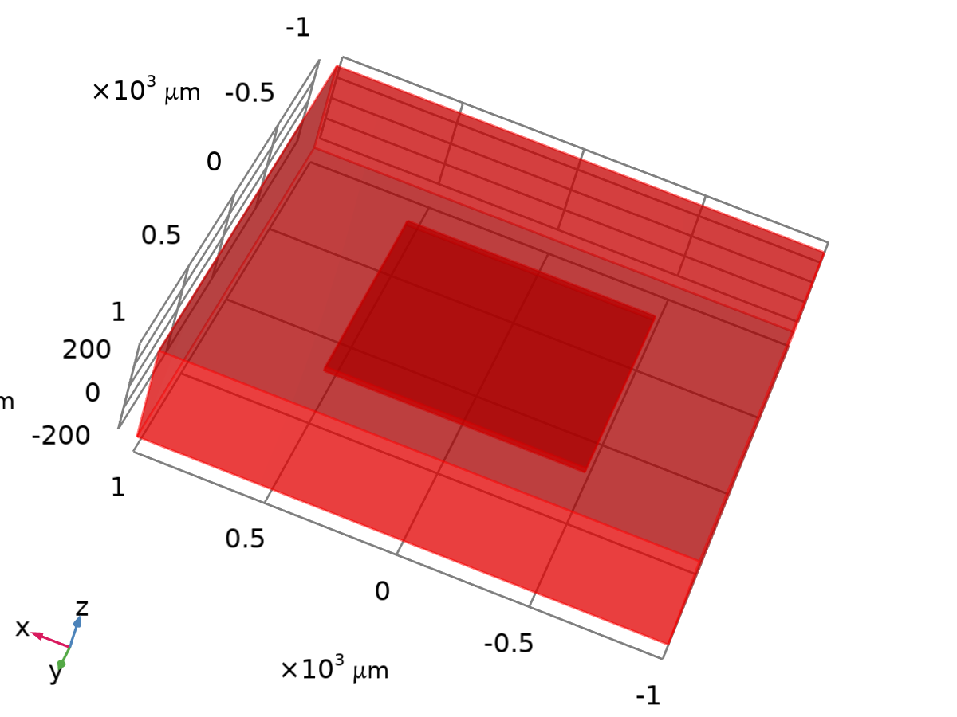
Dataset: Study 1/Solution 1
  - Derived Values
    - Global Evaluation 1
Output
Evaluated in

Data
Description | Value
Dataset

Expressions
Expression | Unit | Description
1/ec.G11 | Ω

Expressions
Name | Value | Unit | Description
solid.refpntx | 0 | m | Reference point for moment computation, x-coordinate
solid.refpnty | 0 | m | Reference point for moment computation, y-coordinate
solid.refpntz | 0 | m | Reference point for moment computation, z-coordinate

  - Tables
    - Table 1
Global Evaluation 1
    - Table 2
Global Evaluation 1
1/ec.G11 (Ω)
0.25082

  - Plot Groups
    - 3D Plot Group 1
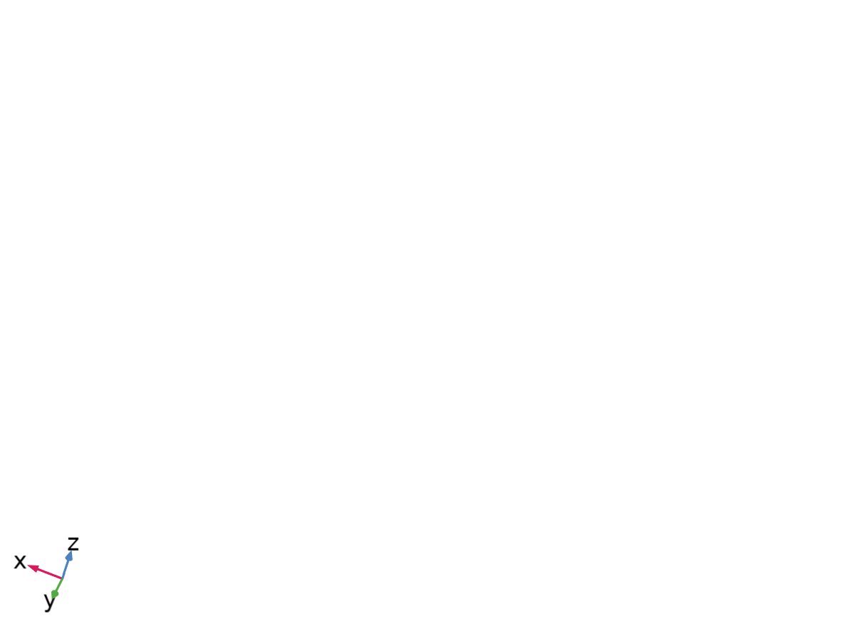
    - Stress (solid)
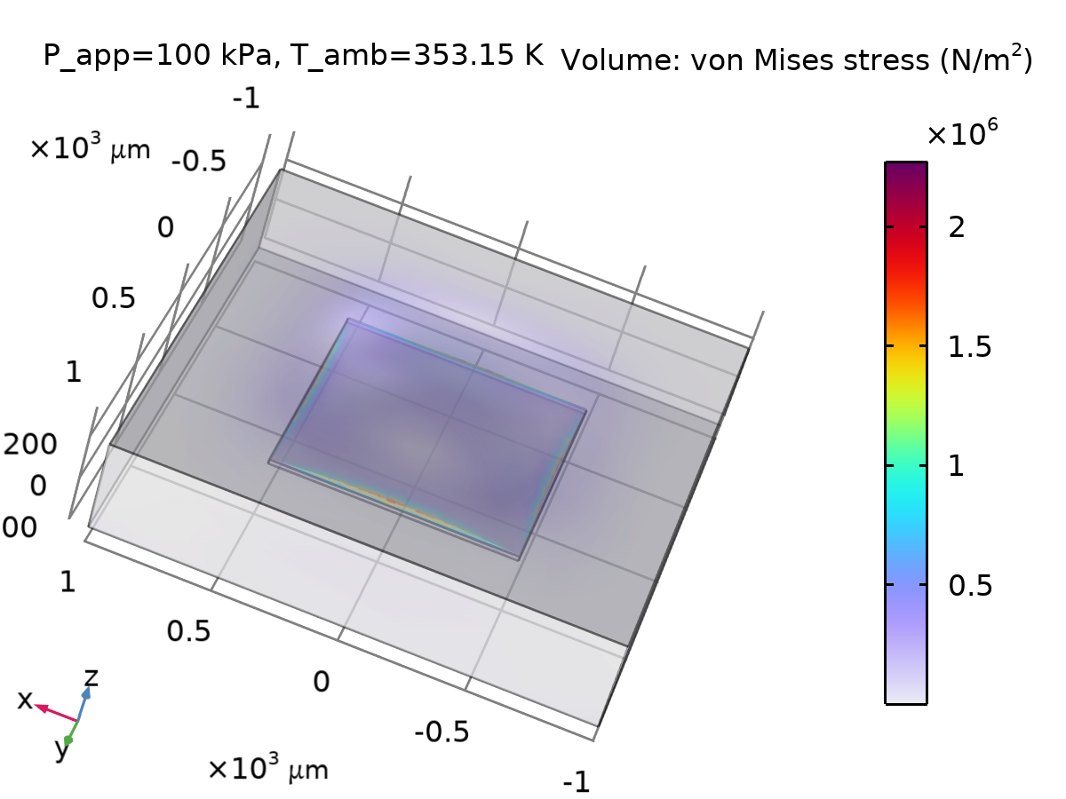
Volume: von Mises stress (N/m²)
    - Electric Potential
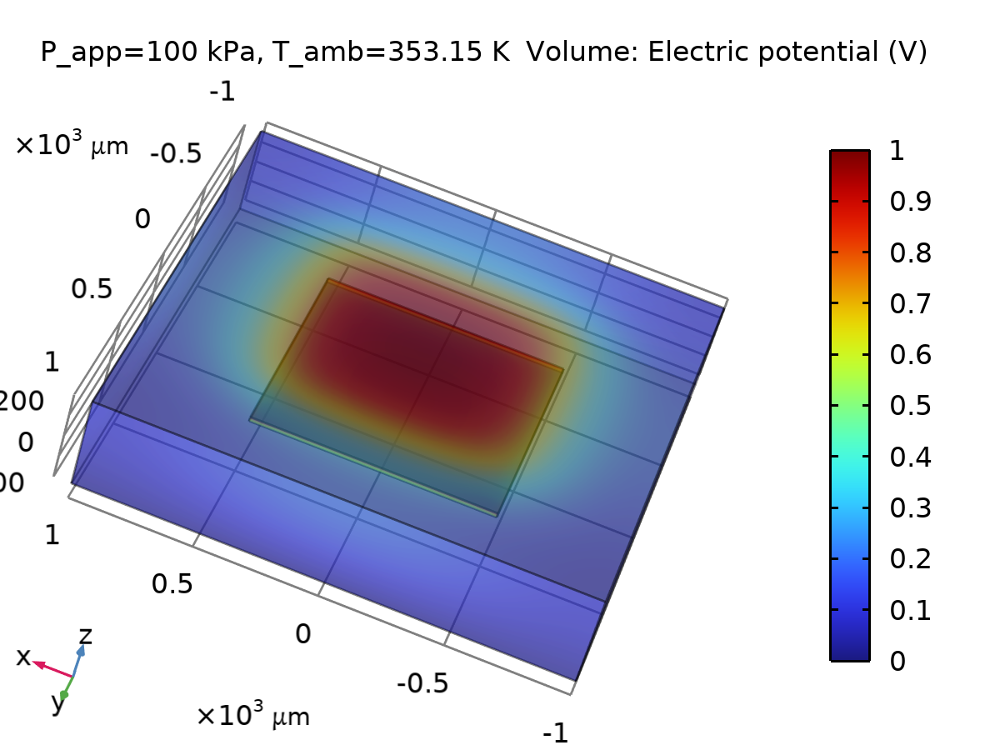
Volume: Electric potential (V)
    - 1D Plot Group 4
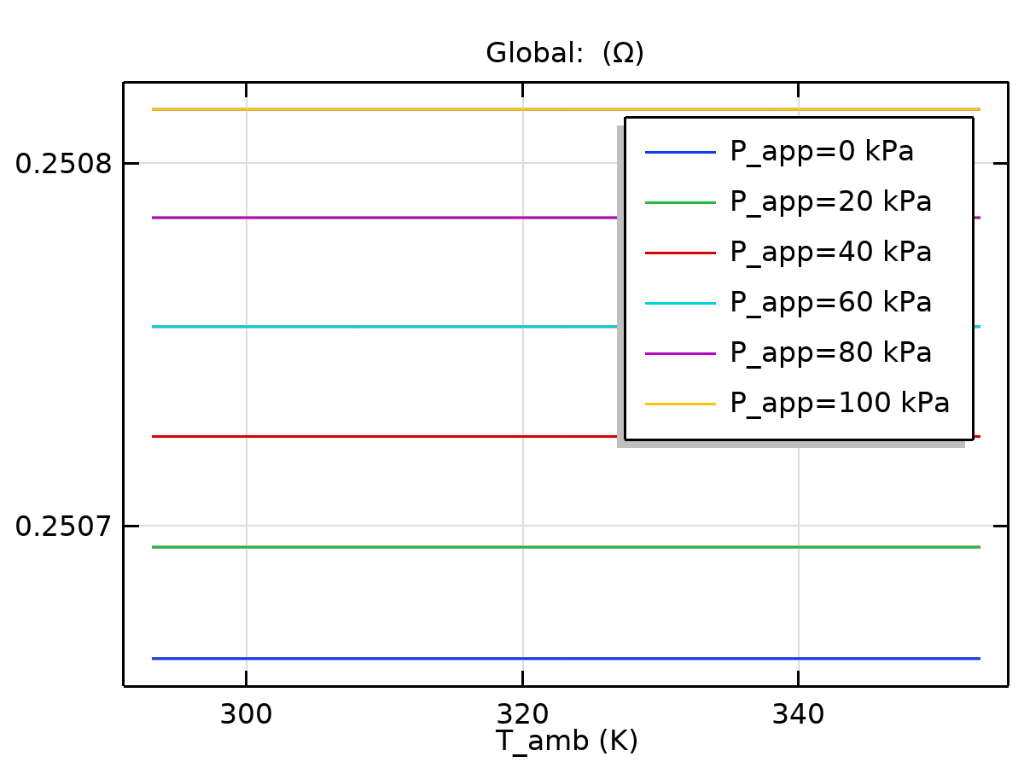
Global: (Ω)
    - 1D Plot Group 5
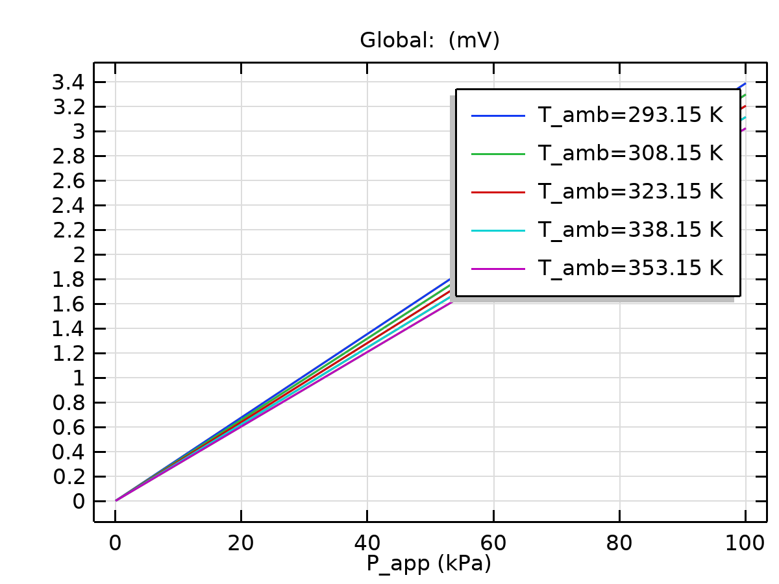
Global: (mV)
    - v(4)
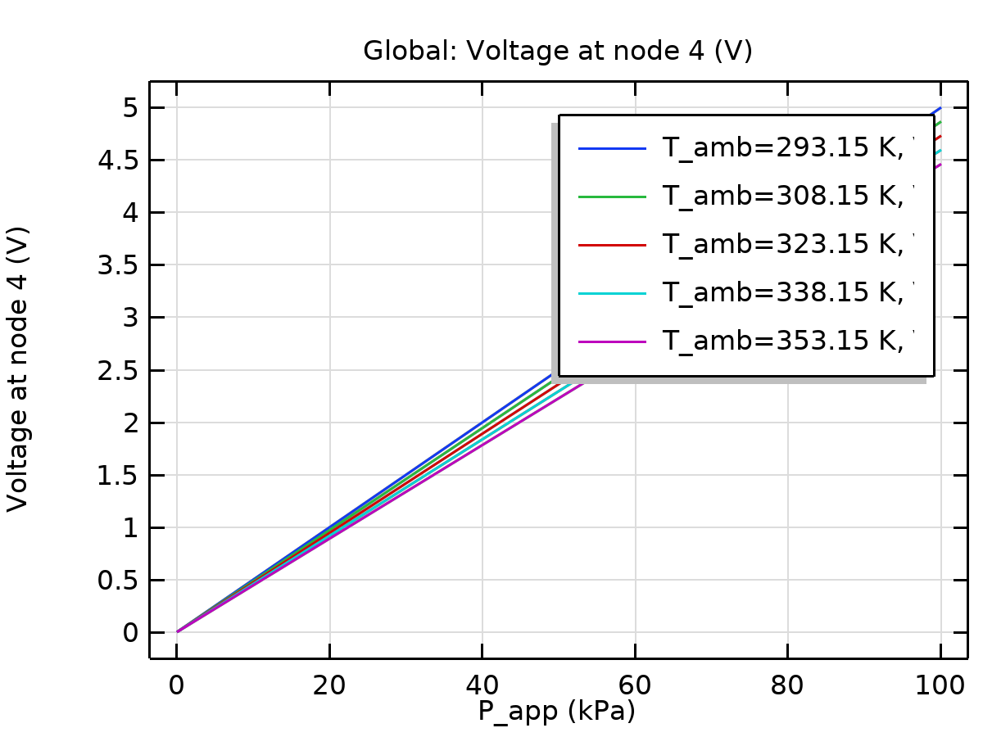
Global: Voltage at node 4 (V)

