Architecture Document
Multi‑Vendor E‑Commerce Backend Platform (v1)
Spring Boot • Hibernate/Spring Data JPA • Oracle • REST APIs | 2026-02-19

1. Purpose and Audience
This architecture document consolidates system requirements, database model, workflows, and API specifications for a multi‑vendor e‑commerce backend. It is designed as an end‑to‑end guide for a junior Java developer.

2. Architecture Overview

2.1 High-level components
- API Layer (Controllers): REST endpoints, request validation, authentication entry points.
- Application Layer (Services): business rules, transaction boundaries, orchestration (checkout, approval).
- Persistence Layer (Repositories): Spring Data JPA repositories and custom queries/locking.
- Domain Model: entities, enums, value objects, status machines.
- Security: JWT auth, RBAC, tenant scoping by vendor_id/customer_id.
- Observability: structured logs, correlation id, exception handling.

2.2 Key design decisions
- Stock consistency uses database transaction + pessimistic inventory locks during checkout.
- Checkout is idempotent via Idempotency-Key to prevent duplicate orders on retries.
- Order model supports multi-vendor by storing vendor_id per OrderItem (vendor-level fulfillment).
- Product visibility gated by status (ACTIVE only visible to customers).

3. Database Design
3.1 ERD
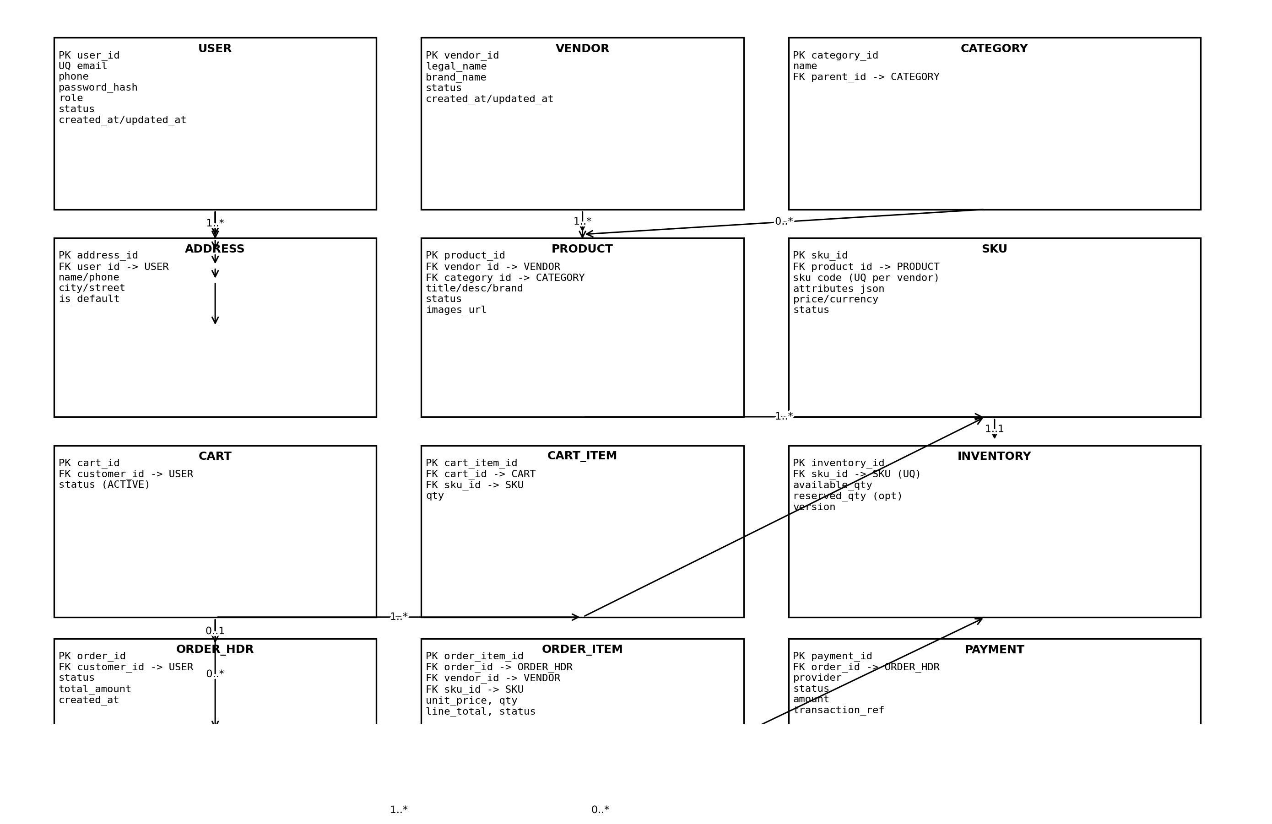

3.2 Entity summary
Entity | Ownership/Scope | Notes
USER | Global | Role, status, auth credentials.
VENDOR | Global | Approved/suspended by Admin.
PRODUCT/SKU/INVENTORY | Vendor-scoped | Catalog + stock per vendor.
CART/CART_ITEM | Customer-scoped | One active cart per customer.
ORDER_HDR/ORDER_ITEM | Customer + Vendor | Header by customer; items by vendor.
PAYMENT | Order-scoped | Payment attempts and final state.

4. Core Workflows (Swimlane Flows)

4.1 Customer checkout (multi-vendor, transactional)
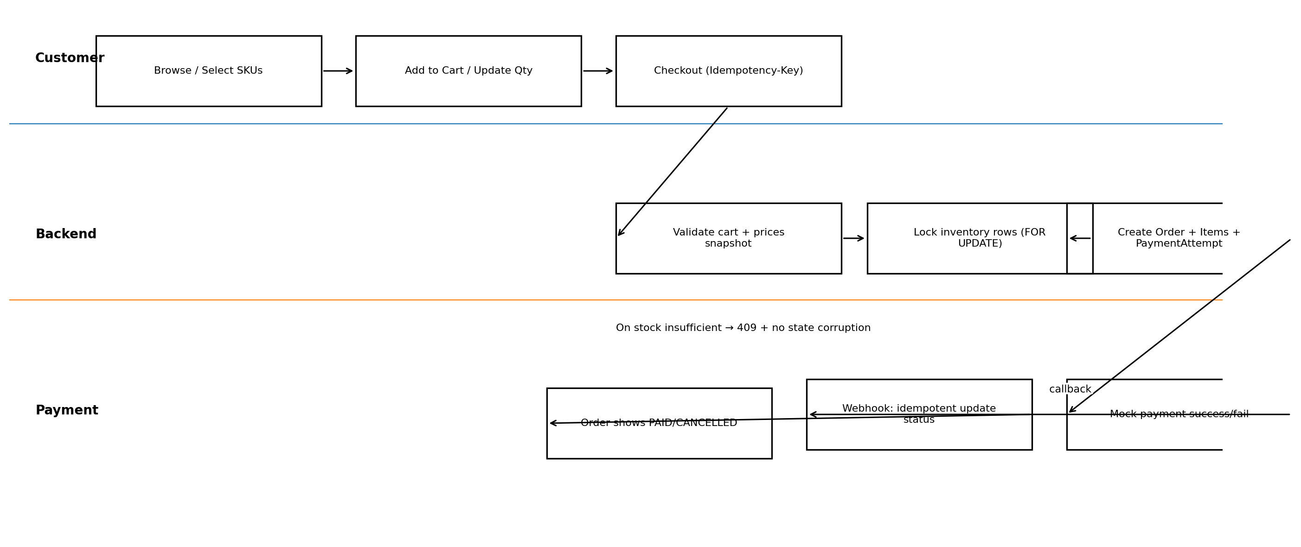

4.2 Vendor publish product (approval gate)
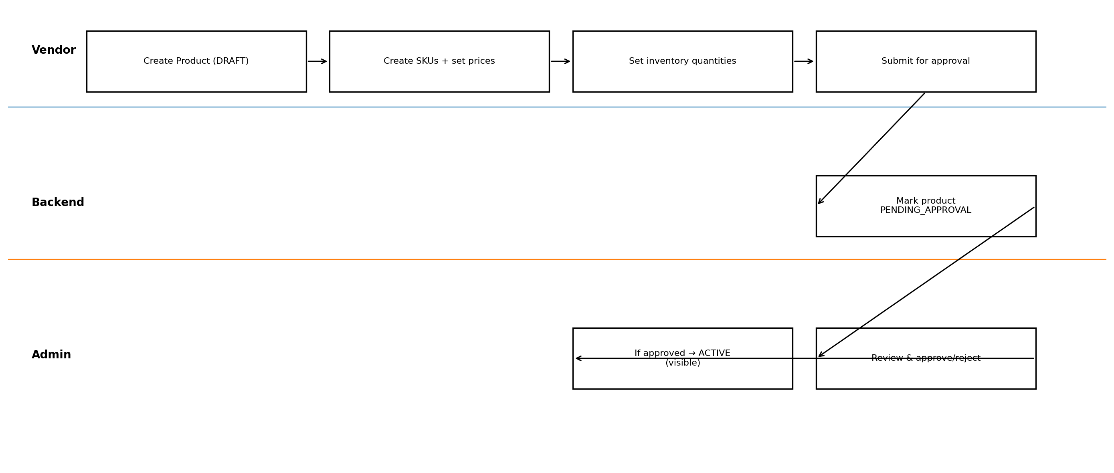

4.3 Vendor fulfillment (item-level statuses)
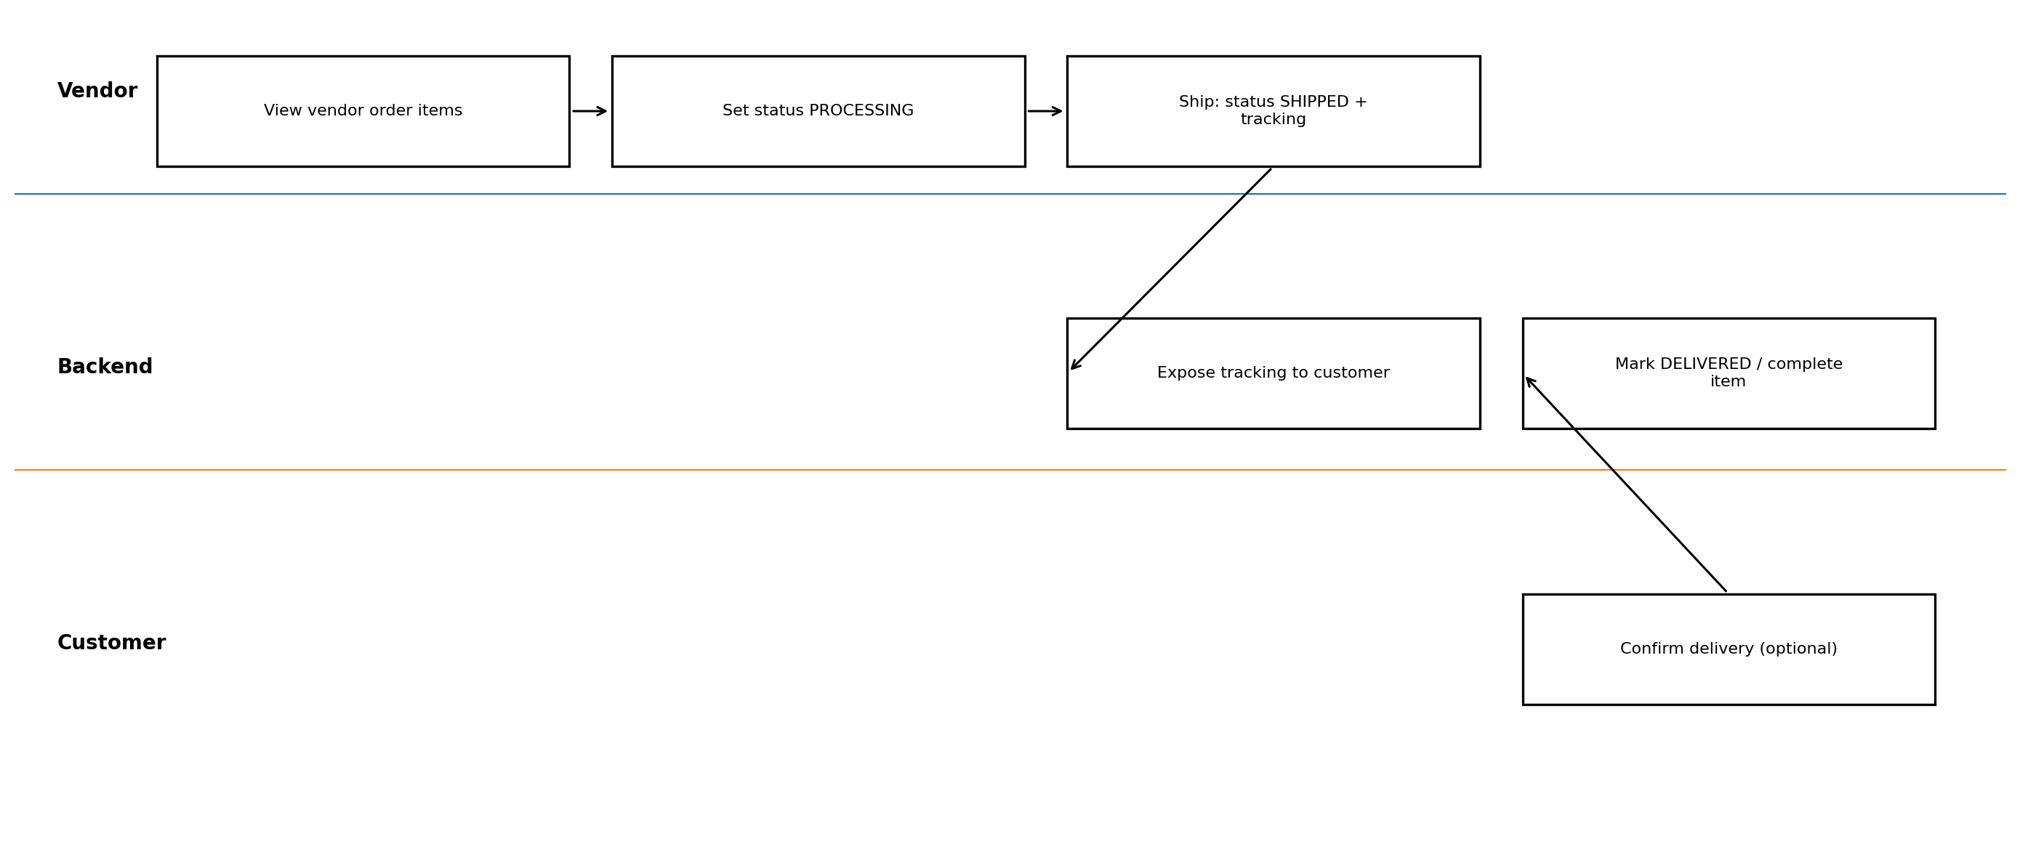

5. User Story Flowcharts (One per Story)
These flowcharts map each user story to the backend interactions and validations.

US-C1 Register Login
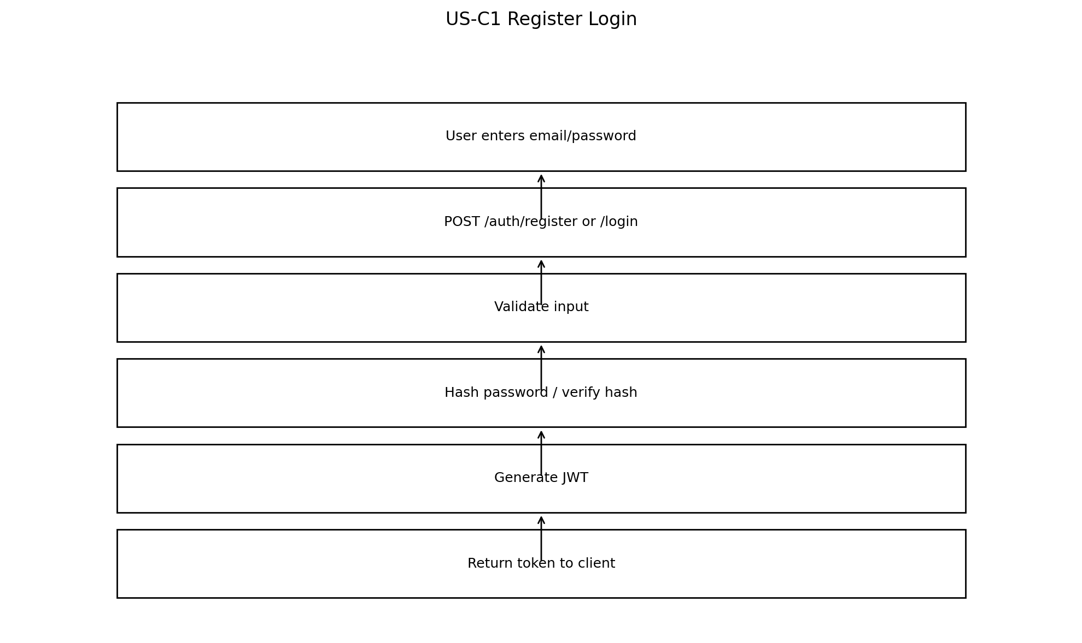

US-C2 Browse Search
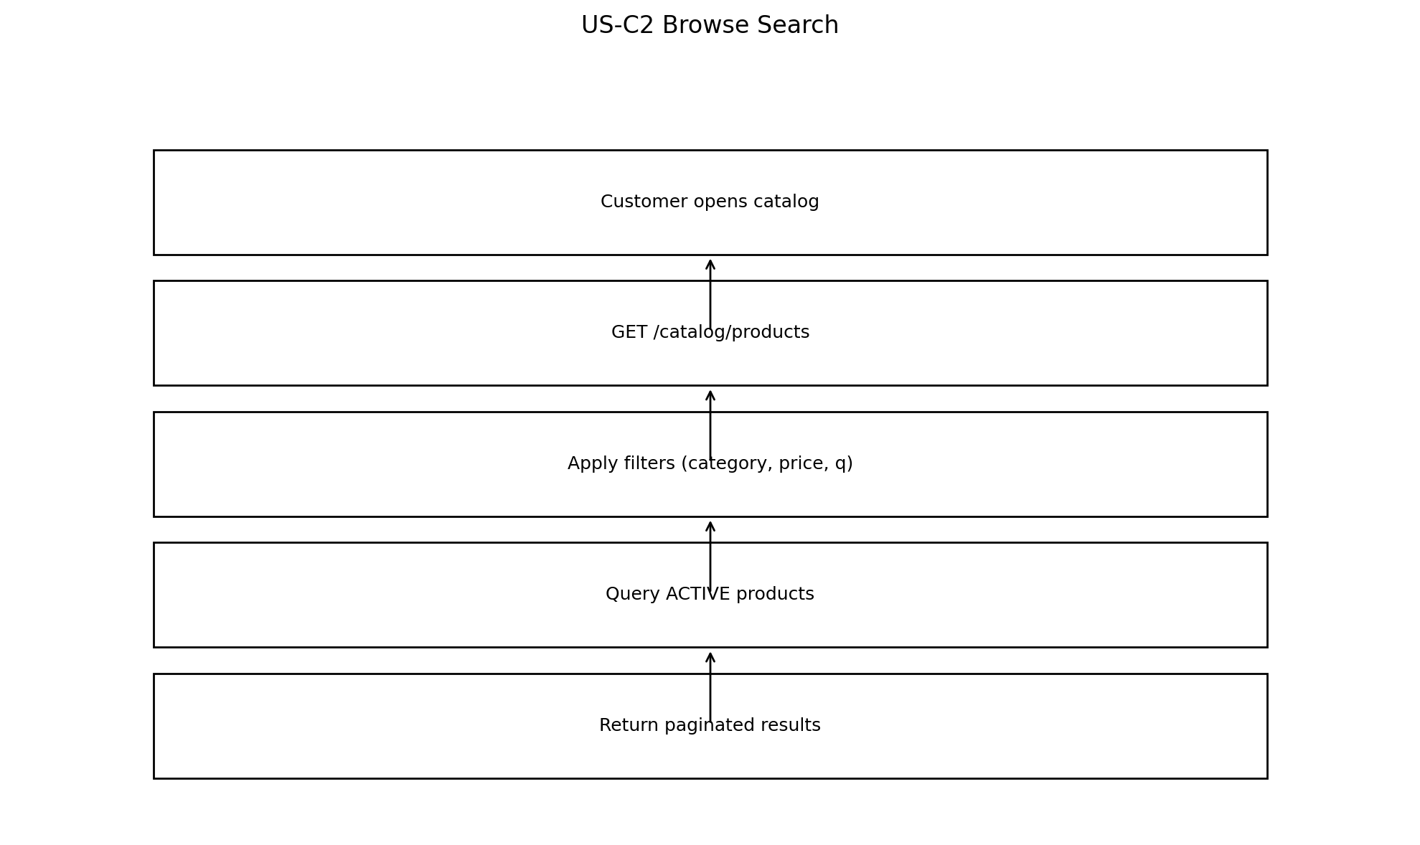

US-C3 Add To Cart
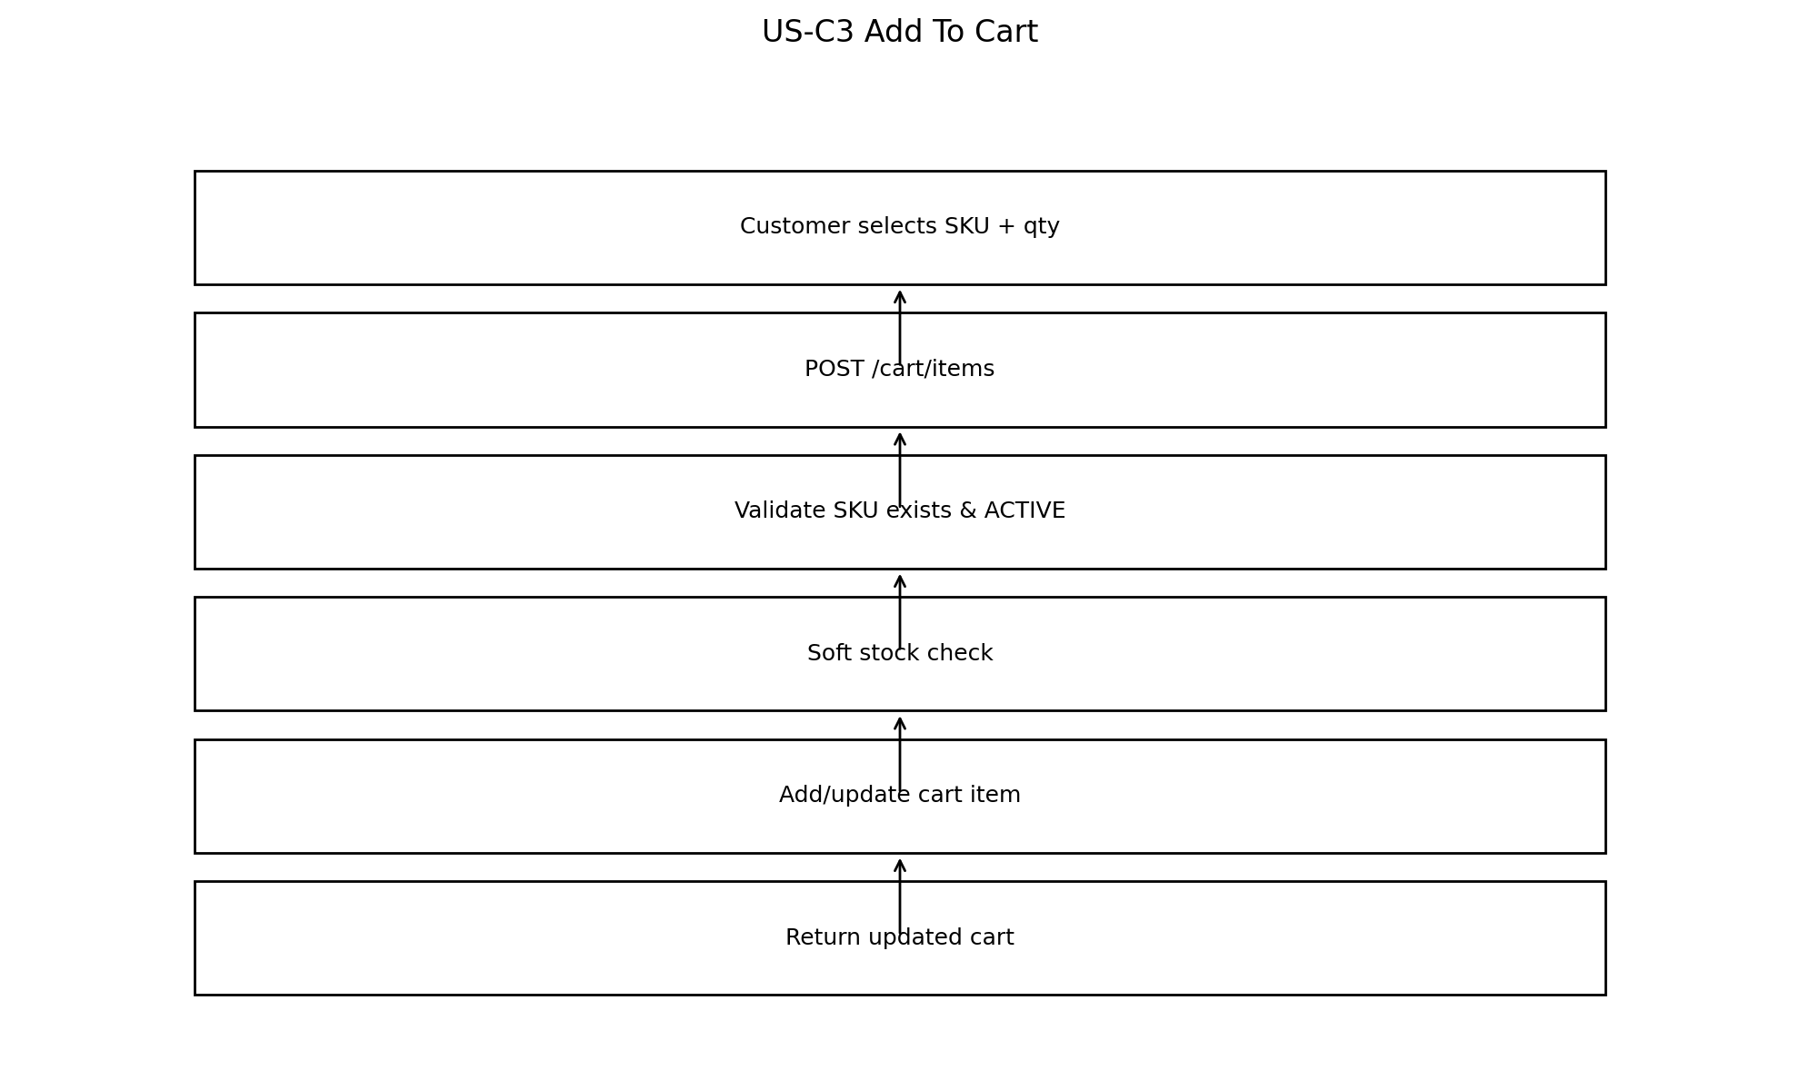

US-C4 Checkout
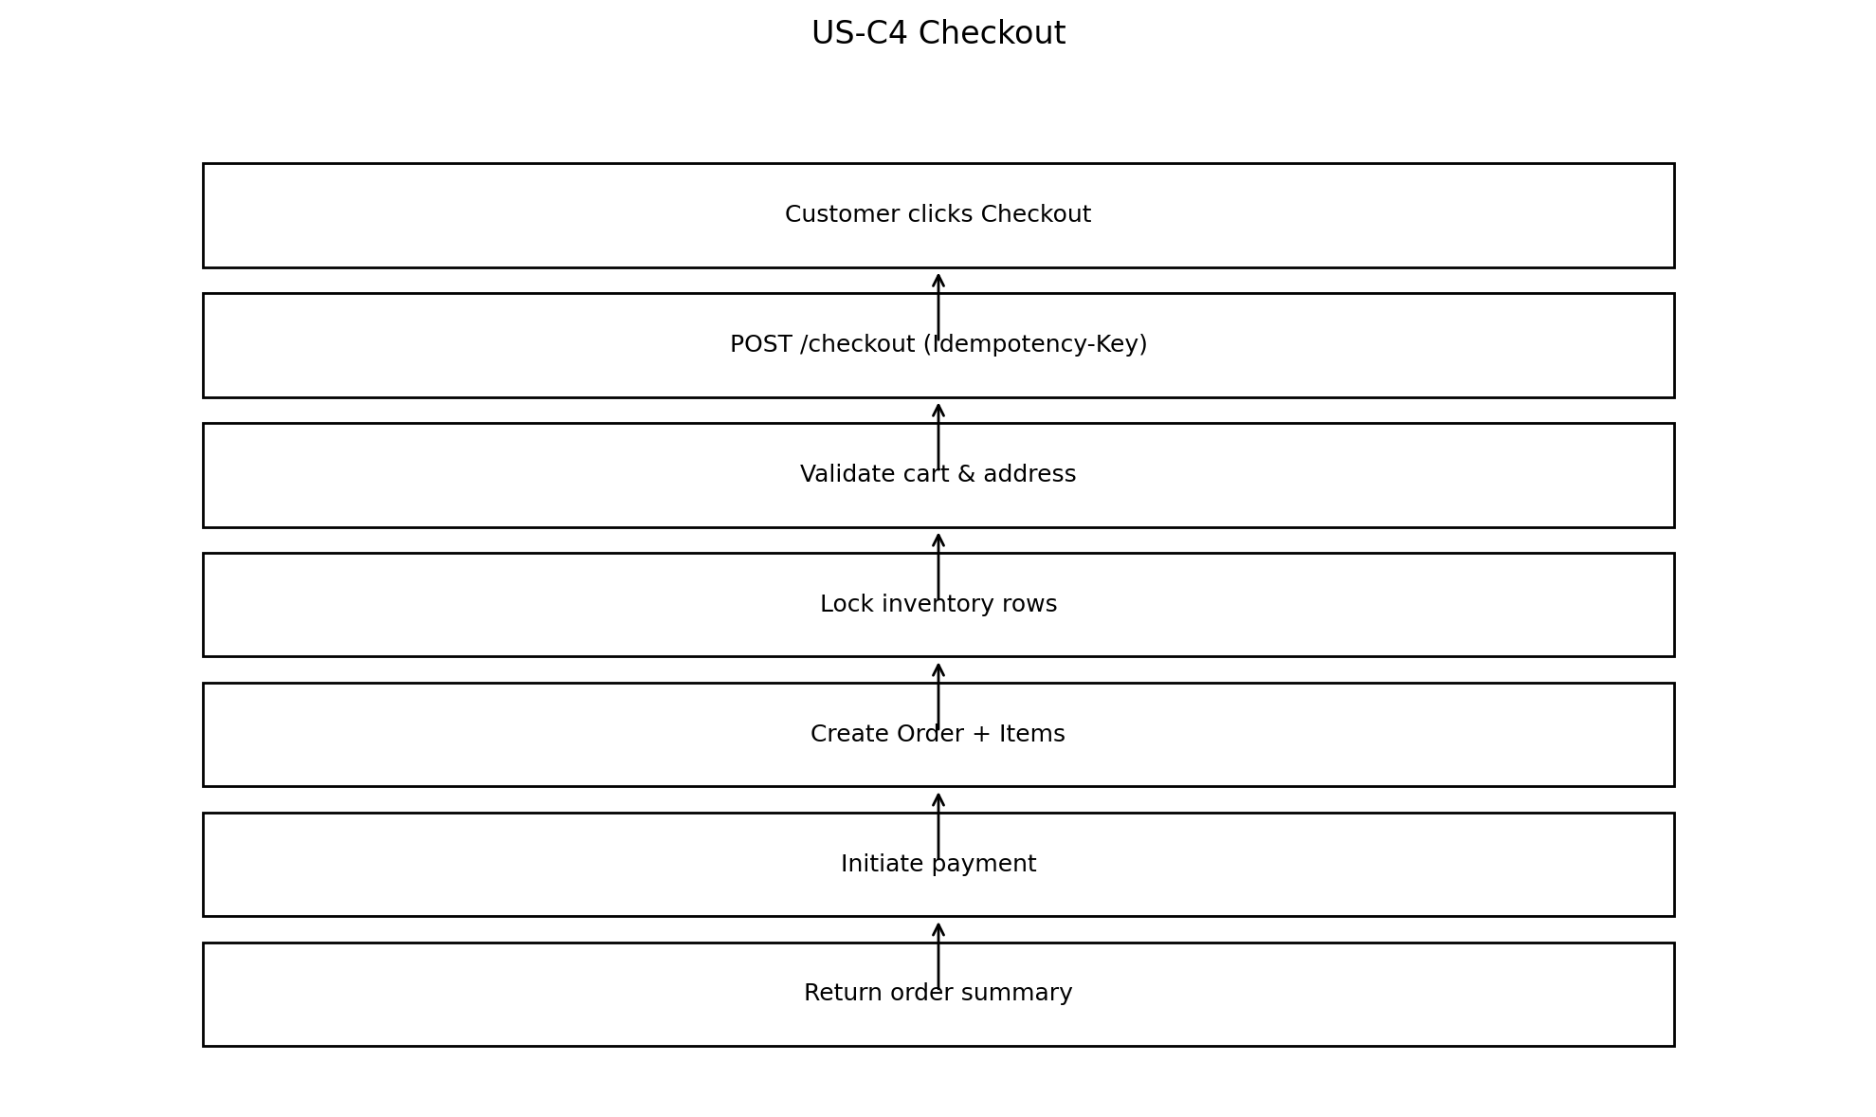

US-C5 View Orders
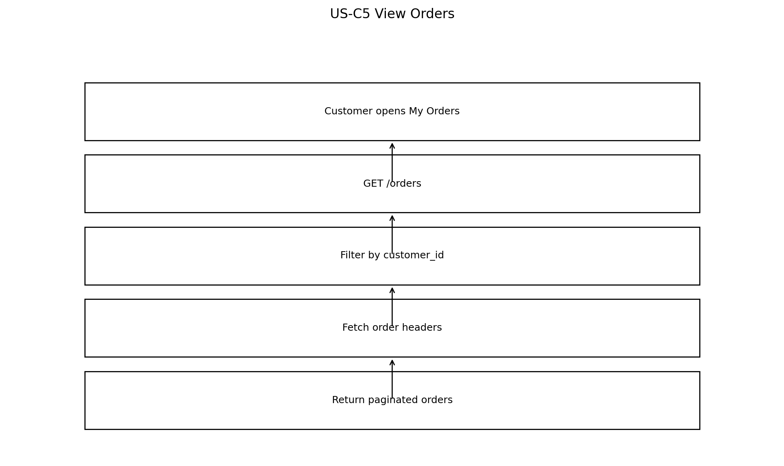

US-V1 Manage Products
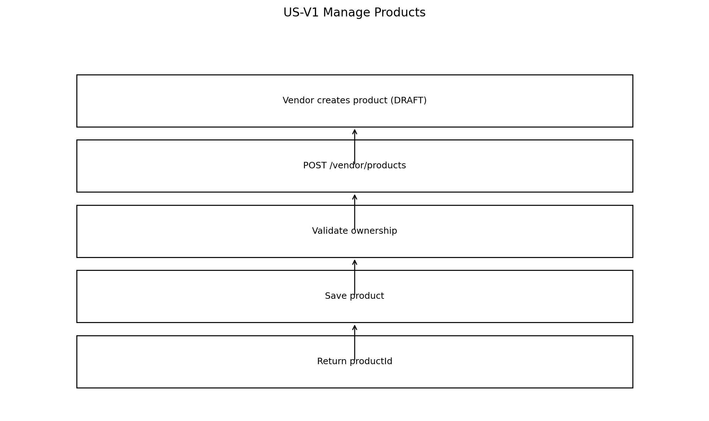

US-V2 Update Inventory
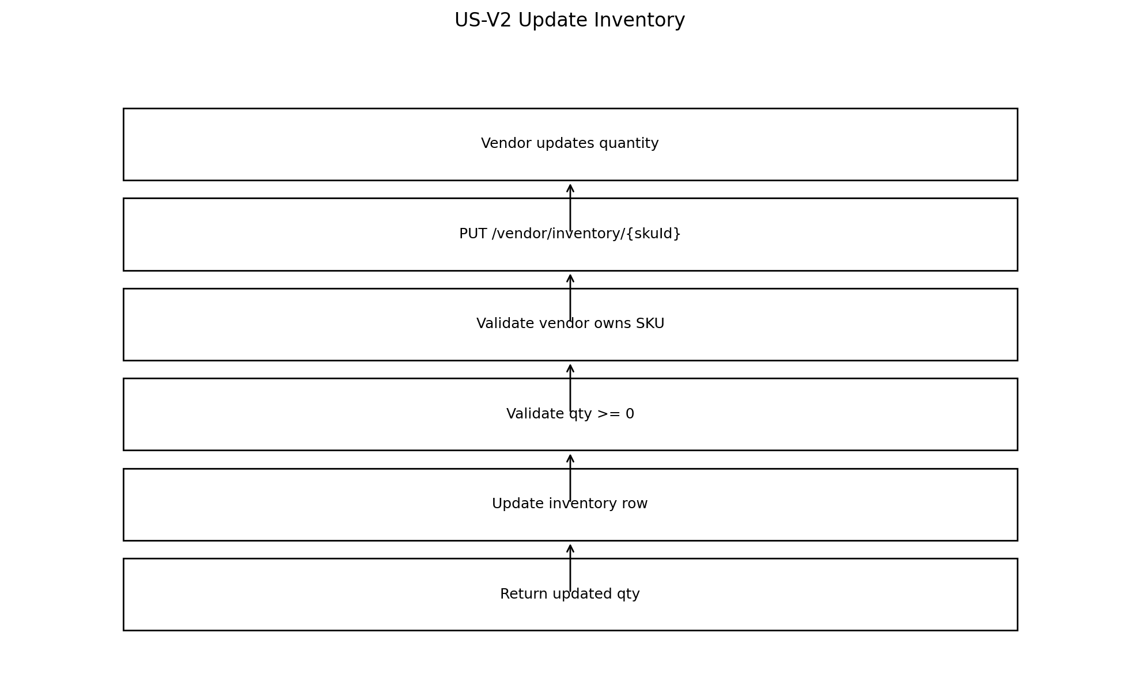

US-V3 View Order Items
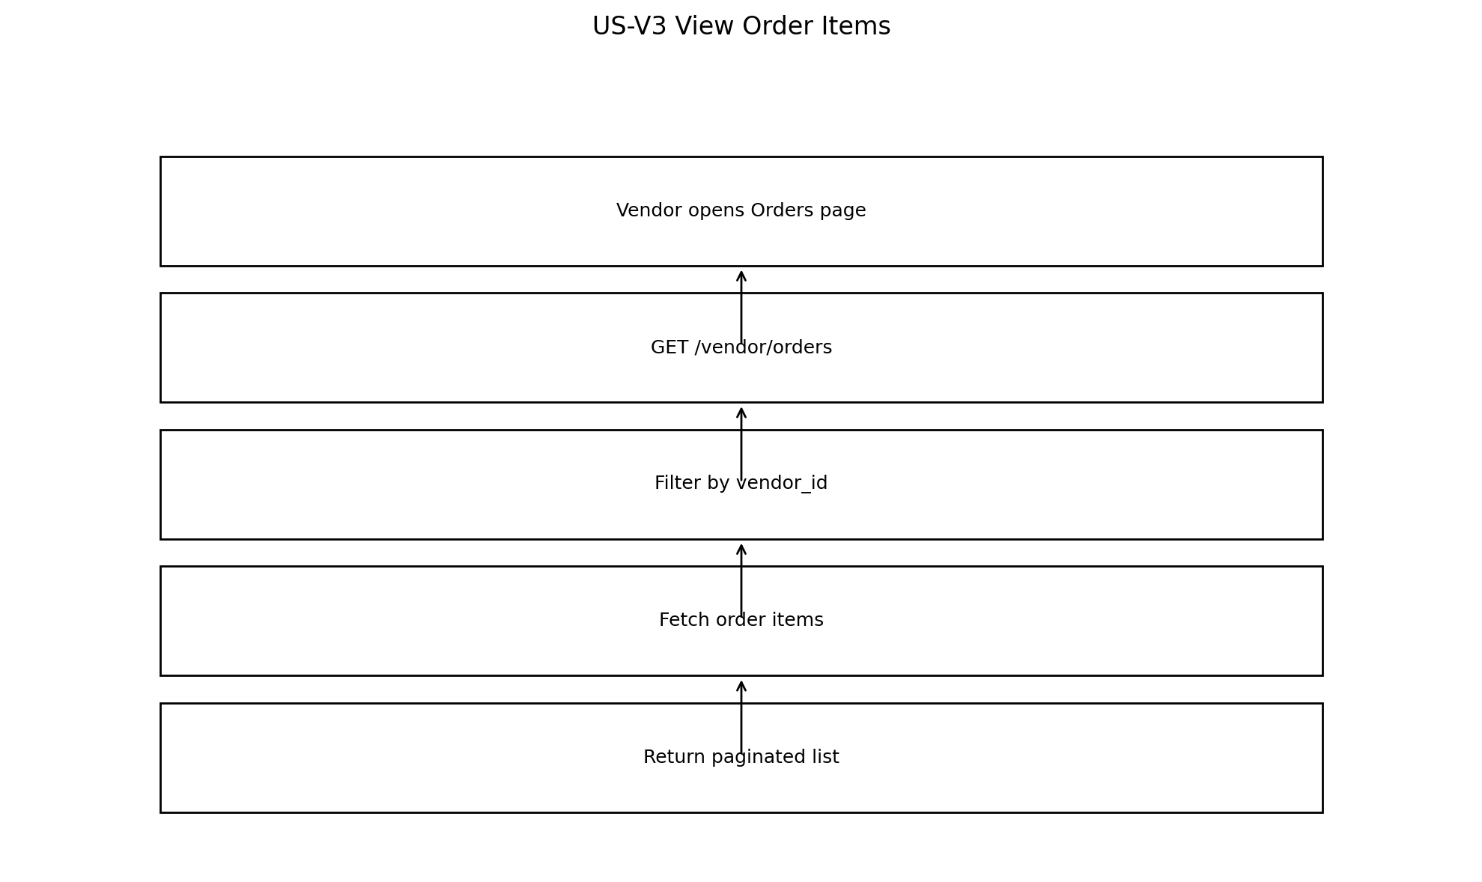

US-V4 Ship Order Item
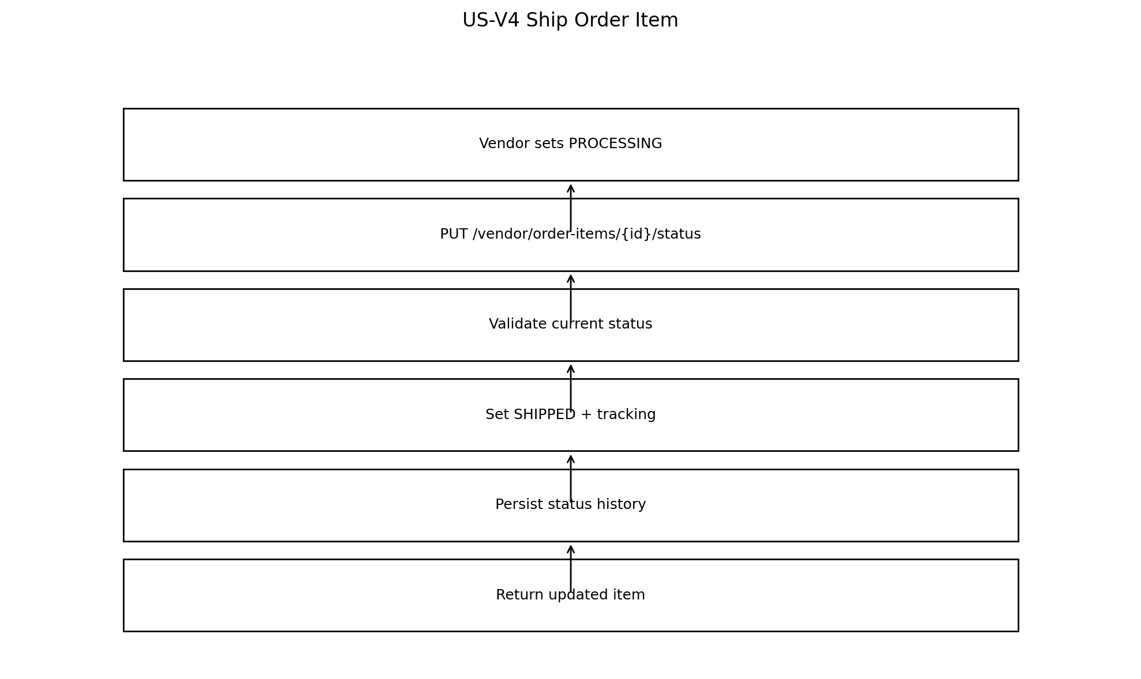

US-A1 Approve Vendor
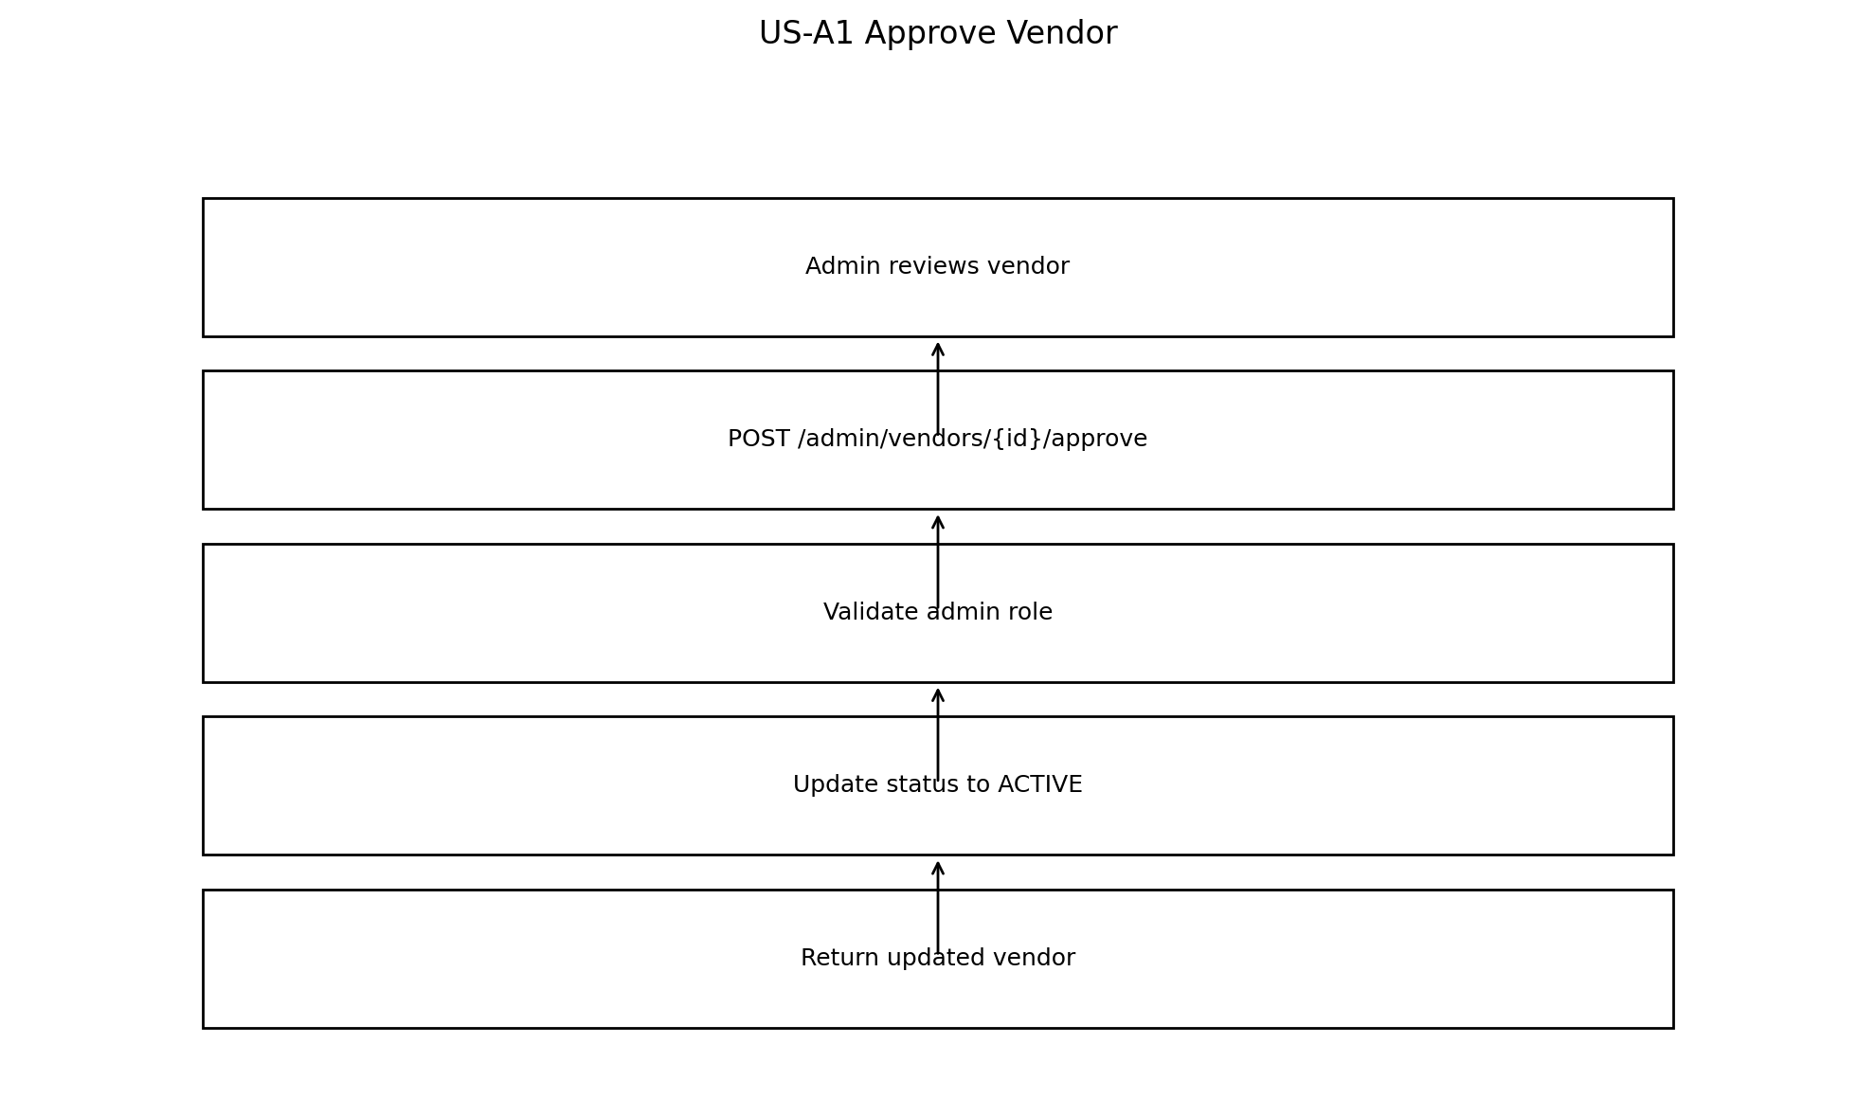

US-A2 Approve Product
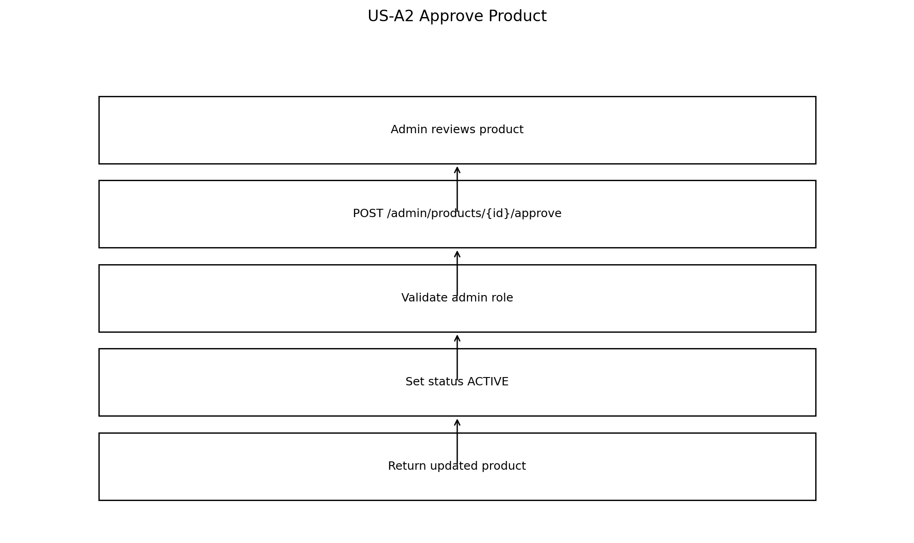

US-A3 Manage Categories
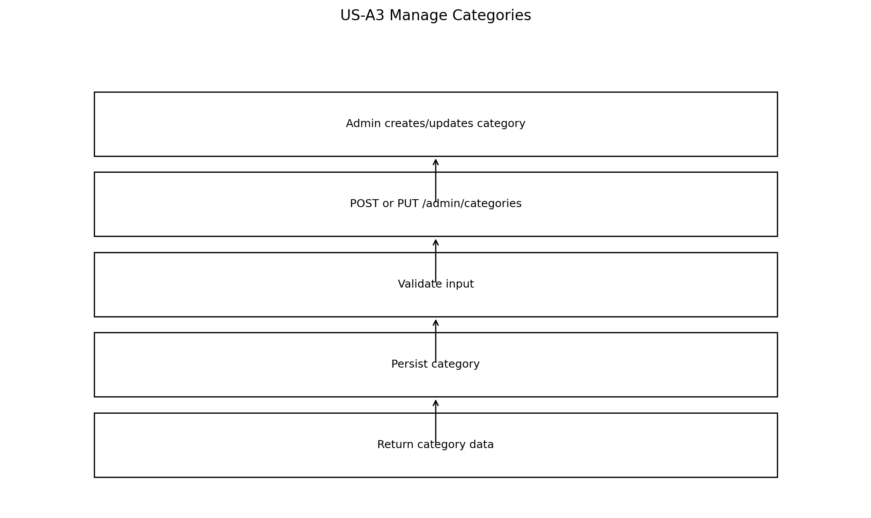

6. API Build Plan
- Step 1: Auth + RBAC (JWT).
- Step 2: Categories (Admin).
- Step 3: Vendor onboarding + approval.
- Step 4: Vendor catalog: products, SKUs, inventory.
- Step 5: Customer catalog browse/search.
- Step 6: Cart CRUD.
- Step 7: Checkout transactional + idempotency.
- Step 8: Mock payment initiate + webhook.
- Step 9: Vendor fulfillment status updates.

7. Endpoint Reference
Full endpoint field-level specifications are provided in the companion API spec document. In this architecture document, keep the focus on build order, boundaries, and workflows.
Companion documents generated in this workspace:
- Multi-Vendor_E-Commerce_Backend_Platform_Mini_SRS.docx
- MultiVendor_Diagrams_and_API_Spec.docx

8. Status Machines (Rules Summary)
- VENDOR: PENDING_APPROVAL ↔ ACTIVE ↔ SUSPENDED (Admin controlled).
- PRODUCT: DRAFT → PENDING_APPROVAL → ACTIVE | REJECTED; ACTIVE → ARCHIVED.
- ORDER_HDR: CREATED/PENDING_PAYMENT → PAID | CANCELLED; PAID → COMPLETED.
- ORDER_ITEM: PENDING → PROCESSING → SHIPPED → DELIVERED (Vendor controlled; invalid transitions return 409).

9. Non-functional Standards
- Pagination and sorting on list endpoints.
- Standard error format + global exception handler.
- Audit fields and status history records.
- Service-level tests for checkout and status transitions; integration test for inventory locking.
- Swagger/OpenAPI maintained alongside code.
End of Architecture Document.

