Multi‑Vendor E‑Commerce — Diagrams + API Build Plan + Endpoint Specs
Date: 2026-02-19 | Stack: Spring Boot + JPA/Hibernate + Oracle

1. Database ERD Diagram
High-level ERD for v1 entities and relationships:
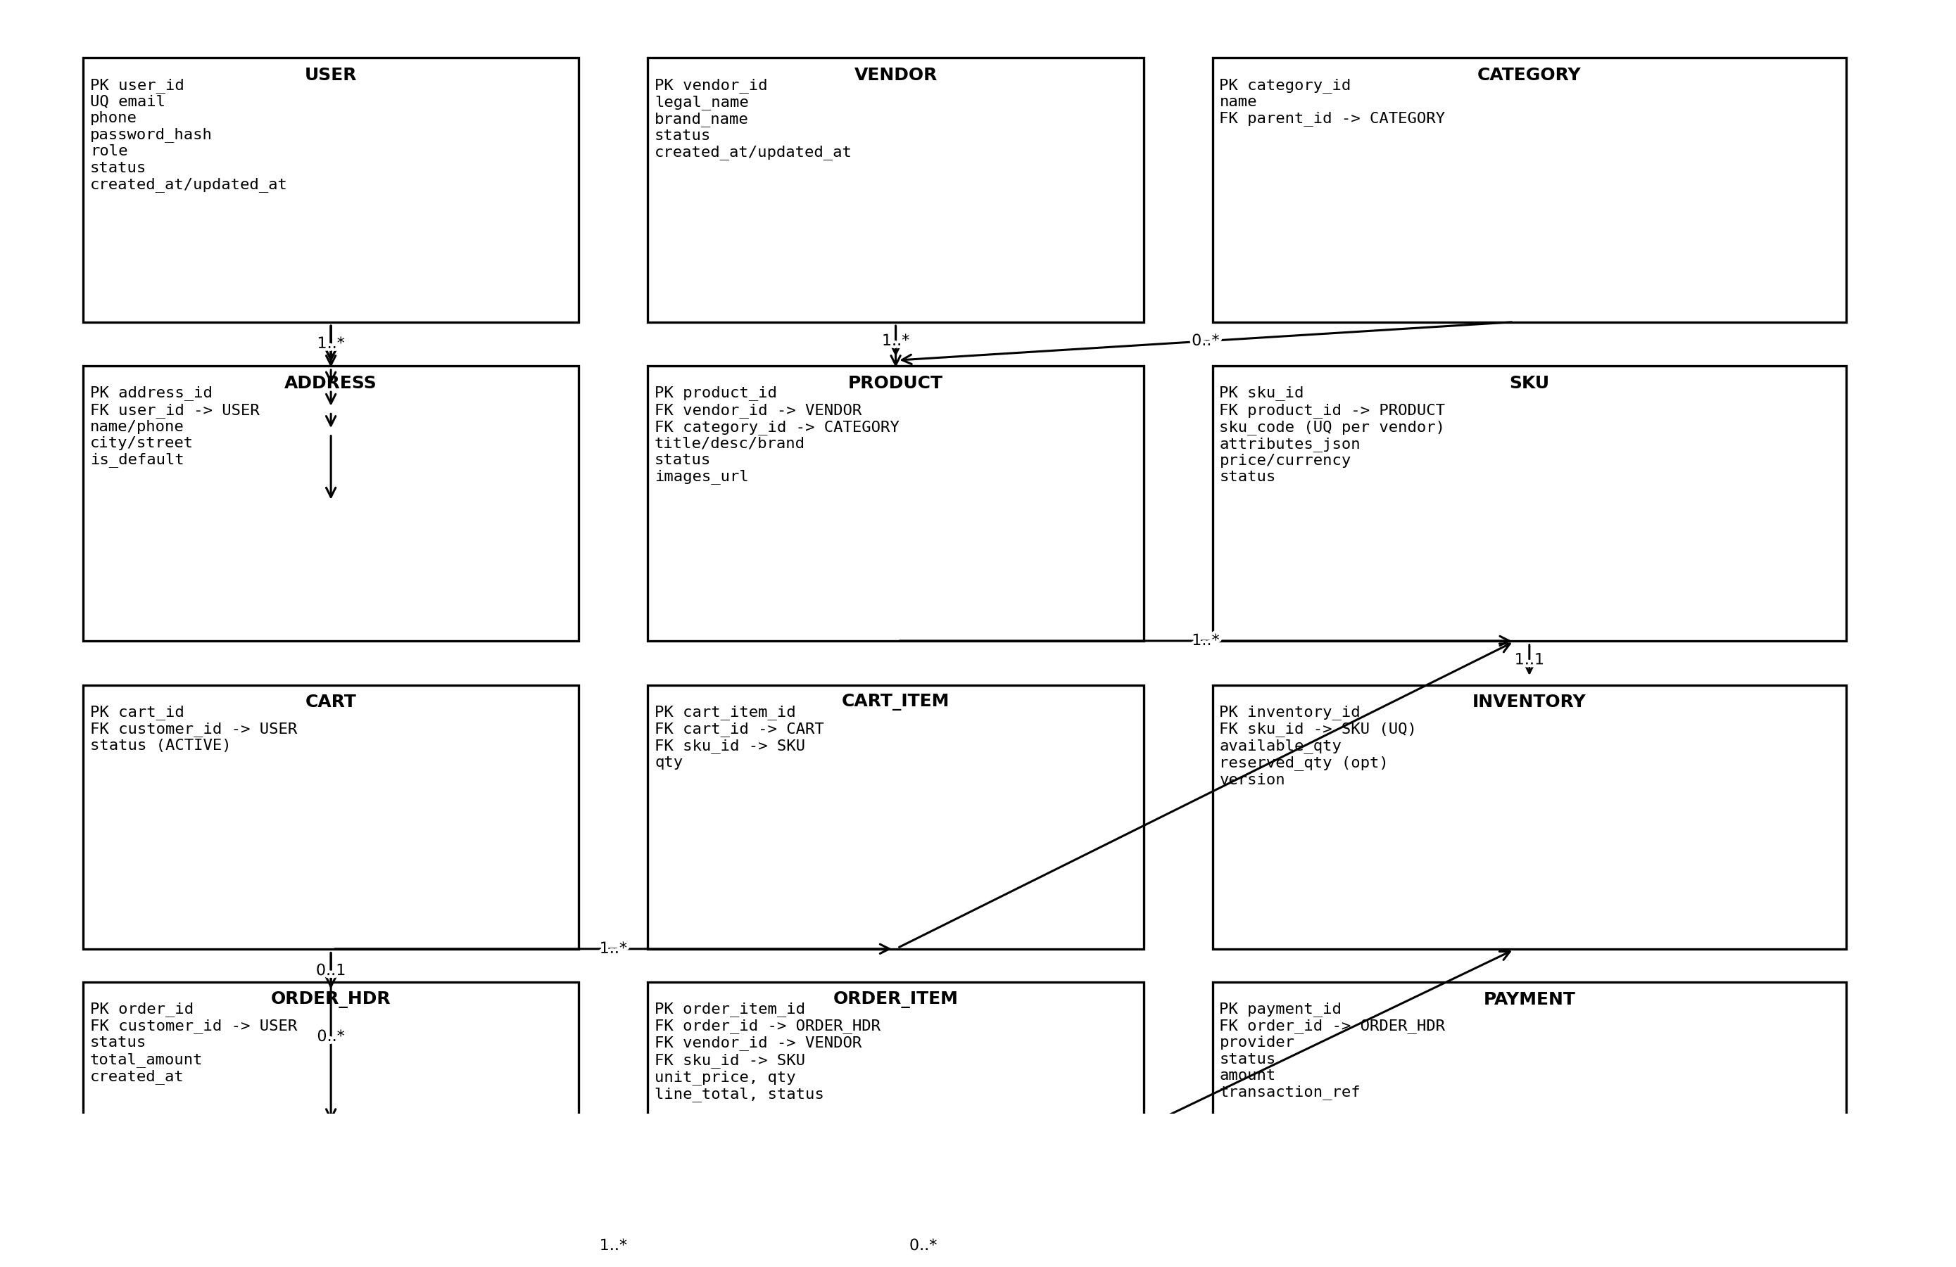

2. Workflow Diagrams

2.1 Customer Checkout Flow (US-C4)
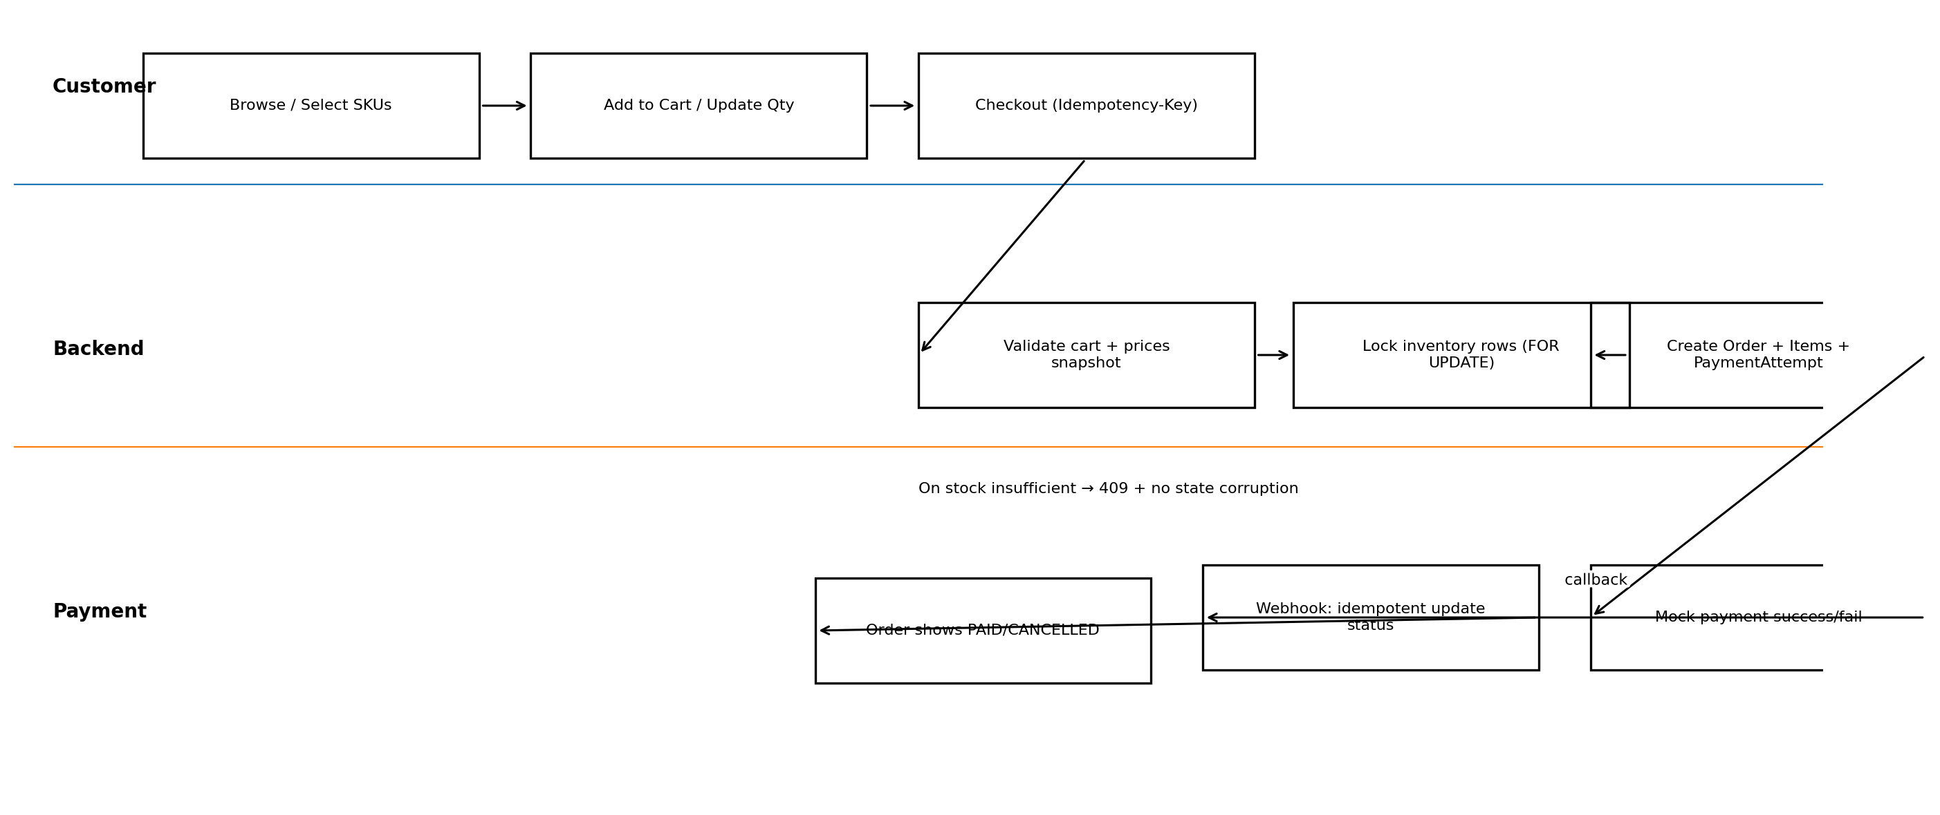

2.2 Vendor Product Publish Flow (US-V1, US-V2)
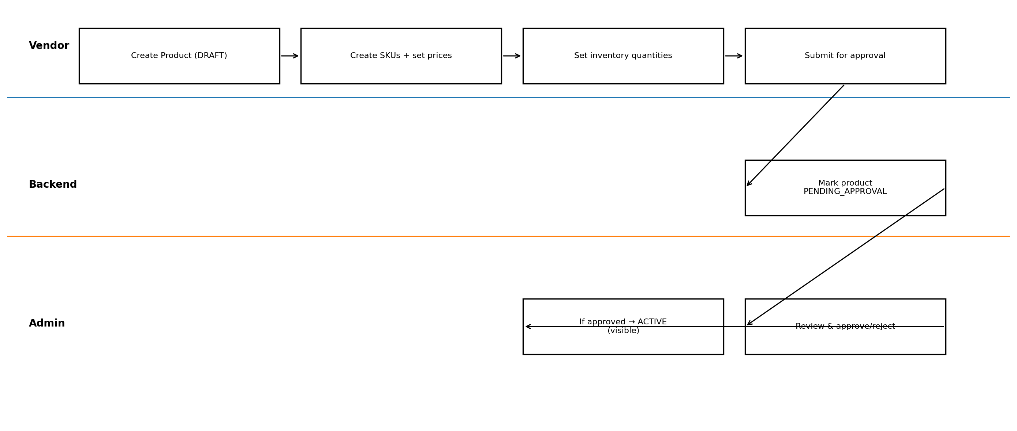

2.3 Vendor Fulfillment Flow (US-V3, US-V4)
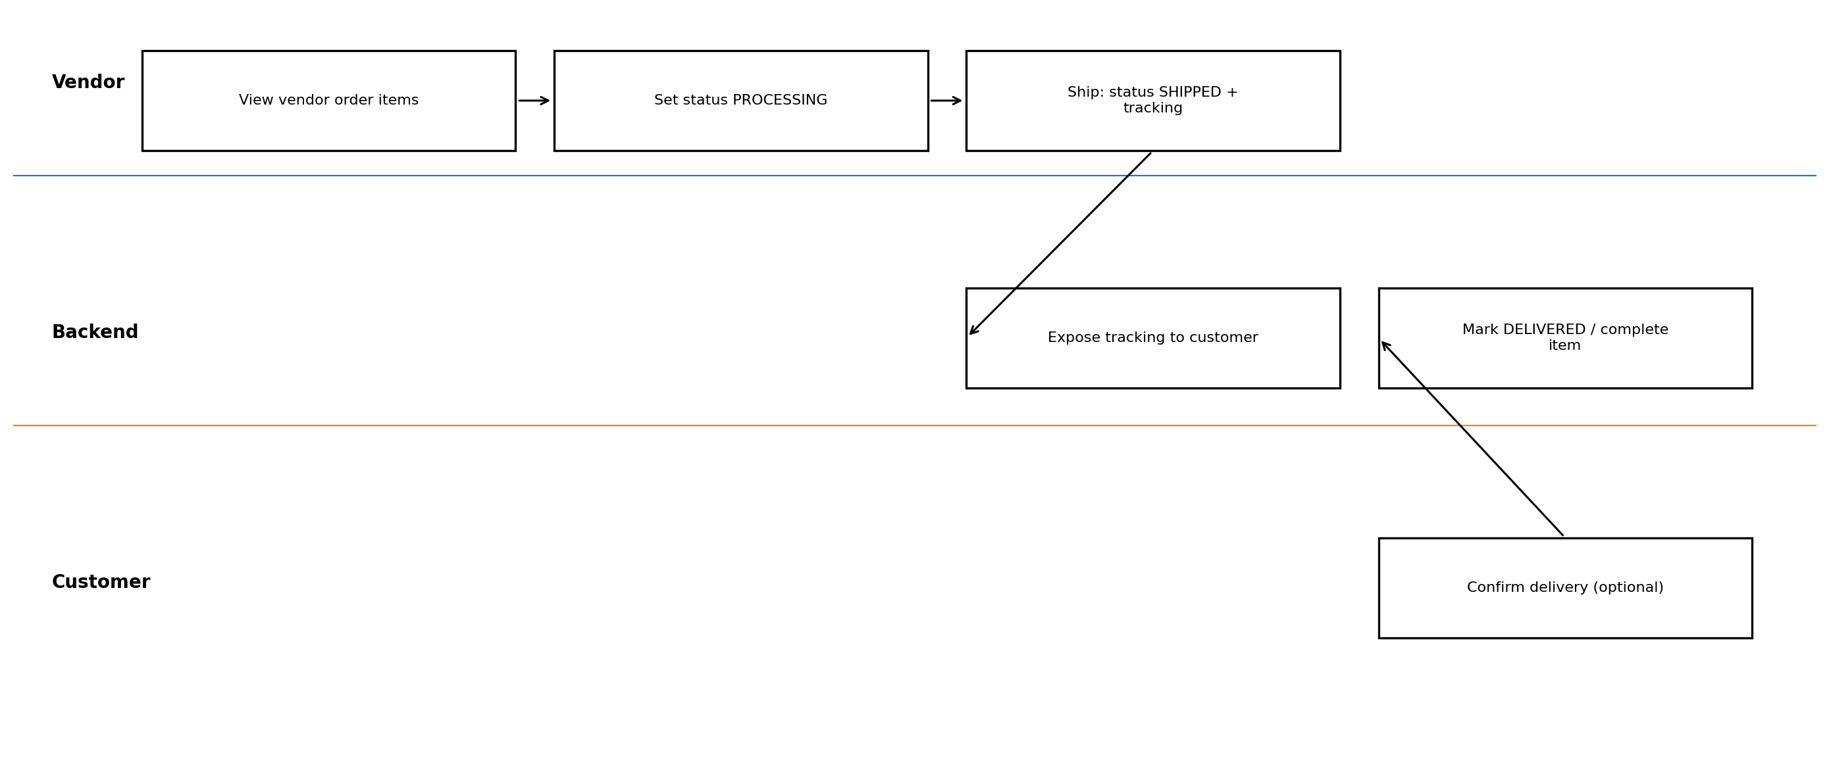

3. API Build Order (What to implement first)
- Step 1 — Auth + RBAC: registration/login, JWT, roles, /me.
- Step 2 — Admin Categories: create/update/list categories.
- Step 3 — Vendor Onboarding: vendor profile + approval (admin).
- Step 4 — Vendor Catalog: products (DRAFT), SKUs, inventory update.
- Step 5 — Customer Catalog: browse/search ACTIVE products + product details.
- Step 6 — Cart: add/update/remove items.
- Step 7 — Checkout (Transactional): lock inventory + create order + idempotency.
- Step 8 — Mock Payment: initiate + webhook idempotent state update.
- Step 9 — Vendor Fulfillment: list vendor order items + status updates + tracking.

4. Endpoint Specifications (Request/Response Attributes)
Notes:
- All requests/response bodies are JSON.
- All list endpoints support pagination: page (0..), size, sort (e.g., createdAt,desc).
- Errors use standard schema: timestamp, path, errorCode, message, details.

4.1 Endpoint list (summary)
Method | Path | Auth | Purpose
POST | /api/auth/register | Public | Create customer account
POST | /api/auth/login | Public | Login and obtain JWT
GET | /api/me | Any Auth | Current user profile
POST | /api/admin/categories | ADMIN | Create category
PUT | /api/admin/categories/{id} | ADMIN | Update category
GET | /api/catalog/categories | Public | List categories
POST | /api/vendor/profile | VENDOR_OWNER | Create/update vendor profile
POST | /api/admin/vendors/{id}/approve | ADMIN | Approve vendor
POST | /api/admin/vendors/{id}/suspend | ADMIN | Suspend vendor
POST | /api/vendor/products | VENDOR | Create product (DRAFT)
PUT | /api/vendor/products/{id} | VENDOR | Update product (must own)
POST | /api/vendor/products/{id}/submit-for-approval | VENDOR | Submit product for admin approval
POST | /api/vendor/skus | VENDOR | Create SKU variant
PUT | /api/vendor/inventory/{skuId} | VENDOR | Set inventory quantity
GET | /api/catalog/products | Public | Search ACTIVE products
GET | /api/catalog/products/{id} | Public | Product details
GET | /api/cart | CUSTOMER | Get active cart
POST | /api/cart/items | CUSTOMER | Add item to cart
PUT | /api/cart/items/{itemId} | CUSTOMER | Update item quantity
DELETE | /api/cart/items/{itemId} | CUSTOMER | Remove cart item
POST | /api/checkout | CUSTOMER | Create order from cart (transactional)
POST | /api/payments/{orderId}/initiate | CUSTOMER | Initiate payment (mock)
POST | /api/payments/webhook | Provider | Payment confirmation webhook (idempotent)
GET | /api/orders | CUSTOMER | List customer orders
GET | /api/vendor/orders | VENDOR | List vendor order items
PUT | /api/vendor/order-items/{id}/status | VENDOR | Update vendor fulfillment status

4.2 Endpoint details

POST /api/auth/register
- Auth: Public
- Purpose: Create customer account
Request body fields:
- - email: string
- - password: string
- - phone: string (opt)
- - fullName: string (opt)
Response body example fields:
- - userId: long
- - email: string
- - role: CUSTOMER
- - token: jwt
Common errors:
- - 400 validation
- - 409 email exists

POST /api/auth/login
- Auth: Public
- Purpose: Login and obtain JWT
Request body fields:
- - email: string
- - password: string
Response body example fields:
- - token: jwt
- - user:
- - user.userId: long
- - user.email: string
- - user.role: string
Common errors:
- - 400 validation
- - 401 invalid credentials

GET /api/me
- Auth: Any Auth
- Purpose: Current user profile
Request body: (none)
Response body example fields:
- - userId: long
- - email: string
- - role: string
- - vendorId: long (if vendor)
Common errors:
- - 401 unauthenticated

POST /api/admin/categories
- Auth: ADMIN
- Purpose: Create category
Request body fields:
- - name: string
- - parentId: long (nullable)
Response body example fields:
- - categoryId: long
- - name: string
- - parentId: long|null
Common errors:
- - 400 validation
- - 403 forbidden

PUT /api/admin/categories/{id}
- Auth: ADMIN
- Purpose: Update category
Request body fields:
- - name: string
- - parentId: long (nullable)
Response body example fields:
- - categoryId: long
- - name: string
- - parentId: long|null
Common errors:
- - 400 validation
- - 403 forbidden
- - 404 not found

GET /api/catalog/categories
- Auth: Public
- Purpose: List categories
Request body: (none)
Response body example fields:
- - (array response)

POST /api/vendor/profile
- Auth: VENDOR_OWNER
- Purpose: Create/update vendor profile
Request body fields:
- - legalName: string
- - brandName: string
- - contactEmail: string
- - contactPhone: string
Response body example fields:
- - vendorId: long
- - status: PENDING_APPROVAL|ACTIVE|SUSPENDED
Common errors:
- - 400 validation
- - 403 forbidden

POST /api/admin/vendors/{id}/approve
- Auth: ADMIN
- Purpose: Approve vendor
Request body: (none)
Response body example fields:
- - vendorId: long
- - status: ACTIVE
Common errors:
- - 403 forbidden
- - 404 not found

POST /api/admin/vendors/{id}/suspend
- Auth: ADMIN
- Purpose: Suspend vendor
Request body fields:
- - reason: string (opt)
Response body example fields:
- - vendorId: long
- - status: SUSPENDED
Common errors:
- - 403 forbidden
- - 404 not found

POST /api/vendor/products
- Auth: VENDOR
- Purpose: Create product (DRAFT)
Request body fields:
- - title: string
- - description: string
- - brand: string (opt)
- - categoryId: long (opt)
- - images: ['url', '...']
Response body example fields:
- - productId: long
- - status: DRAFT
Common errors:
- - 400 validation
- - 403 forbidden

PUT /api/vendor/products/{id}
- Auth: VENDOR
- Purpose: Update product (must own)
Request body fields:
- - title: string
- - description: string
- - brand: string (opt)
- - categoryId: long (opt)
- - images: ['url', '...']
Response body example fields:
- - productId: long
- - status: DRAFT|REJECTED|PENDING_APPROVAL|ACTIVE
Common errors:
- - 403 forbidden
- - 404 not found
- - 409 invalid state

POST /api/vendor/products/{id}/submit-for-approval
- Auth: VENDOR
- Purpose: Submit product for admin approval
Request body: (none)
Response body example fields:
- - productId: long
- - status: PENDING_APPROVAL
Common errors:
- - 403 forbidden
- - 404 not found
- - 409 invalid state

POST /api/vendor/skus
- Auth: VENDOR
- Purpose: Create SKU variant
Request body fields:
- - productId: long
- - skuCode: string
- - attributes: {'color': 'string', 'size': 'string'}
- - price: decimal
- - currency: string
Response body example fields:
- - skuId: long
- - status: ACTIVE|INACTIVE
Common errors:
- - 400 validation
- - 403 forbidden
- - 409 skuCode exists

PUT /api/vendor/inventory/{skuId}
- Auth: VENDOR
- Purpose: Set inventory quantity
Request body fields:
- - availableQty: int >= 0
Response body example fields:
- - skuId: long
- - availableQty: int
Common errors:
- - 400 validation
- - 403 forbidden
- - 404 not found

GET /api/catalog/products
- Auth: Public
- Purpose: Search ACTIVE products
Request body fields:
- - q: string (opt)
- - categoryId: long (opt)
- - vendorId: long (opt)
- - minPrice: decimal (opt)
- - maxPrice: decimal (opt)
- - page: int
- - size: int
- - sort: string
Response body example fields:
- - content: [ ... ]
- - page:
- - page.number: int
- - page.size: int
- - page.totalElements: long
- - page.totalPages: int

GET /api/catalog/products/{id}
- Auth: Public
- Purpose: Product details
Request body: (none)
Response body example fields:
- - productId: long
- - title: string
- - description: string
- - skus: [ ... ]
Common errors:
- - 404 not found

GET /api/cart
- Auth: CUSTOMER
- Purpose: Get active cart
Request body: (none)
Response body example fields:
- - cartId: long
- - items: [ ... ]
Common errors:
- - 401/403

POST /api/cart/items
- Auth: CUSTOMER
- Purpose: Add item to cart
Request body fields:
- - skuId: long
- - qty: int > 0
Response body example fields:
- - cartItemId: long
- - skuId: long
- - qty: int
Common errors:
- - 400 validation
- - 404 sku not found
- - 409 insufficient stock (soft)

PUT /api/cart/items/{itemId}
- Auth: CUSTOMER
- Purpose: Update item quantity
Request body fields:
- - qty: int > 0
Response body example fields:
- - cartItemId: long
- - qty: int
Common errors:
- - 400 validation
- - 403 forbidden
- - 404 not found

DELETE /api/cart/items/{itemId}
- Auth: CUSTOMER
- Purpose: Remove cart item
Request body: (none)
Response body example fields:
- - deleted: True
Common errors:
- - 403 forbidden
- - 404 not found

POST /api/checkout
- Auth: CUSTOMER
- Purpose: Create order from cart (transactional)
Request body fields:
- - addressId: long
- - couponCode: string (opt)
Response body example fields:
- - orderId: long
- - status: PENDING_PAYMENT
- - totalAmount: decimal
- - payment:
- - payment.paymentId: long
- - payment.status: INITIATED
Common errors:
- - 400 validation
- - 409 stock conflict
- - 409 duplicate Idempotency-Key returns existing order

POST /api/payments/{orderId}/initiate
- Auth: CUSTOMER
- Purpose: Initiate payment (mock)
Request body fields:
- - method: MOCK
- - returnUrl: string (opt)
Response body example fields:
- - paymentId: long
- - status: PENDING
- - redirectUrl: string (mock url)
Common errors:
- - 403 forbidden
- - 404 not found
- - 409 invalid order state

POST /api/payments/webhook
- Auth: Provider
- Purpose: Payment confirmation webhook (idempotent)
Request body fields:
- - orderId: long
- - transactionRef: string
- - status: SUCCESS|FAIL
Response body example fields:
- - ok: True
Common errors:
- - 401/403 invalid secret
- - 409 invalid transition

GET /api/orders
- Auth: CUSTOMER
- Purpose: List customer orders
Request body fields:
- - page: int
- - size: int
- - sort: string
Response body example fields:
- - content: [ ... ]
- - page:
- - page.number: int
- - page.size: int
- - page.totalElements: long
- - page.totalPages: int
Common errors:
- - 401/403

GET /api/vendor/orders
- Auth: VENDOR
- Purpose: List vendor order items
Request body fields:
- - status: string (opt)
- - page: int
- - size: int
- - sort: string
Response body example fields:
- - content: [ ... ]
- - page:
- - page.number: int
- - page.size: int
- - page.totalElements: long
- - page.totalPages: int
Common errors:
- - 401/403

PUT /api/vendor/order-items/{id}/status
- Auth: VENDOR
- Purpose: Update vendor fulfillment status
Request body fields:
- - status: PROCESSING|SHIPPED|DELIVERED
- - trackingNo: string (required for SHIPPED)
Response body example fields:
- - orderItemId: long
- - status: string
- - trackingNo: string|null
Common errors:
- - 403 forbidden
- - 404 not found
- - 409 invalid transition

End of document.

