**GitHub Repository: https://github.com/mohamede2022/SOS-game**

**Sprint #0 Report**

Instructions

**Objectives**

* Make decisions on the SOS software development project.
* Learn unit testing and GUI programming in the language of your choice.

**Deliverables and Grading Policy**

Read the “CS 449 Homework Overview” document **carefully** and make the key decisions for the software development. Use the following template to complete your report.

1. **Key Decisions of the SOS Project (2 points)**

|  |  |
| --- | --- |
| Object-oriented programming language | Python |
| GUI library (strongly encouraged) | Tkinter |
| IDE (Integrated Development Environment) | Pycharm |
| Unit framework (e.g., JUnit for Java) | pytest |
| Programming style guide (must read it carefully) | Python Style Guide |
| Project hosting site | Github.com |
| Other decisions if applicable | Use commenting to describe changes/additions |

Sample programming style guides:

* Google Java Style Guide: <https://google.github.io/styleguide/javaguide.html>
* Google C++ Style Guide: <https://google.github.io/styleguide/cppguide.html>
* Google Python Style Guide: <https://google.github.io/styleguide/pyguide.html>

1. **Unit testing (4 points)**

Find a tutorial on the unit test framework you have chosen and write at least two xUnit tests of a program you have written or found elsewhere. Attach here (1) the screenshot of your program execution and (2) the source code of your program.

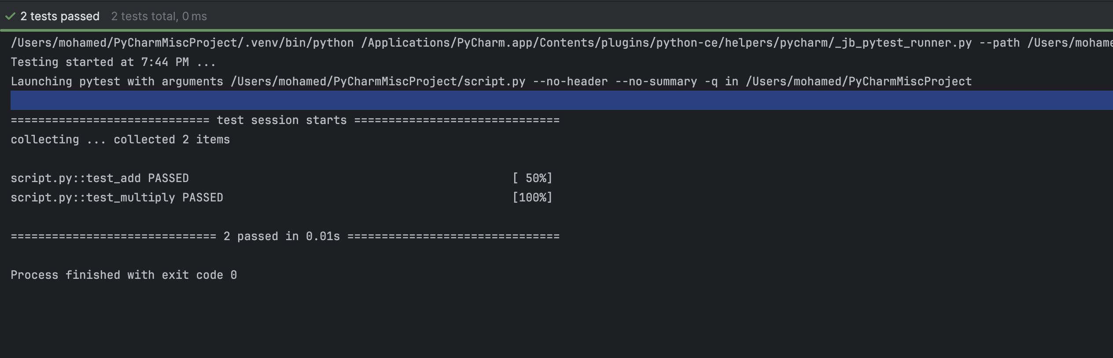

1. **GUI programming (4 points)**

Write a GUI program in the language you have chosen for your SOS project. The GUI of your program must include text, lines, a check box, and radio buttons. While you are recommended to consider the GUI for the SOS game board, it is not required. In this assignment, any GUI program of your own work is acceptable.

Attach here (1) the screenshot of your program execution and (2) the source code of your program.

