CDI COLLEGE
ASSIGNMENT 2
Technical Analysis Using R
Preliminary Stage

Student Name | Mohamed Elahwel
Course | BDA400 – Data Science Tools and Techniques
Assignment | CA_BDA400_A02
Portfolio Symbols | AAPL, MSFT, NVDA
Submission Date | November 12, 2026
GitHub Repository
https://github.com/mohamedelahwelca-hub/TechnicalAnalysis

1. Introduction and Objectives
This report documents the preliminary stage of a technical-analysis project using R. The purpose of this stage is to configure the development environment, create a GitHub repository, install the required R packages, define a portfolio of stock symbols, import historical market data, calculate basic statistics, and display the results.
The assignment objectives are to:
- Set up a GitHub account and a repository named TechnicalAnalysis.
- Install and verify R and RStudio.
- Install the R packages required for market-data retrieval and analysis.
- Create portfolio.txt with one stock symbol per line.
- Write functions to import stock data and calculate basic statistics.
- Display imported stock data, calculated statistics, and price charts.
- Document the work and provide the repository link.

2. GitHub Account and Repository Setup
A GitHub repository named TechnicalAnalysis was created under the account mohamedelahwelca-hub. An Assignment2 folder was created to keep the files for this stage together. The repository is public and can be accessed using the link below.
Repository: https://github.com/mohamedelahwelca-hub/TechnicalAnalysis
The Assignment2 folder contains the assignment report, README files, portfolio.txt, stock_statistics.csv, and technical_analysis.R. The Stock_Charts folder contains the three generated chart images.
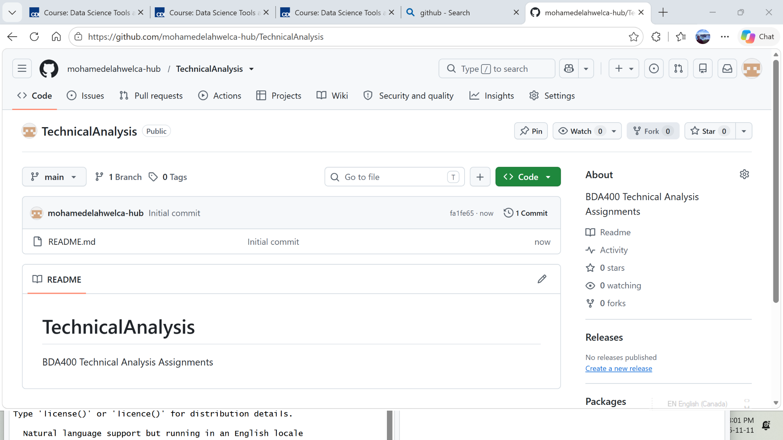
Figure 1. GitHub TechnicalAnalysis repository overview.
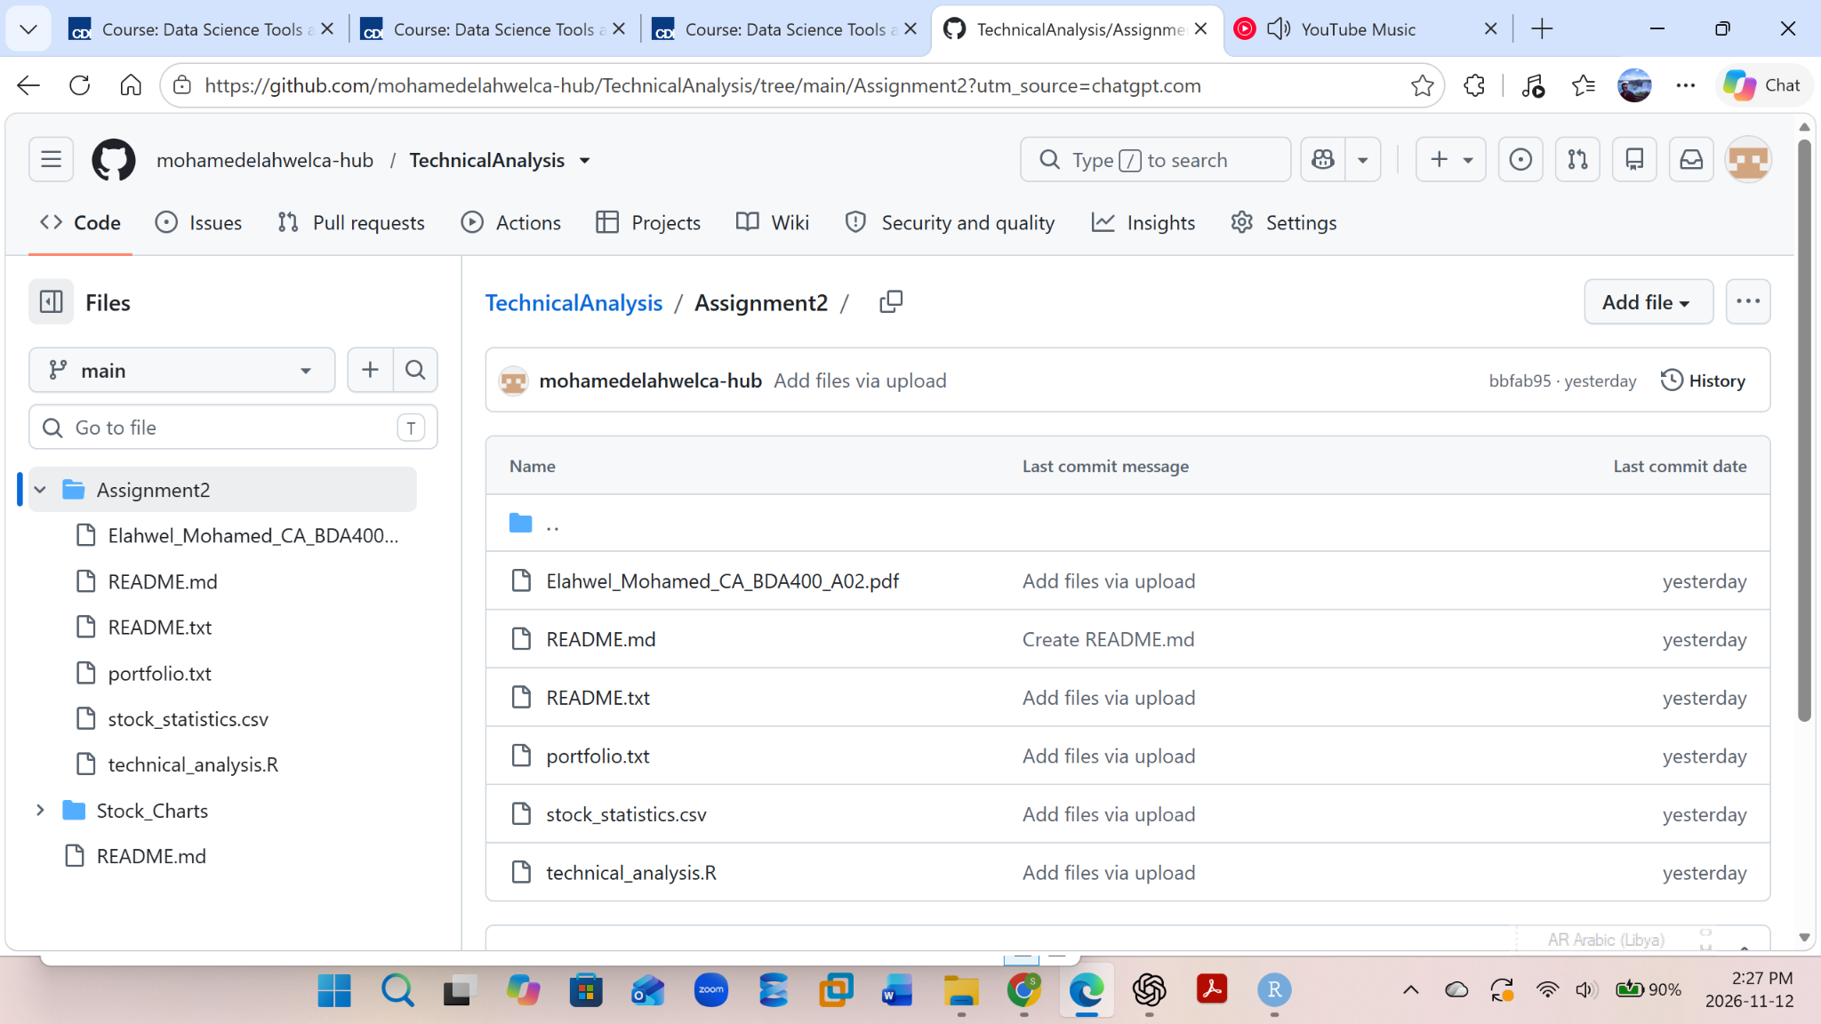
Figure 2. Assignment2 folder showing the project deliverables.

3. Installing and Verifying R and RStudio
R and RStudio Desktop were opened on the Windows computer. The R Console confirms that R version 4.6.2 is running. The RStudio version command returned 2026.10.1.239. These version checks verify that both applications are available and running.
R.version.string
RStudio.Version()$version
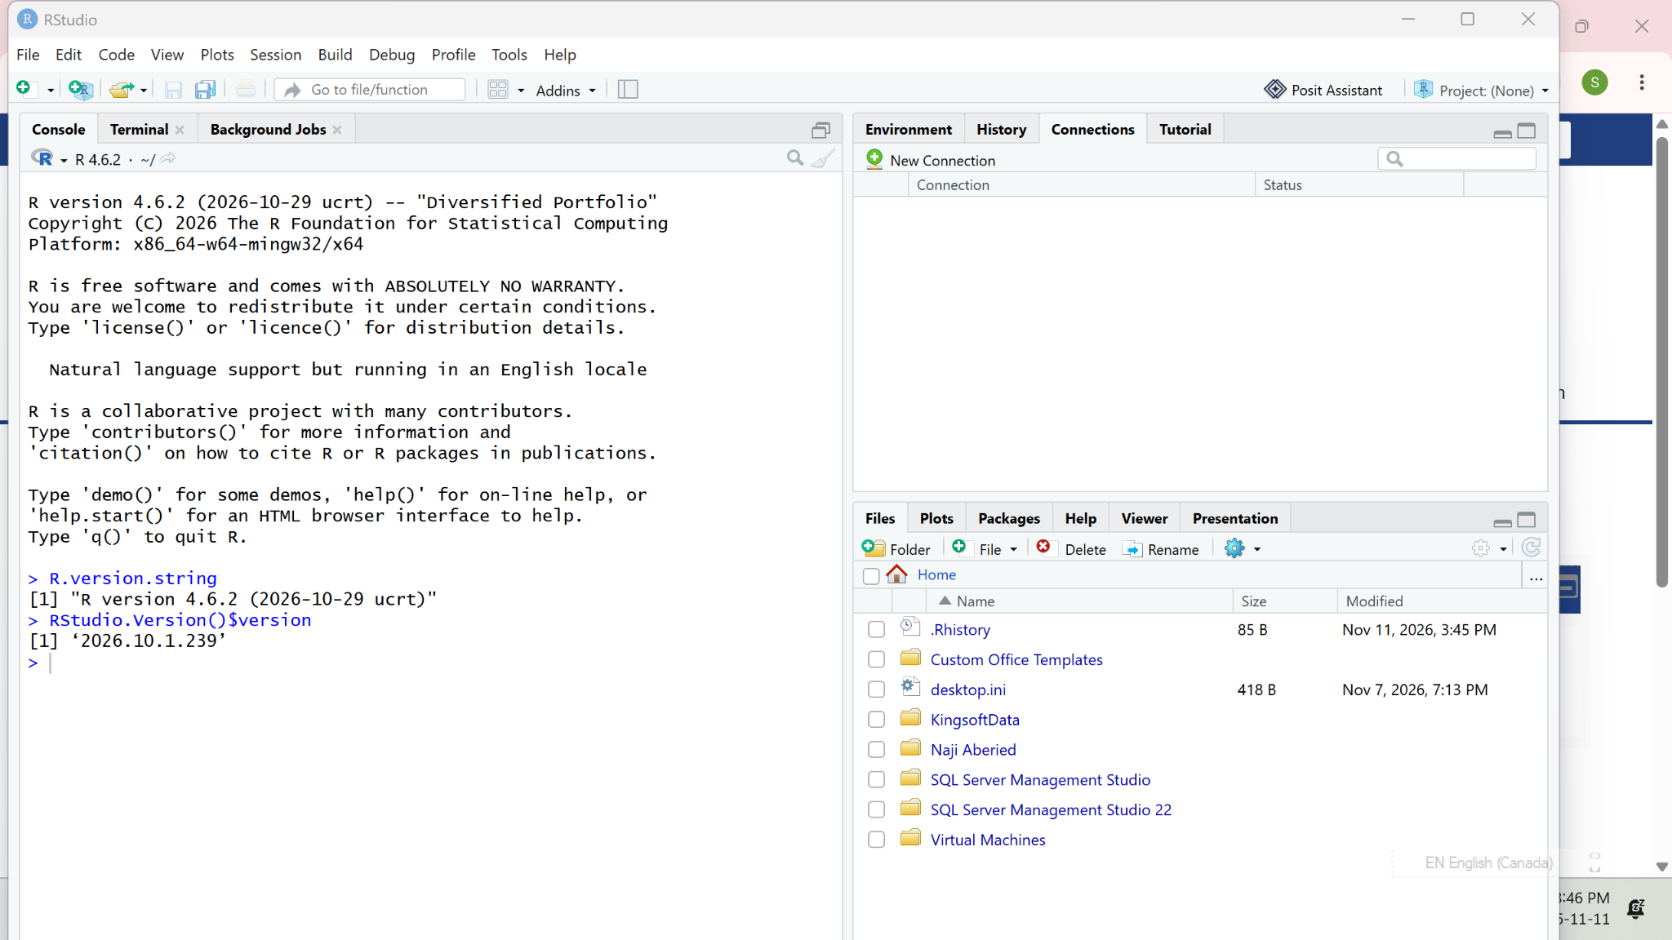
Figure 3. RStudio Console showing R 4.6.2 and RStudio 2026.10.1.239.
Note: The captured evidence documents the installed applications and their version verification. It does not show the original download wizard or installation progress.

4. Installing Required R Packages
The project uses quantmod, TTR, xts, and ggplot2. The script checks whether the packages are available, installs any missing packages, and loads them into the R session.
install.packages(c("quantmod", "TTR", "xts", "ggplot2"))
library(quantmod)
library(TTR)
library(xts)
library(ggplot2)
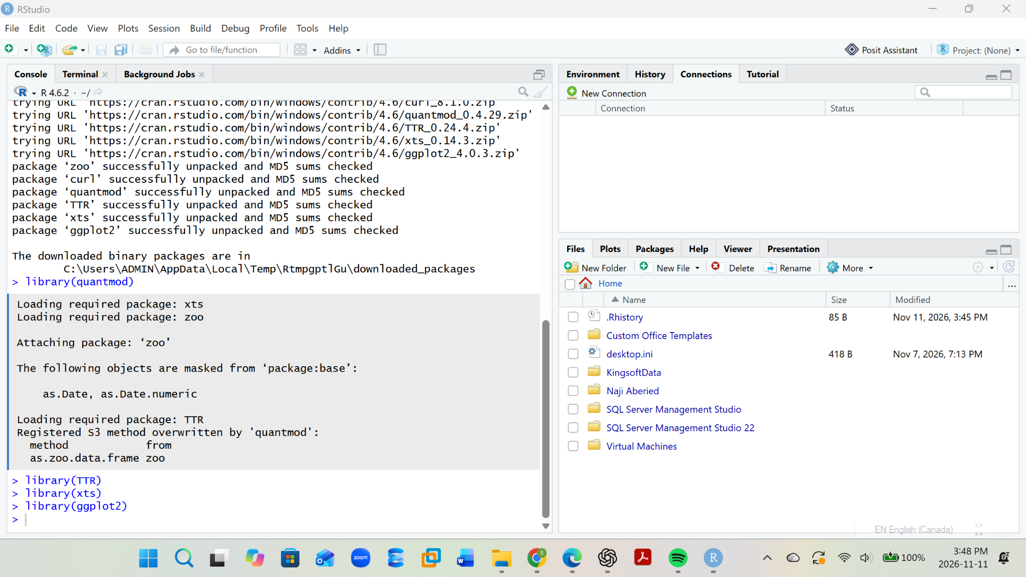
Figure 4. R Console showing package installation and package loading.
quantmod is used to retrieve market data, TTR provides technical-analysis calculations, xts supports time-indexed data, and ggplot2 is used to create visualizations.

5. Project Configuration and Portfolio
A plain-text file named portfolio.txt was created in the Assignment2 working folder. It lists one ticker symbol per line:
AAPL
MSFT
NVDA
These symbols represent Apple Inc. (AAPL), Microsoft Corporation (MSFT), and NVIDIA Corporation (NVDA). The script reads this file to determine which symbols to process.
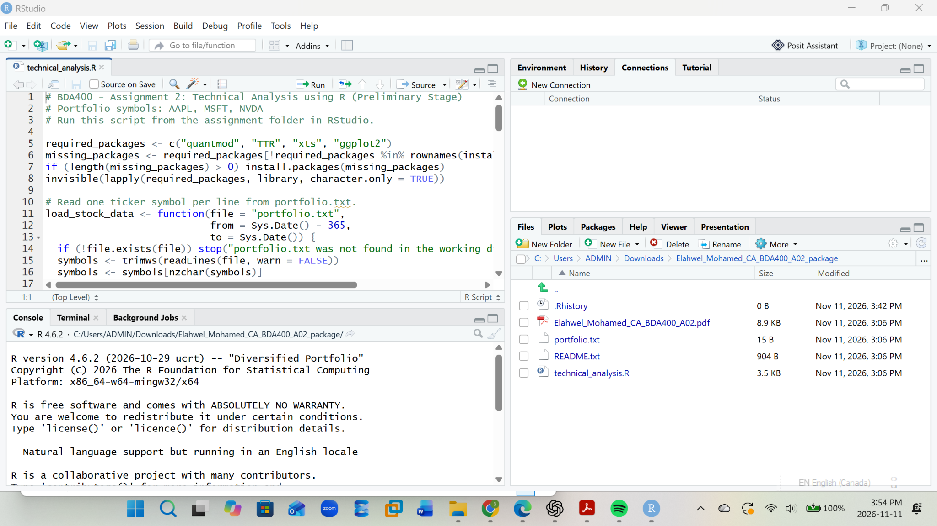
Figure 5. Project folder showing portfolio.txt and technical_analysis.R.

6. Importing Stock Data
The load_stock_data() function reads portfolio.txt, removes blank entries, and retrieves historical stock data for each ticker using quantmod. Each successful symbol is stored as a separate time-series object. The script requests approximately one year of daily historical data, subject to data-provider availability and internet access.
The downloaded market data can include Open, High, Low, Close, Volume, and Adjusted price fields. The script uses the closing-price series for the summary calculations and charts.
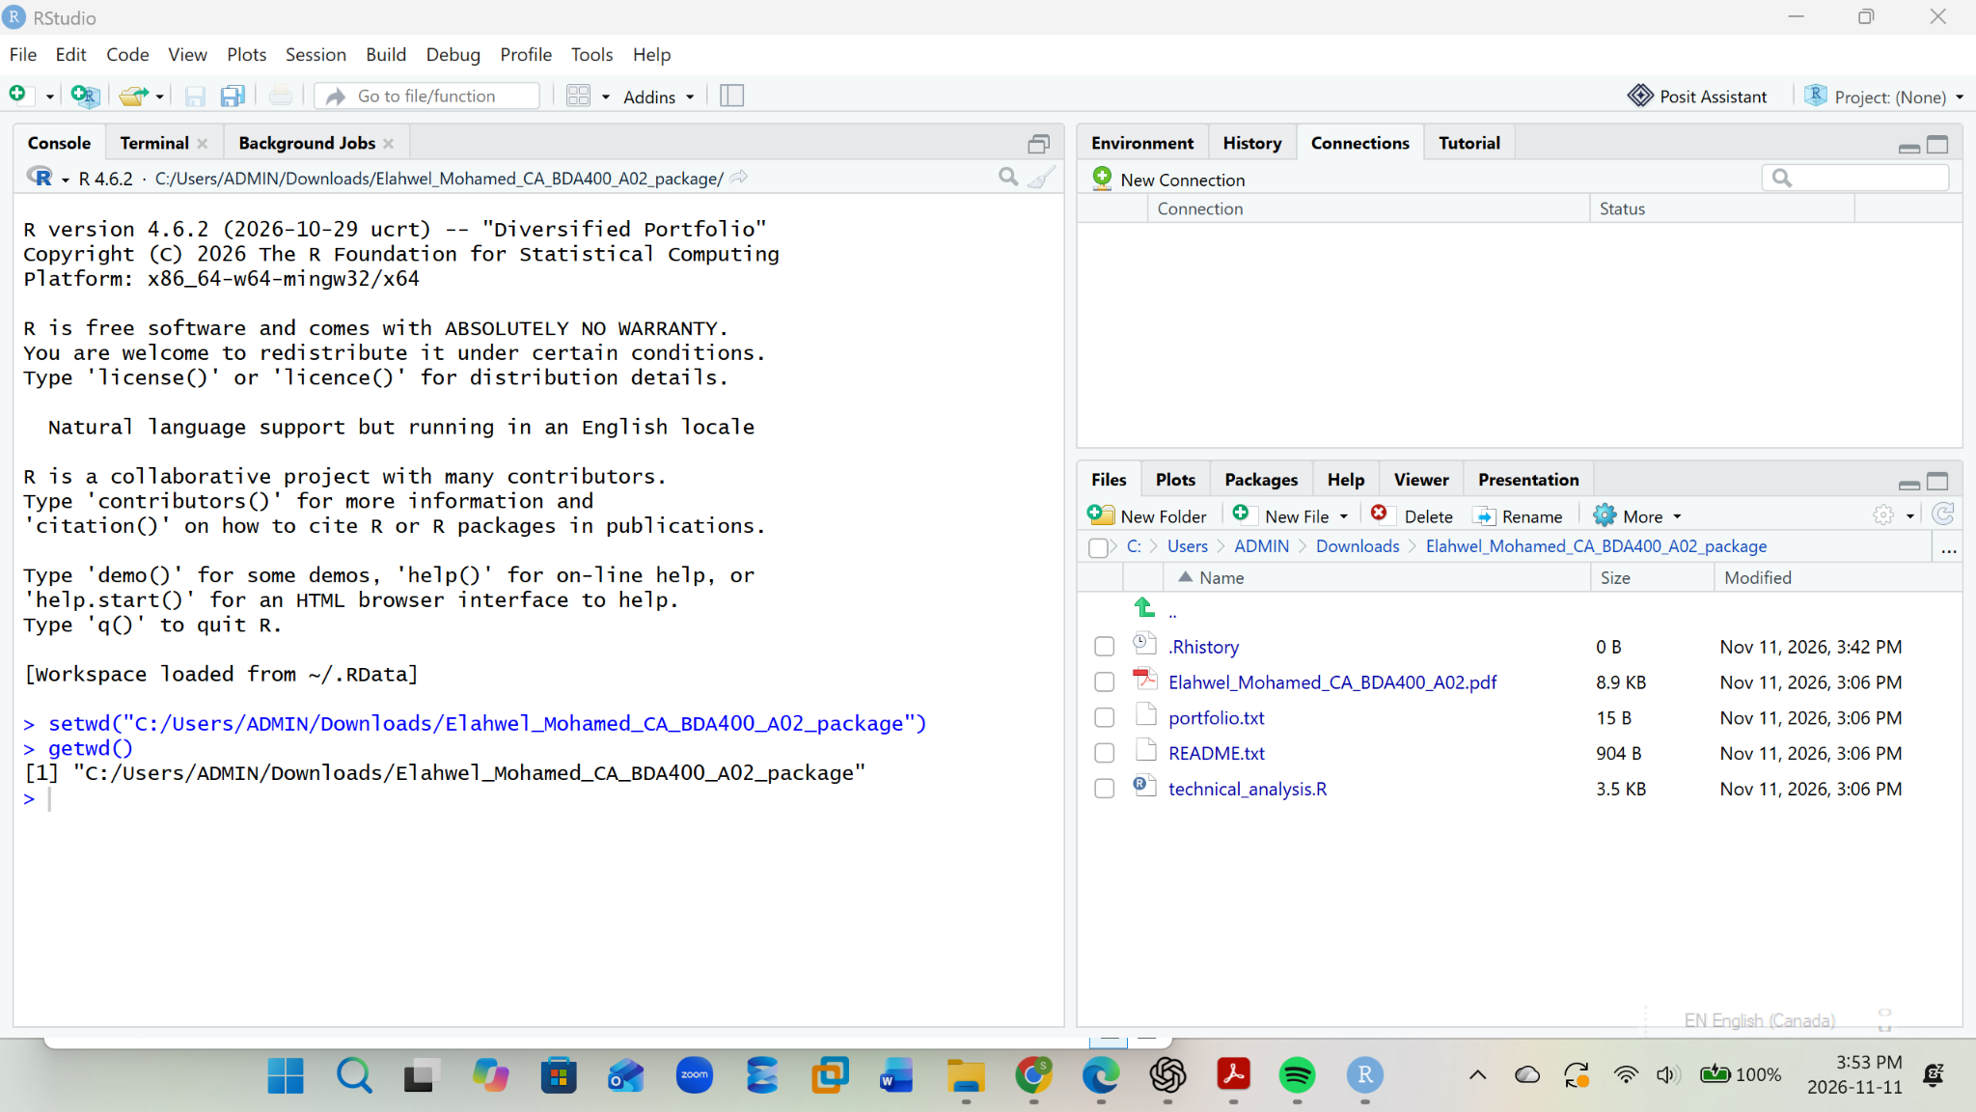
Figure 6. RStudio project files after setting the working directory.

7. Calculating Basic Statistics
The calculate_statistics() function calculates the latest 20-day simple moving average, mean, mode, median, and standard deviation for each stock's closing prices. A custom frequency-based function is used for the statistical mode because R's base mode() function reports an object's storage type rather than its most frequent numeric value.
The following values were displayed in the RStudio Console during the run:
Symbol | 20-day MA | Mean | Mode | Median | Std. Dev.
AAPL | 344.2325 | 293.6280 | 272.95 | 289.36 | 30.60415
MSFT | 531.0945 | 448.7340 | 483.47 | 451.10 | 53.41159
NVDA | 206.1830 | 200.3415 | 210.96 | 199.00 | 17.68746
The figures above reproduce the values visible in the captured RStudio output. They are the results of the recorded run and may change when the script is run again because market prices and downloaded history change over time.
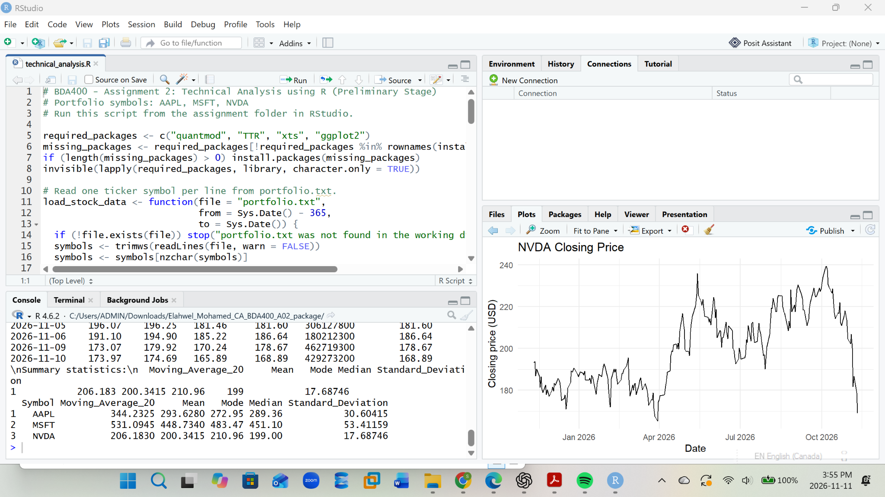
Figure 7. RStudio output showing recent NVDA prices, summary statistics, and a closing-price chart.

8. Displaying Data and Visualizations
The script displays recent rows of imported data and prints the summary statistics. It also creates a closing-price line chart for each ticker and saves the images as AAPL.png, MSFT.png, and NVDA.png in the Stock_Charts folder. The combined summary table is exported to stock_statistics.csv.
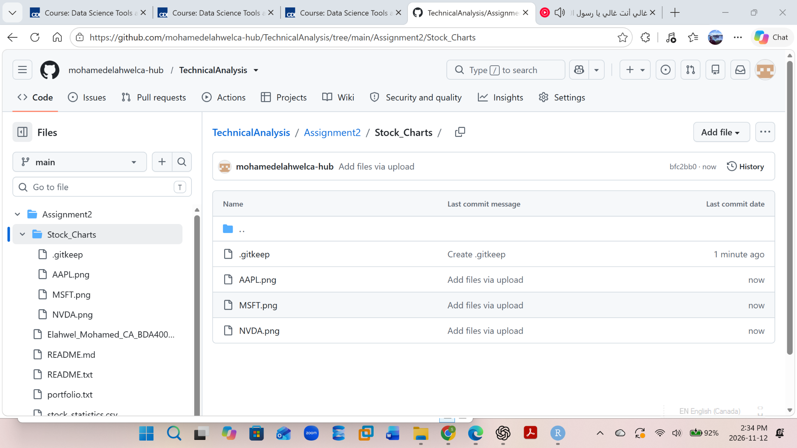
Figure 8. GitHub Stock_Charts folder showing AAPL.png, MSFT.png, and NVDA.png.
The NVDA chart captured in Figure 7 plots the daily closing price over the retrieved period. The same plotting routine is used for the other two portfolio symbols.

9. How to Run the Project
1. Download or clone the TechnicalAnalysis repository from GitHub.
2. Open the Assignment2 folder as the working directory in RStudio.
3. Confirm that portfolio.txt and technical_analysis.R are in the same folder.
4. Open technical_analysis.R and run the script from top to bottom using Source.
5. Allow the script to install any required packages if prompted.
6. Review the Console for imported data and calculated statistics.
7. Review the Plots pane and the Stock_Charts folder for the generated charts.
8. Confirm that stock_statistics.csv has been created, then commit and push the updated files to GitHub.

10. Project Deliverables
- portfolio.txt – the stock symbols AAPL, MSFT, and NVDA.
- technical_analysis.R – package setup, data import, statistics, display, chart generation, and CSV export code.
- stock_statistics.csv – the exported summary statistics.
- Stock_Charts/AAPL.png, Stock_Charts/MSFT.png, and Stock_Charts/NVDA.png – the generated stock charts.
- README.txt / README.md – project and repository notes.
- Elahwel_Mohamed_CA_BDA400_A02.docx – this assignment report.

11. Conclusion
The preliminary technical-analysis workflow has been configured and demonstrated in RStudio. The project reads the portfolio symbols, retrieves historical data, calculates the required basic statistics, displays the results, generates stock charts, and exports a CSV summary. The GitHub repository provides an organized location for the assignment files and visual outputs.

12. Final Submission Checklist
Requirement | Evidence / Status
TechnicalAnalysis GitHub repository | Repository link included; public repository visible.
Assignment2 folder and project files | Folder and files shown in Figure 2.
R and RStudio | Versions verified in Figure 3.
Required R packages | Package loading evidence shown in Figure 4.
portfolio.txt | Portfolio symbols documented in Section 5.
R script and calculations | Script execution and results documented in Figures 5–7.
Charts and CSV output | Chart files shown in Figure 8; CSV appears in Assignment2 folder.

Repository link: https://github.com/mohamedelahwelca-hub/TechnicalAnalysis

