**Communication Module:**

**ESP32**

ESP32 is a low-cost, low-power system on a chip (SoC) microcontroller with integrated Wi-Fi and Bluetooth connectivity, developed by Espressif Systems. It is based on the Xtensa LX6 processor, which has two cores running at up to 240 MHz, and includes 520KB SRAM, 4MB Flash memory, and various peripheral interfaces, such as UART, SPI, I2C, I2S, and PWM.

ESP32 also features a built-in security module with support for AES, SHA-2, RSA, and ECC cryptographic algorithms, making it suitable for applications that require secure data communication. The Wi-Fi and Bluetooth connectivity is supported by multiple protocols, including 802.11b/g/n, BLE, and Classic Bluetooth.

ESP32 is widely used in various IoT applications, such as home automation, smart lighting, sensor networks, and industrial automation, due to its low power consumption, high performance, and rich set of features.

It is also supported by a large community of developers and enthusiasts, which provides extensive documentation, tutorials, and open-source libraries to help developers get started with their projects.

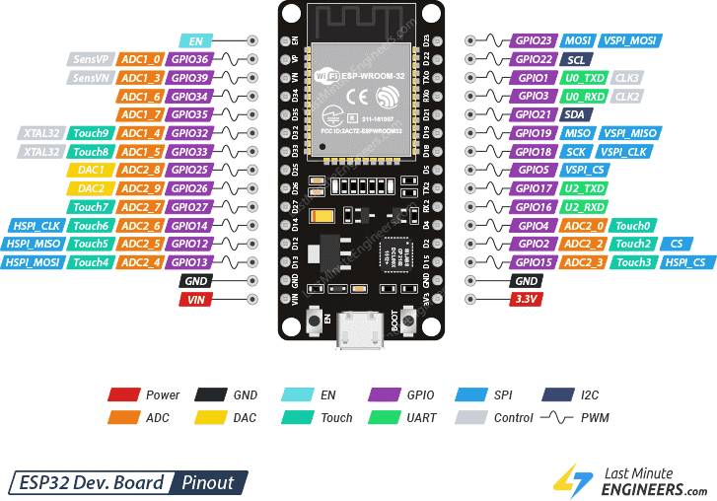

**Feature and specifications**

1. **Processor**: Dual-core Tensilica LX6 microprocessor with clock frequency of up to 240 MHz.
2. **Memory**: 520 KB of SRAM and 4 MB of flash memory.
3. **Wireless** Connectivity:
   * Wi-Fi 802.11 b/g/n with up to 150 Mbps data rate.
   * Bluetooth v4.2 BR/EDR and BLE (Bluetooth Low Energy) with a maximum transmission power of 20 dBm.
   * Supports multiple protocols including A2DP, AVRCP, SPP, GATT, and GAP.
4. **Peripherals**:
   * 12-bit SAR ADC with up to 18 channels.
   * 2 × 8-bit DAC.
   * 2 × I2C interfaces.
   * 3 × UART interfaces.
   * 2 × SPI interfaces.
   * 2 × I2S interfaces for audio applications.
   * 16 × PWM output.
   * 10 × capacitive touch sensing GPIOs.
   * SD/SDIO/CE-ATA/MMC/eMMC host controller with SDIO 3.0 support.
   * Ethernet MAC interface with dedicated DMA and IEEE 1588 support.
   * CAN 2.0 support.
5. **Power Consumption**:
   * Deep sleep mode with power consumption as low as 10 µA.
   * Modem sleep mode with power consumption as low as 2.5 mA.
6. **Operating Voltage**: 2.2V to 3.6V.
7. **Operating Temperature**: -40°C to 125°C.
8. **Development Environment**: Supports Arduino IDE, Espressif IDF (Integrated Development Framework), MicroPython, and Lua RTOS.Top of Form

The ESP32 is a versatile microcontroller that can perform a **wide range of** **functions** depending on the application requirements. Here are some common functions that the ESP32 can perform:

1. ***Wireless Communication***: The ESP32 can be used to establish wireless communication using Wi-Fi and Bluetooth protocols. It can be used to connect to the internet, send/receive data, and control devices remotely.
2. ***Sensor Data Acquisition and Processing***: The ESP32 has several built-in peripherals, including ADC, DAC, I2C, SPI, and UART interfaces, that can be used to acquire and process data from sensors. It can be used to measure temperature, humidity, light, motion, and other physical parameters.
3. ***Actuator Control***: The ESP32 can be used to control various types of actuators, such as motors, relays, and LEDs. It can be used to build home automation systems, smart lighting systems, and other devices that require remote control.
4. ***Data Logging***: The ESP32 can be used to log data from sensors and store it in its flash memory or an external SD card. It can be used to monitor environmental conditions, track machine performance, and perform other data logging tasks.
5. ***Machine Learning***: The ESP32 can be used to perform machine learning tasks, such as pattern recognition, image processing, and classification. It can be used to build smart cameras, voice assistants, and other intelligent devices.
6. ***Edge Computing***: The ESP32 can be used to perform edge computing tasks, such as data preprocessing, filtering, and aggregation. It can be used to reduce the amount of data transmitted over the network and improve the performance of IoT systems.