بسم الله الرحمن الرحيم

|  |  |
| --- | --- |
| Robotic Vacuum Cleaner | Final  Documentation  Students : **Hiba Ghannam**  **Hawa’ Osama**    Supervisor : Aladdin Masri  Hardware Project |

An-Najah National University

Faculty of Engineering

Department of Computer Engineering



Contents

Table of Contents

Abstract 3

Introduction 4

1.What is a robotic vacuum cleaner 5

1.1. Idea 6

1.2. Features 6

1.3. Application Scope 6

2.Hardware Components 7

2.1.Robot Body 8

2.2. Microcontroller 9

2.3.Motors 10

2.4 Sensors 12

2.5 Keypad 13

2.6 Power Supply 14

3.Software Algorithms 15

4.Problems and future development21

Conclusion23

References24

Abstract

The purpose of this project is to design and implement a Robotic Vacuum Cleaner. Robotic Vacuum Cleaner is designed to make cleaning process become easier rather than by using manual vacuum. The idea is by having sensors to detect any object and send the output to a PIC that will control the Robotic Vacuum Cleaner movement.

By using Robotic Vacuum Cleaner, user can choose one of two modes:

1- Free mode, user can just turn on the Vacuum Robot to clean without having to operate the Robotic Vacuum Cleaner.

2- Controlled mode that allow user to specify the dimensions of any area using keypad.

The hardware of Vacuum Robot consists of the microcontroller, the motor, the vacuum body, the sensors, the power supply and the keypad. Software is used to write the programming and algorithms.

Introduction

This documentation is aimed at equipping you to have the technical understanding needed for our project .This will enable you to become familiar with the idea of the project, the hardware and the algorithms, as well as what we envision as its possible future development.

In chapter 1, we will introduce the project idea, the features and the project scope.

Chapter 2 will give you explanatory information about all hardware components. It will explain the mechanical part of our project and the electrical components. The mechanical part involves the body, the drive system, the sensor layout and the electrical part involves in microcontroller, drive circuit and sensor interface.

Chapter 3 will explain the algorithms that used to control the movement of Robotic Vacuum Cleaner and to avoid the obstacles.

In chapter 4 we will discuss the problems we faced and solutions that we reached. Also chapter 4 will explain any possible future development for our projects and finally the conclusions.

This documentation is provided with an appendix to explain some definitions that are used through this document.

Finally, the references of all researches of the project are followed to our documentation.

Chapter 1

What is a Robotic

Vacuum Cleaner?

Chapter 1: What is a Robotic Vacuum Cleaner?

**1.1 Idea**

In fact, most of us usually using a hand controlled vacuum for cleaning. From time to time technology come up and need to upgrade for easier human task. In addition, most of the people are working and they did not have enough time to clean. Moreover, most of vacuum robots in the market are expensive and may be large in size. So it is difficult to clean anywhere like under beds. Therefore, this project is built to be one of the advantages for human to clean the floor within small period and more effective.

**1.2 Features**

1. Small size so it will enter a small area.

2. Low cost, cost of body, three sensors, microcontroller and one motors driver.

3. Free mode without give the dimensions of area.

4. Controlled mode by enter the dimensions using keypad

5. A void any obstacle at the center of a given area.

6. A void any obstacle at any corner of a given area.

**1.3 Application Scope**

Robotic Vacuum Cleaner is developed to make cleaning process easier especially for working people. This Robotic Vacuum Cleaner is designed for specific area such as under beds, as well as a specific room or carpet that has a specific obstacle in the center or corner.

Chapter 2

Hardware Components

Chapter 2: Hardware Components

**2.1 Robot Body**

Robot Body is the mechanical part of the robot which consists of:

1-Wheels: we used 4 wheels that we take from toy car with their motors, and we choose that toy car because of its suitable price and it has its own power supply without additional price also it can carry the hand vacuum over it. Figure-1 shows the wheels with motors.

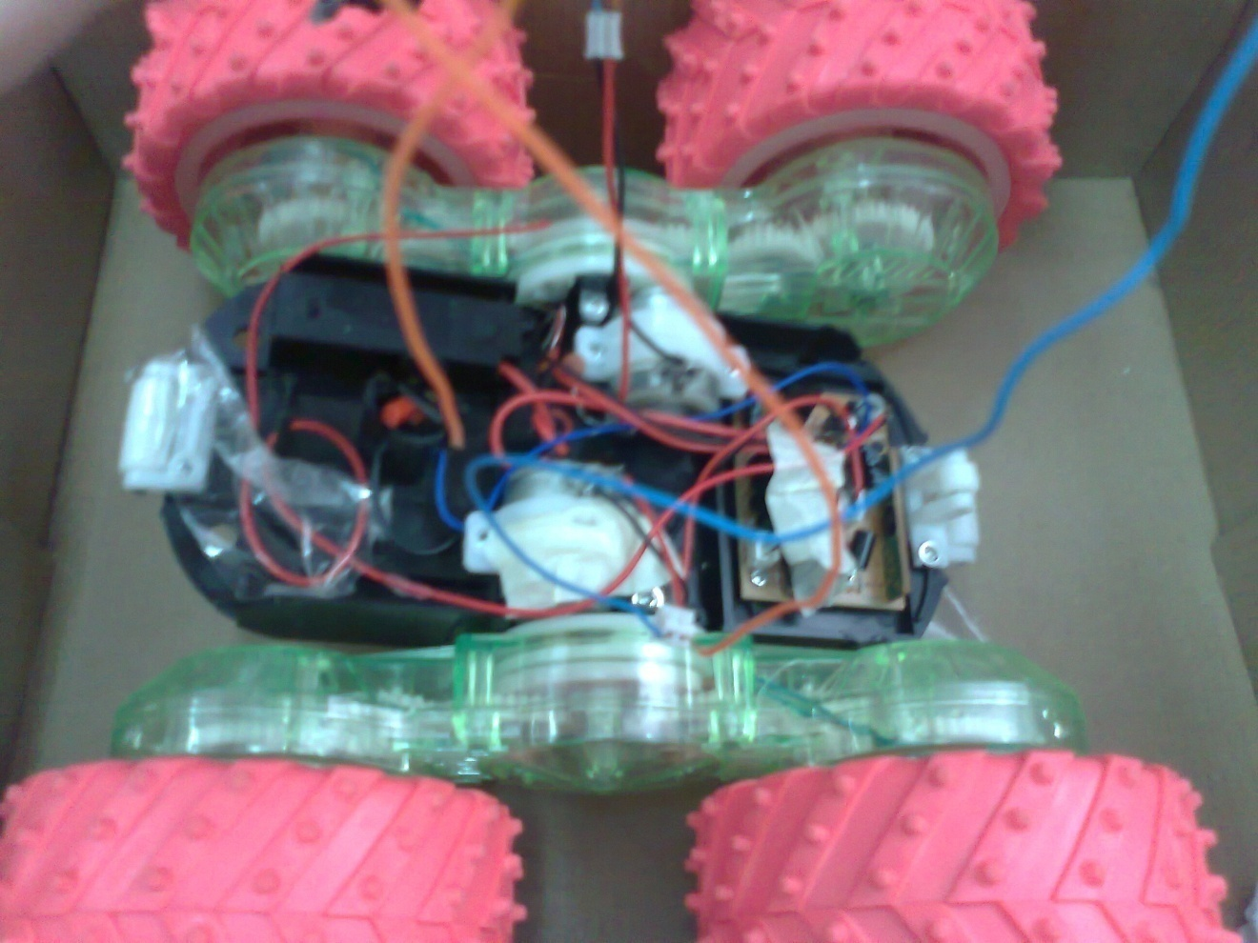

Figure-1 wheels and their motors of robot body

2- Hand vacuum cleaner which we connect with the wheels. It has its own dc power supply and it suitable to be carried by the wheels. Figure-2 shows the vacuum.

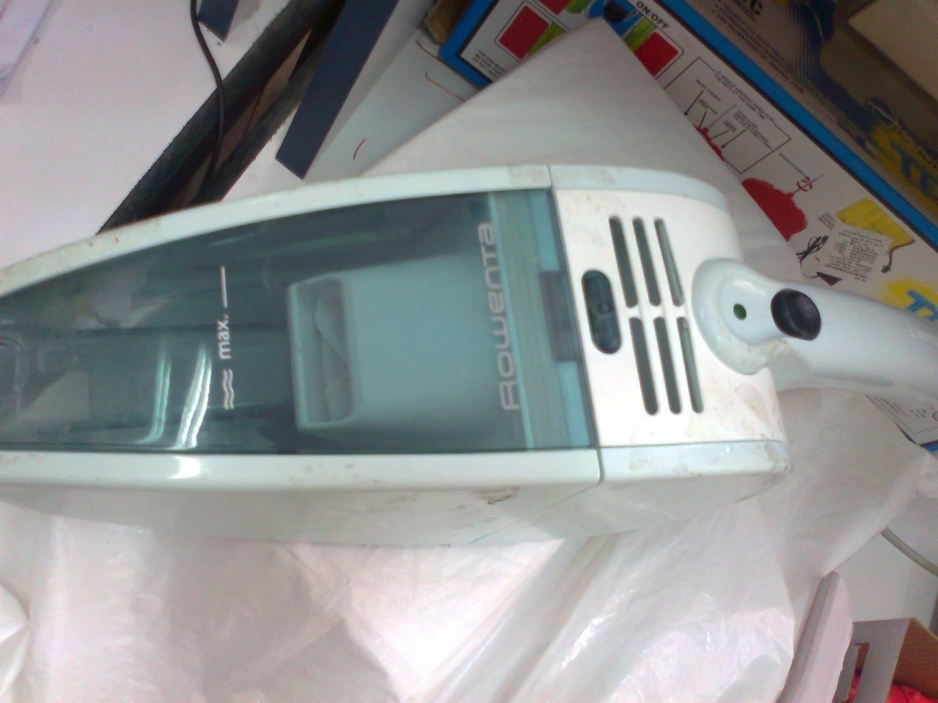

Figure-2 hand vacuum

**2.2 Microcontroller**

In our project we use Pic18f4620 microcontroller with 4MH frequency, we use the controller to control all parts of the motor, for example it used to control the speed and direction of the motor, and it used to control when to use the sensor. Figure-3 shows the basic circuit for Pic18f4620.We used Picc program to write our own code to send it we used boot loader.

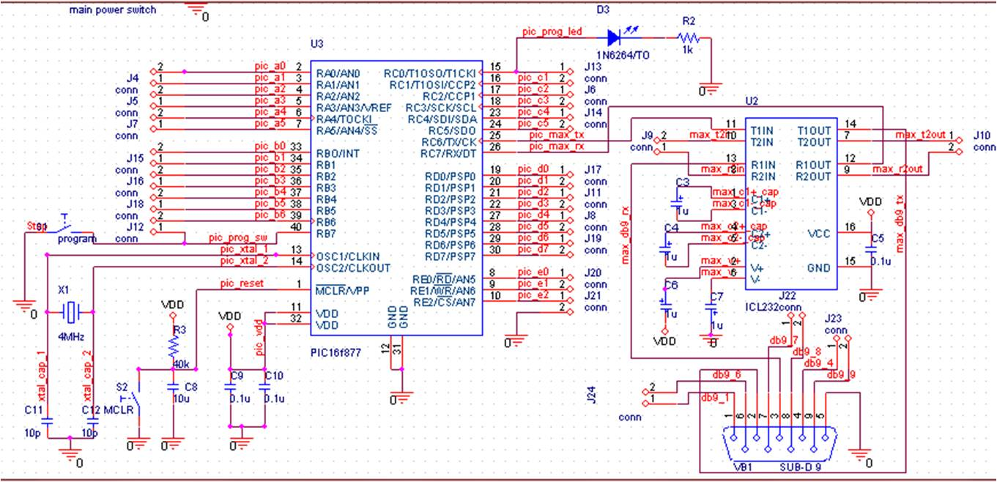

Figure-3 Pic18f4620 basic circuit

In our project we connect motors to port C through motors drivers, we connect also sensors to port A to used ADC and we used port B to connect keypad.

**2.3 Motors**

The motor used to move the robot in all direction, in our project we use two dc motors, each motor controls two wheels, and the motion has five states:

* Forward the two motors rotate in the same direction.
* Backward two motors rotate in the same direction but this direction is I the opposite of the forward direction.
* Left, to turn the car left, the left motor is turn on and the right motor is turned off so the car rotate I the right axis.
* Right, to turn the car right, we do the same for turn right but this time we turn the right motor on, and the left one off.
* Circular direction, this turn the car with any angle from 0 to 360,by turn left motor one direction and the right motor I the opposite direction .
* **H-Bridge Motor Driver**

L293D is a dual H-Bridge motor driver, so with one IC we can interface two DC motors which can be controlled in both clockwise and counter clockwise .L293D has output current of 600mA and peak output current of 1.2A per channel. Moreover for protection of circuit from back EMF output diodes are included within the IC. The output supply (VCC2) has a wide range from 4.5V to 36V, which has made L293NE a best choice for DC motor driver. (1)

We connect four output of the PIC microcontroller to the input of the H-Bridge, as in figure-4

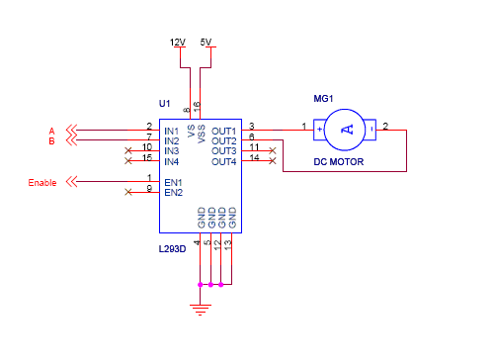

Figure-4 H-Bridge L293NE

The controller control the motor according to this truth table in table-1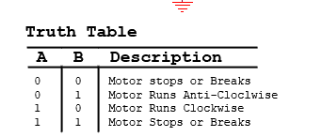

Table-1 truth table to control motor direction

**2.3 Sensors**

Act as sensing component to the environment. It is used to detect color, heat, humidity, touch, light, obstacle and etc. For Vacuum Cleaner Robot, sensors are used to detect obstacles.

We used 3 sensors, one is ultrasonic sensor at the front of the body and the others are IR sensors, one to the left and right. The reason to use ultrasonic is to give more accurate result to detect glass objects. The IR sensors used as an alternative of ultrasonic because we didn’t find any ultrasonic sensor in our market when we choose we to used left and right sensors to take more accurate results.

The ultrasonic sensor is Ez0 type with 2.5V - 5.5V power and it provides very short to long-range detection. The EZ0 detects objects from 0-inches to 254-inches (6.45-meters) and provides sonar range information from 6-inches out to 254-inches with 1-inch resolution. Objects from 0-inches to 6-inches range as 6-inches. The interface output formats included are pulse width output, analog voltage output, and serial digital output. Figure-5 shows the sensor.

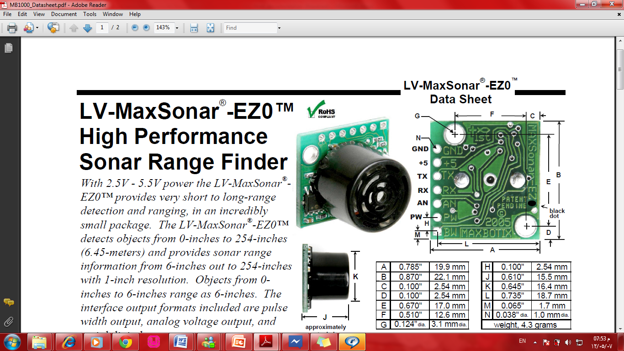

Figure-5EZ0

The IR is sharp sensor of GP2Y0A21YK0F type as shown in figure-6. GP2Y0A21YK0F has these features:

1. Distance measuring range: 10 to 80 cm

2. Analog output type

3. Package size: 29.5×13×13.5 mm

4. Consumption current: Typ. 30 mA

5. Supply voltage: 4.5 to 5.5 V

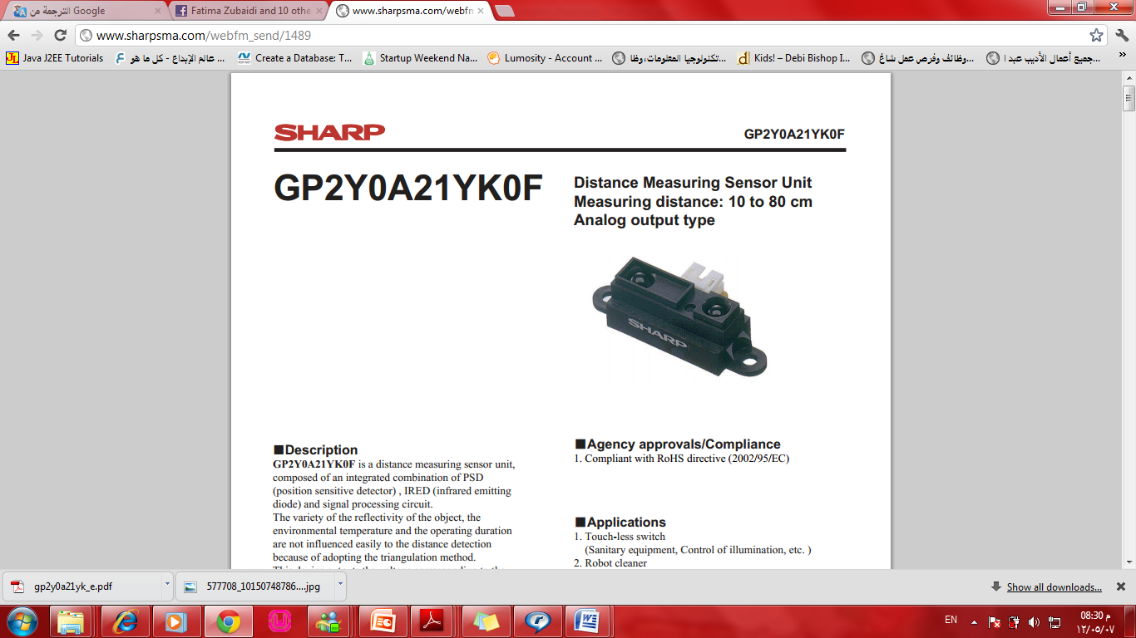

Figure-6GP2Y0A21YK0F

**2.4 keypad**

The keypad used to enter the dimensions of the area needed to be clean. The keypad columns and rows connected to PIC port, to program it we enable one column and disable the other columns, we start check which button clicked in those columns, and we repeat this pattern to each column in the keypad.

*output_bit( PIN_B3,0);*

*output_bit( PIN_B1,1);*

*output_bit( PIN_B6,1);*

*output_bit( PIN_B5,1);//row #1 enable row # 1*

*if(!input(PIN_B0))/////////////check if key one is clicked*

*{*

*delay_ms(200);*

*if(!input(PIN_B0)){*

*printf( "*");*

*delay_ms(500);*

*}*

*}*

*))*

*if(!input(PIN_B2)) /////////////check if key zero is clicked*

*{*

*delay_ms(200);*

*if(!input(PIN_B2)){*

*printf( "0");*

*delay_ms(500);*

*}*

*}*

**2.5 Power Supply**

We need power to both PIC Micro Controller and the motor the motor need power 9volt source to the motor ad 5 volt power source to the microcontroller we the main power supply in our circuit is rechargeable dc battery connected to mc7805ct regulator.

Chapter 3

Software

Algorithms

Chapter 3: Software Algorithms

There are different algorithms from own development and we classify them in many cases depending on the position of obstacle.

**Case1:** No obstacle at the center of the area and all obstacles are only in the corners or at the center of two ends only, as in figure-7

start

start

Figure-7 case1of algorithm

In this case as we see above the robot should be at one of two started points and the dimensions given by keypad, then the front sensor will first check if there is an object at a 14 cm, if no it will go forward and when reach the 14 cm it will check the right hands side to turn 180 degree and go to the next line it will check the right side by right sensor. The sensors on the right prevent the robot from turning when the distance of dimension becomes zero or when the distance from the object is less than 10cm.

**Case2:** No obstacle at the center of the area and obstacles are in the corners or at the center of two ends only, as in figure-8

start

start

Figure-8 case2 of algorithm

The second case is just as above but the robot should start at different start points and in these two cases we only use two sensors the front and the right and surly we can use the left instead of the right.

The following two cases are in development and we are working on and we will try to reach some results about them until our presentation.

**Case3:** No obstacle at the center of the area and obstacles are in the corners or at the center of any end, as in figure-9

start

start

Figure-9 case3 of algorithm

**Case4:** Add an obstacle at the center of the area, as in figure-10

start

start

Figure-10 case4 of algorithm

In the last two cases we will use two three sensors to detect objects.

**Algorithm description**

In basic idea of our algorithm that the robot keeps going forward until it finds an obstacle left or right the robot need to decide which side it need to turn left or right according to these case

**Case1**: For the first line it determine it by read values from left sensor and right sensor so

* If it discovers an obstacle to the left, the robot turns right.

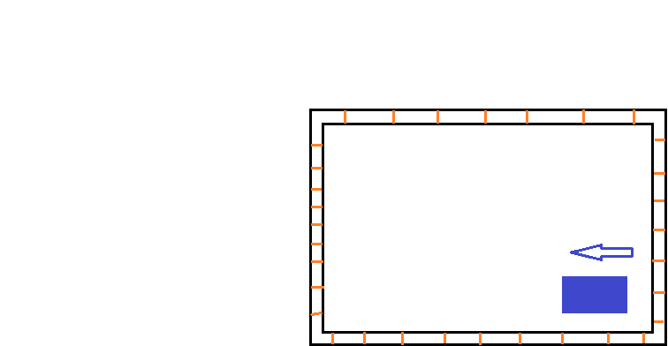

Figure 11-obstacle on left robot turns right

* If it discovers an obstacle in the right it turns left

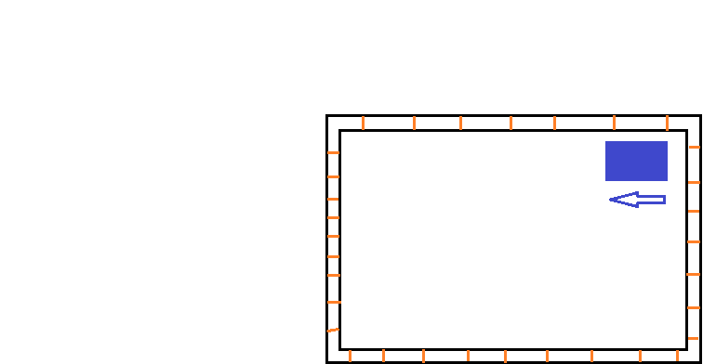

Figure 12-obstical on right robot turn left

* If there is an obstacle in both left and right, the robot keep going backward and check the value of right and left sensor until it find region where is there is no obstacle on left or right direction.

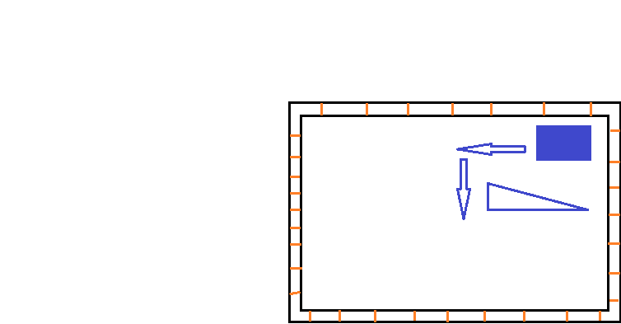

Figure 13- obstacle in left and right robot move backward then turn left

**Case2:** For the second line the robot checks the sensor opposite to sensor it has checked in the first line. For example, if the robot discovers it do not have sensor in the right hand so it turns first line to left then right then to left in the second line, but if it discovers obstacle in the left it keeps moving backward until it get away from the obstacle.

For the third, fourth, fifth……etc each as the second line it each line check turns opposite to line previous line.

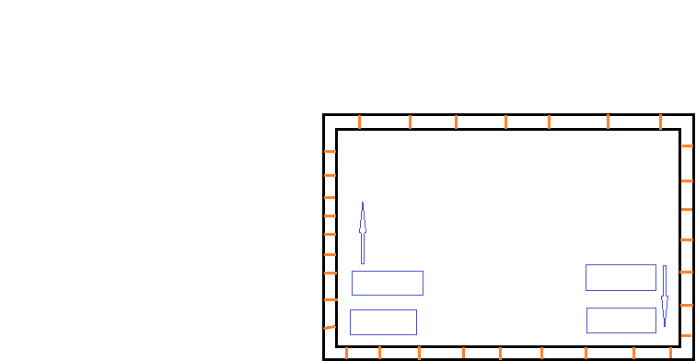

Figure 14-car moves first line and turns left, then second line and turns right

**Note**

Case1and Case2 deal with obstacle in the corner of room

**Case3:** For obstacle in the middle of the room, the robot needs to have the width and height of the room. In the our case, we choose to enter the dimensions of the room by the keypad, and the start of each line the robot store the value of the front sensor if it’s less than the width or height of the room it detect that obstacle in the middle until. Now we don’t write this part of algorithm, but at the end of the project we hope to write at the end of this week.

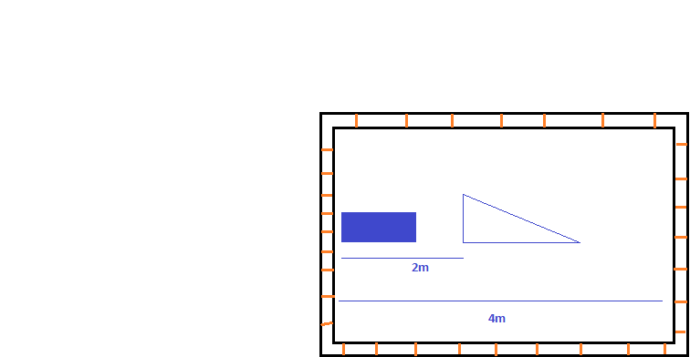

Figure 15-user enters 4m as height of room. Front sensor of robot reads 2m so it detects

obstacle in the middle of room.

Chapter 4

**Problems**

**and Future**

**Development**

Chapter 4: **Problems and Future Development**

**Problems**: **Through our project we faces these problems :**

* The problem of unavailable ICs like ultrasonic sensor which we used instead of it the IR.
* The problem of find a suitable toy car that will carry the vacuum.
* A problem that happened because of the vacuum weight, that caused a problems in turning the wheels
* Problem with motor and high current needed to operate them, and safety method needed to protect the basic circuit from the backward current.
* Mechanical problem in the case of building and combining robot part.
* Problem of dealing with sensor and floating value, some time sensor read wrong value so we put technique to ensure the sensor gives us right values

**Future development**

* Now we are working to make the robot smart enough to detect all objects in any position of room.
* In the future we hope to make the robot smarter such that when the robot cleans any room it will save the information about obstacle and its location and if the user want to clean a room it just will restore information and will clean faster.
* We hope to make the robot to clean tables such that it can detect edges and it will clean the tables without falling down.

Conclusion

In our project we tried to produce a smart robot vacuum cleaner that detects more objects with a goods price and with ease of use.

We notice that any future development will make our robot more smartness, and this depends in future development of other algorithms that depends in the form of obstacles.

**References**

1. http://www.8051projects.net/dc-motor-interfacing/l293d-interfacing-with-microcontroller.php
2. Robotics experiment with PIC microcontroller tutorial  
   It is used in our research to choose our components
3. http://www.sharpsma.com/webfm_send/1489

It is a tutorial about GP2Y0A21YK0F

1. http://www.maxbotix.com/documents/MB1000_Datasheet.pdf

It is a tutorial about EZ0

1. http://www.alldatasheet.com/datasheet-pdf/pdf/26888/TI/L293NE.html It is about L293NE
2. http://category.alldatasheet.com/index.jsp?semiconductor=DC-Motor

It is about DC motor

1. http://www.datasheetarchive.com/keypad%203x4-datasheet.html

It is about 3*4 Keypad that we used

1. http://www.sparkfun.com/search/results?term=ir&what=products

To choose the suitable sensors and data sheets

1. http://www.sparkfun.com/search/results?term=ultrasonic&what=products

To see the types of ultrasonic sensors

1. http://people.ece.cornell.edu/land/courses/ece4760/FinalProjects/s2006/hac24/index.html

Tutorial about vacuum cleaner robot