

Under supervision

Dr:ahmed saif

**By**

Sheriff Arafat

Mahmoud nabil

Mohamed mamdouh

Mohamed abdelazize

Abdelrahman najeh

Mahmoud amer

Describetion:

This project is a store for selling auto spare parts online and there are all kinds of spare parts for all cars. The customer has to order an order and then receive it after three days.

project screens:

1;The main page contains the name of the project and a background image, and logging in and registering for the first time.

2: The login screen contains a name and password field and a button to register

3: The login screen for the first time asks for some information about the user in order to create a personal account for him

4: The displays screen contains all the exhibits requested by the user, determines their number, and then calculates the total amount.

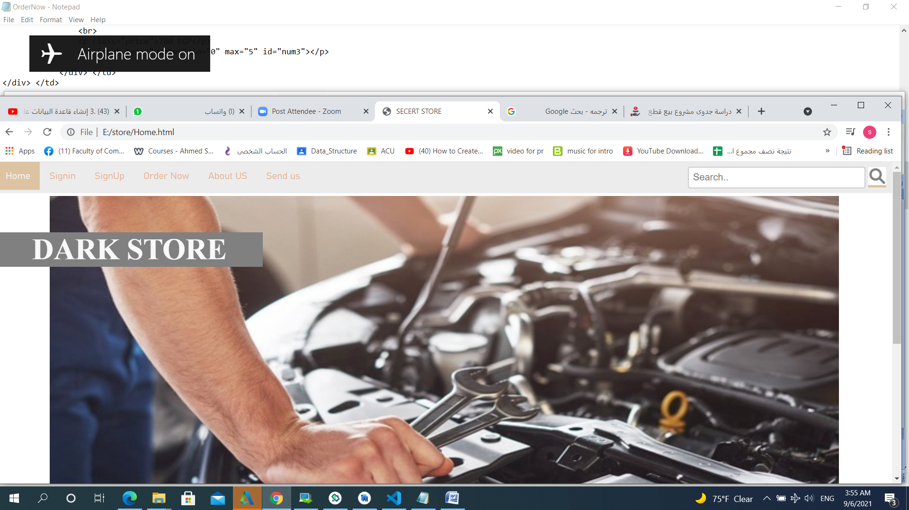

4: Website developers screen and information about them

**Samary:**

**Web pages, which are the basic infrastructure of websites, are pages that are built in markup language (html) that contain files or content to be shared on the Internet.**

**And they are linked to form an integrated website, which can usually be accessed through the homepage.**

**Web pages can be accessed and transmitted using Hypertext Transfer Protocol (HTTP),**

**which can optionally use its encryption to ensure the security and privacy of the user. The web browser,**

**Displays the page's content according to its HTML markup instructions on a computer or mobile device.**

**Thank you**