CSE211 Web Programming, Fall Semester 25/26
Final Course Project
Group 9 –
Youssef Atta Mohamed (223103574)
Mohamed Ahmed Mohamed (224200083)
Wahballah Ahmed Wahballah (221100971)
Ziad Abdullah (221101546)
Submission Date: Sunday, January 5, 2026

Executive Summary
This report documents the final project for the CSE211 Web Programming course. The project is a fully functional web-based event management system designed to demonstrate essential web development skills using HTML5, CSS3, JavaScript (ES6), and optional back-end technologies. The system enables users to browse events, register through interactive forms, calculate budgets, and interact with dynamic content in a responsive and accessible interface.

The project follows a clear separation of concerns. HTML was used to create semantic and accessible structures, CSS handled responsive layouts and styling, and JavaScript implemented dynamic behavior such as form validation, event filtering, and calculations. Bonus features such as backend integration, deployment, and documentation were also included.

The team collaborated using GitHub and applied validation and testing to ensure compliance with web standards. The final system fulfills both functional and non-functional requirements and reflects the practical application of course concepts.
References
* MDN Web Docs
* W3C HTML & CSS Validation Services

Appendix A: AI Assistance Acknowledgment
Artificial Intelligence tools were used to assist with language refinement, structuring, and formatting guidance. All core ideas, implementation, and final decisions remain the responsibility of the project team.
Appendix B: Team Contribution Breakdown

1. Youssef Atta Mohamed – HTML Developer
Responsible for all HTML pages, semantic structure, navigation, forms, accessibility, and validation.

2. Mohamed Ahmed Mohamed – CSS Developer
Responsible for styling, responsive layouts, animations, media queries, and CSS validation.

3. WAHABALLAH Ahmed Wahballah – JavaScript Developer
Responsible for DOM manipulation, form validation, filtering logic, budget calculator, and testing.

4. Ziad Abdullah – Bonus & Documentation
Responsible for backend integration, hosting, GitHub management, documentation, validation reports, and final integrations .
Appendix C: Additional Visualizations
Supplementary figures, diagrams, and visual materials relevant to the project are included here.

Appendix C: Additional Visualizations
Figure C.1: Events Page Interface
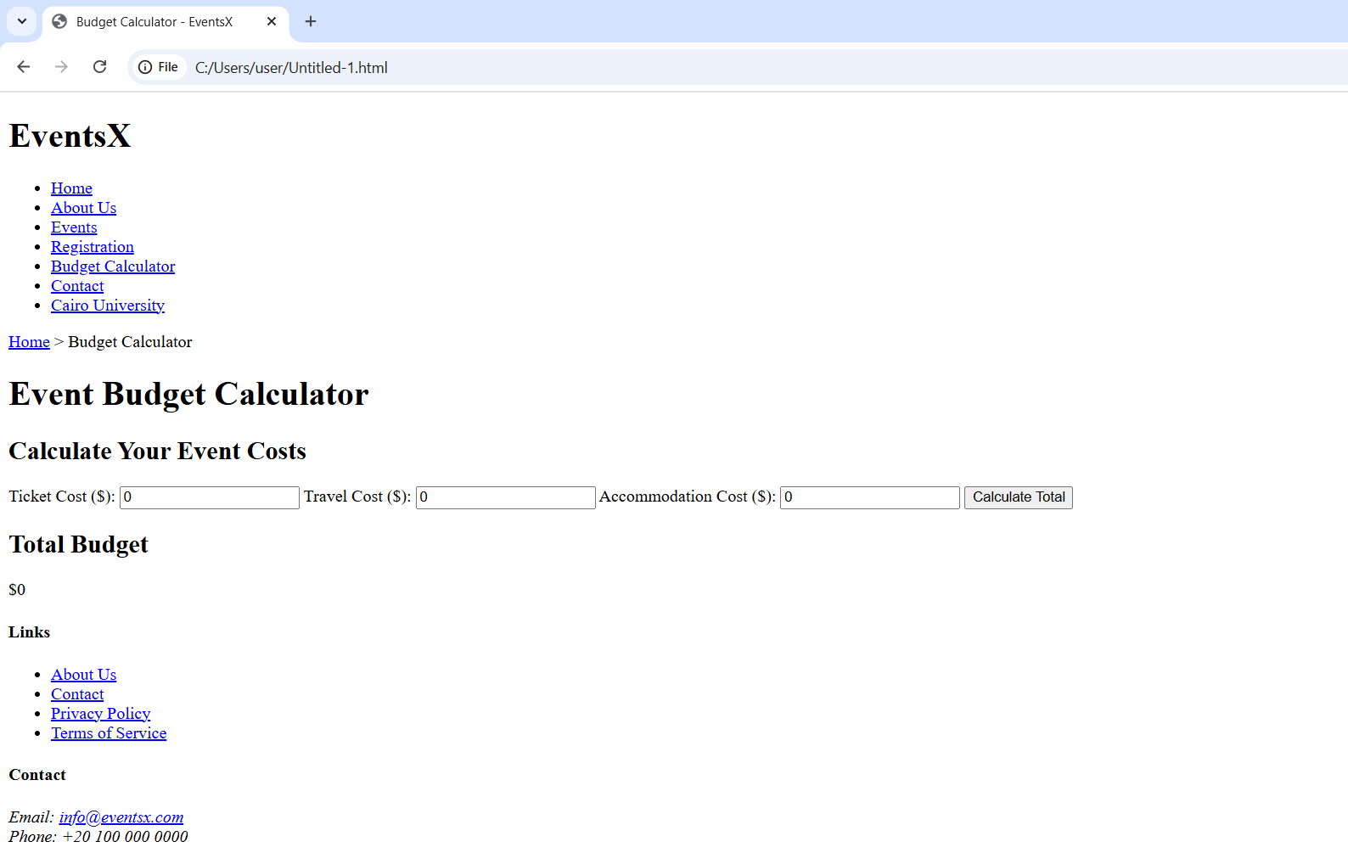

Figure C.2: Event Budget Calculator Interface
