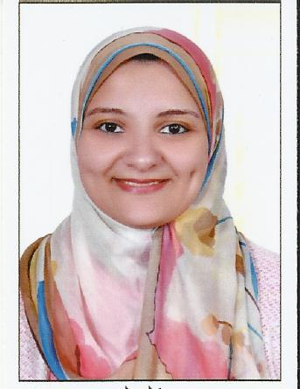

**Curriculum vitae**

Name:    Eman Mohamed Atef Abd Elfatah

Tel :       01206573203

Email :     [emandiyaa@hotmail.com](mailto:emandiyaa@hotmail.com)

**personal information** :-

**Birth of date:**    1-04-1986

**Place of Birth:**    Saudi Arabia

**Gender**  :  Female

**Nationality :**    Egyptian

**Marital Status: Married**

**Education:**

**University Degree**:    Bachelor of License of Arts –Arabic Language

**University:** Ain Shams University –Egypt –Cairo

**Year of graduation** : 2006

**Grade**: : Good

**languages:**

**Arabic**:  Mother tongue

**English**:  Good in Reading, writing and speaking

**Computer Skills:**

Windows-Word- Excel- Internet

Employment History:

* Correspondence for Egyptian Centre for Media and Culture (Australia) from September 2006 until September 2010.
* Correspondence for AL Quran AL Kareem Radio (Australia) from June 2007 until October 2010.
* Arabic Teacher for Grade 2 in Lycee –Masr Language School –Giza –Egypt from August 2007 until September 2009.
* Arabic Teacher for Grade 3 in American –Masr Language School –Giza –Egypt from August 2009 until September 2010.
* Secretary and Public Relation Coordinator at Promotion Link LLC – Sultanate of Oman from April 2011 until August 2018

References in Australia:

Mr. Essam Khalil –Managing Director of Egyptian Center for Media and Culture in Australia

phone +61-402832196.

References in Egypt:

MS. Amani – Supervisor

phone +2-01000769020

References in Oman:

Mr. Bahaa Youssef

Phone: 00968-99344813

Driving licenses:

Egypt Driving licenses & Oman Driving licenses

Other skills:

·          Fast learner ·          Communication skills

·          Self-motivated ·          Reliable