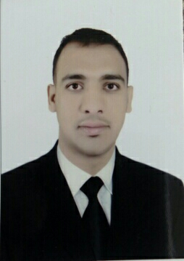
Mohamed Ebeid Mohamed Youssef
Email: Mohamed01110429084@gmail.com
Address:Egypt. Qena
Phone: +201110429084
_____________________________
Objective:
.Seeking a position where I can maximize my teaching experience.
.Need to work in new area that development my skills and learning new things.
_____________________________
Experience
Physical education Teacher. .Teaching physical education and sports
with experience in special needs. .Helping in school works
in Egyptian Ministry of education. .development students and teachers in fitness and sports
From June 2013 to currently.
Receptionist in Bright sky travel .helping guests
Hurghada. Egypt .Telephone operator
.From September 2012 to June 2013 .problem solving
Recreation in sun rise hotels and resorts
From July 2010to June 2011 .Working in sports activity
________________________________
Education
B.C.physical education South valley university
Egypt. Qena .training and teaching physical education
June 2010
________________________________
Skills
Microsoft office,teaching for special needs,good to do camps and scouts,society working,time management,love working in education,good communication skills,team leader,problem solving.
______________________________
Language
English Arabic French
Advanced Mother tongue beginner
________________________________
Projects
Design an account in Facebook to my school which give us good contact with our students and parents as well helping us to go away in learning process.
_________________________________
Achievement
.Teaching and training physical education in my school that resulted in development
Fitness and sports activity for students and teachers
.Holds school championships
__________________________________
Certification &courses
.Teaching method for special needs in August 2017
.Microsoft certificate educator in December 2017
.Camps and scouts in March 2018
.ICDL in July 2014
.INTEL in August 2015
.First Aid in April 2009
.Leadership training in April 2018
.Certified teaching with technology by Microsoft in December 2017
_____________________________________
Honor and awards
.Teacher of year from my school
.Good player in hand ball team
.Thanks from UNESCO to my research about open education and lifelong learning.
______________________________________
Publication
Research in lifelong learning and open education and their relationship to sustainable development.
______________________________________
Reference:
Mr Ashraf rashwan school manger in qena education management.
Address:Qena. Egypt
Contact: email/ rashwan_elkady@yahoo.com
Phone:+201067671126

