Name: Nourhan Ashraf Kotb 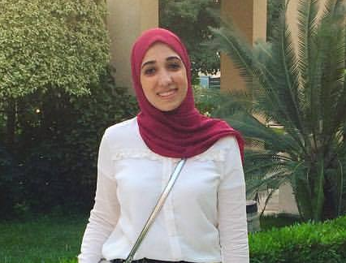
Address: 8 Gardenia building, ElHaram
Mobile phone: 01154594342
E-mail: nourhan.ashrafk@gmail.com
Date of birth: 11/5/1993
Gender: Female

Education:
Bachelor's Degree from Department of Spanish, Faculty of Arts, Cairo University. | 2015
General Secondary Certificate from El-Horreya language School. | 2011

Languages:

Mother tongue | Arabic
Fluent  Very good | English  Spanish
Good | French

Cairo British College  Co-teacher for Year One.  Cairo British College  Co-teacher for year One.  Winners Language School  Class Teacher for KG 2. | Experience:  2016-present  2015-2016  2014-2015

Courses Attended:

2016 | Educational and Psychological Qualification Course for Teachers.
2015  2015  2015 | TEFL Course.  Workshop on “The 7Habits of Highly Effective People” Leader in Me.  Smart Board “SMART Notebook11”
References:
Available whenever required.

 | .

