Few-Shot Gaussian Splatting with Diffusion-Based Augmentation
Mohamed Eyad · Università degli Studi di Genova
When do diffusion-generated views help few-shot Gaussian Splatting?
Mohamed Eyad · Robotics Engineering, Università degli Studi di Genova · 236 controlled training runs, two scenes, single 4 GB GPU
1Setup
Scene truck (Tanks & Temples, 251 images) with COLMAP poses. Every eighth image by sorted filename is held out for test and frozen across all conditions; few-shot subsets are drawn from the remaining pool by farthest-point sampling over camera centres, so the K views are well spread. The seed selects only the starting camera — three seeds share no images at k = 5, and which five you draw is worth up to 0.65 dB, so every result below is a paired difference against the same seed's own baseline. Training is 7,000 iterations at half resolution; PSNR, SSIM and LPIPS are computed on the held-out views. Repeating one configuration three times gives a noise floor of σ = 0.039 dB.
Three augmentation strategies
- Inpainting — mask a region of a real view and regenerate it. The camera pose is copied exactly, so no new viewpoint is created.
- Outpainting — widen the frustum and fabricate the border. Same camera centre, larger field of view: genuinely new peripheral content.
- Pose-guided — estimate depth, warp the image to an interpolated camera, and fill the disocclusion holes with diffusion. A fully novel viewpoint.
2What real photographs are worth
Real views | PSNR | SSIM | LPIPS | Per added view
5 | 15.20 | 0.538 | 0.410 | —
10 | 17.11 | 0.658 | 0.302 | +0.382
20 | 19.74 | 0.784 | 0.203 | +0.263
219 (all) | 25.23 | 0.907 | 0.123 | +0.028
Table 1. Few-shot floors and the full-data ceiling, three seeds each. The per-view column is what one additional real photograph buys at that point.
The full-data run reaches 25.23 dB against ≈25.4 dB published for this scene at the full 30,000-iteration schedule, which validates the pipeline. The value of a real view falls by an order of magnitude across the range — +0.382 dB each between 5 and 10, +0.028 dB each beyond 20. This decay matters later: it is the term that makes synthetic coverage worth less as data accumulates.
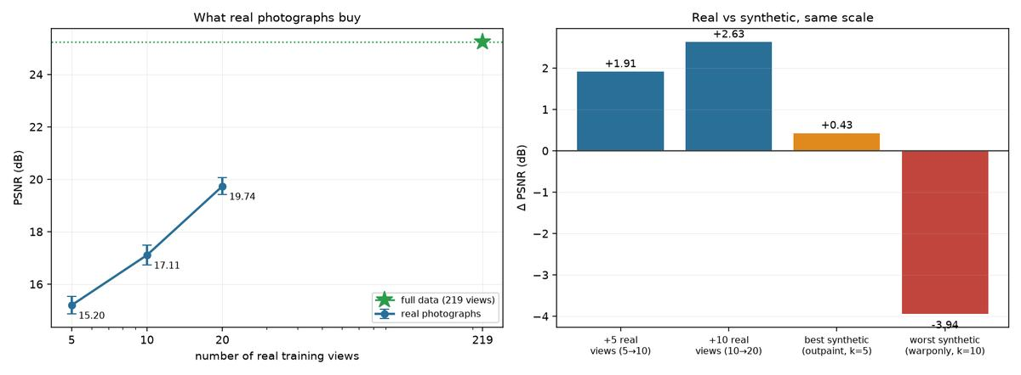
Left: PSNR against number of real views, with the full-data ceiling. Right: the best and worst synthetic effects drawn on the same axis as the value of real photographs.
3The crossover
Synthetic : real | k = 5 | k = 10 | k = 20
20% | +0.140 ± 0.089 * | +0.172 ± 0.121 * | -0.283 ± 0.071 *
50% | +0.140 ± 0.135 * | +0.013 ± 0.118 | -0.542 ± 0.026 *
100% | +0.182 ± 0.119 * | -0.423 ± 0.248 * | -0.983 ± 0.228 *
200% | +0.285 ± 0.069 * | -0.003 ± 0.064 | -0.618 ± 0.195 *
Table 2. Outpainting, ΔPSNR against the same seed's baseline, three seeds. * marks cells whose mean exceeds the between-seed standard deviation.
The other two strategies bracket the explanation. Inpainting, which copies the camera pose exactly, is flat everywhere — between -0.213 and +0.029 dB — despite producing convincing images. Pose-guided, which invents a fully novel viewpoint, is harmful at every subset size and gets worse as k grows, reaching -1.884 dB. Ordering the three strategies by how much new camera pose they invent orders them exactly by how much damage they do.
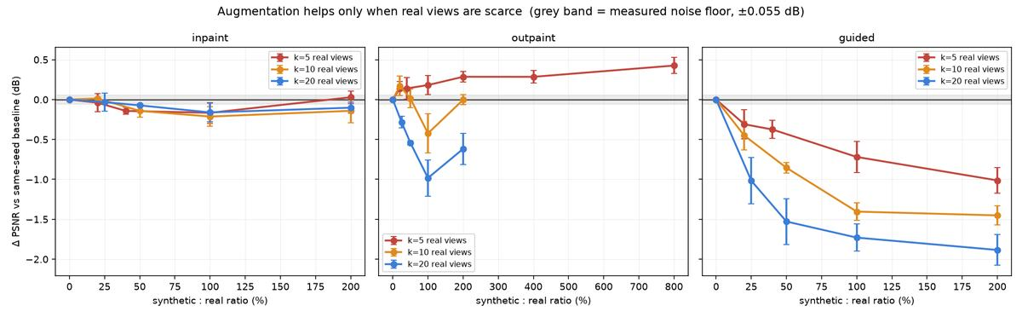
Paired ΔPSNR against each seed's own baseline. Grey band is the measured noise floor (±0.055 dB). Outpainting crosses from positive to negative as real views accumulate; inpainting is flat; pose-guided is harmful everywhere and worsens with k.
Why the sign flips
A synthetic view supplies coverage and inconsistency in fixed proportion. Coverage loses value as real views accumulate — that is the per-view column of Table 1, falling tenfold. Inconsistency does not: a contradictory view is just as harmful at twenty views as at five, and arguably worse, because it now contradicts a better-determined geometry. Two terms, one decaying and one roughly constant, are sufficient to produce a sign change.
4Four controls
Control | Question | Result
Warp-only | Is the diffusion step the cause of pose-guided damage? Identical poses and hole masks, diffusion skipped, holes left black. | Removing diffusion costs a further 2.49 dB (-3.94 vs baseline)
Duplication | Is outpainting's gain just seeing real views more often? Real images repeated to the same count, no fabricated content. | Not significant — 80–85% of the gain is the fabricated border
Checkpoint swap | Does the result belong to one diffusion model? Dreamshaper-8 in place of SD 1.5. | Holds: +0.193 dB vs +0.285 at the same ratio
Checkpoint swap, across k | Does the sign change belong to one model, or only the gain? | Reverses too: +0.193 at k=5 → -0.825 at k=20
Noise floor | How large must an effect be to be real? One configuration repeated three times. | σ = 0.039 dB (±0.055 paired)
Table 3. Each control isolates one candidate explanation. All are paired within seed on truck.
The warp-only control is the decisive one. Removing the diffusion step made pose-guided far worse, so diffusion was contributing up to 2.49 dB of repair — it is the stage holding the result up, not the stage breaking it. The damage is therefore not hallucinated content or warping artifacts but pose novelty itself. Together with the checkpoint swap (better photorealism, marginally worse result) and inpainting's flatness, three independent lines agree: what a synthetic view contributes is coverage, not photorealism.
The checkpoint swap was extended across every subset size, because a swap tested only where augmentation helps cannot tell whether the crossover belongs to Stable Diffusion 1.5. It does not: Dreamshaper-8 runs +0.193 dB at k = 5 and -0.825 at k = 20, the same reversal. Its curve also sits below SD 1.5 at every size, so it crosses earlier — at k = 10, where SD 1.5 is indistinguishable from zero (-0.003), the better-looking model is already separated and negative (-0.163). A checkpoint finetuned to make each image individually more convincing has no reason to be more consistent between images.
5Does it generalise?
Ratio | truck k=5 | drjohnson k=5 | truck k=20 | drjohnson k=20
20% | +0.140 * | +0.239 * | -0.283 * | -0.310 *
50% | +0.140 * | +0.134 * | -0.542 * | -0.147 *
100% | +0.182 * | +0.829 * | -0.983 * | -0.242
200% | +0.285 * | +0.989 * | -0.618 * | +0.195
Table 4. Outpainting on both scenes, each paired against its own same-seed baseline. drjohnson (Deep Blending, indoor, 230 views) trains at quarter resolution, so absolute PSNR is not comparable between scenes — the deltas are.
The sign flip reproduces on an indoor room. At k = 5 every ratio is positive in both scenes; at k = 20 every statistically separated point is negative in both. Indoors the effect is stronger — +0.989 dB against truck's +0.285 — and all three metrics move together, where on truck outpainting bought PSNR while SSIM stayed flat. drjohnson's baselines scatter 1.68 dB between seeds against truck's 0.33, so an unpaired comparison could not have resolved a 0.2 dB effect at all.
6Testing the mechanism
The account in §3 predicts something that can fail. If the harm comes from inconsistency rather than augmentation as such, an intervention supplying geometric constraint without inventing a viewpoint should never cross over. Monocular depth regularisation is that intervention: a depth network predicts an inverse-depth map per real training photo, anchored to scene scale against the sparse COLMAP points that view observes (median R² 0.964). No camera is invented, no pixel fabricated. Synthetic views receive no depth supervision — estimating depth from a fabricated image to constrain geometry would be circular.
 | k = 5 | k = 10 | k = 20
+ depth prior | +0.259 ± 0.111 * | +0.163 ± 0.073 * | +0.155 ± 0.039 *
+ outpainting (200%) | +0.285 ± 0.069 * | -0.003 ± 0.064 | -0.618 ± 0.195 *
+ both | +0.714 ± 0.202 * | +0.294 ± 0.045 * | -0.355 ± 0.198 *
interaction | +0.169 ± 0.094 * | +0.134 ± 0.136 | +0.108 ± 0.031 *
Table 5. A 3×2×2 factorial: subset size × outpainting × depth prior, three seeds, paired within seed. The last row is the interaction — how far + both exceeds the sum of the two applied separately.
The shape agrees as well: the prior's benefit decays with subset size (+0.259 → +0.155 dB), exactly as diminishing returns on constraint predict. It simply never turns negative, because there is no contradiction term to overtake it — the two-term account of §3 reduced to its first term and observed alone. The two also compound: at k = 5 the combination reaches +0.714 dB, the largest gain in this study, with a positive interaction at all three sizes. They repair different deficiencies — outpainting supplies peripheral content, the prior supplies constraint — which agrees with the duplication control.
7Conclusions
- Diffusion augmentation is not free coverage. It helps only while real views are scarce, and the crossover reproduces across an outdoor object and an indoor room.
- The mechanism is pose novelty. Four controls exclude image quality, hallucinated hole content, warping artifacts, and mere view repetition.
- Constraint beats coverage where data is plentiful. A depth prior never crosses over, costs +6.6% Gaussians against outpainting's +103%, and needs no diffusion model.
- Practical recipe: at 5–10 real views use both (+0.714 and +0.294 dB); at 20, use the depth prior alone, since adding synthetic views costs about half a decibel.
- Scale honestly: the best synthetic condition anywhere is worth 6.7× less than simply taking five more photographs.
Limitations
The 7,000-iteration operating point is load-bearing. Re-running the two headline cells at 30,000 shows the benefit does not survive: outpainting at k = 5 falls from +0.285 to -0.078 dB, while the harm at k = 20 persists (-0.618 to -0.743). The unaugmented baselines fall too (15.20 → 15.04 at k = 5), so 30,000 is past this regime's optimum rather than better converged — few-shot 3DGS overfits long before it. Early stopping is the correct setting here, but the positive result is conditional on it.
Three seeds supports a consistency check (|mean| > σ), not a formal significance test. The crossover is bracketed between k = 5 and k = 20, not located. The depth loss weight is upstream's default, untuned for few-shot, so its gain is likely a floor. Depth and the second scene were each swept partially — one scene and one ratio respectively. Both checkpoints tested are SD 1.5-class, the only ones fitting 4 GB; multi-view-consistent generators (Zero123++, SV3D) are the natural next step and are arguably what pose-guided augmentation is really reaching for.
All 236 runs, raw metrics, patches and code: github.com/mohamedeyaad/fewshot-gaussian-splatting · every number above is read programmatically from runs/*/results.json · full write-up in results/report.html

