Diffusion Augmentation for Few-Shot Splatting — full report
Mohamed Eyad · Università degli Studi di Genova
Few-shot 3D reconstruction · experimental report
Diffusion Augmentation Helps Few-Shot Gaussian Splatting Only When Data Is Scarcest
166 controlled training runs on the truck scene show that the value of a synthetic view depends on how many real views you already have. At five real images outpainting helps at every ratio; by twenty it hurts at every ratio. The crossover is measurable, it reproduces on a second scene indoors (34 further runs), and the best synthetic condition anywhere is still worth 6.7× less than five more photographs.
Floor, 5 views
15.20
PSNR
Floor, 10 views
17.11
PSNR
Floor, 20 views
19.74
PSNR
Full-data ceiling
25.23
PSNR, 219 views
Best augmentation
+0.285
outpainting, k=5, 200%
Worst augmentation
-1.884
pose-guided, k=20, 200%
01 Gaussian Splatting when photographs are scarce
3D Gaussian Splatting represents a scene as millions of anisotropic translucent blobs. Training projects them into each known camera and adjusts every blob's position, covariance, colour and opacity until the renders match the photographs.
With a few hundred views the problem is well constrained: every surface is observed from many directions, and a blob that is wrongly placed will contradict some view. With ten views it is badly under-constrained. The optimiser can reproduce those ten images almost exactly — our few-shot runs reach a training loss of 0.007 — while the underlying geometry is arbitrary. Render from an unseen camera and the scene collapses into smears and semi-transparent floaters.
The scale of the problem is easy to state. Training on 219 real views reaches 25.23 dB on the held-out set. Training on 10 reaches 17.11 dB. Few-shot costs 8.12 dB, and that gap is what augmentation would have to close.
Because the whole sweep was run at three subset sizes, the price of scarcity can be measured directly rather than assumed:
Real views | PSNR | SSIM | LPIPS | Δ PSNR | per view
5 | 15.20 ± 0.33 | 0.5375 | 0.4096 | — | —
10 | 17.11 ± 0.39 | 0.6584 | 0.3017 | +1.91 | +0.382
20 | 19.74 ± 0.33 | 0.7842 | 0.2027 | +2.63 | +0.263
219 | 25.23 | 0.9070 | 0.1227 | +5.50 | +0.028
Table 1. Held-out quality against the number of real training views. Three seeds per row except the full-data ceiling, which is a single deterministic split.
The per-view column falls from +0.382 dB to +0.263 dB and then to roughly +0.03 dB — the diminishing return you would expect, and a check that the pipeline behaves sensibly. It also sets the exchange rate against which every synthetic image in this study should be judged: five real photographs are worth +1.91 dB.
The full-data baseline reaches 25.23 dB at 7,000 iterations against roughly 25.4 dB reported in the literature for this scene at 30,000. The pipeline reproduces published behaviour, so the few-shot deficit is a property of the setting rather than a defect in the implementation.
02 Three augmentation strategies, and the pose problem
A diffusion model returns pixels. Gaussian Splatting cannot use pixels without a camera pose. Every strategy is therefore defined by how it obtains one, and that choice determines both how much new information it contributes and how much error it risks.
Inpainting
A region of a real view is masked and regenerated; everything outside the mask is copied from the original bit for bit. The pose is inherited exactly, so pose error is zero. The cost is that the viewpoint is unchanged — it contributes no new geometric evidence.
Outpainting
The frame is extended by 25% and the border is generated. The camera does not move, so the pose is again exact, but the intrinsics change: the focal length in pixels is unchanged (the lens is the same; more of the image plane is captured) while the principal point shifts by the paste offset. The horizontal field of view widens from 80.1° to 92.9°. Treating the focal length as if it scaled with the frame is the standard silent failure here, so both properties are asserted at generation time.
Pose-guided synthesis
The only strategy that supplies a genuinely new viewpoint. A monocular depth map is predicted for a real view, then anchored to true scene scale by least-squares fitting against the sparse COLMAP points that view observed — without this the depth is relative and the warp is meaningless. Pixels are back-projected and re-projected into a camera interpolated between two real views, leaving holes where hidden surfaces are revealed; diffusion fills only those holes. Mean alignment R² was 0.988 across the ten source views, and roughly 10% of each output is invented.
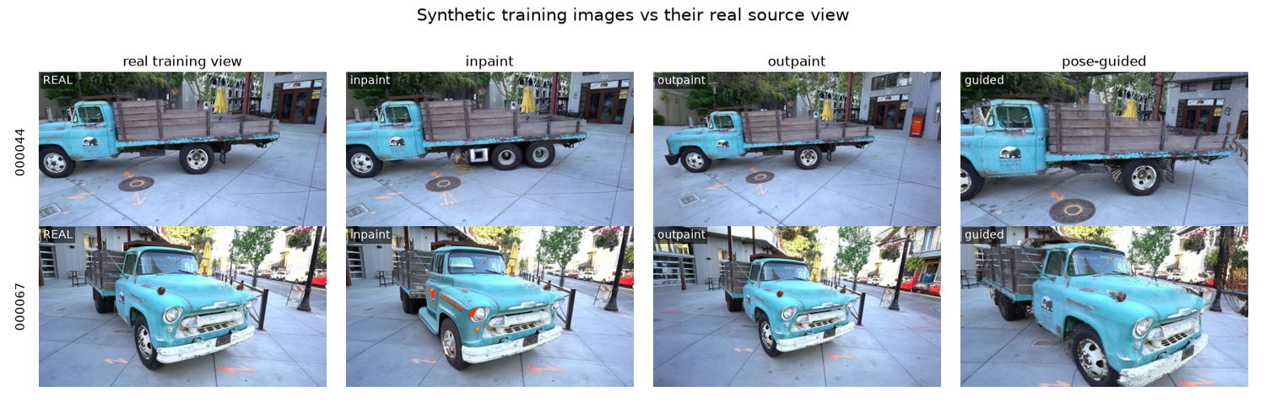
Figure 1 — Synthetic training images beside the real view they derive from. Inpainting has given the truck a second rear axle and an invented white box; outpainting fabricates the scene beyond the original frame; pose-guided renders a genuinely different viewpoint, with roughly 10% of its pixels invented.
03 Experimental design
A frozen held-out set
Every eighth image by sorted filename is reserved as the test set — 32 views — leaving a pool of 219. That split is identical in every condition, and ground truth is always a real photograph. The upstream code ties train and test together through its hold-out rule, so a small patch was added to honour an explicit split file, allowing an arbitrary K-image training subset while the test set stays byte-identical.
Subset selection and pairing
The ten real views are chosen by farthest-point sampling over camera positions, which guarantees angular coverage. Measured across three seeds, this reduces the worst coverage gap variation to 0.19 units against 2.04 for uniform random selection — roughly nine times less seed-to-seed variance, which matters because the effects being measured are small.
Each augmented run is compared against the same seed's own zero-synthetic baseline, on identical real images. The only variable that moves is the number of synthetic views, and synthetic sets are strictly nested: the two images used at 20% are the first two of the five used at 50%, and so on.
The noise floor
Gaussian Splatting is not bit-reproducible. Python-level seeds are pinned by the upstream code, but the rasterizer's backward pass uses CUDA atomics whose completion order varies, and densification amplifies the difference. Three repeats of an identical configuration give:
Quantity | PSNR | SSIM | LPIPS
Standard deviation | 0.039 | 0.0002 | 0.0007
Table 1. Run-to-run variation under an identical configuration (3 repeats). Any effect smaller than roughly √2 × these values is indistinguishable from noise.
A paired delta subtracts two independently noisy runs, so its noise floor is approximately 0.039 × √2 ≈ 0.055 dB. Effects are only claimed where they clear it.
04 Results
Every condition was run at three seeds and 7,000 iterations at half resolution. Deltas are against each seed's own baseline at the same subset size; an asterisk marks deltas whose magnitude exceeds their own standard deviation.
Reading the matrix below across a row is the finding: the same synthetic ratio changes sign depending on how many real views it is added to.
Ratio | k = 5 | k = 10 | k = 20
Inpainting
20% | -0.039 ± 0.113 | +0.014 ± 0.017 | -0.032 ± 0.113
50% | -0.142 ± 0.045 * | -0.142 ± 0.078 * | -0.073 ± 0.024 *
100% | -0.166 ± 0.130 * | -0.213 ± 0.121 * | -0.161 ± 0.118 *
200% | +0.029 ± 0.078 | -0.141 ± 0.152 | -0.102 ± 0.072 *
Outpainting
20% | +0.140 ± 0.089 * | +0.172 ± 0.121 * | -0.283 ± 0.071 *
50% | +0.140 ± 0.135 * | +0.013 ± 0.118 | -0.542 ± 0.026 *
100% | +0.182 ± 0.119 * | -0.423 ± 0.248 * | -0.983 ± 0.228 *
200% | +0.285 ± 0.069 * | -0.003 ± 0.064 | -0.618 ± 0.195 *
Pose-guided
20% | -0.309 ± 0.183 * | -0.451 ± 0.182 * | -1.017 ± 0.292 *
50% | -0.375 ± 0.114 * | -0.855 ± 0.068 * | -1.528 ± 0.286 *
100% | -0.719 ± 0.196 * | -1.404 ± 0.111 * | -1.729 ± 0.170 *
200% | -1.013 ± 0.160 * | -1.451 ± 0.121 * | -1.884 ± 0.193 *
Table 2. Change in PSNR against the same-seed zero-synthetic baseline, by synthetic ratio (down) and number of real views (across). Green is an improvement, red a degradation.
Outpainting is positive at every ratio at five views, mixed at ten, and negative at every ratio at twenty. Pose-guided is negative everywhere and grows steadily worse as real views accumulate. Inpainting barely moves at any subset size.
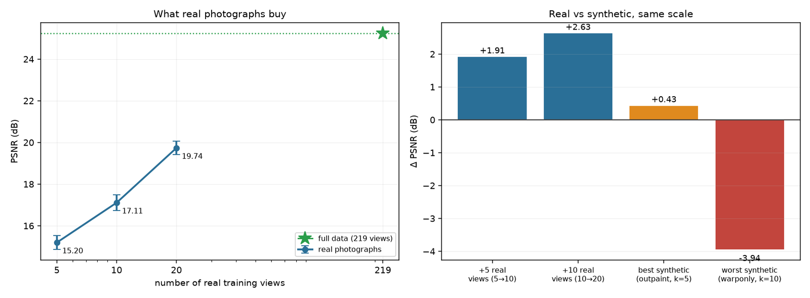
Figure 2 — Left: held-out quality against the number of real training views, with the full-data ceiling marked. Right: the same quantities on one axis. Adding five real photographs is worth several times the best synthetic condition measured anywhere in this study, and the worst synthetic condition costs more than the best one gains.
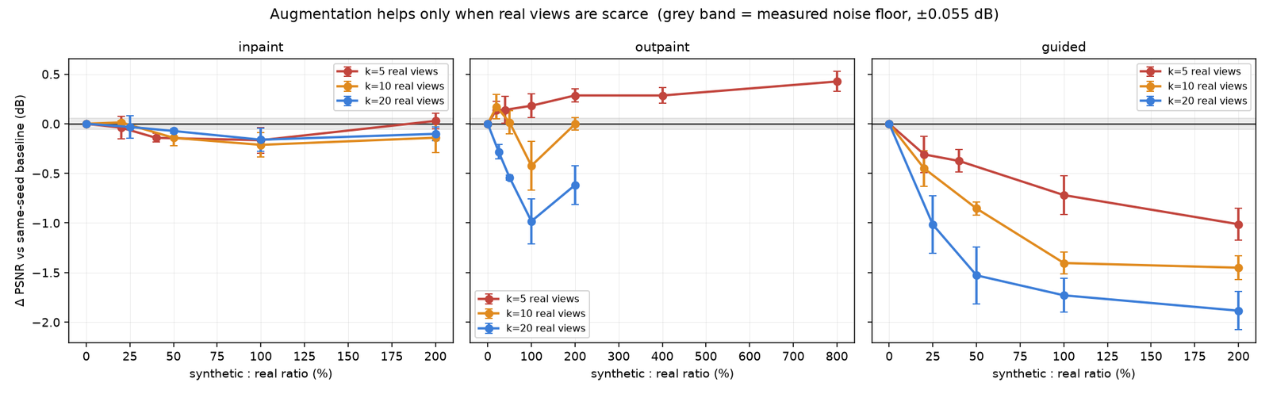
Figure 3 — Change in PSNR against the same seed's own zero-synthetic baseline, one line per subset size. Error bars are the standard deviation across three seeds; the grey band is the measured noise floor. Inpainting is flat and independent of subset size; outpainting crosses from beneficial at five views to harmful at twenty; pose-guided is harmful everywhere and worsens as real views accumulate.
Three behaviours, one explanatory axis
The three strategies do not merely differ in magnitude; they respond to subset size in three qualitatively different ways. Order them by how much camera pose each one invents and the pattern resolves.
Inpainting copies the pose exactly. It contributes no new viewpoint, therefore no new geometric information and no new opportunity for views to disagree. Its effect is small, slightly negative, and — uniquely — independent of subset size. There is nothing for the subset size to interact with.
Outpainting keeps the camera centre but widens the frustum. It contributes real peripheral coverage together with fabricated content. At five views the coverage dominates and every ratio helps; by twenty views enough real signal is present that the fabrication dominates instead, and every ratio hurts. This is the crossover.
Pose-guided synthesis invents a genuinely new viewpoint. It offers the most potential information and the most opportunity for contradiction, and the contradiction wins at every subset size tested. Worse, the damage grows with real views: −0.31 dB at five, −0.45 at ten, −1.02 at twenty for the smallest ratio. The better the reconstruction it is inserted into, the more there is to corrupt.
A control: is the diffusion step responsible?
Pose-guided synthesis changes two things at once relative to a real training view — the camera pose, and the roughly 10% of pixels diffusion invents to cover disocclusions. Its damage could belong to either. A control separates them: warp to exactly the same poses, then leave the holes black and never load Stable Diffusion at all.
The poses are bit-identical between the two conditions (maximum quaternion and translation difference 0.00e+00, identical hole fractions), because the random stream is advanced identically whether or not diffusion runs. The only variable is the hole content.
Ratio | Pose-guidedwarp + SD | Warp-onlyholes black | Diffusioncontribution
20% | -0.451 ± 0.182 * | -1.278 ± 0.138 * | +0.827
50% | -0.855 ± 0.068 * | -2.191 ± 0.235 * | +1.336
100% | -1.404 ± 0.111 * | -3.441 ± 0.276 * | +2.037
200% | -1.451 ± 0.121 * | -3.939 ± 0.496 * | +2.488
Table 3. Warp-only control at k = 10, three seeds. The final column is (with diffusion) − (without), which is the diffusion step's isolated contribution.
The result reverses the obvious hypothesis. Removing diffusion makes the condition dramatically worse — -3.94 dB at the 200% ratio against −1.45 with it. The diffusion step is contributing up to +2.49 dB of repair, and SSIM and LPIPS agree at every ratio.
So the pose-guided damage cannot be attributed to hallucinated hole content or to residual warping artifacts: the stage responsible for both is the stage holding the result up. What remains is the pose novelty itself — views the optimiser trusts completely that disagree with the geometry the real photographs imply.
Black rectangles are themselves a severe artifact, so part of the +2.49 dB is simply diffusion beating a very low bar. The control does not establish that the diffusion output is good. It establishes that the diffusion step is net positive, which is sufficient to rule it out as the cause of the degradation — the question that was actually open. A second line of evidence agrees: sparser subsets need longer interpolation baselines and therefore larger holes, so an artifact explanation predicts more damage at k = 5. The measured damage is smallest at k = 5.
A second control: is the positive result model-specific?
Outpainting at five views is the only condition here that improves quality, which invites the objection that the effect belongs to Stable Diffusion 1.5 rather than to the strategy. Repeating that sweep with Dreamshaper-8 tests it. Dreamshaper-8 is an SD 1.5 finetune: same architecture, same 2.65 GB of VRAM, materially better photorealism — so it varies image quality while holding everything structural fixed. A larger model would confound quality with capacity, and does not fit in 4 GB regardless.
Ratio | SD 1.5 | Dreamshaper-8 | Difference
20% | +0.140 ± 0.089 * | +0.074 ± 0.075 | -0.066
40% | +0.140 ± 0.135 * | +0.075 ± 0.129 | -0.065
100% | +0.182 ± 0.119 * | +0.159 ± 0.064 * | -0.022
200% | +0.285 ± 0.069 * | +0.193 ± 0.069 * | -0.092
Table 4. Outpainting at k = 5 under two diffusion checkpoints, three seeds. The real image region is preserved byte-for-byte in both; only the fabricated periphery differs (mean |Δ| of 0.07 inside the frame versus 30.3 outside).
The effect is positive at every ratio under the second model, and the curve keeps the same rising shape. The benefit is a property of the augmentation, not of one checkpoint.
The magnitudes are slightly smaller throughout, which is the more informative detail. Dreamshaper-8 produces visibly better images and obtains a marginally worse result. If photorealism were the mechanism, the better model should have helped more. It did not — which agrees with the warp-only control, where diffusion's contribution was geometric repair rather than image quality, and with inpainting, which produces convincing images at a perfect pose and is nonetheless useless. Across three independent lines of evidence, what a synthetic view contributes is coverage, not photorealism.
All of that concerns k = 5, where outpainting helps — the half of the claim least in doubt. The finding of this study is the sign change, so the ablation is only worth its name if the second model reverses too.
real views | SD 1.5 | Dreamshaper-8
5 real views | +0.285 ± 0.069 * | +0.193 ± 0.069 *
10 real views | -0.003 ± 0.064 | -0.163 ± 0.141 *
20 real views | -0.618 ± 0.195 * | -0.825 ± 0.173 *
Table 4b. Both checkpoints at the 200% ratio across every subset size, each paired against the same seed's own baseline. The crossover is a property of augmentation only if the right-hand column changes sign as the left one does.
It does. Dreamshaper-8 runs +0.193 dB at k = 5 and -0.825 dB at k = 20 — the same reversal, on a different checkpoint. The crossover is not an artefact of Stable Diffusion 1.5.
Two details sharpen the mechanism further. The second model's curve sits below the first at every subset size, so its crossing point arrives earlier: at k = 10, where SD 1.5 is indistinguishable from zero (-0.003), Dreamshaper-8 is already separated and negative (-0.163). And Dreamshaper-8 is the more photorealistic model. A checkpoint finetuned to make each image individually more convincing has no reason to be more consistent between images, and plausibly less — it commits to invented detail with greater confidence. Better-looking training data, measurably worse reconstruction, at every subset size tested.
Does it generalise? A second scene
The checkpoint swap rules out one model. It does not rule out one scene. Every number above comes from truck: a single object, outdoors, photographed on a loop around it. The obvious failure mode for the whole study is that the crossover is a property of that capture geometry rather than of few-shot reconstruction.
34 further runs repeat the outpainting sweep on drjohnson from the Deep Blending dataset — an indoor room, 230 views, a fundamentally different capture regime — at k = 5 and k = 20, the two ends of the crossover.
Ratio | truck k=5 | drjohnson k=5 | truck k=20 | drjohnson k=20
20% | +0.140 ± 0.089 * | +0.239 ± 0.157 * | -0.283 ± 0.071 * | -0.310 ± 0.197 *
50% | +0.140 ± 0.135 * | +0.134 ± 0.102 * | -0.542 ± 0.026 * | -0.147 ± 0.123 *
100% | +0.182 ± 0.119 * | +0.829 ± 0.428 * | -0.983 ± 0.228 * | -0.242 ± 0.378
200% | +0.285 ± 0.069 * | +0.989 ± 0.521 * | -0.618 ± 0.195 * | +0.195 ± 0.410
Table 5. Outpainting on both scenes, paired against each scene's own same-seed baseline, three seeds. Absolute PSNR is not comparable across the two (drjohnson trains at quarter resolution); the deltas are.
The sign flip reproduces. At k = 5 every ratio is positive in both scenes; at k = 20 every statistically separated point is negative in both. An outdoor object and an indoor room agree that synthetic views are worth having at five real photographs and worth avoiding at twenty.
Indoors the effect is not merely present but stronger, and on better evidence. The k = 5 benefit reaches +0.989 dB against truck's +0.285, and all three metrics move together: where truck bought PSNR while SSIM stayed flat, drjohnson improves SSIM by +0.0493 and LPIPS by -0.0106 at the same point. Agreement across three metrics with different failure modes is considerably harder to obtain by chance than agreement in one.
One cell dissents: k = 20 at the 200% ratio is positive in PSNR, though not separated from zero. LPIPS is worse there — as it is at every k = 20 ratio — so the honest reading is a metric disagreement at a point where the effect is small, not a counterexample.
A methodological note falls out of this scene for free. Its baselines scatter 1.68 dB between seeds against truck's 0.33, because which five views one happens to draw matters far more in a room than on a loop around an object. An unpaired comparison at that noise level could not resolve a 0.2 dB effect at all. Pairing every augmented run against its own seed's baseline holds the paired deviations to 0.10–0.52 dB and keeps the effect measurable — the design choice earning its keep on a scene it was not designed for.
Why the sign flips
A synthetic view supplies coverage and inconsistency in fixed proportion. Coverage has diminishing value as real views accumulate — the per-view column in Table 1 falls by an order of magnitude between the first step and the last. Inconsistency does not diminish; a contradictory view is just as harmful at twenty views as at five, and arguably more so because it now contradicts a better-determined geometry. Two terms, one decaying and one roughly constant, are sufficient to produce a sign change, and that is what the data show.
Testing the mechanism: constraint without a viewpoint
The account above is an explanation, and explanations are cheap. What makes it worth more is that it predicts something which could fail: if the harm comes from inconsistency rather than from augmentation as such, an intervention supplying geometric constraint without inventing a viewpoint should never cross over, because it has no contradictory geometry to accumulate.
Monocular depth regularisation is that intervention. A depth network predicts an inverse-depth map for each real training photograph; each map is anchored to true scene scale by a least-squares fit against the sparse COLMAP points that view observes (median R² 0.964), and training then minimises image error and depth disagreement together. No camera is invented and no pixel is fabricated. Synthetic views receive no depth supervision at all — estimating depth from a fabricated image and then using it to constrain geometry would be circular — so the prior acts on real photographs only.
 | k = 5 | k = 10 | k = 20
+ depth prior | +0.259 ± 0.111 * | +0.163 ± 0.073 * | +0.155 ± 0.039 *
+ outpainting (200%) | +0.285 ± 0.069 * | -0.003 ± 0.064 | -0.618 ± 0.195 *
+ both | +0.714 ± 0.202 * | +0.294 ± 0.045 * | -0.355 ± 0.198 *
interaction | +0.169 ± 0.094 * | +0.134 ± 0.136 | +0.108 ± 0.031 *
Table 6. Depth regularisation crossed with outpainting at every subset size — a 3×2×2 factorial, three seeds, every cell paired against the same seed's own unaugmented baseline. The final row is the interaction: how far + both exceeds the sum of the two interventions applied separately.
The prediction holds. The depth prior is positive and separated from zero at every subset size, including k = 20, where outpainting costs -0.618 dB. Coverage crosses over; constraint does not. The two interventions differ in exactly one respect — whether a camera that never existed is invented — and only the one that invents a camera reverses sign.
The shape agrees too. The prior's benefit decays with subset size (+0.259 at k = 5 down to +0.155 at k = 20), which is what diminishing returns on constraint predict: the more real views pin the geometry, the less an approximate prior can add. It simply never turns negative, because there is no contradiction term to overtake it. That is the two-term account of the previous section reduced to its first term and observed in isolation.
The two also compound rather than overlap. At k = 5 the combination reaches +0.714 dB — the largest improvement anywhere in this study — with a positive interaction at all three subset sizes. They repair different deficiencies: outpainting supplies peripheral content that no real view recorded, the prior supplies constraint on geometry already observed, and neither substitutes for the other. This agrees with the duplication control, which found 80–85% of outpainting's benefit comes from the fabricated borders rather than from repeated views.
The practical consequence is a recommendation the earlier sections could not support: at five or ten real views use both; at twenty use the prior alone, since adding synthetic views costs roughly half a decibel. At k = 10 outpainting by itself is inert, yet combined with the prior it beats the prior alone — a depth constraint makes otherwise worthless synthetic views worth having.
Gaussian count as a mechanism
Model complexity grows sharply under both geometric strategies. Against a baseline of 493,990 Gaussians, inpainting barely moves the count — +3–5%, since it adds no new scene area — while outpainting and pose-guided both inflate it by roughly 60% at the 200% ratio.
The count alone, however, does not predict the damage, and that is the more interesting result. Outpainting reaches the higher of the two counts (+62% versus +58% at the 200% ratio, and higher at every matched ratio) while costing essentially nothing in PSNR. Its extra primitives are earned: the widened frustum exposes real peripheral scene content that genuinely requires more Gaussians to represent. Pose-guided spends a comparable budget reconciling views that disagree with one another, and multi-view inconsistency forces the optimiser to spawn semi-transparent Gaussians satisfying each contradictory view separately — which is precisely what a floater is.
The discriminator is therefore not how many primitives get added, but whether they explain real geometry or contradictory geometry. Densification statistics on their own cannot distinguish the two cases, which is worth knowing for anyone hoping to use Gaussian count as a cheap proxy for reconstruction health.
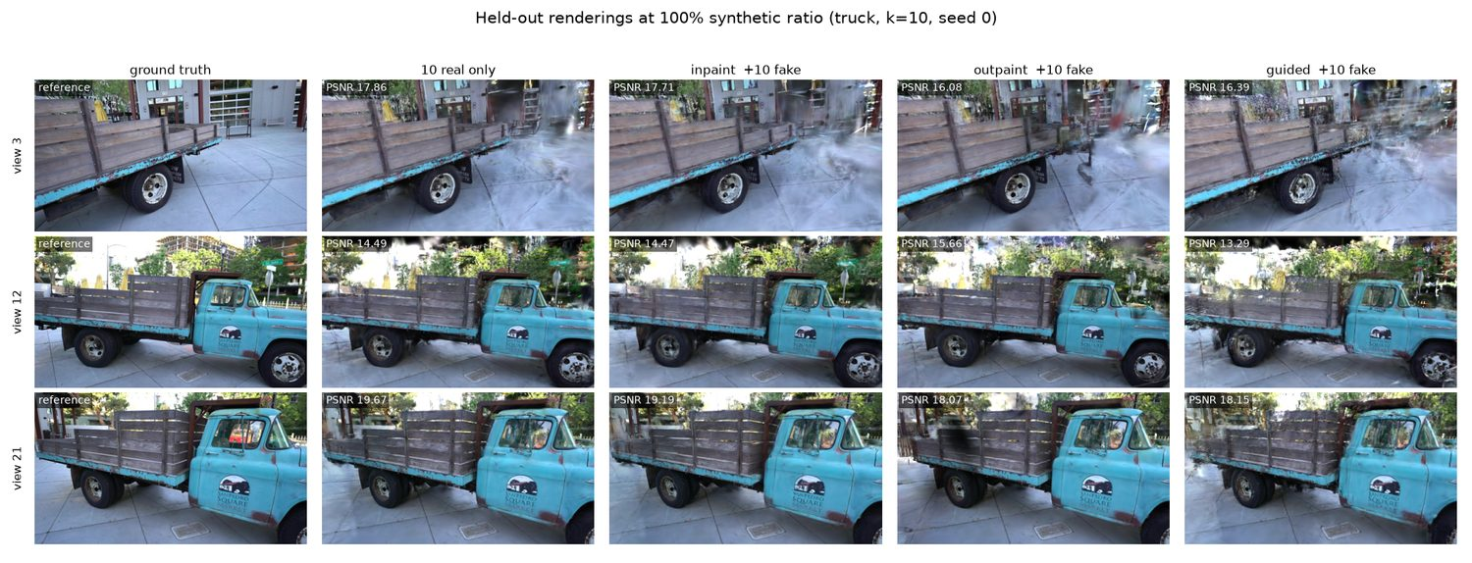
Figure 3 — Held-out renderings at the 100% synthetic ratio. Degradation appears as smearing and semi-transparent floaters, most severely under pose-guided synthesis.
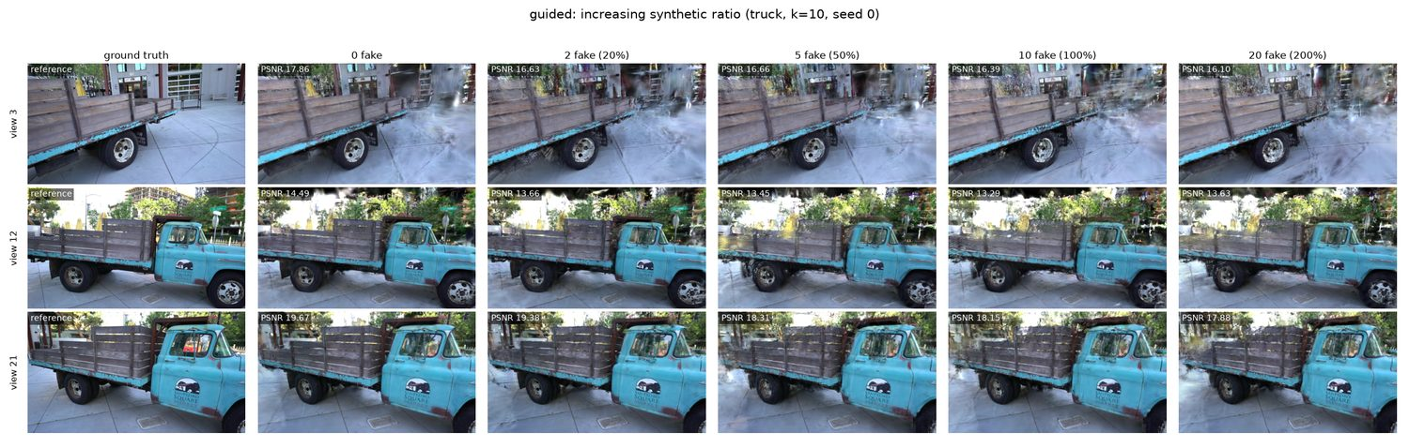
Figure 4 — Pose-guided synthesis as the synthetic ratio increases. Unlike the other two strategies this degrades monotonically; there is no recovery at 200%.
05 When is diffusion augmentation worth it?
There is a defensible answer, and it is narrower than the question usually assumes: only below roughly ten real views, only with outpainting, and only for a small fraction of the gap. The best condition measured anywhere in this study is +0.285 dB (outpainting, k=5, 200%) against a 10.04 dB deficit at that subset size — under 3% of what is missing.
Set against the alternative, that number is easy to interpret. Going from five to ten real photographs is worth +1.91 dB. The best synthetic condition is therefore roughly 6.7× less valuable than simply taking five more pictures, and the worst condition (pose-guided, k=20, 200%, -1.884 dB) costs several times more than the best one gains. If real capture is possible at all, it dominates.
The useful result is the shape of the trade-off. Augmentation contributes value only when it adds information the training set lacks, and it does harm in proportion to how much it fabricates — but the balance between those two terms is not fixed. It is governed by how much real data is already present, which is why the same method can be beneficial and harmful in the same study.
Stable Diffusion generates each image independently, with no knowledge of the others. It is a 2D prior being asked to supply 3D evidence. Better image quality does not address this; the fix would be a pose-conditioned multi-view model that is consistent across views by construction. Such models exist — Zero123++, ImageDream, SV3D — but they are trained on isolated objects against clean backgrounds and do not transfer to an outdoor street scene, and their weights exceed 4 GB of VRAM.
The practical guidance follows directly: use augmentation only when real views are in the single digits, prefer the strategy that widens the frustum without moving the camera, and treat any method that invents a viewpoint as a liability until multi-view consistency can be guaranteed. Above roughly ten real views, spend the effort on photographs instead.
06 Full results
k | Ratio | Fakes | Δ PSNR | Δ SSIM | Δ LPIPS | Gaussians | Seeds
Inpainting
5 | 20% | 1 | -0.039 ± 0.113 | -0.0013 ± 0.0010 * | +0.0015 ± 0.0021 | 407,708 | 3
5 | 40% | 2 | -0.142 ± 0.045 * | -0.0044 ± 0.0029 * | +0.0054 ± 0.0025 * | 407,287 | 3
5 | 100% | 5 | -0.166 ± 0.130 * | -0.0108 ± 0.0014 * | +0.0127 ± 0.0020 * | 424,857 | 3
5 | 200% | 10 | +0.029 ± 0.078 | +0.0032 ± 0.0020 * | +0.0005 ± 0.0028 | 422,181 | 3
10 | 20% | 2 | +0.014 ± 0.017 | -0.0036 ± 0.0014 * | +0.0048 ± 0.0015 * | 511,400 | 3
10 | 50% | 5 | -0.142 ± 0.078 * | -0.0097 ± 0.0023 * | +0.0117 ± 0.0023 * | 514,777 | 3
10 | 100% | 10 | -0.213 ± 0.121 * | -0.0141 ± 0.0046 * | +0.0169 ± 0.0043 * | 518,331 | 3
10 | 200% | 20 | -0.141 ± 0.152 | -0.0109 ± 0.0027 * | +0.0146 ± 0.0033 * | 506,504 | 3
20 | 25% | 5 | -0.032 ± 0.113 | -0.0054 ± 0.0014 * | +0.0055 ± 0.0014 * | 659,699 | 3
20 | 50% | 10 | -0.073 ± 0.024 * | -0.0094 ± 0.0016 * | +0.0102 ± 0.0011 * | 643,371 | 3
20 | 100% | 20 | -0.161 ± 0.118 * | -0.0130 ± 0.0009 * | +0.0142 ± 0.0009 * | 654,977 | 3
20 | 200% | 40 | -0.102 ± 0.072 * | -0.0096 ± 0.0032 * | +0.0122 ± 0.0027 * | 665,248 | 3
Outpainting
5 | 20% | 1 | +0.140 ± 0.089 * | +0.0011 ± 0.0016 | -0.0030 ± 0.0012 * | 498,936 | 3
5 | 40% | 2 | +0.140 ± 0.135 * | -0.0039 ± 0.0051 | -0.0015 ± 0.0027 | 545,739 | 3
5 | 100% | 5 | +0.182 ± 0.119 * | -0.0079 ± 0.0021 * | -0.0026 ± 0.0020 * | 702,001 | 3
5 | 200% | 10 | +0.285 ± 0.069 * | -0.0054 ± 0.0034 * | -0.0015 ± 0.0029 | 775,275 | 3
10 | 20% | 2 | +0.172 ± 0.121 * | -0.0027 ± 0.0045 | +0.0011 ± 0.0025 | 590,337 | 3
10 | 50% | 5 | +0.013 ± 0.118 | -0.0137 ± 0.0021 * | +0.0092 ± 0.0040 * | 690,797 | 3
10 | 100% | 10 | -0.423 ± 0.248 * | -0.0295 ± 0.0046 * | +0.0201 ± 0.0040 * | 784,870 | 3
10 | 200% | 20 | -0.003 ± 0.064 | -0.0227 ± 0.0034 * | +0.0172 ± 0.0029 * | 799,500 | 3
20 | 25% | 5 | -0.283 ± 0.071 * | -0.0171 ± 0.0018 * | +0.0124 ± 0.0020 * | 755,582 | 3
20 | 50% | 10 | -0.542 ± 0.026 * | -0.0305 ± 0.0015 * | +0.0247 ± 0.0015 * | 851,226 | 3
20 | 100% | 20 | -0.983 ± 0.228 * | -0.0499 ± 0.0024 * | +0.0429 ± 0.0023 * | 919,535 | 3
20 | 200% | 40 | -0.618 ± 0.195 * | -0.0400 ± 0.0020 * | +0.0359 ± 0.0010 * | 880,910 | 3
Pose-guided
5 | 20% | 1 | -0.309 ± 0.183 * | -0.0298 ± 0.0155 * | +0.0218 ± 0.0116 * | 423,546 | 3
5 | 40% | 2 | -0.375 ± 0.114 * | -0.0394 ± 0.0121 * | +0.0294 ± 0.0069 * | 455,403 | 3
5 | 100% | 5 | -0.719 ± 0.196 * | -0.0843 ± 0.0126 * | +0.0595 ± 0.0104 * | 562,950 | 3
5 | 200% | 10 | -1.013 ± 0.160 * | -0.0990 ± 0.0095 * | +0.0712 ± 0.0090 * | 717,500 | 3
10 | 20% | 2 | -0.451 ± 0.182 * | -0.0369 ± 0.0109 * | +0.0334 ± 0.0109 * | 555,110 | 3
10 | 50% | 5 | -0.855 ± 0.068 * | -0.0769 ± 0.0051 * | +0.0653 ± 0.0050 * | 630,934 | 3
10 | 100% | 10 | -1.404 ± 0.111 * | -0.1157 ± 0.0056 * | +0.0997 ± 0.0074 * | 731,332 | 3
10 | 200% | 20 | -1.451 ± 0.121 * | -0.1232 ± 0.0032 * | +0.1085 ± 0.0084 * | 779,278 | 3
20 | 25% | 5 | -1.017 ± 0.292 * | -0.0520 ± 0.0113 * | +0.0426 ± 0.0061 * | 730,738 | 3
20 | 50% | 10 | -1.528 ± 0.286 * | -0.0789 ± 0.0149 * | +0.0681 ± 0.0080 * | 788,240 | 3
20 | 100% | 20 | -1.729 ± 0.170 * | -0.1024 ± 0.0053 * | +0.0950 ± 0.0025 * | 815,810 | 3
20 | 200% | 40 | -1.884 ± 0.193 * | -0.1180 ± 0.0027 * | +0.1084 ± 0.0005 * | 815,385 | 3
Table 5. All 36 augmented conditions (108 runs). Paired change against the same-seed, same-subset-size zero-synthetic baseline. LPIPS is inverted so that lower is better.
07 Limitations
- The warp-only control uses black holes, which is a harsh comparison. It establishes that the diffusion step is net positive and therefore not the cause of the pose-guided damage, but it does not measure how good the diffusion output is in absolute terms. A gentler control — filling holes by classical inpainting rather than diffusion — would separate "diffusion specifically" from "any plausible fill".
- The control was run at k = 10 only. Whether the diffusion step remains net positive at k = 5 and k = 20 is untested, though the pose-guided damage grows with k while hole sizes shrink, which argues it would.
- The depth loss weight was never tuned. Upstream's schedule (1.0 decaying to 0.01) was chosen for scenes with hundreds of views, where photographs are highly informative and the prior is a mild correction. At five views the balance plausibly favours trusting the prior longer, so +0.259 dB is more likely a floor than a ceiling. Tuning it honestly would need a validation split carved out of the training pool — selecting the weight on test PSNR would be fitting to the held-out set.
- Depth regularisation was tested on one scene, at one ratio. Only truck, and the outpainting arm only at the 200% ratio — not at 100%, where outpainting does its worst damage, nor at the 800% ratio that produced the best augmentation-only result. Whether the prior's immunity to the crossover survives indoors is untested.
- Two scenes, one of them partially swept. The crossover is confirmed on truck (outdoor object) and drjohnson (indoor room), but the second scene was swept for outpainting only, at the two ends k = 5 and k = 20. Inpainting and pose-guided were not repeated there, so "inpainting is flat" and "pose-guided always hurts" remain single-scene claims. The second scene also trains at a different resolution, so only within-scene deltas transfer between them, never absolute PSNR.
- Ratios are not exactly the specified values at every subset size. Only k = 20 divides cleanly into 25/50/100/200%; at k = 5 and k = 10 the 25% point is fractional (1.25 and 2.5 images) and was rounded down, giving 20% and 40% respectively.
- 7,000 iterations, not 30,000 — and the choice is load-bearing. Densification is scheduled to 15,000, so training stops while the model is still gaining primitives. It is applied identically to every condition, so the comparisons hold; but re-running the two headline cells at 30,000 shows the benefit does not survive it. Outpainting at k = 5 falls from +0.285 dB to -0.078, while the harm at k = 20 persists (-0.618 to -0.743). The unaugmented baselines fall too (15.20 → 15.04 dB at k = 5), so 30,000 is past this regime's optimum rather than better converged — few-shot 3DGS overfits long before it. The positive result is therefore specific to the early-stopped operating point, which is the right one here but must be stated as a condition on the claim.
- Two checkpoints, one architecture. SD 1.5 inpainting and Dreamshaper-8 were both swept, and both reverse sign — but Dreamshaper-8 is an SD 1.5 finetune, so the ablation varies image quality while holding the architecture fixed. A genuinely different generator was out of reach: SDXL inpainting needs ~6.5 GB and FLUX ~54 GB against this card's 4 GB.
- The crossover is bracketed, not located. Outpainting is positive at k = 5 and negative at k = 20. The sign change lies somewhere between, but with only three subset sizes its position is not resolved.
08 Reproducibility
Every number in this report is read directly from the per-run results.json files by the script that generates it, so the document cannot drift from the experiments.
Strategy | Seconds / image
Inpainting | 7.5 s
Outpainting | 8.4 s
Pose-guided | 8.4 s
Table 6. Generation cost per synthetic image, measured on the RTX 3050 Ti.
Two patches to the upstream 3DGS repository are required and are shipped as documented diffs: <cstdint> must be included in rasterizer_impl.h, since GCC 13 no longer provides it transitively; and dataset_readers.py is extended to honour an explicit split.json. Building the CUDA extensions additionally requires --no-build-isolation, because the setup scripts import torch at module level.
The pipeline runs end to end on 4 GB of VRAM: 1.4 GB for few-shot training, 3.0 GB for the full-data baseline, and 2.7 GB for diffusion. Geometry is covered by unit tests — an identity warp must reproduce its source exactly, and interpolating fully to a neighbouring camera must land on that camera's pose.
Few-Shot Gaussian Splatting with Diffusion-Based Data Augmentation · Tanks & Temples truck · 166 training runs · metrics computed on 32 held-out real photographs.

