MANUFACTURING PRACTICES ASSIGNMENT

MOHAMED FAHAD LAL
R2A1
ROLL NO:33

Different Types of Tools Used in Foundry
- Hand Tools
  - Trowels:
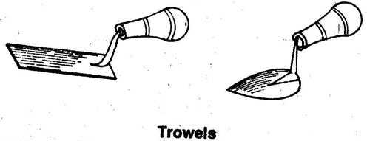
Trowels are molder’s tools, typically made of steel. They are primarily used for scraping away sand, pressing down surfaces, and repairing damaged areas of molds and cores.
  - Shovel
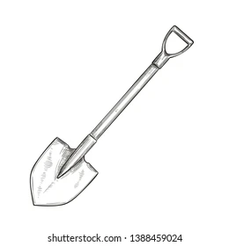
A shovel is a manual tool featuring an MS pan attached to a wooden handle. It is used for moving sand between locations and for blending sand mixtures.
  - Rammers
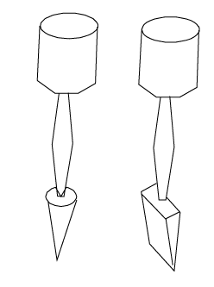
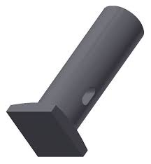
Rammers are used in foundries to compact molding sand, ensuring strength. Inconsistent ramming leads to swelling in cast metal. The primary types are peg and flat rammers. The peg rammer ensures uniform compaction, layering sand into the mold box’s corners and recesses.
  - Lifters:
Lifters are tools for mold repair and cleaning, removing sand particles from mold cavities where slicks prove ineffective. They consist of steel strips with a right-angled bend at one end. The Yankee Lifter, featuring a right-angled bend on one side and a heart-shaped trowel on the other, is widely used in foundry work.

  - Swabs:
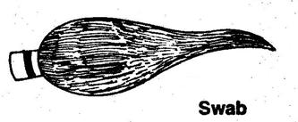
Swabs are dampening tools featuring long, thick wet fibers at one end. These fibers moisten the pattern edges before removal, preventing mold damage. In a Bulb Swab, the bulb acts as a water reservoir for continuous dampening.
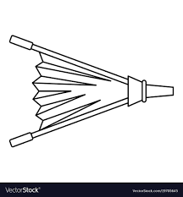
  - Bellows:
Bellows clean molds by blowing low-pressure air to remove sand particles. Excessive pressure can damage the mold.
  - Draw spikes and draw screws:
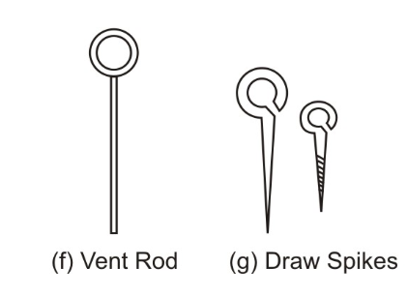
These are made from steel rods. They are used to remove patterns from the mould. Draw spike, a sharp and tapered pin, removes wooden patterns, while Draw screw, with a threaded tip, pulls out metallic patterns.
  - Strike off bar:
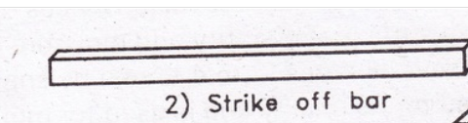
This is a wooden or metallic rectangular tool used to strike off excess moulding sand from the moulding box. The size of the Strike off bar is usually larger than the width of the moulding box.
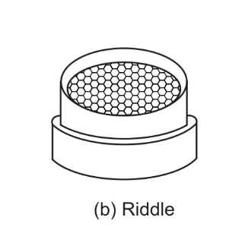
  - Riddle
It is some times called sieve. This is used to sieve moulding sand by removing metal particles, nails, small wooden pieces. The size of the mesh is decided by the sand to be sieved.
  - Vent Wire:
This is a wooden or metallic rectangular tool used to strike off excess moulding sand from the moulding box. The size of the Strike off bar is usually larger than the width of the moulding box.

  - Spure pin and sprue cutter:
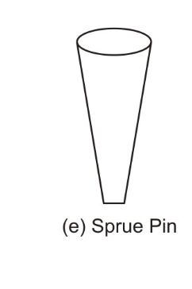
These are similar in shape and use. They are used for making vertical holes in the mould.
Sprue pin is a tapered wooden or steel rod placed vertically inside the moulding box while filling the sand and is later withdrawn to form a hole called runner through which molten metal is poured.
Sprue cutter is a tapered hollow cylinder used to create a hole by inserting it into the rammed moulding sand.

  - Moulding box:
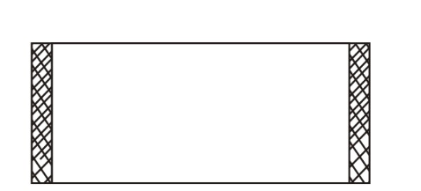
Moulding Box or Moulding Flask is made of metal or wood in pair namely Cope (Upper Part) and Drag (Lower Part) If there are three parts the middle part is called ‘Cheek’.
In Greensand moulding wooden flasks are generally employed. In Dry Sand moulding, since the box is subjected to heat for drying, metallic boxes are preferred. Closed and Open moulding boxes are main types.
  - Moulding board:
This sturdy, flat wooden platform features reinforced support. It stabilizes the molding box during sand filling and compaction.
  - Core:
It is a sturdy sand body made separately in a core box. It is used as an insert in moulds to form recesses, interior cavities, and more, and is collapsed once the molten metal is poured. The main types are horizontal, vertical, and balanced cores.
  - Clamps:
These are used to secure the cope and drag together in position, preventing them from separating while molten metal is poured into the mould.
- Pouring Equipments
  - Ladle
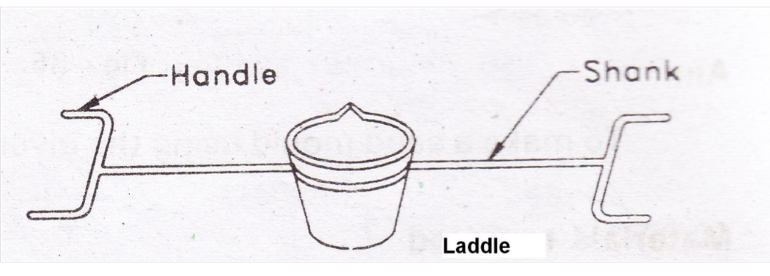
These are made of mild steel and are used for transporting molten metal. The size depends on its metal holding capacity. The inside is lined with refractories. A hand ladle can hold about 10 to 15 kg of molten metal, while for more than 15 kg up to 50 kg, a Bull ladle is more suitable.
  - Crucible:
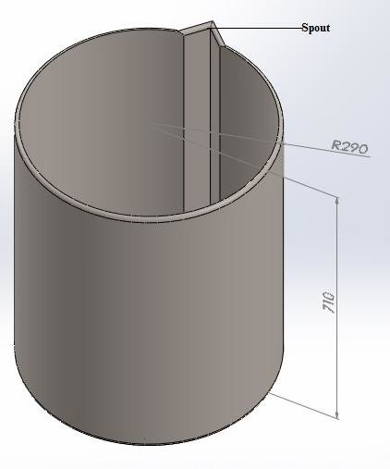
These are made of mild steel and are used for transporting molten metal. The size depends on its metal holding capacity. The inside is lined with refractories. A hand ladle can hold about 10 to 15 kg of molten metal, while for more than 15 kg up to 50 kg, a Bull ladle is more suitable.

