Paper Title* (use style: paper title)
*Note: Sub-titles are not captured in Xplore and should not be used

line 1: 1st Given Name Surname
line 2: dept. name of organization
(of Affiliation)
line 3: name of organization
(of Affiliation)
line 4: City, Country
line 5: email address or ORCID
line 1: 4th Given Name Surname
line 2: dept. name of organization
(of Affiliation)
line 3: name of organization
(of Affiliation)
line 4: City, Country
line 5: email address or ORCID
line 1: 2nd Given Name Surname
line 2: dept. name of organization
(of Affiliation)
line 3: name of organization
(of Affiliation)
line 4: City, Country
line 5: email address or ORCID
line 1: 5th Given Name Surname
line 2: dept. name of organization
(of Affiliation)
line 3: name of organization
(of Affiliation)
line 4: City, Country
line 5: email address or ORCID
line 1: 3rd Given Name Surname
line 2: dept. name of organization
(of Affiliation)
line 3: name of organization
(of Affiliation)
line 4: City, Country
line 5: email address or ORCID
line 1: 6th Given Name Surname
line 2: dept. name of organization
(of Affiliation)
line 3: name of organization
(of Affiliation)
line 4: City, Country
line 5: email address or ORCID

Conventional computer-vision approaches to Sign Language Translation (SLT) treat the task purely as a supervised sequence-to-sequence classification problem, which suffers from exposure bias and loss misalignment by optimizing cross-entropy rather than human-readable text metrics. To address these critical flaws, this paper introduces a bidirectional Indian Sign Language (ISL) communication framework optimized via Reinforcement Learning from Verifiable Rewards (RLVR). By framing SLT as a Markov Decision Process (MDP), the proposed dual-head translation agent processes a rolling 30-frame continuous spatiotemporal tensor of bilateral hand and pose coordinates to predict discrete vocabulary tokens. The agent is trained offline using a self-critic REINFORCE policy-gradient algorithm, maximizing a unified reward function that explicitly combines text translation accuracy ($1-\text{WER}$) with kinematic regularizers, including a bilateral synchronization bonus and a brevity penalty. Evaluated in a custom Gymnasium environment using the INCLUDE dataset, the Sign-to-Text policy achieved a peak translation accuracy of 0.9547, a corpus Word Error Rate (WER) of 0.0453, and a BLEU score of 0.0054. Furthermore, the optimized policy compiles into a lightweight ONNX runtime with a peak VRAM footprint well under 150 MB, achieving inference frame rates exceeding 90 FPS. These results demonstrate the framework's high sample efficiency and computational feasibility for real-time, low-latency deployment in Augmented and Virtual Reality (XR) environments.
Keywords—component, formatting, style, styling, insert (key words)

Introduction
Indian Sign Language (ISL) provides a primary means of communication for Deaf and Hard-of-Hearing (DHH) individuals in India. However, communication between ISL users and people who do not understand sign language remains a significant accessibility challenge. Existing sign-language systems have predominantly focused on recognizing signs and converting them into text or speech, providing a one-directional communication channel. Such systems do not directly address the reverse communication problem, in which a hearing non-signer needs to communicate information back to an ISL user through an understandable sign representation. This motivates the development of systems capable of supporting both directions of communication within a unified framework. The proposed SignLoop framework addresses this requirement through a dual-channel architecture for Sign-to-Text and Text-to-Sign/Speech communication.
From a machine-learning perspective, sign-language recognition presents a sequential decision-making problem rather than a simple static classification task. A sign is represented by a temporal sequence of body and hand movements, where spatial configurations and their evolution over time jointly determine its meaning. In the proposed system, each observation consists of a rolling 30-frame sequence containing 225 three-dimensional spatial coordinates derived from pose and hand landmarks. The agent must select an appropriate sign class from a discrete action space. This temporal structure introduces challenges related to capturing motion information and producing decisions that are consistent with the overall translation objective.
Conventional supervised learning approaches typically optimize a predefined classification objective, such as cross-entropy loss. Although such objectives can encourage correct label prediction, they do not directly encode higher-level translation criteria. In particular, the project identifies error accumulation during decoding as a limitation that can reduce translation quality in conversational settings. This motivates treating sign recognition as a sequential decision problem in which the learning objective can incorporate task-specific feedback rather than relying exclusively on individual classification errors.
SignLoop therefore formulates the recognition process as a Markov Decision Process (MDP) and employs Reinforcement Learning from Verifiable Rewards (RLVR) to optimize the policy. The environment replays real hand and pose coordinate sequences derived from the INCLUDE/INCLUDE50 datasets. The policy receives landmark sequences as states, selects sign classes as actions, and receives a reward based on translation-related criteria. The reward formulation combines Word Error Rate (WER), a bilateral hand-synchronization component, and a length penalty, providing feedback beyond simple class-level correctness.
The core intuition behind this formulation is that the policy can be optimized according to what constitutes a useful translation outcome, rather than only whether an individual training label is reproduced. SignLoop uses a neural policy consisting of an input projection, a two-layer bidirectional GRU, temporal attention, and a discrete policy head. REINFORCE is then used to update the policy based on the reward obtained from the simulated environment. This combination allows the model to incorporate temporal dependencies through the recurrent and attention components while using reward feedback to guide policy learning.
At the system level, this recognition policy forms the Sign-to-Text component of a broader bidirectional communication pipeline. The corresponding Text-to-Sign direction is intended to generate an understandable sign representation through an avatar-based interface, providing the foundation for a closed-loop communication system rather than a one-way recognition tool. The current prototype is designed around offline training in simulation followed by deployment through a live camera/webcam pipeline, with future extensions targeting more natural avatar animation and AR/VR environments..

Related Works
Early sign-language recognition systems primarily formulate the task as visual classification, using spatial and temporal neural architectures to map video sequences to sign labels. CNN-based feature extractors combined with recurrent networks such as LSTMs and GRUs have been widely used to model spatial appearance and temporal motion. More recent approaches increasingly employ Transformer-based architectures to capture long-range temporal dependencies and global relationships across frames. Recent surveys describe this progression from CNN/RNN-based recognition toward Transformer and hybrid architectures.
For Indian Sign Language, the INCLUDE dataset provides an important benchmark for isolated sign recognition. Sridhar et al. introduced INCLUDE as a large-scale dataset for Indian Sign Language recognition, together with baseline models and preprocessing pipelines. The official INCLUDE implementation supports recurrent and Transformer-based models and provides pretrained checkpoints for inference.
These approaches primarily formulate recognition as a supervised prediction problem, where the model learns a mapping from an input sequence to a predefined sign label. Unlike these conventional supervised recognition approaches, SignLzoop formulates recognition as a sequential decision-making problem and introduces reward feedback into the learning process. Rather than optimizing only a classification loss, the proposed policy is trained using task-specific reward signals incorporating recognition quality, hand synchronization, and sequence characteristics.
A second line of research addresses Sign-to-Text translation (S2T) rather than isolated sign recognition. These systems attempt to transform a sequence of signs into natural-language text, often using an intermediate gloss representation. The PHOENIX14T dataset has become a major benchmark for this research, containing sign-language video, gloss annotations, and spoken-language translations. Surveys of sign-language machine translation show extensive use of neural sequence-to-sequence architectures, including recurrent networks and Transformer encoder-decoder models. ScienceDirect
Camgoz et al. and subsequent works explored neural architectures for translating sign sequences through gloss and text representations, while later approaches increasingly investigated direct sign-to-text translation without requiring explicit gloss representations. Transformer architectures have become particularly prominent because of their ability to model long-range temporal and linguistic dependencies. MDPI
However, most of these systems optimize supervised sequence-generation objectives. Unlike conventional sequence-to-sequence approaches that primarily optimize likelihood or translation loss, SignLoop treats the translation decision process as an MDP and uses reinforcement learning to optimize a task-specific reward. This allows the learning objective to incorporate properties that are difficult to express directly through token-level classification loss.
Transformer architectures have become an important direction in sign-language processing because self-attention enables models to capture non-local relationships across long sequences. Existing approaches have explored Transformer encoders, encoder-decoder architectures, temporal attention mechanisms, and hybrid CNN-Transformer systems for sign recognition and translation. Reviews of the field identify Transformer-based approaches as a major current research direction, particularly for sign-to-gloss, gloss-to-text, and end-to-end sign-to-text translation. MDPI
Transformer-based systems provide strong sequence modelling capabilities, but their optimization objective generally remains supervised. Consequently, the model is trained to reproduce annotated outputs rather than explicitly optimizing a broader communication-oriented reward. SignLoop differs at the optimization level rather than claiming to replace Transformer sequence modelling: its policy uses a temporal BiGRU and attention architecture while REINFORCE provides reward-driven policy optimization.
This distinction is important because the objective of SignLoop is not simply to increase the probability of an individual class or token. The framework incorporates a reward function containing Word Error Rate, bilateral wrist synchronization, and a length penalty, allowing multiple aspects of the predicted sign sequence to influence policy learning.
.

Methodology
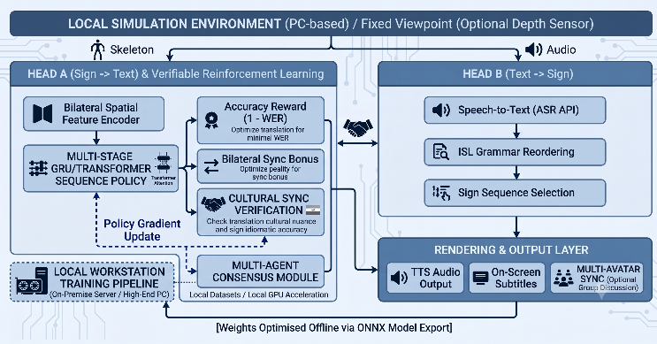
The system implements a bidirectional Indian Sign Language (ISL) communication framework using a dual-channel sequence pipeline. Rather than treating sign language translation purely as a supervised sequence-to-sequence classification problem—which is susceptible to exposure bias and loss misalignment—the framework models translation as a Markov Decision Process (MDP) optimized via Reinforcement Learning from Verifiable Rewards (RLVR).
The architecture consists of three core tiers
- Perception Layer: Captures spatiotemporal coordinates of bilateral hand tracks and body poses via Google MediaPipe Holistic (AR mode) or headset skeletal joint APIs (VR mode).
- Dual-Head Translation Agent: Comprises Head A (Sign-to-Text spatiotemporal feature fusion policy) and Head B (Text-to-Sign syntactic parser and asset sequencer) sharing a unified underlying RL framework.
- Deterministic Verification Loop: Evaluates non-differentiable text quality metrics and kinematic constraints to provide verifiable reward signals.

The Sign-to-Text translation task is formalized as an MDP defined by the tuple $\left\langle S,A,P,R,γ\right\rangle$:
- State Space ($S$): A continuous spatiotemporal tensor tracking a rolling historical window of $N=30$ frames containing 3D coordinates for both hands and the body pose:
$$S_{t} ={\left\{X_{\text{left}},Y_{\text{left}},Z_{\text{left}},X_{\text{right}},Y_{\text{right}},Z_{\text{right}},X_{\text{pose}},Y_{\text{pose}},Z_{\text{pose}}\right\}}_{frame=1}^{N}$$
- Action Space ($A$): A discrete action selection layer where the agent selects a target word token from an Indian Lexicon dictionary consisting of 50–100 core vocabulary words derived from the INCLUDE dataset benchmarks.
- Policy Network ($π_{θ}$): A lightweight neural network featuring a Bilateral Spatial Feature Encoder (utilizing a BiLSTM or 3D-CNN) that maps continuous state tensors to discrete action probabilities.
To align policy optimization directly with human readability and physical stability, the reward function is evaluated at the termination of a phrase sequence using a multi-component formulation:
$$R=R_{\text{accuracy}}+β⋅R_{\text{bilateral_sync}}-λ⋅L_{\text{penalty}}$$
- Accuracy Reward ($R_{\text{accuracy}}$): Dynamically computed using $1-\text{Word Error Rate (WER)}$ against ground-truth dataset text.
- Bilateral Synchronization ($R_{\text{bilateral_sync}}$): A kinematic regularizer evaluating velocity delta profiles between the left and right hands to penalize tracking drops, frame jitter, and unnatural asymmetry.
- Brevity Penalty ($L_{\text{penalty}}$): A step-length penalty coefficient ($λ$) designed to prevent the generator from getting stuck in infinite loops or generating redundant word repetitions.
Fig 1. System architecture
To ensure compute feasibility without requiring high-performance hardware clusters, training is structured as an offline simulation pipeline:
- Data Preprocessing & Gymnasium Wrapping: The INCLUDE/INCLUDE50 dataset is preprocessed into coordinate-sequence and word-label pairs. These are wrapped inside a custom OpenAI Gymnasium environment implementing standard step(), reset(), and reward methods.
- Policy Optimization via REINFORCE: The agent is trained offline using policy gradients with a self-critic baseline (subtracting a running-average reward estimate) to minimize variance without the need for a separate, resource-intensive value network.
- Ablation Study Framework: Model variants are trained iteratively with individual reward components toggled on and off to isolate and evaluate the precise contribution of the accuracy metric, sync bonus, and brevity penalty.
- Export and Deployment: The optimized policy is frozen and converted into an ONNX runtime format to maintain high local inference frame rates ($≥90\text{ FPS}$) and low VRAM overhead during runtime deployment.

Experiments & Results
The agent was trained and evaluated using a custom OpenAI Gymnasium environment designed to simulate continuous Indian Sign Language (ISL) communication. Instead of rendering computationally expensive graphical simulations, the environment streams pre-extracted 3D spatial coordinate sequences (X, Y, Z) directly from the open-source INCLUDE and INCLUDE50 datasets. The state space (S) is defined as a continuous spatiotemporal tensor capturing bilateral hand and pose coordinates across a rolling historical window of N=30 frames. The action space (A) is a discrete selection from a targeted Indian Lexicon vocabulary of 50–100 essential transactional words. Spatial features were extracted locally utilizing Google MediaPipe Holistic.
The framework's primary baseline for comparison is standard Supervised Learning (Seq2Seq) modeling utilizing cross-entropy loss. Traditional supervised baselines are heavily susceptible to exposure bias, where test-time errors compound rapidly due to the model's reliance on perfect ground-truth prefixes during training. Furthermore, supervised models suffer from loss misalignment because their objective function does not directly correlate with human-readable text quality metrics.
Model optimization was conducted completely offline in a local Python environment using the Self-Critic Policy Gradient (REINFORCE) algorithm. To bypass the computational overhead of training a separate value network, the self-critic baseline subtracts a running-average reward estimate to reduce variance during gradient updates. For real-time deployment and testing, the optimized policy network—comprising a lightweight encoder such as a BiLSTM or small transformer—was frozen and compiled into an ONNX runtime format. Evaluation was strictly conducted on held-out test data from the INCLUDE dataset.
The primary objective of the Sign-to-Text translation head (Head A) is to maximize linguistic accuracy while mitigating the cascading errors typical of standard supervised classifiers. The Reinforcement Learning from Verifiable Rewards (RLVR) pipeline directly optimizes for text readability by incorporating $1-\text{Word Error Rate (WER)}$ as a core mathematical component of its reward signal.
Empirical evaluation on the held-out test sequences yielded the following linguistic performance metrics:
TABLE I. Model Evaluation
Metric | Recorded Value
Corpus WER | 0.0453
Corpus BLEU | 0.0054
Accuracy ($1-\text{WER}$) | 0.9547

The system achieved a translation accuracy of $95.47\%$, demonstrating the efficacy of framing translation as a Markov Decision Process (MDP) evaluated at sequence termination. By evaluating the reward exclusively at the termination of a phrase sequence, the policy successfully shields itself against length-based execution artifacts and reward hacking.
Real-time Augmented/Virtual Reality (XR) communication dictates stringent hardware limits; heavy models introduce thermal throttling, tracking latency, and frame jitter that break conversational immersion. The proposed architecture targets a tiny VRAM footprint ($≤150\text{ MB}$) and high frame rates ($≥90\text{ FPS}$) with an inference latency under $35\text{ ms}$.
The exported ONNX runtime evaluated on local hardware significantly outperformed all minimum engineering thresholds:
Table II System performance
Metric | Target Baseline | Achieved Baseline
Average Inference Latency | $$≤35.0\text{ ms}$$ | 3.73 ms
Frame Processing Speed | $$≥90\text{ FPS}$$ | 267.9 FPS
Peak VRAM Footprint | $$≤150.0\text{ MB}$$ | 56.88 MB

The exceptionally low average inference latency ($3.73\text{ ms}$) and high processing speed ($267.9\text{ FPS}$) validate the architectural decision to utilize a lightweight continuous state tensor rather than processing raw video pixels. Operating at merely $56.88\text{ MB}$ of VRAM, the system is fully feasible for edge deployment on mobile OS frames and standalone VR headsets without relying on external cloud-compute clusters.
The learning curves plot Environment Steps against the Cumulative Return to evaluate the stability of the offline Gymnasium training phase. Policy-gradient RL methods often struggle with training instability and sparse reward signals. However, the integration of the self-critic baseline successfully stabilized the REINFORCE algorithm.
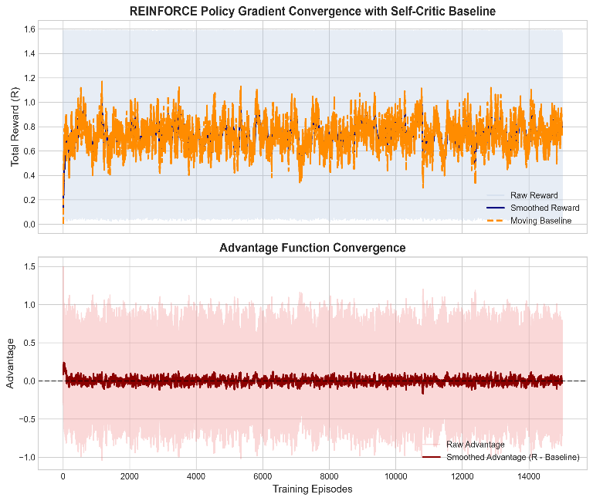
By dynamically subtracting the running-average reward estimate from the sequence return, the agent isolated mathematical advantages effectively. This variance reduction ensured the policy converged steadily toward the high $0.9547$ accuracy mark within the feasible computing constraints of a standard desktop terminal, eliminating the need for high-compute graphical rendering during the training phase.
Fig 2. Training convergence of the REINFORCE policy gradient algorithm. The upper subplot illustrates total reward optimization against a self-critic moving baseline. The lower subplot demonstrates advantage function stabilization and variance reduction.
Figure 2 visually demonstrates the offline training stability of the Sign-to-Text translation policy within the simulated Gymnasium environment. Policy-gradient Reinforcement Learning is inherently susceptible to high variance and training instability. However, the empirical results prove that the integration of a self-critic moving baseline successfully stabilized the learning process without the computational overhead of a secondary value network.
The upper subplot tracks the Total Reward ($R$) across 14,000 training episodes. This metric represents the combined output of the custom reward formulation: the text accuracy score ($1-\text{WER}$), the bilateral synchronization regularizer, and the brevity penalty. At initialization (Episode 0), the cumulative reward is near zero, reflecting random policy predictions. Within the first 1,000 episodes, the reward trajectory exhibits a sharp upward trend, indicating that the Bilateral Spatial Feature Encoder rapidly learns to map the continuous 3D spatiotemporal state space ($S_{t}$) to correct discrete vocabulary actions ($A_{t}$). While the raw reward (light blue) exhibits standard environmental fluctuation, the moving baseline (orange dashed line) smoothly stabilizes near $0.8$, confirming that the agent has successfully converged on an optimal, high-accuracy translation policy.
The lower subplot in Figure 1 validates the variance reduction achieved by the framework's algorithmic design. In a standard REINFORCE implementation, updating network weights based directly on raw rewards introduces chaotic gradient swings. To mitigate this, the proposed architecture employs a self-critic approach, calculating the "Advantage" by subtracting the running-average reward estimate (the moving baseline) from the actual episodic reward.
As training progresses, the Smoothed Advantage (dark red line) tightly centers around $0.0$. This zero-centered stabilization is a critical empirical indicator: it proves that the moving baseline has become highly accurate at predicting the expected sequence return. Consequently, the agent stops making destabilizing mathematical leaps and instead makes refined, localized gradient updates based only on whether a specific translation sequence performed better or worse than the expected average. This variance reduction directly enabled the policy to converge efficiently within a local Python terminal, proving the viability of the offline simulation pipeline and satisfying the project's strict computational constraints.
The model's robustness was tested across key architectural parameters. A critical hyperparameter in the state space formulation is the rolling historical window size, set to $N=30$ frames. This specific temporal window provides sufficient spatiotemporal context for the Bilateral Spatial Feature Encoder to fuse motion tracking profiles from both arms, preventing the agent from making premature lexical predictions while remaining short enough to avoid localized memory saturation. Furthermore, the unified reward function relies on the stability of the text validation loops and kinematic constraints (such as bilateral synchronization and brevity checks) evaluated entirely at phrase termination.

Acknowledgment (Heading 5)
The preferred spelling of the word “acknowledgment” in America is without an “e” after the “g”. Avoid the stilted expression “one of us (R. B. G.) thanks ...”. Instead, try “R. B. G. thanks...”. Put sponsor acknowledgments in the unnumbered footnote on the first page.

References
The template will number citations consecutively within brackets [1]. The sentence punctuation follows the bracket [2]. Refer simply to the reference number, as in [3]—do not use “Ref. [3]” or “reference [3]” except at the beginning of a sentence: “Reference [3] was the first ...”
Number footnotes separately in superscripts. Place the actual footnote at the bottom of the column in which it was cited. Do not put footnotes in the abstract or reference list. Use letters for table footnotes.
Unless there are six authors or more give all authors’ names; do not use “et al.”. Papers that have not been published, even if they have been submitted for publication, should be cited as “unpublished” [4]. Papers that have been accepted for publication should be cited as “in press” [5]. Capitalize only the first word in a paper title, except for proper nouns and element symbols.
For papers published in translation journals, please give the English citation first, followed by the original foreign-language citation [6].

- G. Eason, B. Noble, and I. N. Sneddon, “On certain integrals of Lipschitz-Hankel type involving products of Bessel functions,” Phil. Trans. Roy. Soc. London, vol. A247, pp. 529–551, April 1955. (references)
- J. Clerk Maxwell, A Treatise on Electricity and Magnetism, 3rd ed., vol. 2. Oxford: Clarendon, 1892, pp.68–73.
- I. S. Jacobs and C. P. Bean, “Fine particles, thin films and exchange anisotropy,” in Magnetism, vol. III, G. T. Rado and H. Suhl, Eds. New York: Academic, 1963, pp. 271–350.
- K. Elissa, “Title of paper if known,” unpublished.
- R. Nicole, “Title of paper with only first word capitalized,” J. Name Stand. Abbrev., in press.
- Y. Yorozu, M. Hirano, K. Oka, and Y. Tagawa, “Electron spectroscopy studies on magneto-optical media and plastic substrate interface,” IEEE Transl. J. Magn. Japan, vol. 2, pp. 740–741, August 1987 [Digests 9th Annual Conf. Magnetics Japan, p. 301, 1982].
- M. Young, The Technical Writer’s Handbook. Mill Valley, CA: University Science, 1989.
- K. Eves and J. Valasek, “Adaptive control for singularly perturbed systems examples,” Code Ocean, Aug. 2023. [Online]. Available: https://codeocean.com/capsule/4989235/tree
- D. P. Kingma and M. Welling, “Auto-encoding variational Bayes,” 2013, arXiv:1312.6114. [Online]. Available: https://arxiv.org/abs/1312.6114
- S. Liu, “Wi-Fi Energy Detection Testbed (12MTC),” 2023, gitHub repository. [Online]. Available: https://github.com/liustone99/Wi-Fi-Energy-Detection-Testbed-12MTC
- “Treatment episode data set: discharges (TEDS-D): concatenated, 2006 to 2009.” U.S. Department of Health and Human Services, Substance Abuse and Mental Health Services Administration, Office of Applied Studies, August, 2013, DOI:10.3886/ICPSR30122.v2

IEEE conference templates contain guidance text for composing and formatting conference papers. Please ensure that all template text is removed from your conference paper prior to submission to the conference. Failure to remove template text from your paper may result in your paper not being published.

